**5. BUCKET SORT**

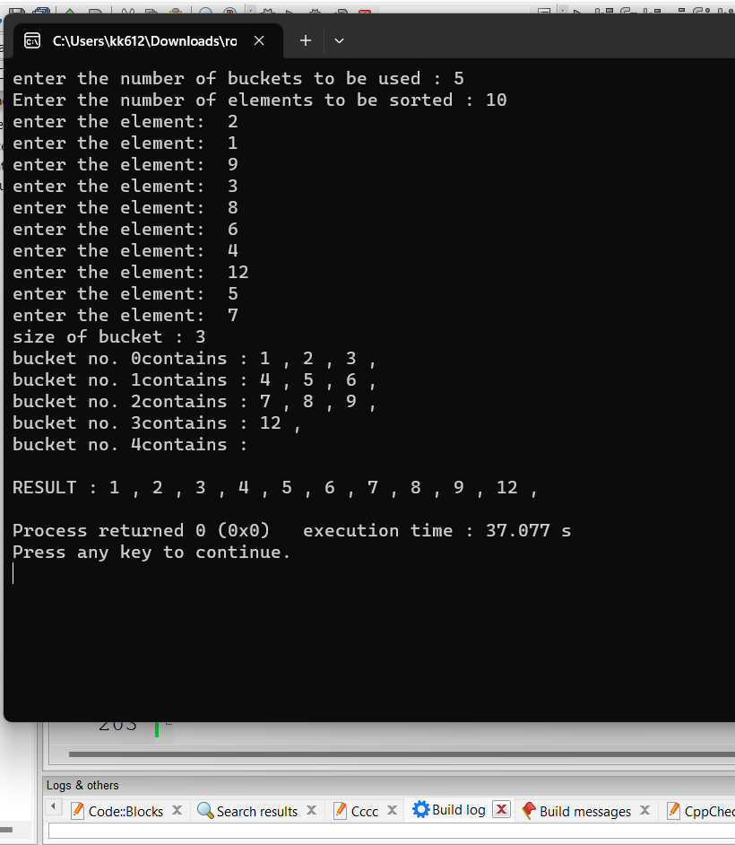

#include <bits/stdc++.h>

using namespace std;

void insertion_sort(int *arr,int size){

for(int i=1;i<size;i++){

int curr =arr[i];

int j = i-1;

int k=i;

while(j>=0 && arr[j] > curr){

//if current is larger smaller than previous than

//shift previous to current

arr[k] = arr[j];

k--;

j--;

}

arr[k] = curr;

}

}

class bucket{

int *buc;

int n;

int curr;

public:

bucket(){

}

bucket(int s){ //size of 1 bucket

n=s;

buc = new int[n];

curr=0;

}

void print(){

for(int i=0;i<curr;i++){

cout<<buc[i]<<" , ";

}

}

void sort_me(){

if(curr>1)

insertion_sort(buc,curr);

}

void set_data(int s){

n=s;

buc = new int[n];

curr=0;

}

void add(int data){

buc[curr] =data;

curr++;

}

int *get_arr(){

return buc;

}

int no_of_data_entered(){

return curr;

}

};

int max(int *arr,int size){

int ans = arr[0];

for(int i=1;i<size;i++){

if(ans<arr[i]){

ans = arr[i];

}

}

return ans;

}

int min(int *arr,int size){

int ans = arr[0];

for(int i=1;i<size;i++){

if(ans>arr[i]){

ans = arr[i];

}

}

return ans;

}

void print(bucket *buckets,int no_bucket){

for(int i=0,j=0;i<no_bucket;i++){

cout<<"bucket no. "<<i<<"contains : ";

buckets[i].print();

cout<<endl;

}

}

void print_arr(int *arr,int size){

for(int i=0;i<size;i++){

cout<<arr[i]<<" , ";

}

}

void bucket_sort(int *arr,const int size,bucket *buckets,int size_of_bucket,int no_bucket,int start){

for(int i=0;i<size;i++){

buckets[ ((arr[i]-start)/size_of_bucket)].add(arr[i]);

}

for(int i=0;i<no_bucket;i++){

buckets[i].sort_me();

}

print(buckets,no_bucket);

//conqour all the buckets

int countt=0;

for(int i=0;i<no_bucket;i++){

const int *temp = buckets[i].get_arr(); //

for(int j=0;j<buckets[i].no_of_data_entered();j++){

arr[countt] = temp[j];

countt++;

}

}

cout<<endl;

cout<<"RESULT : ";

print_arr(arr,size);

cout<<endl;

}

int main()

{

cout<<"enter the number of buckets to be used : ";

int no_bucket=0;

cin>>no_bucket;

cout<<"Enter the number of elements to be sorted : ";

int size=0;

cin>>size;

int *arr = new int[size];

for(int i=0;i<size;i++){

cout<<"enter the element: ";

cin>>arr[i];

}

int start =min(arr,size);

int size_of_bucket = ceil((max(arr,size) - min(arr,size) +1)*1.0 /no_bucket*1.0);

cout<<"size of bucket : "<<size_of_bucket<<endl;

bucket *arr_bucket = new bucket[no_bucket];

for(int i=0;i<no_bucket;i++){

arr_bucket[i].set_data(size_of_bucket);

}

bucket_sort(arr,size,arr_bucket,size_of_bucket,no_bucket,start);

return 0;

}