**6.) RANDOMIZED SELECT**

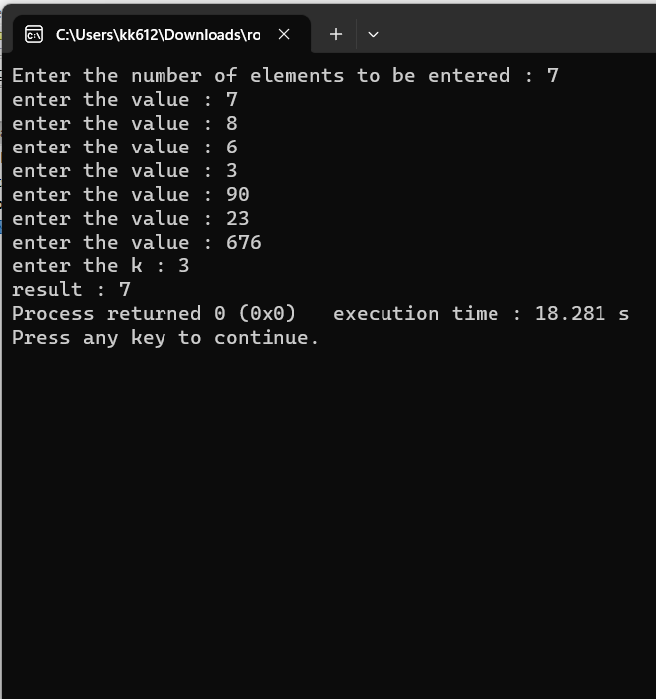

#include <iostream>

#include <cstdlib>

#include <ctime>

using namespace std;

void swap(int &a, int &b) {

int temp = a;

a = b;

b = temp;

}

int partition(int *arr,int s ,int l){ //

int random_index = (rand() % (l - s + 1)) + s ;

swap(arr[random_index],arr[l]);

int x = arr[l];

int i = s-1;

for(int j=s;j<l;j++){ // 1 2 3 4 5 6 7

if(arr[j]<=x){

i++;

swap(arr[i],arr[j]);

}

}

swap(arr[i+1],arr[l]);

return i+1;

}

int randomized_select(int *arr,int s,int l,int k){

if(s==l){

return arr[l];

}

int position_of_pivot = partition(arr,s ,l);

//int rel = position_of_pivot-s+1;

if(k == position_of_pivot){

return arr[position_of_pivot];

}else if(position_of_pivot>k){

//left subarray

return randomized_select(arr,s,position_of_pivot-1,k);

}else{

return randomized_select(arr,position_of_pivot+1,l,k);

//right subarray

}

}

int main()

{

cout<<"Enter the number of elements to be entered : ";

int n=0;

cin>>n;

int *arr = new int[n];

for(int i=0;i<n;i++){

cout<<"enter the value : ";

int temp=0;

cin>>temp;

arr[i]=temp;

}

srand(time(NULL));

cout<<"enter the k : ";

int k=0;

cin>>k;

cout<<"result : "<<randomized_select(arr,0,n-1,k-1);

return 0;

}