**7. BFS**

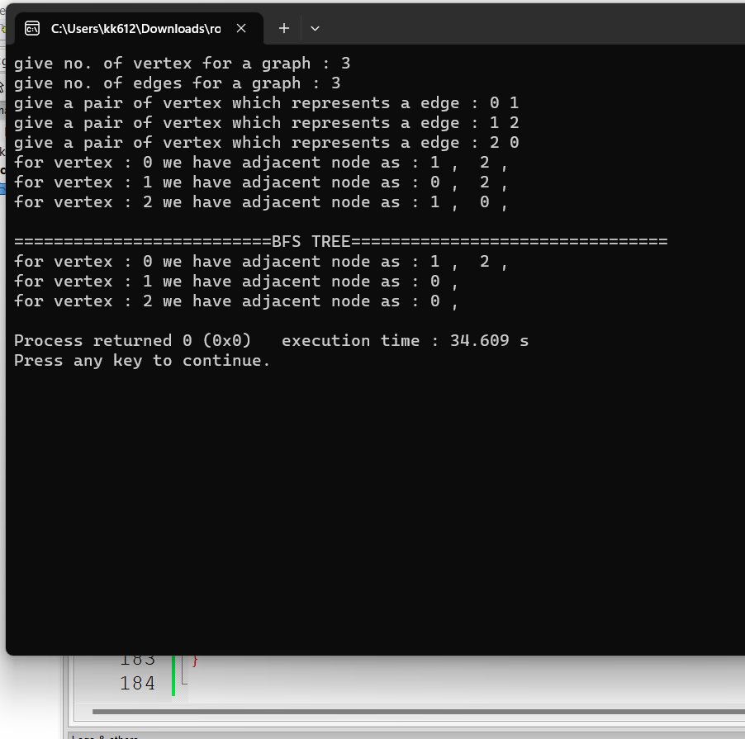

#include <iostream>

#include <queue>

using namespace std;

class node{

int vertex;

friend class LinkedList;

public:

node* next;

node(){

next=0;

}

node(int v){

vertex = v;

next=0;

}

int get_vertex(){

return vertex;

}

};

//linkedlist

class LinkedList{

friend class node;

public:

node *head;

node *last;

LinkedList(){

head=0;

last=0;

}

void set_head(node *ptr){

head =ptr;

last = ptr;

}

void set_next(node *ptr){

if(head !=0){

last->next = ptr;

}

last = ptr;

}

};

void print(LinkedList *vertex_arr,int size){

for(int i=0;i<size;i++){

cout<<"for vertex : "<<i<<" we have adjacent node as : ";

node *temp = vertex_arr[i].head;

temp = temp->next;

while(temp !=0){

cout<<temp->get_vertex();

cout<<" , ";

temp = temp->next;

}

cout<<endl;

}

}

void BFS(LinkedList *vertex_arr,int size,int src){

int *discovered = new int[size];

for(int i=0;i<size;i++){

discovered[i] =0;

} //setting discovered for every vertex as false

discovered[src] = 1; // for s discovered is true

int dis=1;

int layer_count=0;

//current bfs tree = null

LinkedList *bfs_tree = new LinkedList[size];

queue<int> q;

q.push(src);

bfs_tree[src].set_head(new node(src));

while(!q.empty()){

int u = q.front();

q.pop();

node *v= vertex_arr[u].head;

v = v->next;

while(v !=0){ //breaks this loop will add adjacent vertices of node

if(discovered[v->get_vertex()]==0){ //if not discovered

if(bfs_tree[v->get_vertex()].head == 0){

bfs_tree[v->get_vertex()].set_head(new node(v->get_vertex()));

}

discovered[v->get_vertex()]=1;

dis++;

bfs_tree[u].set_next(new node(v->get_vertex()));

bfs_tree[v->get_vertex()].set_next(new node(u));

q.push(v->get_vertex());

}

v = v->next;

}

layer_count++;

}

print(bfs_tree,size);

}

int main()

{

cout<<"give no. of vertex for a graph : ";

int no_vertex=0;

cin>>no_vertex;

//initalization of the array of list , each has a vertex has head

LinkedList *vertex_arr = new LinkedList[no_vertex];

//giving values to each head vertex

for(int i=0;i<no_vertex;i++){

vertex_arr[i].set_head(new node(i));

}

cout<<"give no. of edges for a graph : ";

int no_edges=0;

cin>>no_edges;

//building a Graph :: Adjancent list

for(int i=0;i<no_edges;i++){

cout<<"give a pair of vertex which represents a edge : ";

int u=0,v=0;

cin>>u>>v;

vertex_arr[u].set_next(new node(v));

vertex_arr[v].set_next(new node(u));

}

print(vertex_arr,no_vertex);

cout<<endl;

cout<<"==========================BFS TREE================================"<<endl;

BFS(vertex_arr,no_vertex,0);

return 0;

}