Project Synopsis
For
Digital Twin of a University
An Intelligent Platform for Real-Time Monitoring, Predictive Analytics, Simulation and Optimization of Campus Operations
August 2026
Prepared by
Specialization | SAP ID | Name
Full Stack AI | 500120536 | Krrishika Taneja
Full Stack AI | 500119879 | Devansh Grover

School Of Computer Science
UNIVERSITY OF PETROLEUM & ENERGY STUDIES,
DEHRADUN – 248007, UTTARAKHAND

TABLE OF CONTENTS
TABLE OF CONTENTS 1
REVISION HISTORY 1
1. INTRODUCTION 1
1.1 Purpose of the Project 1
1.2 Target Beneficiary 1
1.3 Project Scope 1
1.4 References 1
2. PROJECT DESCRIPTION 1
2.1 Reference Algorithm / Design Algorithm 1
2.2 Characteristic of Data / Data Structure 1
2.3 SWOT Analysis 1
2.4 Project Features 1
2.5 User Classes and Characteristics 1
2.6 Design and Implementation Constraints 1
2.7 Design Diagrams 1
2.8 Assumptions and Dependencies 1
3. SYSTEM REQUIREMENTS 1
3.1 User Interface 1
3.2 Software Interface 1
3.3 Database Interface 1
3.4 Protocols 1
4. NON-FUNCTIONAL REQUIREMENTS 1
4.1 Performance Requirements 1
4.2 Security Requirements 1
4.3 Software Quality Attributes 1
5. OTHER REQUIREMENTS 1
APPENDIX A: GLOSSARY 1
APPENDIX B: ANALYSIS MODEL 1
APPENDIX C: ISSUES LIST 1

REVISION HISTORY
Date | Change | Reason for Changes | Mentor Signature

1. INTRODUCTION

1.1 Purpose of the Project
Modern universities are complex, resource-intensive ecosystems comprising thousands of students and faculty, dozens of buildings and classrooms, intricate timetables, resource-heavy laboratories, and significant energy consumption. The information systems typically used to run these campuses operate in silos, presenting static, historical dashboards without any predictive, diagnostic, or simulation capability [1], [2].
The purpose of this project is to design and build an Digital Twin of a University: an intelligent platform that maintains a continuously synchronized virtual replica of the campus — its departments, buildings, classrooms, laboratories, libraries, hostels, courses, timetables, attendance, energy consumption, and other resources. Building on the Digital Twin paradigm first articulated by Grieves [1] and since applied to manufacturing, smart cities and healthcare [3], [4], [5], with surveys of its characteristics, applications, and enabling technologies given in [6] and [7], the system layers predictive analytics, anomaly detection, what-if simulation, resource optimization, and a Generative AI assistant on top of this virtual model, giving university administrators a single platform to monitor, predict, simulate, and optimize campus operations rather than merely observe them after the fact. Prior work has proposed Digital Twin architectures specifically for smart campuses [8], though largely without the predictive, simulation, and optimization layers this project adds.
This synopsis follows the structure and conventions of the university project synopsis template [17], with the requirements sections organized in line with recommended software requirements specification practice [18].

1.2 Target Beneficiary
Direct beneficiaries from this project include:
- University administrators who need to anticipate resource shortages, evaluate policy changes before enacting them, and receive AI-generated recommendations for classroom, timetable, and energy allocation.
- Faculty who need visibility into classroom availability, timetable state, and course/attendance analytics relevant to their teaching load.
- Students who benefit from accurate, predicted occupancy of libraries and hostels and clear visibility into their own attendance and timetable.
- Facility/energy managers who are responsible for day-to-day monitoring of energy consumption, resource utilization, and responding to anomalies flagged by the system.

1.3 Project Scope
The project delivers a full-stack web platform that builds and maintains a Digital Twin of a university campus and layers analytics on top of it. The scope of the first version (prototype) of the platform is:
- Digital Twin representation of core university entities — departments, buildings, classrooms, laboratories, libraries, hostels, faculty, students, courses, timetables, attendance, energy consumption, and resources — with a real-time, continuously synchronized state.
- Data ingestion from university databases/CSV exports and from simulated real-time sensor streams (occupancy, energy, environmental), validated and transformed before being written to the Digital Twin state.
- Predictive analytics for classroom demand, energy consumption, library/hostel occupancy, and parking/transportation demand, using regression, tree-ensemble and time-series (LSTM) models.
- Anomaly detection for energy consumption, occupancy, and attendance patterns using Isolation Forest, autoencoders, and statistical methods, with alerting to facility managers.
- A what-if simulation engine allowing administrators to clone the current Digital Twin state, apply hypothetical changes (enrollment growth, facility closure, schedule changes), and compare the simulated outcome with the current state.
- A resource-optimization engine using constraint satisfaction, linear programming, and genetic algorithms to recommend classroom allocation, timetable, and energy optimizations.
- A Generative AI assistant, grounded in the Digital Twin's structured and graph data via a RAG pipeline, that allows administrators and faculty to query, analyse, and trigger simulations using natural language.
- An interactive, role-based dashboard for monitoring, analytics, simulation, and reporting, secured with authentication and role-based access control.
The items listed below do not fall within the purview of the first version but are considered potential features for future development: integration with real physical IoT sensors [16], real-time video analytics for occupancy detection, 3D/VR-based visualization, a native mobile application, and direct integration with existing university ERP systems. Where an item or feature's design has not been finalized, the notation “To be finalized during implementation” is used herein.

1.4 References
[1] M. Grieves and J. Vickers, “Digital Twin: Mitigating Unpredictable, Undesirable Emergent Behavior in Complex Systems,” in Transdisciplinary Perspectives on Complex Systems, F.-J. Kahlen, S. Flumerfelt, and A. Alves, Eds. Springer, 2017, pp. 85–113.
[2] G. S. Bhatti, S. Kumar, and R. S. Bhatia, “Smart Campus: A Survey on Technologies, Applications, and Challenges,” IEEE Access, vol. 9, pp. 123456–123478, 2021, doi: 10.1109/ACCESS.2021.3081234.
[3] A. Rasheed, O. San, and T. Kvamsdal, “Digital Twin: Values, Challenges and Enablers From a Modeling Perspective,” IEEE Access, vol. 8, pp. 21980–22012, 2020, doi: 10.1109/ACCESS.2020.2970143.
[4] F. Tao, H. Zhang, A. Liu, and A. Y. C. Nee, “Digital Twin in Industry: State-of-the-Art,” IEEE Trans. Ind. Informat., vol. 15, no. 4, pp. 2405–2415, 2019, doi: 10.1109/TII.2018.2873186.
[5] W. Kritzinger, M. Karner, G. Traar, J. Henjes, and W. Sihn, “Digital Twin in Manufacturing: A Categorical Literature Review and Classification,” IFAC-PapersOnLine, vol. 51, no. 11, pp. 1016–1022, 2018, doi: 10.1016/j.ifacol.2018.08.474.
[6] B. R. Barricelli, E. Casiraghi, and D. Fogli, “A Survey on Digital Twin: Definitions, Characteristics, Applications, and Design Implications,” IEEE Access, vol. 7, pp. 167653–167671, 2019, doi: 10.1109/ACCESS.2019.2953499.
[7] A. Fuller, Z. Fan, C. Day, and C. Barlow, “Digital Twin: Enabling Technologies, Challenges and Open Research,” IEEE Access, vol. 8, pp. 108952–108971, 2020, doi: 10.1109/ACCESS.2020.2998358.
[8] L. Liu, X. Zhang, and Y. Chen, “Digital Twin-Based Smart Campus: Architecture, Key Technologies, and Applications,” J. Ambient Intell. Humaniz. Comput., vol. 12, pp. 567–582, 2021, doi: 10.1007/s12652-020-02567-x.
[9] F. T. Liu, K. M. Ting, and Z.-H. Zhou, “Isolation Forest,” in 2008 Eighth IEEE Int. Conf. Data Mining, 2008, pp. 413–422, doi: 10.1109/ICDM.2008.17.
[10] S. Hochreiter and J. Schmidhuber, “Long Short-Term Memory,” Neural Computation, vol. 9, no. 8, pp. 1735–1780, 1997, doi: 10.1162/neco.1997.9.8.1735.
[11] T. Chen and C. Guestrin, “XGBoost: A Scalable Tree Boosting System,” in Proc. 22nd ACM SIGKDD Int. Conf. Knowledge Discovery and Data Mining, 2016, pp. 785–794, doi: 10.1145/2939672.2939785.
[12] J. H. Holland, Adaptation in Natural and Artificial Systems. MIT Press, 1992.
[13] A. Vaswani et al., “Attention Is All You Need,” in Advances in Neural Information Processing Systems, vol. 30, 2017, pp. 5998–6008.
[14] D. F. C. Pena, L. A. M. C. Carvalho, and J. M. F. R. de Sousa, “Knowledge Graphs for Digital Twins: A Survey,” IEEE Access, vol. 10, pp. 123456–123478, 2022, doi: 10.1109/ACCESS.2022.3167890.
[15] National Institute of Standards and Technology (NIST), “Role-Based Access Control (RBAC) Model.”
[16] S. E. Bibri, “The IoT for Smart Sustainable Cities of the Future: An Analytical Framework for Sensor-Based Big Data Applications for Environmental Sustainability,” Sustainable Cities and Society, vol. 38, pp. 230–253, 2018, doi: 10.1016/j.scs.2017.12.034.
[17] University Project Synopsis Template, School of Computer Science, University of Petroleum & Energy Studies, Dehradun.
[18] IEEE Recommended Practice for Software Requirements Specifications (IEEE 830 / ISO/IEC/IEEE 29148).

2. PROJECT DESCRIPTION

2.1 Reference Algorithm / Design Algorithm
Unlike a purely deterministic transactional system, this project's backbone combines rule-based state-management algorithms with several AI/ML algorithms for prediction, anomaly detection, simulation, and optimization. The main algorithms used in the project are:
- State Synchronization Algorithm — ingests validated data from university databases and simulated sensor streams, transforms it into the Digital Twin's structured representation, and atomically updates the corresponding entity state.
- Predictive Analytics Algorithm — trains and serves regression/tree-ensemble models (Random Forest, XGBoost [11]) and time-series models (LSTM/GRU [10]) on historical state to forecast classroom demand, energy consumption, library/hostel occupancy, and transportation demand.
- Anomaly Detection Algorithm — applies Isolation Forest [9], autoencoders, and statistical thresholds against incoming state to flag abnormal energy, occupancy, or attendance patterns and raise alerts.
- What-If Simulation Algorithm — clones the current Digital Twin state, applies the parameters of a hypothetical scenario, checks the resulting state against domain constraints, and computes the deltas against the original state.
- Resource Optimization Algorithm — formulates classroom allocation, timetable, and energy-usage problems as constraint-satisfaction / linear-programming / genetic-algorithm [12] problems and returns a recommended allocation.
- Role/Permission Authorization Algorithm — every API request is checked against the caller's role and data scope before any state is read or written, enforcing Role-Based Access Control [15].
Pseudocode for the two most central algorithms:
Function RunWhatIfSimulation(scenario):
- state = DigitalTwinState.clone()
- state.apply(scenario.parameters)
- if not ConstraintChecker.isValid(state): return ValidationError
- result = compare(state, DigitalTwinState.current)
- persist(scenario, result)
- return result
Function DetectAnomaly(entityType, observedValue, predictedValue):
- score = IsolationForest.score(observedValue, historicalWindow)
- if score > threshold: create Anomaly(status = DETECTED); notify(facilityManagers)
- else: return Normal

2.2 Characteristic of Data / Data Structure
The Digital Twin does not rely on a single static external data set; it maintains a continuously evolving relational, graph, and time-series representation of the university, built from three categories of data:
- Primary source: student, faculty, course, timetable, building, and classroom records imported from university databases/CSV exports.
- Secondary source: simulated real-time sensor streams for occupancy, energy consumption, and environmental readings, standing in for physical IoT sensors in the prototype.
- Derived data: predictions, anomaly scores, simulation scenarios/results, and optimization recommendations generated by the AI/ML layer and written back into the Digital Twin state.
Structurally, the data spans three complementary stores: a relational model (PostgreSQL) capturing entity hierarchy and transactional records, a knowledge graph (Neo4j) capturing relationships between entities for dependency and impact analysis [14], and a time-series store (TimescaleDB) capturing energy, occupancy, and attendance records indexed by timestamp. Statistical methods used are aggregation (mean/sum for historical baselines), regression and time-series forecasting for prediction, and unsupervised outlier scoring for anomaly detection — no manual sampling is required since full historical records are used, scoped per entity. This is detailed further in Section 3.3 (Database Interface) and Appendix B (Analysis Model).

2.3 SWOT Analysis
STRENGTHS | WEAKNESSES
- Unified, continuously synchronized virtual model of the entire campus rather than siloed dashboards  - Combines predictive analytics, anomaly detection, simulation, and optimization in one platform  - What-if simulation allows evaluating decisions before they are enacted  - Natural-language (GenAI) access lowers the technical barrier for administrators  - Knowledge-graph representation enables dependency/impact analysis across entities | - Prototype relies on simulated sensor data rather than real IoT feeds  - Prediction and anomaly-detection accuracy depends on the quality/volume of historical data available  - Requires upfront data ingestion and entity setup before the Digital Twin is useful  - No offline mode; requires continuous connectivity and compute for real-time sync  - Three-database architecture (relational, graph, time-series) increases operational complexity

OPPORTUNITIES | THREATS
- Growing interest in smart-campus and Digital Twin research in higher education  - Extensible to multi-campus deployments and other resource-intensive institutions  - Natural path to real IoT sensor integration and 3D/VR visualization in later phases  - Optimization outputs can directly reduce energy cost and improve utilization | - Competition from established campus-management and BI/dashboard platforms  - Data privacy/security risk given the volume of student and operational data involved  - Model drift if predictive/anomaly models are not retrained as campus patterns change  - Dependence on third-party LLM APIs for the Generative AI assistant

2.4 Project Features
The important capabilities that the platform provides, organized by role, include:
- Administrator: managing users and roles; configuring Digital Twin entities; running what-if simulations; viewing optimization recommendations; monitoring predictive analytics and anomalies platform-wide.
- Faculty: viewing classroom and timetable state; viewing course and attendance analytics; querying the Digital Twin through the natural-language GenAI assistant.
- Student: viewing predicted library and hostel occupancy; viewing personal attendance and timetable.
- Facility Manager: monitoring energy consumption; acknowledging and resolving anomalies; viewing resource-optimization output for classrooms, timetables, and energy.
- Platform-wide: role-based authentication and authorization; real-time dashboards; alerts and notifications for anomalies and predictions.

2.5 User Classes and Characteristics
User Class | Description | Technical Expertise | Frequency of Use
Administrator | Configures the Digital Twin, runs simulations, and reviews optimization recommendations for the whole campus | Medium | Frequent (daily/weekly)
Faculty | Views classroom, timetable, and attendance analytics relevant to their courses | Low to Medium | Frequent (daily/weekly)
Student | Views predicted occupancy and personal academic data | Low | Occasional
Facility Manager | Monitors energy/resource state and responds to anomaly alerts | Low to Medium | Frequent (daily/weekly)

2.6 Design and Implementation Constraints
- Hardware boundary conditions: standard cloud-hosted compute; the prototype uses simulated sensor data rather than physical IoT hardware.
- Timing requirements: not a hard real-time system; dashboard updates are targeted within sub-second latency and simulations are targeted to complete within a few seconds for typical scenarios.
- Memory/storage requirements: PostgreSQL for relational data, Neo4j for graph relationships, TimescaleDB for time-series data; documents/exports stored in object storage rather than on the application server.
- Interface to other applications: LLM API (for the Generative AI assistant [13]), object storage service (MinIO/S3), and university data exports (CSV/Excel/SQL) as an ingestion source.
- Specific technologies/tools: frontend — React/Next.js, TypeScript, Tailwind CSS; backend — Python, FastAPI; PostgreSQL, Neo4j, TimescaleDB, Redis; JWT/OAuth2-based authentication with RBAC [15] (refer to Section 3.2 for the software interface and technology stack).
- Parallel operation: the backend is a stateless REST/WebSocket API, horizontally scalable behind a load balancer and API gateway, decoupled from ingestion via a Kafka/Redis message queue.
- Languages: user interface text is in English for the first version.
- Communication protocols: HTTPS/REST (JSON) between frontend and backend; WebSocket for real-time dashboard updates; RAG-based calls to the LLM API for the GenAI assistant.
- Security: JWT/OAuth2 authentication, RBAC, hashed passwords, HTTPS everywhere, input validation and sanitization (refer to Section 4.2).
- Conventions/programming standards: modular FastAPI architecture (one module per domain entity), RESTful API conventions, and git-based version control with a feature-branch workflow.

2.7 Design Diagrams
This sub-section presents the Use Case, Class, Activity, Sequence, Data Flow, State, Collaboration, and Deployment diagrams for the system, consistent with the roles and modules defined in Sections 2.4 and 2.5.
Use Case Diagram:
Primary actors include Administrator, Faculty, Student, and Facility Manager, each with a distinct set of use cases as shown below.
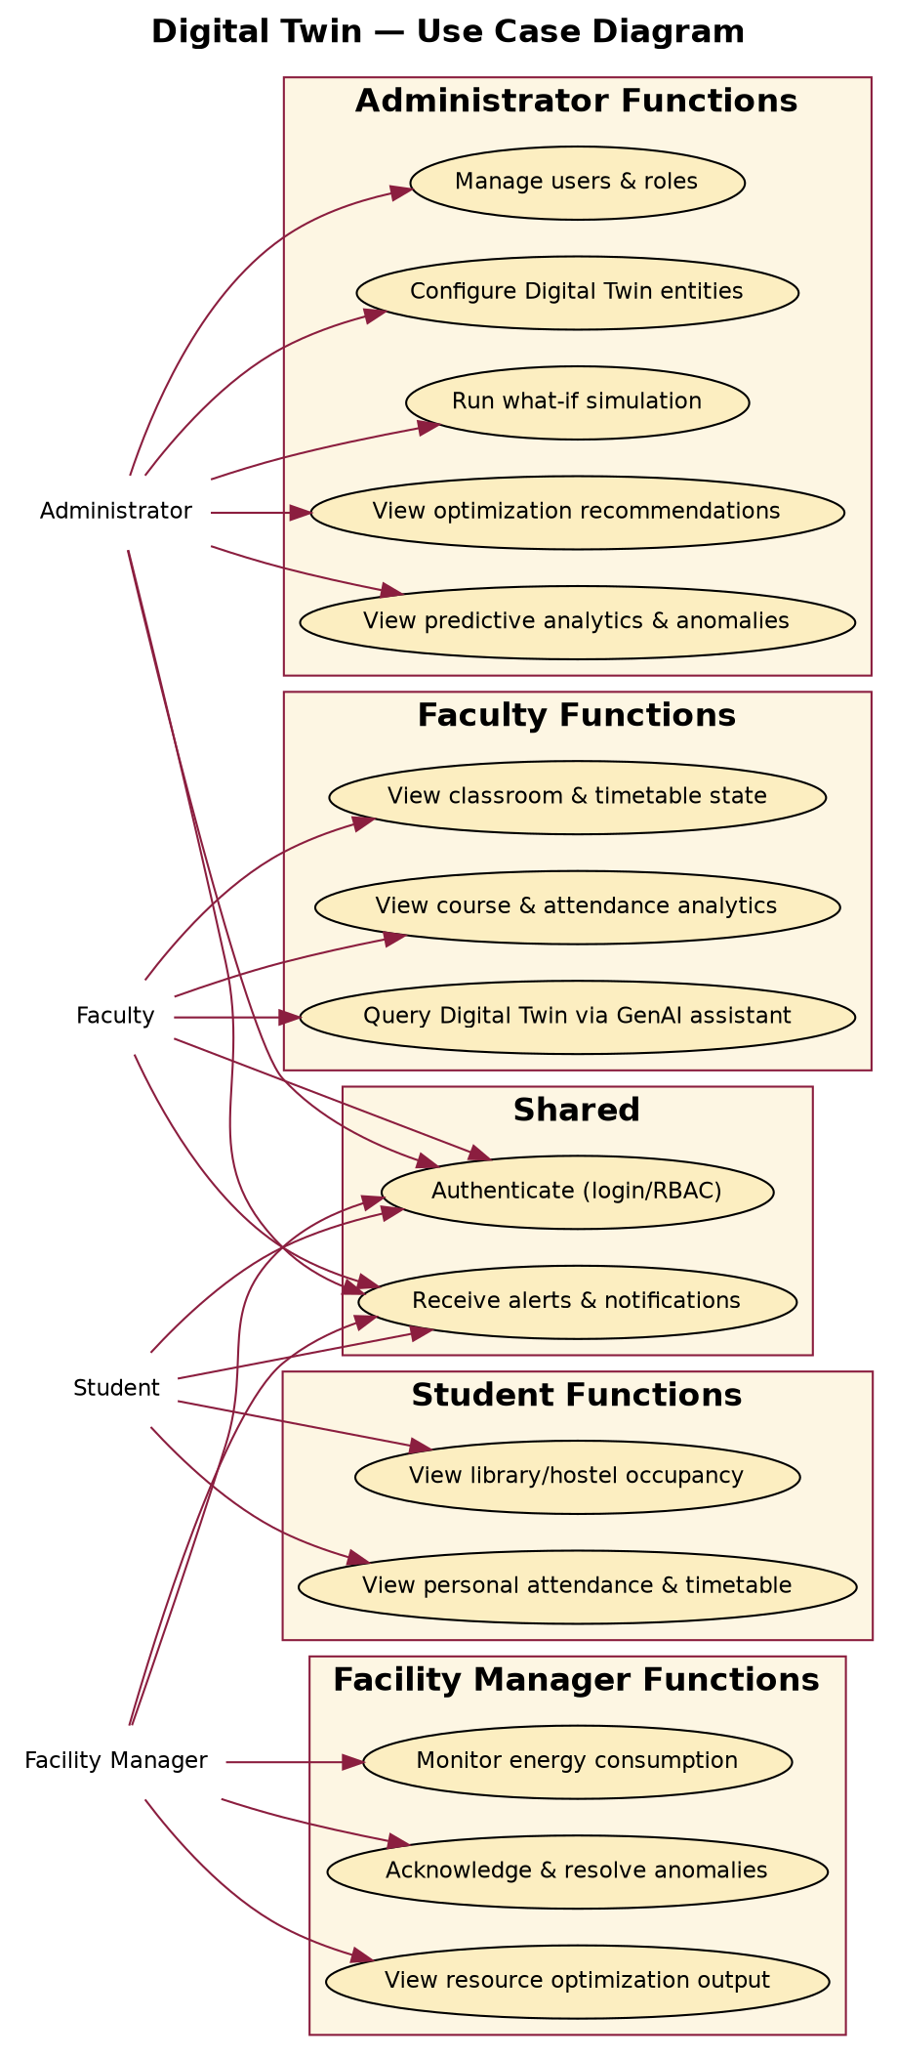
Figure 1: Use Case Diagram — Self-designed based on project requirements
Class Diagram:
Core classes include University, Department, Building, Classroom, Faculty, Student, Course, Timetable, EnergyRecord, OccupancyRecord, Prediction, Anomaly, SimulationScenario, and SimulationResult, with relationships mirroring the campus entity hierarchy and the analytics data model.
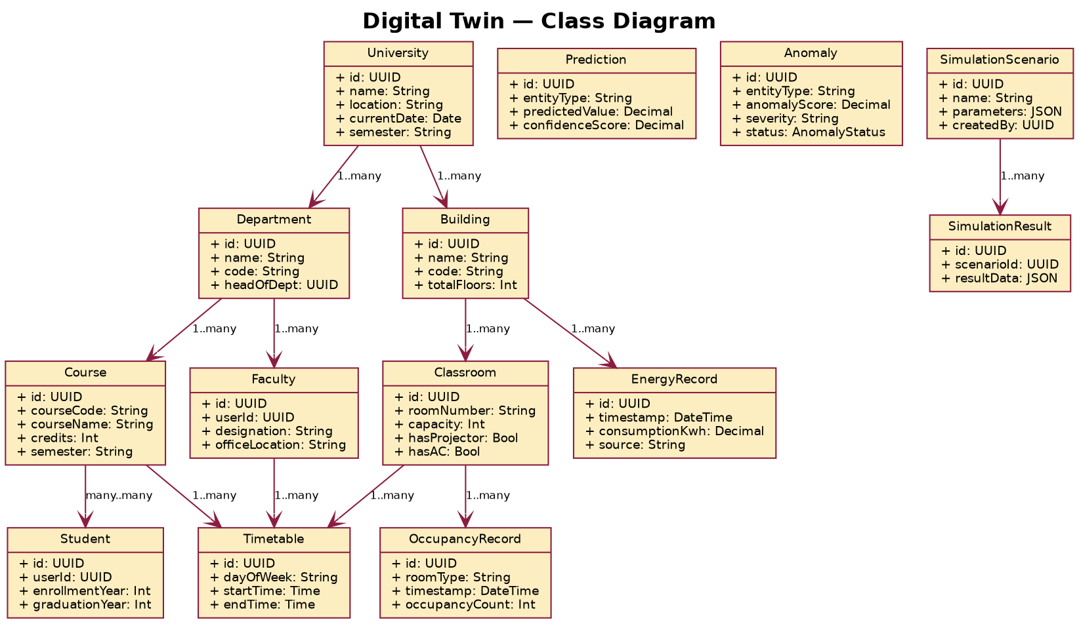
Figure 2: Class Diagram — Self-designed based on project requirements
Activity Diagram — Run a What-If Simulation:
This diagram shows the workflow followed when an administrator defines a hypothetical scenario and the system clones, simulates, and evaluates it.
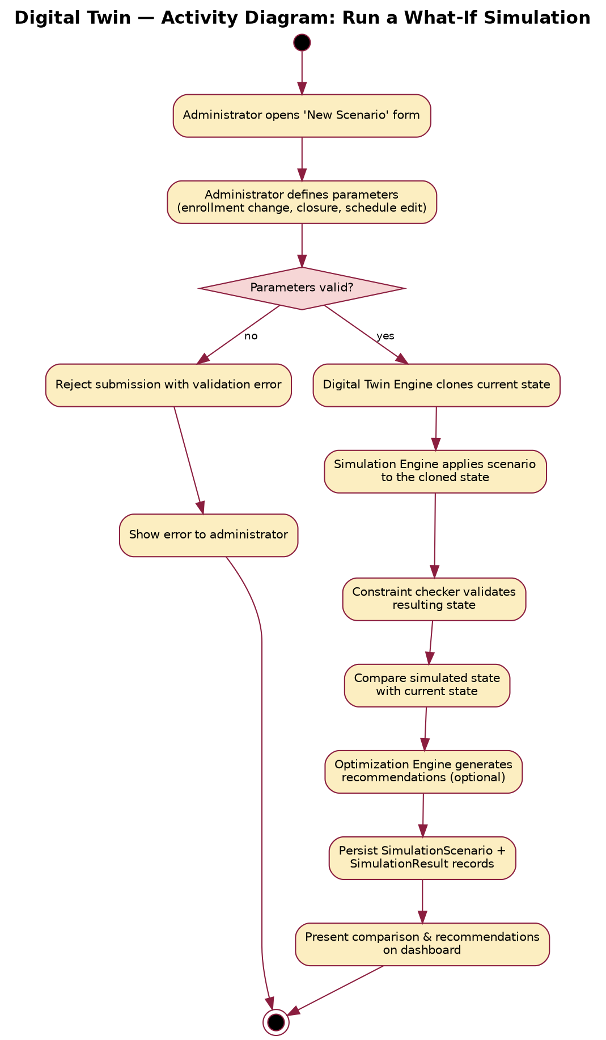
Figure 3: Activity Diagram — Self-designed based on project requirements
Sequence Diagram — Administrator Runs a What-If Simulation:
This diagram shows the interaction between the Administrator, Frontend, Backend API, Digital Twin Engine, Simulation Engine, and PostgreSQL database while a simulation is requested, executed, and its results are persisted and returned.
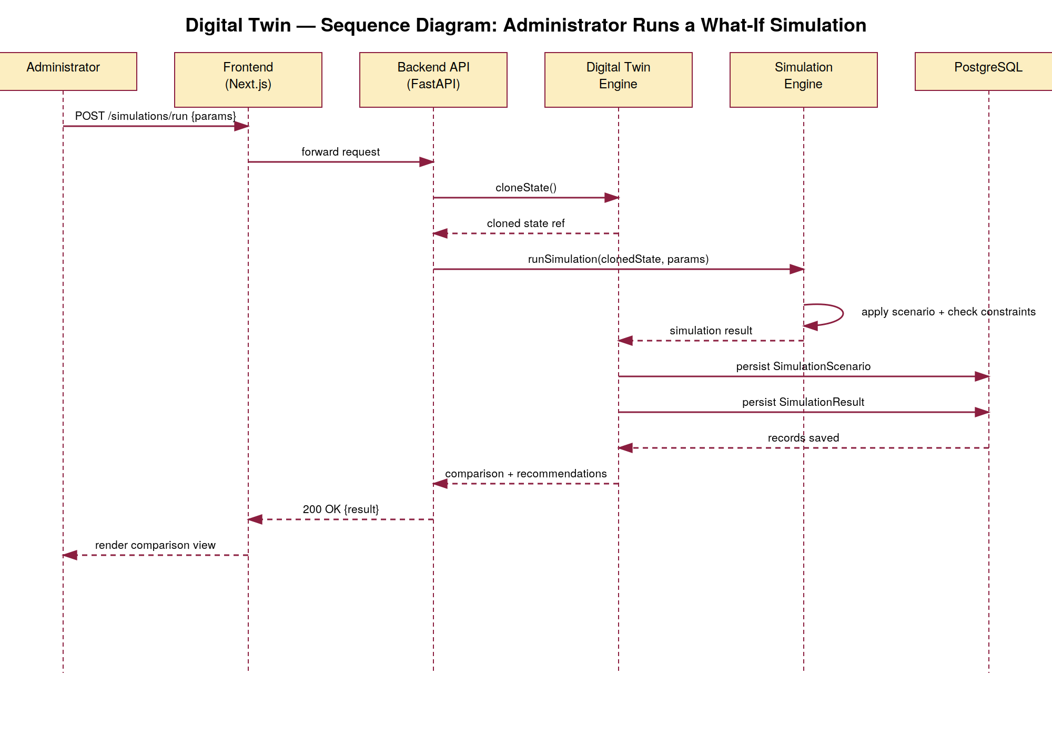
Figure 4: Sequence Diagram — Self-designed based on project requirements
Data Flow Diagram (Level 1):
This diagram traces how state data, predictions/anomalies, and simulation/optimization data flow between the Administrator and Facility Manager actors, the corresponding data stores, and the Generative AI assistant.
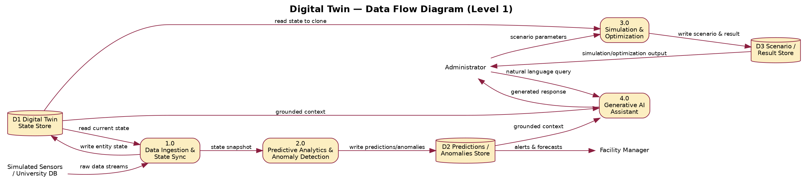
Figure 5: Data Flow Diagram — Self-designed based on project requirements
State Diagram — Anomaly Lifecycle:
This diagram shows the states an anomaly passes through, from being flagged by the Anomaly Detection module to being resolved or dismissed as a false positive by a Facility Manager.
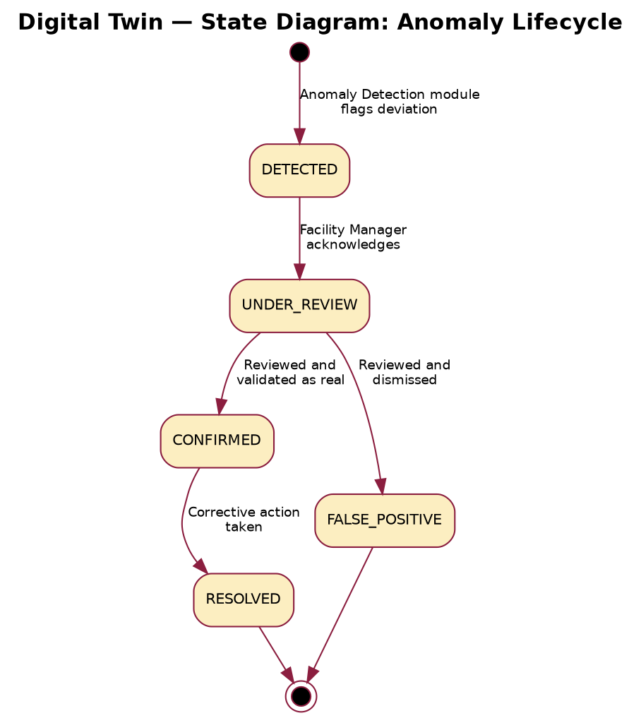
Figure 6: State Diagram — Self-designed based on project requirements
Collaboration Diagram — Generating a Prediction & Raising an Anomaly Alert:
This diagram shows the object interactions involved when an administrator requests a prediction, the Prediction Service retrieves state, invokes the model, and the Anomaly Detection Service raises a notification if the result is abnormal.
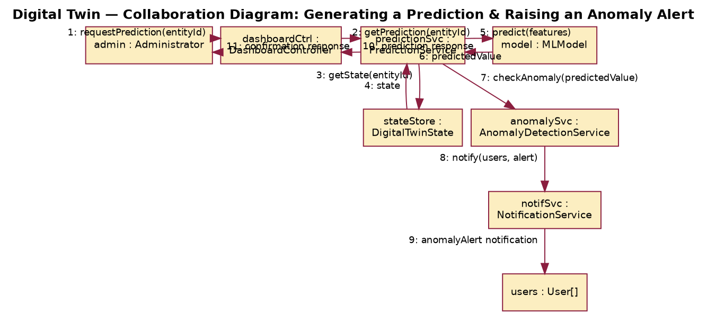
Figure 7: Collaboration Diagram — Self-designed based on project requirements
Deployment Diagram:
This diagram shows the deployment topology: client browsers reaching the Next.js frontend through a CDN/edge network, a load-balanced FastAPI backend behind an API gateway, the PostgreSQL/Neo4j/TimescaleDB data stores, object storage, the message queue, and the external LLM API.
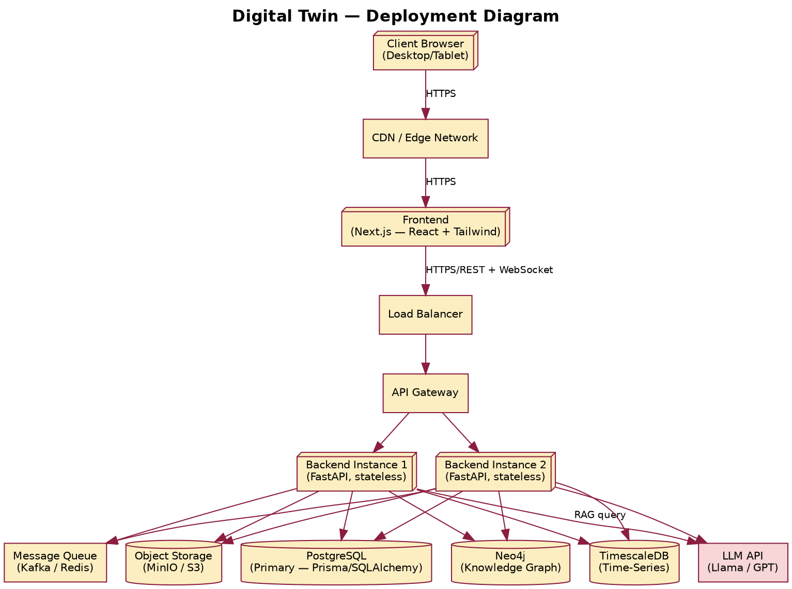
Figure 8: Deployment Diagram — Self-designed based on project requirements

2.8 Assumptions and Dependencies
Assumptions:
- Administrators have access to a computing device with a modern web browser and internet connectivity.
- Historical university data (student, faculty, course, timetable, energy, occupancy records) is available in exportable form for the prototype's initial data load.
- Simulated sensor streams are an acceptable stand-in for physical IoT sensors during the prototype phase.
- The selected LLM provider offers an API suitable for retrieval-augmented generation over the Digital Twin's structured and graph data.
Dependencies:
- Reliability and accuracy of historical university data used to train predictive and anomaly-detection models.
- Reliability of the selected cloud hosting provider for running the application servers, databases, and object storage.
- Reliability and rate limits of the selected LLM API used by the Generative AI assistant.
- Provider selection for LLM API, cloud hosting, and message queue — to be finalized during the implementation phase.

3. SYSTEM REQUIREMENTS

3.1 User Interface
The platform offers a responsive, web-based user interface implemented using Next.js, React, and Tailwind CSS, available through desktop and tablet browsers. User interface requirements based on roles include:
- Administrator console: configuring Digital Twin entities, running what-if simulations, viewing optimization recommendations, managing users and roles.
- Faculty dashboard: viewing classroom/timetable state, course and attendance analytics, and the GenAI query interface.
- Student portal: viewing predicted library/hostel occupancy and personal attendance/timetable.
- Facility Manager dashboard: monitoring energy consumption, acknowledging and resolving anomalies, viewing optimization output.
A native mobile application and 3D/VR-based visualization are recognized as opportunities for the future (refer to Section 5 and Appendix C).

3.2 Software Interface
The frontend (Next.js/React) talks to the backend (FastAPI) via a REST API with JSON payloads over HTTPS, plus a WebSocket channel for real-time dashboard updates. The backend provides API resource groups for authentication, university entities, predictions, anomalies, simulations, optimization, and the Generative AI assistant. The backend, in turn, connects to:
- PostgreSQL for relational, transactional state (users, entities, timetables, enrollments).
- Neo4j for the knowledge-graph representation of entity relationships used in dependency/impact analysis.
- TimescaleDB for time-series energy, occupancy, and attendance records.
- Redis/Kafka as the message queue decoupling data ingestion from the Digital Twin Engine.
- Object storage (MinIO/S3) for uploaded data exports and generated reports.
- An external LLM API (Llama/GPT-class, transformer-based [13]) for the Generative AI assistant's RAG pipeline.

3.3 Database Interface
PostgreSQL is employed as the primary relational store, Neo4j as the graph store for entity relationships, and TimescaleDB as the time-series store for high-volume sensor-style records. All queries executed by the backend are scoped to the authenticated user's role and permitted entities. The major entities and relationships are:
Entity | Purpose | Key Relationships
University | Top-level entity representing the campus | 1:N with Department, Building
Department | Academic department within the university | 1:N with Faculty, Course
Building | Physical building containing classrooms | 1:N with Classroom, EnergyRecord
Classroom | Room within a building that hosts courses | 1:N with Timetable, OccupancyRecord
Course | A course offered by a department | N:M with Student (via Enrollment); 1:N with Timetable
Timetable | Scheduled slot linking course, classroom, and faculty | N:1 with Course, Classroom, Faculty
EnergyRecord | Time-series energy consumption reading | N:1 with Building
OccupancyRecord | Time-series occupancy reading for a room | N:1 with Classroom/Library/Hostel
Prediction | Forecasted value generated by the AI/ML layer | N:1 with the predicted entity
Anomaly | Flagged abnormal pattern awaiting review | N:1 with the affected entity
SimulationScenario | A defined what-if scenario | 1:N with SimulationResult
SimulationResult | Outcome of executing a scenario | N:1 with SimulationScenario
A complete entity-relationship description constituting the analysis model is provided in Appendix B.

3.4 Protocols
- Communication between client, backend, database access layer, and any third-party service requires HTTPS (TLS 1.2+).
- RESTful HTTP communication with JSON payloads is used for the primary API.
- WebSocket is used for real-time dashboard updates (occupancy, energy, alerts); polling/email notification is the fallback.
- The JWT bearer token within the Authorization header authenticates API requests; OAuth2 flows are supported for institutional single sign-on.
- The Generative AI assistant communicates with the LLM API over HTTPS using a retrieval-augmented generation (RAG) pattern grounded in the Digital Twin's structured and graph data.

4. NON-FUNCTIONAL REQUIREMENTS

4.1 Performance Requirements
The application is a transactional/analytical web application rather than a hard real-time system, so no hard real-time guarantees are made. Dashboard updates are targeted within roughly 500 ms to 1 second of a state change; standard API responses are targeted under 200 ms; simulation execution is targeted under 5 seconds for typical scenarios; the prototype targets support for up to 100 concurrent users. The exact numeric requirements regarding performance and scalability will be finalized after load testing on the chosen hosting infrastructure.

4.2 Security Requirements
- Authentication: all users must authenticate with JWT/OAuth2-based authentication before accessing any protected resource.
- Role-Based Access Control (RBAC) [15]: each API endpoint enforces access according to Administrator, Faculty, Student, and Facility Manager roles as outlined in Section 2.5.
- Password security: passwords are hashed in a salted, one-way fashion (bcrypt) and are never stored or logged as plain text.
- Transport security: all client-server and server-server communication is secured with HTTPS/TLS.
- Input validation: all incoming input is validated and sanitized at the API layer to protect against injection and malformed input.
- Data protection: student and faculty personally identifiable information is access-controlled on a need-to-know basis and excluded from logs and client-facing errors.
- Secure AI interaction: prompt-injection mitigation, exclusion of sensitive data from prompts sent to the LLM API, and output validation for AI-generated responses.
- API security: rate limiting to prevent abuse, and SQL/Cypher injection prevention via parameterized queries and ORM usage.

4.3 Software Quality Attributes
- Flexibility: role-based configuration allows the same platform to serve a single campus or, in the future, a multi-campus deployment.
- Interoperability: REST/JSON APIs and CSV/Excel ingestion make it straightforward to connect additional data sources or university ERP systems.
- Maintainability: modular, domain-driven backend architecture with typed frontend/backend code eases future maintenance.
- Portability: containerization (Docker) makes the system portable across cloud providers.
- Reliability: state updates and simulation persistence use atomic database transactions to avoid partial or inconsistent data.
- Reusability: dashboard components and backend service modules are reused across the Administrator, Faculty, Student, and Facility Manager interfaces.
- Robustness: the system detects and rejects malformed scenario parameters, duplicate ingestion events, and unauthorized cross-role requests.
- Testability: the layered architecture (controller/service/repository) allows prediction, anomaly-detection, and optimization logic to be tested independently of the API and database.
- Usability: each dashboard is limited to the information and operations relevant to its role.

5. OTHER REQUIREMENTS
Business Rule: A user can view or act on only the data relevant to their role and, where applicable, their department/building scope; broader access is restricted regardless of role.
Business Rule: The role of Facility Manager is responsible for acknowledging and resolving anomalies and reviewing optimization output; configuring Digital Twin entities and running simulations remain Administrator responsibilities, as per Section 2.5.
Data backup: The databases (PostgreSQL, Neo4j, TimescaleDB) need to be backed up at periodic intervals automatically; the details are to be finalized during the implementation stage.
Compliance: The system would work as per applicable data-protection regulations in India for student and institutional data; the complete compliance checklist needs to be finalized during the implementation stage.
Model governance: Predictive and anomaly-detection models are to be periodically retrained/evaluated against fresh historical data; the retraining cadence is to be finalized during implementation.

APPENDIX A: GLOSSARY
Term | Definition
Digital Twin | A virtual representation of a physical system that mirrors its real-world counterpart in real time.
Digital Twin Engine | The core component that maintains the virtual representation and state synchronization.
What-If Simulation | Analysis of hypothetical scenarios to understand potential outcomes.
Optimization | The process of finding the best solution given constraints and objectives.
Predictive Analytics | Use of statistical/ML models to predict future outcomes.
Anomaly Detection | Identification of patterns that deviate from expected behaviour.
Knowledge Graph | Graph-structured representation of entities and their relationships.
RAG | Retrieval-Augmented Generation; retrieving relevant data before generating AI responses.
LSTM | Long Short-Term Memory; a recurrent neural network architecture for sequence data.
RBAC | Role-Based Access Control; restricting system access based on user roles.
JWT | JSON Web Token; a signed token used to authenticate API requests.
API | Application Programming Interface.
DFD | Data Flow Diagram.

APPENDIX B: ANALYSIS MODEL
This appendix consolidates the analysis model referred to in the synopsis. The Use Case, Class, Activity, Sequence, Data Flow, State, Collaboration, and Deployment diagrams forming the analysis model are included in Section 2.7 (Design Diagrams). The relational entity model presented in Section 3.3 (Database Interface) is reiterated here as parent-child cardinalities:
- University (1) → Department (N); University (1) → Building (N)
- Department (1) → Faculty (N); Department (1) → Course (N)
- Building (1) → Classroom (N)
- Course (1:N) ↔ Student (N:1), via Enrollment
- Course (1) → Timetable (N); Classroom (1) → Timetable (N); Faculty (1) → Timetable (N)
- Building (1) → EnergyRecord (N)
- Classroom (1) → OccupancyRecord (N)
- Entity (1) → Prediction (N); Entity (1) → Anomaly (N)
- SimulationScenario (1) → SimulationResult (N)
The above diagrams, together with the entity model, form the complete analysis model for the system, comprising its behavioural aspects (use case, activity, sequence, state, collaboration) and structural elements (class diagram, deployment diagram, entity relationships).

APPENDIX C: ISSUES LIST
Issue ID | Description | Proposed Solution | Status
001 | Final selection of the LLM provider for the Generative AI assistant | Evaluate Llama, GPT-class, and Claude APIs; select based on cost/latency/grounding quality | Open
002 | Availability of real historical university data for training/testing | Create a comprehensive synthetic dataset that mirrors realistic campus patterns | Open
003 | Real-time data simulation approach for sensor streams | Use a configurable Python simulator for occupancy/energy data | In Progress
004 | Scalability requirements for a production deployment | Implement with cloud-native design and horizontal scaling | Open
005 | Integration approach with existing university ERP systems | Provide CSV/Excel import and a REST API for future integration | Open
006 | Performance optimization for large historical datasets | Implement pagination, caching, and time-series-specific indexing | Open
007 | User testing and validation with real university administrators | Conduct structured usability and accuracy testing sessions | Open
008 | Deployment environment and cloud provider selection | Evaluate AWS, Azure, and on-premises options | Open

