
Software Requirements Specification
For
Digital Twin of a University
An Intelligent Platform for Real-Time Monitoring, Predictive Analytics, Simulation and Optimization of Campus Operations
October 2026
Prepared by
Specialization | SAP ID | Name
Full Stack AI | 500120536 | Krrishika Taneja
Full Stack AI | 500119879 | Devansh Grover
Department of Informatics
School of Computer Science
UNIVERSITY OF PETROLEUM & ENERGY STUDIES
Dehradun – 248007, Uttarakhand
TABLE OF CONTENTS
Topic | Page No.
Table of Contents | 2
Revision History | 3
1. INTRODUCTION | 4
1.1 Purpose of the Project | 4
1.2 Target Beneficiary | 4
1.3 Project Scope | 5
1.4 References | 6
2. PROJECT DESCRIPTION | 9
2.1 Reference Algorithm / Design Algorithm | 9
2.2 Characteristic of Data / Data Structure | 11
2.3 SWOT Analysis | 12
2.4 Project Features | 12
2.5 User Classes and Characteristics | 14
2.6 Design and Implementation Constraints | 15
2.7 Design Diagrams | 16
2.8 Assumptions and Dependencies | 23
3. SYSTEM REQUIREMENTS | 25
3.1 User Interface | 25
3.2 Software Interface | 25
3.3 Database Interface | 26
3.4 Protocols | 28
4. NON-FUNCTIONAL REQUIREMENTS | 29
4.1 Performance Requirements | 29
4.2 Security Requirements | 29
4.3 Software Quality Attributes | 30
5. OTHER REQUIREMENTS | 31
APPENDIX A: GLOSSARY | 32
APPENDIX B: ANALYSIS MODEL | 33
APPENDIX C: ISSUES LIST | 34
LIBRARIES DOCUMENTATION | 36
REVISION HISTORY
Date | Change | Reason for Changes | Mentor Signature

1. INTRODUCTION

1.1 Purpose of the Project
Modern universities are complex, resource-intensive ecosystems made up of thousands of students and faculty, dozens of buildings, laboratories, libraries and hostels, intricate timetables, and significant energy consumption. The information systems used to run these campuses typically operate in silos and present static, historical dashboards that offer no predictive, diagnostic or simulation capability [1], [2].
The purpose of this project is to design and build a Digital Twin of a University: an intelligent platform that maintains a continuously synchronized virtual replica of the campus — its departments, buildings, classrooms, laboratories, libraries, hostels, courses, timetables, attendance, energy consumption and other resources. Building on the Digital Twin paradigm articulated by Grieves and Vickers [1] and since applied to manufacturing, smart cities and healthcare [3]–[5] (with surveys of its characteristics, applications and enabling technologies in [6] and [7]), the system layers predictive analytics, anomaly detection, what-if simulation, resource optimization and a Generative AI assistant on top of this virtual model, giving university administrators a single platform to monitor, predict, simulate and optimize campus operations rather than merely observe them after the fact. Prior work has proposed Digital Twin architectures specifically for smart campuses [8], though largely without the predictive, simulation and optimization layers that this project adds.
The motivation is twofold. Practically, campus decisions such as admitting more students, closing a building for maintenance or re-allocating classrooms are currently taken without being able to test their consequences. Academically, the project bridges the gap between theoretical knowledge of data engineering, machine learning and layered web-service design and the practical implementation of an analytics platform using FastAPI, a multi-store data layer (PostgreSQL, Neo4j, TimescaleDB), scikit-learn and WebSockets.
This document is the Software Requirements Specification (SRS) for the platform. It follows the UPES SRS template and the recommended practice for software requirements specifications . It refines the approved project synopsis and records, for every capability, whether it is implemented in the current backend prototype or planned for a later iteration.

1.2 Target Beneficiary
The primary beneficiaries of the Digital Twin platform are:
- University administrators — anticipate resource shortages, evaluate policy changes (enrollment growth, building closure) before enacting them, and receive data-driven recommendations for classroom allocation.
- Faculty — gain visibility into classroom availability, their timetable and course/attendance data.
- Students — see predicted occupancy of libraries and hostels and view their own attendance and timetable.
- Facility and energy managers — monitor energy consumption and resource utilisation, and acknowledge and resolve anomalies flagged by the system.
- Researchers and students of data-intensive systems — a reference implementation of a Digital Twin with a clean service-layer architecture.

1.3 Project Scope
The project delivers a full-stack web platform that builds and maintains a Digital Twin of a university campus and layers analytics on top of it. The scope of the first version (prototype) is listed below. Items marked [Implemented] exist in the delivered backend; items marked [Planned] are committed scope still to be built.
- [Implemented] Digital Twin representation of 17 core entities — university, departments, buildings, classrooms/labs/libraries/hostels, faculty, students, courses, enrollments, timetable, attendance, energy and occupancy records, predictions, anomalies, simulation scenarios and results, maintained as a real-time, continuously synchronized state (currently exposed as a per-building live snapshot).
- [Implemented] Data ingestion from university databases / CSV exports (students, courses, energy readings) and from simulated real-time sensor streams (occupancy and energy; environmental readings to be added), validated and transformed before being written to the Digital Twin state.
- [Implemented] Predictive analytics for classroom demand, energy consumption, library/hostel occupancy, and parking/transportation demand using regression, tree-ensemble and time-series (LSTM) models. The prototype currently produces 24-hour hourly forecasts of building energy consumption and room occupancy using a Random Forest regressor, with hold-out Mean Absolute Error (MAE).
- [Implemented] Anomaly detection for energy consumption, occupancy and attendance patterns using Isolation Forest, autoencoders and statistical methods, with alerting to facility managers. The prototype currently covers energy readings (Isolation Forest combined with a z-score gate) with an anomaly lifecycle (detected → acknowledged → resolved / dismissed).
- [Implemented] What-if simulation engine allowing administrators to clone the current Digital Twin state, apply hypothetical changes (enrollment growth, facility closure, schedule changes) and compare the simulated outcome with the current state. The prototype implements enrollment growth and building closure, deep-copying the twin state and reporting baseline, scenario, deltas, warnings and feasibility; schedule-change scenarios are to be added.
- [Implemented] Resource-optimization engine using constraint satisfaction, linear programming and genetic algorithms to recommend classroom allocation, timetable and energy optimizations. The prototype currently implements classroom allocation using the Hungarian algorithm to minimise wasted seats.
- [Implemented] JWT/OAuth2-style authentication, bcrypt password hashing, role-based access control for four roles, login rate limiting, and a JWT-secured WebSocket channel for live broadcasts.
- [Planned] An interactive, role-based dashboard (Next.js / React / TypeScript / Tailwind CSS) for monitoring, analytics, simulation and reporting, secured with authentication and role-based access control and consuming the REST and WebSocket APIs.
- [Planned] Advanced models and optimization: XGBoost [11] and LSTM/GRU [10] forecasting, autoencoder anomaly detection, and linear-programming / genetic-algorithm [12] timetable and energy optimization.
- [Planned] A Generative AI assistant, grounded in the Digital Twin's structured and graph data via a retrieval-augmented generation (RAG) pipeline, that allows administrators and faculty to query, analyse and trigger simulations using natural language.
- [Planned] Data and messaging stack as specified in the synopsis: PostgreSQL (relational), Neo4j [14] (knowledge graph) and TimescaleDB (time series) stores, with a Kafka / Redis message queue decoupling ingestion from the Digital Twin Engine. The prototype currently serves all structured and time-stamped data from MySQL 8.0 (see Issue 009).
Out of scope for version 1 (future development): integration with physical IoT sensors [16], real-time video analytics for occupancy detection, 3D/VR visualisation, a native mobile application, and direct integration with university ERP systems. Where a design decision is not finalised, the notation “To be finalized during implementation” is used.
Key deliverables: (i) a RESTful and WebSocket backend with automated tests; (ii) database schema, migrations and seed data for a UPES-like campus; (iii) the analytics services (forecast, anomaly, simulation, optimization); (iv) the web dashboard; and (v) this SRS together with the design diagrams and library documentation.

1.4 References
[1] M. Grieves and J. Vickers, “Digital Twin: Mitigating Unpredictable, Undesirable Emergent Behavior in Complex Systems,” in Transdisciplinary Perspectives on Complex Systems, F.-J. Kahlen, S. Flumerfelt, and A. Alves, Eds. Springer, 2017, pp. 85–113.
[2] G. S. Bhatti, S. Kumar, and R. S. Bhatia, “Smart Campus: A Survey on Technologies, Applications, and Challenges,” IEEE Access, vol. 9, 2021, doi: 10.1109/ACCESS.2021.3081234.
[3] A. Rasheed, O. San, and T. Kvamsdal, “Digital Twin: Values, Challenges and Enablers From a Modeling Perspective,” IEEE Access, vol. 8, pp. 21980–22012, 2020, doi: 10.1109/ACCESS.2020.2970143.
[4] F. Tao, H. Zhang, A. Liu, and A. Y. C. Nee, “Digital Twin in Industry: State-of-the-Art,” IEEE Trans. Ind. Informat., vol. 15, no. 4, pp. 2405–2415, 2019, doi: 10.1109/TII.2018.2873186.
[5] W. Kritzinger, M. Karner, G. Traar, J. Henjes, and W. Sihn, “Digital Twin in Manufacturing: A Categorical Literature Review and Classification,” IFAC-PapersOnLine, vol. 51, no. 11, pp. 1016–1022, 2018, doi: 10.1016/j.ifacol.2018.08.474.
[6] B. R. Barricelli, E. Casiraghi, and D. Fogli, “A Survey on Digital Twin: Definitions, Characteristics, Applications, and Design Implications,” IEEE Access, vol. 7, pp. 167653–167671, 2019, doi: 10.1109/ACCESS.2019.2953499.
[7] A. Fuller, Z. Fan, C. Day, and C. Barlow, “Digital Twin: Enabling Technologies, Challenges and Open Research,” IEEE Access, vol. 8, pp. 108952–108971, 2020, doi: 10.1109/ACCESS.2020.2998358.
[8] L. Liu, X. Zhang, and Y. Chen, “Digital Twin-Based Smart Campus: Architecture, Key Technologies, and Applications,” J. Ambient Intell. Humaniz. Comput., vol. 12, pp. 567–582, 2021, doi: 10.1007/s12652-020-02567-x.
[9] F. T. Liu, K. M. Ting, and Z.-H. Zhou, “Isolation Forest,” in 2008 Eighth IEEE Int. Conf. Data Mining, 2008, pp. 413–422, doi: 10.1109/ICDM.2008.17.
[10] S. Hochreiter and J. Schmidhuber, “Long Short-Term Memory,” Neural Computation, vol. 9, no. 8, pp. 1735–1780, 1997, doi: 10.1162/neco.1997.9.8.1735.
[11] T. Chen and C. Guestrin, “XGBoost: A Scalable Tree Boosting System,” in Proc. 22nd ACM SIGKDD Int. Conf. Knowledge Discovery and Data Mining, 2016, pp. 785–794, doi: 10.1145/2939672.2939785.
[12] J. H. Holland, Adaptation in Natural and Artificial Systems. MIT Press, 1992.
[13] A. Vaswani et al., “Attention Is All You Need,” in Advances in Neural Information Processing Systems, vol. 30, 2017, pp. 5998–6008.
[14] D. F. C. Pena, L. A. M. C. Carvalho, and J. M. F. R. de Sousa, “Knowledge Graphs for Digital Twins: A Survey,” IEEE Access, vol. 10, 2022, doi: 10.1109/ACCESS.2022.3167890.
[15] National Institute of Standards and Technology (NIST), “Role-Based Access Control (RBAC) Model.”
[16] S. E. Bibri, “The IoT for Smart Sustainable Cities of the Future: An Analytical Framework for Sensor-Based Big Data Applications for Environmental Sustainability,” Sustainable Cities and Society, vol. 38, pp. 230–253, 2018, doi: 10.1016/j.scs.2017.12.034.

2. PROJECT DESCRIPTION
The Digital Twin of a University is a web-based analytics platform whose backend is a stateless FastAPI service. The target data layer is PostgreSQL, Neo4j and TimescaleDB with a Kafka / Redis message queue; the current prototype persists to a MySQL 8 database. It maintains a structured virtual model of the campus, continuously refreshed from CSV imports and a simulated sensor stream, and exposes that model — together with predictions, anomalies, simulations and optimization recommendations — through a role-protected REST API and a live WebSocket channel. The services performing the analytics are written as pure functions with no database or HTTP dependency, so each can be tested and replaced independently.

2.1 Reference Algorithm / Design Algorithm
Unlike a purely transactional system, the backbone of this project combines rule-based state-management algorithms with several machine-learning and optimization algorithms. The algorithms used are summarised in Table 1, and the end-to-end working is given in the numbered flow that follows.
Table 1: Algorithms used in the platform
Algorithm | Technique | Purpose | Status
State Synchronization | Validate → transform → atomic transactional write (SQLAlchemy commit / rollback) | Ingest CSV rows and sensor ticks into the twin state without partial writes | Implemented
Predictive Analytics | Random Forest regression (100 trees) on calendar features: hour, weekday, weekend flag, sin/cos of hour; 80/20 hold-out MAE | 24-hour hourly forecast of building energy and room occupancy | Implemented (XGBoost [11], LSTM/GRU [10] planned)
Anomaly Detection | Isolation Forest [9] AND absolute z-score ≥ 3 on a rolling window | Flag abnormal energy readings and raise an Anomaly record | Implemented (autoencoder planned)
What-If Simulation | Deep copy of twin state → apply scenario → capacity / relocation feasibility check → compute deltas | Evaluate enrollment growth and building closure before they happen | Implemented
Resource Optimization | Assignment problem solved with the Hungarian algorithm (scipy linear_sum_assignment) per time block; cost = capacity − enrollment | Minimise wasted seats in classroom allocation | Implemented (LP / genetic algorithm [12] planned)
Authorization | JWT validation → user lookup → role guard (require_role) before any handler runs [15] | Role-Based Access Control on every endpoint | Implemented

Working of the system (reference flow)
- Authentication. The user submits email and password to POST /auth/login. After a per-IP rate-limit check, the bcrypt hash is verified and a signed JWT (HS256, default 60-minute expiry) carrying the user id as subject is returned. The token is sent as a Bearer header on all later requests.
- Authorization. Each request passes through get_current_user (decode token, load active user) and require_role(...), which returns HTTP 401 for invalid or expired tokens and HTTP 403 for insufficient role.
- Data ingestion. An administrator uploads CSV files (students, courses, energy) which are validated row by row; and/or POST /telemetry/tick (or the optional background simulator) generates energy and occupancy readings for every building and space.
- Anomaly detection. For every new energy reading, the recent window of readings is passed to the anomaly service; if both the Isolation Forest and the z-score gate agree, an Anomaly (status DETECTED) is stored and a message is broadcast on the WebSocket channel.
- Twin state. GET /twin/state aggregates, per building, the latest energy reading, the number of open anomalies and the latest occupancy and utilisation percentage for every space.
- Prediction. POST /predictions/energy/{id} or /predictions/occupancy/{id} trains a Random Forest on the stored history, stores 24 hourly Prediction rows with the model name and MAE, and returns them.
- Simulation. An administrator submits a scenario (enrollment_growth or close_building); the engine clones the state, applies the parameters, checks feasibility, and persists the SimulationScenario and SimulationResult.
- Optimization. POST /optimization/classrooms computes a new classroom assignment per time block and returns before/after wasted seats, the percentage improvement and the list of proposed room changes.
- Review. Facility managers acknowledge, resolve or dismiss anomalies through PATCH /anomalies/{id}; invalid transitions are rejected with HTTP 409.
Pseudocode of the two central algorithms
Function RunWhatIfSimulation(scenario):
- state = DigitalTwinState.deepCopy()
- apply(scenario.type, scenario.parameters) to state
- violations = checkConstraints(state) // capacity overflow, sessions that cannot be relocated
- result = { baseline, scenario, deltas = diff(state, current), warnings, feasible = (violations == 0) }
- persist(scenario, result); return result
Function DetectAnomaly(observed, historicalWindow):
- if length(historicalWindow) < 10: return Normal // not enough history
- iso = IsolationForest(n_estimators = 100, contamination = 0.05).fit(historicalWindow)
- z = |observed − mean(window)| / std(window)
- if iso.predict(observed) == −1 AND z ≥ 3.0: create Anomaly(status = DETECTED); broadcast(alert)
- else: return Normal

2.2 Characteristic of Data / Data Structure
The Digital Twin does not depend on a single static external data set. It maintains a continuously evolving relational and time-stamped representation of the university built from three categories of data:
- Primary source: student, faculty, course, enrollment, timetable, building and classroom records imported from university databases or CSV exports (students, courses and energy readings are supported by the ingestion endpoint).
- Secondary source: simulated real-time sensor streams of occupancy and energy consumption produced by the campus_data generators (including deliberate anomaly injection), standing in for physical IoT sensors in the prototype.
- Derived data: predictions (with model name and MAE), anomalies (observed vs. expected value, score, status), and simulation scenarios / results written back by the analytics layer.
The seed script creates a reproducible synthetic campus so that the platform can be developed and demonstrated without real student data. This is summarised in Table 2.
Table 2: Characteristics of the seeded data set
Data | Volume | Notes
University / departments | 1 / 4 | UPES Dehradun and four departments
Buildings / spaces | 6 / ≈25 | Types: academic, lab, library, hostel; spaces are classroom, lab, library or hostel
Faculty / students | 12 / 200 | Each linked to a user account
Courses and enrollments | 16 courses | Students enrolled per semester and department
Timetable | Conflict-free | Day (0–6), start hour, end hour, course, room, faculty
Energy and occupancy | 4 days, hourly | Per building (kWh) and per space (head-count)
Attendance | 30 days | Present / absent per student per course per date

Structurally, the data spans three complementary stores: a relational model (PostgreSQL) capturing entity hierarchy and transactional records, a knowledge graph (Neo4j) capturing relationships between entities for dependency and impact analysis [14], and a time-series store (TimescaleDB) capturing energy, occupancy and attendance records indexed by timestamp. In the current prototype the relational and time-stamped data are held in MySQL 8.0 (InnoDB, utf8mb4), managed through SQLAlchemy 2.0 ORM models and versioned Alembic migrations. The time-stamped tables (energy_records and occupancy_records) carry composite indexes on (entity id, timestamp) to support history queries and training-window retrieval. Predictions and anomalies use a polymorphic reference (entity_type, entity_id, metric) so they can attach to either a building or a room. Simulation inputs and outputs are stored as JSON columns. The entity model is described in Section 3.3 and Appendix B.
No manual sampling is needed because full historical records for the selected entity are used. The statistical methods applied are: aggregation (mean and standard deviation as the baseline for the z-score), regression on cyclical calendar features for forecasting (evaluated by hold-out MAE), and unsupervised outlier scoring (Isolation Forest) for anomaly detection. A knowledge graph [14] and a dedicated time-series store are part of the target architecture (see Section 3.3 and Issue 009).

2.3 SWOT Analysis
Table 3: SWOT analysis
STRENGTHS | WEAKNESSES
• Unified, continuously synchronized virtual model of the campus instead of siloed dashboards  • Predictive analytics, anomaly detection, simulation and optimization in one platform  • What-if simulation evaluates decisions before they are enacted  • Pure-function service layer makes the analytics testable and replaceable  • Clear RBAC with four roles | • Prototype depends on simulated sensor data, not real IoT feeds  • Forecast and anomaly accuracy depend on quality and volume of history  • Initial data load and entity set-up needed before the twin is useful  • No offline mode; needs continuous connectivity for live sync  • Simpler models in v1 (Random Forest, Isolation Forest) than those planned
OPPORTUNITIES | THREATS
• Growing interest in smart-campus and Digital Twin research in higher education  • Extensible to multi-campus deployments and other resource-intensive institutions  • Natural path to IoT integration, a GenAI assistant and 3D/VR views  • Optimization output can directly reduce energy cost and improve room utilisation | • Competition from established campus-management and BI platforms  • Privacy and security risk given student and operational data  • Model drift if models are not retrained as campus patterns change  • Dependence on third-party LLM APIs for the planned assistant

2.4 Project Features
The platform provides the capabilities below, organised by role. A use-case view of these functions is given in Figure 2 (Section 2.7).
- Administrator: manage users and roles; configure departments, buildings, classrooms, courses and timetable; import CSV data; run what-if simulations; run classroom optimization; monitor predictions and anomalies platform-wide.
- Faculty: view classroom and timetable state; view their own timetable; view course and attendance data; view student lists; (planned) query the twin using the GenAI assistant.
- Student: view predicted library and hostel occupancy; view personal timetable and attendance percentage.
- Facility Manager: monitor energy consumption; list, acknowledge, resolve or dismiss anomalies; run and review classroom optimization output.
- Platform-wide: JWT authentication; role-based authorization; live twin updates over WebSocket; paginated REST APIs; health check; interactive OpenAPI documentation at /docs.
Functional requirements
Table 4: Functional requirements and implementation status
ID | Requirement | Roles | Status
FR-01 | The system shall authenticate users by email and password and return a signed JWT access token. | All | Implemented
FR-02 | The system shall reject more than 10 login attempts per minute from one IP address with HTTP 429. | All | Implemented
FR-03 | The system shall let an administrator create users with a role and list all users. | Admin | Implemented
FR-04 | The system shall let an administrator create departments, buildings, classrooms (classroom, lab, library, hostel), courses and timetable entries; all authenticated users may read them. | Admin / All | Implemented
FR-05 | The system shall validate timetable entries (day 0–6, end hour > start hour) and reject constraint violations with HTTP 422 / 409. | Admin | Implemented
FR-06 | The system shall import students, courses and energy readings from CSV and return a per-row result of the import. | Admin | Implemented
FR-07 | The system shall generate simulated energy and occupancy readings for all buildings and spaces on request (telemetry tick) and optionally on a timed background loop. | Authenticated | Implemented
FR-08 | The system shall return a per-building twin state: latest energy, open-anomaly count and per-space occupancy and utilisation percentage. | All | Implemented
FR-09 | The system shall return paginated energy and occupancy history filtered by building or room; students shall see only library and hostel occupancy. | All (students restricted) | Implemented
FR-10 | The system shall forecast the next 24 hourly values of building energy and room occupancy, store them with model name and MAE, and list them with pagination. | All (students restricted) | Implemented
FR-11 | The system shall flag an energy reading as anomalous only when Isolation Forest and the z-score gate both agree, and store it with status DETECTED. | System | Implemented
FR-12 | The system shall let administrators and facility managers list anomalies and move them through DETECTED → ACKNOWLEDGED → RESOLVED / DISMISSED; invalid transitions return HTTP 409. | Admin, FM | Implemented
FR-13 | The system shall run what-if simulations of enrollment growth (percent, optional department) and building closure, and persist scenario, baseline, scenario metrics, deltas, warnings and feasibility. | Admin | Implemented
FR-14 | The system shall recommend a classroom allocation that minimises wasted seats and report before/after waste, percentage improvement and room changes. | Admin, FM | Implemented
FR-15 | The system shall let faculty and students view their own timetable and students view their attendance percentage per course. | Faculty, Student | Implemented
FR-16 | The system shall broadcast live updates to JWT-authenticated WebSocket clients and expose a /health endpoint. | All | Implemented
FR-17 | The system shall provide role-specific web dashboards (administrator, faculty, student, facility manager). | All | Planned
FR-18 | The system shall forecast with XGBoost and LSTM/GRU and detect anomalies with autoencoders. | System | Planned
FR-19 | The system shall optimise timetables and energy usage with linear programming / genetic algorithms. | Admin, FM | Planned
FR-20 | The system shall answer natural-language questions and trigger simulations through a RAG-based Generative AI assistant. | Admin, Faculty | Planned
FR-21 | The system shall support institutional single sign-on through OAuth 2.0. | All | Planned

2.5 User Classes and Characteristics
Table 5: User classes
User Class | Description | Technical Expertise | Frequency of Use
Administrator (admin) | Configures the twin, manages users, imports data, runs simulations and optimization for the whole campus | Medium | Frequent (daily / weekly)
Faculty (faculty) | Views classroom, timetable, course and attendance data relevant to their teaching | Low to Medium | Frequent (daily / weekly)
Student (student) | Views predicted library / hostel occupancy and personal timetable and attendance | Low | Occasional
Facility Manager (facility_manager) | Monitors energy and resource state, handles anomaly alerts, reviews optimization output | Low to Medium | Frequent (daily / weekly)
System Administrator / DevOps | Deploys and monitors the containers, database, migrations and backups (no application role) | High | As needed

Table 6: Role–permission matrix (as enforced in the backend)
Capability | Admin | Faculty | Student | Facility Mgr
Manage users; create entities; import CSV | Yes | — | — | —
Read departments, buildings, classrooms, courses, timetable | Yes | Yes | Yes | Yes
List students | Yes | Yes | — | —
Own timetable / own attendance | — | Timetable | Both | —
Twin state, energy history | Yes | Yes | Yes | Yes
Occupancy history and forecast | All spaces | All spaces | Library / hostel only | All spaces
Energy forecast | Yes | Yes | Yes | Yes
List / update anomalies | Yes | — | — | Yes
Run / view simulations | Yes | — | — | —
Classroom optimization | Yes | — | — | Yes

2.6 Design and Implementation Constraints
- Hardware boundary conditions: standard cloud-hosted or local compute; the prototype uses simulated sensor data, so no physical IoT hardware is required.
- Timing requirements: not a hard real-time system. Standard API calls target under 200 ms, live updates 0.5–1 s, simulations under 5 s for typical scenarios.
- Memory / storage: PostgreSQL for relational data, Neo4j for graph relationships and TimescaleDB for time-series data (the prototype currently uses MySQL 8.0 with a connection pool of 10 and 20 overflow); Redis for caching and the message queue; documents and exports stored in object storage (MinIO / S3) rather than on the application server.
- Interfaces to other applications: LLM API (for the Generative AI assistant [13]), object storage service (MinIO / S3), and university data exports (CSV / Excel / SQL) as an ingestion source.
- Specific technologies and tools: backend — Python 3.11+, FastAPI, SQLAlchemy 2.0, Alembic, Pydantic v2, PyJWT, bcrypt, scikit-learn, SciPy, NumPy, pandas; data — PostgreSQL, Neo4j, TimescaleDB, Redis (prototype currently on MySQL 8.0); messaging — Kafka / Redis; containers — Docker Compose; testing — pytest; frontend — Next.js, React, TypeScript, Tailwind CSS; authentication — JWT / OAuth2 with RBAC [15].
- Parallel operations: the backend is a stateless REST / WebSocket API, horizontally scalable (several Uvicorn workers or containers) behind a load balancer and API gateway, and decoupled from ingestion via a Kafka / Redis message queue; the telemetry simulator runs as an asynchronous background task and executes its database work in a worker thread.
- Language requirements: user-interface text is in English in version 1.
- Communication protocols: HTTPS/REST with JSON; WebSocket for live updates (Section 3.4).
- Security considerations: JWT, RBAC, bcrypt, input validation, rate limiting (Section 4.2).
- Design conventions and programming standards: layered architecture (routers → services → ORM models); services are pure functions; Pydantic schemas validate every request and response; RESTful naming; Git with feature branches; type hints throughout.

2.7 Design Diagrams
This sub-section presents the architecture, Use Case, Class, Activity, Sequence, Data Flow, State, Collaboration, Entity-Relationship and Deployment diagrams, consistent with the roles and modules defined in Sections 2.4 and 2.5. Figures 1, 9 and 10 were drawn for the implemented backend stack (FastAPI, MySQL, Redis); Figures 2–8 are carried over from the approved synopsis.
High-Level System Architecture
The browser talks to a FastAPI application over HTTPS and WebSocket. Routers delegate to a service layer of pure functions, and persistence goes through SQLAlchemy to MySQL.
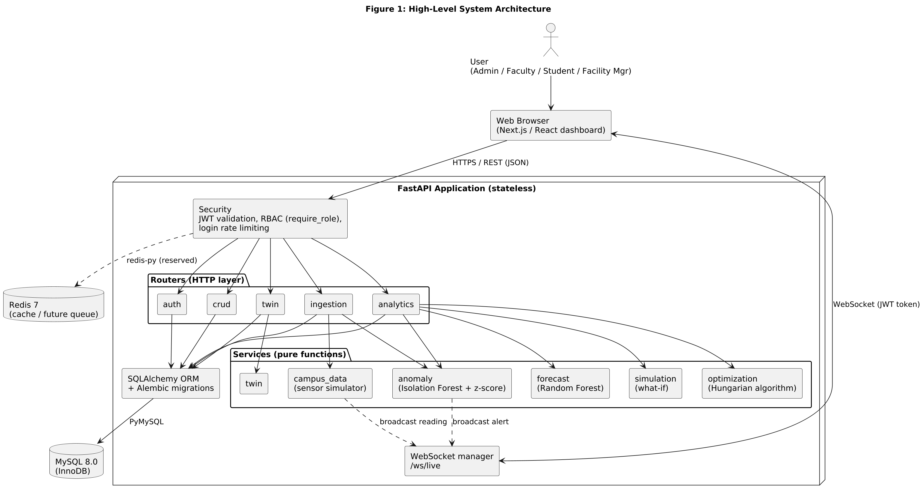
Figure 1: High-Level System Architecture — Source: Self-designed based on project requirements
Use Case Diagram
Primary actors are Administrator, Faculty, Student and Facility Manager, each with a distinct set of use cases.
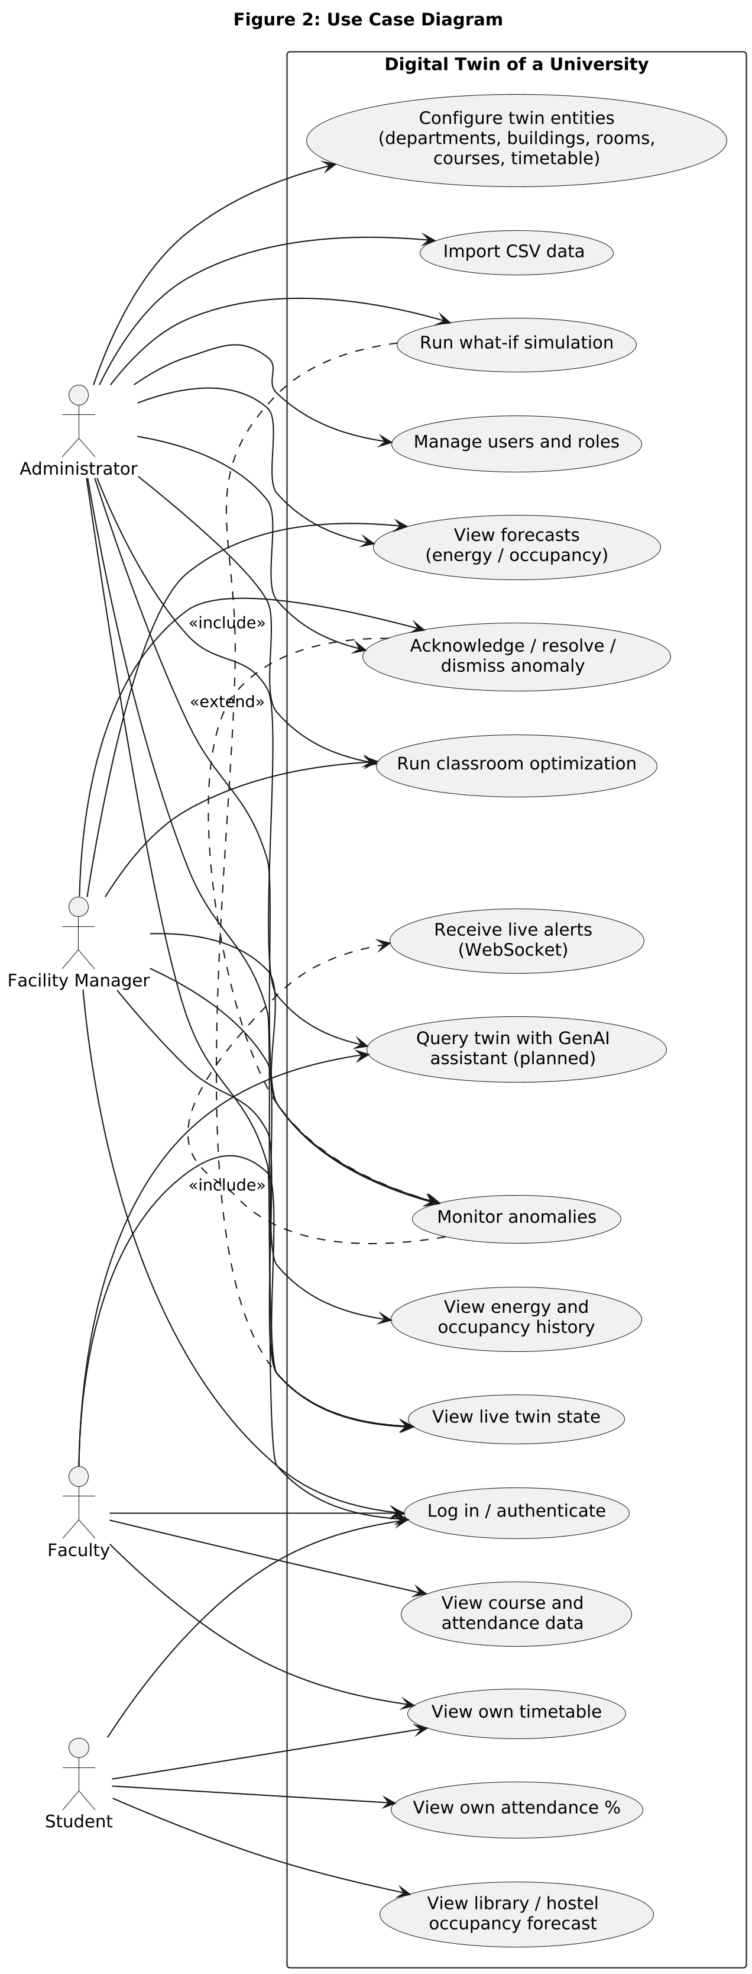
Figure 2: Use Case Diagram — Source: Self-designed based on project requirements
Class Diagram
Core classes include University, Department, Building, Classroom, Faculty, Student, Course, Timetable, EnergyRecord, OccupancyRecord, Prediction, Anomaly, SimulationScenario and SimulationResult.
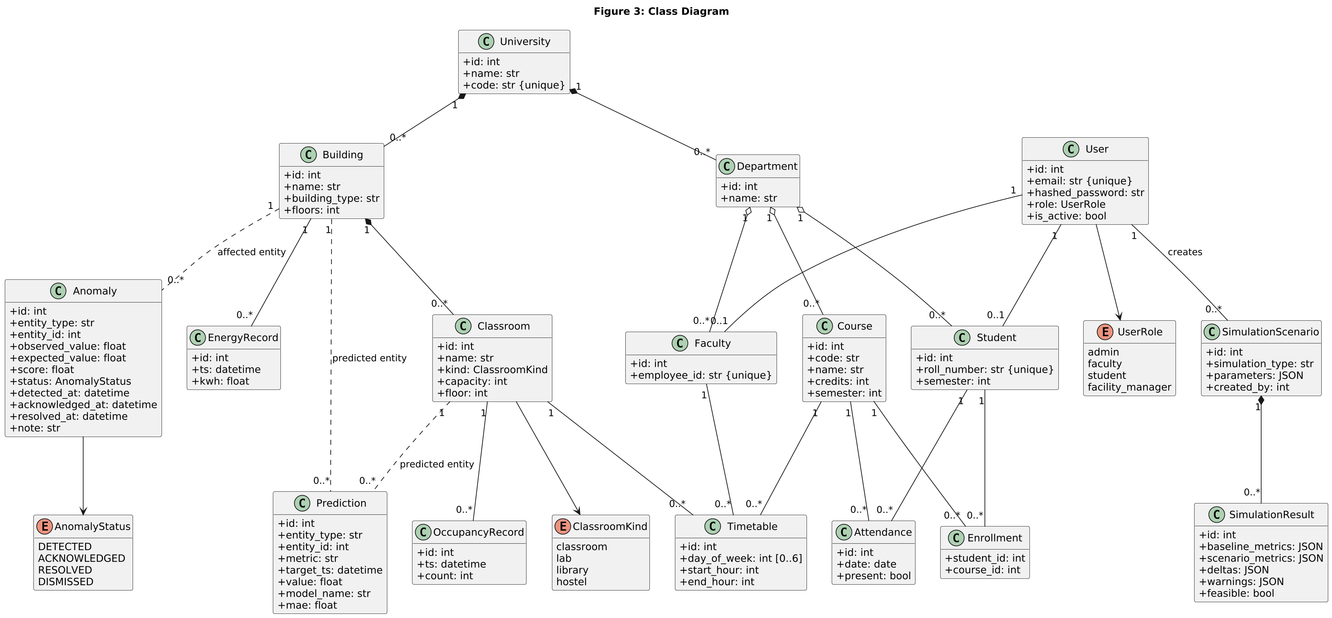
Figure 3: Class Diagram — Source: Self-designed based on project requirements
Activity Diagram — Run a What-If Simulation
The workflow when an administrator defines a hypothetical scenario and the system clones, simulates and evaluates it.
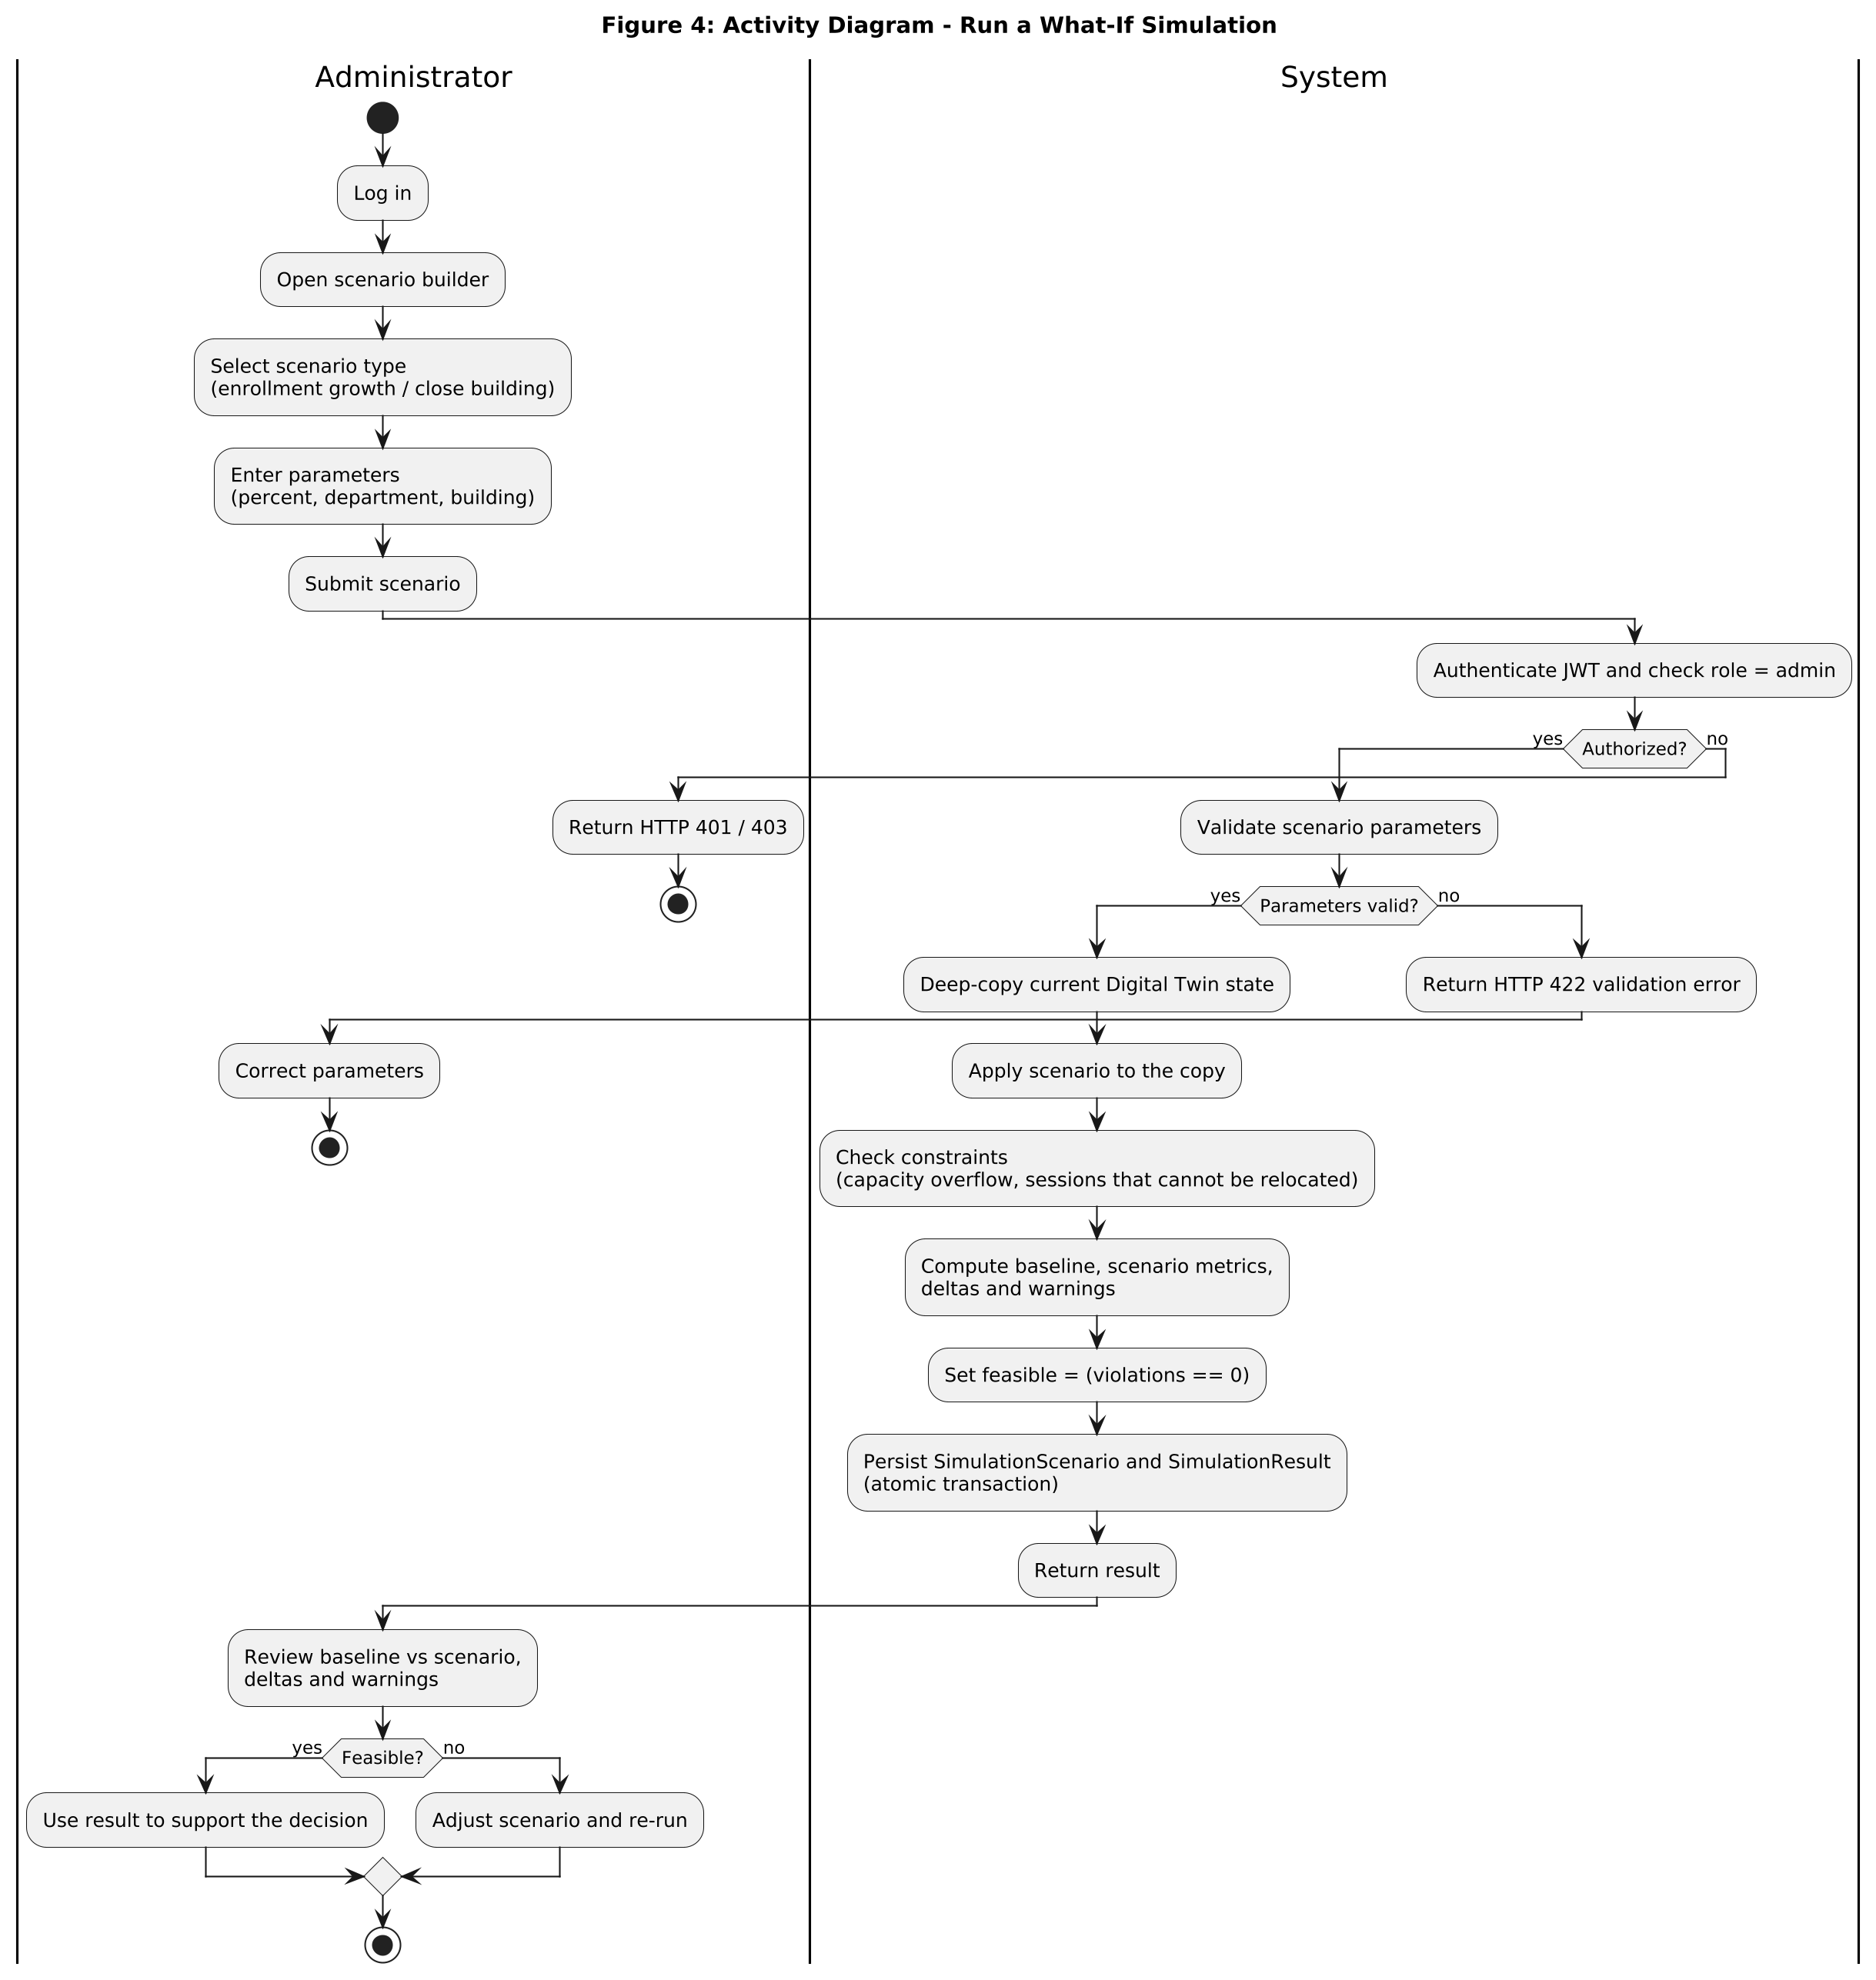
Figure 4: Activity Diagram — Run a What-If Simulation — Source: Self-designed based on project requirements
Sequence Diagram — Administrator Runs a What-If Simulation
Interaction between the Administrator, Frontend, Backend API, Digital Twin Engine, Simulation Engine and database.
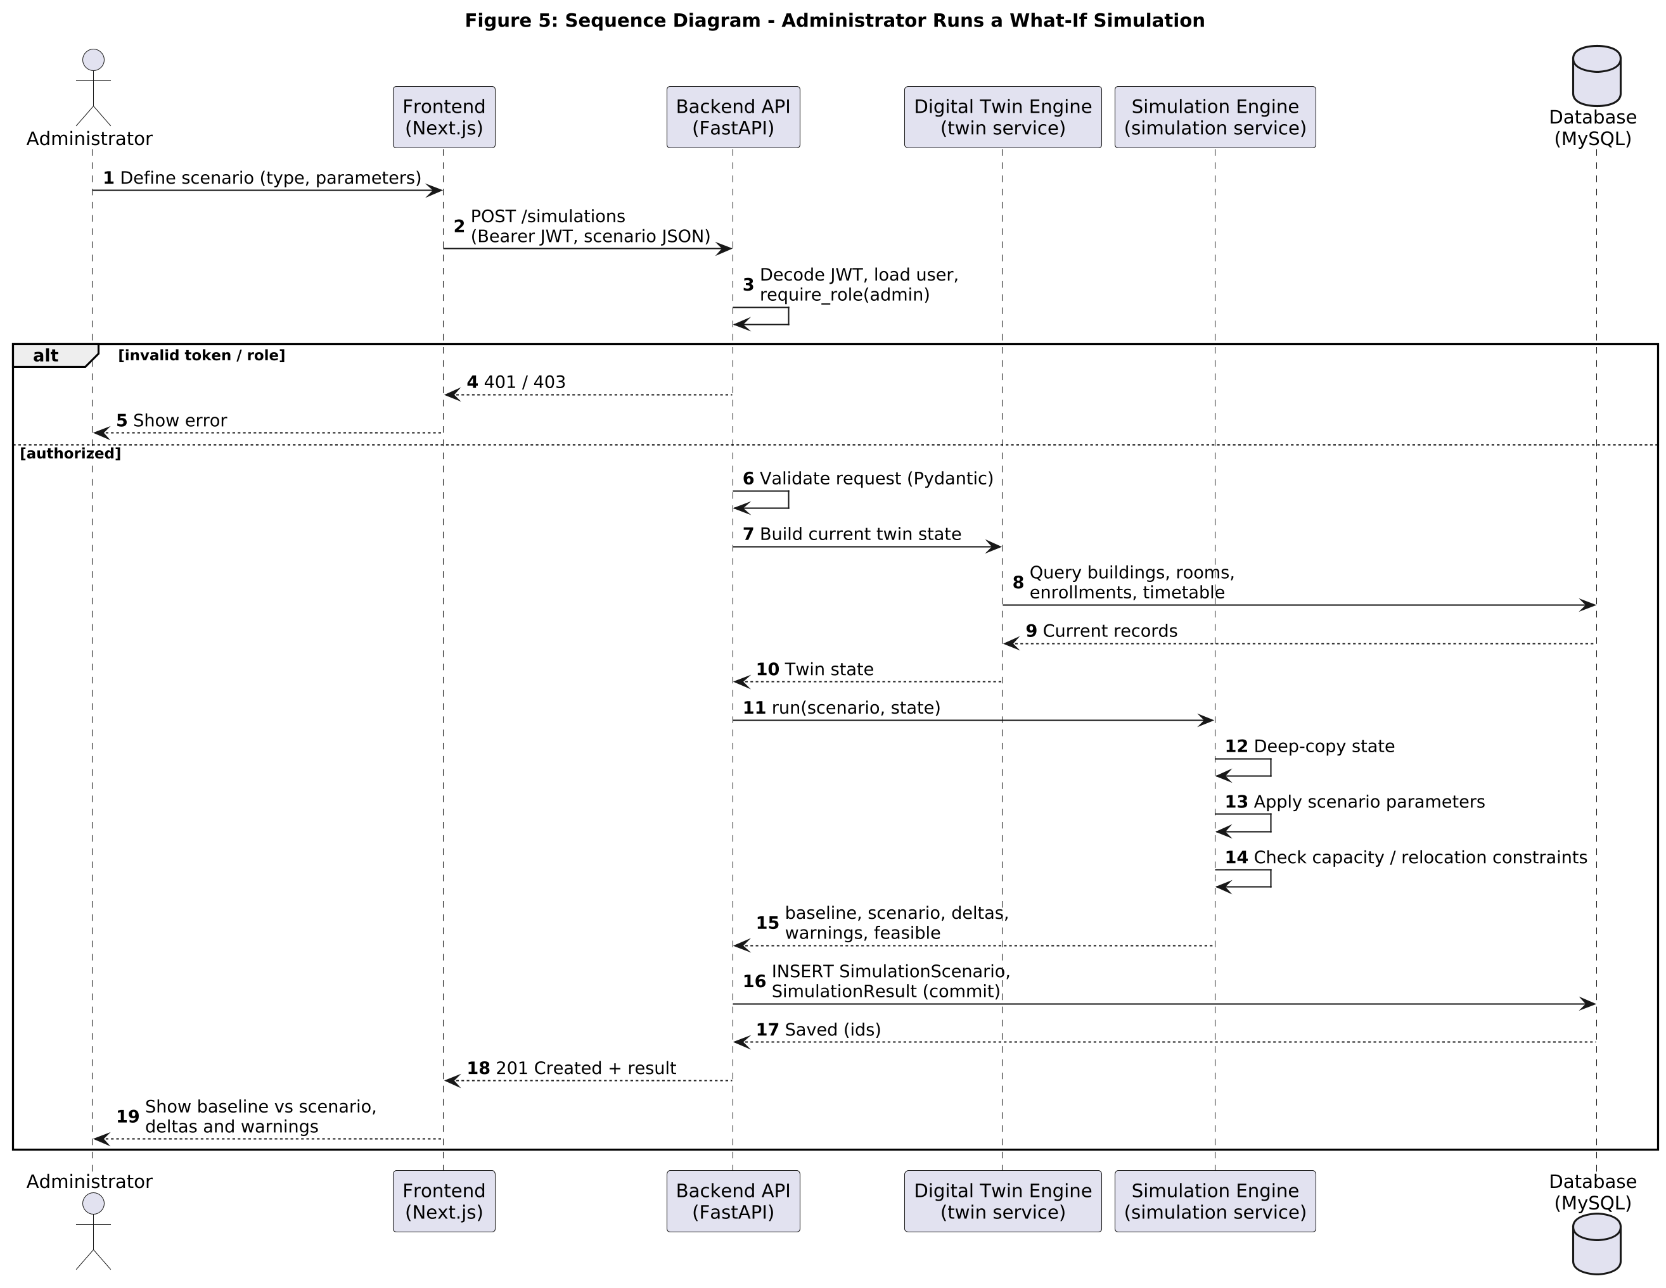
Figure 5: Sequence Diagram — Administrator Runs a What-If Simulation — Source: Self-designed based on project requirements
Data Flow Diagram (Level 1)
How state data, predictions / anomalies and simulation / optimization data flow between actors and data stores.
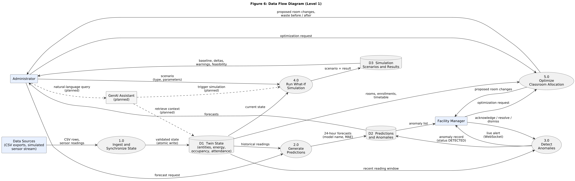
Figure 6: Data Flow Diagram (Level 1) — Source: Self-designed based on project requirements
State Diagram — Anomaly Lifecycle
States from DETECTED to ACKNOWLEDGED, RESOLVED or DISMISSED. Any other transition is rejected with HTTP 409.
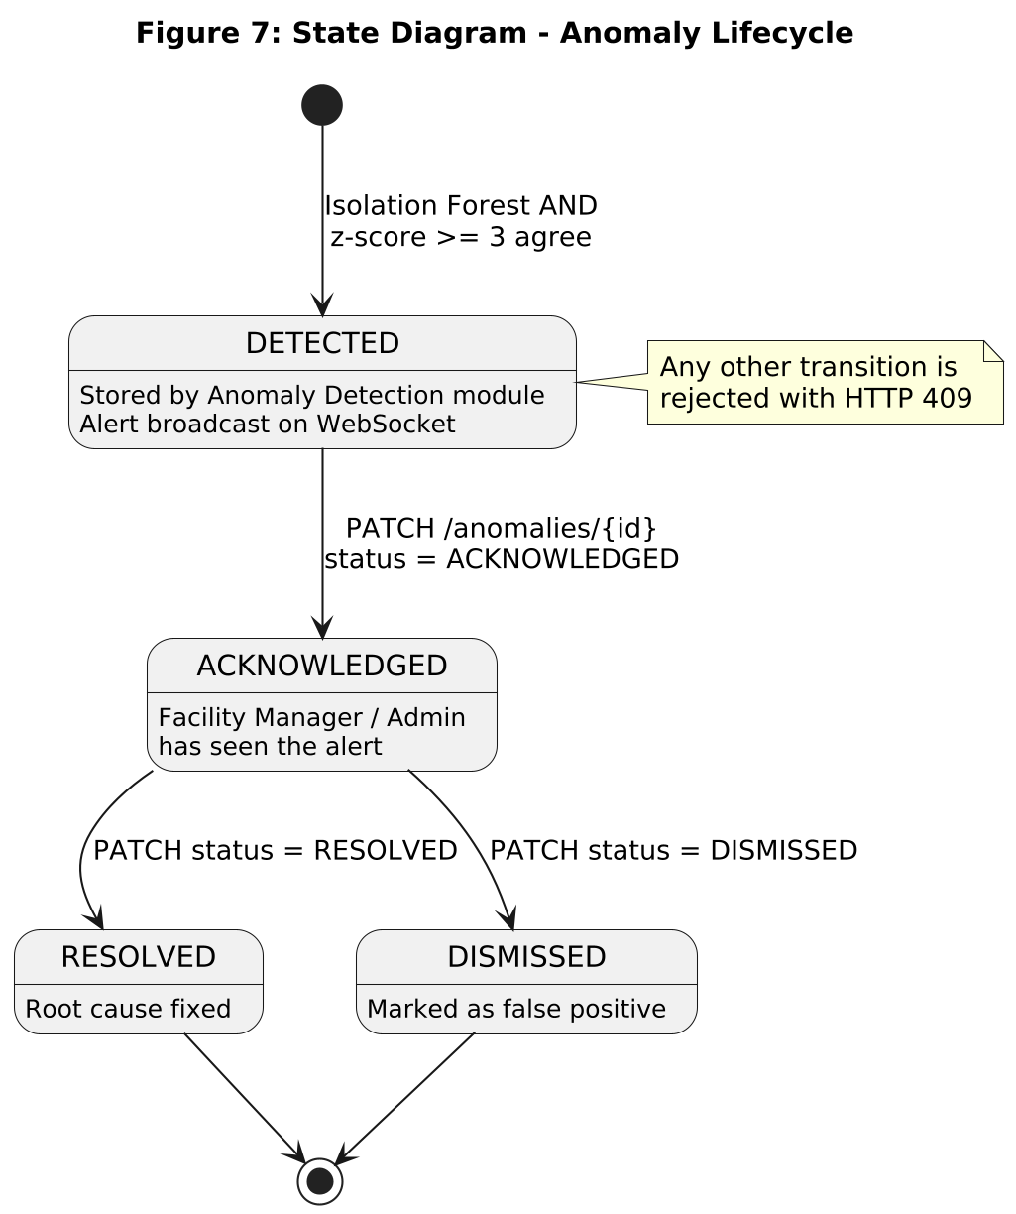
Figure 7: State Diagram — Anomaly Lifecycle — Source: Self-designed based on project requirements
Collaboration Diagram — Prediction and Anomaly Alert
Object interactions when a prediction is requested and an abnormal result raises an alert.
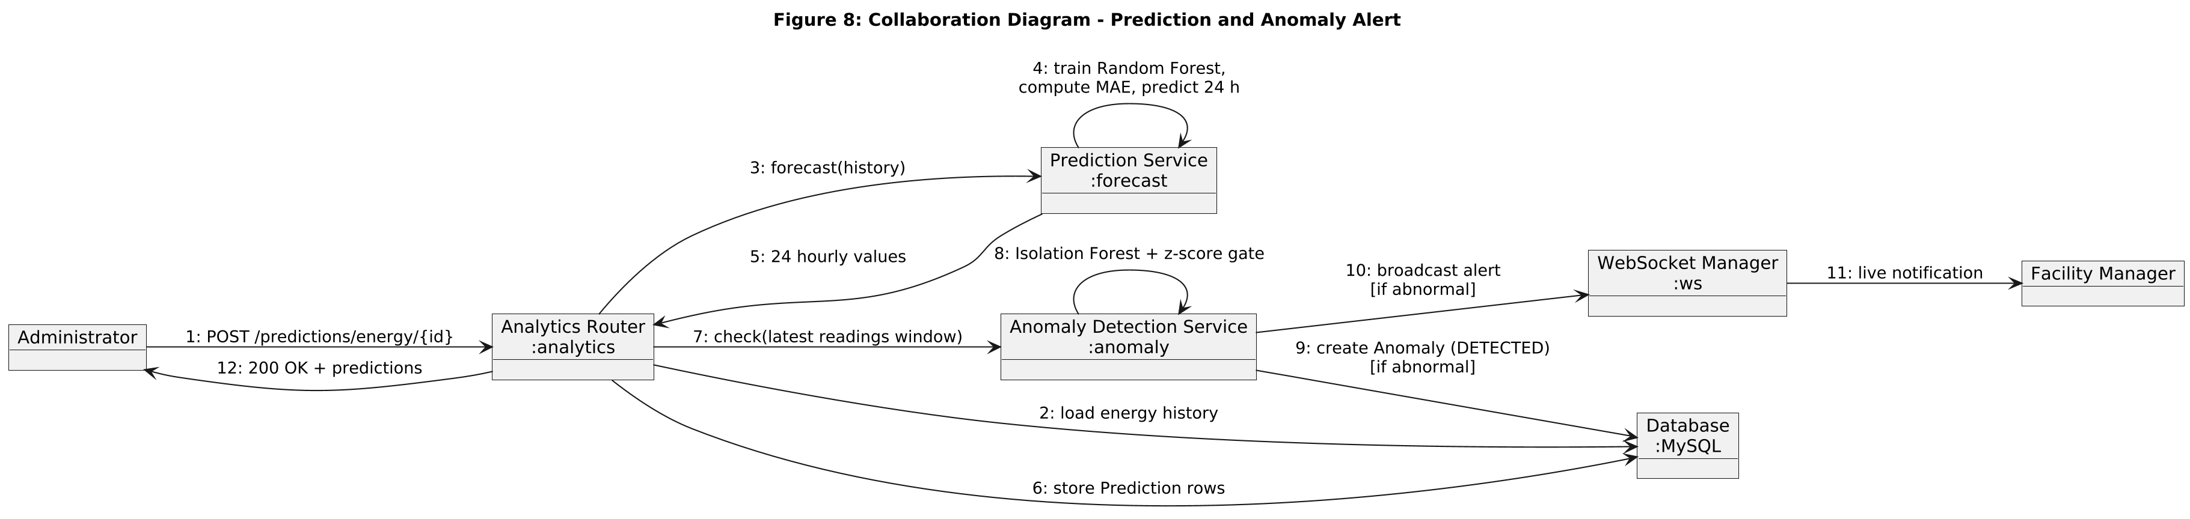
Figure 8: Collaboration Diagram — Prediction and Anomaly Alert — Source: Self-designed based on project requirements
Entity-Relationship Diagram
The 17 persisted entities and their cardinalities. Prediction and Anomaly reference buildings or rooms polymorphically through entity_type and entity_id.
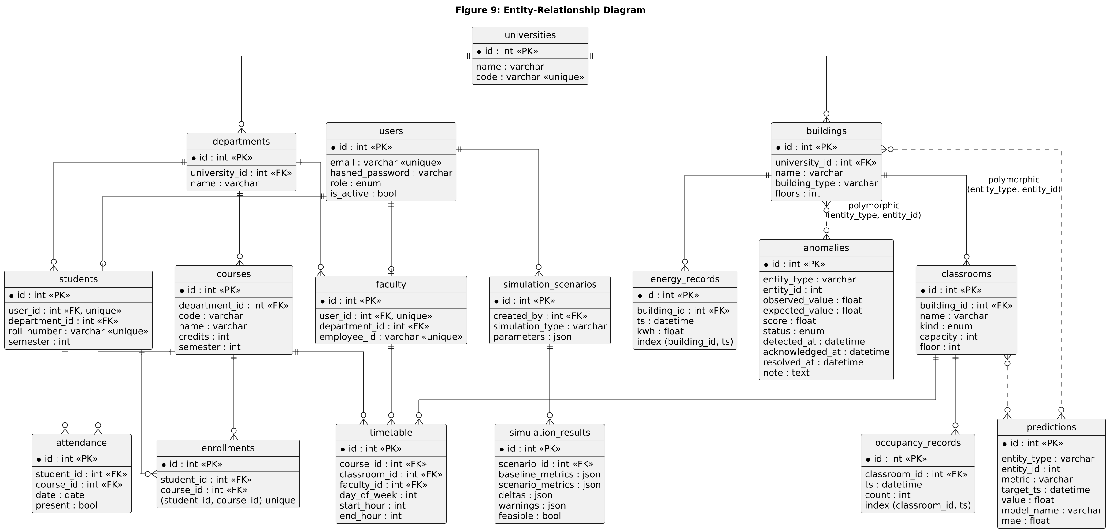
Figure 9: Entity-Relationship Diagram — Source: Self-designed based on project requirements
Deployment Diagram
Deployment topology of the prototype: stateless FastAPI containers behind a reverse proxy, with MySQL and Redis containers managed by Docker Compose.
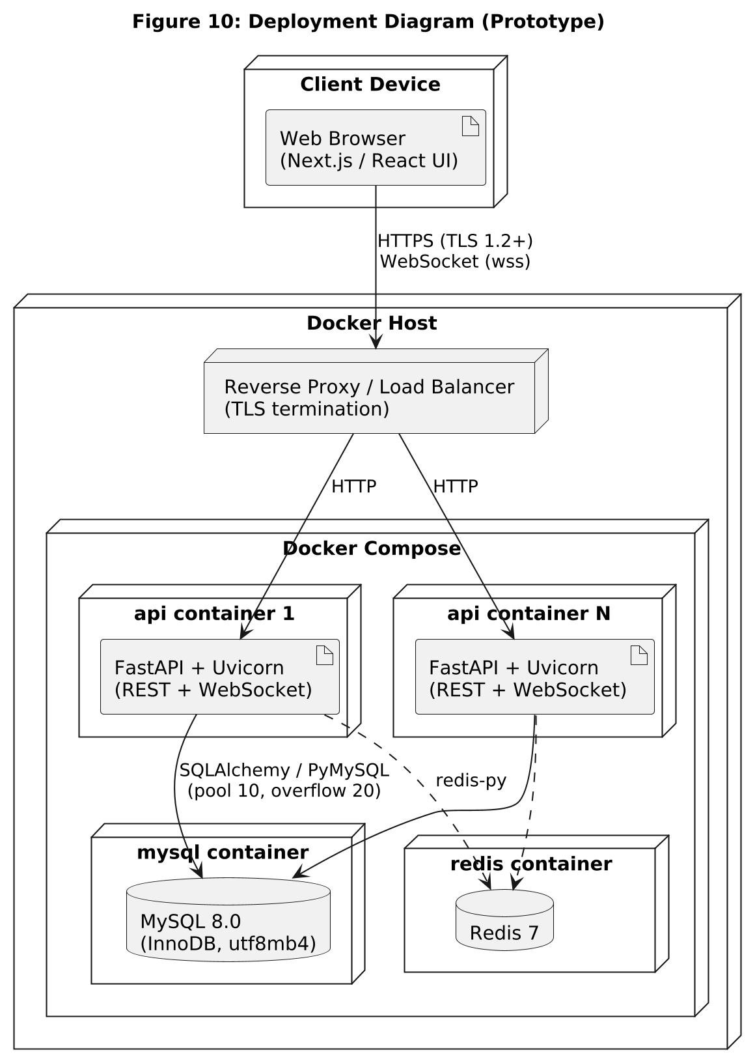
Figure 10: Deployment Diagram — Source: Self-designed based on project requirements

2.8 Assumptions and Dependencies
Assumptions
- Users have a computing device with a modern web browser and internet connectivity.
- Historical university data (students, faculty, courses, timetable, energy, occupancy) is available in exportable CSV form for the initial load; until then, the synthetic seed data is used.
- Simulated sensor streams are an acceptable stand-in for physical IoT sensors during the prototype phase.
- Timetable hours are whole hours and one timetable slot occupies one room.
- A suitable LLM provider with an API for retrieval-augmented generation will be available for the planned assistant.
Dependencies
- Accuracy and availability of the historical data used to train the forecasting and anomaly models.
- Docker and Docker Compose for the MySQL and Redis services; Python 3.11 or later.
- Open-source libraries listed in the Libraries Documentation section (FastAPI, SQLAlchemy, scikit-learn, SciPy, etc.).
- Cloud hosting provider, LLM provider and message-queue choice — to be finalized during implementation.

3. SYSTEM REQUIREMENTS

3.1 User Interface
The user interface is a responsive web application (Next.js, React, Tailwind CSS) for desktop and tablet browsers. It consumes the REST and WebSocket APIs described in Section 3.2. The backend already enables CORS for the front-end origin (default http://localhost:3000). The screens required per role are:
- Authentication: login form; token held client-side and sent as a Bearer header; redirect to login on HTTP 401.
- Administrator console: user and role management; forms for departments, buildings, classrooms, courses and timetable; CSV upload with a row-level result view; scenario builder and result comparison (baseline vs. scenario, deltas, warnings); optimization view with proposed room changes.
- Faculty dashboard: own timetable, classroom availability, course and attendance views, student lists.
- Student portal: library / hostel occupancy forecast, personal timetable and attendance percentage.
- Facility Manager dashboard: live per-building energy and utilisation cards from /twin/state and WebSocket, anomaly queue with acknowledge / resolve / dismiss actions, optimization output.
- Common: charts for history and forecast, paginated tables, and clear error messages that never expose internal details.
A native mobile application and 3D/VR visualisation are future opportunities (Section 1.3).

3.2 Software Interface
The front end communicates with the backend through a REST API (JSON over HTTPS) and a WebSocket channel for live broadcasts. The backend is organised into five routers — auth, crud, twin, ingestion and analytics — which call the service modules forecast, anomaly, simulation, optimization, twin and campus_data. All list endpoints are paginated with page and page_size parameters. The backend connects to PostgreSQL (relational, transactional state), Neo4j (knowledge graph for dependency / impact analysis), TimescaleDB (time-series energy, occupancy and attendance records), Redis / Kafka (message queue decoupling ingestion from the Digital Twin Engine), object storage (MinIO / S3) for data exports and generated reports, and an external LLM API (Llama / GPT-class, transformer-based [13]) for the Generative AI assistant's RAG pipeline. The current prototype reaches MySQL 8.0 through SQLAlchemy and PyMySQL and Redis 7 through redis-py. Interactive documentation is generated automatically at /docs.
Table 7: REST and WebSocket interface
Method | Path | Access | Description
POST | /auth/login | Public (rate-limited) | OAuth2 password login; returns JWT
GET | /auth/me | Any | Current user profile
GET / POST | /auth/users | Admin | List / create users
GET / POST | /departments, /buildings, /classrooms, /courses, /timetable | Read: any; write: admin | Campus entities (GET by id also available)
GET | /faculty | Any | Faculty list
GET | /students | Admin, Faculty | Student list
GET | /me/timetable | Faculty, Student | Own timetable
GET | /me/attendance | Student | Own attendance percentage per course
GET | /twin/state | Any | Per-building live snapshot
POST | /telemetry/tick | Any authenticated | Generate one round of simulated sensor data
GET | /telemetry/energy, /telemetry/occupancy | Any (students: library / hostel only for occupancy) | History of readings
POST | /ingestion/csv?entity_type= | Admin | Import students, courses or energy CSV
POST | /predictions/energy/{building_id}, /predictions/occupancy/{classroom_id} | Any (students restricted) | Generate 24-hour forecast
GET | /predictions | Any | List stored predictions
GET / PATCH | /anomalies, /anomalies/{id} | Admin, Facility Manager | List anomalies / update status
POST / GET | /simulations, /simulations/{id} | Admin | Run / list / view what-if simulations
POST | /optimization/classrooms | Admin, Facility Manager | Classroom allocation optimization
GET | /health | Public | Health check
WS | /ws/live?token= | Valid JWT | Real-time broadcasts

Standard status codes are used: 200/201 for success, 401 for a missing or invalid token, 403 for insufficient role, 404 for missing resources, 409 for constraint or lifecycle violations, 422 for validation errors and 429 for rate limiting. Planned external interfaces are an LLM API for the GenAI assistant, an object-storage service and a message queue.

3.3 Database Interface
PostgreSQL is the primary relational store, Neo4j the graph store for entity relationships and TimescaleDB the time-series store for high-volume sensor-style records. All queries executed by the backend are scoped to the authenticated user's role and permitted entities. The version 1 prototype runs on MySQL 8.0 (InnoDB engine, utf8mb4 character set). The schema is defined by SQLAlchemy 2.0 models, created through the Alembic migration 001_initial_schema, and also provided as plain DDL (db/schema.sql) with example analytical queries (db/queries.sql). Sessions are created per request through a FastAPI dependency and closed afterwards; the engine uses connection pre-ping, hourly connection recycling and a pool of 10 connections with 20 overflow. Role checks and ORM-parameterised queries ensure that SQL is never built from user input. Redis 7 is provisioned for caching and the message queue.
Table 8: Database entities and relationships
Entity | Purpose | Key attributes / relationships
User | Login account and role | email (unique), hashed_password, role (admin / faculty / student / facility_manager), is_active
University | Top-level campus | code (unique); 1:N Department, Building
Department | Academic unit | 1:N Faculty, Student, Course
Building | Physical building | building_type (academic, lab, library, hostel), floors; 1:N Classroom, EnergyRecord
Classroom | Room / lab / library / hostel space | kind, capacity (> 0), floor; 1:N Timetable, OccupancyRecord
Faculty | Teaching staff profile | 1:1 User; employee_id (unique); N:1 Department
Student | Student profile | 1:1 User; roll_number (unique), semester; N:1 Department
Course | Course offered | credits, semester; N:M Student via Enrollment
Enrollment | Student–course link | unique (student_id, course_id)
Timetable | Scheduled slot | day_of_week 0–6, start_hour < end_hour; N:1 Course, Classroom, Faculty
Attendance | Daily attendance | student, course, date, present
EnergyRecord | Energy reading | building_id, ts, kwh; index (building_id, ts)
OccupancyRecord | Occupancy reading | classroom_id, ts, count; index (classroom_id, ts)
Prediction | Forecast value | entity_type, entity_id, metric, target_ts, value, model_name, mae
Anomaly | Flagged abnormal reading | observed_value, expected_value, score, status, detected / acknowledged / resolved timestamps, note
SimulationScenario | Defined what-if scenario | simulation_type, parameters (JSON), created_by; 1:N SimulationResult
SimulationResult | Scenario outcome | baseline_metrics, scenario_metrics, deltas, warnings (JSON), feasible

The Neo4j knowledge graph [14] and the TimescaleDB time-series store specified in the synopsis serve dependency / impact analysis and high-volume telemetry. In the version 1 prototype both concerns are temporarily served by MySQL (foreign keys and indexed time-stamped tables); migration to the synopsis stack is tracked as Issue 009 in Appendix C.

3.4 Protocols
- HTTPS (TLS 1.2+): all client–server communication in deployment; TLS terminates at the reverse proxy or load balancer.
- REST over HTTP with JSON payloads: primary API, validated with Pydantic v2 schemas.
- WebSocket (/ws/live): pushes live twin updates (occupancy, energy, alerts). The server accepts a connection only if the JWT supplied as the token query parameter is valid; otherwise it closes with code 4001. The server only broadcasts and ignores incoming messages. Polling is the fallback.
- JWT bearer authentication (RFC 7519): HS256-signed token in the Authorization header; OAuth2 password flow for login; OAuth2 single sign-on planned.
- Database protocols: MySQL wire protocol via PyMySQL (prototype); PostgreSQL, Neo4j (Bolt) and TimescaleDB connections in the target stack; Redis RESP protocol.
- CSV ingestion: multipart/form-data upload, validated row by row.
- RAG over HTTPS (planned): the GenAI assistant will call the LLM API over HTTPS with retrieved twin data as context.
- Synchronization: database writes use transactions with rollback on error; the WebSocket connection manager drops dead sockets automatically.

4. NON-FUNCTIONAL REQUIREMENTS

4.1 Performance Requirements
The platform is an analytical web application, not a hard real-time system, so no hard real-time guarantees are made. The targets in Table 9 are to be confirmed by load testing on the chosen hosting infrastructure.
Table 9: Performance targets
ID | Requirement | Target
NFR-P1 | Standard API response time (95th percentile) | < 200 ms
NFR-P2 | Live dashboard update after a state change | 0.5 – 1 s
NFR-P3 | What-if simulation for a typical scenario | < 5 s
NFR-P4 | Forecast generation (train + 24-hour prediction) on one entity history | To be measured; target < 5 s for typical history sizes
NFR-P5 | Concurrent users supported by the prototype | Up to 100
NFR-P6 | List endpoints | Paginated (page, page_size); indexed time-series queries
NFR-P7 | Telemetry simulator interval | Configurable, default 10 s

4.2 Security Requirements
- Authentication: all users must authenticate with JWT/OAuth2-based authentication before accessing any protected resource; tokens expire (default 60 minutes) and inactive users are rejected.
- Authorization (RBAC) [15]: the require_role guard enforces the admin, faculty, student and facility_manager permissions of Table 6 on each endpoint, and students are restricted to library and hostel occupancy.
- Password security: passwords are salted and hashed with bcrypt and are never stored or logged in plain text.
- API security and brute-force protection: rate limiting to prevent abuse; login is limited to 10 attempts per IP per 60 seconds (HTTP 429).
- Transport security: HTTPS/TLS 1.2+ for all traffic; WebSocket connections authenticated by JWT.
- Input validation: Pydantic schemas and database constraints (unique, check and foreign-key constraints) reject malformed input at the API layer; ORM usage and parameterised queries prevent SQL and Cypher injection.
- Configuration secrets: SECRET_KEY, database credentials and the Redis URL are read from environment variables; defaults in .env.example are for development only and must be replaced in production.
- Data protection: student and faculty personal data is available only to permitted roles and must be excluded from logs and client-facing error messages. The system shall operate in line with applicable Indian data-protection regulations (to be finalized).
- Secure AI interaction (planned): prompt-injection mitigation, exclusion of sensitive data from LLM prompts, and validation of generated output.
- Known gaps to close before production: see Issues 010–012 and 015 in Appendix C.

4.3 Software Quality Attributes
- Adaptability / Flexibility: behaviour is configured through environment variables (token lifetime, simulator interval, CORS origins); new scenario types can be added as new pure functions.
- Availability: a health endpoint, container restart policy and MySQL / Redis health checks in Docker Compose support the availability of the deployed prototype.
- Correctness: the backend ships with 46 automated pytest tests covering the pure services and the API; tests run against an in-memory SQLite database so no MySQL is needed.
- Interoperability: REST/JSON, OpenAPI documentation and CSV import make it straightforward to connect other data sources or ERP systems.
- Maintainability: modular layered architecture; one router per domain area; typed code; Alembic-versioned schema.
- Portability: Docker Compose runs the infrastructure on any Docker host; the application is plain Python.
- Reliability: transactions with rollback; lifecycle transitions validated; the background simulator logs errors and survives failed ticks.
- Reusability: service functions have no framework dependencies and can be reused by batch jobs, notebooks or the future GenAI assistant.
- Robustness: malformed scenario parameters, invalid status transitions, duplicate keys and unauthorised cross-role requests are rejected with explicit status codes; a forecast with fewer than 10 data points is refused.
- Testability: pure-function services can be tested without a database or HTTP layer; fixtures supply an isolated database per test.
- Usability: each dashboard shows only the information and actions relevant to the user’s role.

5. OTHER REQUIREMENTS
- Business rule 1: a user can view or act on only the data relevant to their role and, where applicable, their department or building scope; broader access is denied regardless of role.
- Business rule 2: only a Facility Manager or Administrator may acknowledge, resolve or dismiss anomalies; configuring twin entities and running simulations are Administrator responsibilities.
- Business rule 3: an anomaly is created only when both the Isolation Forest and the z-score condition are met, to limit false alarms.
- Business rule 4: the classroom optimizer assigns a lab session only to a lab and never assigns a room smaller than the enrollment.
- Data backup: The databases (PostgreSQL, Neo4j, TimescaleDB; MySQL in the current prototype) must be backed up automatically at periodic intervals; frequency and retention are to be finalized during implementation.
- Model governance: forecasting and anomaly models are to be re-evaluated periodically against fresh data; the stored MAE of each prediction supports monitoring. The retraining cadence is to be finalized.
- Compliance: the system shall follow applicable Indian data-protection regulations for student and institutional data; the full checklist is to be finalized.
- Environment: Git/GitHub for version control; Docker Compose for MySQL and Redis; pip with requirements.txt; Alembic for migrations (alembic upgrade head); seed script (python -m scripts.seed, with --reset to rebuild); pytest for tests; OpenAPI documentation at /docs.
- Seed credentials: development accounts (admin and facility manager) are created by the seed script and must be removed or changed before any real deployment.

APPENDIX A: GLOSSARY
Term | Definition
Digital Twin | A virtual representation of a physical system that mirrors its real-world counterpart in real time.
Digital Twin Engine | The component that maintains the virtual representation and state synchronization.
What-If Simulation | Analysis of hypothetical scenarios on a copy of the twin state to understand potential outcomes.
Optimization | Finding the best solution subject to constraints and objectives.
Predictive Analytics | Use of statistical / machine-learning models to forecast future values.
Anomaly Detection | Identification of patterns that deviate from expected behaviour.
Random Forest | Ensemble of decision trees used here for regression forecasting.
Isolation Forest | Unsupervised algorithm that isolates outliers using random trees [9].
z-score | Number of standard deviations by which a value differs from the mean.
MAE | Mean Absolute Error; average absolute difference between predicted and actual values.
Hungarian algorithm | Polynomial-time algorithm for the assignment problem (minimum-cost matching).
Knowledge Graph | Graph-structured representation of entities and their relationships.
RAG | Retrieval-Augmented Generation; retrieving relevant data before generating an AI response.
LSTM | Long Short-Term Memory; recurrent neural network for sequence data [10].
RBAC | Role-Based Access Control; restricting access based on user roles [15].
JWT | JSON Web Token; signed token used to authenticate API requests.
ORM | Object-Relational Mapping; here SQLAlchemy.
REST / API | Representational State Transfer; Application Programming Interface.
WebSocket | Full-duplex protocol over a single TCP connection, used for live updates.
IoT | Internet of Things; networked physical sensors.
DFD | Data Flow Diagram.
FM | Facility Manager.
SRS | Software Requirements Specification.

APPENDIX B: ANALYSIS MODEL
The analysis model combines the behavioural and structural views listed below.
- Development model — Agile / iterative: database schema and authentication first, then entity CRUD, ingestion and twin state, analytics services (forecast, anomaly, simulation, optimization), WebSocket updates, tests, and finally the front end and GenAI assistant.
- Layered architecture: routers (HTTP concerns) → services (pure domain logic) → ORM models (persistence). Services do not import the web framework or the database session, which gives low coupling and high cohesion.
- Domain-oriented modules: identity and access (auth), campus structure (crud), live state (twin, ingestion), and intelligence (analytics).
- Behavioural views: use case, activity, sequence, state and collaboration diagrams (Figures 2, 4, 5, 7, 8).
- Structural views: architecture, class, entity-relationship and deployment diagrams (Figures 1, 3, 9, 10); data movement is shown in the DFD (Figure 6).
The entity cardinalities used in the database design are:
- University (1) → Department (N); University (1) → Building (N)
- Department (1) → Faculty (N); Department (1) → Student (N); Department (1) → Course (N)
- Building (1) → Classroom (N)
- User (1) ↔ Faculty (1); User (1) ↔ Student (1)
- Student (N) ↔ Course (N), via Enrollment
- Course (1) → Timetable (N); Classroom (1) → Timetable (N); Faculty (1) → Timetable (N)
- Student (1) → Attendance (N); Course (1) → Attendance (N)
- Building (1) → EnergyRecord (N); Classroom (1) → OccupancyRecord (N)
- Building / Classroom (1) → Prediction (N); Building (1) → Anomaly (N) (polymorphic reference)
- User (1) → SimulationScenario (N); SimulationScenario (1) → SimulationResult (N)

APPENDIX C: ISSUES LIST
Table 10: Open requirements and design issues
Issue ID | Description | Proposed Solution | Status
001 | Final selection of the LLM provider for the GenAI assistant | Evaluate Llama, GPT-class and Claude APIs on cost, latency and grounding quality | Open
002 | Availability of real historical university data for training and testing | Use the synthetic seed data set; obtain anonymised exports later | In Progress
003 | Real-time data simulation approach for sensor streams | Configurable simulator (telemetry tick and optional background loop) with anomaly injection | Resolved
004 | Scalability for a production deployment | Cloud-native deployment with several stateless API containers behind a load balancer | Open
005 | Integration with existing university ERP systems | CSV import is available; add a documented REST integration later | In Progress
006 | Performance on large historical data sets | Pagination and composite time indexes exist; add caching and partitioning / a time-series store if needed | In Progress
007 | User testing with real university administrators | Structured usability and accuracy testing sessions | Open
008 | Deployment environment and cloud provider selection | Evaluate AWS, Azure and on-premises options | Open
009 | Synopsis specifies PostgreSQL, Neo4j and TimescaleDB, but the prototype currently uses MySQL 8.0 | Migrate to the synopsis stack (PostgreSQL + Neo4j + TimescaleDB) behind the existing SQLAlchemy models and service interfaces; keep MySQL for the prototype until then | Open
010 | Login rate limiter is in-memory and per process; it resets on restart and does not work across multiple containers | Move counters to Redis (already provisioned) | Open
011 | JWT uses a shared HS256 secret with a development default; no refresh tokens | Enforce a strong secret from a secrets manager; add refresh tokens; consider RS256 | Open
012 | WebSocket token is passed in the query string and may appear in logs | Use a short-lived one-time ticket or a sub-protocol header | Open
013 | XGBoost, LSTM/GRU, autoencoder, linear-programming and genetic-algorithm components are not yet implemented | Add behind the existing service interfaces and compare against the Random Forest / Hungarian baselines | Open
014 | GenAI assistant (RAG) and knowledge graph are not yet implemented | Design the retrieval layer over the twin tables; add the LLM client | Open
015 | /telemetry/tick is open to any authenticated role, so even a student can trigger data generation | Restrict to admin / facility manager or disable outside demo mode | Open
016 | Web dashboard not yet integrated with the backend | Build role-based screens against the documented API | In Progress

LIBRARIES DOCUMENTATION

1. Introduction to Libraries
This section lists the libraries used by the Digital Twin backend, following the library-documentation format of the reference StreamFlix SRS . The backend is written in Python 3.11+ and uses the Python standard library as its foundation, together with the third-party packages pinned in requirements.txt.

2. Core Python System Libraries
Table 11: Standard-library modules
Module | Purpose in the Digital Twin
datetime | Timestamps for readings, predictions, anomalies and JWT expiry (timezone-aware UTC).
asyncio | Background telemetry simulator, non-blocking WebSocket broadcasts and running blocking database work in a thread.
contextlib | Application lifespan (start / stop of the simulator).
enum | UserRole, ClassroomKind and AnomalyStatus.
copy | Deep copy of the twin state for what-if simulation.
math | Sine and cosine encoding of the hour of day for forecasting.
typing / __future__ | Type hints and postponed annotations.
logging | Application and simulator logging.

3. Web, Data and Security Libraries
Table 12: Third-party libraries and their roles
Library (requirements.txt) | Purpose | Used for
fastapi ≥ 0.115 | Web framework: routing, dependency injection, WebSocket, OpenAPI | Routers, deps.py, main.py
uvicorn[standard] ≥ 0.30 | ASGI server | Running the application
sqlalchemy ≥ 2.0.30 | ORM and connection pooling | models.py, database.py, queries
pymysql ≥ 1.1, cryptography ≥ 43 | MySQL driver and authentication support | Connecting to MySQL 8
alembic ≥ 1.13 | Schema migrations | alembic/versions/001_initial_schema.py
pydantic ≥ 2.9, pydantic-settings ≥ 2.5 | Request / response validation; environment-based settings | schemas.py, config.py
PyJWT ≥ 2.9 | JWT creation and verification (HS256) | security.py, WebSocket authentication
bcrypt ≥ 4.2 | Password hashing | security.py
python-multipart ≥ 0.0.9 | Form and file upload parsing | Login form, CSV upload
python-dotenv ≥ 1.0 | Loading .env files | Configuration
redis ≥ 5.1 | Redis client | Cache / future queue
slowapi ≥ 0.1.9 | Rate-limiting helper (listed in requirements) | Login currently uses a built-in limiter (see Issue 010)
httpx ≥ 0.27 | HTTP client | Test client for the API tests

4. Analytics Libraries
Table 13: Machine-learning and numerical libraries
Library | Component used | Purpose
scikit-learn ≥ 1.5 | RandomForestRegressor, IsolationForest, train_test_split | Forecasting and anomaly detection
numpy ≥ 1.26 | Arrays, mean, standard deviation | Feature matrices, z-score, cost matrices
scipy ≥ 1.14 | scipy.optimize.linear_sum_assignment | Hungarian algorithm for classroom allocation
pandas ≥ 2.2 | DataFrames | Data preparation
pytest ≥ 8.3 | Test runner | 46 automated tests (services and API)

5. Library Summary by Module
Table 14: Libraries by backend module
Module | FastAPI | SQLAlchemy | Pydantic | PyJWT / bcrypt | scikit-learn | SciPy / NumPy
routers/auth.py | Yes | Yes | Yes | Yes | — | —
routers/crud.py | Yes | Yes | Yes | — | — | —
routers/ingestion.py | Yes | Yes | Yes | — | — | —
routers/analytics.py | Yes | Yes | Yes | — | — | —
services/forecast.py | — | — | — | — | Yes | NumPy
services/anomaly.py | — | — | — | — | Yes | NumPy
services/optimization.py | — | — | — | — | — | Yes
services/simulation.py | — | — | — | — | — | —
services/twin.py | — | Yes | — | — | — | —
security.py / deps.py | Yes | Yes | — | Yes | — | —
ws.py / main.py | Yes | — | — | Yes | — | —

