Module 6) Python Fundamentals Introduction to Python Theory:

🐍

• Introduction to Python and its Features (simple, high-level, interpreted language).

Python is a simple and easy programming language used to create computer programs.
It was created by Guido van Rossum.
Python is popular because it is easy to learn and easy to read.
Features of Python (Simple)
1️⃣ Simple Language
Python has easy syntax, so beginners can learn it quickly.
2️⃣ High-Level Language
You do not need to worry about computer hardware details.
3️⃣ Interpreted Language
Python runs code line by line, which makes it easier to find errors.
• History and evolution of Python.
History of Python
- 1989 – Guido van Rossum started working on Python.
- 1991 – First version of Python was released.
- 2000 – Python 2.0 was released with many new features.
- 2008 – Python 3.0 was introduced with improved design and performance.

🔄 Evolution of Python
Python has improved over time with new versions.
Python 1.x
- Basic features
- Simple programming
Python 2.x
- More libraries and better performance
- Widely used for many years
Python 3.x
- Modern version
- Faster and better features
- Most used version today

• Advantages of using Python over other programming languages.
Advantages of Using Python :-
Python has many advantages compared to other programming languages.
1️⃣ Easy to Learn
Python has simple and clear syntax, so beginners can learn it quickly.
2️⃣ Easy to Read and Write
Python code looks like simple English, which makes programs easy to understand.
3️⃣ Free and Open Source
Python is free to download and use, and anyone can improve it.
4️⃣ Large Library Support
Python has many built-in libraries that help in tasks like web development, data analysis, and automation.
5️⃣ Portable (Platform Independent)
Python programs can run on Windows, Linux, and macOS without changing the code.
6️⃣ Used in Many Fields
Python is used for:
- Web development
- Data science
- Artificial intelligence
- Machine learning
- Automation
7️⃣ Large Community Support
Many developers around the world use Python, so help and learning resources are easily available.

.Installing Python and setting up the development environment (Anaconda, PyCharm, or VS Code).

1️⃣ Install Python
Steps:
- Go to the official website: python.org
- Download the latest version of Python.
- Run the installer.
- ✔ Select “Add Python to PATH”.
- Click Install.
After installation, Python is ready to use.

2️⃣ Development Environments for Python
A development environment helps you write and run Python code easily.

Anaconda
- A complete package for Python programming.
- Includes many tools and libraries for data science and machine learning.
- Comes with Jupyter Notebook for running code step-by-step.

PyCharm
- A powerful IDE (Integrated Development Environment) for Python.
- Good for large projects and professional development.
- Provides features like debugging and code suggestions

Visual Studio Code
- A lightweight and popular code editor.
- Supports Python with extensions.
- Easy to use for beginners.

• Writing and executing your first Python program.
Step 1: Write code
Open any editor (like Notepad)
Type:
print("Hello, World!")
Save it as: hello.py

Step 2: Run it
Open Command Prompt (or Terminal) and type:
python hello.py

Output:
Hello, World!

Lab:
• Write a Python program that prints "Hello, World!".
print("Hello, World!")
▶️ Output:
Hello, World!

• Set up Python on your local machine and write a program to display your name.
1. Install Python
- Go to Python website
- Download and install it
- Tick “Add Python to PATH” while installing
Program:
name = input("Enter your name: ")
print("Hello,", name)

Example Run:
Enter your name: Rahul
Hello, Rahul

Explanation:
- input() → takes input from user
- print() → shows output on screen

2. Programming Style Theory:
• Understanding Python’s PEP 8 guidelines.
Understanding Python’s PEP 8 Guidelines
PEP 8 (Python Enhancement Proposal 8) is the official style guide for writing clean and readable Python code in Python.
Why PEP 8 matters
- Makes code easy to read
- Keeps code consistent
- Helps others (and you) understand code faster
- Key PEP 8 Rules (Simple)
1. Indentation
Use 4 spaces per level
if True:
print("Hello")
2. Line Length
- Keep lines under 79 characters

3. Variable Names
- Use lowercase with underscores
user_name = "Rahul"
total_marks = 90

4. Function Names
- Same style: lowercase + underscores
def calculate_total():
pass

5. Class Names
- Use CapitalizedWords (CamelCase)
class StudentDetails:
pass

6. Spaces Around Operators
Add spaces for readability
x = 5 + 3 # correct
x=5+3 # not recommended

7. Blank Lines
- Use blank lines to separate functions/classes
8. Comments
- Write clear comments
# This prints a greeting
print("Hello")

❌ Bad vs ✅ Good Example
❌ Bad:
x=10
y=20
print(x+y)
✅ Good:
x = 10
y = 20
print(x + y)

• Indentation, comments, and naming conventions in Python.
🐍 Indentation, Comments & Naming in Python
1. Indentation (Spacing)
- Python uses spaces to define blocks of code
- Always use 4 spaces
if True:
print("Hello") # inside block
Without proper indentation → error ❌
2. Comments (Notes in code)
- Used to explain code
- Python ignores comments
# This is a comment
print("Hello")
Shortcut: helps others understand your code

3. Naming Conventions (Variable names)
- Use lowercase + underscore
user_name = "Rahul"
total_marks = 90
- ❌ Wrong: userName, TotalMarks
- ✅ Correct: user_name, total_marks
In Short:
- Indentation → structure of code
- Comments → explanation
- Naming → clean & readable names

• Writing readable and maintainable code.
Writing Readable & Maintainable Code in Python
Simple Rules:
1. Use Clear Names
age = 20 # ✅ good
a = 20 # ❌ bad

2. Keep Code Simple
- Avoid complex logic
- Break code into small parts

3. Use Functions
def greet():
print("Hello")

4. Add Comments
# Calculate total marks
total = 50 + 40

5.
Follow Proper Spacing
x = 5 + 3 # ✅ readable

6. Organize Code
- Use proper indentation
- Separate code with blank lines

Lab: • Write a Python program that demonstrates the correct use of indentation, comments, and variablesfollowing PEP 8 guidelines.
def calculate_total_marks():
student_name = input("Enter your name: ")
marks_math = int(input("Enter Math marks: "))
marks_science = int(input("Enter Science marks: "))
total_marks = marks_math + marks_science
print("Name:", student_name)
print("Total Marks:", total_marks)
calculate_total_marks()
Input :
Rahul
50
60
Output:
Name: Rahul
Total Marks: 110

3. Core Python Concepts Theory:
• Understanding data types: integers, floats,strings, lists, tuples, dictionaries,sets
1. Integer (int)
- Whole numbers (no decimal)
x = 1

2. Float
- Decimal numbers
price = 99.5

3. String (str)
- Text (inside quotes)
name = "Rahul"

4. List
- Ordered, changeable collection
marks = [50, 60, 70]
Can change values:
marks[0] = 80

5. Tuple
- Ordered, not changeable
points = (10, 20, 30)
6. Dictionary
- Data in key : value form
student = {
"name": "Rahul",
"marks": 90
}
7. Set
- Unordered, unique values only
numbers = {1, 2, 3, 3}
Output will be:
{1, 2, 3}
In Short:
- int → number
- float → decimal
- str → text
- list → changeable list
- tuple → fixed list
- dict → key-value
- set → unique values

.

• Python variables and memory allocation.
Variable
- Variable = name that stores a value
x = 10

Memory Allocation
- Value is stored in memory (RAM)
- Variable points to that value
a = 5
b = a Both a and b point to same value (5)
Change Value
a = 10
Now a → 10, but b → 5 (new memory created)

• Python operators: arithmetic, comparison, logical, bitwise.
1. Arithmetic Operators
Arithmetic operators basic mathematical operations ke liye use hote hain.
Examples:
- + (Addition) → 5 + 3 = 8
- - (Subtraction) → 5 - 3 = 2
- * (Multiplication) → 5 * 3 = 15
- / (Division) → 5 / 2 = 2.5
- % (Modulus) → 5 % 2 = 1
- // (Floor Division) → 5 // 2 = 2
- ** (Exponent) → 5 ** 2 = 25
2. Comparison Operators
Comparison operators do values ko compare karte hain aur result True ya False me dete hain.
Examples:
- == (Equal) → 5 == 5 → True
- != (Not Equal) → 5 != 3 → True
- > (Greater than) → 5 > 3 → True
- < (Less than) → 3 < 5 → True
- >= (Greater or Equal) → 5 >= 5 → True
- <= (Less or Equal) → 3 <= 5 → True

3. Logical Operators
Logical operators conditions ko combine karne ke liye use hote hain.
Examples:
- and → dono conditions true honi chahiye
(5>3 and 2>1) → True
- or → koi ek condition true ho
(5>3 or 2>5) → True
- not → condition ko reverse karta hai
not(5>3) → False

4. Bitwise Operators
Bitwise operators binary values (bits) par kaam karte hain.
Examples:
- & (AND) → 5 & 3 = 1
- | (OR) → 5 | 3 = 7
- ^ (XOR) → 5 ^ 3 = 6
- ~ (NOT) → ~5 = -6
- << (Left Shift) → 5 << 1 = 10
- >> (Right Shift) → 5 >> 1 = 2

Lab:
• Write a Python program to demonstrate the creation of variables and different data types.
# Demonstrating variables and data types in Python
# Integer
age = 25
# Float
height = 5.9
# String
name = "John Doe"
# Boolean
is_student = True

# List (ordered, mutable collection)
marks = [85, 90, 78, 92]
# Tuple (ordered, immutable collection)
coordinates = (10.5, 20.3)
# Dictionary (key-value pairs)
person = {
"name": "John Doe",
"age": 25,
"is_student": True
}
# Set (unordered collection of unique elements)
unique_numbers = {1, 2, 3, 4, 5}
# Printing values and their data types
print("Name:", name, "| Type:", type(name))
print("Age:", age, "| Type:", type(age))
print("Height:", height, "| Type:", type(height))
print("Is Student:", is_student, "| Type:", type(is_student))
print("Marks:", marks, "| Type:", type(marks))
print("Coordinates:", coordinates, "| Type:", type(coordinates))
print("Person:", person, "| Type:", type(person))
print("Unique Numbers:", unique_numbers, "| Type:", type(unique_numbers))

• Practical Example 1: How does the Python code structure work?
# Python program to demonstrate code structure
# Step 1: Variable creation
name = "Alice"
marks = 75
# Step 2: Conditional statement (decision making)
if marks >= 50:
result = "Pass"
else:
result = "Fail"
# Step 3: Function definition
def display_result(student_name, student_marks, student_result):
print("Student Name:", student_name)
print("Marks:", student_marks)
print("Result:", student_result)
# Step 4: Function call
display_result(name, marks, result)
How Python Code Structure Works
1. Top-to-Bottom Execution
- Python runs code line by line from top to bottom.
2. Indentation Defines Blocks
- Indentation (spaces) is mandatory in Python.
- It defines blocks for:
  - if statements
  - loops
  - functions
Example:
if marks >= 50:
result = "Pass" # inside block

3. Statements and Expressions
- Each line is a statement (instruction).
- Example:
marks = 75

4. Functions Organize Code
- Functions group reusable code.
def display_result(...):
# block of code

5. Comments Improve Readability
- Lines starting with # are ignored by Python.

Output of the Program
Student Name: Alice
Marks: 75
Result: Pass

• Practical Example 2: How to create variables in Python?
# Creating variables of different types
# Integer variable
age = 20
# Float variable
price = 99.99
# String variable
name = "Rahul"
# Boolean variable
is_logged_in = True
# Multiple variable assignment
x, y, z = 10, 20, 30
# Same value assigned to multiple variables
a = b = c = 5
# Printing variables
print("Name:", name)
print("Age:", age)
print("Price:", price)
print("Logged In:", is_logged_in)
print("x:", x, "y:", y, "z:", z)
print("a:", a, "b:", b, "c:", c)
# Checking data types
print("Type of name:", type(name))
print("Type of age:", type(age))
print("Type of price:", type(price))
print("Type of is_logged_in:", type(is_logged_in))
• Practical Example 3: How to take user input using the input() function.
The input() function is used to take input from the user at runtime.
Example:
name = input("Enter your name: ")
age = input("Enter your age: ")
print("Hello", name)
print("You are", age, "years old")
Explanation:
- input() always takes data as a string (str) by default.
- Whatever the user types is stored in the variable.
If you need a number:
age = int(input("Enter your age: "))
print("Next year, your age will be:", age + 1)

• Practical Example 4: How to check the type of a variable dynamically
The type() function tells you the data type of a variable.
Example:
a = 10
b = 3.14
c = "Hello"
d = True
print(type(a)) # int
print(type(b)) # float
print(type(c)) # str
print(type(d)) # bool

Dynamic Example (with user input):
value = input("Enter something: ")
print("You entered:", value)
print("Data type is:", type(value))
Output will always be:
<class 'str'>
because input() returns a string.
Converting and Checking Type:
num = int(input("Enter a number: "))
print("Type after conversion:", type(num))

4.Conditional Statements
• Introduction to conditional statements: if, else, elif.
What are Conditional Statements?
Conditional statements are used to make decisions in a program.
The program checks a condition:
- If it is true → do something
- If it is false → do something else

1. if Statement
Used to check one condition
Example:
age = 18
if age >= 18:
print("You can vote")
If condition is true → code runs
If false → nothing happens

2. if-else Statement
Used when there are two choices
Example:
age = 16
if age >= 18:
print("You can vote")
else:
print("You cannot vote")
If true → first block runs
If false → else block runs

3. if-elif-else Statement
Used when there are multiple conditions
Example:
marks = 75
if marks >= 90:
print("Grade A")
elif marks >= 75:
print("Grade B")
elif marks >= 50:
print("Grade C")
else:
print("Fail")
The program checks from top to bottom
First true condition runs

Important Points
- Use : after condition
- Indentation (space) is important
- elif means "else if"

• Nested if-else conditions.
Nested if-else refers to placing an if or if-else statement inside another if or else block. It is used when a program needs to check multiple conditions in a step-by-step manner.

Lab:
• Practical Example 5: Write a Python program to find greater and less than a number using if_else.
Program
num = int(input("Enter a number: "))
if num > 0:
print("The number is greater than 0")
else:
print("The number is less than or equal to 0")

Explanation
- The user enters a number
- If the number is greater than 0, it prints "greater"
- Otherwise, it prints "less or equal"

Another Example (compare two numbers)
a = int(input("Enter first number: "))
b = int(input("Enter second number: "))
if a > b:
print("First number is greater")
else:
print("Second number is greater or equal")

• Practical Example 6: Write a Python program to check if a number is prime using if_else.
num = int(input("Enter a number: "))
if num > 1:
for i in range(2, num):
if num % i == 0:
print("Not a Prime Number")
break
else:
print("Prime Number")
else:
print("Not a Prime Number")

Explanation (Simple)
- A prime number is divisible only by 1 and itself
- First, we check if number is greater than 1
- Then we check divisibility using loop
- If divisible → Not prime
- If not divisible → Prime

• Practical Example 7: Write a Python program to calculate grades based on percentage using if-else ladder.
percentage = float(input("Enter your percentage: "))
if percentage >= 90:
print("Grade A")
elif percentage >= 75:
print("Grade B")
elif percentage >= 50:
print("Grade C")
elif percentage >= 35:
print("Grade D")
else:
print("Fail")

Explanation (Simple)
- User enters percentage
- Program checks conditions one by one (top to bottom)
- First true condition decides the grade
- If none match → "Fail"

Grade System Used
- 90 and above → A
- 75 to 89 → B
- 50 to 74 → C
- 35 to 49 → D
- Below 35 → Fail

• Practical Example 8: Write a Python program to check if a person is eligible to donate blood using a nested if.

age = int(input("Enter your age: "))
weight = int(input("Enter your weight (kg): "))
if age >= 18:
if weight >= 50:
print("You are eligible to donate blood")
else:
print("You are not eligible (Weight should be at least 50 kg)")
else:
print("You are not eligible (Age should be at least 18)")

Explanation (Simple)
- First condition checks age ≥ 18
- If true → second condition checks weight ≥ 50
- If both are true → eligible
- If any condition fails → not eligible

5.Looping (For, While) Theory:
Theory:
• Introduction to for and while loops.
1. for Loop
A for loop is used when you know how many times you want to run the loop.
Syntax:
for variable in range(n):
# code
Example:
for i in range(5):
print(i)
Output:
0 1 2 3 4

2. while Loop
A while loop is used when you want to run code until a condition becomes false
Syntax:
while condition:
# code
Example:
i = 0
while i < 5:
print(i)
i += 1
Output:
0 1 2 3 4

Key Difference
Feature | for loop | while loop
Use | Fixed repetitions | Condition-based
Control | Range/sequence | Condition
Risk | Less chance infinite | Can become infinite

Conclusion
- Use for loop when iterations are known
- Use while loop when condition decides repetition
• How loops work in Python.
Basic Working Principle
- A loop starts with a condition or range
- The program checks the condition
- If it is true, the loop body (code inside loop) runs
- After execution, the condition is checked again
- This process continues until the condition becomes false

Working of for Loop
- The for loop works on a sequence (like list, string, or range)
- It takes each value one by one and executes the code
Steps:
- Take first value
- Execute code
- Move to next value
- Repeat until sequence ends

Working of while Loop
- The while loop works based on a condition
Steps:
- Check condition
- If true → execute code
- Update condition (important)
- Repeat until condition becomes false

Important Concept: Infinite Loop
- If the condition never becomes false, the loop runs forever
- This is called an infinite loop

• Using loops with collections (lists, tuples, etc.).
Using Loops with Collections (Lists, Tuples, etc.)
In Python, loops are commonly used to access and process elements of collections like lists, tuples, strings, and sets.

What are Collections?
Collections are data types that can store multiple values:
- List → []
- Tuple → ()
- String → " "
- Set → {}

Using for Loop with Collections
The for loop is mainly used to iterate (go through) each element in a collection.
Example with List:
numbers = [1, 2, 3, 4]
for num in numbers:
print(num)
Prints each number one by one

Example with Tuple:
colors = ("red", "blue", "green")
for color in colors:
print(color)

Example with String:
name = "Python"
for ch in name:
print(ch)
Prints each character

Using while Loop with Collections
while loop is used with index (position)
Example:
numbers = [10, 20, 30, 40]
i = 0
while i < len(numbers):
print(numbers[i])
i += 1

Lab:
• Practical Example 1: Write a Python program to print each fruit in a list using a simple for loop. List1 = ['apple', 'banana', 'mango']
List1 = ['apple', 'banana', 'mango']
for fruit in List1:
print(fruit)
Output
apple
banana
mango

• Practical Example 2: Write a Python program to find the length of each string in List1.
List1 = ['cat', 'elephant', 'tiger']
for item in List1:
print(item, ":", len(item))
Output
cat : 3
elephant : 8
tiger : 5

• Practical Example 3: Write a Python program to find a specific string in the list using a simple for loop and if condition.
List1 = ['apple', 'banana', 'mango']
search = input("Enter string to search: ")
for item in List1:
if item == search:
print("String found")
break
else:
print("String not found")
• Practical Example 4: Print this pattern using nested for loop: markdown Copy code
*
* *
* * *
* * * *
for i in range(1, 5):
for j in range(i):
print("*", end=" ")
print()
Output
*
* *
* * *
* * * *

6.Generators and Iterators Theory:
• Understanding how generators work in Python.
Understanding Generators in Python
Generators are a special type of function used to generate values one by one, instead of returning all values at once.

Key Idea
Normal function → returns all values at once
Generator → yields values one at a time (on demand)

How Generators Work
- Generators use the keyword yield instead of return
- When yield is used:
  - The function pauses
  - It saves its state (variables, position)
- When called again, it continues from where it left off

• Difference between yield and return.
- return is used to end a function and send back a value. Once return is executed, the function stops completely.
- yield is used in generators to produce values one by one. It pauses the function and resumes from the same point when called again.
In short:
- return → gives result and ends function
- yield → gives value and continues later

• Understanding iterators and creating custom iterators.
Understanding Iterators and Custom Iterators
An iterator is an object that allows you to access elements one by one from a collection.

How Iterators Work
- Iterators follow the iterator protocol
- They use two main methods:
  - __iter__() → returns the iterator object
  - __next__() → returns the next element
- When no elements are left, it raises StopIteration

Custom Iterators
Custom iterators are user-defined iterators created by implementing the __iter__() and __next__() methods in a class.
They allow you to control how data is iterated, such as defining your own sequence or logic.

Key Points
- Iterators process data one element at a time
- They are memory efficient
- Used internally in loops like for
- Custom iterators give full control over iteration process
Lab:
• Write a generator function that generates the first 10 even numbers.
Python Generator Function (First 10 Even Numbers)
def even_numbers():
for i in range(1, 11):
yield i * 2
gen = even_numbers()
for num in gen:
print(num)

• Write a Python program that uses a custom iterator to iterate over a list of integers.
class MyIterator:
def __init__(self, data):
self.data = data
self.index = 0
def __iter__(self):
return self
def __next__(self):
if self.index < len(self.data):
value = self.data[self.index]
self.index += 1
return value
else:
raise StopIteration
List1 = [10, 20, 30, 40]
obj = MyIterator(List1)
for num in obj:
print(num)

7.Functions and Methods Theory:
Theory:
• Defining and calling functions in Python.
A function is a block of code that performs a specific task and can be reused.

Defining a Function
Functions are defined using the def keyword.
Syntax:
def function_name():
# code

Calling a Function
To use a function, we call it by its name.
Syntax:
function_name()

Example
def greet():
print("Hello")
greet()

Key Points
- def is used to define a function
- Function runs only when it is called
- Helps in code reuse and organization

• Function arguments (positional, keyword, default).

Function arguments are values passed to a function when it is called.

1. Positional Arguments
- Values are passed in the same order as parameters
- Order is important
Example:
func(a, b) → a gets first value, b gets second

2. Keyword Arguments
- Values are passed using parameter names
- Order does not matter
Example:
func(a=10, b=20)

3. Default Arguments
- Parameters have default values
- If no value is given, default is used
Example:
def func(a=5) → if no value passed, a = 5

Key Points
- Positional → order matters
- Keyword → name matters
- Default → value already given

• Scope of variables in Python.
Scope means the area where a variable can be accessed or used in a program.

Types of Scope
1. Local Scope
- Variable declared inside a function
- Can be used only inside that function

2. Global Scope
- Variable declared outside all functions
- Can be used anywhere in the program

3. Enclosing Scope
- Found in nested functions
- Inner function can access variables of outer function

4. Built-in Scope
- Predefined names in Python (like print, len)
- Available everywhere

Key Points
- Local variables cannot be accessed outside their function
- Global variables can be accessed anywhere
- Python follows LEGB rule:
  - L → Local
  - E → Enclosing
  - G → Global
  - B → Built-in

• Built-in methods for strings, lists, etc.

Python provides many built-in methods to perform common operations on data types like strings and lists.

String Methods
Used to work with text data.
- lower() → converts to lowercase
- upper() → converts to uppercase
- strip() → removes spaces
- replace() → replaces a word/character
- find() → finds position of a substring

List Methods
Used to manage and modify lists.
- append() → adds element at end
- insert() → adds element at specific position
- remove() → removes element
- pop() → removes last element
- sort() → sorts the list
- reverse() → reverses the list
Tuple Methods
Tuples have limited methods:
- count() → counts occurrences
- index() → finds position

Dictionary Methods
Used for key-value pairs:
- keys() → returns all keys
- values() → returns all values
- items() → returns key-value pairs
- get() → gets value using key
Key Points
- Methods are called using dot (.) operator
- They make coding easy and efficient
- Different data types have different methods

Lab:
• Practical Example: 1) Write a Python program to print "Hello" using a string.
print("Hello")
Explanation (short):
- "Hello" is a string
- print() function is used to display output on screen
• Practical Example: 2) Write a Python program to allocate a string to a variable and print it.
Allocate a string to a variable
message = "Hello, World!"
# Print the string
print(message)
Explanation (short):
- message is a variable that stores a string.
- print() is used to display the value on the screen.

• Practical Example: 3) Write a Python program to print a string using triple quotes.
# Print a string using triple quotes
print("""Hello, World!""")
Explanation (short):
- Triple quotes (""" """) allow you to write strings easily.
- Useful for multi-line strings as well.

• Practical Example: 4) Write a Python program to access the first character of a string using index value.
# Define a string
text = "Hello"
# Access the first character using index
first_char = text[0]
# Print the first character
print(first_char)
Explanation (short):
- Indexing in Python starts from 0.
- text[0] gives the first character of the string.

• Practical Example: 5) Write a Python program to access the string from the second position onwards using slicing.
# Define a string
text = "Hello World"
# Access string from second position onwards
result = text[1:]
# Print the result
print(result)
Explanation (short):
- Index starts from 0, so second position = index 1.
- text[1:] means from index 1 till the end of the string.

• Practical Example: 6) Write a Python program to access a string up to the fifth character.
# Define a string
text = "Hello World"
# Access string up to the fifth character
result = text[:5]
# Print the result
print(result)
Explanation (short):
- text[:5] means start from index 0 and go up to index 5 (not included).
- So it prints the first 5 characters.

• Practical Example: 7) Write a Python program to print the substring between index values 1 and 4.
# Define a string
text = "Hello World"
# Print substring between index 1 and 4
result = text[1:4]
# Print the result
print(result)
Explanation (short):
- text[1:4] means start from index 1 and go up to index 4 (not included).
- So it prints characters at index 1, 2, and 3.

• Practical Example: 8) Write a Python program to print a string from the last character.
# Define a string
text = "Hello World"
# Access the last character
last_char = text[-1]
# Print the last character
print(last_char)
Explanation (short):
- Negative indexing starts from the end.
- text[-1] gives the last character of the string.

• Practical Example: 9) Write a Python program to print every alternate character from the string starting from index 1.
# Define a string
text = "Hello World"
# Print every alternate character starting from index 1
result = text[1::2]
# Print the result
print(result)
Explanation (short):
- text[1::2] means start from index 1 and take every 2nd character.
- It skips one character each time.

8. Control Statements (Break, Continue, Pass)
Theory:
• Understanding the role of break, continue, and pass in Python loops.
1. break
- The break statement is used to exit the loop immediately.
- When a condition is met, the loop stops and control moves outside the loop.
for i in range(1, 6):
if i == 3:
break
print(i)
Output:
1
2
The loop stops when i becomes 3.

2. continue
- The continue statement is used to skip the current iteration.
- The loop does not stop; it continues with the next iteration.
for i in range(1, 6):
if i == 3:
continue
print(i)
Output:
1
2
4
5
The value 3 is skipped.

3. pass
- The pass statement is a placeholder.
- It does nothing but is used when a statement is required syntactically.
for i in range(1, 4):
if i == 2:
pass
print(i)

Output:
1
2
3
pass means “do nothing”.

Summary:
- break → stops the loop
- continue → skips one iteration
- pass → does nothing

Lab:
• Practical Example: 1) Write a Python program to skip 'banana' in a list using the continue statement. List1 = ['apple', 'banana', 'mango']
# Define the list
List1 = ['apple', 'banana', 'mango']
# Loop through the list
for item in List1:
if item == 'banana':
continue
print(item)
Output:
apple
mango
Explanation (short):
- When the item is 'banana', continue skips it.
- So only 'apple' and 'mango' are printed.

• Practical Example: 2) Write a Python program to stop the loop once 'banana' is found using the break statement.
# Define the list
List1 = ['apple', 'banana', 'mango']
# Loop through the list
for item in List1:
if item == 'banana':
break
print(item)
Output:
apple
Explanation (short):
- When 'banana' is found, break stops the loop immediately.
- So only 'apple' is printed.
9. String Manipulation Theory:
• Understanding how to access and manipulate strings
Accessing Strings
Strings in Python are sequences of characters, so we can access them using indexing and slicing.
1. Indexing
- Each character has a position (index).
- Index starts from 0.
text = "Hello"
print(text[0]) # H
print(text[-1]) # o (last character)

2. Slicing
- Used to get a part (substring) of a string.
text = "Hello World"
print(text[1:5]) # ello
print(text[:5]) # Hello
print(text[6:]) # World

Manipulating Strings
1. Changing Case
text = "hello"
print(text.upper()) # HELLO
print(text.lower()) # hello

2. Replacing Characters
text = "Hello World"
print(text.replace("World", "Python")) # Hello Python

3. Concatenation (Joining Strings)
a = "Hello"
b = "World"
print(a + " " + b) # Hello World

4. Checking in String
text = "Hello World"
print("Hello" in text) # True
print("Python" in text) # False

Summary:
- Indexing → access one character
- Slicing → access part of string
- Methods → modify string (upper, lower, replace, etc.)

. • Basic operations: concatenation, repetition, string methods (upper(), lower(), etc.).
1. Concatenation (Joining Strings)
- Used to join two or more strings using +.
a = "Hello"
b = "World"
result = a + " " + b
print(result)
Output:
Hello World

2. Repetition
- Used to repeat a string multiple times using *.
text = "Hi "
print(text * 3)
Output:
Hi Hi Hi

3. String Methods
(a) upper()
- Converts string to uppercase.
text = "hello"
print(text.upper())
Output:
HELLO

(b) lower()
- Converts string to lowercase.
text = "HELLO"
print(text.lower())
Output:
hello
(c) strip()
- Removes spaces from beginning and end.
text = " Hello "
print(text.strip())
Output:
Hello
(d) replace()
- Replaces one word/character with another.
text = "Hello World"
print(text.replace("World", "Python"))
Output:
Hello Python

(e) find()
- Finds position of a substring.
text = "Hello"
print(text.find("e"))
Output:
1

Summary:
- + → join strings
- * → repeat string
- upper(), lower() → change case
- strip() → remove spaces
- replace() → change content
- find() → locate position

• String slicing.
What is String Slicing?
- String slicing is used to extract a part (substring) of a string.

Basic Syntax:
string[start : end : step]
- start → starting index
- end → ending index (not included)
- step → gap between characters

Examples:
1. Basic Slicing
text = "Hello World"
print(text[1:5])
Output:
ello

2. From Start
print(text[:5])
Output:
Hello

3. Till End
print(text[6:])
Output:
World

4. Using Step
print(text[::2])
Output:
HloWrd

5. Reverse String
print(text[::-1])
Output:
dlroW olleH

Important Points:
- Index starts from 0.
- End index is not included.
- Negative indexing works (-1 is last character).

Summary:
- [start:end] → substring
- [::2] → skip characters
- [::-1] → reverse string

Lab:
• Write a Python program to demonstrate string slicing.
# Define a string
text = "Hello World"
# Different slicing examples
print("Original String:", text)
print("text[1:5] =", text[1:5]) # from index 1 to 4
print("text[:5] =", text[:5]) # from start to index 4
print("text[6:] =", text[6:]) # from index 6 to end
print("text[::2] =", text[::2]) # every 2nd character
print("text[::-1] =", text[::-1]) # reverse string

Output:
Original String: Hello World
text[1:5] = ello
text[:5] = Hello
text[6:] = World
text[::2] = HloWrd
text[::-1] = dlroW olleH

Explanation (short):
- Slicing helps to extract parts of a string.
- [start:end:step] format is used.
- End index is not included.

• Write a Python program that manipulates and prints strings using various string methods.
text = " hello world "
# Apply different string methods
print("Original String:", text)
print("Uppercase:", text.upper())
print("Lowercase:", text.lower())
print("Stripped:", text.strip())
print("Replace:", text.replace("world", "Python"))
print("Title Case:", text.title())
print("Length:", len(text))
print("Find 'world':", text.find("world"))

Output:
Original String: hello world
Uppercase: HELLO WORLD
Lowercase: hello world
Stripped: hello world
Replace: hello Python
Title Case: Hello World
Length: 15
Find 'world':

Explanation (short):
- upper() → converts to uppercase
- lower() → converts to lowercase
- strip() → removes extra spaces
- replace() → replaces words
- title() → capitalizes each word
- len() → gives length of string
- find() → finds position of substring
10. Advanced Python (map(), reduce(), filter(), Closures and Decorators)
Theory:
• How functional programming works in Python.
. Functions are “first-class citizens”
In Python, functions can be:
- Stored in variables
- Passed as arguments
- Returned from other functions
def greet(name):
return "Hello " + name
say_hello = greet # function assigned to variable
print(say_hello("Krrish"))

2. Pure Functions
A pure function:
- Always gives the same output for same input
- Does NOT change external variables
def add(a, b):
return a + b
❌ Not pure:
total = 0
def add(a):
global total
total += a # changing outside variable

3. Immutability (No data change)
Instead of modifying data, you create new data.
# Functional style
numbers = [1, 2, 3]
new_numbers = numbers + [4] # new list created

4. Lambda Functions (anonymous functions)
Small one-line functions using lambda
square = lambda x: x * x
print(square(5))

5. map(), filter(), reduce()
map() → applies function to all elements
numbers = [1, 2, 3]
result = list(map(lambda x: x*2, numbers))
print(result) # [2, 4, 6]
filter() → selects elements based on condition
numbers = [1, 2, 3, 4]
result = list(filter(lambda x: x % 2 == 0, numbers))
print(result) # [2, 4]
reduce() → combines all values into one
from functools import reduce
numbers = [1, 2, 3, 4]
result = reduce(lambda x, y: x + y, numbers)
print(result) # 10

6. Recursion (function calling itself)
Instead of loops, functional programming often uses recursion.
def factorial(n):
if n == 1:
return 1
return n * factorial(n-1)

7. List Comprehension (Pythonic functional style)
Cleaner alternative to map and filter
numbers = [1, 2, 3, 4]
# square each number
result = [x*x for x in numbers]
# even numbers only
even = [x for x in numbers if x % 2 == 0]

• Using map(), reduce(), and filter() functions for processing data
1. map() → Transform Data
Concept:
map() is used when you want to apply a function to every element of a sequence.
. 2. filter() → Select Data
Concept:
filter() is used to select only those elements that satisfy a condition
3. reduce() → Combine Data
Concept:
reduce() is used to combine all elements into a single value

Function | Purpose | Output Type
map() | Transform data | List/sequence
filter() | Select data | List/sequence
reduce() | Combine data | Single value

• Introduction to closures and decorators.
Closure
A closure is:
A function that remembers variables from its outer function.
- Inner function uses outer function’s data
- It keeps that data even after the outer function ends
Simple line:
“A function that remembers its outer data.”

Decorator
A decorator is:
A function that adds extra behavior to another function.
- It does not change the original function
- It just adds something before or after it
Simple line:
“A function that modifies another function.”

Difference
- Closure → remembers data
- Decorator → modifies function

Lab:

• Write a Python program to apply the map() function to square a list of numbers.
# list of numbers
numbers = [1, 2, 3, 4, 5]
# using map to square each number
squared = list(map(lambda x: x**2, numbers))
# print result
print(squared)
Output:
[1, 4, 9, 16, 25]

• Write a Python program that uses reduce() to find the product of a list of numbers.
from functools import reduce
# list of numbers
numbers = [1, 2, 3, 4, 5]
# using reduce to find product
product = reduce(lambda x, y: x * y, numbers)
# print result
print(product)
Output:
120

• Write a Python program that filters out even numbers using the filter() function.
# list of numbers
numbers = [1, 2, 3, 4, 5, 6]
# using filter to keep only odd numbers
result = list(filter(lambda x: x % 2 != 0, numbers))
# print result
print(result)
Output:
[1, 3, 5]

Module 7)
(Python – Collections, functions and Modules)
{Accessing List Theory}:-
  - Understanding how to create and access elements in a list.
A list is an ordered collection used to store multiple values in a single variable.
Lists are created using square brackets [ ], with elements separated by commas.Elements are accessed using index values, and indexing starts from 0

2. Indexing in lists (positive and negative indexing)
Indexing is used to access elements of a list.
- Positive indexing:
Starts from the beginning (0, 1, 2, …)
- Negative indexing:
Starts from the end (-1, -2, -3, …)
This helps in accessing elements from both directions.
.
3. Slicing a list (accessing a range of elements)
Slicing is used to access a range of elements from a list.
Syntax: list[start : end]
- start is included
- end is excluded
It returns a new list containing the selected elements.
{Lab}:-
1• Write a Python program to create a list with elements of multiple data types (integers, strings, floats, etc.).
my_list = [10, "Hello", 3.14, True]
print("List with multiple data types:")
print(my_list)
This list contains:
- Integer → 10
- String → "Hello"
- Float → 3.14
- Boolean → True

2• Write a Python program to access elements at different index positions.
my_list = [10, "Hello", 3.14, True]
print("First element:", my_list[0])
print("Second element:", my_list[1])
print("Third element:", my_list[2])
print("Last element:", my_list[-1])
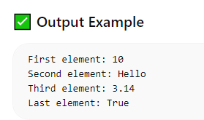

{Practical Examples}:-
  - Write a Python program to create a list of multiple data type elements.
my_list = [10, "Hello", 3.14, True]
print("List:", my_list)
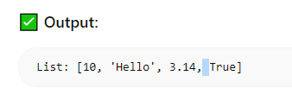
  - Write a Python program to find the length of a list using the len() function.
my_list = [10, "Hello", 3.14, True]
length = len(my_list)
print("Length of list:", length)
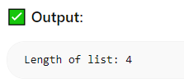

2.{List Operations Theory}:-
1• Common list operations: concatenation, repetition, membership.
* Concatenation:
It is used to join two or more lists using the + operator.
.It creates a new list containing elements of both lists.
* Repetition:
It is used to repeat elements of a list using the * operator.
. It duplicates the list a specified number of times.
* Membership:
It is used to check whether an element exists in a list using in or not in.
. It returns True or False.
2.Understanding list methods like append(), insert(), remove(), pop().
* append():
Adds an element at the end of the list.
* insert():
Adds an element at a specific position (index) in the list.
* remove():
Removes a specific element (value) from the list.
* pop():
Removes and returns the element from a specific index (default is last).

(Lab):-
1• Write a Python program to add elements to a list using insert() and append().
my_list = [10, 20, 30]
# append() → adds at end
my_list.append(40)
# insert() → adds at specific index
my_list.insert(1, 15)
print("Updated List:", my_list)
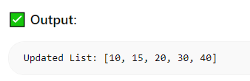
2• Write a Python program to remove elements from a list using pop() and remove().
my_list = [10, 20, 30, 40]
# remove() → removes by value
my_list.remove(20)
# pop() → removes by index (last by default)
my_list.pop()
print("Updated List:", my_list)
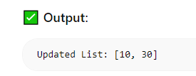

{Practical Examples}:-
3) Write a Python program to update a list using insert() and append().
my_list = ["Apple", "Banana"]
my_list.append("Mango") # add at end
my_list.insert(1, "Orange") # add at index 1
print("Updated List:", my_list)
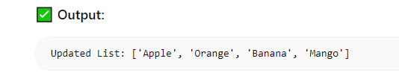

4) Write a Python program to remove elements from a list using pop() and remove().
my_list = ["Apple", "Banana", "Mango", "Orange"]
my_list.remove("Banana") # remove by value
my_list.pop(1) # remove by index
print("Updated List:", my_list)
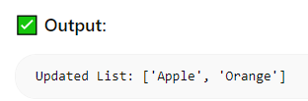

3.{Working with Lists}
(Theory):-
1• Iterating over a list using loops.
Iterating means traversing each element of a list one by one.
- It is commonly done using loops like for and while.
- The loop accesses each element and performs operations on it.
Example idea: using loop to print all elements

2• Sorting and reversing a list using sort(), sorted(), and reverse().
sort():
Sorts the original list in ascending order (changes the list itself).
sorted():
Returns a new sorted list without changing the original list.
reverse():
Reverses the order of elements in the list (modifies the original list).
3• Basic list manipulations: addition, deletion, updating, and slicing
Addition:
Adding elements using append () or insert ().
Deletion:
Removing elements using remove () or pop ().
Updating:
Changing values by assigning new values using index.
Slicing:
Accessing a range of elements using list [start end]
Lab:
• Write a Python program to iterate over a list using a for loop.
my_list = [10, 20, 30, 40]
for i in my_list:
print(i)
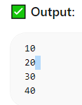
• Write a Python program to sort a list using both sort() and sorted().
my_list = [40, 10, 30, 20]
# using sort() → modifies original list
my_list.sort()
print("After sort():", my_list)
# using sorted() → returns new list
new_list = sorted(my_list)
print("After sorted():", new_list)
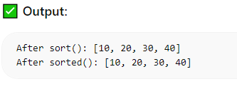

{Practical Examples}:-
5) Write a Python program to iterate through a list and print each element.
my_list = ["Apple", "Banana", "Mango"]
for item in my_list:
print(item)
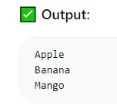
6) Write a Python program to insert elements into an empty list using a for loop and append().
my_list = []
for i in range(1, 6):
my_list.append(i)
print("List:", my_list)
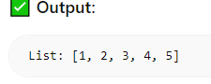

4.{Tuple Theory}:-
• Introduction to tuples, immutability.
A tuple is an ordered collection of elements, similar to a list.
Tuples are created using parentheses ( ).
Immutability:
Tuples are immutable, which means their elements cannot be changed, added, or removed after creation.
• Creating and accessing elements in a tuple.
- Tuples are created using ( ) with elements separated by commas.
- Elements are accessed using indexing, starting from 0.
Example idea: t = (10, 20, 30)
Access using index: t[0], t[1]

• Basic operations with tuples: concatenation, repetition, membership.
Concatenation:
Combining two tuples using the + operator.
Repetition:
Repeating a tuple using the * operator.
Membership:
Checking if an element exists using in or not in.

(Lab):-
1• Write a Python program to create a tuple with multiple data types.
my_tuple = (10, "Hello", 3.14, True)
print("Tuple:", my_tuple)
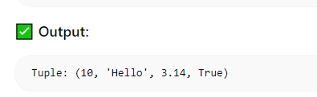
2 • Write a Python program to concatenate two tuples.
t1 = (1, 2, 3)
t2 = (4, 5, 6)
t3 = t1 + t2
print("Concatenated Tuple:", t3)
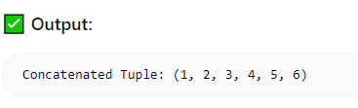
[Practical Examples]:-
7) Write a Python program to convert a list into a tuple.
my_list = [10, 20, 30]
my_tuple = tuple(my_list)
print("Tuple:", my_tuple)
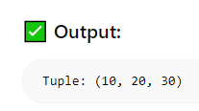

8) Write a Python program to create a tuple with multiple data types.
my_tuple = (10, "Hello", 3.14, True)
print("Tuple:", my_tuple)
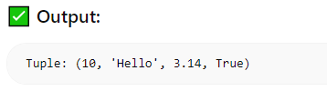
9) Write a Python program to concatenate two tuples into one.
t1 = ("A", "B")
t2 = ("C", "D")
result = t1 + t2
print("Result:", result)
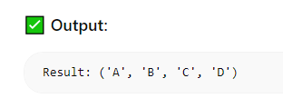
10) Write a Python program to access the value of the first index in a tuple.
t = (10, 20, 30, 40)
print("First element:", t[0])
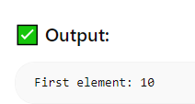
- (Accessing Tuples)
(Theory):-
1. Accessing tuple elements using positive and negative indexing
- Indexing is used to access elements in a tuple.
- Positive indexing:
Starts from the beginning (0, 1, 2, …)
Example: t[0] gives the first element
- Negative indexing:
Starts from the end (-1, -2, -3, …)
Example: t[-1] gives the last element
2.Slicing a tuple to access ranges of elements
Slicing is used to access a range of elements from a tuple.
It uses the format tuple[start:end].
.start is included
.end is excluded

{Lab}:-
1• Write a Python program to access values between index 1 and 5 in a tuple.
t = (10, 20, 30, 40, 50, 60, 70)
# Access from index 1 to 5
result = t[1:6]
print("Values:", result)
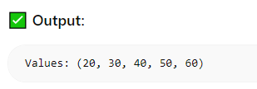
2• Write a Python program to access alternate values between index 1 and 5 in a tuple.
t = (10, 20, 30, 40, 50, 60, 70)
# Access alternate values (step = 2)
result = t[1:6:2]
print("Alternate Values:", result)
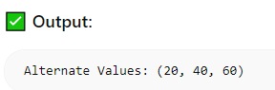
    - t[1:6] kya karta hai?
t = (10, 20, 30, 40, 50, 60, 70)
result = t[1:6]
Rule: t[start:end]
- start = include hota hai
- end = include nahi hota
Yaha:
- start = 1 → 20 se start
- end = 6 → 6 include nahi hoga
Step:
Index position:
Index: 0 1 2 3 4 5 6
Value: 10 20 30 40 50 60 70
t[1:6] → index 1 se 5 tak
Result:
(20, 30, 40, 50, 60)

📌 2. t[1:6:2] kya karta hai?
result = t[1:6:2]
Format: t[start:end:step]
- start = 1
- end = 6
- step = 2 (har 2nd element lo)

Step-by-step:
Start from index 1 → 20
+2 step → index 3 → 40
+2 step → index 5 → 60
Result:
(20, 40, 60)
Simple samajh
- t[1:6] → continuous values
- t[1:6:2] → gap chhod ke (alternate values)

Shortcut trick
- : → range
- ::2 → alternate
- ::3 → every 3rd element

{Practical Examples}:-
11) Write a Python program to access values between index 1 and 5 in a tuple.
t = (10, 20, 30, 40, 50, 60, 70)
result = t[1:6]
print("Values:", result)
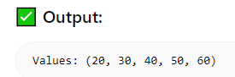
12) Write a Python program to access the value from the last index in a tuple.
t = (10, 20, 30, 40)
print("Last element:", t[-1])
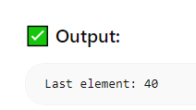

(6. Dictionaries):-
Theory: -
1• Introduction to dictionaries: key-value pairs.
A dictionary in Python is used to store data in key-value pairs.
- A key is like a name
- A value is the data of that name
Each key has its own value, and keys must be unique.
Data in a dictionary is written inside curly brackets {}.
We use keys to access values, not index numbers.
A dictionary is changeable (mutable), so we can update or modify it easily.

2• Accessing, adding, updating, and deleting dictionary elements.
- Accessing Elements:
Values in a dictionary are accessed using their keys, not by index.
- Adding Elements:
New elements are added by inserting a new key-value pair into the dictionary.
- Updating Elements:
Existing values can be changed by using the same key and assigning a new value to it.
- Deleting Elements:
**Elements can be removed from a dictionary by specifying their key.
A dictionary is mutable, which means its elements can be added, updated, or deleted easily.

3• Dictionary methods like keys(), values(), and items().
- keys():
This method returns all the keys present in the dictionary.
- values():
This method returns all the values stored in the dictionary.
- items():
This method returns all the elements as key-value pairs (in the form of tuples).
** These methods are used to easily access and work with the data stored in a dictionary.
(Lab):-
1• Write a Python program to create a dictionary with 6 key-value pairs.
d = {
"name": "Krrish",
"age": 18,
"city": "Ahmedabad",
"course": "Python",
"marks": 85,
"grade": "A"
}
print(d)
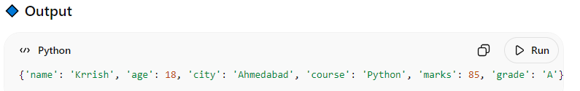
2• Write a Python program to access values using dictionary keys.
d = {
"name": "Krrish",
"age": 18,
"city": "Ahmedabad"
}
print(d["name"])
print(d["age"])
print(d["city"])
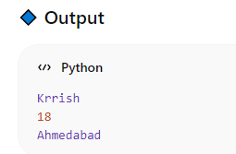

(Practical Examples):-
13) Write a Python program to create a dictionary of 6 key-value pairs.
d = {
"name": "Krrish",
"age": 18,
"city": "Ahmedabad",
"course": "Python",
"marks": 85,
"grade": "A"
}
print(d)
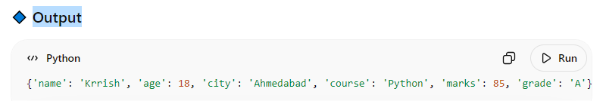
14) Write a Python program to access values using keys from a dictionary.
d = {
"student": "Rahul",
"roll_no": 101,
"subject": "Maths"
}
print(d["student"])
print(d["roll_no"])
print(d["subject"])
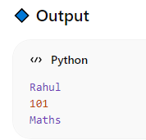
(7. Working with Dictionaries): -
(Theory): -
1• Iterating over a dictionary using loops.
Iterating over a dictionary means traversing through all its elements one by one using loops.
- A dictionary can be iterated using loops like for loops.
- When iterating, we can access:
  - keys of the dictionary
  - values of the dictionary
  - both key-value pairs together
- Iteration helps to process or display all elements in the dictionary.
** It is a simple and efficient way to work with all data stored in a dictionary.

2 • Merging two lists into a dictionary using loops or zip().
Merging two lists into a dictionary means:
One list is used as keys
Another list is used as values
- Using a loop:
We take elements one by one from both lists and make key-value pairs.
- Using zip():
It directly joins both lists and forms pairs of key and value.
This helps to convert two simple lists into one dictionary easily.

3• Counting occurrences of characters in a string using dictionaries.
Counting occurrences means:
. Finding how many times each character appears in a string.
- A dictionary is used to store characters as keys
- Their count (frequency) is stored as values
- We go through each character in the string
- If the character already exists, we increase its count
- If not, we add it with value 1
**This helps to easily count and store the frequency of each character.

{Lab}:-
1 • Write a Python program to update a value in a dictionary.
d = {
"name": "Rahul",
"age": 18,
"city": "Delhi"
}
# update value
d["age"] = 20
print(d)
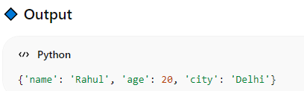

{Lab}:-
2• Write a Python program to merge two lists into one dictionary using a loop
keys = ["name", "age", "city"]
values = ["Rahul", 18, "Delhi"]
d = {}
for i in range(len(keys)):
d[keys[i]] = values[i]
print(d)
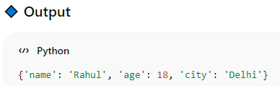

(Practical Examples):-
15) Write a Python program to update a value at a particular key in a dictionary.
d = {
"name": "Rahul",
"age": 18,
"city": "Delhi"
}
# update value at a particular key
d["city"] = "Mumbai"
print(d)
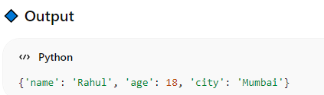

16) Write a Python program to separate keys and values from a dictionary using keys() and values() methods.
d = {
"name": "Rahul",
"age": 18,
"city": "Delhi"
}
# separate keys and values
keys = d.keys()
values = d.values()
print(keys)
print(values)
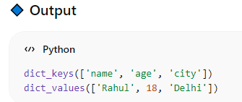
17) Write a Python program to convert two lists into one dictionary using a for loop.
list1 = ["name", "age", "city"]
list2 = ["Rahul", 18, "Delhi"]
d = {}
for i in range(len(list1)):
d[list1[i]] = list2[i]
print(d)
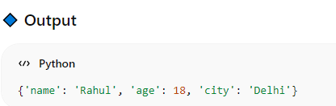
18) Write a Python program to count how many times each character appears in a string.
s = "hello"
d = {}
for ch in s:
if ch in d:
d[ch] += 1
else:
d[ch] = 1
print(d)
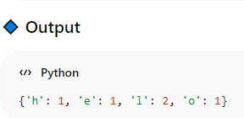

8. (Functions):-
{Theory}:-
1 • Defining functions in Python.
A function is a block of code used to perform a task.
- It is created using the def keyword
- It can take input (parameters)
- It can return a result
** Functions help to reuse code and make programs simple.

2• Different types of functions: with/without parameters, with/without return values.
Functions can be of different types:
- Without parameters & without return
Takes no input and does not return anything
- With parameters & without return
Takes input but does not return anything
- Without parameters & with return
Takes no input but returns a value
- With parameters & with return
Takes input and also returns a value
** These types help us use functions in different ways based on our needs.

3• Anonymous functions (lambda functions).
An anonymous function is a function without a name.
- It is created using the lambda keyword
- It is used for small and simple operations
- It can take any number of inputs but has only one expression
**Lambda functions are used when we need a quick, short function without defining it using def.

(Lab):- 1• Write a Python program to create a function that takes a string as input and prints it.
def show_text(text):
print(text)
show_text("Hello World")
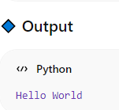
2• Write a Python program to create a calculator using functions.
def add(a, b):
return a + b
def sub(a, b):
return a - b
def mul(a, b):
return a * b
def div(a, b):
return a / b
# input
x = int(input("Enter first number: "))
y = int(input("Enter second number: "))
print("Addition:", add(x, y))
print("Subtraction:", sub(x, y))
print("Multiplication:", mul(x, y))
print("Division:", div(x, y))
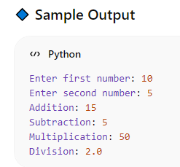
[Practical Examples]:-
19) Write a Python program to print a string using a function.
def show_message():
print("Welcome to Programming")
show_message()
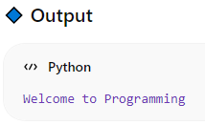
20) Write a Python program to create a parameterized function that takes two arguments and prints their sum.
def add_numbers(a, b):
print(a + b)
add_numbers(10, 5)
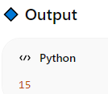
21) Write a Python program to create a lambda function with one expression.
square = lambda x: x * x
print(square(5))
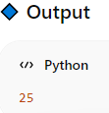
22) Write a Python program to create a lambda function with two expressions.
add = lambda a, b: a + b
print(add(10, 5))
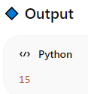

9.{Modules }:-
(Theory): -
1• Introduction to Python modules and importing modules.
A module is a file that contains code (functions, variables).
. It helps to reuse and organize code
. We use import to use a module in our program
. Modules make code simple and clean
2• Standard library modules: math, random.
** Standard Library Modules:
Python already provides some built-in modules.
- math → used for mathematical operations
- random → used to generate random values
3• Creating custom module
** Creating Custom Module:
- We can create our own module by writing code in a .py file
- This file can contain functions and variables
- Then we can import it in another program
(Lab):-
1• Write a Python program to import the math module and use functions like sqrt(), ceil(), floor().
import math
num = 25.3
print("Square root:", math.sqrt(num))
print("Ceil value:", math.ceil(num))
print("Floor value:", math.floor(num))
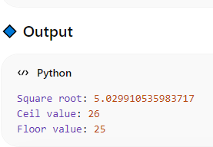
2• Write a Python program to generate random numbers using the random module.
import random
# generate random number
print("Random number (0-1):", random.random())
# generate random integer
print("Random integer (1-10):", random.randint(1, 10))
# choose random element
l = [10, 20, 30, 40]
print("Random choice:", random.choice(l))
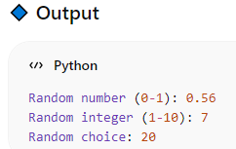
{Practical Examples}:-
23) Write a Python program to demonstrate the use of functions from the math module.
import math
num = 9
print("Square root:", math.sqrt(num))
print("Power:", math.pow(num, 2))
print("Factorial:", math.factorial(num))
print("Ceil value:", math.ceil(4.3))
print("Floor value:", math.floor(4.7))
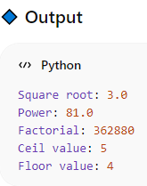
24) Write a Python program to generate random numbers between 1 and 100 using the random module.
import random
# generate random number between 1 and 100
num = random.randint(1, 100)
print("Random number:", num)
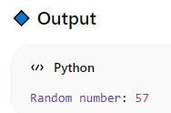

Module 8)

(Advance Python Programming): -
Printing on Screen
- Example 1: Printing Text
Theory:
1• Introduction to the print () function in Python.
The print() function in Python is used to display output on the screen.
It is one of the most commonly used functions in Python programming.
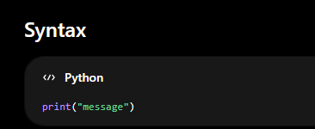

Purpose of print()
The print () function helps programmers:
- Display text
- Show numbers
- Print variable values
- Display program results

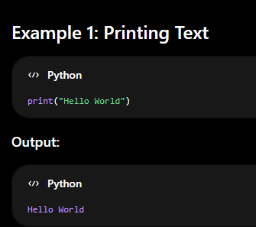

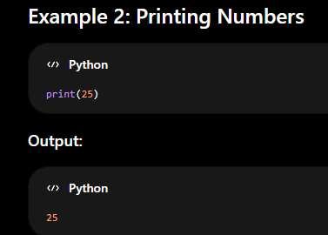

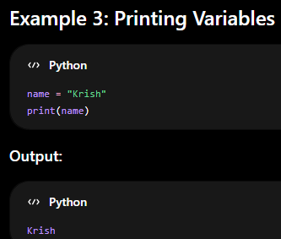

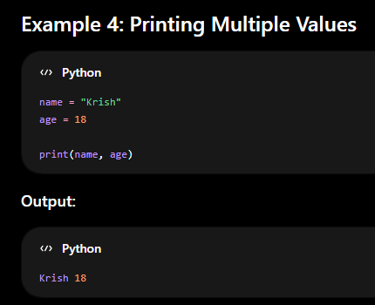

2 • Formatting outputs using f-strings and format ().
1. Using f-strings
f-strings allow variables to be placed directly inside a string.
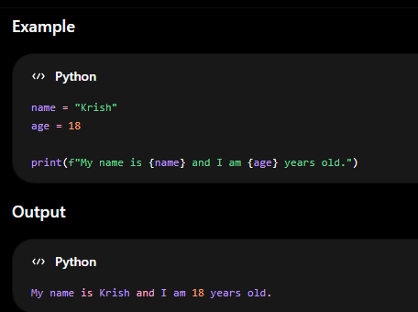
2. Using format () Method
The format () method inserts values into a string.
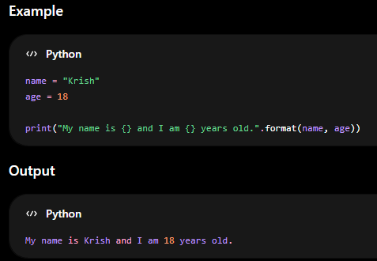
Lab:
• Write a Python program to print a formatted string using print() and f-string
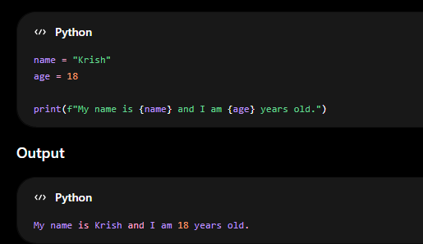

Practical Example:
  - Write a Python program to print “Hello, World!” on the screen.

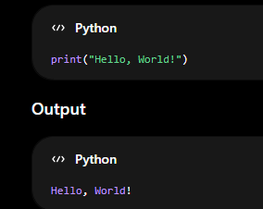

Reading Data from Keyboard
  - Theory:
1 • Using the input() function to read user input from the keyboard
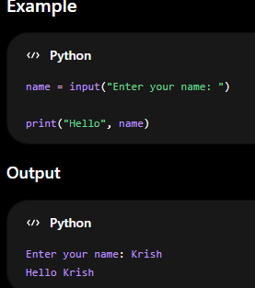
2• Converting user input into different data types (e.g., int, float, etc.).
By default, input() takes data as a string.
We use type conversion to change it into int, float, etc.
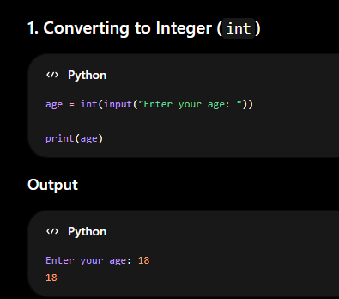
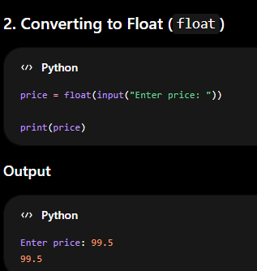

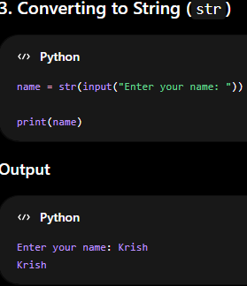

Lab:
• Write a Python program to read a name and age from the user and print a formatted output
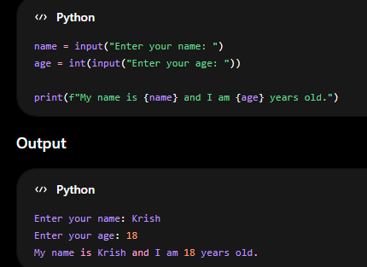
Practical Example:
2) Write a Python program to read a string, an integer, and a float from the keyboard and display them.
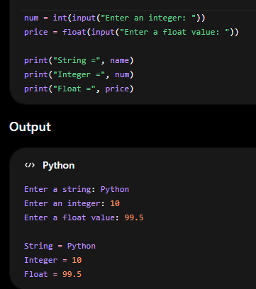
  - Opening and Closing Files
Theory:
1• Opening files in different modes ('r', 'w', 'a', 'r+', 'w+').
File Opening Modes in Python
Python uses the open() function to open files.
Syntax: 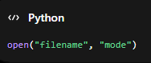

1. Read Mode ('r')
Used to read a file.
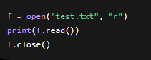
File must exist.
Default mode is 'r'.

2. Write Mode ('w')
Used to write data into a file.
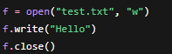
Creates file if it does not exist.
Old data gets deleted.

3. Append Mode ('a')
Used to add data at the end of a file.
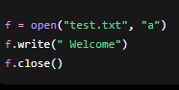
Old data remains safe.
New data is added at the end.

4. Read and Write Mode ('r+')
Used for both reading and writing.
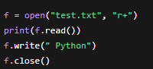
File must exist.
Allows both reading and writing.

5. Write and Read Mode ('w+')
Used for writing and reading.
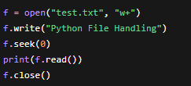
Creates file if it does not exist.
Old data is erased.

2• Using the open() function to create and access files.
• Closing files using close().
The open() function is used to create and access files in Python.
Syntax: 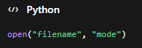
filename → name of the file
mode → operation mode (r, w, a, etc.)
Example: Creating and Writing to a File
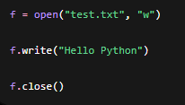
"w" mode creates the file.
write() stores data in the file.
*Accessing and Reading a File
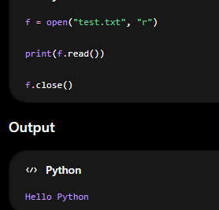

Closing Files using close()
The close() function is used to close the file after work is completed.
Example:
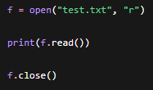
Why close() is Important
- Saves file changes properly
- Frees memory
- Prevents file corruption

Practical Example: 3)
Write a Python program to create a file and write a string into it.
