# Governance in a Decentralized Autonomous Organization.

**Is a DAO really effective without a coreteam?**By Charles Okaformbah/ @justcharlz

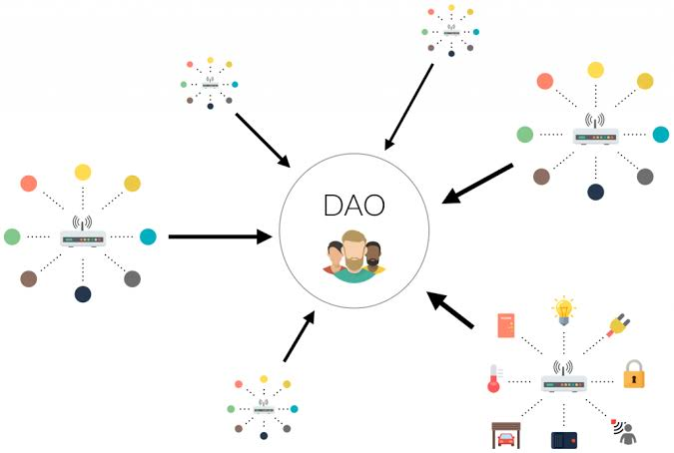  
*DAO image courtesy: Cryptocurrency Times*

*Let me start with a short story. It was a club with lots of teenagers and few adults that were once like us. They weren’t being accountable to us because they felt we don’t matter and they control the club’s resources. We endured until after 3years when we had to elect new leaders and guess what, it was payback time. We’d nominate 1 adult and 1 teenage for each role then gave the teenagers all our votes leaving the adults disappointed. It felt good to embarrass them that way before they left the club. But what if there was a way we do not have to endure their misgivings for 3 years and still maintain the resources of our club whereby we can fork our club away from their control? Would a DAO governance structure serve such purpose where there is no central control? Of course, if we had a clause in our by-law(Smart Contract) that states that with a vote of no-confidence on the leaders supported by majority of the club members calling for a new election, leadership change would be an easy and frequent process. Governance is the central piece of a DAO.*

Decentralized Autonomous Organizations are entities or ventures that operate based on Smart Contracts or executable programs/protocols. Mostly created on the Ethereum Network due to its Smart Contract capability, the DAO has no conventional management structure and its codes are open source. A Decentralized Autonomous form of governance confers privileges and right to vote or form consensus regarding critical decisions on its members that might not be geographically concentrated, who are obligated to participate actively in the decision making process of the organization. Unlike democracy where executive powers and decisions are conferred on certain people, a DAO takes everyone into consideration without granting executive powers to anyone to run the affairs of the organization. The Bitcoin network is the first DAO-structured entity and has proved that a DAO form of governance could really work in a virtual economy but how effective can this be in the real world. Can legacy organizations and powerful corporations running government and our world be built on a DAO? An experiment to discuss for another day.

## A DAO without a CoreTeam?

*Errm!* I don’t see the possibility but governance/final decision always lies on the community. A DAO’s smart contract does not give birth to its self. It is created by a team that majorly serves as the spearhead or guide to what the organization instead doing. I have been privileged to work in both worlds; a centrally govern organization where decisions were made by the company’s executives but finality rest on the owner of the company thereby making the company’s executives stupid for wasting their time but still getting paid. This also show the influence Satoshi Nakamoto would have had on Bitcoin community and its success if the governance of the system was centralized thereby affecting adoption negatively. Currently, the Bitcoin network runs without a central control but core-team of developers who dedicate themselves to its development. The system also purges itself of distractors who try to run a centralize governance/idea regarding the network, by consensus voting through its fork design which showcases the power of opensource software mixed with a community of believers/users that is made up of Miners, Exchangers, Wallet Developers, Users and a whole lot of interest. The Bitcoin Foundation which is an NGO was also formed to promote the development and structure of the Bitcoin Network and it is being funded by organizations benefiting from the network through grants.

Another DAO-like project worthy of note is Ethereum. This has steered controversy and argument in the blockchain community; if Ethereum is truly operating a central governance structure or being run by Vitalik Buterin and the other core developers who babysitter the tech and are still actively participating in the protocol development and Fork schedules implementation, then fork upgrades won’t be an issue as all node users and projects under the Network would have no say. Recently, Constantinople was delayed after a bug was found on the Ethereum Improvement Proposal and so everyone had to wait for another date. Does this mean that governance of the system lies on the select few? Nope! Governance still lies on the community of users which includes the Block producers, exchanges, wallet developers, individual users and the developers itself. All these form the governance structure as all needs to be in agreement else a chain split, though with the migration from the current Proof of Work to Proof of Stake, the Ethereum Network discourages splitting of the chain.

Let’s also look at Dash DAO; an organization that is self-funding, open to anyone and has no central governing entity recently [acquired Dash Core Group, the legal entity for Dash’s Development team](https://www.dash.org/forum/threadds/dash-core-group-becomes-first-legally-dao-owned-entity.29452/), to help in furthering the development and use of DASH. This goes to also proves that a DAO without a core-team can’t really work without some element of central control to serve as day to day running outfit. A unique feature of the Dash DAO is the control of funds as this is controlled by the voting privileged users who approve proposal/projects and the needed funding to execute such proposal/project.

The most important element in a DAO-structured Organization is the governance especially the control of Finance. Just like the name implies “Decentralized Autonomous Organization”, it’s decentralized without any central control but needs a structure of governance that rewards or penalizes actions.

## Is DAICO The Future of DAO Funding?

The advent of ICO and its misuse by scammers and teams gave rise to various decentralized project funding platforms and alternative funding structures that ensure the teams/founders don’t run away with contributed funds and that the project remains on track. One of such structure is “DAICO” as suggested by Vitalik Buterin which stands for Decentralized Autonomous Initial Coin Offering; an amalgamation of DAO and ICO.

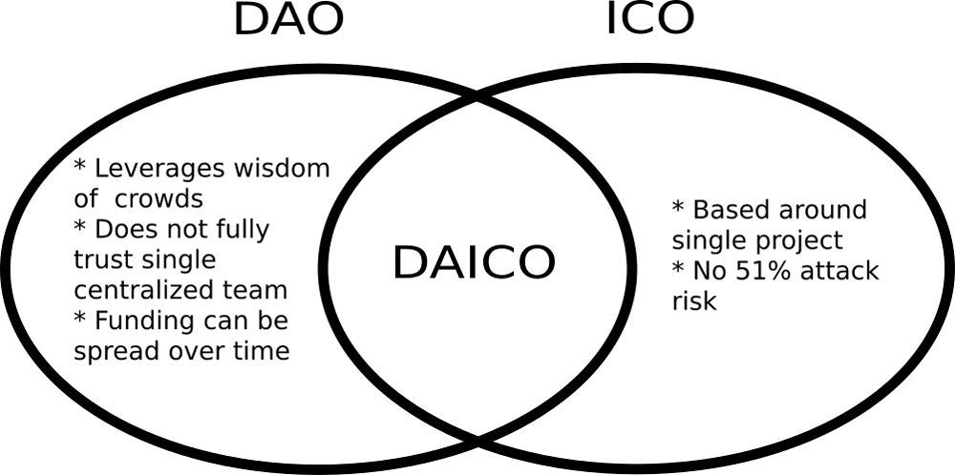  
*image of DAICO*

Based on Vitalik’s idea;

*The idea is as follow. A DAICO contract is published by a single development team that wishes to raise funds for a project. The DAICO contract starts off in “contribution mode”, specifying a mechanism by which anyone can contribute ETH to the contract and get tokens in exchange. This could be a capped sale, an uncapped sale, a dutch auction, an interactive coin offering, a KYC’d sale with dynamic per-person caps or whatever other mechanism the team chooses. Once the contribution period ends, the ability to contribute ETH stops and the initial token balances are set; from there on the tokens can become tradeable. After contribution period, the contract has one major state variable: tap(units: wei/sec), initializes to zero. The tap determines the amount per second that the development team can take out of the contract.*

With this structure, teams can withdraw ether from the Smart Contract that holds the funds raised from crowdsale. Once the project does not seem to do well, contributors can withdraw their remaining funds. So far, some teams are adopting this structure like [Abyss team](https://www.coindesk.com/vitalik-new-idea-icos-tested?amp) but with some little structural change and improvement.

## Are there any demerits to the DAO Governance structure?

Yep! A DAO structured organization is not at all perfect and can even lead to a naturally death when funding becomes an issue. Some of the demerits are in the decision making process which is super slow and frustrating. By the very nature of a DAO venture or structured organization, decision making has to be based on consensus/votes by a significant number of the stakeholders involve in order to form a quorum or for the final decision to be valid. If this is not achieved as at when due, projects/proposals get delayed and the team/individual putting forward the proposal gets frustrated especially when it is a time-based proposal.

Apathy during voting and decision making is another demerit of a DAO. If no well thought-out game theory that puts all participants in check, ensuring that those who fail to participate actively are penalized, it is as good as running a centralized organization because decisions will majorly be voted by a few thereby making it a lopsided organization where few works for the majority to reap its benefit. However, this could actually be avoided by rewarding those who engage actively and penalizing those who remain docile in the system.

Another issue to look at is the legal status of a DAO. Since nobody owns the organization, what happens to it in the outside world away from the digital economy? Who can be sued and who sues if such a case arises or in the case of liquidating a tangible asset owned by the DAO, what rules are to be followed.

## Conclusion

Looking at the features of a DAO which leverages on the knowledge of the crowd, does not trust centralized team and can spread funding overtime with the opportunity presented by ICO crowdfunding on the blockchain via the use of cryptocurrencies, teams and backers of such project can both have control on the outcome of the project. Governance is based on consensus by the eligible contributors but before a DAO gets to this stage, the open source Smart Contract or protocol which contains all the rules that would govern the organization needs to be put in place and what other way to do this than having funds systematically released to the core-team developing such rules/program. I am not that good at conclusions and summary but I think you get the point I am making. ☺