**OVERVIEW-**

**Title- JUSTIN**

**Type of Application**- Android Application

**What does this Application---**

* In this application user can login in single panel and specify their role by checking box, whether he or she is volunteer as student or service provider. According to them, this application provide different functionalities.
* Service Provider—can provide pick-up and drop facilities or provide the accommodation.
* Volunteer--- can meet user personally or guide them through phone about new places and things, he or she needs to survive.
* Students or Immigrants—can login and access the service, provide by volunteer. Service providers can get their pay through this application.

**Compitition—**AirBnB, Quora

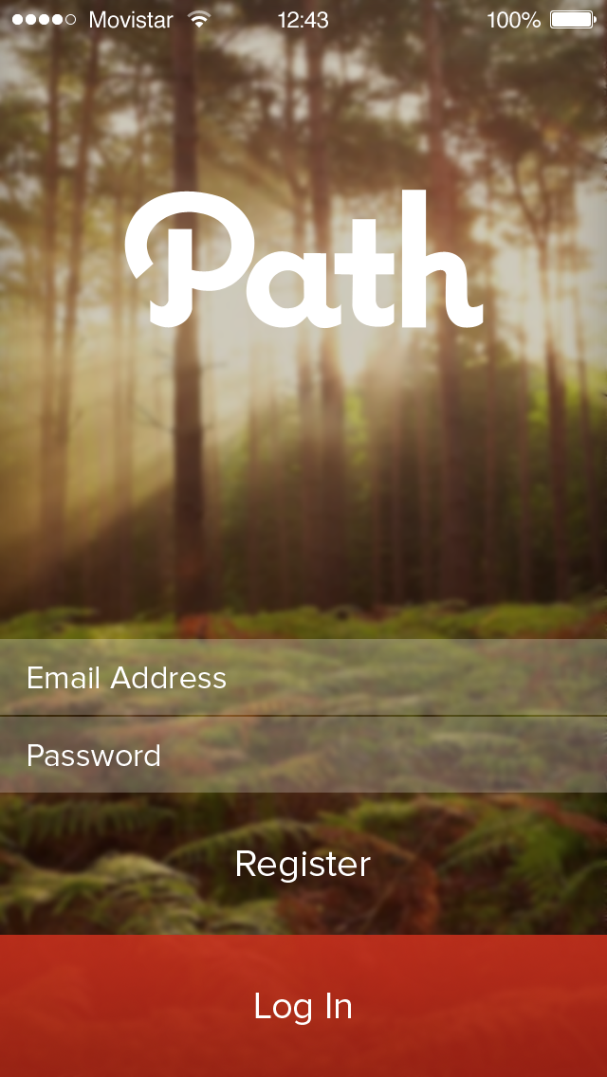

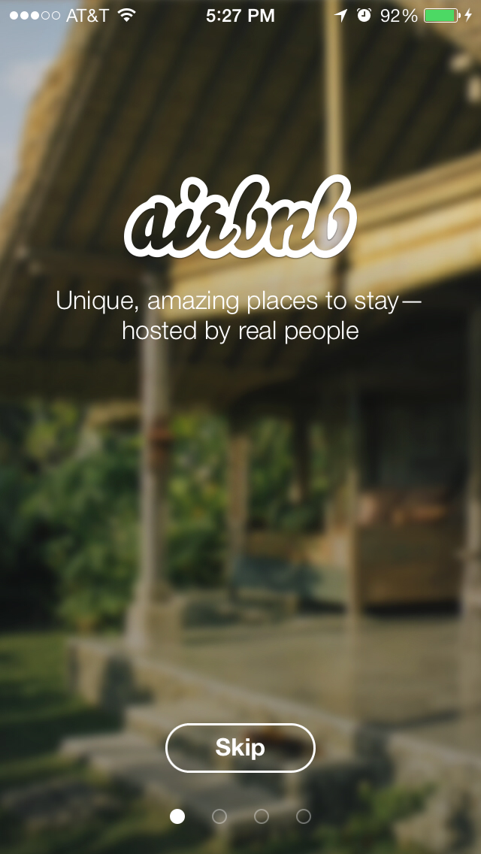

**Target Audience—**

International Students and Immigrants —

* Students visit to other countries to study there, but they faces my problems regarding pick-up and accommodation, so with this application, they can get help.
* Sometimes people migrates from one country to other country and they do not know about the process of migration. So they can get help from the volunteers.

**Tools--**

Balsamiq

Justin Mind

Adobe XD

Adobe Photoshop

**Features---**

Purely concentrated on immigrants and provide all the basic needs to user.

1. Accomodation
2. Guidance
3. Answer of Queries

In this application, immigrants can discuss their problem with other users and get their views.

**This application has following pages—**

* Login
* Sign Up
* Post Advertisements
* Search Posts
* View Posts
* Write or Share problems

**Admin—**

* Access to all users
* Access to advertisements and payment done by service providers.
* Access to post made by users.
* Admin can track all the activities done by users

**Timeline**

|  |  |
| --- | --- |
| **Process** | **Delivery** |
| Planning,Research /Outreach | 1-2 weeks |
| Design, Consultation | 2-6 weeks |
| Development | Up to 8 weeks |
| Testing/ Launch | 2-3 weeks |

**Expence**

|  |  |  |  |  |  |  |
| --- | --- | --- | --- | --- | --- | --- |
| **Name** | | | **Price** | **Qty** | | **Subtotal** |
| Planning,Research /Outreach | | | $300.00 | 1 | | $300.00 |
| Design, Consultation | | | $600.00 | 1 | | $600.00 |
| Development | | | $2000.00 | 1 | | $2000.00 |
|  | | | | Subtotal | | $2900.00 |
| Tax1(7.5%) | | $217.00 |
| Total | | $3117.50 |
| **TEAM GROUP 04** | | | | |
| S.NO | ID | NAME | | |
| **1** | **1892867** | **KRISHAN SINGH** | | |
| **2** | **1894040** | **PARMINDER KAUR** | | |
| **3** | **1893498** | **VEERPAL KAUR VIRK** | | |