Design and Real World Evaluation of Motivational
Techniques for Blind & Low Vision Exercise
Kyle Rector¹, Roger Vilardaga¹, Leo Lansky¹, Kellie Lu², Cynthia L. Bennett¹,
Richard E. Ladner¹, Julie A. Kientz¹
¹DUB Group | University of Washington  Seattle, WA 98195  {rectorky, ladner}@cs.washington.edu, {vilardag, llansky, bennec3, jkientz}@uw.edu | ²Columbia University  New York, NY 10027  kellielu@gmail.com

ABSTRACT

People who are blind or low-vision may have a harder time participating in exercise classes due to inaccessibility, travel difficulties, or lack of encouragement. Accessible exergames have the potential to provide a convenient and safe environment in which to exercise, while receiving the positive benefits of fitness. Several accessible exergames have been developed and evaluated over 1-2 lab sessions. However, the potential of these exergames has yet to be evaluated over a longer study period in real world settings. To this end, we have designed and developed Eyes-Free Yoga as a fully functioning exergame with four full workouts and motivational techniques. We ran an 8-week deployment study in the homes of four people who are blind or low-vision. We found that participants used the game throughout the study period and the motivational techniques enhanced their exercise experience. The findings of this work have implications for designing exergames for the blind.

Author Keywords
Accessibility; video games; exergames; visual impairments; Kinect; motivation; deployment; eyes-free; audio feedback; yoga; health.

ACM Classification Keywords
K.4.2 [Computers and Security]: Social Issues – Assistive technologies for persons with disabilities, H.5.2 [Information Interfaces and Presentation]: User Interfaces.

INTRODUCTION
A number of barriers can prevent people who are blind or low-vision from exercising, including inaccessibility, travel difficulties, or lack of encouragement [30, 32, 34]. There is a lack of access to recreational and athletic programs [30] and a lack of help or encouragement in developing physical recreating skills from people in general [34] or parents [36]. In addition, class instructors often do not know how to adapt their classes for the blind [33]. These barriers can have a negative impact on physical activity for people who are blind or low-vision; they are more likely to be obese than their sighted counterparts [4, 39]. Having the ability to exercise independently can mitigate the barriers above to allow broader access to the positive benefits of exercise.
One recent trend to increase independent exercise for people who are blind or low-vision is through the development of exergames, or exercise games. Several exergames have been developed for the blind: VI-Tennis [23], VI-Bowling [24], Pet-N-Punch [25], and Eyes-Free Yoga [32]. These systems have provided positive benefits to independent blind exercise, including physical exertion, enjoyment, and knowledge of performance. These systems have demonstrated a potential for eyes-free exergames. One common denominator, however, is that the evaluation of these systems have all occurred in lab settings with 1-2 sessions. Studying the feasibility and motivating factors of an accessible exergame system used over a longer term in real world settings can further demonstrate their potential.
To this end, we have designed and developed Eyes-Free Yoga as a fully functional exergame (built upon the prototype in [32]) and conducted an 8-week deployment study of our system in the homes of four visually impaired participants. Our system provides four full yoga workouts with descriptive audio instructions. The close collaboration with yoga instructors has made Eyes-Free Yoga a system that can introduce the sport of yoga in an accessible and independent setting. We developed and evaluated three motivational techniques over an 8-week study. The results suggest that participants were motivated to use the system throughout the entire study period as measured in minutes per day, and the motivational techniques enhanced their exercise experience.
There are several contributions to this work. First, we developed a fully-featured exergame accessible to the blind that is feasible for in-home use for an extended period. Second, we learned how our motivational techniques can enhance exergame play. Finally, our work provides insights on what factors accessible exergames can include to motivate continued exercise for the blind.

Background and Related work

Persuasive Technologies
One aspect of exercise technologies well-studied in the HCI community is how to persuade people to continue toward their exercise goals. According to Fogg [12], there are three different functional roles that a persuasive technology can take: 1) a tool to increase capability, 2) a medium that provides an experience, or 3) a social actor that creates a relationship. Some existing tools to promote exercise include Fitbit, Jawbone’s UP, and Houston [6]. Fitness tools can make a user’s target behavior easier to achieve by presenting relevant measurements using numbers or other visual stimuli. Choe et al. found that positive framing of numerical information can impact one’s self-efficacy to complete their goal [5]. A few examples that provide a medium are UbiFit [7], Fish’n’Steps [19], or GoalPost/GoalLine [28]. These provide an experience of growing a garden, fish, or trophy case, with the growth reflecting their fitness level. Persuasive technologies that act as social actors include UbiFit [7], larklife, relational agent interface (named Laura) [1], and the mobile lifestyle coach [14]. Each of these systems provides coaching support and rewards for positive feedback, such as a happy face for completing activities.
Finally, Fritz et al. found users that wore wearable fitness trackers found benefits as a tool reporting numbers and as a social actor when providing rewards and social networking capabilities over from participants using tools anywhere from 3-54 months [13]. We designed Eyes-Free Yoga to be a persuasive technology that uses non-visual techniques to serve as a tool to lower the barrier to practice yoga through sound-based posture guidance. In addition, we designed the system to be a social actor that provides positive feedback through words of encouragement and musical awards.

Exergames
Researchers have evaluated the use of exergames in deployment studies to assess exergame potential and health outcomes. For example, Uzor et al. found after a 12-week study with older adults, there was better adherence to the exergame than standard care, which demonstrated potential for real world use [37]. In addition, Kosse et al. conducted a 6-week evaluation with the elderly with the goal of improving their balance, which was successful using the Berg Balance Scale [18]. Like both of these systems, we hope to learn the potential Eyes-Free Yoga may have in real world use by assessing usage in minutes per day, self-efficacy, mindfulness, and physical activity enjoyment. We also employed advised techniques to make Eyes-Free Yoga persuasive such as providing a selection of workouts [9], virtual rewards for physical activity [2] and antecedent stimuli [1] by informing participants how close they were to earning badges or advancing to the next level.

Accessible Exergames
The space of accessible games or exergames is a young field in both research and practice. There are three possible phases during gameplay in which a disability can have a negative impact: 1) receiving stimuli, 2) determining a response, and 3) providing input to the game [41]. For the visually impaired, the problem occurs with the first phase since most stimuli in video games are visual [23]. Blind Hero is an accessible game that uses a glove to transmit haptic feedback to a player [40]. While there are efforts in research on video game accessibility, this problem is not solved when generalizing to mainstream video games [31].
The accessibility community has recognized accessible exergaming for the visually impaired as a research problem [22]. Two strong efforts from the research community are the creation of accessible alternatives to Wii Sports games, VI-Bowling [24] and VI-Tennis [23]. Morelli et al. completed a careful analysis of primary (or necessary) visual cues used in Wii Sports Bowling and Tennis and converted them to audio feedback from the speakers or tactile feedback from the Wii Remote. VI-Tennis was evaluated with children who had better scores and enjoyment with the accessible version. VI-Bowling, evaluated with adults, was found to be enjoyable and a sufficient challenge. Morelli et al. developed a solution using sensory substitution to make Kinect games accessible to for eyes-free interactions [26].
Instead of making an existing game accessible, researchers have invented exergames, including Pet-N-Punch [25]. This game, which uses the Wii remote and nunchuck, encourages exercise in the upper body with auditory and tactile feedback. The player has to hit rodents and pet cats at a farm. The researchers measured energy expenditure and scores and found participants were able to achieve light to moderate exercise. They also found participants comparing scores to one another after the completion of the study.
Eyes-Free Yoga is also an original game, as opposed to an existing game modification. While energy expenditure is useful for assessing the effectiveness, our measures of success are over the long term, including minutes of exercise per day, self-efficacy, mindfulness, and physical activity enjoyment. Finally, to our knowledge, this is the first deployment study of an accessible exergame for the blind.

Eyes-Free yoga design
Eyes-Free Yoga is designed to be a yoga exergame accessible to people who are blind or low-vision by providing auditory-only instructions and feedback. This is built upon previous work [31] that uses the Kinect platform to guide players through six different yoga poses and provides feedback on how to correct their position. It is an engaging experience with yoga music and confirmation tones as a player would fix their yoga pose. These characteristics are strategies for systems that direct human action [15]. The original Eyes-Free Yoga followed six principles in its design: accessible, yogic, encourages confidence, targeted to novices, accessibility features do not compromise learning, and encourages a challenging workout. The full details of the initial implementation are described in [32].
We have expanded on this design significantly to move it from a lab setting to the real world as a fully functional system designed for long-term engagement with new postures, four full workouts, and motivational techniques that can be used without assistance from researchers. This section describes the new version and its additional features.

Eyes-Free Yoga Hardware and Software
The Eyes-Free Yoga prototype consists of a suite of hardware: 1) Windows laptop, 2) Microsoft Kinect for Windows, and 3) External speakers. In addition to default programs, the laptops had Windows 8.1, Kinect for Windows Toolkit, Python, NonVisual Desktop Access (NVDA), and the Eyes-Free Yoga custom software installed. We saved five Rich Text Format (rtf) files to the Desktop containing transcripts of the audio instructions for Workouts 1-4 and computer instructions to use NVDA and Eyes-Free Yoga. Eyes-Free Yoga appeared as a shortcut on the desktop so users could quickly access the program. We configured the laptops to automatically login and start the screen reader so blind users are able to work without assistance. Users interact with the system using NVDA screen reader. To simplify use, they only had to navigate the desktop and within RTF files if they were open.
Workout 1 (26 min)  - Cat/Cow Pose  - Child’s Pose  - Downward Dog Pose  - Downward Dog Flow  - Standing Forward Fold  - Standing Forward Flow  - Mountain Pose | Workout 2 (40 min)  - Lower Back Release  - Thread the Needle Pose  - Bridge Pose  - Bridge Flow  - Happy Baby  - Bound Angle Pose  - Reclined Twist  - Corpse Pose
Workout 3 (67 min)  - Mountain Pose  - Warrior I Pose  - Warrior II Pose  - Reverse Warrior Pose  - Tree Pose  - Chair Pose  - Standing Forward Fold  - Downward Dog Pose  - Plank Pose  - Cobra Pose  - Reclined Twist  - Corpse Pose | Workout 4 (80 min)  - Cat/Cow Pose  - Child’s Pose  - Downward Dog Pose  - Downward Dog Flow  - Plank Pose  - Chair Pose  - Standing Forward Fold  - Tree Pose  - Warrior I Pose  - Warrior II Pose  - Reverse Warrior Pose  - Bridge Pose  - Happy Baby  - Bound Angle Pose  - Reclined Twist  - Corpse Pose
Table 1. Pose sequence of the four different workouts.

Eyes-Free Yoga contains four workouts of varying length (see Table 1). The four sequences eand the verbal scripts describing each pos, were developed in consultation with one yoga instructor to ensure a properly designed workout that provided variety [9]. All standing poses have custom corrections, based on a technique described in [32] that uses the Kinect to detect body posture and provide verbal corrections and audio-based feedback when the pose is correct..

Eyes-Free motivational techniques
In addition to providing an accessible alternative to yoga that is suitable for the home, we were interested in motivating users begin to practice yoga and sustain their practice over a longer period of time. This corresponds to Fogg’s Behavior Grid as a “Green Path” behavior, which is doing a new behavior from now on This path suggests to: #1) couple the trigger with an existing habit, #2) increase one’s self-efficacy by making the behavior easier to do, and #3) reduce demotivation by making the behavior more familiar. However, standard motivational techniques in persuasive technologies are many times visual, and thus we had to design motivational techniques to be accessible. We developed auditory reminders (fulfills #1) and musical levels and audio badges (fulfills #2 and #3) specifically designed to be suitable for people who were blind or low vision:
- Musical reminders: Ten minutes before a person prefers to exercise, the computer plays the first background music track as a reminder to exercise. The system asks the user to choose a time they would prefer to exercise, similar to creating a habit as in [35].
- Musical levels: As a person advances to the next level, they hear water sounds with increasing power in addition to the background music (see Table 2). This conveys a sense of progress. Participants spent 1.5x as long as they did in the previous level.
Level # | # Minutes spent in level | Background Water
1 | 30 | None
2 | 45 | Water drops
3 | 67.5 | Creek
4 | 101.25 | Stream
5 | 151.875 | Lake
6 | 227.8125 | Rapids
7 | 341.71875 | Sea
8 | Until end of study | Ocean
Table 2. Level progression of Eyes-Free Yoga. Participants spent 1.5x longer in each level.

- Musical achievements: We developed three different types of musical achievements, or badges, that one could receive while exercising:
Performance Badge: A person needs to achieve the posture specified by the system for at least 50% of the standing postures and complete the full workout. If the workout had no standing postures, they still needed to complete the workout.
Endurance Badge: For each workout, the person needs to exercise for a minimum required amount of time.
Consistency Badge: A person needs to earn three endurance badges within one calendar week.
These three badges all have a distinct musical sound. Players can visit their badges by visiting the “Trophy Case.” The trophy case announces the number of badges earned and plays the respective sounds. To keep people motivated and knowledgeable during the workout, the system announces when they had less than five minutes to receive an endurance or consistency badge. While it is possible that these motivational techniques may not be compatible with yoga, we hoped that the accessible techniques would provide more information and encouragement during exercise.

We developed the musical levels and achievements in conjunction with Eyes-Free Yoga in Microsoft Visual Studio with C#. They were implemented behind a flag so users would only hear them if the motivational techniques option was enabled. We implemented musical reminders with Microsoft’s Task Scheduler by running Windows Media Player with background music at specified dates and times.

Eyes-Free yoga deployment Study Design
We conducted an 8-week in-home deployment study of Eyes-Free Yoga with four people with visual impairments. Below, we discuss the study procedure and participants.

Procedure
We designed the deployment study to be 8 weeks in duration where participants used it under two conditions:
- Baseline – Participants used the system as described in “Eyes-Free Yoga Design.”
- Treatment – Participants used the Baseline system and also had the motivational techniques described in “Eyes-Free Motivational Techniques” enabled.
We conducted a sequential single case experimental study using randomization tests [16]. We chose this study design because it provides internal validity even for a small number of participants [10], which is useful for difficult to recruit populations such as those with disabilities. It is also an agile method that has been recommended to evaluate technologies for behavior change [38]. To increase statistical power, we conducted an ABAB study design, where A is Baseline and B is Treatment. Given the requirements of randomization tests, the length of each A and B phase were determined at random prior to the beginning of each single case experiment [16], with a constraint that each A and B phase was at least 7 days so participants could experience each condition. The number of measurements for each single case experiment was 56, which allowed a total of 4495 random arrangements and hence a minimum p value of 2.22 × 10e-4. In this study, the primary outcome measure was the number of minutes per day of exercise. We hypothesized that the motivational features would encourage them to workout more, as well as increase their self-efficacy, mindfulness, and enjoyment.
The study began with an in-person meeting. Researchers conducted an audio-recorded interview consisting of questions about demographics and their background with exercise, yoga, and exercise technology. We scheduled two future phone interviews and one in-person meeting, depending on each individual’s ABAB randomized sequence. We installed the equipment in their home and supervised while the participants familiarized themselves with the system.
The researchers set up the participants’ preferred NVDA settings including voice, volume, and speed. The participant navigated the Desktop using NVDA and then opened and listened to the computer instructions. The participant started Eyes-Free Yoga and used it until they had just begun Workout 1 and exited the system. Upon leaving, we told the participant that they were able to use or not use the system and pick Workouts 1-4 whenever they would like.
Participants first used the system in phase A, or Baseline. After every workout, the system sent participants an email to complete a survey where they could answer questions about self-efficacy, mindfulness, and physical activity enjoyment. They could also give text-based feedback and report any issues. Within the last 1-3 days of Baseline phase A, we conducted the first phone interview and asked questions about their experience using the system, whether they would recommend it to others, and their exercise habits.
Participants then used the system in phase B, or Treatment. Participants completed the same three surveys as in phase A. Within the last 1-3 days of Treatment phase B, we conducted the second phone interview where we asked the same questions as the first phone interview, in addition to their experiences with the three motivational techniques. The participants then completed another phase A and B before completing the study. At the end of the study, we collected the equipment and conducted a final interview. We included questions asked in both phone interviews in addition to asking how participants felt when the Treatment was removed and added back in again.
To ensure that Eyes-Free Yoga was running reliably and data collection was robust, each laptop used a python script and Windows Task Scheduler to send a daily email containing Eyes-Free Yoga usage logs to the researchers. If a problem arose with Eyes-Free Yoga, researchers also had access to the laptops via remote desktop.
The surveys that were emailed after every workout inquired about self-efficacy (“I feel that I am able to complete my exercise goal for the week, Rate your degree of confidence by recording a number from 0 to 100, where 0 = Cannot do at all, 50 = Moderately certain can do, and 100 = Highly certain can do”), mindfulness [11], and physical activity enjoyment [17]. To make the surveys a manageable length, we took four questions from the mindfulness scale that had the highest factor loading: “It’s easy for me to keep track of my thoughts and feelings,” “I am able to accept the thoughts and feelings I have,” “I am able to focus on the present moment,” and “I am able to pay close attention to one thing for a long period of time.” We completed the same for the physical activity enjoyment scale (PACES) where people chose values in a range between two opinions: “It’s very exhilarating … It’s not at all exhilarating,” “It’s very gratifying … It’s not at all gratifying,” “It’s very pleasant … It’s not at all pleasant,” and “It’s very refreshing … It’s not at all refreshing.”

Participants
 |  | P1 | P2 | P3 | P4
Minutes | SMD  p-value | -0.325  0.174 | 0.495  0.162 | -0.304  0.240 | 0.375  0.302
Self-efficacy | SMD  p-value | 0.041  0.988 | 0.137  0.208 | NaN  0.236 | 0.495  0.500
Mindfulness | SMD  p-value | -0.200  0.788 | 0.170  0.648 | -0.578  0.755 | -1.761  0.464
Enjoyment | SMD  p-value | 0.090  0.867 | 0.1450.752 | 0.728  0.836 | ∞  0.125
Table 4. Standardized Mean Difference and p-values for each outcome between phases.
 | P1 | P2 | P3 | P4 | Pooled | Meta-analysis of RTS
Minutes  (%) | -38.3 | 50.2 | -31 | -57.3 | 9.55 | p=.024*
Self-efficacy (%) | 1 | 33.7 | 1.69 | 17.91 | 2.38 | p=.315
Mindfulness (%) | 1 | -5.4 | 15.1 | 22.7 | 8.35 | p=.865
Enjoyment (%) | 2.9 | -2.5 | 15.67 | 1.2 | 4.32 | p=.836
Table 3. Percentage of change for each outcome between phases, pooled % changes and results of meta-analysis of RTs. Mindfulness and Enjoyment increase as the score decreases, so we calculated a % decrease as positive.

We initially recruited 6 participants for our study, but due to varying circumstances, 2 of them had to drop from the study before they could complete the first A Baseline phase. Thus, we had 4 total participants complete the Eyes-Free Yoga deployment study. There were 3 females and 1 male, 2 were totally blind since birth, 1 could see some light and bright colors up close, and 1 was blind in one eye and low-vision in the other. They ranged in age from 29 to 54 years, with an average age of 43.5. Their professions consisted of postdoctoral fellow, unemployed, collections representative, and retired. The participants varied in yoga experience, from no experience, one class, a few classes, and several classes in the past. Three participants had never tried exergames, and one had tried Wii Sports in the past.

Ideally, we would prefer to conduct a study with more participants, but there were several constraints that made 4 participants an achievable number. We only recruited participants who were blind or low-vision, within one hour of travel from the researchers, interested in learning yoga, not traveling for at least two weeks consecutively, willing to have a Microsoft Kinect in their household, and willing to have two phone calls and two in-person visits with 1-2 researchers. As a result, we conducted the sequential single case experimental study using randomization tests to increase our statistical power given our constraints.
We recruited participants through email lists for people who are blind or low-vision. We conducted the study at each person’s residence, consisting of several study sessions: 1-2 hours for the initial visit, 15-30 minutes per phone call, and 30 minutes to 1 hour for the final visit. We compensated participants $50 for each 1/3 of the study and another $50 upon completion of the study for a total of $200. All four participants completed all of the steps of the study.

results

Quantitative results
We gathered quantitative data throughout the study via system usage logs and surveys on self-efficacy, mindfulness, and physical activity enjoyment completed after each workout. We found that number of minutes exercised per day by all four participants pooled together increased in Treatment (see Table 5). In addition, the motivational techniques enhanced Eyes-Free Yoga.

Minutes Exercised Per Day
The four participants practiced yoga between the Baseline and Treatment conditions consistently throughout the study. For each participant, Standardized Mean Differences between phases (SMD) were not statistically significant (see Table 4). However, the pooled % of change between phases (see Table 5) suggests an overall percentage increase in number of minutes practiced per day (9.55), and a meta-analysis of these SCDs [29] suggests that this difference was statistically significant (p = 0.024). Figure 1 and Figure 4 show the usage patterns for each particiant, with possible external factors that may have affected usage.

Self-Efficacy
The self-efficacy for P1, P2, and P4 was higher in the Treatment condition than the Baseline Condition, but these differences were not statistically significant (see Table 4). P3 had almost zero variability, thus mean differences were unreliable (see Table 4). Figure 2 shows the reported self-efficacy throughout the study. As seen in Table 5, P2 and P4 had a 33.7% and 17.91% increase in self-efficacy between conditions.
Interestingly, for P2 there was a small reduction in self-efficacy the first time they progress from Baseline to Treatment and a big jump the second time around. In addition, P2 experienced more stable levels of self-efficacy in Treatment than in Baseline. The trimmed range of scores was narrower for B1 and B2 than for A1 and A2 (see Figure 3). P4’s self-efficacy increased over the study duration (see Figure 2d, highest scores obtained towards the end of Treatment).

Mindfulness
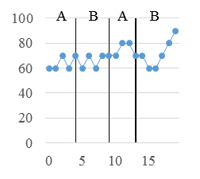 | 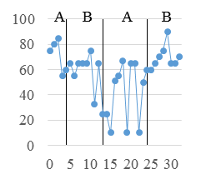 | 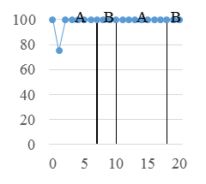 | 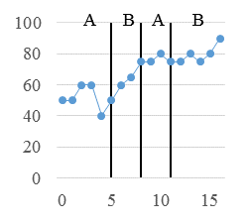
a) | b) | c) | d)
Figure 2. Self-Efficacy of P1 (a), P2 (b), P3 (c), and P4 (d). Workout # is on the x-axis and reported self-efficacy is on the y-axis. Scores range from 0 (low self-efficacy) to 100 (high self-efficacy).
Scores range from

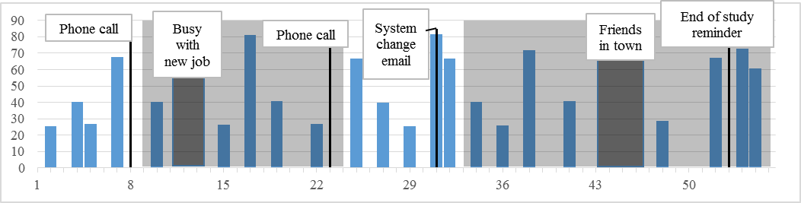
a) P1 usage chart over the 8 week study period. There was a 6 day vacation between days 10 and 11.
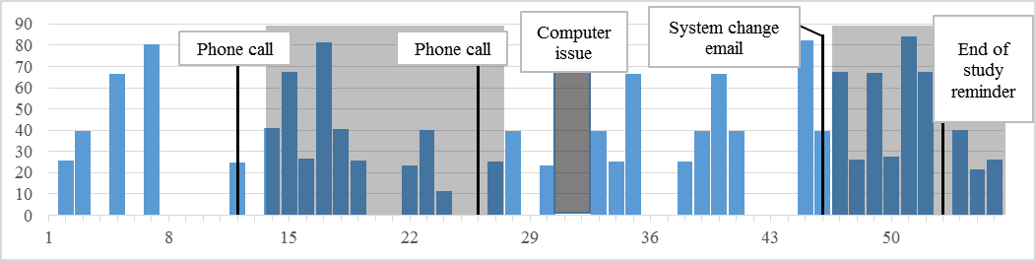
b) P2 usage chart over the 8 week study period. There was a 13 day vacation between days 10 and 11.
Figure 1. Usage of P1 and P2 over the 8-week deployment. Day # is on the x-axis and # minutes exercised is on the y-axis. Baseline has a white background, while Treatment has a shaded background.
P1, P3, and P4’s scores for mindfulness decreased from Baseline to Treatment, where a lower score is better (see Table 5). Furthermore, P3 and P4’s mindfulness has a downward trend throughout the study duration (see Figure 5). However, these differences were not statistically significant (see Table 4). P2 had a 5.4% increase in mindfulness from Baseline to Treatment, but the difference was not statistically significant (see ct, P2’s mindfulness varied throughout the study (see Figure 5).
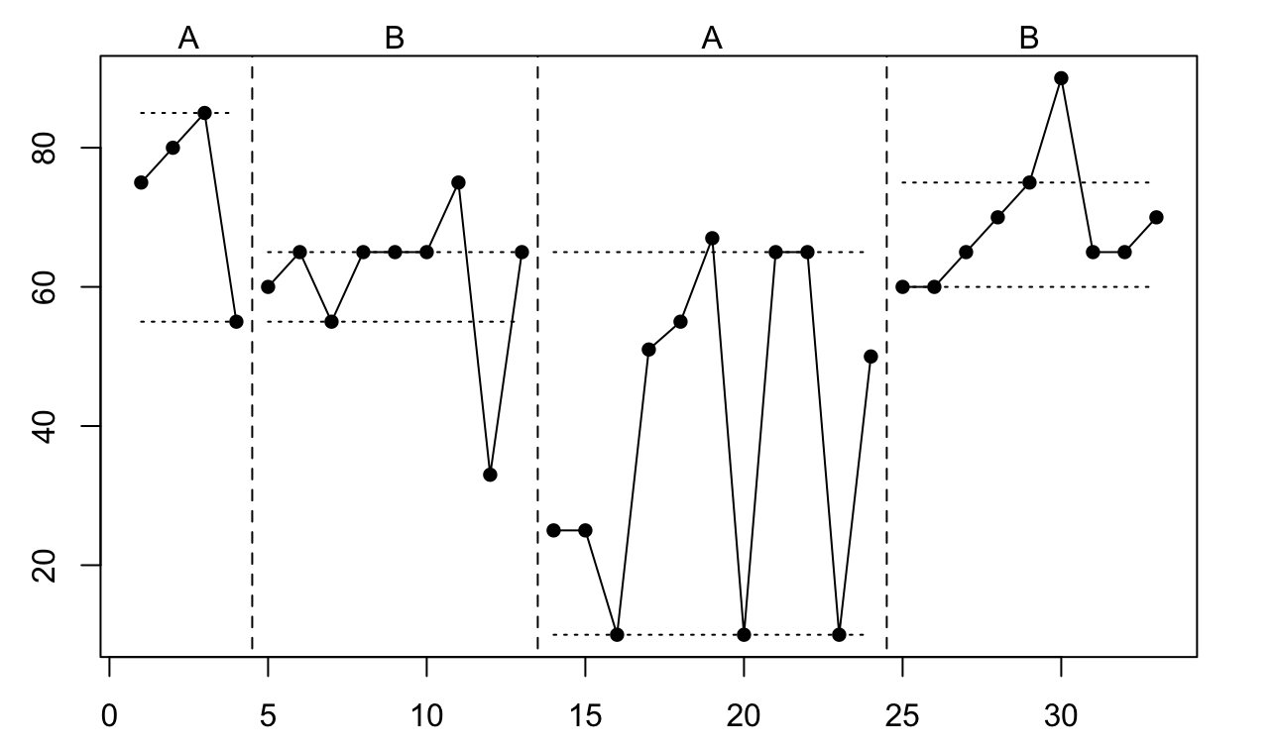
Figure 3. P3 Self-Efficacy zoomed in on results, with trimmed range. Workout # is on the x-axis and reported self-efficacy is on the y-axis.

Physical Activity Enjoyment
Similarly to mindfulness, P1, P3, and P4’s scores for the Physical Activity Enjoyment Scale (PACES) decreased from Baseline to Treatment, where a lower score is better (see Table 5). These differences were not statistically significant (see Table 4). P2 had an overall increase of 2.5% from Baseline to Treatment, but the difference was not statistically significant (see Table 4).
As Table 5 shows, secondary outcomes were measured with less frequency (3 times per week, as opposed to 7 times per week), and therefore randomization tests had reduced statistical power to detect differences between phases. This might explain why despite overall increases in self-efficacy, mindfulness, and enjoyment in the expected direction, a meta-analysis of these outcomes did not reach statistical significance. Statistical significance also depends on the effect size of the manipulation (Treatment), so it is also possible that larger effect size could have led to statistically significant results.
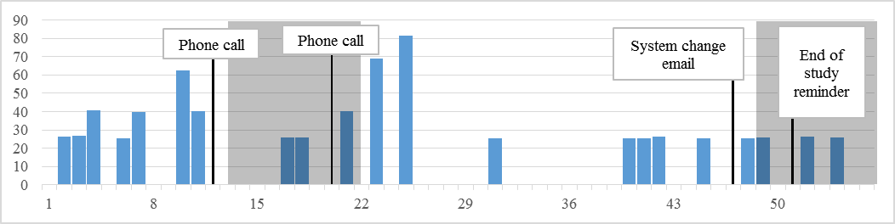
c) P3 usage chart over the 8 week study period.
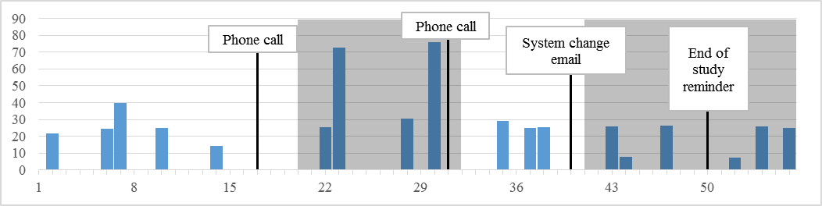
d) P4 usage chart over the 8 week study period.
Figure 4. Usage of P3 and P4 over the 8 week deployment. Day # is on the x-axis and # minutes exercised is on the y-axis. Baseline has a white background, while Treatment has a shaded background.

Qualitative results
We gathered qualitative data throughout the study with four interviews and the surveys completed after each workout. The participants gave explicit reasons for why they enjoyed the system and why the system helped them.

Benefits of Eyes-Free Motivational Techniques
While the motivational techniques did not necessarily change the behavior of each participant’s exercise habits (see Table 5), they enhanced Eyes-Free Yoga.
The auditory badges were the most noticed and well-received feature from when they were introduced: I noticed the earning badges is something new so that’s really cool (P3). In particular, people enjoyed the anticipation of getting the badges during the workouts: I’m curious when I’m going to get the next badge (P2). Providing more information about when a participant would receive a badge provided enjoyment during the game: I liked hearing that I was about to get an endurance badge (P1), and: That was cool. I liked that. It tells you "you have five minutes before you earn a certain badge" (P3). This confirms the persuasive element of antecedent feedback mention in [1].
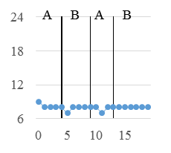 | 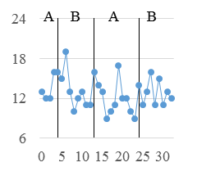 | 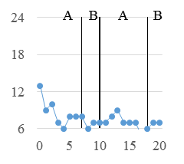 | 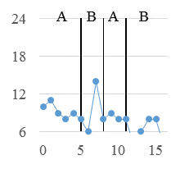
a) | b) | c) | d)
Figure 5. Mindfulness of P1 (a), P2 (b), P3 (c), and P4 (d). Workout # is on the x-axis and reported mindfulness is on the y-axis. Scores range from 6 (most mindful) to 24 (least mindful).

The musical levels were added as extra background noise and were not as noticeable by the majority of participants. P3, however, favored the levels during gameplay: I noticed another sound was added to the music. So I thought it was a good addition. As P3 progressed through the levels, they continued to report positive feedback about the background water: I thought that was cool, it sounded like a mini lake or something. Finally, P3 was interested in integrating different sounds into the game: Possibly drums, Native American type of music, or they could choose the type of music. Overall, this feature may be of benefit to players and so it should be an option for gameplay.
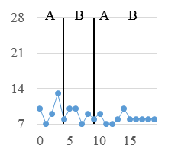 | 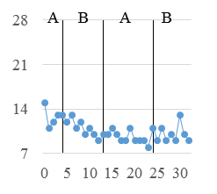 | 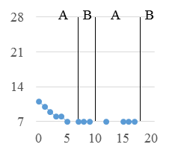 | 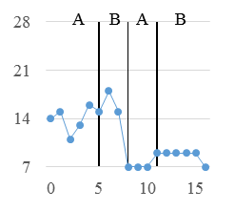
a) | b) | c) | d)
Figure 6. Physical Activity Enjoyment Scale (PACES) of P1 (a), P2 (b), P3 (c), and P4 (d). Workout # is on the x-axis and reported PACES on the y-axis. Scores range from 7 (most enjoyment) to 24 (least enjoyment).

The auditory reminders did not serve their intended purpose, but P1 and P2 found this feature helpful. For instance: Establishing certain times of day was more helpful (P1). P3 would have the computer quiet until playing, and so the musical reminder creates the mood for playing. Overall, participants found that they did not need the musical reminders, because they either made the decision that I’d done the routine for the day or I wouldn’t for the day (P2).
Overall, the motivational techniques enhanced gameplay. When participants were asked how they felt when these features were removed, they took notice: It was a little disappointing to not have the musical achievements (P1), and Kind of bland. It was just more mechanical. Once they were added it added so much more to it and it seemed empty (P3). In addition, P2: definitely noticed that they were gone. Once you get used to them being there, they’re part of your internal clock. Interestingly, this corresponds with P2’s higher stability of self-efficacy in Treatment (see Figure 3) than in A2, when Treatment was removed.
As the motivational techniques were added back to the system, P2 emphasized their impact: They made the whole experience better. It just reminded me that I was in the process of the whole game. It also kind of reminded me to trigger in my head of what to do tomorrow and what I did today. P3 added: It was just a better experience.

Increase in Exercise
Two of the four participants used Eyes-Free Yoga as a gateway to exercise on a regular basis (P1, P4). Participants were asked before and during the study about their current exercise level using the exercise stages of change [21]. Two participants had been exercising regularly for more than 6 months (“maintenance phase” [21]), while one participant had intentions within the next 6 months (“contemplation phase” [21]), and within the next 30 days (preparation phase). By the end of the study, the latter two participants had been maintaining a regular exercise regimen and were in the “action phase.” P1 had moved from the preparation phase to the action phase and said this at the end of the study: I feel like I’ve gotten stronger.

Yoga Comprehension and Enjoyment
Because the participants had the ability to use Eyes-Free Yoga over the 8-week study period, they were able to gain a better understanding of and appreciation for yoga. Yoga can provide a balance between relaxation and physical challenge. For instance: I like the meditation times and quiet my brain and concentrate on breathing (P2), while on the other hand: Its good practice for balancing and a form of exercise and it’s good that it’s challenging (P4). P1 expressed that they learned more about yoga as the study progressed: By the last times I was getting better because I was getting different feedback. I felt like I must've learned something. In addition, P1 achieved their highest levels of self-efficacy at the end of the study (see Figure 3). P3 found a benefit from using Eyes-Free Yoga throughout the study: Now the more I do it, it’s more natural. I would say more at ease, or more relaxed. This corresponds well with the fact that P3’s mindfulness score improved throughout the study (see Figure 5).

Reasons for Motivation
We found that regardless of motivational techniques, participants chose to use the system. There were several reasons for using Eyes-Free Yoga, including enjoying the four different routines: I’ve been able to learn the routine and anticipate what’s coming next and refine the poses a little bit (P1). P2 also favored the use of routines: I enjoyed the fact that there were four different routines. Some at night when I wanted to relax or stretch and the other ones for more of a strenuous workout. I incorporated into my other workouts.
Another reason for adhering to the system was the accessible feedback: I like the feedback. … It’s definitely something that I can participate in and use easily and feel like I can learn it and it’s easy to comprehend (P3) and: It does have good instruction about the poses. As a blind person it was very accessible in that way (P4).

Factors that Affect Study Data
While participants were enthusiastic to use the system, there were also factors that made using the system a challenge. For example, P1 started a new job and had to figure out their new schedule: A little harder for me to stay motivated because I’m working full time. I have to really convince myself to do it. Another reason was a warmer summer: I feel fatigued so I try not to play when it’s really hot (P1), and: It was also pretty hot (P4).
Another factor pertained to the conundrum of yoga also being a game, as identified by P1 and P2. Despite this, they enjoyed the experience: I don’t usually think of yoga as being a video game. A different way of thinking about it, but I realized it can be kind of fun (P1), and: Don’t get caught up, doing it just to acquire virtual accomplishment. Nonetheless, I liked when I got the accomplishments (P2). In addition, P2 had one experience where they felt they did not deserve a badge: Not sure I deserved a Performance badge today; I was shaking, wobbling, and grimacing all over the place (P2).

Eyes-Free Yoga as a Motivator for the Blind
Eyes-Free Yoga as a system may have provided motivation due to the benefits particular to people who are blind or low-vision. P2 found that Eyes-Free Yoga provided a safe environment to learn yoga: It’s interesting and a good way for someone to demystify it in privacy with as little or as much as they want. Especially for someone like me that’s blind. When you're in a room with other people you wonder if you're the short thumb, so there’s a little sense of being awkward especially when you're doing something like this.
Another benefit to Eyes-Free Yoga are the detailed descriptions that are accessible to blind players, which addresses the fact that exercise instructors do not know how to communicate with the blind [33]: I’ve always wondered what yoga was like and how to do the actual positions but I just never had the opportunity to me or learn the movements or have them described. So if someone was interested in doing yoga on their own, I would recommend it (P3).

Discussion & conclusion
Because participants had the opportunity in both the Baseline and Treatment conditions to learn yoga in an accessible way in the privacy of their own home, this may have affected use in both conditions. In other words, the effect of the motivational techniques may have been mitigated due to the system itself being an intrinsic motivator.
While Eyes-Free Yoga may motivate more in-home exercise for the blind, this may not translate to yoga classes. For instance, P1 felt that Eyes-Free Yoga made exercise more convenient: I don’t have that much free time. I haven’t a found a place to go yet to exercise since we moved here. P2 also expressed similar concern: I feel like I know more of the poses, and that’s less intimidating. But how willing am I to get to a place? The game is not solving other issues. P4 mentioned money as a factor to use Eyes-Free Yoga over a yoga class: For me the taking public classes are usually about having the money. While attending yoga classes can be beneficial, we found that developing a system for in-home exercise can be a viable solution, similar to developing exergames for older adults [20].
The participants of this study have expressed interest in using the system again: It is definitely something I would want to invest in when it became available (P1), I made it a part of my day to day routine (P2) and If I had the opportunity again I would probably try it (P4). One participant plans to purchase a yoga cd set, P4 has added new exercises: The system got me to stretch more, and squats.
We carefully chose our study design, but we identify limitations in this approach. Most notably, our experiment was comparing a Baseline and Treatment, with a Baseline condition that was powerful to begin with: introducing yoga in an accessible format. It may be possible that we did not see differences in mindfulness, self-efficacy, and physical activity enjoyment that were statistically significant due to the fact that the sport of yoga itself may be directly involved. With consistent use of the system throughout the study and positive qualitative feedback, we confirm that our system has potential for long-term use and that the motivational techniques can be a positive, though not required, option for players.
We have developed an accessible exergame, Eyes-Free Yoga, which contains four yoga workouts, custom feedback, and motivational techniques. We have shown through an 8-week in-home evaluation with four people who are blind or low-vision that the game itself motivated use throughout the study and that the motivational techniques can be a good option to enhance the exercise. In contrast to yoga classes, Eyes-Free Yoga provides an accessible solution where people who are blind or low-vision can learn in a safe environment independently. Based on the results of our study, we plan to make Eyes-Free Yoga widely available and to provide general insights on deployments of exergames for the blind.

REFERENCES
- Adams, M.A., Marshall, S.J., Dillon, L., Caparosa, S., Ramirez, E., Phillips, J., Normal, G.J. A theory-based framework for evaluating exergames as persuasive technology. Persuasive 2009 (2009), 45:1 – 45:8.
- Berkovsky, S., Coombe, M., Freyne, J., Bhandari, D., Baghei, N. Physical activity motivating games: virtual rewards for real activity. CHI 2010 (2010), 243-252.
- Bickmore, T.W., Caruso, L., Clough-Gorr, K. Acceptance and usability of a relational agent interface by urban older adults. Ext. Abstracts CHI 2005 (2005), 1212-1215.
- Capella-McDonnall, M. The need for health promotion for adults who are visually impaired. Journal of Visual Impairment and Blindness 101, 3 (2007), 133-145.
- Choe, E.K., Lee, B., Munson, S., Pratt, W., Kientz, J.A. Persuasive Performance Feedback: The Effect of Framing on Self-Efficacy. AMIA 2013, 825-833.
- Consolvo, S., Everitt, K., Smith, I., Landay, J.A. Design requirements for technologies that encourage physical activity. CHI 2006 (2006), 457-466.
- Consolvo, S., et al. Activity sensing in the wild: a field trial of ubifit garden CHI 2008 (2008), 1797-1806.
- Dallery, J, Cassidy, R.N., Raiff, B.R. Single-case experimental designs to evaluate novel technology-based health interventions. Journal of Medical Internet Research 15, 2 (2013), 1-17.
- Doyle, J., Daniel, K., Caulfield, B. Design considerations in therapeutic exergaming. Pervasive Health 2011, IEEE (2011), 389-393.
- Dugard, P. Randomization tests: A new gold standard? Journal of Contextual Behavioral Science 3, 1 (2014) 65-68.
- Feldman, G., Hayes, A., Kumar, S., Greeson, J., Laurenceau, J-P. The development and initial validation of the cognitive and affective mindfulness scale-revised (CAMS-R). Journal of Psychopathology and Behavioral Assessment 29, 3 (2007), 177-190.
- Fogg, B.J. Persuasive Technology: Using Computers to Change What We Think and Do. Morgan Kaufmann, New York, NY, USA, 2003.
- Fritz, T., Huang, E.M., Murphy, G.C., Zimmerman, T. Persuasive technology in the real world: a study of long-term use of activity sensing devices for fitness. CHI 2014 (2014), 487-496.
- Gasser, R., Brodbeck, D., Degen, M., Luthiger, J., Wyss, R., Reichlin, S. Persuasiveness of a mobile lifestyle coaching application using social facilitation. Persuasive Technology 2006 (2006), 27-38.
- Heer, J., Good, N., Ramirez, A., Davis, M., Mankoff, J. Presiding over accidents: system direction of human action. CHI 2004 (2004), 463-470.
- Heyvaert, M., Onghena, P. Randomization tests for single-case experiments: State of the art, state of the science, and state of the application. Journal of Contextual Behavioral Science 3, 1 (2014), 51–64.
- Kendzierski, D., DeCarlo, K.J. Physical Activity Enjoyment Scale: Two validation studies. Journal of Sport & Exercise Psychology 13, 1 (1991), 50-64.
- Kosse, N.M., Caliouw, S.R., Vuijk, P-J, Lamouth, C.JC. Exergaming: Interactive balance training in healthy community-dwelling older adults. Journal of Cyber Therapy and Rehabilitation 4, (2011), 399-407.
- Lin, J.J., Mamykina, L., Lindtner, S., Delajoux, G., Strub, H.B. Fish’n’Steps: Encouraging physical activity with an interactive computer game. UbiComp 2006 (2006), 261-278.
- Liu, Z., Liao, C., and Choe, P. An Approach of Indoor Exercise: Kinect-Based Video Game for Elderly People. CCD 2014 (2014), 193-200.
- Marcus, B.H., Selby, V.C., Niaura, R.S., Rossi, J.S. Self-efficacy and the stages of exercise behavior change. Research Quarterly for Exercise and Sport 63, (1992), 60-66.
- Morelli, A. Haptic/Audio based exergaming for visually impaired individuals. SIGACCESS Newsletter 96, (2010), 50-53.
- Morelli, T., Foley, J., Columna, L., Lieberman, L., Folmer, E. VI-Tennis: a Vibrotactile/Audio Exergame for Players who are Visually Impaired. FDG 2010 (2010), 147-154.
- Morelli, T., Foley, J., Columna, L., Lieberman, L., Folmer, E. VI-Tennis: a Vibrotactile/Audio Exergame for Players who are Visually Impaired. FDG 2010 (2010), 147-154.
- Morelli, T., Foley, J., Folmer, E. Vi-bowling: A Tactile Spatial Exergame for Individuals with Visual Impairments. ASSETS 2010 (2010), 179-186.
- Morelli, T., Foley, J., Lieberman, L., Folmer, E. Pet-N-Punch: upper body tactile/audio exergame to engage children with visual impairments into physical activity. Graphics Interface 2011 (2011), 223-230.
- Morelli, T., Folmer, E. Real-time sensory substitution to enable players who are blind to play video games using whole body gestures. FDG 2011 (2011), 83-90.
- Munson, S.A., Consolvo, S. Exploring goal-setting, rewards, self-monitoring, and sharing to motivate physical activity. Pervasive Health 2012, IEEE (2012), 25-32.
- Onghena, P., Edgington, E. S. Customization of Pain Treatments: Single-Case Design and Analysis. The Clinical Journal of Pain 21, 1 (2005), 56–68.
- Ponchillia, P.E. ACCESSPORTS: A model for adapting mainstream sports activities for individuals with visual impairments. RE:view, 27, 1 (1995), 5–15.
- Porter, J.R., Kientz, J.A. An empirical study of issues and barriers to mainstream video game accessibility. ASSETS 2013 (2013), 3-10.
- Rector, K., Bennett, C.L., Kientz, J.A. Eyes-Free Yoga: An Exergame Using Depth Cameras for Blind & Low Vision Exercise. ASSETS 2013 (2013), 12:1-12:8.
- Rimmer, J.H. Building Inclusive Activity Communities for People with Vision Loss. Journal of Visual Impairment & Blindness 100, suppl (2006), 863-865.
- Sherrill, C., Rainbolt, W., Ervin, S. Physical recreation of blind adults: Present practices and childhood memories. Journal of Visual Impairment & Blindness, 78, 8 (1984), 367–368.
- Stawarz, K., Cox, A.L., Blandford, A. Don't forget your pill!: designing effective medication reminder apps that support users' daily routines. CHI 2014 (2014), 2269-2278.
- Stuart, M.E., Lieberman, L., Hand, K.E. Beliefs about physical activity among children who are visually impaired and their parents. Journal of Visual Impairment & Blindness, 100, 4 (2006), 223-234.
- Uzor, S., Baillie, L. Investigating the long-term use of exergames in the home with elderly fallers. CHI 2014, ACM Press (2014), 2813-2822.
- Vilardaga, R., B. Bricker, J., G. McDonell, M. The promise of mobile technologies and single case designs for the study of individuals in their natural environment. Journal of Contextual Behavioral Science 3, 2 (2014) 148–153.
- Weil, E., Wachterman, M., McCarthy, E.P., Davis, R.B., O’Day, B., Iezzoni, L.I., Wee C.C. Obesity among adults with disabling conditions. Journal of the American Medical Association 288, 10 (2002), 1265-1268.
- Yuan, B., Folmer, E. Blind hero: enabling guitar hero for the visually impaired. ASSETS 2008, ACM Press (2008), 169-176.
- Yuan, B., Folmer, E., Harris Jr, F.C. Game accessibility: a survey. Universal Access in the Information Society 10, 1 (2011), 81-100.

http://www.fitbit.com/
https://jawbone.com/up#up24
http://lark.com/products/lark/expert-coaching
http://www.behaviorwizard.org/wp/behavior-grid/
Workout 1: 20 minutes, Workout 2: 30 minutes, Workout 3: 45 minutes, Workout 4: 60 minutes.

