GATHERED

Event & Attendee
Management System
Project Report

Stack: HTML, CSS, vanilla JavaScript, Node.js, Express, SQLite
Architecture: Single-page application frontend with REST API backend
Database: SQLite using better-sqlite3

1. Introduction
The Event & Attendee Management System is a web application for creating events and managing registrations. It provides a simple workflow for event organizers to define an event, set its capacity, register attendees, search guest records, and remove records when necessary.
The application uses a single-page frontend. Users begin at a homepage and choose one of two workflows:
- Manage events - create gatherings, set capacity, view upcoming events, and delete events.
- Register attendees - add guests, search the guest list, filter by event, and delete attendee records.
View changes happen with JavaScript, so the browser does not reload while moving through the application or submitting forms.

2. Objectives
- Create and list events.
- Register attendees to a selected event.
- Maintain a one-to-many event-to-attendee relationship.
- Search attendees by name and filter by event.
- Delete attendees and events.
- Reject invalid, duplicate, and over-capacity registrations.
- Provide clear HTTP status codes and error messages.
- Update the page dynamically using Fetch API calls.

3. Technologies Used
Technology | Purpose
HTML5 | Semantic page structure and forms
CSS3 | Responsive visual design and workflow screens
JavaScript | SPA navigation, validation, Fetch calls, and DOM rendering
Node.js | Backend JavaScript runtime
Express | REST API and static frontend server
SQLite | Local relational database
better-sqlite3 | Synchronous SQLite driver for Node.js

4. Project Structure
.
├── server.js
├── package.json
├── package-lock.json
├── events.db
├── README.md
├── REPORT.md
├── Event_Attendee_Management_Report.docx
├── report-home.png
├── report-events.png
├── report-attendees.png
└── public/
├── index.html
├── style.css
└── app.js
The events.db file is created automatically when the server starts. The three PNG files are screenshots captured from the running website and embedded in this report.

5. User Interface and Complete Flow

5.1 Homepage
The homepage introduces the application and gives the user two clear choices. This keeps the interface focused instead of displaying every form at the same time.
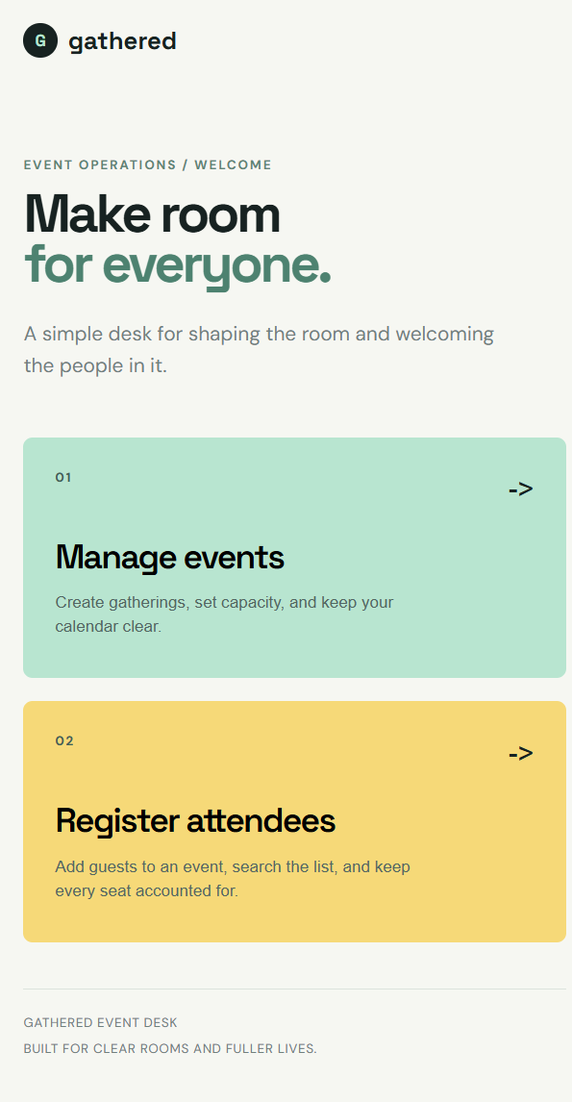
Figure 1. Gathered homepage with the two workflow buttons.
- Manage events - create gatherings, set capacity, and keep the calendar clear.
- Register attendees - add guests, search the list, and keep every seat accounted for.
The page remains a single-page application because JavaScript changes the visible view without navigating to a different HTML page.

5.2 Event Management Flow
- The user selects Manage events from the homepage.
- The form requests an event name, date, venue, and capacity.
- The frontend performs quick validation.
- The form sends a POST /api/events request.
- The backend validates and stores the event in SQLite.
- The event list is fetched again and rendered without a reload.
- Each event displays its current registration count and capacity.
- Deleting an event also deletes its attendees through ON DELETE CASCADE.
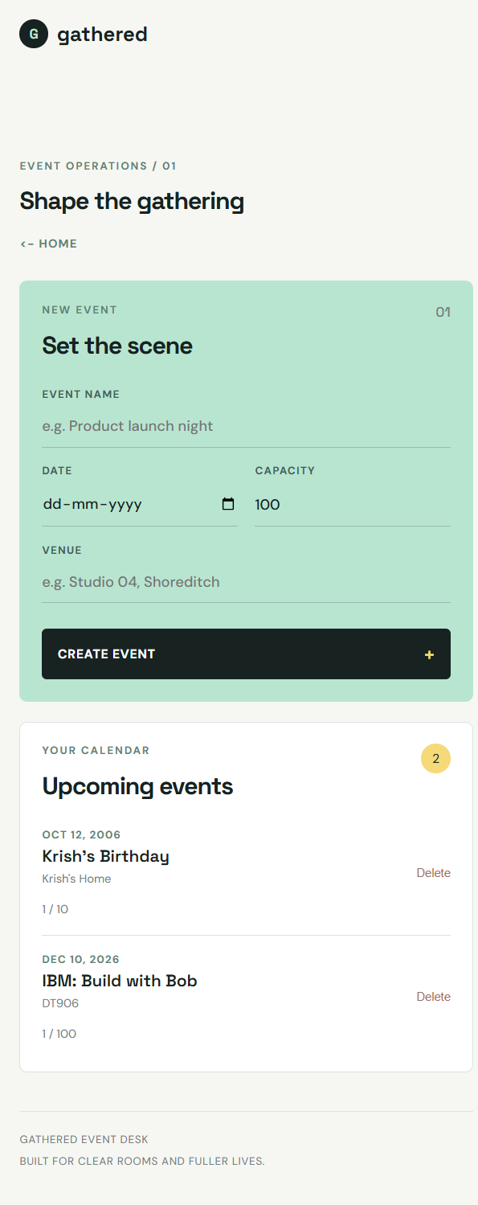
Figure 2. Event management screen with event form and calendar list.

5.3 Attendee Registration Flow
- The user selects Register attendees from the homepage.
- The event dropdown is populated from GET /api/events.
- The user enters an event, full name, email address, and ticket type.
- The frontend checks required fields and email format.
- The form sends POST /api/events/:id/attendees.
- The backend checks event existence, email validity, ticket type, capacity, and duplicate registration.
- A successful attendee is stored and the guest list is fetched again.
- The attendee table supports name search and event filtering.
- An attendee can be deleted with DELETE /api/attendees/:id.
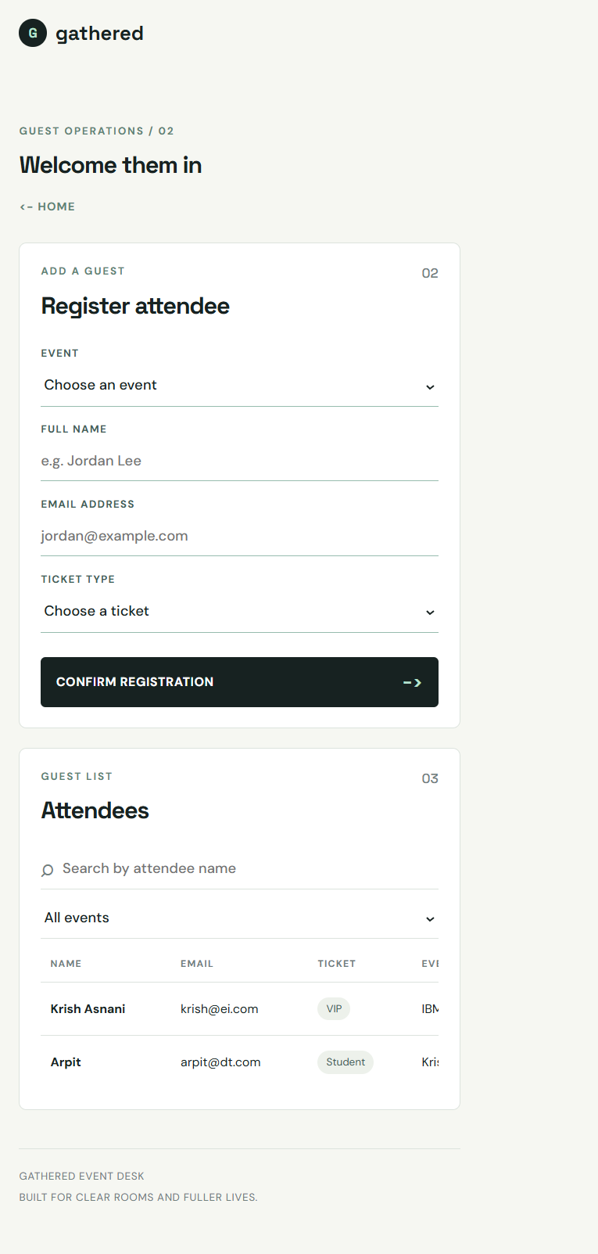
Figure 3. Attendee registration form, filters, and guest list.

6. Database Design
The system uses a one-to-many relationship: one event can have many attendees, while each attendee belongs to exactly one event.
CREATE TABLE events (
id INTEGER PRIMARY KEY AUTOINCREMENT,
name TEXT NOT NULL,
date TEXT NOT NULL,
venue TEXT NOT NULL,
capacity INTEGER NOT NULL DEFAULT 100
);
CREATE TABLE attendees (
id INTEGER PRIMARY KEY AUTOINCREMENT,
name TEXT NOT NULL,
email TEXT NOT NULL,
ticket_type TEXT NOT NULL CHECK (ticket_type IN ('General', 'VIP', 'Student')),
event_id INTEGER NOT NULL,
FOREIGN KEY (event_id) REFERENCES events(id) ON DELETE CASCADE,
UNIQUE (event_id, email)
);
Foreign-key enforcement is explicitly enabled for SQLite:
db.pragma('foreign_keys = ON');
The unique constraint prevents the same normalized email address from registering for the same event more than once.

7. REST API
Method | Route | Purpose | Success
POST | /api/events | Add an event | 201
GET | /api/events | List events and attendee counts | 200
GET | /api/attendees | List all attendees | 200
GET | /api/events/:id/attendees | List attendees for an event | 200
GET | /api/attendees/search?name=&eventId= | Search or filter attendees | 200
POST | /api/events/:id/attendees | Register an attendee | 201
DELETE | /api/attendees/:id | Delete an attendee | 200
DELETE | /api/events/:id | Delete an event | 200

Error status codes
- 400 - Missing or invalid input.
- 404 - Event or attendee does not exist.
- 409 - Duplicate registration or event capacity has been reached.
- 500 - Unexpected server error.
All database queries use parameterized placeholders such as ? to reduce SQL injection risk.

8. Validation Rules

Event validation
- Name, date, and venue are required.
- Capacity must be a positive whole number.

Attendee validation
- Name, email, ticket type, and event ID are required.
- Email must match the expected email format.
- Ticket type must be General, VIP, or Student.
- The event must exist.
- The current attendee count must be below capacity.
- Email addresses are trimmed and converted to lowercase before storage.
- Duplicate registration is rejected with status 409.
The frontend repeats basic checks for quick feedback, but all important checks are enforced by the backend.

9. Testing and Results
Test case | Expected result | Result
Register with an empty name | 400 | Passed
Register with abc@ as the email | 400 | Passed
Register the same email twice for one event | 409 | Passed
Register to event ID 9999 | 404 | Passed
Register when the event is at capacity | 409 | Passed
Search for a name that does not exist | 200 with [] | Passed
Delete attendee ID 9999 | 404 | Passed
Delete an event with attendees | Attendees cascade-deleted | Passed

The application was also checked with JavaScript syntax validation and workspace diagnostics. No errors were reported for the frontend or backend files.

10. Installation and Execution
Install dependencies from the project directory:
npm install
Start the server:
npm start
Open the application at:
http://localhost:3000
For development with automatic restart:
npm run dev
If port 3000 is already occupied, use another port:
$env:PORT=3001; npm start

11. Conclusion
The completed application provides a practical event and attendee management workflow with a relational database, RESTful backend, server-side validation, capacity control, duplicate protection, cascade deletion, and a no-reload single-page frontend. The two-button homepage separates event management from attendee registration while keeping the entire user experience inside one lightweight HTML, CSS, and JavaScript application.

