Mini Project Report on

Cab Transaction Using Facial Recognition and Matching

Human Machine Interaction Laboratory
B.E Semester VIII

 | Submitted by
Group Members Name | PID | Division | Roll No.
Rohan Chavan | 1152082 | B | 4
Saniket Patil | 2152014 | B | 33
Kshitij Shukla | 2152053 | B | 46

Under the guidance of

Ms. Tina D’abreo

(Assistant Professor)


Department of Computer Engineering St. John College of Engineering and Management, Palghar

University of Mumbai
2019-2020
Table of Content

Sr. No |  | Content | Page No
1 | Introduction |  | 1
 | 1. | HMI and its importance
 | 2. | project
2 | Problem Statement |  | 2
3 | Proposed Solution |  | 3
4 | Client Description |  | 4
5 | Requirements of the End User of the system |  | 5
6 | Technology used for Development |  | 6
7 | Good Screen Design principles/guidelines. |  | 7
8 | Components used in UI of system: |  | 9
 | 1. | Types of menus
 | 2. | Types of windows
 | 3. | Types of messages
 | 4. | Use screen controls
 | 5. | Navigation and flow
 | 6. | Use of colors and graphics/images.
8 | Results |  | 12

1. Introduction

1.1 HMI and its importance

A Human-Machine Interface (HMI) is a user interface or dashboard that connects a person to a machine, system, or device. HMIs come in a variety of forms, from built-in screens on machines, to computer monitors, to tablets, but regardless of their format or which term you use to refer to them, their purpose is to provide insight into mechanical performance and progress.

Significance of HMI

From an industrial perspective, the most valuable aspect of HMI technology is the ability to closely monitor production and respond to changing production demands, which improves efficiency and decreases downtime. These benefits are a result of improved diagnostics and monitoring. A properly designed HMI solution not only enhances productivity for the operator, but also provides line of sight into the system to control or maintain the machine. Alarming is a great example of an HMI function that provides visual indicators of a machine’s issue and its severity.

1.2 Project

The project ‘Web based Art Gallery’ is an online platform created for the artists to display their art to the world while allowing a user to view these arts without the need of visiting a physical art institution. The system will serve as a platform for the unknown of new generation artist to step in the artistic realm irrespective of their reputation in the art community.

1
2. Problem Statement

Today’s online transactions are not convenient for users to enter long high security passwords every time they want to make a transaction or remember their UPI VPA(Virtual Private Address), or even carry credit cards or debit cards everywhere. That’s highly inconvenient to the users. So, system are proposing a system where system don’t have to carry cards or remember your VPAs. With the popularity in India of mobile payment platforms such as Paytm and PhonePe, QR codes can be found almost anytime, anywhere in Indian daily life. From luxury shopping centers to street vendors, consumers can make payments easily by scanning a QR code with their smartphones. The awkwardness of forgetting your wallets at home no longer exists. As long as system have a mobile payment set up on your phone, system can virtually always go cashless in India. But, things are changing as system speak. QR codes are just a step in the evolution of mobile payment technology and they may soon be a thing of the past. In fact, soon people in India may be able to forget about QR codes, and pay with virtually nothing but themselves. This new payment method system are talking about is facial recognition, which systemare planning to implement in Cabs.

2
3. Proposed Solution

The proposed system involves automated cashless payment system using facial recognition. This system will work as an API between the payment system and any other application in which face of the user can be used for authentication. Using this system, the user can directly pay fares for the cab rides or hotel stay etc. The initial step of the system is the registration process. During the time of registration, the system will collect the facial information of the user by asking user to upload an video of user’s face. The system will then extract the frames from that video which will be used stored in the database for further use. Every user has a specific user directory, in which all the frames collected from the video will be saved. This dataset of images will be used to train our facial recognition model powered by OPENCV, Local Binary Patterns Histograms Face Recognizer (LBPH) algorithm. After the complete registration process, the user can login into the system by using facial recognition, and selects the destination. The system will then allocate a nearby cab to the user, and ensure the pickup for that user. Based on the pickup point and the destination, an invoice will be generated and the amount will be shown to the user. After the completion of the ride, the user will be redirected to the payment engine, where user will be prompted to enter his special pin to complete the transaction.

3
4. Client Description

A client of a professional person or organization is a person or company that receives a service from them in return for payment. For the proposed system, there are 2 clients as following:

Cab Driver

The Driver will be the person who would own that cab and thus have the admin privileges of maintaining the system in that cab, such as view all transactions, rides, distances, trips, fares that took place in his cab.

Cab Customer

A customer will be a type of user who would ride the taxi, view the trip details, make transactions and store the summary of the trip in his account.

4
5. Requirements of the End User of the system

5.1 Hardware Requirements

The minimum hardware requirements state the required hardware specifications that are needed for proper execution of the application’s operations and application itself in the user’s device.

Dual Core Processor based Computer.
512 MB RAM.
Touch monitor / pointing device.

Web Cam

5.2 Software Requirements

The minimum software requirements state the technologies which are needed by the user to run the application.

Web Browser

Internet connection

5
  - Technology used for Development

Django (Python Web Framework)

Django is a Python-based free and open-source web framework, which follows the model-template-view (MTV) architectural pattern. Django's primary goal is to ease the creation of complex, database-driven websites. The framework emphasizes reusability and "pluggability" of components, less code, low coupling, rapid development, and the principle of don't repeat yourself. Python is used throughout, even for settings files and data models. Django also provides an optional administrative create, read, update and delete interface that is generated dynamically through introspection and configured via admin models.

HTML 5

HTML5 is a markup language used for structuring and presenting content on the World Wide Web. HTML5 includes detailed processing models to encourage more interoperable implementations; it extends, improves and rationalizes the markup available for documents, and introduces markup and application programming interfaces (APIs) for complex web applications. For the same reasons, HTML5 is also a candidate for cross-platform mobile applications, because it includes features designed with low-powered devices in mind.

CSS 3

Cascading Style Sheets (CSS) is a style sheet language used for describing the presentation of a document written in a markup language like HTML. CSS is designed to enable the separation of presentation and content, including layout, colors, and fonts.

Bootstrap 4

Bootstrap is a free and open-source CSS framework directed at responsive, mobile-first front-end web development. It contains CSS- and (optionally) JavaScript-based design templates for typography, forms, buttons, navigation, and other interface components.

Heroku (Web Server)

Heroku is a cloud platform as a service (PaaS) supporting several programming languages. The Heroku network runs the customer's apps in virtual containers which execute on a reliable runtime environment. Heroku calls these containers "Dynos." These Dynos can run code written in Node, Ruby, PHP, Go, Scala, Python, Java, or Clojure.

6
  - Good Screen Design principles/guidelines

Visibility of system status.

Users should always be informed of system operations with easy to understand and highly visible status displayed on the screen within a reasonable amount of time.

Match between system and the real world.

Designers should endeavor to mirror the language and concepts users would find in the real world based on who their target users are. Presenting information in logical order and piggybacking on user’s expectations derived from their real-world experiences will reduce cognitive strain and make systems easier to use.

User control and freedom.

Offer users a digital space where backward steps are possible, including undoing and redoing previous actions.

Consistency and standards.

Interface designers should ensure that both the graphic elements and terminology are maintained across similar platforms. For example, an icon that represents one category or concept should not represent a different concept when used on a different screen.

Error prevention.

Whenever possible, design systems so that potential errors are kept to a minimum. Eliminating or flagging actions that may result in errors are two possible means of achieving error prevention.

Recognition rather than recall.

Minimize cognitive load by maintaining task-relevant information within the display while users explore the interface.

Flexibility and efficiency of use.

With increased use comes the demand for less interactions that allow faster navigation. This can be achieved by using abbreviations, function keys, hidden commands and macro facilities. Users should be able to customize or tailor the interface to suit their needs so that frequent actions can be achieved through more convenient means.
7
Aesthetic and minimalist design.

All unnecessary information competes for the user's limited attentional resources, which could inhibit user’s memory retrieval of relevant information. Therefore, the display must be reduced to only the necessary components for the current tasks, whilst providing clearly visible and unambiguous means of navigating to other content.

Help users recognize, diagnose and recover from errors.

Designers should assume users are unable to understand technical terminology, therefore, error messages should almost always be expressed in plain language to ensure nothing gets lost in translation.

Help and documentation.

Ideally, we want users to navigate the system without having to resort to documentation. However, depending on the type of solution, documentation may be necessary.

8
8. Components used in UI of system

8.1 Types of Menu

Standard Horizontal Menu Hamburger Menu

Mega Menu

Scroll –Triggered

Vertical Sidebar Navigation

Hover Activated Dropdown Menu Sticky or Fixed Menu

Type of menu used in the system / website is the combination of Hamburger Menu, Mega Menu and Sticky or Fixed Menu. The system / website is responsive to the screen size. When screen width greater than 400px, Standard Horizontal Menu and Mega Menu type is applied, also when screen width is smaller than 400px, Hamburger Menu is applied.

8.2 Types of Windows

Application Window Document Window Dialog Box

The system / website uses Application Window type for the users to interact with the systm.

8.3 Types of Messages

System Messages

- Status Messages

- Informational Messages

- Warning Messages

- Critical Messages

  - Question Messages

Instructional Messages

The system / website consist of only warning messages which are generated when an error is generated while trying to login with incorrect credentials and also while trying to add a new with a pre-existing art title.

9
8.4 Use Screen Controls

Screen controls are the elements of a screen that constitute its body. They are graphic objects that represent the properties or operations of other objects. Various screen controls, includes

Buttons

Text entry/read-only controls Selection controls

Combination entry/selection controls Specialized operable controls
Custom controls

Presentation controls Web controls

8.5 Navigation and Flow

Navigation flow is a feature that allows users to navigate from one screen to another as per the business flow in the sequence specified after transaction is done in each screen.

There are 3 types of navigation flow available.

Lateral navigation

Use lateral navigation to communicate information across individual screens so users can view them one by one. Navigate screens by swiping right or left, or by rotating the bezel, and page indicators should indicate which part of the content is currently being viewed.

Hierarchical navigation

Use hierarchical navigation when you can't display all the content at one level, or when you divide content into primary and secondary information.

Back navigation

Back navigation returns users to the previous screen, allowing users to retrace their steps and determine where they are. Users can backtrack to the previous screen by pressing the Back key.

The system / website uses the combination of ‘Hierarchical navigation’ and ‘Back navigation’.

10
8.6 Use of colors and graphics/images.

Color may be used as a formatting aid in structuring a screen or as a visual code to categorize and identify information or data. It may aslo be used to portray objects naturally and make a screen more appealing to look at. Proper use of contrast is always recommended while choosing the colors. Graphics or images always enhance the appeal of a screen along with maximizing in retrieval of information through minimum effort.

The system / website used plain white background on the pages inorder to showcase even flow while using dark colored navigation bar to differentiate the navigation controls.

11
9. Results

Login and Register

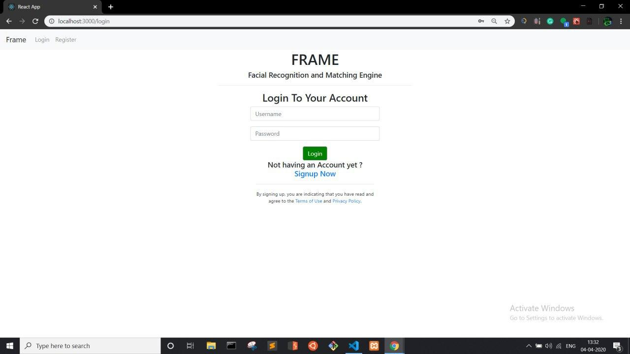

Fig. 9.1 Login Page

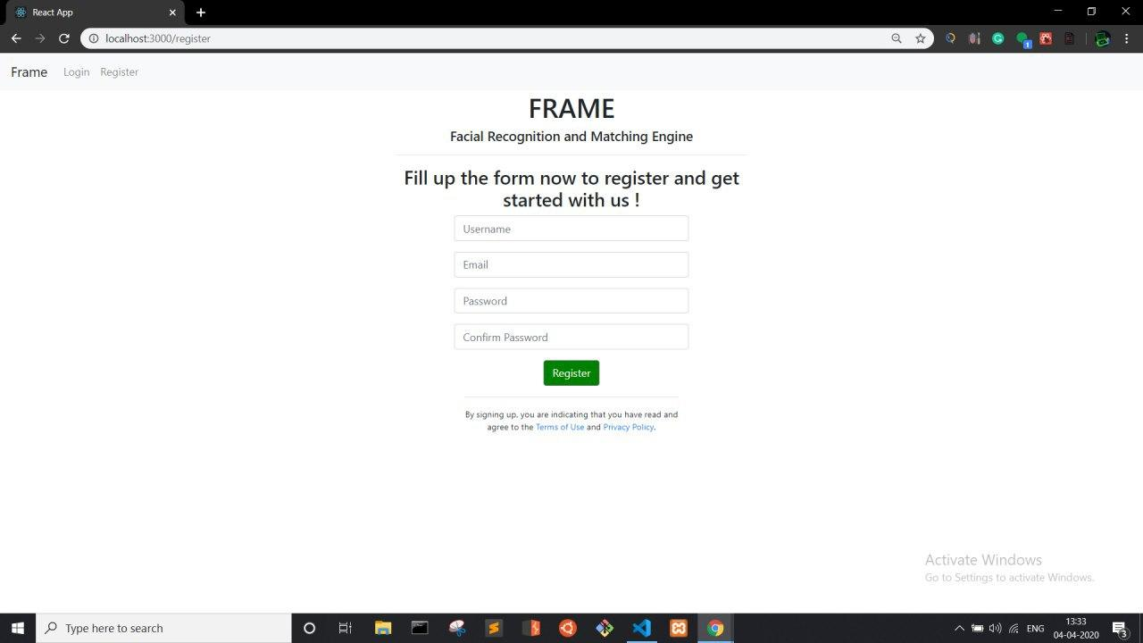

Fig. 9.2 Register Page

In order to upload, delete art, an artist has to register and log into system. ‘General’ user does not need to create an account to access the arts.

12

Logged In Screen

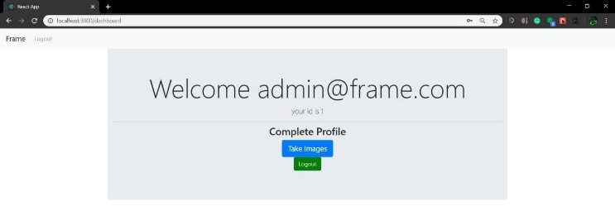
Fig. 9.3 Logged In Screen

Upon login the user will be greeted with the above screen from which he can take images for the database.

Dataset Collection

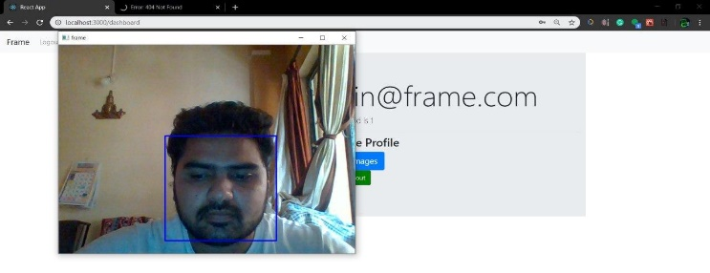
Fig. 9.4 Dataset Collection

Home Page
Client Homescreen

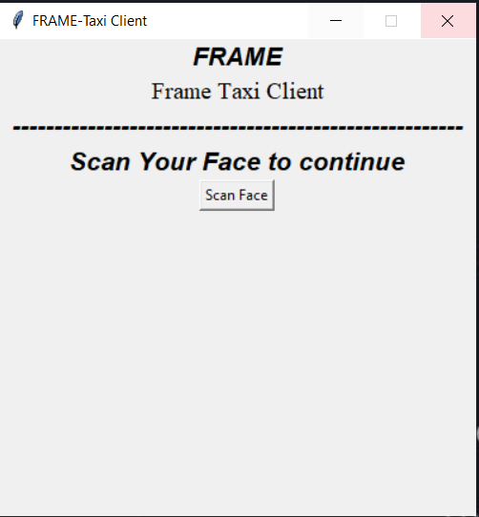
Fig. 9.5 Client Homescreen

13
The Home screen of the client side application will be as above. Only the registered users’ face will be able to log in.

Logged In homescreen

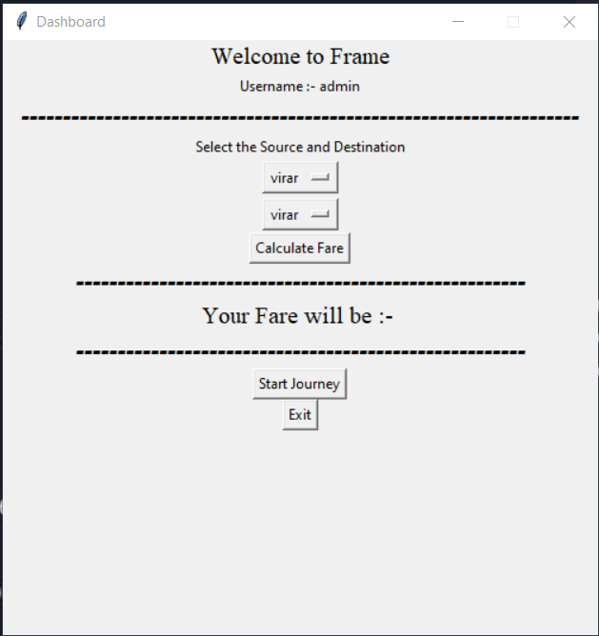

Fig. 9.6 client Logged in Homepage

Here the user has options to select source and destination of journey, get fare details, and make transactions.

14

