Week 2
- Perform the describe and info steps

import pandas as pd
import numpy as np
import matplotlib.pyplot as plt
import seaborn as sns
from google.colab import files
uploaded = files.upload()
housing = pd.read_csv("housing.csv")
housing.info()
housing.describe()

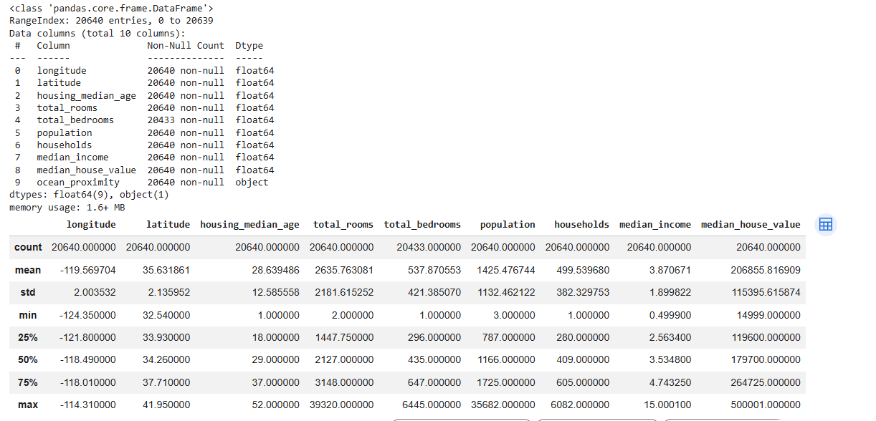

2. Plot the histogram of each feature( Indicate what does histogram
indicate on median_income and house_median_age)

housing.hist(figsize=(12,10))
plt.show()
plt.figure()
housing["median_income"].hist()
plt.title("Median Income Distribution")
plt.xlabel("Median Income")
plt.ylabel("Frequency")
plt.show()

plt.figure()
housing["housing_median_age"].hist()
plt.title("Housing Median Age Distribution")
plt.xlabel("Housing Median Age")
plt.ylabel("Frequency")
plt.show()

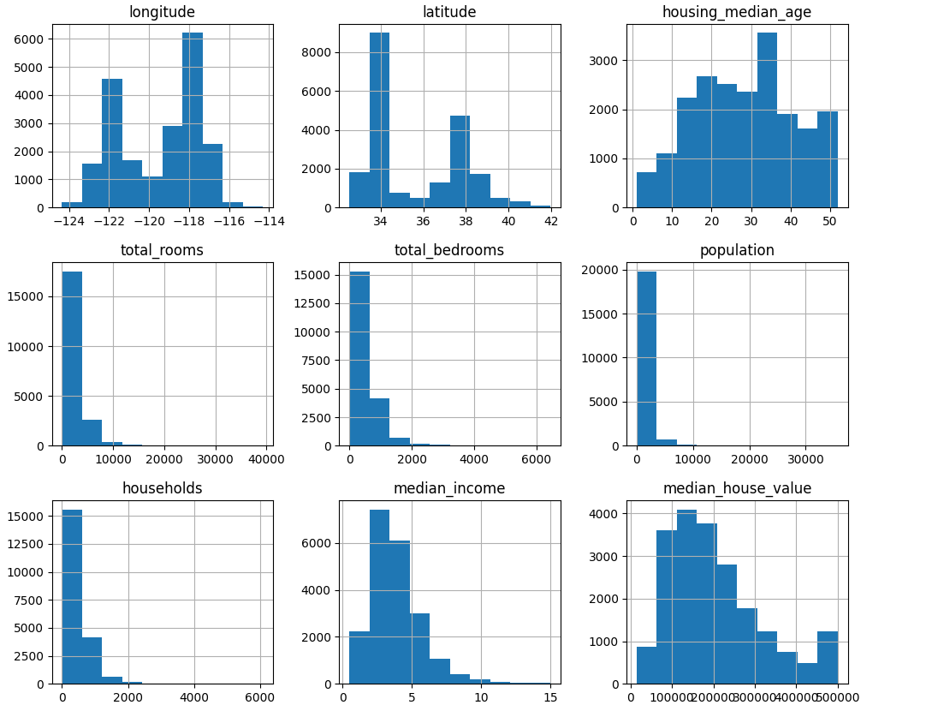
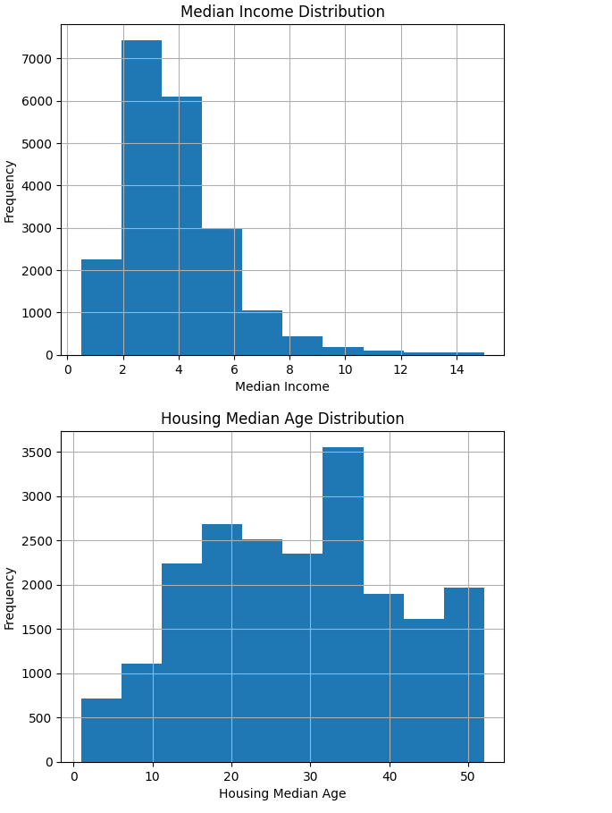
3. Demonstrate the process of creating a test set( write the difference
between random and stratified test set)
from sklearn.model_selection import train_test_split

train_set, test_set = train_test_split(housing, test_size=0.2, random_state=42)

print("Random Test Set Size:", len(test_set))
from sklearn.model_selection import StratifiedShuffleSplit

housing["income_cat"] = pd.cut(
housing["median_income"],
bins=[0.,1.5,3.0,4.5,6.,np.inf],
labels=[1,2,3,4,5]
)

split = StratifiedShuffleSplit(n_splits=1, test_size=0.2, random_state=42)

for train_index, test_index in split.split(housing, housing["income_cat"]):
strat_train_set = housing.loc[train_index]
strat_test_set = housing.loc[test_index]

print("Stratified Test Set Size:", len(strat_test_set))

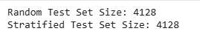

4. List the geographical features from the dataset and plot a graph to
Visualize Geographical Data(what does the graph indicate w.r.t
housing prices and location)
plt.figure()
housing.plot(
kind="scatter",
x="longitude",
y="latitude",
alpha=0.4,
s=housing["population"]/100,
c="median_house_value",
cmap="jet",
colorbar=True
)
plt.show()

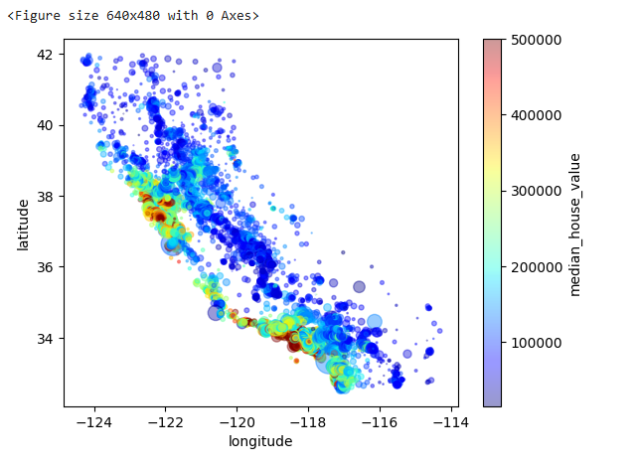

5. Plot a graph to show features correlation with housing price.
Which feature corelates to the maximum. Plot the graph for that
with housing price and analyze what the graph indicate
corr_matrix = housing.corr(numeric_only=True)

corr_with_price = corr_matrix["median_house_value"].sort_values(ascending=False)

print(corr_with_price)
top_feature = corr_with_price.index[1]

plt.figure()
plt.scatter(housing[top_feature], housing["median_house_value"])
plt.xlabel(top_feature)
plt.ylabel("median_house_value")
plt.show()

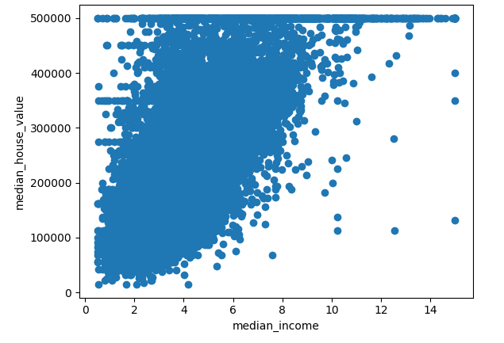

6. List the features that could be combined to improve correlation and
plot again to see if correlation has improved
housing["rooms_per_household"] = housing["total_rooms"] / housing["households"]
housing["bedrooms_per_room"] = housing["total_bedrooms"] / housing["total_rooms"]
housing["population_per_household"] = housing["population"] / housing["households"]

new_corr = housing.corr(numeric_only=True)["median_house_value"].sort_values(ascending=False)

print(new_corr)

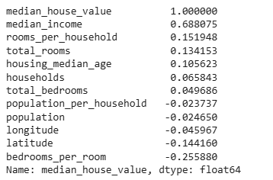

7. List the features that needs to be cleaned and demonstrate the
process of cleaning
print("Missing Values Before:\n", housing.isnull().sum())

# Fill missing total_bedrooms with median
housing["total_bedrooms"] = housing["total_bedrooms"].fillna(
housing["total_bedrooms"].median()
)

print("Missing Values After:\n", housing.isnull().sum())

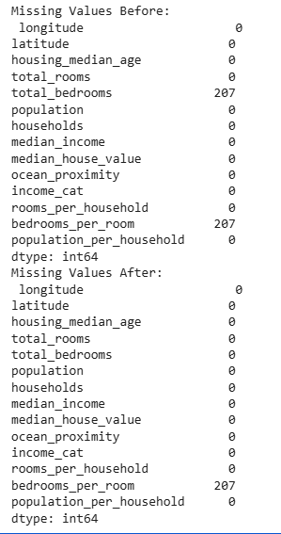

8. Is there any categorical data that needs to be converted to
numerical? If so explain the method used to convert and code the
same and show the output.
from sklearn.preprocessing import OneHotEncoder

encoder = OneHotEncoder()
housing_cat = housing[["ocean_proximity"]]

housing_cat_1hot = encoder.fit_transform(housing_cat)

print("Categories:", encoder.categories_)
print("Encoded Shape:", housing_cat_1hot.shape)

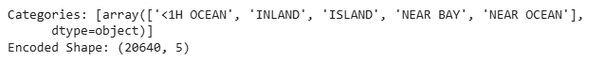

9. Discuss the importance of feature scaling
from sklearn.preprocessing import StandardScaler

scaler = StandardScaler()

housing_num = housing.drop("ocean_proximity", axis=1)

housing_scaled = scaler.fit_transform(housing_num)

print("Scaled Data Shape:", housing_scaled.shape)

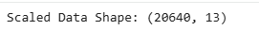

10. Design a pipeline inculcating (Custom transform, feature
scaling and encoding). Explain how it works
from sklearn.base import BaseEstimator, TransformerMixin
from sklearn.pipeline import Pipeline
from sklearn.compose import ColumnTransformer
from sklearn.impute import SimpleImputer
from sklearn.preprocessing import OneHotEncoder, StandardScaler

class CombinedAttributesAdder(BaseEstimator, TransformerMixin):
def fit(self, X, y=None):
return self

def transform(self, X):
rooms_per_household = X[:, 3] / X[:, 6]
population_per_household = X[:, 5] / X[:, 6]
bedrooms_per_room = X[:, 4] / X[:, 3]

return np.c_[X, rooms_per_household, population_per_household, bedrooms_per_room]

housing = pd.read_csv("housing.csv")

housing_num = housing.drop("ocean_proximity", axis=1)
housing_cat = housing[["ocean_proximity"]]

num_attribs = list(housing_num)
cat_attribs = ["ocean_proximity"]

num_pipeline = Pipeline([
("imputer", SimpleImputer(strategy="median")),
("attribs_adder", CombinedAttributesAdder()),
("scaler", StandardScaler()),
])

full_pipeline = ColumnTransformer([
("num", num_pipeline, num_attribs),
("cat", OneHotEncoder(), cat_attribs),
])

housing_prepared = full_pipeline.fit_transform(housing)

print("Final Prepared Data Shape:", housing_prepared.shape)

