**Introduction python with Django**

Python uses a package manager called *pip*

**Update pip package manager**

pip install --upgrade pip

**Install virtualenv (Optional Prerequisite)**

Virtualenv is not essential to develop Django applications, but I highly recommend you use it because it allows you to create virtual Python environments on a single system.

What happens if a new Django version is released after your first project and you want to start a second

project? Do you upgrade the first project to run on the new Django version or start the second project as if

the new Django version doesn’t exist? The first option requires additional work, while the second option

requires you to develop on an outdated Django version. By using virtual Python environments you avoid this

problem, because each project can run its own Django version in isolation.

**Set environment variable**

PATH :- C:\Users\techvision\AppData\Local\Programs\Python\Python36-32\pythonw.exe;

C:\Users\techvision\AppData\Local\Programs\Python\Python36-32\Lib\idlelib\idle.pyw;

C:\Users\techvision\AppData\Local\Programs\Python\Python36-32\Scripts

After installation, open the command prompt and check that the Python version matches the version you installed by executing:

python –version

## **Install virtualenv and virtualenvwrapper**[¶](https://docs.djangoproject.com/en/2.0/howto/windows/#install-virtualenv-and-virtualenvwrapper)

pip install virtualenvwrapper-win

**Then create a virtual environment for your project:**

mkvirtualenv myproject

The virtual environment will be activated automatically and you’ll see “(myproject)” next to the command prompt to designate that. If you start a new command prompt, you’ll need to activate the environment again using:

workon myproject

## **Install Django**[¶](https://docs.djangoproject.com/en/2.0/howto/windows/#install-django)

Django can be installed easily using **pip** within your virtual environment.

In the command prompt, ensure your virtual environment is active, and execute the following command:

pip install django

Django web applications typically group the code that handles each of these steps into separate files:

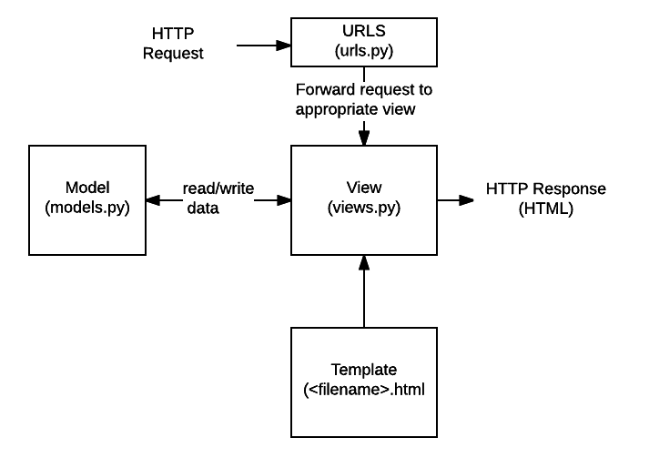

* **URLs:**While it is possible to process requests from every single URL via a single function, it is much more maintainable to write a separate view function to handle each resource. A URL mapper is used to redirect HTTP requests to the appropriate view based on the request URL. The URL mapper can also match particular patterns of strings or digits that appear in an URL, and pass these to a view function as data.
* **View:** A view is a request handler function, which receives HTTP requests and returns HTTP responses. Views access the data needed to satisfy requests via *models*, and delegate the formatting of the response to *templates*.
* **Models:** Models are Python objects that define the structure of an application's data, and provide mechanisms to manage (add, modify, delete) and query records in the database.
* **Templates:** A template is a text file defining the structure or layout of a file (such as an HTML page), with placeholders used to represent actual content. A *view* can dynamically create an HTML page using an HTML template, populating it with data from a *model*. A template can be used to define the structure of any type of file; it doesn't have to be HTML!

**Note**: Django refers to this organisation as the "Model View Template (MVT)" architecture. It has many similarities to the more familar [Model View Controller](https://developer.mozilla.org/en-US/docs/Web/Apps/Fundamentals/Modern_web_app_architecture/MVC_architecture)architecture.

Sending the request to the right view (urls.py)

A URL mapper is typically stored in a file named **urls.py**.

the mapper  (urlpatterns) defines a list of mappings between routes (specific URL patterns) and corresponding view functions. If an HTTP Request is received that has a URL matching a specified pattern then the associated view function will be called and passed the request.

urlpatterns = [

path('admin/', admin.site.urls),

path('book/<int:id>/', views.book-detail, name='book-detail'),

path('catalog/', include('catalog.urls')),

re_path(r'^([0-9]+)/$', views.best),

]

**Create project:**

Create a project called mysite.

django-admin startproject mysite

* To start a Django project you must use the django-admin executable or django-admin.py script that comes with Django.

* A Django project name can be composed of numbers, letters, or underscores.

Django project structure

+<BASE_DIR_project_name>

|

+----manage.py

|

+---+-<PROJECT_DIR_project_name>

|

+-__init__.py

+-settings.py

+-urls.py

+-wsgi.py

• manage.py .- Runs project specific tasks. Just as django-admin is used to execute system wide Django tasks, manage.py is used to execute project specific tasks.

• __init__.py .- Python file that allows Python packages to be imported from directories where it’s present. Note __init__.py is not Django specific, it’s a generic file used in almost all

Python applications.

• settings.py .- Contains the configuration settings for the Django project.

• urls.py .- Contains URL patterns for the Django project.

• wsgi.py .- Contains WSGI configuration properties for the Django project. WSGI is the recommended approach to deploy Django applications on production (i.e., to the public). You

don’t need to set up WSGI to develop Django applications.

cd mysite

**Create App:**

django-admin startapp blog

**Start server:**

python manage.py runserver

Edit and add following files:

1. Mysiit : urls.py
2. from django.contrib import admin
3. from django.urls import path
4. from django.conf.urls import url,include
5. urlpatterns = [
6. path('admin/', admin.site.urls),
7. #path('blog/', include('blog.urls')),
8. url(r'^blog/', include('blog.urls')),
10. ]

2. Add urls.py in blog app

from django.urls import path

from . import views

urlpatterns = [

path('', views.index, name='index'),

]

3. edit and add in view file within blog app

from django.http import HttpResponse

def index(request):

return HttpResponse("Hello, world. You're at the polls index.")