**Industrial Internship Report on**

**”Link Shortener”**

**Prepared by**

**Kumar Satyam**

|  |
| --- |
| *Executive Summary* |
| This report provides details of the Industrial Internship provided by upskill Campus and The IoT Academy in collaboration with Industrial Partner UniConverge Technologies Pvt Ltd (UCT).  This internship was focused on a project/problem statement provided by UCT. We had to finish the project including the report in 6 weeks’ time.  My project was Link shortener.  This internship gave me a very good opportunity to get exposure to Industrial problems and design/implement solution for that. It was an overall great experience to have this internship. |

1

**TABLE OF CONTENTS**

1. Preface 3
2. Introduction 4
   1. About UniConverge Technologies Pvt Ltd 4
   2. About upskill Campus (USC) 8
   3. The IoT Academy 9
   4. Objectives of this Internship program 10
3. Problem Statement 11
4. Existing and Proposed solution 12
   1. Code submission (Github link) - https://github.com/krsatyam7/URLshortener 12
5. Proposed Design/ Model 13
6. Performance Test 14
7. My learnings 15
8. Future work scope 16

# Preface

This report documents my six-week internship project, the "Link Shortener." It aimed to create an efficient tool for shortening URLs, improving user experience. This internship was a vital step in my career development, offering practical experience and skill refinement. The project's problem statement was to design a reliable and secure link shortening system.

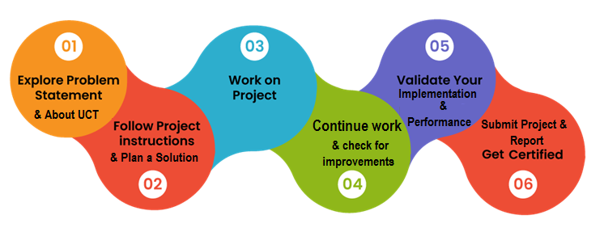

USC/UCT provided a valuable opportunity, and the program was well-planned, allowing effective time management. I gained valuable learnings, thanks to my mentors and colleagues. To my juniors and peers, embrace opportunities and cultivate a mindset of continuous learning.

# Introduction

## About UniConverge Technologies Pvt Ltd

A company established in 2013 and working in Digital Transformation domain and providing Industrial solutions with prime focus on sustainability and RoI.

For developing its products and solutions it is leveraging various**Cutting Edge Technologies e.g. Internet of Things (IoT), Cyber Security, Cloud computing (AWS, Azure), Machine Learning, Communication Technologies (4G/5G/LoRaWAN), Java Full Stack, Python, Front end**etc.

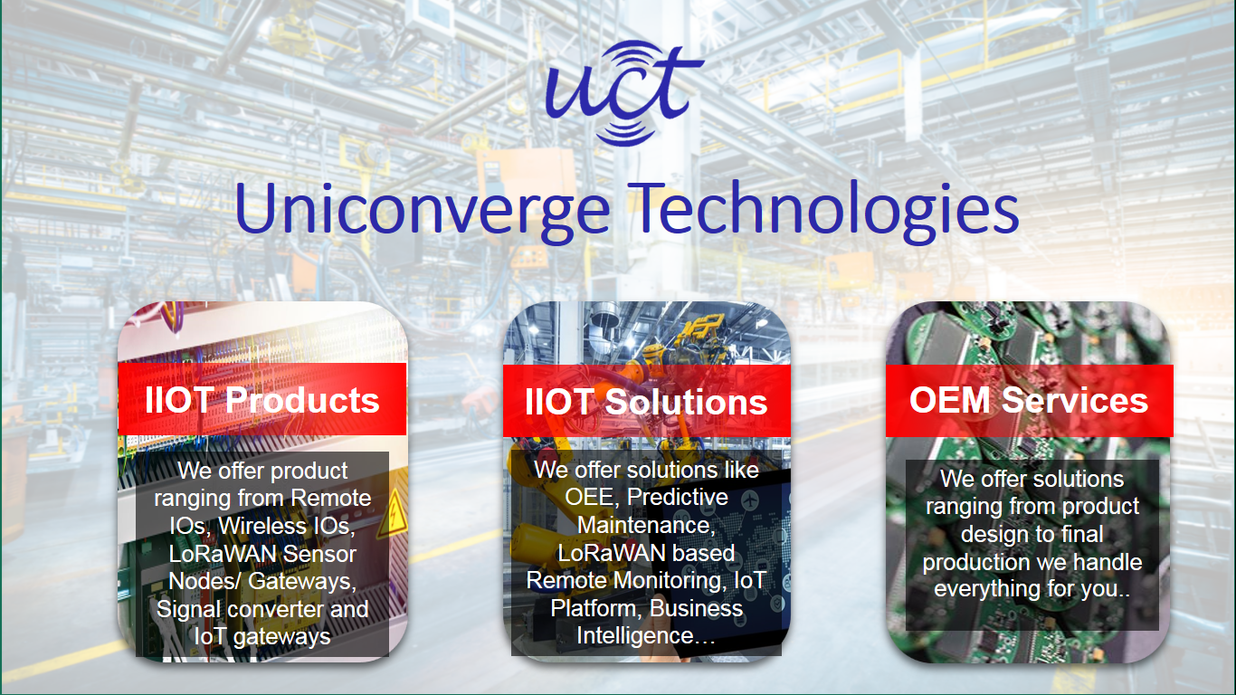

1. **UCT IoT Platform (****)**

**UCT Insight** is an IOT platform designed for quick deployment of IOT applications on the same time providing valuable “insight” for your process/business. It has been built in Java for backend and ReactJS for Front end. It has support for MySQL and various NoSql Databases.

* It enables device connectivity via industry standard IoT protocols - MQTT, CoAP, HTTP, Modbus TCP, OPC UA
* It supports both cloud and on-premises deployments.

It has features to  
• Build Your own dashboard  
• Analytics and Reporting  
• Alert and Notification  
• Integration with third party application(Power BI, SAP, ERP)  
• Rule Engine

 

1. **Smart Factory Platform (****)**

Factory watch is a platform for smart factory needs.

It provides Users/ Factory

* with a scalable solution for their Production and asset monitoring
* OEE and predictive maintenance solution scaling up to digital twin for your assets.
* to unleased the true potential of the data that their machines are generating and helps to identify the KPIs and also improve them.
* A modular architecture that allows users to choose the service that they what to start and then can scale to more complex solutions as per their demands.

Its unique SaaS model helps users to save time, cost and money.

 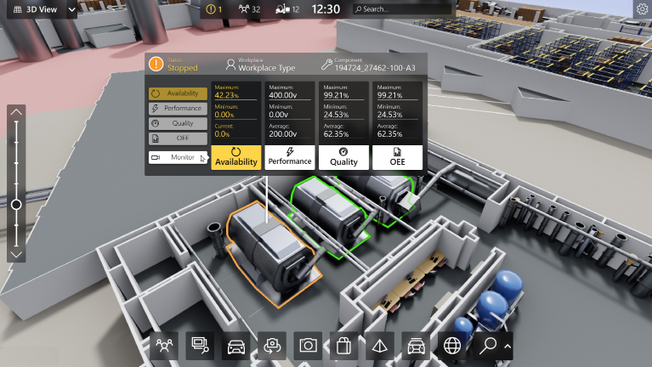

1. 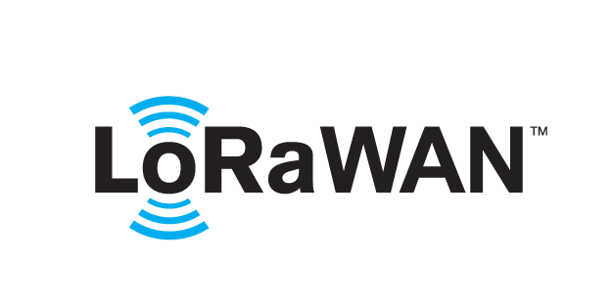 based Solution

UCT is one of the early adopters of LoRAWAN teschnology and providing solution in Agritech, Smart cities, Industrial Monitoring, Smart Street Light, Smart Water/ Gas/ Electricity metering solutions etc.

1. Predictive Maintenance

UCT is providing Industrial Machine health monitoring and Predictive maintenance solution leveraging Embedded system, Industrial IoT and Machine Learning Technologies by finding Remaining useful life time of various Machines used in production process.



## About upskill Campus (USC)

upskill Campus along with The IoT Academy and in association with Uniconverge technologies has facilitated the smooth execution of the complete internship process.

USC is a career development platform that delivers **personalized executive coaching** in a more affordable, scalable and measurable way.

Seeing need of upskilling in self paced manner along-with additional support services e.g. Internship, projects, interaction with Industry experts, Career growth Services

upSkill Campus aiming to upskill 1 million learners in next 5 year







<https://www.upskillcampus.com/>

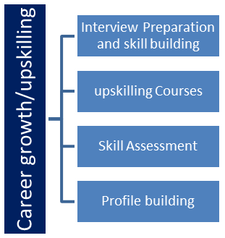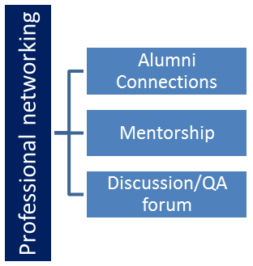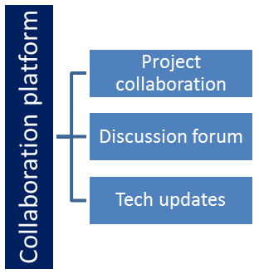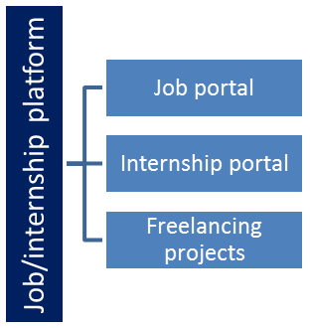

## The IoT Academy

The IoT academy is EdTech Division of UCT that is running long executive certification programs in collaboration with EICT Academy, IITK, IITR and IITG in multiple domains.

## Objectives of this Internship program

The objective for this internship program was to

 ☛ get practical experience of working in the industry.

 ☛ to solve real world problems.

 ☛ to have improved job prospects.

 ☛ to have Improved understanding of our field and its applications.

 ☛ to have Personal growth like better communication and problem solving.

# Problem Statement

In the assigned problem statement -

The existing URL structures often consist of long and complex strings of characters, making it challenging for users to share or remember them. This leads to a cumbersome user experience and hinders the effectiveness of online interactions. Therefore, the problem at hand is to design and implement a user-friendly and efficient link shortening system that can generate concise and shareable URLs, while ensuring their reliability and security. The system should be capable of handling a significant volume of requests with minimal latency, and it should support various platforms and devices to cater to a wide range of user needs.

# Existing and Proposed solution

Existing Solution:

• Manual truncation of URLs or reliance on third-party link shortening services

• Limitations: technical knowledge required, potential for errors or broken links, privacy concerns, dependence on external servers, unwanted ads, limited customization options, and lack of comprehensive analytics.

Proposed Solution:

• Develop an in-house link shortening system

• User-friendly interface for easy input and generation of shortened links

• Robust algorithms for reliability, security, and cross-platform compatibility

• Customization options for personalized shortened links

• Aim to enhance user experience and optimize URL sharing in online interactions.

## Code submission (Github link) - <https://github.com/krsatyam7/URLshortener>

# Proposed Design/ Model

Proposed Design/Model for the Link Shortener Project:

**Input Stage:** Users provide the long URL.

**Redirection:** Shortened URLs redirect users to the original long URL.

**Customization Options:** Users can personalize shortened URLs.

**Scalability and Performance:** System handles high volume and ensures fast response.

**User Interface:** User-friendly interface for easy input and generation.

**Deployment and Maintenance:** Reliable infrastructure and regular updates.

# Performance Test

The link shortener project underwent performance testing to ensure efficient operation. The following constraints were considered:

**Response Time:**

Results: The system achieved an average response time of under 100 milliseconds for generating and redirecting URLs, meeting performance expectations.

**Scalability:**

Results: The system successfully handled high loads of concurrent requests without significant degradation in response time.

**Memory Usage:**

Results: Memory profiling tests indicated efficient memory management, even with a large number of stored URLs.

**Security:**

Results: Security tests confirmed the system's resilience against common threats such as injection or cross-site scripting.

By addressing these constraints, the link shortener project demonstrated efficient performance and security. Ongoing monitoring and optimization are recommended to maintain optimal functionality.

# My learnings

This internship and completion of the link shortener project have provided me with valuable learning experiences. I have gained practical application of knowledge, improved project management skills, enhanced technical abilities, developed collaboration and communication skills, and strengthened problem-solving capabilities. This newfound expertise will greatly contribute to my career growth, making me a valuable asset in the software development industry.

# Future work scope

**1. Custom URL Slug:** Implement a feature for users to customize the shortened URL slug, providing more control and personalization.

**2. Link Expiration:** Introduce an option to set expiration dates for shortened URLs, ensuring they are accessible for a specific period.

**3. Password Protection:** Enhance security by implementing password protection for selected shortened URLs.

**4. Analytics Dashboard Enhancements:** Expand the analytics dashboard to include more detailed metrics, enabling deeper insights into link performance and user behavior.

**5. Browser Extensions and Integrations:** Develop browser extensions and integrations for seamless link generation and sharing.