SentryMCP — Technical Guide
Detailed documentation for engineers, interviewers, and assignment reviewers.
Repository: cross-industry-voice-dataguard (MCP Compliance Agent MVP)

1. Executive Summary
SentryMCP is a multi-domain compliance auditing agent. Operators ask natural-language questions by text or voice. The system routes each request to the correct MCP domain server, retrieves subsystem data, reasons with an LLM (AWS Bedrock), and returns a structured verdict: CLEARED, FLAGGED, ACTION_REQUIRED, or ERROR.

2. Business Problem & Solution

Problem
- Compliance teams use siloed systems: ledgers, patient records, HR policies.
- Manual checks are slow, inconsistent, and hard to audit.
- Context is lost when switching between tools.

Solution
- One interface for text and voice compliance queries.
- MCP connects to domain backends without hard-coding each industry in core logic.
- LLM produces explainable, structured JSON verdicts.
- Multi-turn conversation remembers account/patient context across follow-ups.

3. High-Level Design (HLD)
System context — operators interact with a single compliance platform that fans out to domain MCP servers and AWS services.
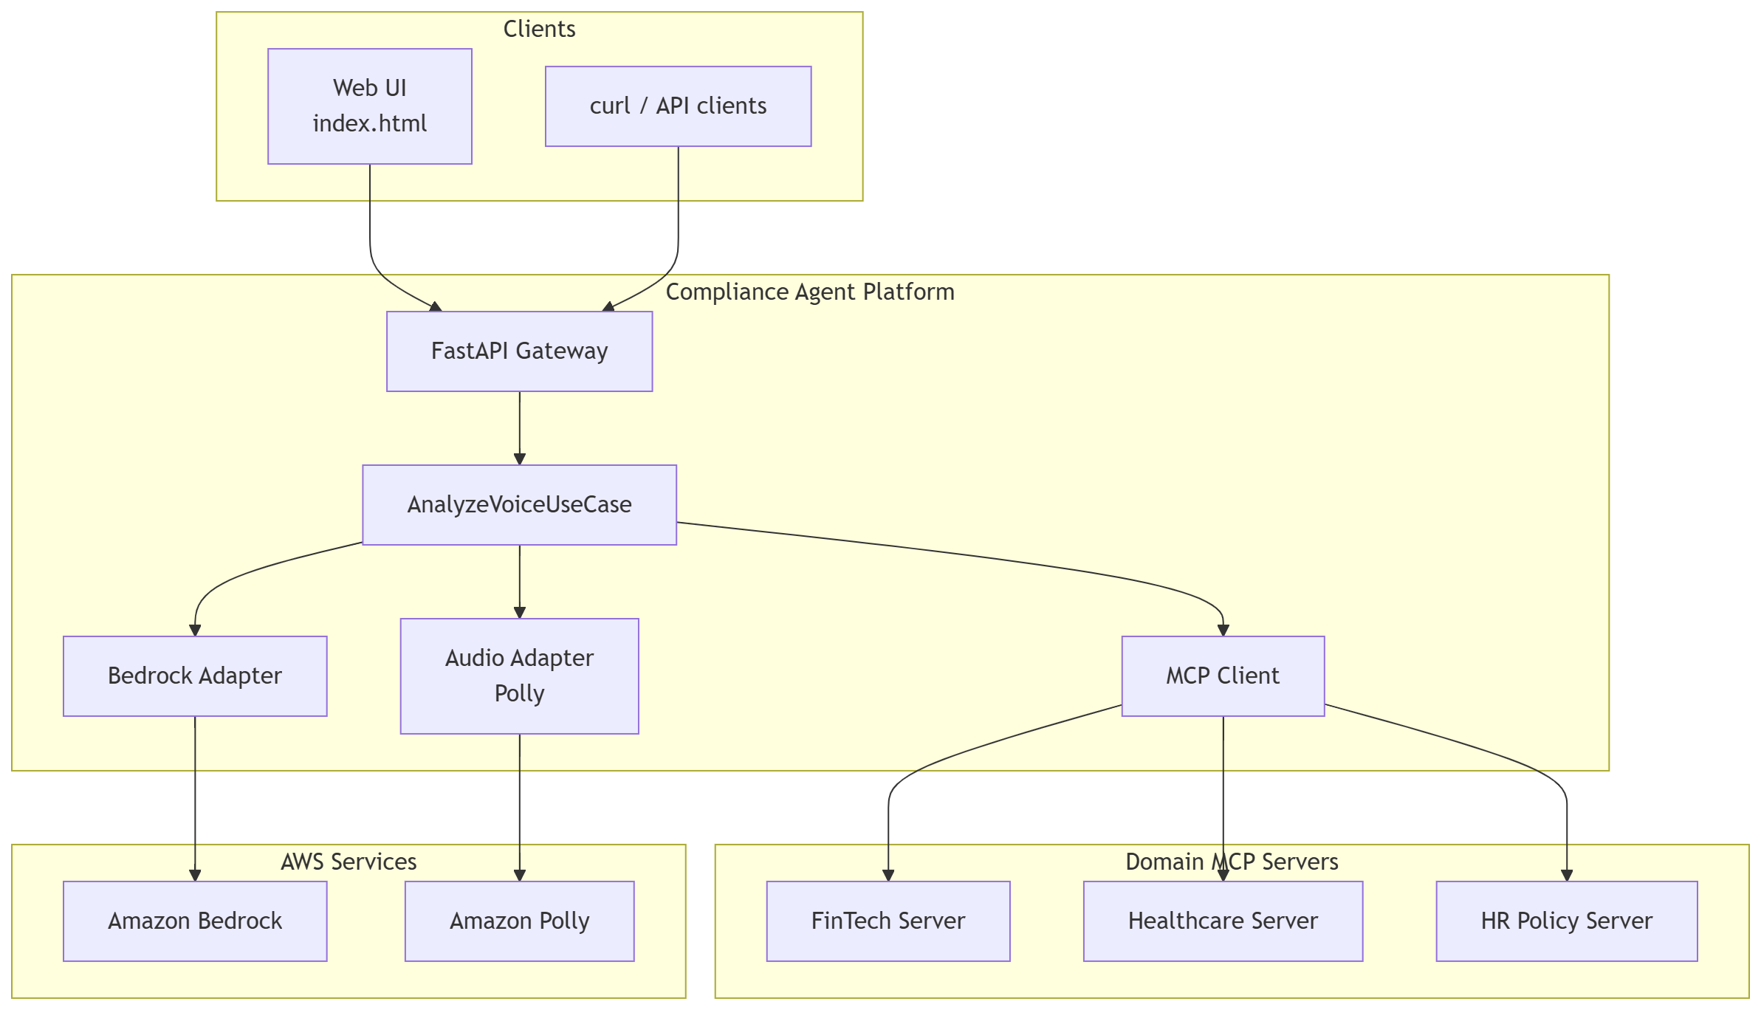
Figure 1: High-Level Design (HLD)
- One orchestrator: AnalyzeVoiceUseCase
- Many domain plugins: FinTech, Healthcare, HR MCP servers
- Swappable LLM and audio adapters (ports & adapters pattern)
- Thin HTTP layer: FastAPI + static web UI

4. Low-Level Design (LLD)
Sequence diagrams show exact call order between components.
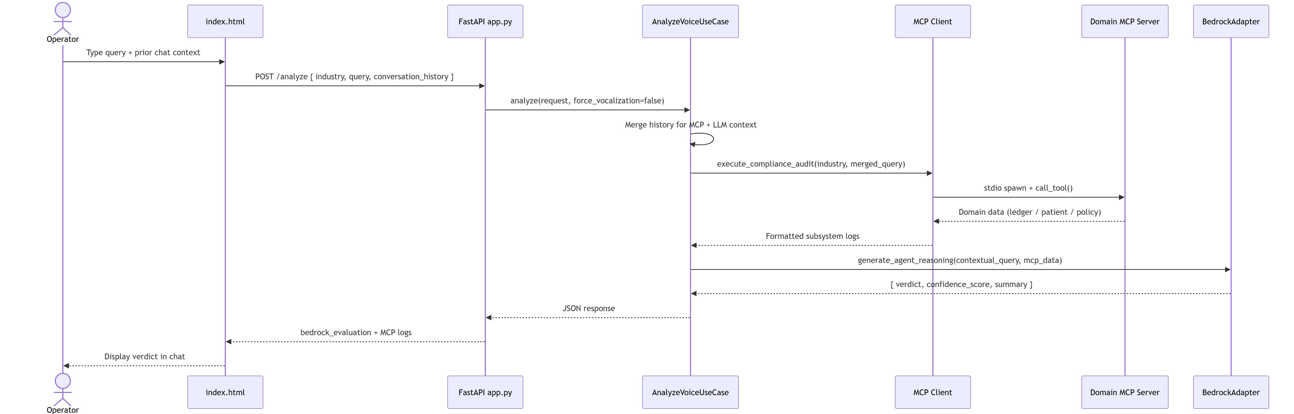
Figure 2: LLD — Text chat (POST /analyze)
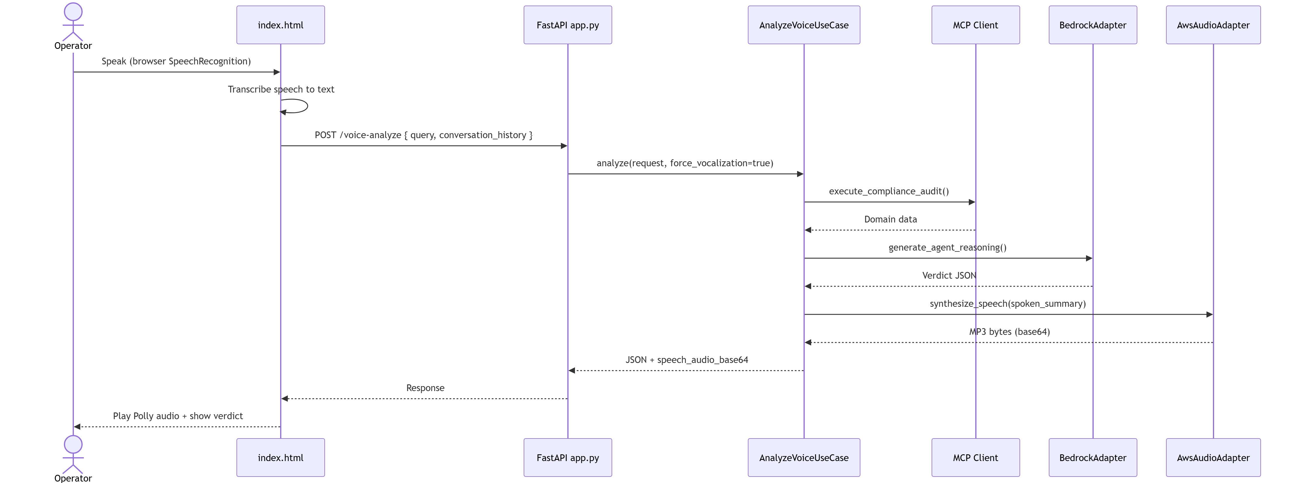
Figure 3: LLD — Voice (POST /voice-analyze)
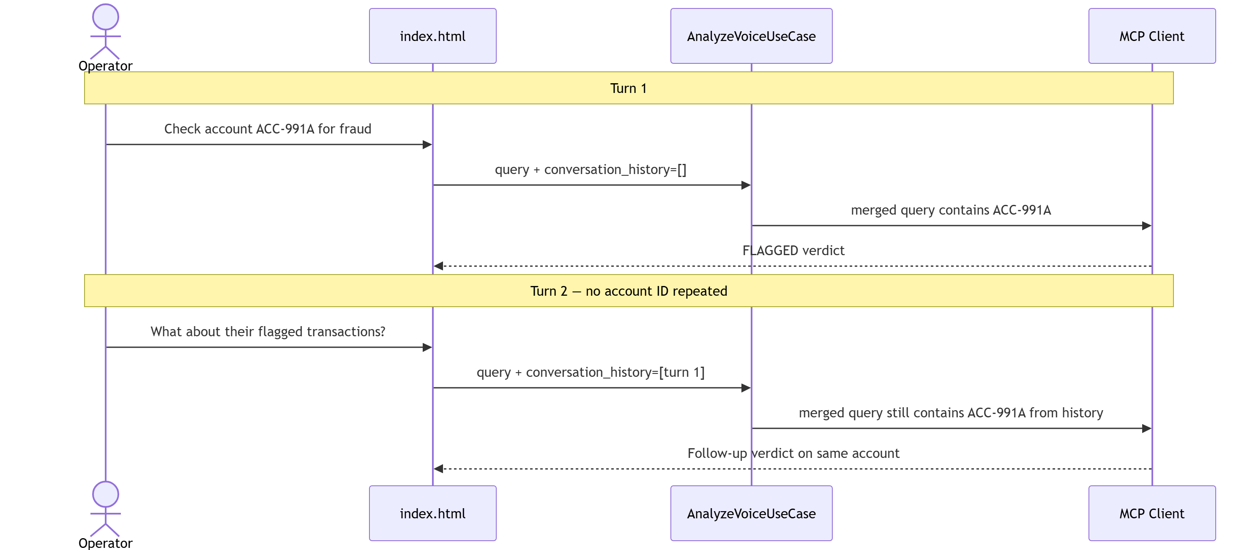
Figure 4: LLD — Multi-turn conversation memory

Layer map
Layer | Path | Role
Entity | core/entities/audit_request.py | Input: industry, query, conversation_history
Ports | core/ports/ | IMcpClientPort, ILlmPort, IAudioPort
Use case | core/use_cases/analyze.py | Orchestrates MCP → LLM → Polly
Inbound | adapters/inbound/api/app.py | FastAPI routes + static UI
MCP adapter | adapters/outbound/mcp/mcp_client.py | Spawn servers, route tools
LLM adapter | adapters/outbound/aws/bedrock_adapter.py | Bedrock → OpenRouter → local
Audio adapter | adapters/outbound/aws/audio_adapter.py | Polly TTS
MCP servers | backend/mcp_servers/ | Domain tools with mock data

5. Domain Plugins
- fintech → audit_financial_account (e.g. ACC-991A)
- healthcare → audit_patient_record (e.g. PAT-204B)
- hr → summarize_hr_policy (keyword → policy topic)

6. Voice-to-Voice
- Speech in: browser Speech Recognition (Chrome/Edge)
- Analysis: MCP + AWS Bedrock
- Speech out: Amazon Polly (POLLY_ENABLED=true)
- No S3 bucket required for default voice mode

7. How to Connect Your Own MCP Server
1. Create backend/mcp_servers/your_domain_server.py with FastMCP and @mcp.tool().
2. Register industry in RealMcpClientAdapter.server_registry (mcp_client.py).
3. Implement _your_domain_args(query) for ID/keyword extraction.
4. Add industry option in src/agentai/static/index.html.
5. Restart API and test with POST /analyze.

8. API Reference
- GET / — Web UI (index.html)
- GET /docs — Swagger
- POST /analyze — text audit
- POST /voice-analyze — voice audit + Polly
- GET /audio-config — Polly / voice mode status

9. Environment Variables
- LLM_PROVIDER=local|bedrock
- POLLY_ENABLED=true
- BEDROCK_MODEL_ID, AWS_REGION, OPENROUTER_API_KEY

10. LinkedIn Demo Script (90 seconds)
- Hook: SentryMCP — multi-domain compliance agent.
- Problem: siloed compliance systems, slow manual checks.
- Architecture: FastAPI → MCP → Bedrock → structured verdict.
- Demo: FinTech ACC-991A → FLAGGED → Polly speaks verdict.
- Follow-up: conversation memory without repeating account ID.
- Close: pluggable MCP domains, portfolio POC, link in description.

11. Future Scope
- Real database connectors replacing mock MCP data
- Enterprise authentication and audit logging
- Cloud deployment (ECS, AgentCore)
- Additional MCP domains (legal, retail, security)

