

Name:- Kumar Saurav Suman UID:- 25MCI10320
Branch:- MCA [AI&ML] Section/Group:- 25MAM-2B
Semester:- 3rd Date of Performance:- 04/10/2026
Subject Name:- Technical Training II Subject Code: 25CAP-707

Experiment-5
Aim:-
To design, develop, test and deploy the responsive food delivery web interface using appropriate web technologies
Implementation:-
index.html
<!doctype html>
<html lang="en">
<head>
<meta charset="UTF-8" />
<meta name="viewport" content="width=device-width, initial-scale=1.0" />
<title>FoodieExpress - Hot Food, Delivered Fast</title>
</head>
<body>
<div id="root"></div>
<script type="module" src="/src/main.jsx"></script>
</body>
</html>
package.json
{
"name": "food-delivery",
"private": true,
"version": "1.0.0",
"type": "module",
"scripts": {
"dev": "vite",

"build": "vite build",
"preview": "vite preview"
},
"dependencies": {
"bootstrap": "^5.3.3",
"bootstrap-icons": "^1.11.3",
"react": "^18.3.1",
"react-dom": "^18.3.1"
},
"devDependencies": {
"@vitejs/plugin-react": "^4.3.1",
"vite": "^5.4.1"
}
}
vite.config.js
import { defineConfig } from 'vite'
import react from '@vitejs/plugin-react'

// https://vitejs.dev/config/
export default defineConfig({
plugins: [react()],
})
src/main.jsx
import React from 'react'
import ReactDOM from 'react-dom/client'
import 'bootstrap/dist/css/bootstrap.min.css'
import 'bootstrap-icons/font/bootstrap-icons.css'
import App from './App.jsx'
import './App.css'

ReactDOM.createRoot(document.getElementById('root')).render(<App />)
src/components/Navbar.jsx
import { useState } from 'react'

function Navbar({ currentPage, setCurrentPage, isLoggedIn, setIsLoggedIn, darkMode, setDarkMode, cartCount, showToast }) {
const [open, setOpen] = useState(false)

const go = (page) => {
setCurrentPage(page)
setOpen(false)
}

const handleLogout = () => {
setIsLoggedIn(false)
setCurrentPage('home')
setOpen(false)
showToast('You have been logged out.', 'info')
}

const link = (page, icon, label) => (
<button
className={currentPage === page ? 'nav-link-btn active' : 'nav-link-btn'}
onClick={() => go(page)}
>
<i className={`bi ${icon} me-1`}></i>{label}
</button>
)

return (
<nav className="app-navbar">
<div className="container d-flex align-items-center justify-content-between">
<span className="brand" onClick={() => go('home')}>
<i className="bi bi-bag-heart-fill me-2"></i>FoodieExpress
</span>

<button className="menu-toggle d-lg-none" onClick={() => setOpen(!open)}>

<i className={`bi ${open ? 'bi-x-lg' : 'bi-list'}`}></i>
</button>

<div className={`nav-items ${open ? 'open' : ''}`}>
{link('home', 'bi-house-door', 'Home')}
{link('cart', 'bi-cart3', 'Cart')}
{cartCount > 0 && <span className="cart-badge">{cartCount}</span>}
{isLoggedIn && link('orders', 'bi-receipt', 'My Orders')}
<button className="icon-btn" onClick={() => setDarkMode(!darkMode)} title="Toggle theme">
<i className={`bi ${darkMode ? 'bi-sun-fill' : 'bi-moon-stars-fill'}`}></i>
</button>
{isLoggedIn ? (
<button className="btn-outline-light-custom" onClick={handleLogout}>
<i className="bi bi-box-arrow-right me-1"></i>Logout
</button>
) : (
<button className="btn-outline-light-custom" onClick={() => go('login')}>
<i className="bi bi-box-arrow-in-right me-1"></i>Login
</button>
)}
</div>
</div>
</nav>
)
}

OUTPUT:

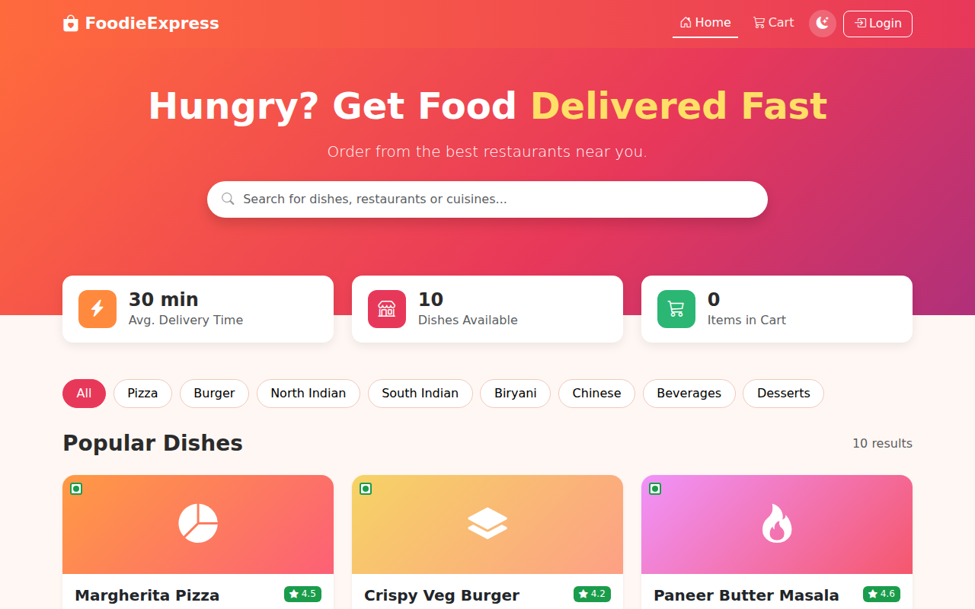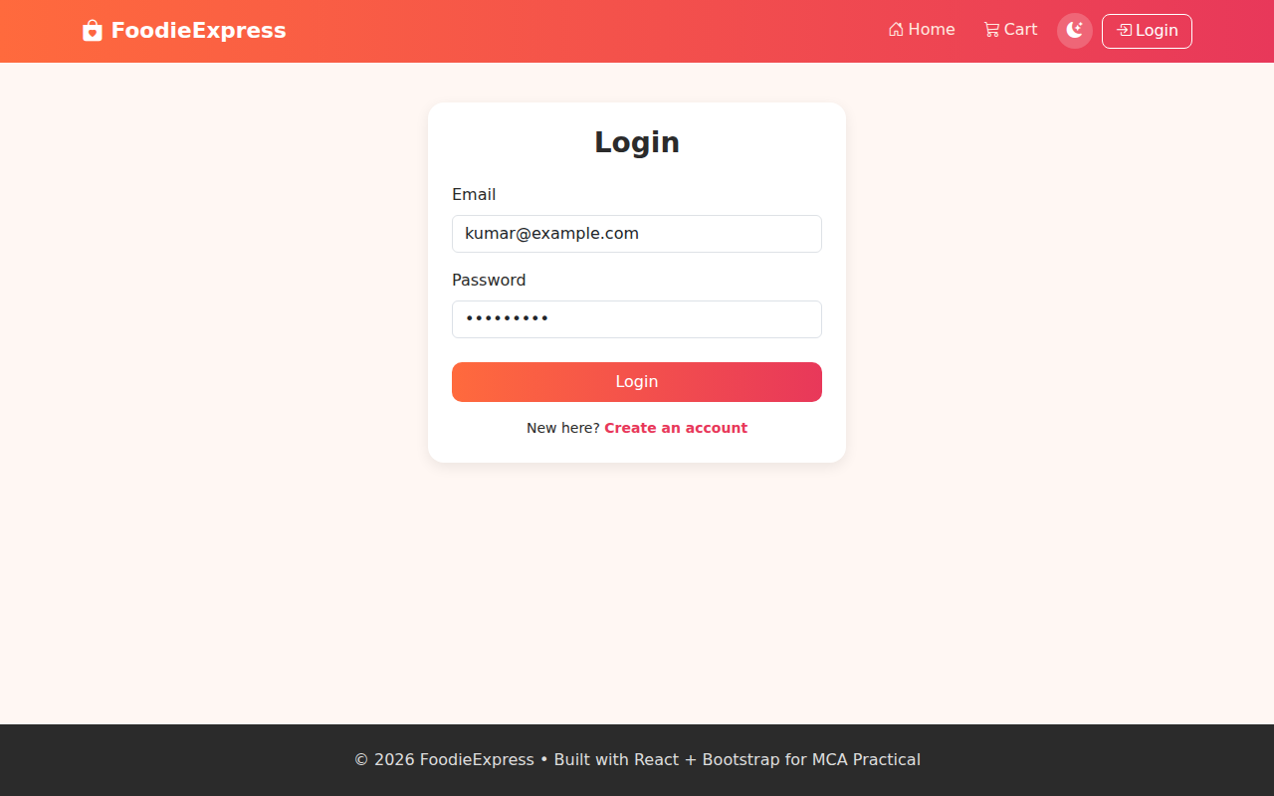
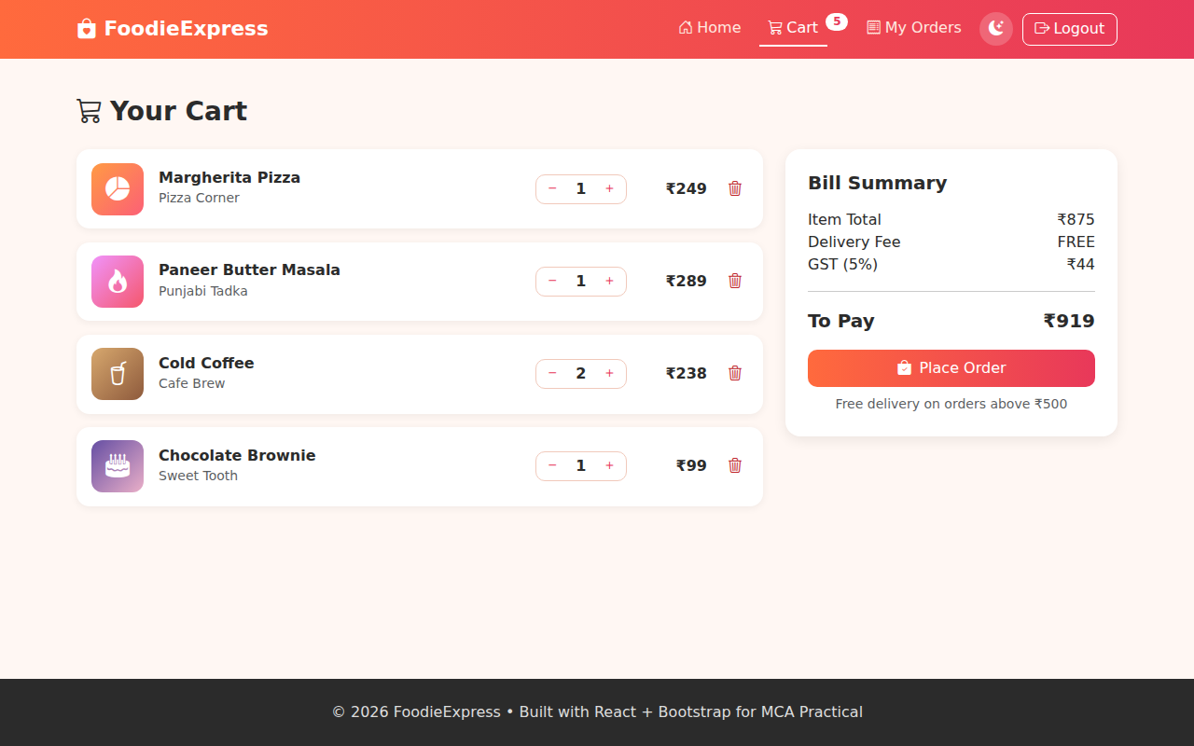

Learning Outcome:-
- Understand the structure of a responsive food delivery web application.
- Develop a responsive frontend using React and Bootstrap.
- Build reusable components and manage application state with React hooks.
- Implement dish search, category filtering and dynamic rendering using map() and filter().
- Implement cart operations, bill calculation and order placement.
- Understand how a backend (Node.js / Python) and a database (MySQL / MongoDB) can be connected to the frontend through REST APIs.
- Test the interface on different screen sizes and prepare the project for deployment using Git & GitHub.

