- Installed flask
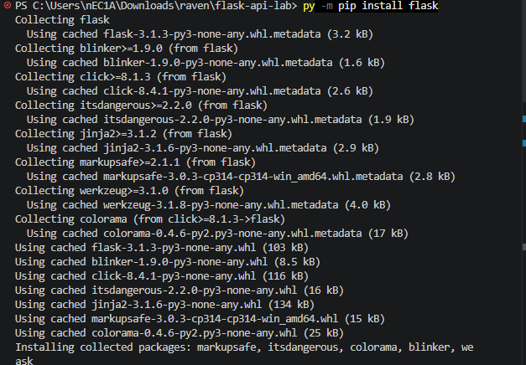

- TESTED GET ON TERMINAL
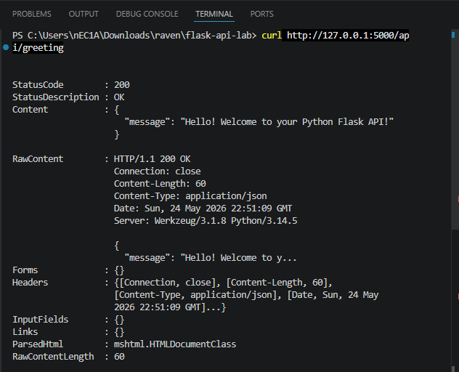

- TESTED GET AND POST IN BASH
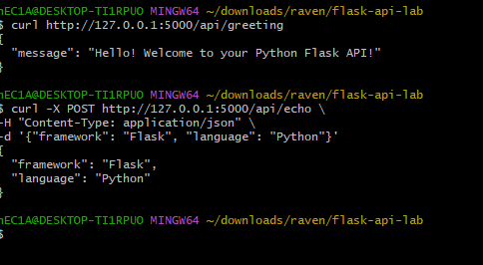

ANSWERS:
- The @app.route() decorator kind of reads like saying "this function is a route" right above it, which just makes intuitive sense. In Express, you're directly calling app.get() or app.post(), which is straightforward too, but Flask's way of listing all the methods you accept in one place gives you a clearer picture, especially when a single function needs to handle multiple types of requests.

- Flask's reputation as a lightweight framework is definitely earned. It's simple and doesn't force you to use stuff you don't need, unlike some other frameworks that bundle everything together. When Flask needs to grab the JSON data you send it, it's just as easy as Express—it happens automatically without extra setup. You just ask for it and it's there. That's what "keeping it simple" truly means.

- Even though we switched from JavaScript to Python and used completely different frameworks, the actual way we talked to the server stayed exactly the same. The paths, the methods we used, the data we sent—all identical. That's because HTTP itself is the real standard here. It doesn't matter what language or framework is running on the server. A client doesn't care if it's talking to Flask, Express, or anything else. As long as you follow the HTTP rules for how to ask and what format to expect back, everything just works. That's the real power of building things this way, the contract between client and server is universal.
MEMBERS:
April Rey Bayog
Jann Mhareoul Abancio
Raven Gadayan

