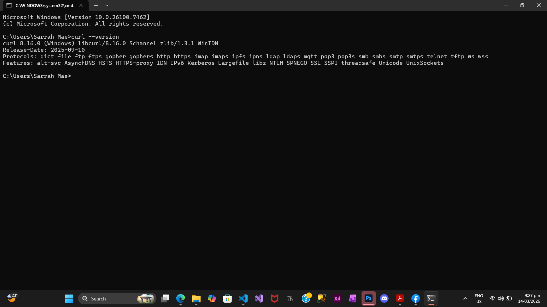
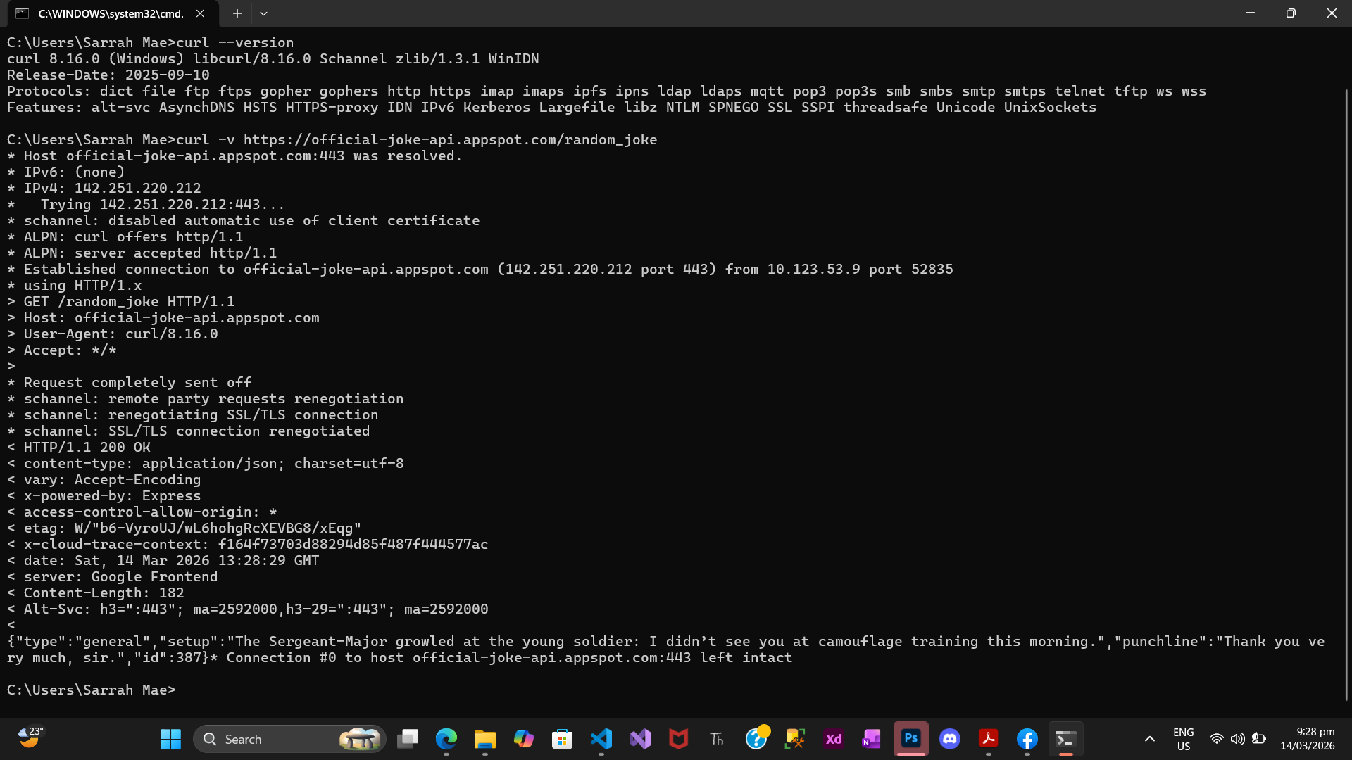

Questions:
- Identify the Method used in the output.
The HTTP method used is GET. It appears in the request line: > GET /random_joke HTTP/1.1. This means the client requested data from the API.

- Identify one Header returned by the server (e.g., Content-Type).
content-type: application/json; charset=utf-8

- What format is the Payload (the actual joke data) returned in?
The payload is returned in JSON (JavaScript Object Notation) format. For example:
{"type":"general","setup":"The Sergeant-Major growled at the young soldier: I didn’t see you at camouflage training this morning.","punchline":"Thank you very much, sir.","id":387}

