- Had put a new item
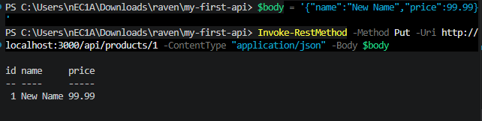

- CHECKED DATA
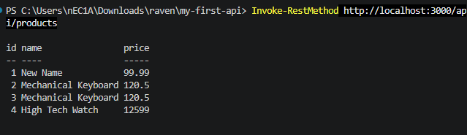

- HAD PUT GAMING MOUSE
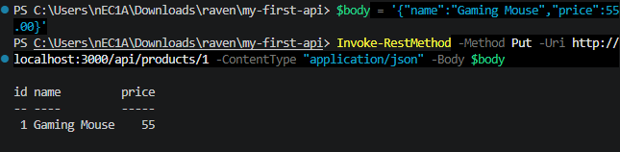

- CHECKED ON THE BROWSER
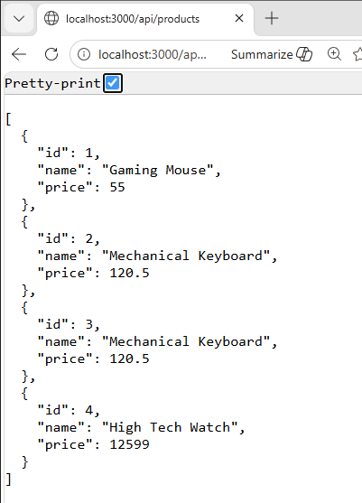

- DELETED AN ITEM
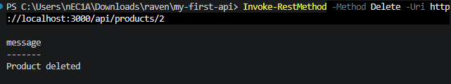

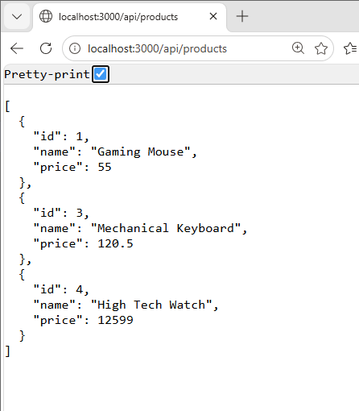
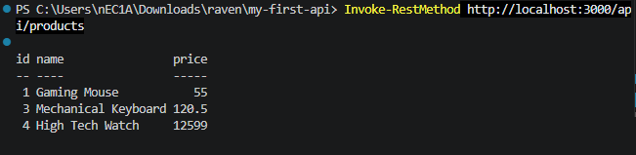
ANSWERS TO THE QUESTIONS:
1. PUT is idempotent and follows a strict synchronous contract, the client sends the complete representation for the resource at a known URL and the server stores/overwrites that representation. POST is for creating/submitting (non‑idempotent) operations or when the server assigns the new resource’s location.

- 404 accurately informs the client the resource didn’t exist so the client can handle it (retry, surface an error, etc.). Returning “success” would silently hide problems, mask bugs or stale state, and break correct REST semantics and client-side logic.

- This Node.js app is the API/application (backend) layer. a RESTful resource server or microservice that implements business logic and persistence.
MEMBERS:
April Rey Bayog
Jann Mhareoul Abancio
Raven Gadayan

