- ITS WORKING
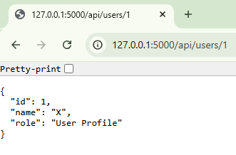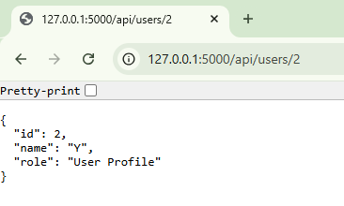
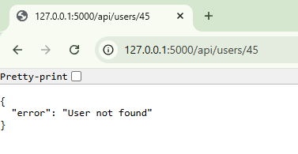
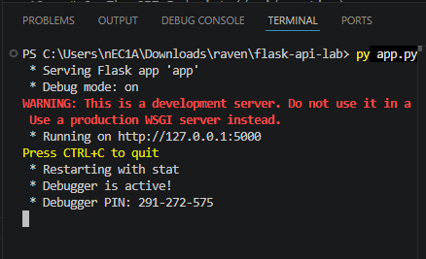

ANSWERS:
1. The Parameter Contract: Flask vs Express

Flask and Express handle URL parameters in fundamentally different ways due to their language and design philosophies. In Flask, parameters are defined directly in the route decorator using <int:id>int:id, and they automatically become function arguments—so in the handler, we simply write def get_user(id): and use id directly. This feels very "natural" because the parameter is already a variable in your function's scope. Express, on the other hand, stores all request data in the req object, so you access parameters via req.params.id. This requires an extra step and feels more "object-based," but there's an advantage: as your route handler grows with middleware, authentication logic, and other request data, having everything accessible through the req object keeps your code organized. For small APIs, Flask's direct approach feels cleaner; for larger APIs with many handlers and complex logic, Express's approach scales better because all request context is in one place.

2. Error Handling: Chaining vs Tuples

Error handling reveals another key difference between the two frameworks. Flask uses tuple returns: return (jsonify({...}), 404), where the second element tells Flask to use that HTTP status code. Express uses method chaining: res.status(404).json({...}), which reads left-to-right and is immediately clear—set the status, then send the JSON. The Flask tuple approach is implicit and requires developers to understand the convention; a new team member might wonder why you're returning a tuple and what the second element means. Express's chaining is explicit and self-documenting. When you're building a large API with dozens of different error responses (400 for bad requests, 401 for unauthorized, 403 for forbidden, 404 for not found, 500 for server errors), Express's .status(CODE).json(...) pattern becomes significantly easier to read, maintain, and debug. Flask's tuple approach becomes verbose and less clear across many endpoints.

3. Language vs Protocol: The curl Command

Here's the remarkable thing: the curl command didn't change at all. You used the exact same syntax to test both the Flask and Express servers—only the port differed. Whether you were hitting Flask on port 5000 or Express on port 3000, the HTTP request was identical: curl http://127.0.0.1:PORT/api/users/1. This is a huge benefit to clients (whether they're mobile apps, web frontends, or other servers) because they only need to understand HTTP—the protocol, not the language. If your company decides to rewrite the entire backend from Python to Node.js, JavaScript to Go, or any language flip, the client doesn't care and doesn't need to change. The HTTP contract—verbs like GET and POST, URL paths, JSON bodies, and status codes—is what matters. This means your API is truly language-agnostic: a mobile developer can consume it without knowing what language powers it, and your backend can evolve independently without breaking clients. The protocol is the real contract; the language is just an implementation detail.

4. Environment Abstraction: .env files

Hardcoding secrets directly into app.py or server.js is dangerous because those files end up in version control—GitHub, GitLab, shared drives, backup archives—and suddenly your API key, database password, or JWT secret is exposed to everyone who has access to the repository. Using a .env file keeps secrets separate: you create .env locally, put it in .gitignore so it's never committed, and then your code reads from it using process.env.DATABASE_URL or similar. This way, the code itself (which is safe to share) never contains the actual secrets. It also provides flexibility: you can use one set of credentials for development, another for staging, and yet another for production, all without changing your code. Different team members or different servers can have different .env files with appropriate values for their environment. When someone clones your repository, they get all the code but no secrets—they create their own .env file with their own credentials. This separation of code and configuration is a security best practice and makes deployment much cleaner and safer.

MEMBERS:
April Rey Bayog
Jann Mhareoul Abancio
Raven Gadayan

