Lab 9.
Leader: Manny Cabaya
Members: Melinda Nipes
Kecel Dujali
Shine Tayogandaga
Isabel Ingrid Monarca
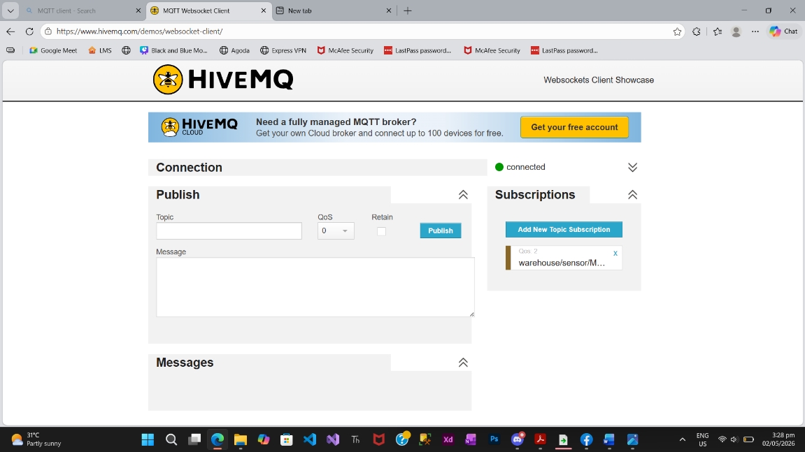
- Part 1

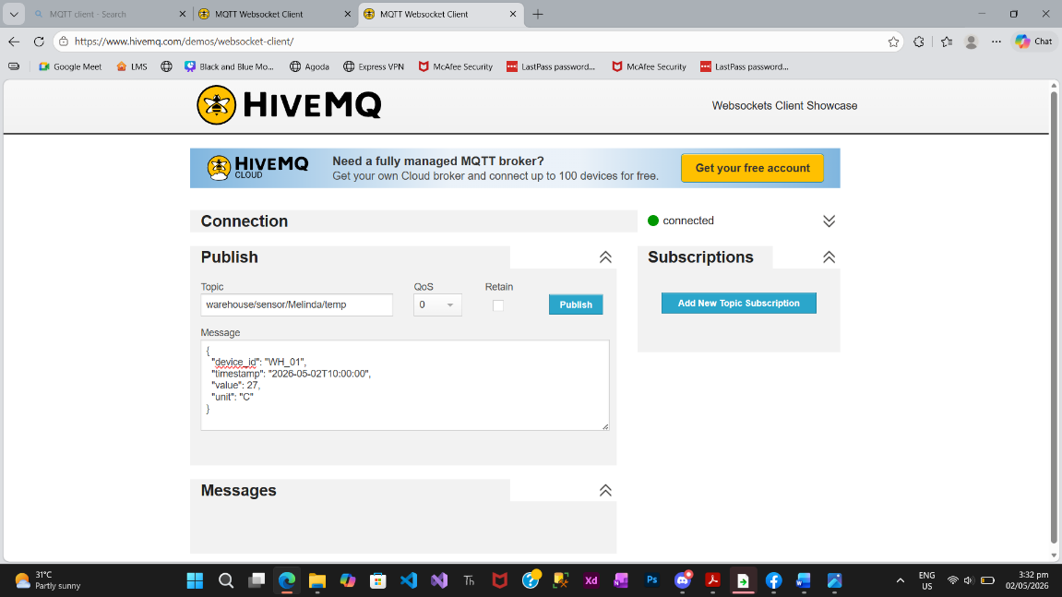
- Part 2
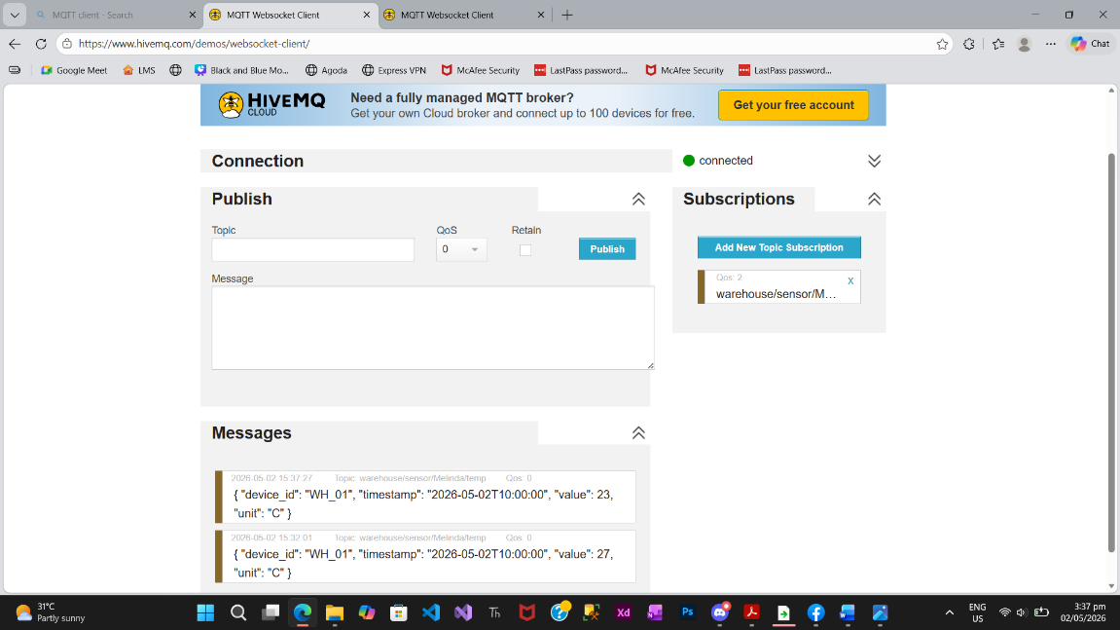
- Part 3
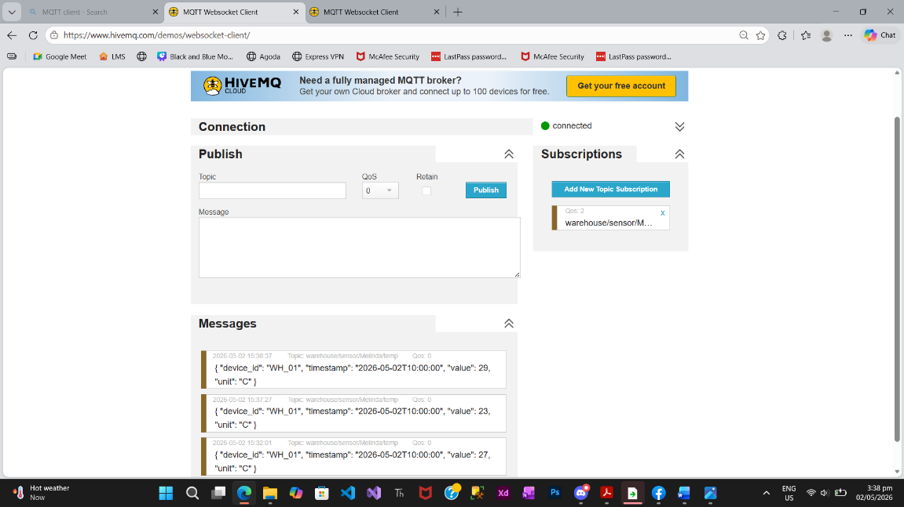

- Tasks
- Did you notice a delay between clicking "Publish" and seeing the message in the "Subscriber" window? Why is low latency important for a warehouse fire sensor?
- There was almost no delay between clicking "Publish" and seeing the message in the subscriber window. The message appeared very fast. This is important for a warehouse fire sensor because it needs to send alerts immediately. If there is a delay, the fire might spread before anyone can respond, which can cause damage and danger.
- Did the "Device" need to know anything about the "Subscriber" (IP address, OS, etc.) to send the data? Explain how the Broker facilitates this "anonymity."
- The device does not need to know anything about the subscriber, like its IP address or system. It just sends data to a topic. The broker is the one responsible for delivering the message to anyone who subscribed to that topic. This makes the system simple because the device and the receiver do not need to communicate directly.
- What happens to the "System" if the "Device" sends a message to the wrong topic (e.g., warehouse/sensor/temp instead of your specific name)?
- If the device sends a message to the wrong topic, the system will not receive it. This is because MQTT only delivers messages when the topic matches exactly. So if there is even a small difference in the topic name, the message will be lost.

