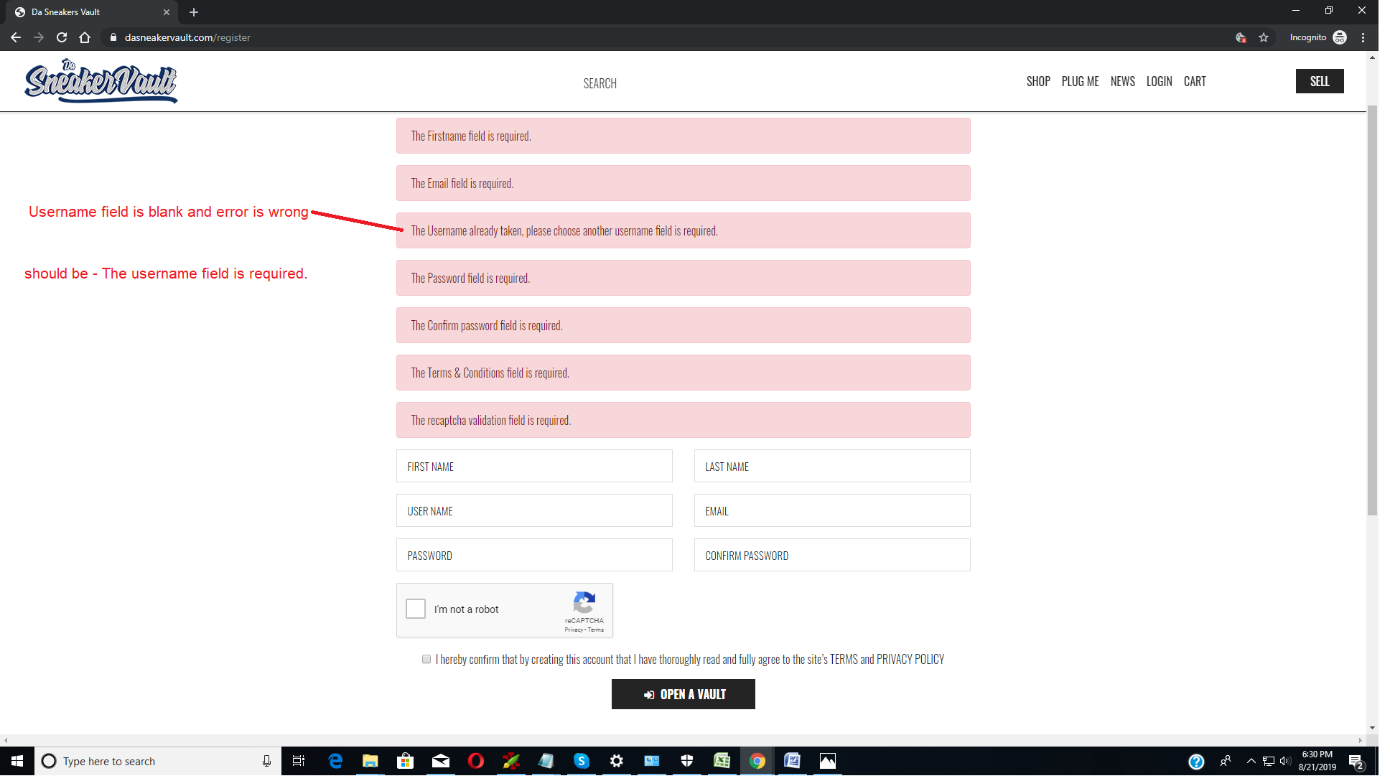
1) Validation Error Message Content.

2) Change Color Of Error Message

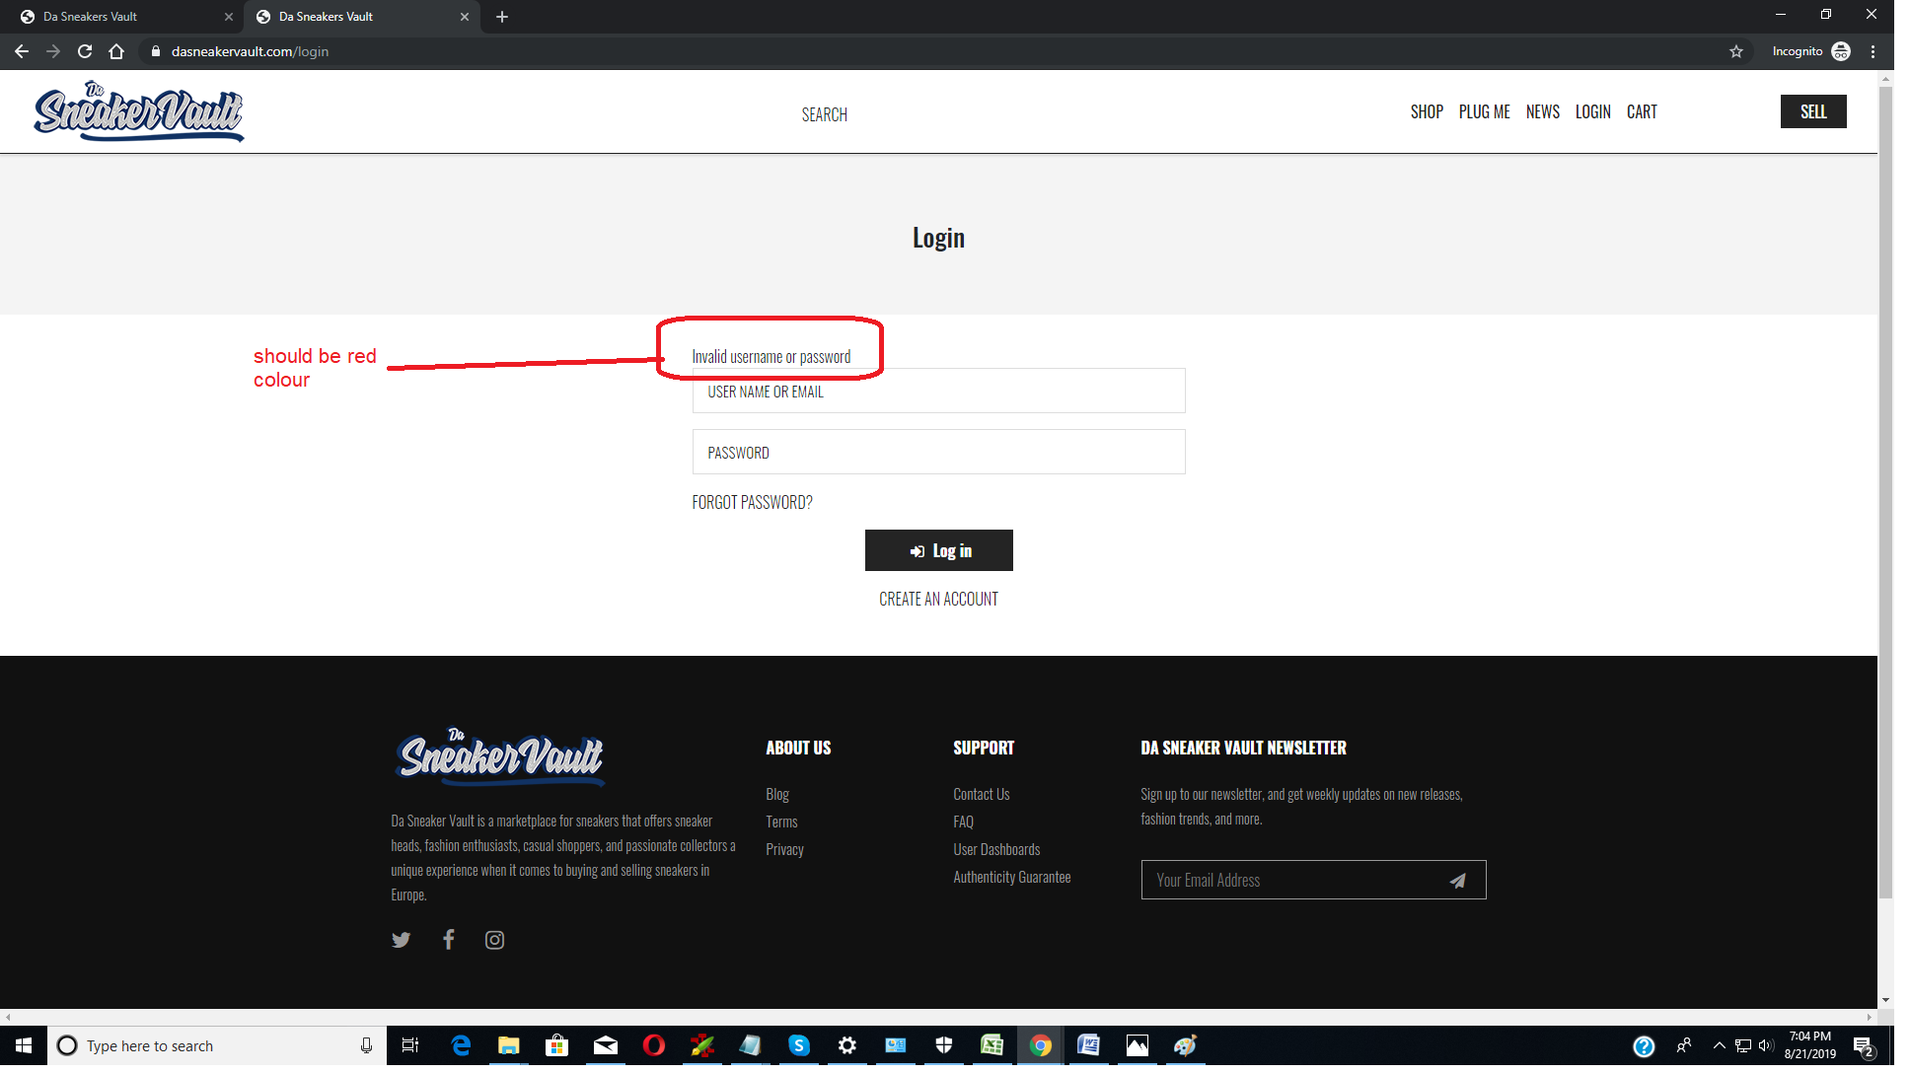

3) Once Product Add to wishlist after page refresh and on secondtime login it should be seen as Added to wishlist
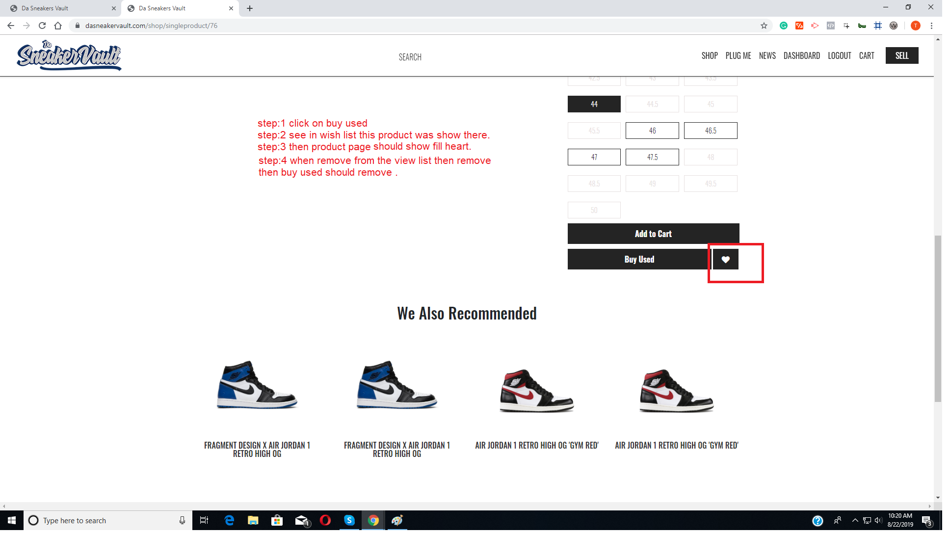

4) Remove button is not working.

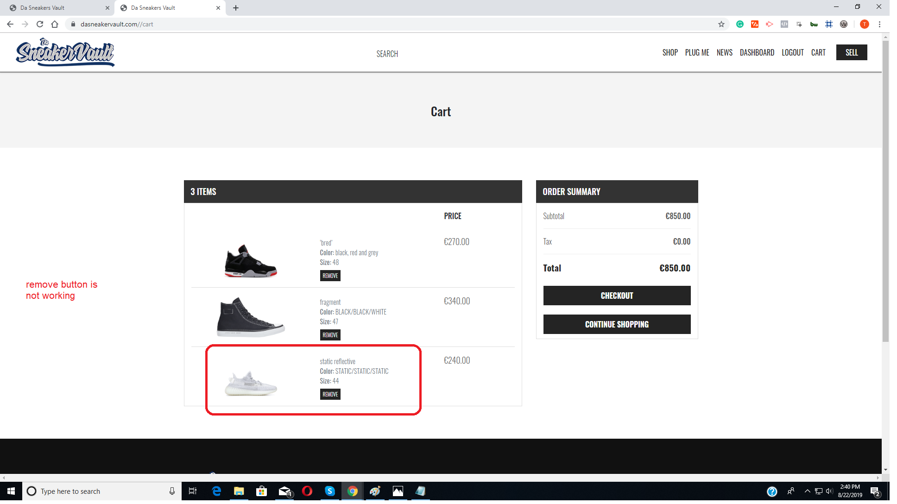
5) After Successfully Insert Address ‘Done’ Message not show proper(jQuery issue).

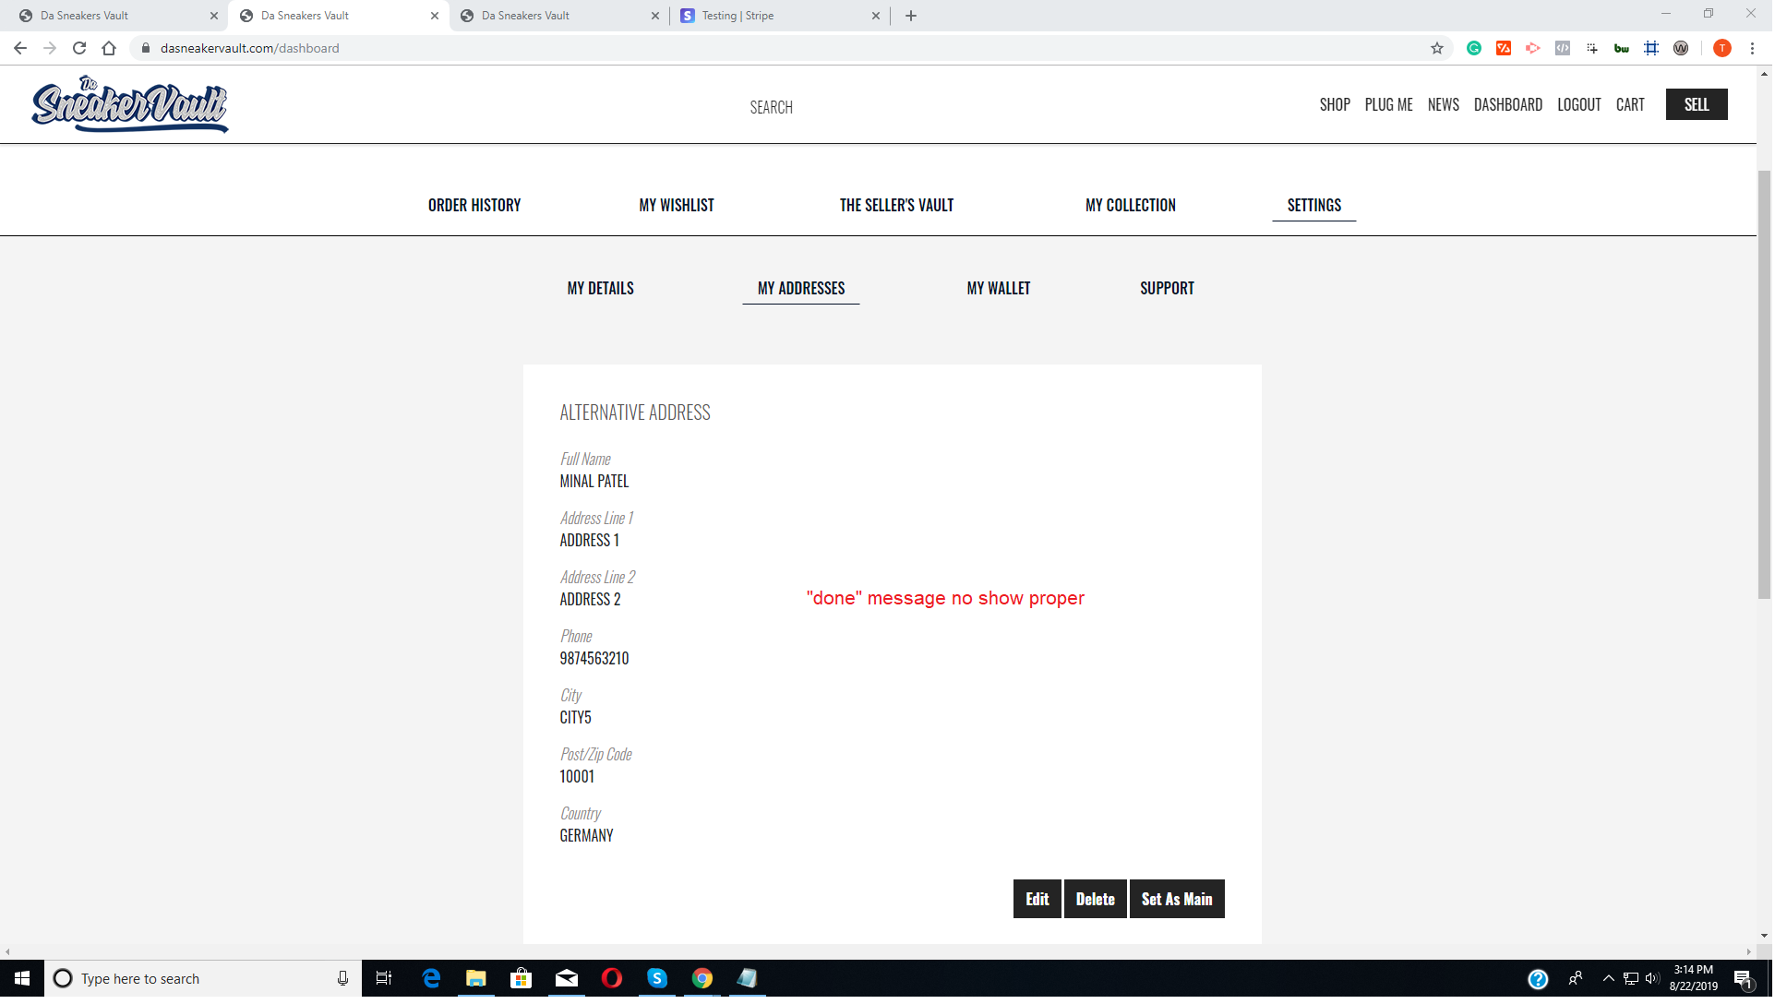
6) If user was already subscribe then email will not send in second time

