import pandas as pd  
import matplotlib.pyplot as plt  
  
from sklearn import model_selection  
from sklearn.preprocessing import StandardScaler  
from sklearn.neural_network import MLPClassifier  
  
from sklearn.metrics import classification_report  
from sklearn.metrics import confusion_matrix  
from sklearn.metrics import accuracy_score  
  
from sklearn import preprocessing  
from yellowbrick.classifier import ConfusionMatrix

df = pd.read_csv("letter-recognition.data", sep = ",")

df.head(10)

T 2 8 3 5 1 8.1 13 0 6 6.1 10 8.2 0.1 8.3 0.2 8.4  
0 I 5 12 3 7 2 10 5 5 4 13 3 9 2 8 4 10  
1 D 4 11 6 8 6 10 6 2 6 10 3 7 3 7 3 9  
2 N 7 11 6 6 3 5 9 4 6 4 4 10 6 10 2 8  
3 G 2 1 3 1 1 8 6 6 6 6 5 9 1 7 5 10  
4 S 4 11 5 8 3 8 8 6 9 5 6 6 0 8 9 7  
5 B 4 2 5 4 4 8 7 6 6 7 6 6 2 8 7 10  
6 A 1 1 3 2 1 8 2 2 2 8 2 8 1 6 2 7  
7 J 2 2 4 4 2 10 6 2 6 12 4 8 1 6 1 7  
8 M 11 15 13 9 7 13 2 6 2 12 1 9 8 1 1 8  
9 X 3 9 5 7 4 8 7 3 8 5 6 8 2 8 6 7

names = ['Class',  
 'x-box',  
 'y-box',  
 'width',  
 'high',  
 'onpix',  
 'x-bar',  
 'y-bar',  
 'x2bar',  
 'y2bar',  
 'xybar',  
 'x2ybr',  
 'xy2br',  
 'x-ege',  
 'xegvy',  
 'y-ege',  
 'yegvx']

X = df.iloc[:, 1 : 17]  
Y = df.select_dtypes(include = [object])

X_train, X_test, Y_train, Y_test = model_selection.train_test_split(X, Y, test_size = 0.20, random_state = 10)

scaler = StandardScaler()  
scaler.fit(X_train)

StandardScaler()

X_train = scaler.transform(X_train)  
X_test = scaler.transform(X_test)

mlp = MLPClassifier(hidden_layer_sizes = (250, 300), max_iter = 1000000, activation = 'logistic')

cm = ConfusionMatrix(mlp, classes="A,B,C,D,E,F,G,H,I,J,K,L,M,N,O,P,Q,R,S,T,U,V,W,X,Y,Z".split(','))

cm.fit(X_train, Y_train.values.ravel())

ConfusionMatrix(ax=<Axes: >,  
 classes=['A', 'B', 'C', 'D', 'E', 'F', 'G', 'H', 'I', 'J', 'K',  
 'L', 'M', 'N', 'O', 'P', 'Q', 'R', 'S', 'T', 'U', 'V',  
 'W', 'X', 'Y', 'Z'],  
 cmap=<matplotlib.colors.ListedColormap object at 0x7f559436aa10>,  
 estimator=MLPClassifier(activation='logistic',  
 hidden_layer_sizes=(250, 300),  
 max_iter=1000000))

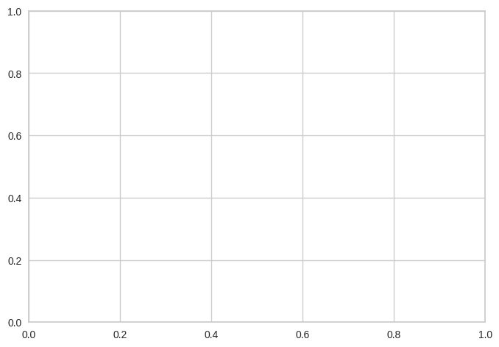

cm.score(X_test, Y_test)

/usr/local/lib/python3.10/dist-packages/sklearn/preprocessing/_label.py:116: DataConversionWarning: A column-vector y was passed when a 1d array was expected. Please change the shape of y to (n_samples, ), for example using ravel().  
 y = column_or_1d(y, warn=True)

0.9745

predictions = cm.predict(X_test)

print("Accuracy: ", accuracy_score(Y_test, predictions))

Accuracy: 0.9745

print(confusion_matrix(Y_test, predictions))

[[170 0 0 0 0 0 0 0 0 0 0 0 0 0 0 0 0 0  
 0 0 0 0 0 0 0 0]  
 [ 0 138 0 0 1 0 0 0 0 0 1 1 0 0 0 0 0 2  
 0 0 0 1 0 0 0 0]  
 [ 0 0 158 0 0 0 0 0 0 0 0 0 0 1 1 0 0 1  
 0 0 0 0 0 0 0 0]  
 [ 0 1 0 171 0 0 0 0 0 0 0 0 0 1 0 0 1 0  
 0 0 0 0 0 0 0 0]  
 [ 0 0 2 0 144 0 0 0 0 0 0 1 0 0 0 0 0 0  
 0 0 0 0 0 0 0 1]  
 [ 0 0 0 0 0 133 0 0 1 0 0 0 0 0 0 1 0 0  
 0 1 0 1 0 0 0 0]  
 [ 0 0 0 0 3 0 135 0 0 0 0 0 1 0 0 1 1 0  
 0 0 0 0 0 0 0 0]  
 [ 0 1 0 2 0 0 1 123 0 0 3 0 0 2 0 0 1 3  
 0 0 0 1 1 0 0 0]  
 [ 0 0 0 0 0 0 0 0 142 4 1 0 0 0 0 0 0 0  
 0 1 0 0 0 0 0 0]  
 [ 0 0 0 0 0 0 0 0 4 136 0 0 0 0 0 0 0 0  
 0 0 0 0 0 0 0 0]  
 [ 0 0 0 0 0 0 0 1 0 0 135 0 0 0 0 0 0 0  
 0 0 0 0 0 0 0 0]  
 [ 0 0 0 0 1 0 1 0 0 0 0 165 0 0 0 0 0 0  
 0 0 0 0 0 0 0 0]  
 [ 0 0 0 0 0 0 0 0 0 0 0 0 167 0 1 0 0 0  
 0 0 0 0 0 0 0 0]  
 [ 0 0 0 0 0 0 0 0 0 0 0 0 0 147 1 0 0 1  
 0 0 0 0 0 0 0 0]  
 [ 0 0 0 3 0 0 0 0 0 0 0 0 0 1 147 0 1 0  
 0 0 1 1 0 0 0 0]  
 [ 0 0 0 0 0 4 0 0 0 0 0 0 0 0 0 152 1 0  
 0 0 0 0 1 0 1 0]  
 [ 0 0 0 0 0 0 0 0 0 0 0 0 0 0 0 2 140 0  
 0 0 0 0 0 0 0 0]  
 [ 0 1 0 1 0 0 0 2 0 0 1 0 0 1 0 0 0 155  
 0 0 0 0 0 0 0 0]  
 [ 0 0 0 0 1 0 0 0 0 0 0 1 0 0 0 0 1 0  
 142 0 0 0 0 0 0 0]  
 [ 0 0 0 1 0 0 0 1 0 0 0 0 0 0 0 0 0 0  
 0 158 0 0 0 0 0 0]  
 [ 0 0 1 0 0 0 0 0 0 0 0 0 0 0 0 0 0 0  
 0 0 160 0 0 0 0 0]  
 [ 0 2 0 0 0 0 0 0 0 0 0 0 0 0 0 1 0 0  
 0 0 0 156 2 0 0 0]  
 [ 0 0 0 0 0 0 0 0 0 0 1 0 1 0 0 0 0 0  
 0 0 0 0 156 0 0 0]  
 [ 0 0 0 0 0 0 0 0 0 0 1 0 0 0 0 0 0 0  
 0 0 0 0 0 162 0 0]  
 [ 0 0 0 0 0 0 0 0 0 0 0 0 0 0 0 0 1 0  
 0 1 0 2 0 0 163 0]  
 [ 0 0 0 1 2 0 0 0 0 1 0 0 0 0 0 0 0 0  
 0 1 0 0 0 0 0 143]]

print(classification_report(Y_test, predictions, digits=5))

precision recall f1-score support  
  
 A 1.00000 1.00000 1.00000 170  
 B 0.96503 0.95833 0.96167 144  
 C 0.98137 0.98137 0.98137 161  
 D 0.95531 0.98276 0.96884 174  
 E 0.94737 0.97297 0.96000 148  
 F 0.97080 0.97080 0.97080 137  
 G 0.98540 0.95745 0.97122 141  
 H 0.96850 0.89130 0.92830 138  
 I 0.96599 0.95946 0.96271 148  
 J 0.96454 0.97143 0.96797 140  
 K 0.94406 0.99265 0.96774 136  
 L 0.98214 0.98802 0.98507 167  
 M 0.98817 0.99405 0.99110 168  
 N 0.96078 0.98658 0.97351 149  
 O 0.98000 0.95455 0.96711 154  
 P 0.96815 0.95597 0.96203 159  
 Q 0.95238 0.98592 0.96886 142  
 R 0.95679 0.96273 0.95975 161  
 S 1.00000 0.97931 0.98955 145  
 T 0.97531 0.98750 0.98137 160  
 U 0.99379 0.99379 0.99379 161  
 V 0.96296 0.96894 0.96594 161  
 W 0.97500 0.98734 0.98113 158  
 X 1.00000 0.99387 0.99692 163  
 Y 0.99390 0.97605 0.98489 167  
 Z 0.99306 0.96622 0.97945 148  
  
 accuracy 0.97450 4000  
 macro avg 0.97426 0.97382 0.97389 4000  
weighted avg 0.97470 0.97450 0.97446 4000

cm.poof()

<Figure size 800x550 with 0 Axes>

<Axes: title={'center': 'MLPClassifier Confusion Matrix'}, xlabel='Predicted Class', ylabel='True Class'>