import numpy as np
import matplotlib.pyplot as plt
import tensorflow as tf
from tensorflow import keras
from sklearn.metrics import confusion_matrix
import seaborn as sns
(x_train, y_train), (x_test, y_test) = keras.datasets.fashion_mnist.load_data()
x_train = x_train / 255.0
x_test = x_test / 255.0
x_train = x_train.reshape(-1, 28, 28, 1)
x_test = x_test.reshape(-1, 28, 28, 1)
class_names = ['T_shirt/top', 'Trouser', 'Pullover', 'Dress', 'Coat',
'Sandal', 'Shirt', 'Sneaker', 'Bag', 'Ankle boot']
plt.figure(figsize=(12, 8))
plt.subplot(2, 2, 1)
classes, counts = np.unique(y_train, return_counts=True)
plt.barh(class_names, counts)
plt.title('Class distribution in training set')
plt.subplot(2, 2, 2)
classes, counts = np.unique(y_test, return_counts=True)
plt.barh(class_names, counts)
plt.title('Class distribution in testing set')
Text(0.5, 1.0, 'Class distribution in testing set')
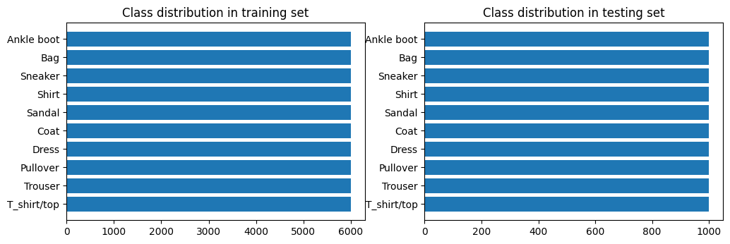
plt.figure(figsize=(10, 10))
for i in range(25):
plt.subplot(5, 5, i + 1)
plt.xticks([])
plt.yticks([])
plt.grid(False)
plt.imshow(x_train[i].reshape((28,28)), cmap=plt.cm.binary)
label_index = int(y_train[i])
plt.title(class_names[label_index])
plt.show()
plt.tight_layout()
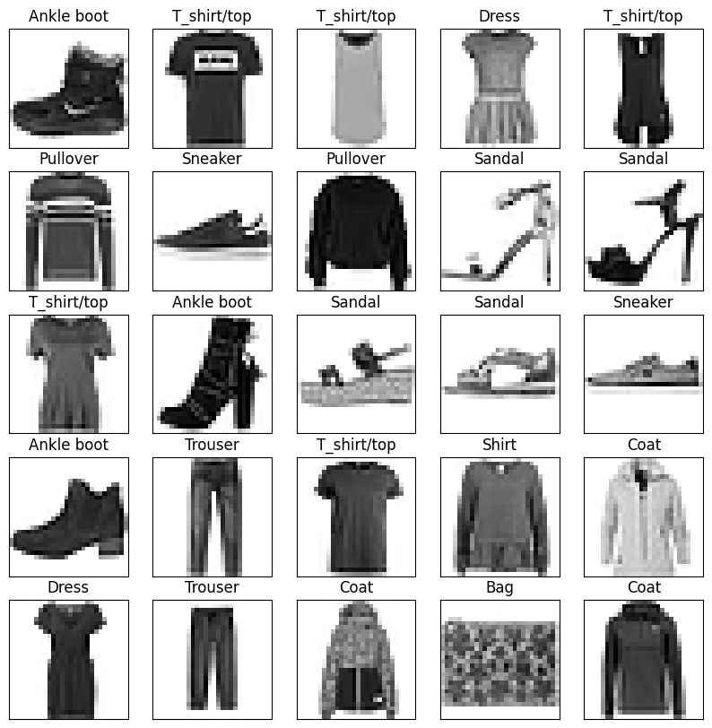
<Figure size 640x480 with 0 Axes>
model = keras.Sequential([
keras.layers.Conv2D(32, (3,3), padding='same', activation='relu', input_shape=(28,28,1)),
keras.layers.MaxPooling2D((2,2)),
keras.layers.Conv2D(64, (3,3), padding='same', activation='relu'),
keras.layers.MaxPooling2D((2,2)),
keras.layers.Flatten(),
keras.layers.Dense(128, activation='relu'),
keras.layers.Dense(10, activation='softmax')
])
model.compile(optimizer='adam',
loss='sparse_categorical_crossentropy',
metrics=['accuracy'])
history=model.fit(x_train, y_train, epochs=10, validation_data=(x_test, y_test))
Epoch 1/10
1875/1875 [==============================] - 8s 4ms/step - loss: 0.0171 - accuracy: 0.9942 - val_loss: 0.6936 - val_accuracy: 0.9169
Epoch 2/10
1875/1875 [==============================] - 8s 4ms/step - loss: 0.0164 - accuracy: 0.9944 - val_loss: 0.6583 - val_accuracy: 0.9178
Epoch 3/10
1875/1875 [==============================] - 8s 4ms/step - loss: 0.0168 - accuracy: 0.9942 - val_loss: 0.6231 - val_accuracy: 0.9160
Epoch 4/10
1875/1875 [==============================] - 9s 5ms/step - loss: 0.0173 - accuracy: 0.9944 - val_loss: 0.7320 - val_accuracy: 0.9165
Epoch 5/10
1875/1875 [==============================] - 9s 5ms/step - loss: 0.0176 - accuracy: 0.9940 - val_loss: 0.6497 - val_accuracy: 0.9144
Epoch 6/10
1875/1875 [==============================] - 8s 4ms/step - loss: 0.0150 - accuracy: 0.9952 - val_loss: 0.6907 - val_accuracy: 0.9102
Epoch 7/10
1875/1875 [==============================] - 8s 4ms/step - loss: 0.0148 - accuracy: 0.9953 - val_loss: 0.7698 - val_accuracy: 0.9109
Epoch 8/10
1875/1875 [==============================] - 8s 4ms/step - loss: 0.0131 - accuracy: 0.9956 - val_loss: 0.7287 - val_accuracy: 0.9142
Epoch 9/10
1875/1875 [==============================] - 7s 4ms/step - loss: 0.0160 - accuracy: 0.9948 - val_loss: 0.7779 - val_accuracy: 0.9143
Epoch 10/10
1875/1875 [==============================] - 8s 4ms/step - loss: 0.0143 - accuracy: 0.9954 - val_loss: 0.7447 - val_accuracy: 0.9122
test_loss, test_acc = model.evaluate(x_test, y_test)
print('Test accuracy:', test_acc)
313/313 [==============================] - 1s 3ms/step - loss: 0.7447 - accuracy: 0.9122
Test accuracy: 0.9121999740600586
plt.figure(figsize=(12, 8))
plt.subplot(2, 2, 1)
plt.plot(history.history['loss'], label='Loss')
plt.plot(history.history['val_loss'], label='val_Loss')
plt.legend()
plt.title('Loss evolution')
plt.subplot(2, 2, 2)
plt.plot(history.history['accuracy'], label='accuracy')
plt.plot(history.history['val_accuracy'], label='val_accuracy')
plt.legend()
plt.title('Accuracy evolution')
Text(0.5, 1.0, 'Accuracy evolution')
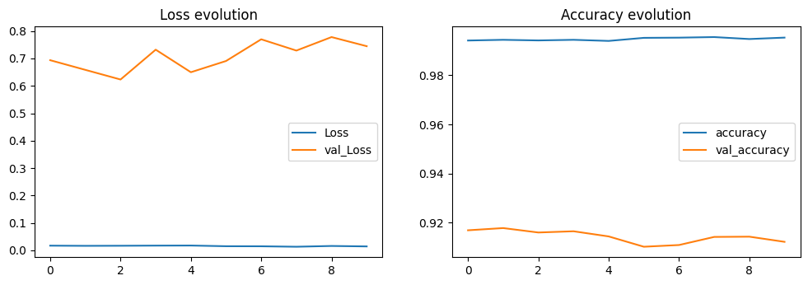
predicted_classes = model.predict(x_test)
predicted_classes = np.argmax(predicted_classes, axis=1)
313/313 [==============================] - 1s 2ms/step
test_img = x_test[0]
prediction = model.predict(x_test)
prediction[0]
313/313 [==============================] - 1s 2ms/step
array([3.2138594e-23, 5.0813801e-24, 6.0510769e-29, 9.1683159e-26,
6.6259837e-30, 5.6733923e-21, 2.8058322e-30, 1.2856535e-21,
1.1930662e-27, 1.0000000e+00], dtype=float32)
np.argmax(prediction[0])
9
L = 5
W = 5
fig, axes = plt.subplots(L, W, figsize = (12,12))
axes = axes.ravel()
for i in np.arange(0, L * W):
axes[i].imshow(x_test[i].reshape(28,28))
axes[i].set_title(f"Prediction Class = {(predicted_classes[i]):0.1f}\n True Class = {y_test[i]:0.1f}")
axes[i].axis('off')
plt.subplots_adjust(wspace=0.5)
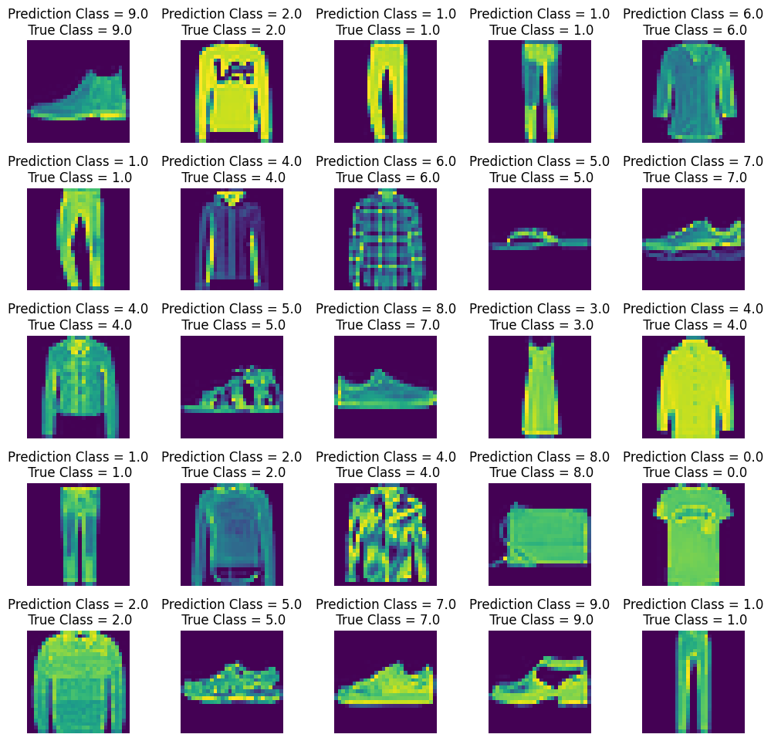
cm = confusion_matrix(y_test, predicted_classes)
plt.figure(figsize = (14,10))
sns.heatmap(cm, annot=True)
<Axes: >
