**Digital Assignment 1**

**Name: Kumar Shubham**

**Regno: 15BCE1283**

**Question 1**

Write a PHP script to read a file, reverse its contents and write the result back to a new file.

**Code:**

**Step 1:** make 2 text documents namely first.txt and second.txt respectively.

**Fill these details in first.txt**

My name is Pushpit Bagga

This is my contact number: 9873561992

**Create an empty text document named as second.txt**

**Code: q1.php**

<?php

$a1 = fopen("first.txt", "r");

$a2 = fopen("second.txt", "w");

for($i = 0; fseek($a1, $i, SEEK_END) !== -1; $i--) {

$text=fgetc($a1);

fwrite($a2,$text);

}

fclose($a1);

fclose($a2);

header("location: q1_1.php");

?>

**q1_1.php**

<?php

$file = fopen("second.txt", "r");

echo "Reveresed File <br><br>";

while (!feof($file)) {

echo fgets($file) . '<br>';

}

?>

**Output in the file second.txt will be**

2991653789 :rebmun tcatnoc ym si sihT

aggaB tiphsuP si eman yM

**Question 2**

Design an html file named grade that gets the marks of 5 subjects from the students. Inside the html program write a corresponding javascript code to get the marks entered and display the corresponding grades in the following format.

A → numeric grade >= 90 B → numeric grade >= 80 C → numeric grade >= 70 NP → otherwise

**Code:**

<!DOCTYPE html>

<html>

<head>

<title>Digital Assignment 1</title>

</head>

<body>

Enter Marks for Mathematics:

<input type="text" id="math"><br><br>

Enter Marks for Chemistry:

<input type="text" id="chem"><br><br>

Enter Marks for Physics:

<input type="text" id="phy"><br><br>

Enter Marks for Biology:

<input type="text" id="bio"><br><br>

Enter Marks for Computer Science:

<input type="text" id="comp"><br><br>

<input type="submit" onclick="grade();"><br><br><br><br>

<label>Output</label><br><br>

<label id="m"></label><br>

<label id="c"></label><br>

<label id="p"></label><br>

<label id="b"></label><br>

<label id="co"></label>

</body>

<script>

function grade(){

/*for Mathematics*/

var math=document.getElementById('math').value;

if(math>=90)

{ document.getElementById('m').innerHTML= "Grade For Mathematics is A";}

else if(math>=80 && math<90){

document.getElementById('m').innerHTML="Grade For Mathematics is B"; }

else if(math>=70 && math<80){

document.getElementById('m').innerHTML="Grade For Mathematics is C";

}

else if(math<70){

document.getElementById('m').innerHTML="Grade For Mathematics is NP";

}

/*for Chemistry*/

var chem=document.getElementById('chem').value;

if(chem>=90)

{ document.getElementById('c').innerHTML="Grade For Chemistry is A";}

else if(chem>=80 && chem<90){

document.getElementById('c').innerHTML="Grade For Chemistry is B"; }

else if(chem>=70 && chem<80){

document.getElementById('c').innerHTML="Grade For Chemistry is C";

}

else if(chem<70){

document.getElementById('c').innerHTML="Grade For Chemistry is NP";

}

/*for Physics*/

var phy=document.getElementById('phy').value;

if(phy>=90)

{ document.getElementById('p').innerHTML="Grade For Physics is A";}

else if(phy>=80 && phy<90){

document.getElementById('p').innerHTML="Grade For Physics is B"; }

else if(phy>=70 && phy<80){

document.getElementById('p').innerHTML="Grade For Physics is C";

}

else if(phy<70){

document.getElementById('p').innerHTML="Grade For Physics is NP";

}

/*for Biology*/

var bio=document.getElementById('bio').value;

if(bio>=90)

{ document.getElementById('b').innerHTML="Grade For Biology is A";}

else if(bio>=80 && bio<90){

document.getElementById('b').innerHTML="Grade For Biology is B"; }

else if(bio>=70 && bio<80){

document.getElementById('b').innerHTML="Grade For Biology is C";

}

else if(bio<70){

document.getElementById('b').innerHTML="Grade For Biology is NP";

}

/*for Computer*/

var comp=document.getElementById('comp').value;

if(comp>=90)

{ document.getElementById('co').innerHTML="Grade For Computer is A";}

else if(comp>=80 && comp<90){

document.getElementById('co').innerHTML="Grade For Computer is B"; }

else if(comp>=70 && comp<80){

document.getElementById('co').innerHTML="Grade For Computer is C";

}

else if(comp<70){

document.getElementById('co').innerHTML="Grade For Computer is NP";

}

}

</script>

</html>

**Question 3**

**3.1** In the following exercise you will create a CSS3 Zebra Striping a Table. On completion, the page will look like following.

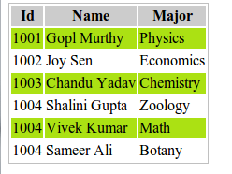

**Code:**

<!DOCTYPE html>

<html>

<head>

<title>Zebra Striping a Table</title>

<style>

table{

border: 1px solid black;

}

#main{

background-color: #bdbdbd;

}

tr:nth-child(even) {

background: #aeea00;

}

</style>

</head>

<body>

<table>

<tr id="main">

<th>Id</th>

<th>Name</th>

<th>Major</th>

</tr>

<tr>

<td>1001</td>

<td>Gopl Murthy</td>

<td>Physics</td>

</tr>

<tr>

<td>1002</td>

<td>Joy Sen</td>

<td>Economics</td>

</tr>

<tr>

<td>1003</td>

<td>Chandu Yadav</td>

<td>Chemistry</td>

</tr>

<tr>

<td>1004</td>

<td>Shalini Gupta</td>

<td>Zoology</td>

</tr>

<tr>

<td>1004</td>

<td>Vivek Kumar</td>

<td>Math</td>

</tr>

<tr>

<td>1004</td>

<td>Sameer Ali</td>

<td>Botany</td>

</tr>

</table>

</body>

</html>

**3.2** In the following exercise you will create a navigation bar. On completion, the page will look like following

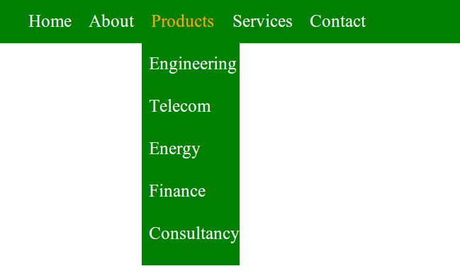

**Code:**

<!DOCTYPE html>

<html>

<head>

<style>

ul {

list-style-type: none;

margin: 0;

padding: 0;

overflow: hidden;

background-color: green;

width: 35%;

}

li {

float: left;

}

li a, .dropbtn {

display: inline-block;

color: white;

text-align: center;

padding: 14px 16px;

text-decoration: none;

}

li a:hover, .dropdown:hover .dropbtn {

color: yellow;

}

li.dropdown {

display: inline-block;

}

.dropdown-content {

display: none;

position: absolute;

background-color: green;

min-width: 160px;

box-shadow: 0px 8px 16px 0px rgba(0,0,0,0.2);

}

.dropdown-content a {

color: white;

padding: 12px 16px;

text-decoration: none;

display: block;

text-align: left;

}

.dropdown-content a:hover {background-color: green;

}

.dropdown:hover .dropdown-content {

display: block;

}

</style>

</head>

<body>

<ul>

<li><a class="active" href="#home">Home</a></li>

<li><a href="#news">About</a></li>

<li class="dropdown">

<a href="#" class="dropbtn">Products</a>

<div class="dropdown-content">

<a href="#">Engineering</a>

<a href="#">Telecom</a>

<a href="#">Energy</a>

<a href="#">Finance</a>

<a href="#">Consultancy</a>

</div>

</li>

<li><a class="active" href="#home">Services</a></li>

<li><a href="#news">Contact</a></li>

</ul>

</body>

</html>

**Question 4**

Design the below form to get the student details. Perform validation using JavaScript.

**Student Information**



First Name:



Last Name:



Phone#



section #



email:

Explain your educational goals. Why are you at VIT and why have you enrolled in this class.



Describe your previous experience with computers



Share your personal story, introduce us to your family and friends and tell us about your hobbies and interests.



Congratulations to all of you who successfully completed this page. You have one more hurdle to jump.

**Code:**

<!DOCTYPE html>

<html>

<head>

<title>Student Information</title>

<style>

#header{

background-color: #cccc99;

padding:1em;

width: 60%;

}

#stud{

font-size: 2em;

position: relative;

top: 0.5em;

}

textarea {

overflow-y: scroll;

overflow-x: scroll;

height: 200px;

width: 200px;

resize: none;

}

</style>

</head>

<body>

<div id="header">

<label id="stud">Student Information</label>

</div><br><br>

<form method="post" name="myForm" onsubmit="return validateForm();">

<table>

<tr>

<th>First Name: </th>

<th><input type="text" name="fname" id="fname"></th>

</tr>

<tr>

<th>Last Name: </th>

<th><input type="text" name="lname" id="lname"></th>

</tr>

<tr>

<th>Phone# </th>

<th><input type="text" name="phone" id="phone"></th>

</tr>

<tr>

<th>section# </th>

<th><input type="text" name="section" id="section"></th>

</tr>

<tr>

<th>email: </th>

<th><input type="text" name="email" id="email"></th>

</tr>

</table>

<p>Explain your educational goals. Why are you at VIT and why have you enrolled in this class.</p>

<textarea style="margin-left:1.7em;" cols="30" rows="15">

</textarea>

<p>Describe your previous experience with computers</p>

<textarea style="margin-left:1.7em;" cols="30" rows="15">

</textarea>

<p>Share your personal story, introduce us to your family and friends and tell us about your

hobbies and interests.</p>

<textarea style="margin-left:1.7em;" cols="30" rows="15">

</textarea>

<p>Congratulations to all of you who successfully completed this page. You have one more

hurdle to jump.</p> <br>

<input type="submit" value="Check in">&nbsp;&nbsp;

<input type="submit" value="Clear">

</form>

</body>

<script>

function validateForm() {

var fname = document.forms["myForm"]["fname"].value;

if(fname==""){

alert("First Name is required");

}

else if(/[^A-Za-z\s]/.test(fname)){

alert("Invalid First Name");

}

var lname = document.forms["myForm"]["lname"].value;

if(lname==""){

alert("Last Name is required")

}

else if(/[^A-Za-z\s]/.test(lname)){

alert("Invalid Last Name");

}

var phone = Number(document.forms["myForm"]["phone"].value);

if(phone==""){

alert("Phone Number is required");

}

else if(Number.isNaN(phone)){

alert("Invalid Phone Number");

}

var section = document.forms["myForm"]["section"].value;

if(section==""){

alert("Section is required");

}

else if(/[^A-Za-z\s]/.test(section)){

alert("Invalid Section");

}

var email = document.forms["myForm"]["email"].value;

var atpos = email.indexOf("@");

var dotpos = email.lastIndexOf(".");

if(email==""){

alert("email is required");

}

else if (atpos<1 || dotpos<atpos+2 || dotpos+2>=email.length) {

alert("Not a valid e-mail address");

}

return false;

}

</script>

</html>

**Question 5**

Create the following HTML Form and perform client side validation using JavaScript.

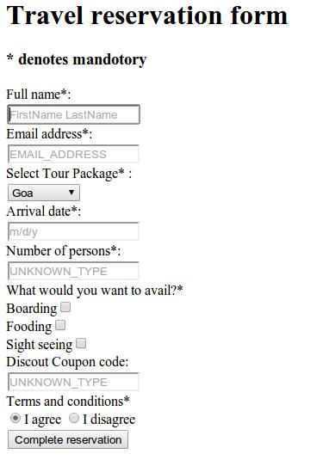

**Code:**

<!DOCTYPE html>

<html lang="en">

<head>

<meta charset="UTF-8">

<title>Travel Reservation form</title>

</head>

<body>

<h1 style="text-align:center;">Travel reservation Form</h1>

<div class="container">

* denotes mandatory

<form>

<div class="form-group">

<label for="Fullname">Full name*:</label><br />

<input type="text" placeholder="FirstName LastName" id="fullname">

</div>

<div class="form-group">

<label for="EmailAddress">EmailAddress*:</label><br/>

<input type="email" placeholder="EMAIL_ADDRESS" id="email">

</div>

<div class="form-group">

<label for="tour">Select Tour Package* :</label><br />

<select id="tour_pakage">

<option value="Goa">Goa</option>

<option value="Goa">Delhi</option>

<option value="Goa">Bangalore</option>

</select>

</div>

<div class="form-group">

<label for="Arrival">Arrival Date*:</label><br>

<input type="date" placeholder="m/d/y" id="arrival">

</div>

<div class="form-group">

<label for="Number">Number of Persons*: </label><br>

<input type="text" placeholder="UNKNOWN_TYPE" id="number">

</div>

<div class="form-group">

<label for="what">What would you like to avail?*</label><br>

Boarding <input type="checkbox" name="avail" id="b"><br>

Fooding<input type="checkbox" name="avail" id="f"><br>

Sight Seeing <input type="checkbox" name="avail" id="s">

</div>

<div class="form-group">

Discount Coupon Code: <br>

<input type="text" placeholder="UNKNOWN_TYPE" id="code">

</div>

<div class="form-group">

<label for="Terms">Terms and conditions*</label><br/>

<input type="radio" name="terms" id="agree">I agree

<input type="radio" id="disagree" name="terms">I disagree

</div>

<div class="form-group">

<input type="button" onclick="test()" value="Complete Reservation" />

</div>

</form>

</div>

</body>

<script>

function test(){

var name = document.getElementById('fullname').value;

var email = document.getElementById('email').value;

var tour_pakage = document.getElementById('tour_pakage').value;

var arrival = document.getElementById('arrival').value;

var num = document.getElementById('number').value;

var agree = document.getElementById('agree').checked;

var disagree = document.getElementById('disagree').checked;

var b = document.getElementById('b').checked;

var f = document.getElementById('f').checked;

var s = document.getElementById('s').checked;

if(!name || !email || !arrival || !num || disagree || (!b && !f && !s)){

alert('Unable to complete. Please check the values');

}

else{

emailCheck = validateEmail(email);

if(!emailCheck){

alert("Email format is wrong");

}

else{

alert('Successful');

}

}

return false;

}

function validateEmail(email) {

var re = /^(([^<>()\[\]\\.,;:\s@"]+(\.[^<>()\[\]\\.,;:\s@"]+)*)|(".+"))@((\[[0-9]{1,3}\.[0-9]{1,3}\.[0-9]{1,3}\.[0-9]{1,3}])|(([a-zA-Z\-0-9]+\.)+[a-zA-Z]{2,}))$/;

return re.test(email);

}

</script>

<style>

body {

overflow: hidden;

}

.container {

width: 80%;

position: absolute;

right: 50%;

left: 40%;

}

.form-group {

margin-top: 1em;

}

</style>

</html>