1) Create s3 bucket and upload some objects to s3.

**To create s3 bucket**

**s3 ---> Buckets ---> create bucket --->Name ---> object ownership (ACL enable) --->Block all public access(disable) --->Bucket version(disable)**

**--->Default encryption(disable) ---> create bucket**

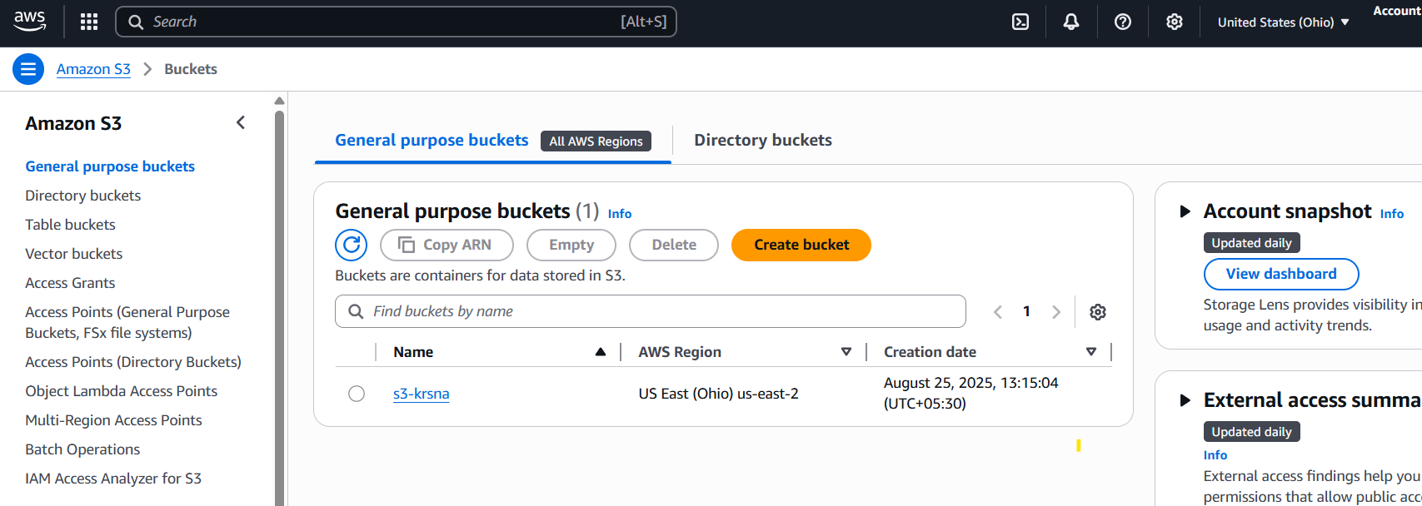

**To upload some objects to s3**

**S3 ---> Buckets ---> select the bucket ---> objects ---> upload ---> Add files ---> upload**

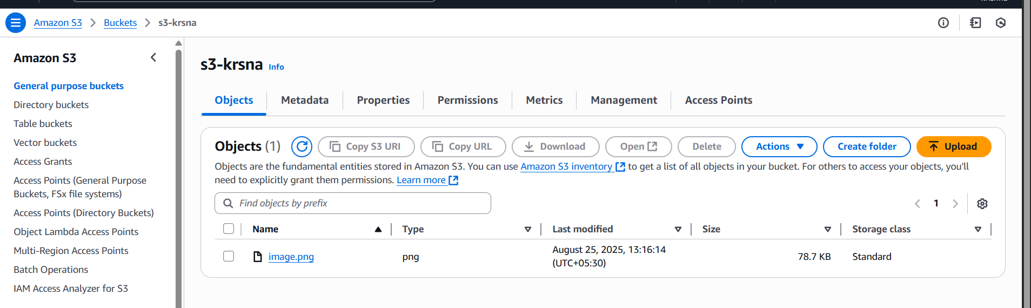

2) Deploy static website in s3 bucket.

**To enable static website hosting**

**S3 ---> Buckets ---> select the bucket ---> properties ---> Static website hosting(enable) ---> Set index and error documents ---> save changes**

**After enable static website you will url**

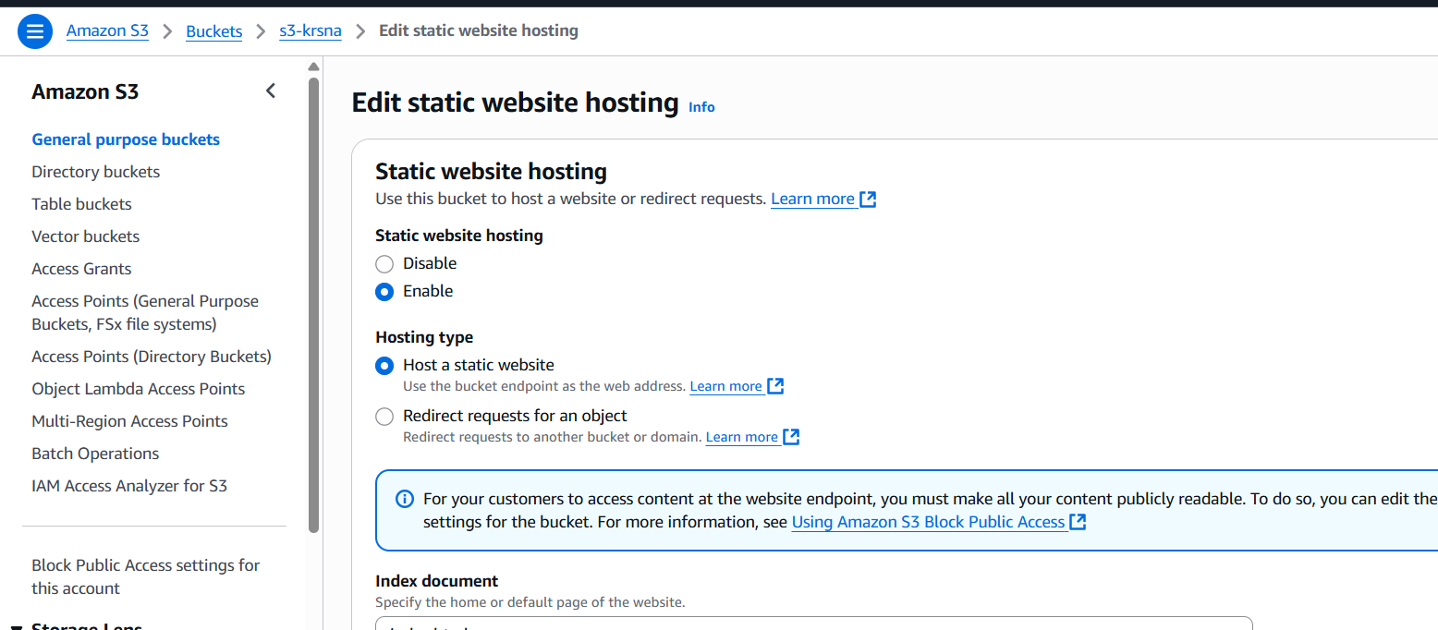

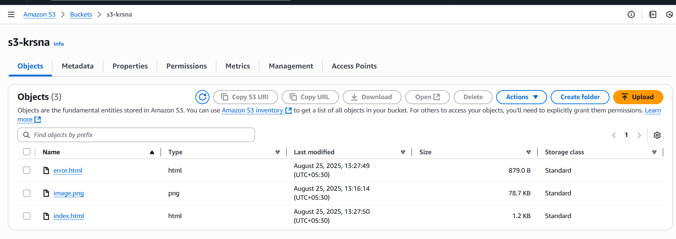

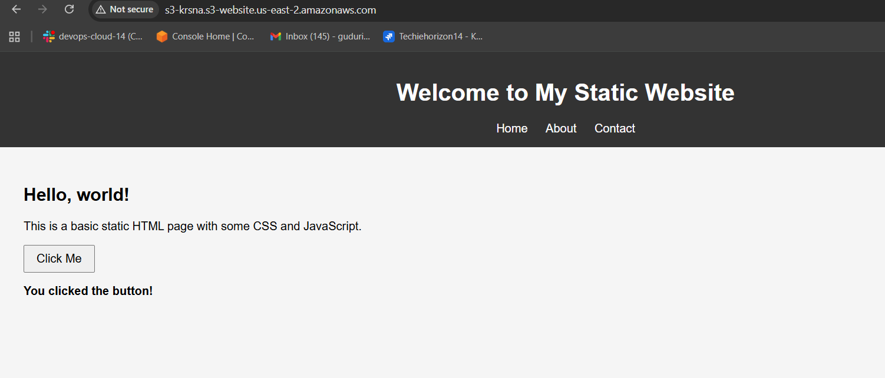

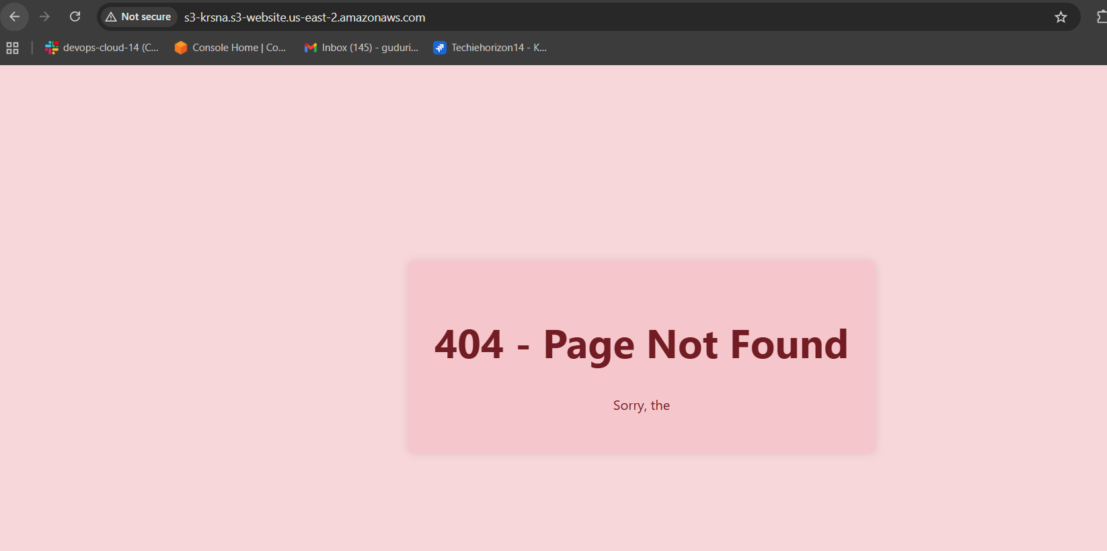

3) Enable cross region replication on s3 buckets.

**Step 1: Create Two Buckets**

* **Source Bucket: s3-ohio-krsna (Region: Ohio)**
* **Destination Bucket: s3-virginia-krsna (Region: N. Virginia)**

**Give permissions to:**

**- Enable versioning**

**-create IAM roles**

**-configure replica rules**

**Step 2: Create Replication Rule**

1. **Go to source bucket (s3-ohio-krsna).**
2. **Click Management → Replication rules → Create replication rule.**
3. **Set the following:**
   * **Rule Name: replication-to-west**
   * **Status: Enabled**
   * **Scope: All objects (leave default)**
   * **Destination Bucket: Select s3-virginia-krsna**
   * **Permissions: Choose Create new IAM role (recommended)**
4. **Click Save.**

**Step 3: Test the Replication**

1. **Upload a file to source bucket (s3-ohio-krsna).**
2. **Check the file’s Replication status (Pending, Completed, or Failed).**
3. **Go to destination bucket (s3-virginia-krsna) and confirm the file is copied there.**

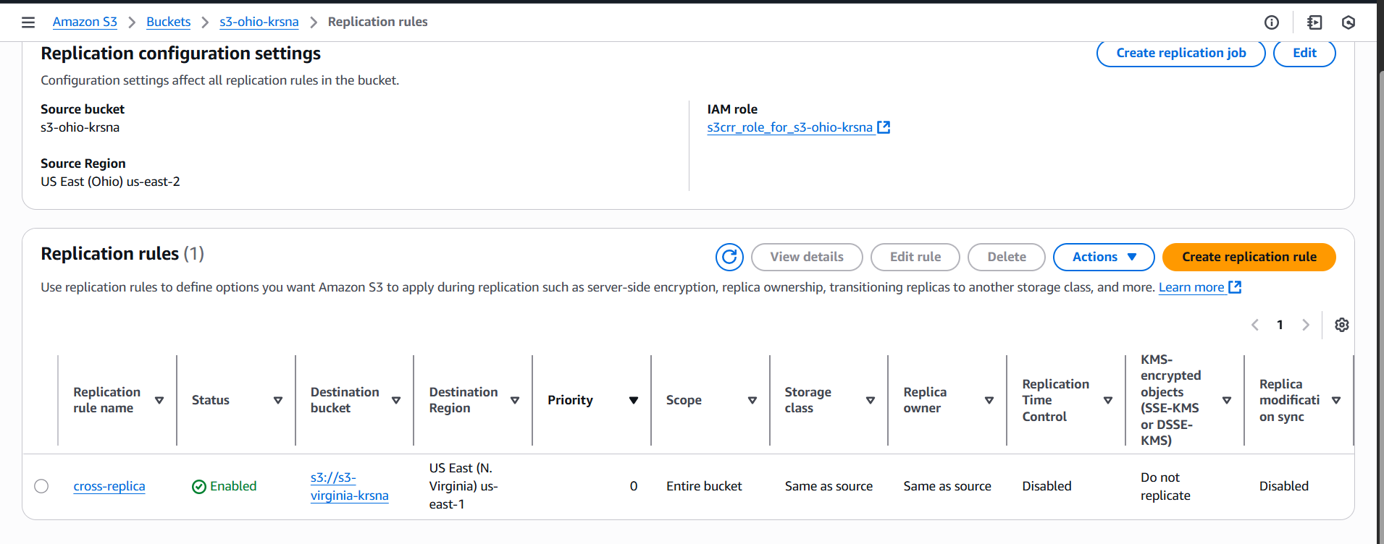

4) Configure bucket policy, only Admin user can see the objects of s3 bucket.

**Create a IAM user with name Admin**

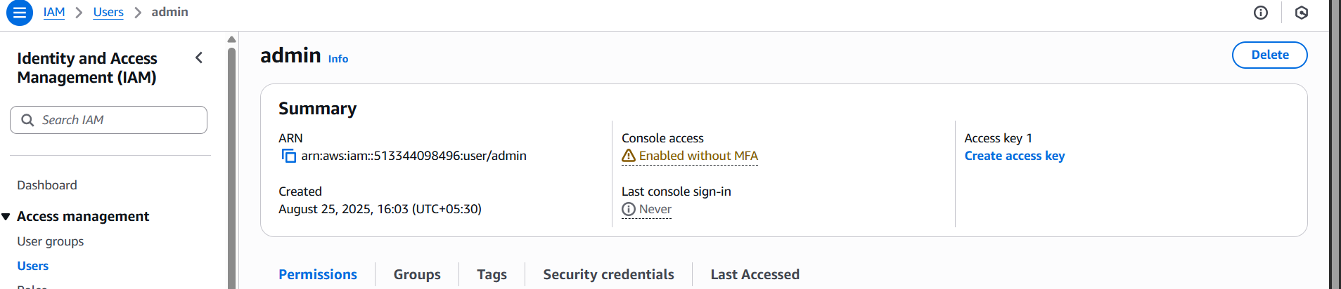

**Configure bucket policy to Admin user**

**S3 ---> Buckets ---> select created bucket ---> permission ---> edit**

**Bucket policy ---> click save changes**

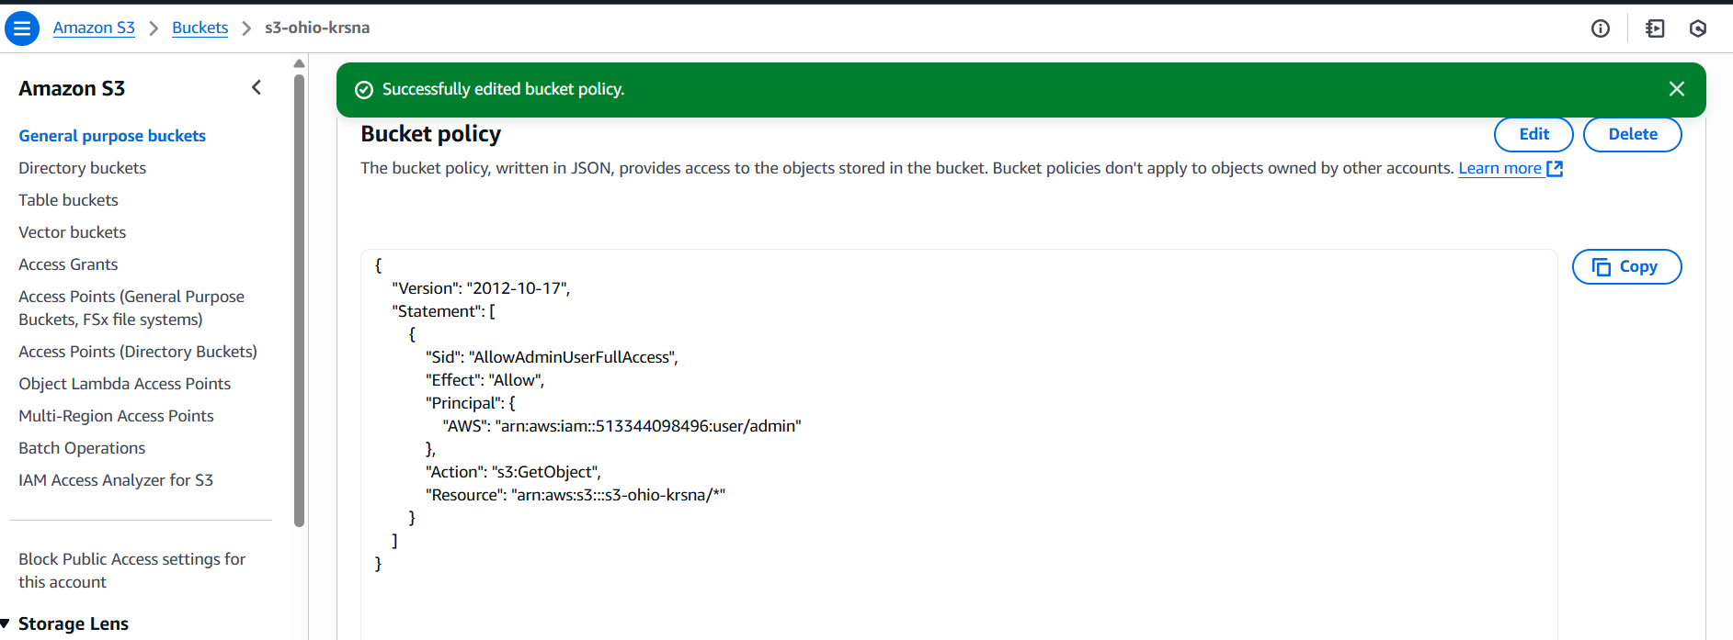

5) Setup lifecycle policies to automatically transition or delete objects based on specific criteria.

**Amazon s3 ---> Buckets ---> select created bucket ---> Management**

**---> click Create lifecycle rule**

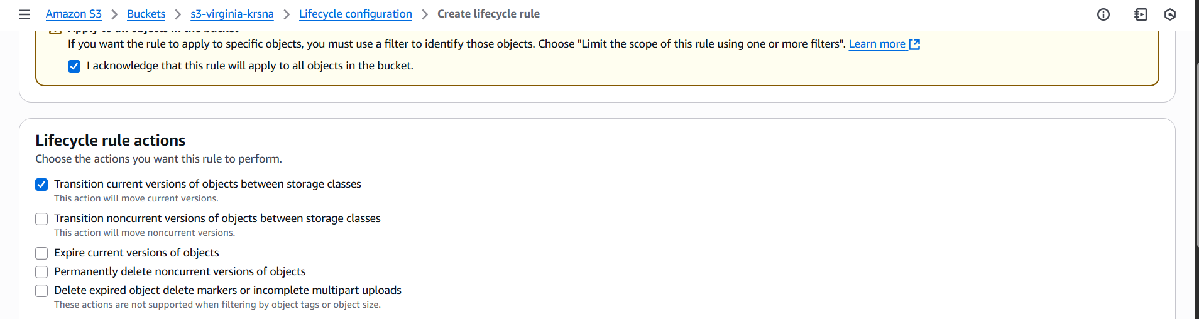

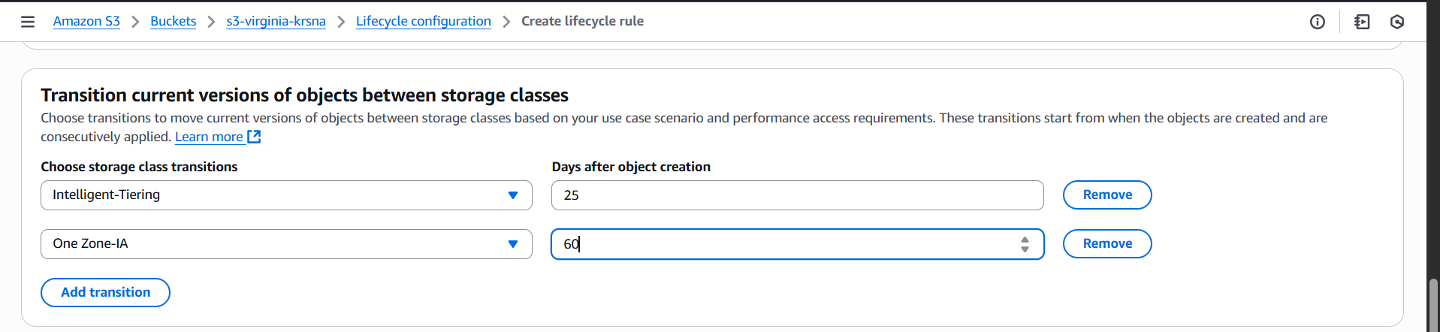

Then click **create rule** then **Lifecycle** is created.

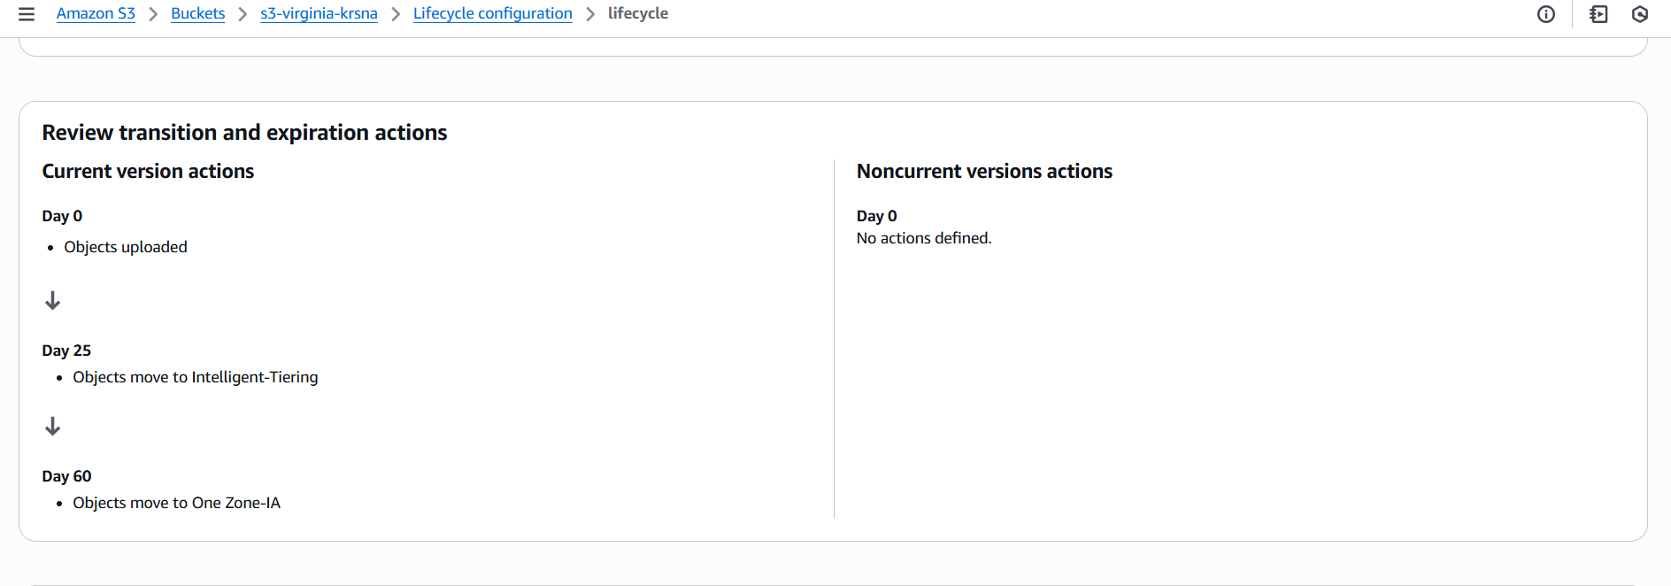

6) Push some objects in s3 using AWS CLI.

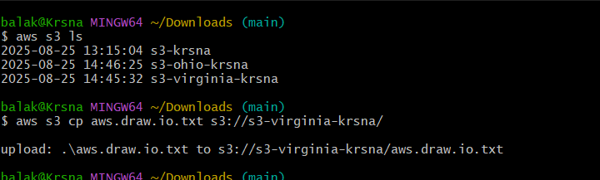

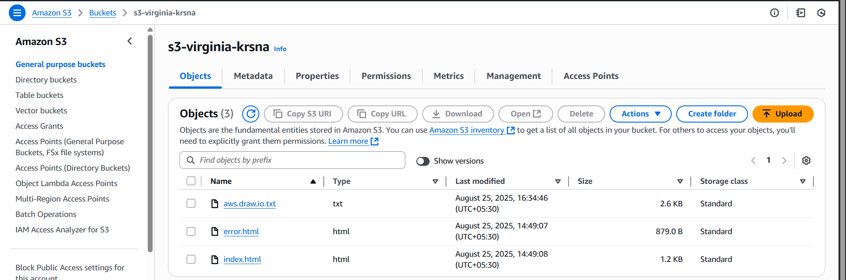

7) Write a bash script to create s3 bucket.

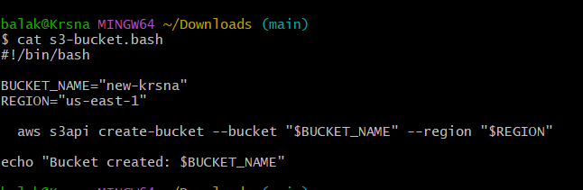

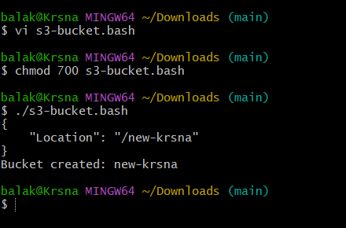

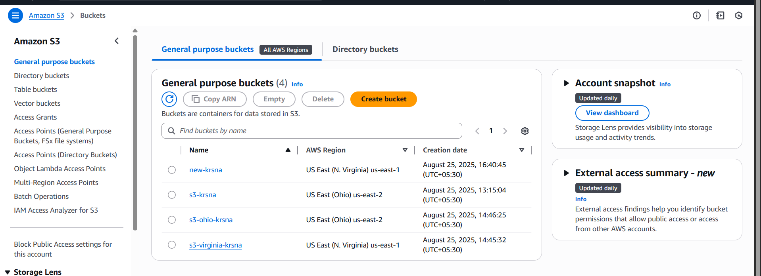

8) Upload one 1 gb of file to s3 using cli.



