1) Configure VPC peering in cross regions.

Create 2 VPC in two different regions

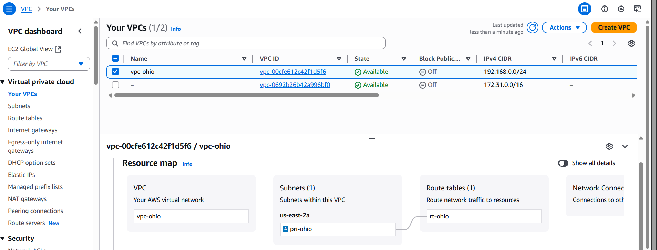

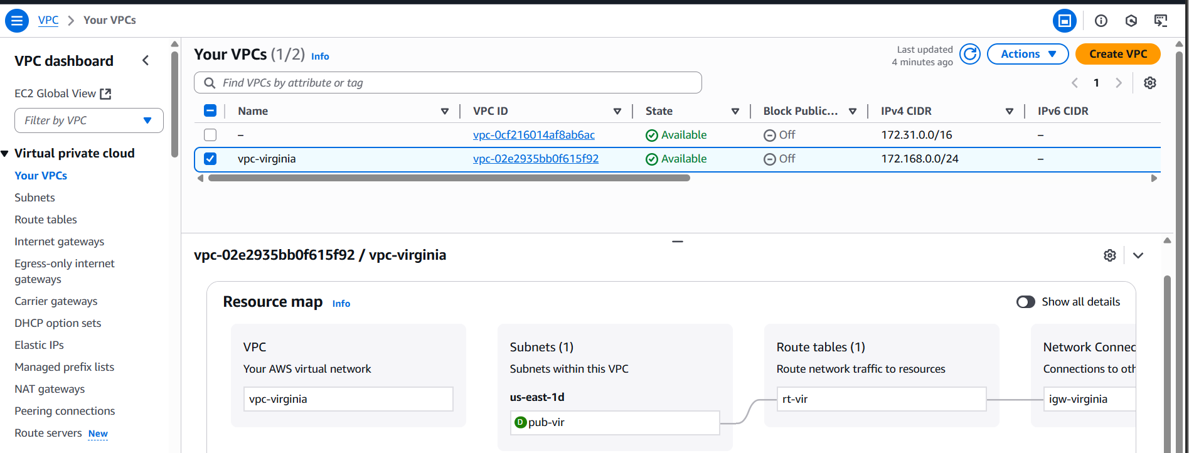

Create subnet for both vpc and attach internet gateway access to root region

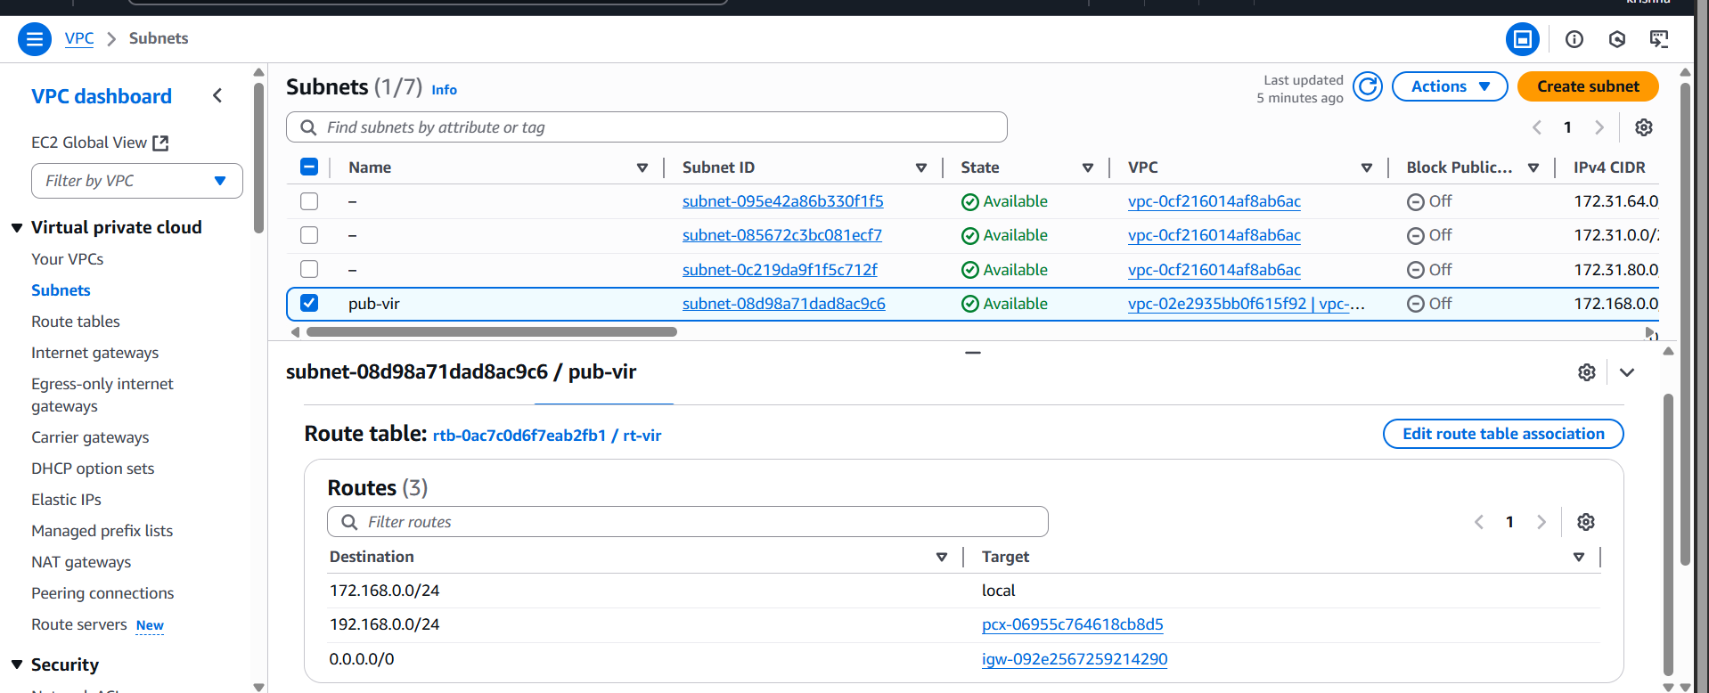

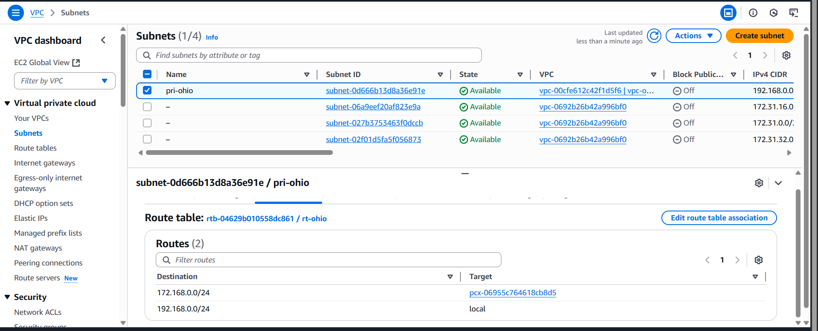

Create peering connection for the root region and send request to the other region and from that region

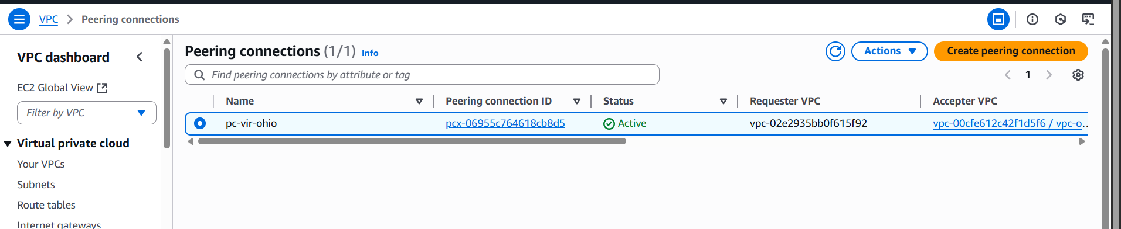

Attach the peering connection to both region’s subnet using opposite CIDR range for the regions

Next create to EC2 instance using region’s VPC and launch the ec2 which has internet access

After connection to instance check the other region is accessible or not by using

Ping private ip of the other instance

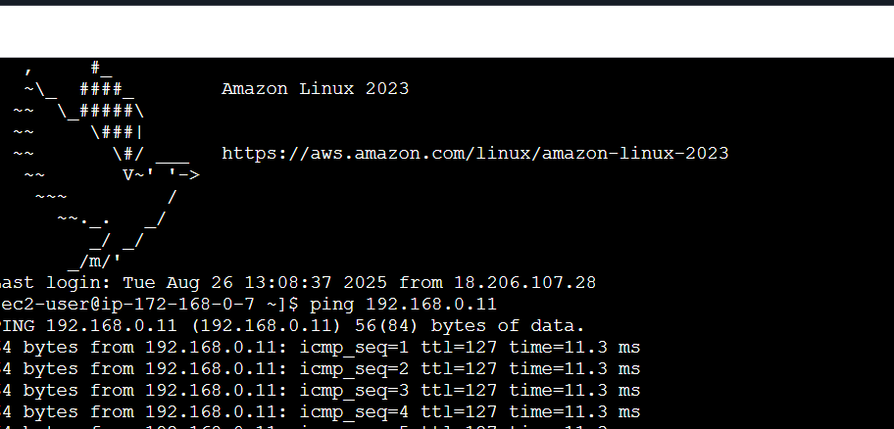

2) Purchase one domain from godaddy.

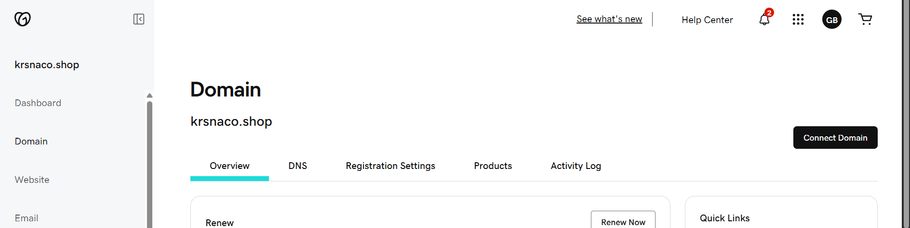

3) Deploy static webiste in s3.

Upload website files to s3  
S3 ---> Buckets ---> select the bucket ---> objects ---> upload ---> Add   
website files ---> upload

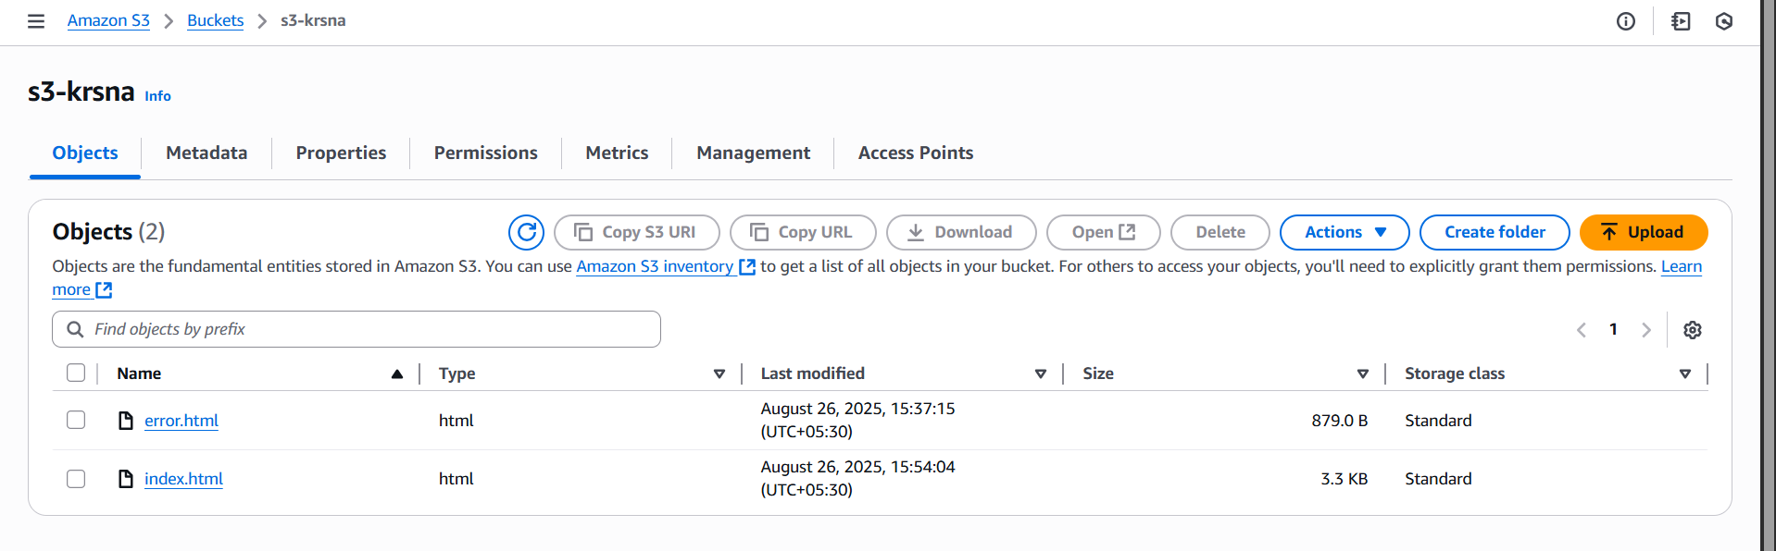

Select created files ---> Actions ---> make public using ACL ---> make   
public  
To enable static website hosting  
 S3 ---> Buckets ---> select the bucket ---> properties ---> Static website   
hosting(enable) ---> Set index and error documents ---> save changes  
After enable static website you will see url

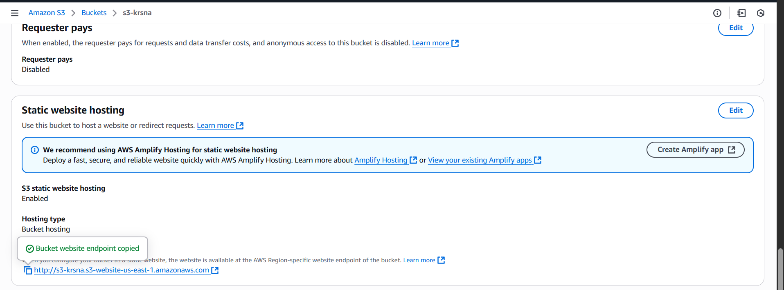

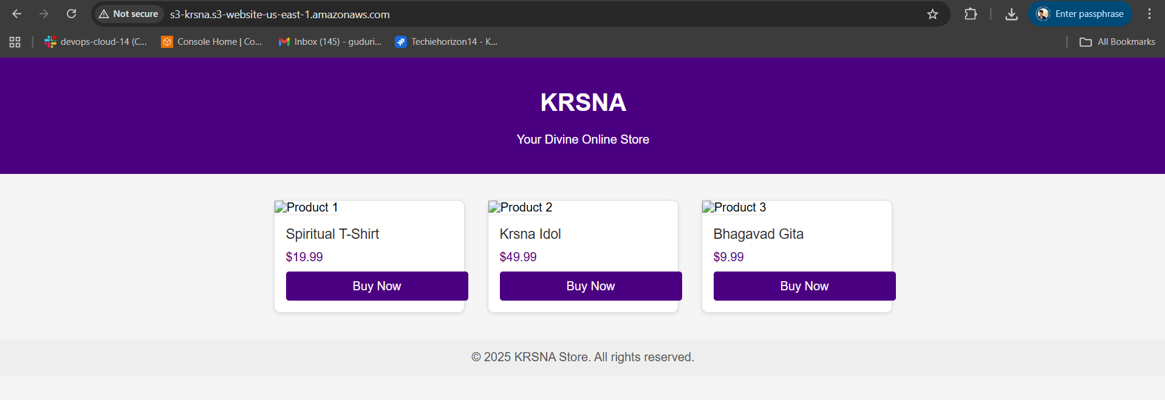

4) Create CDN and attach one SSL certificate.

Create a CloudFront Distribution.  
CloudFront ---> Distributions ---> Create distribution

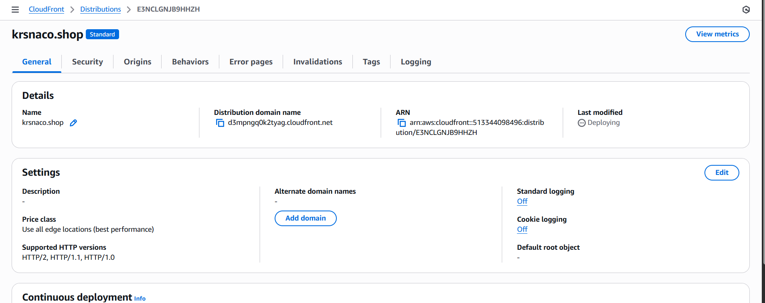

Attach SSL Certificate  
CloudFront ---> Distributions ---> click created distribution --->click edit in  
settings

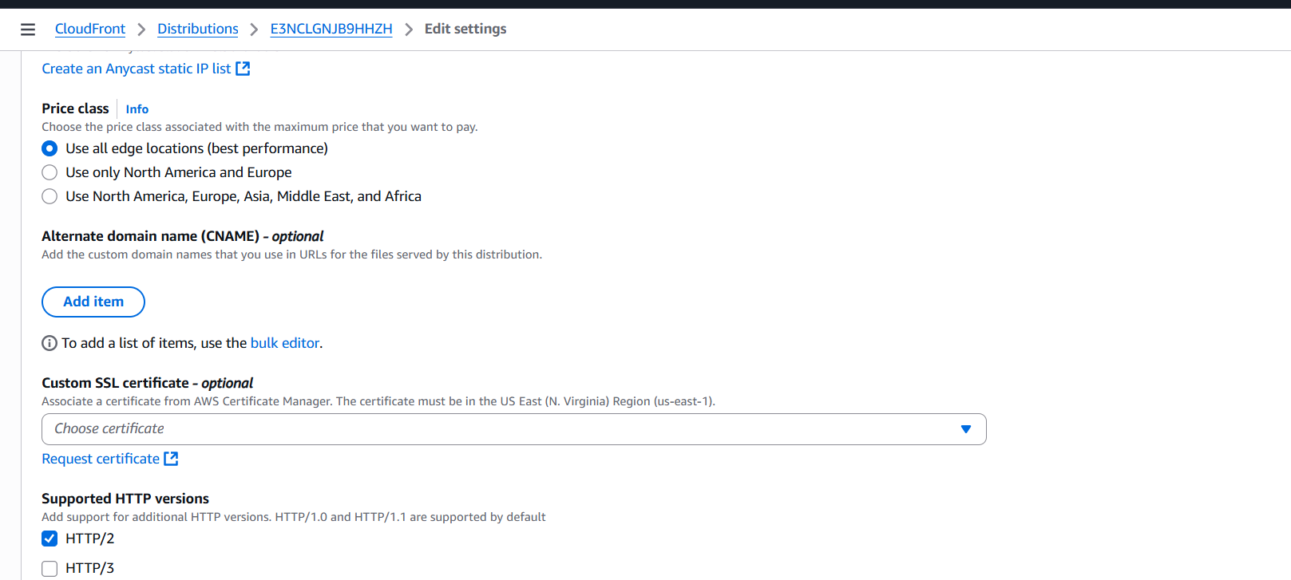

Click Request certicates

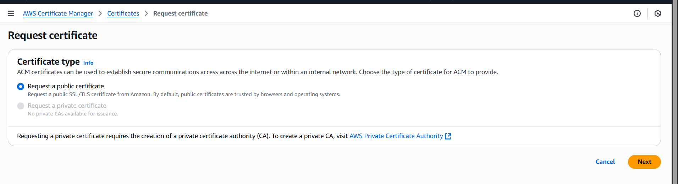

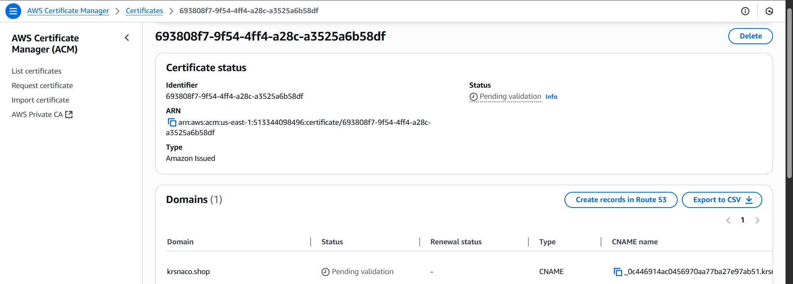

5) Create Route53 hosted zone and MAP the domain with CDN.  
To create hosted zone  
Route53 ---> Hosted zone ---> click Create hosted zones --->  
Enter Domain name(krsnaco.shop) ---> click create hosted zone

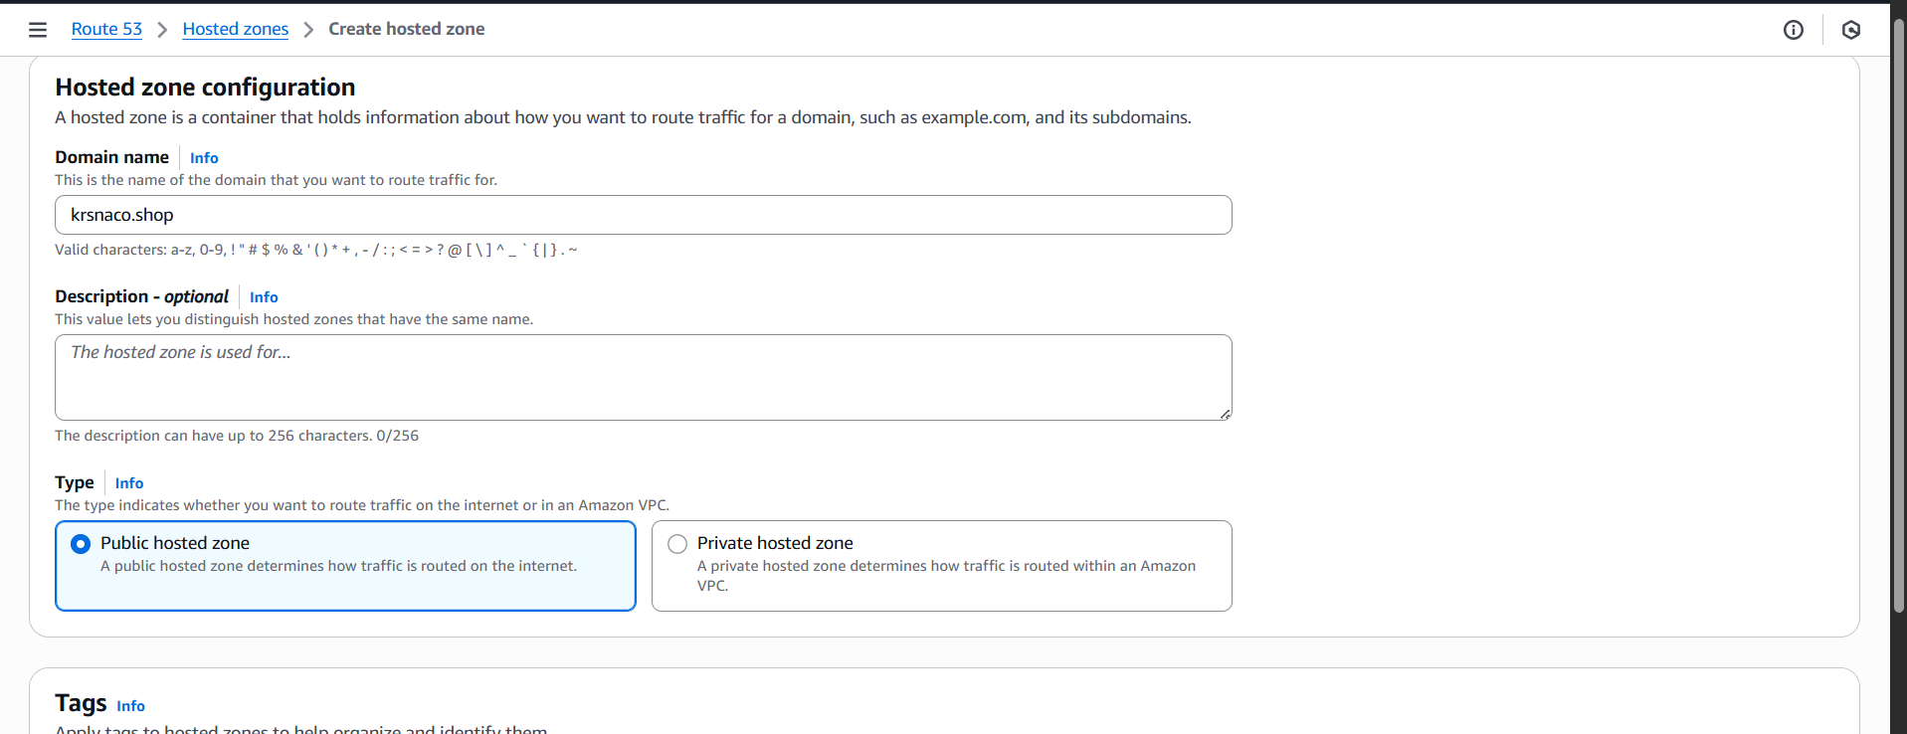

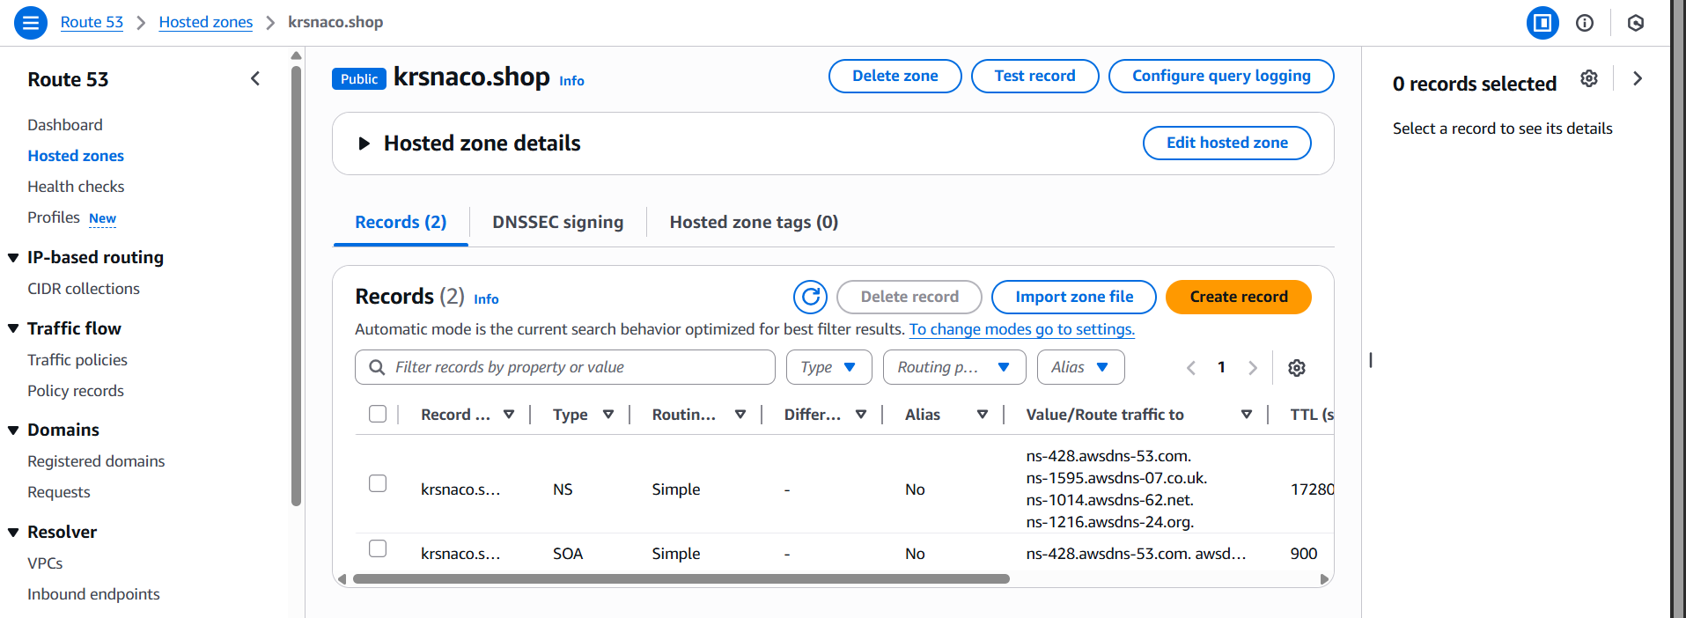  
Add these servers to daddy from created host zone ( krsnaco.shop)   
ns-428.awsdns-53.com.  
ns-1595.awsdns-07.co.uk.  
ns-1014.awsdns-62.net.  
ns-1216.awsdns-24.org.  
Go to Godaddy ---> My Products ---> select your domain (krsnaco.shop)  
---> Manage domain ---> DNS ---> Nameservers ---> ChangeNameservers  
---> I'll use my own nameservers ---> add servernames from Route53

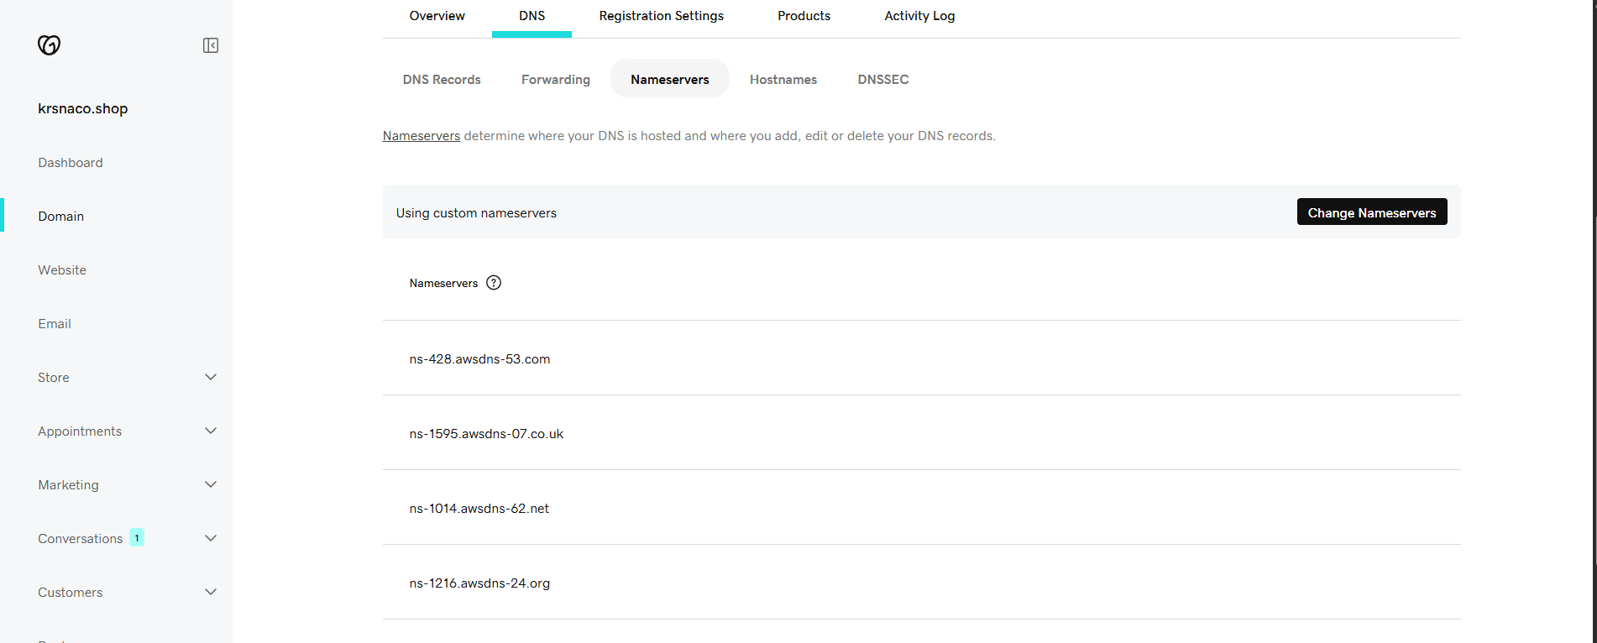

6) Update the index.html in s3 bucket and the updated file should be accessible by using domain name.

Upload index.html in s3 bucket and Make Public using ACL

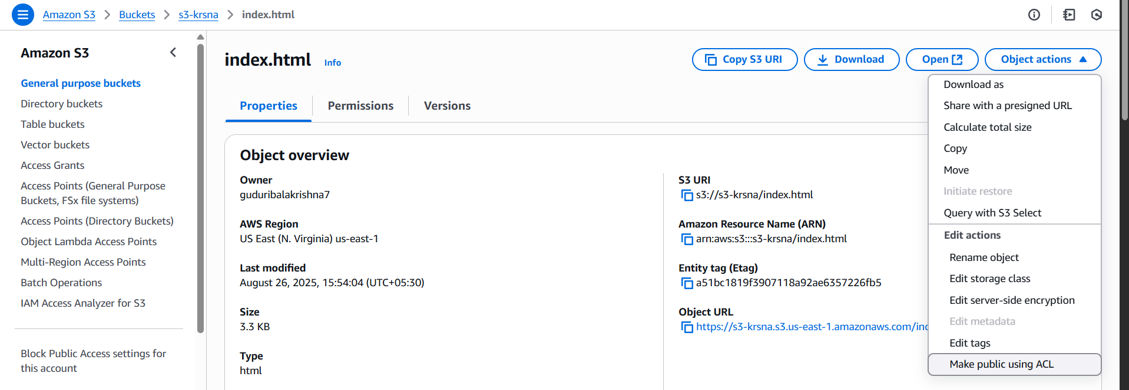  
Enable Static web hosting

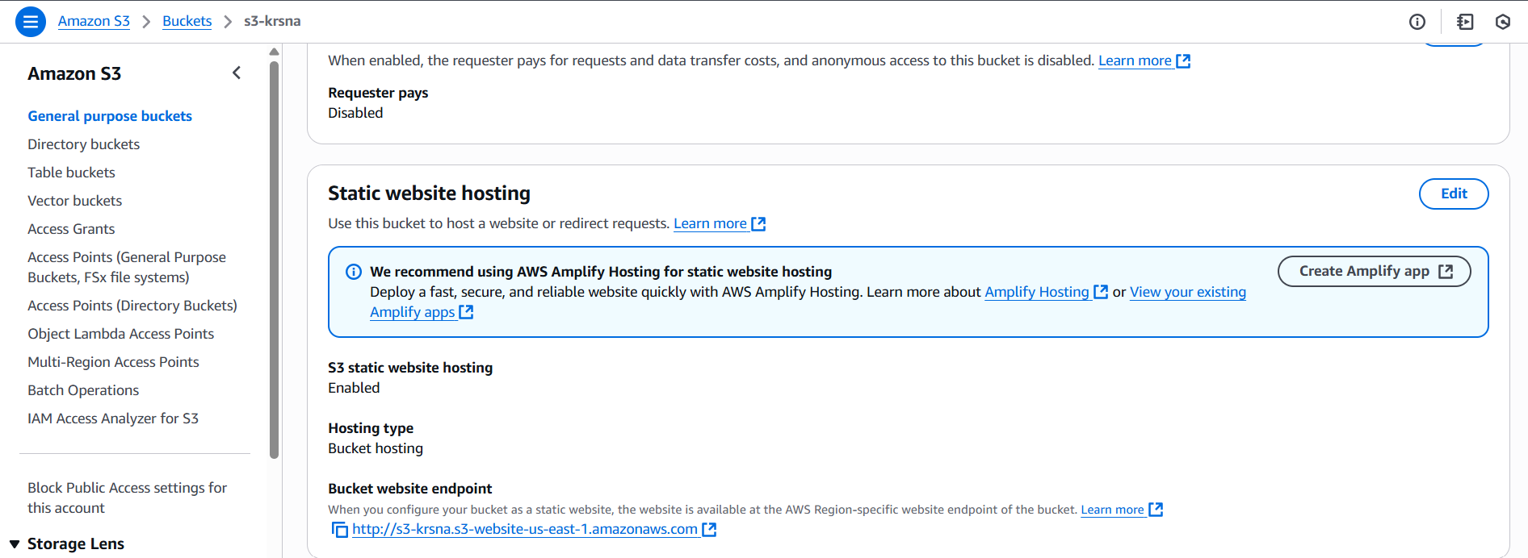

CloudFront ---> Distributions ---> your distribution ---> Invalidation --->   
create invalidation

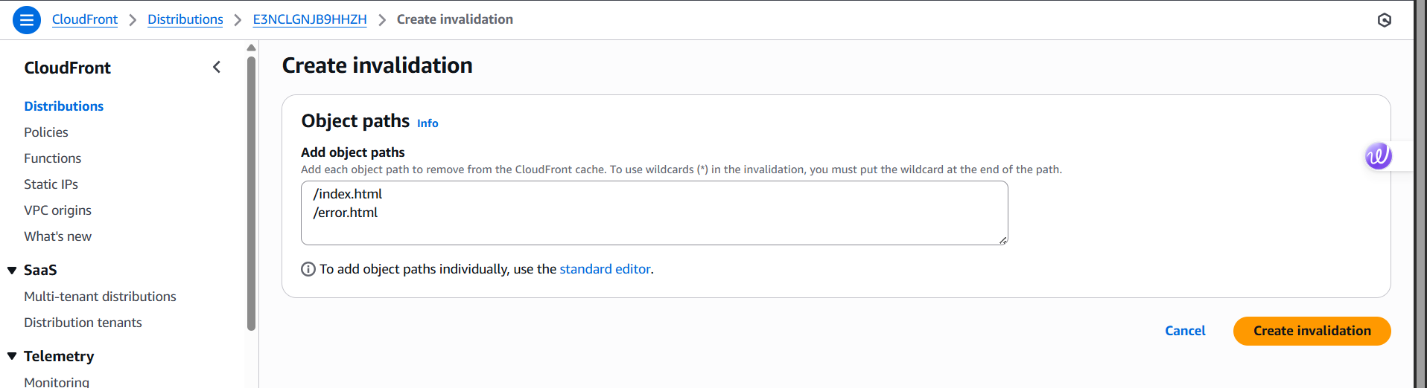  
In created certificates

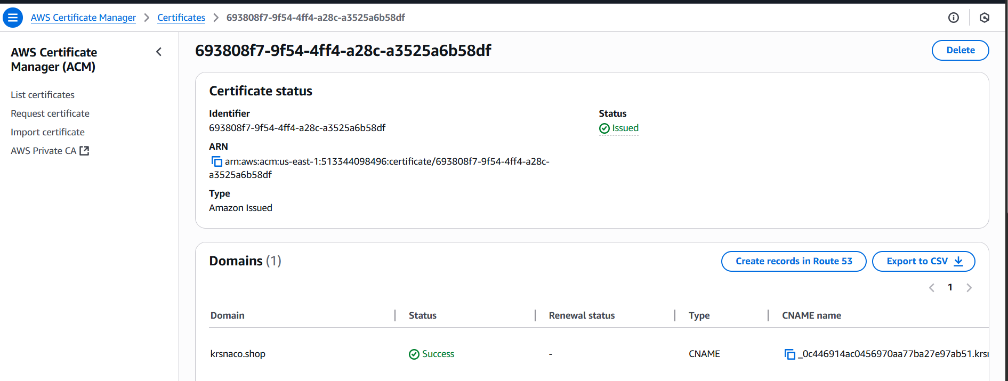  
Click on certificate name as it is showing pending validation. Then it is trying   
to request a certificate for my domain called krsnaco.shop.  
Here the above validation is pending and type CNAME is appearing why   
because this will only approve only when we add CNAME in R53.  
 For this  
If you want to add you can add manually go to R53 and change the record   
type select CNAME if not appearing stop Alias

Copy CNAME VALUE from certificates

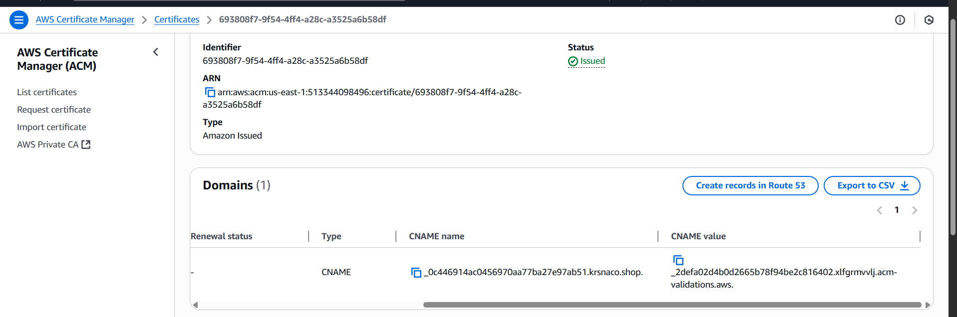

Above click create records in Route53   
To check CNAME record is created in your hosted zone in Route53.

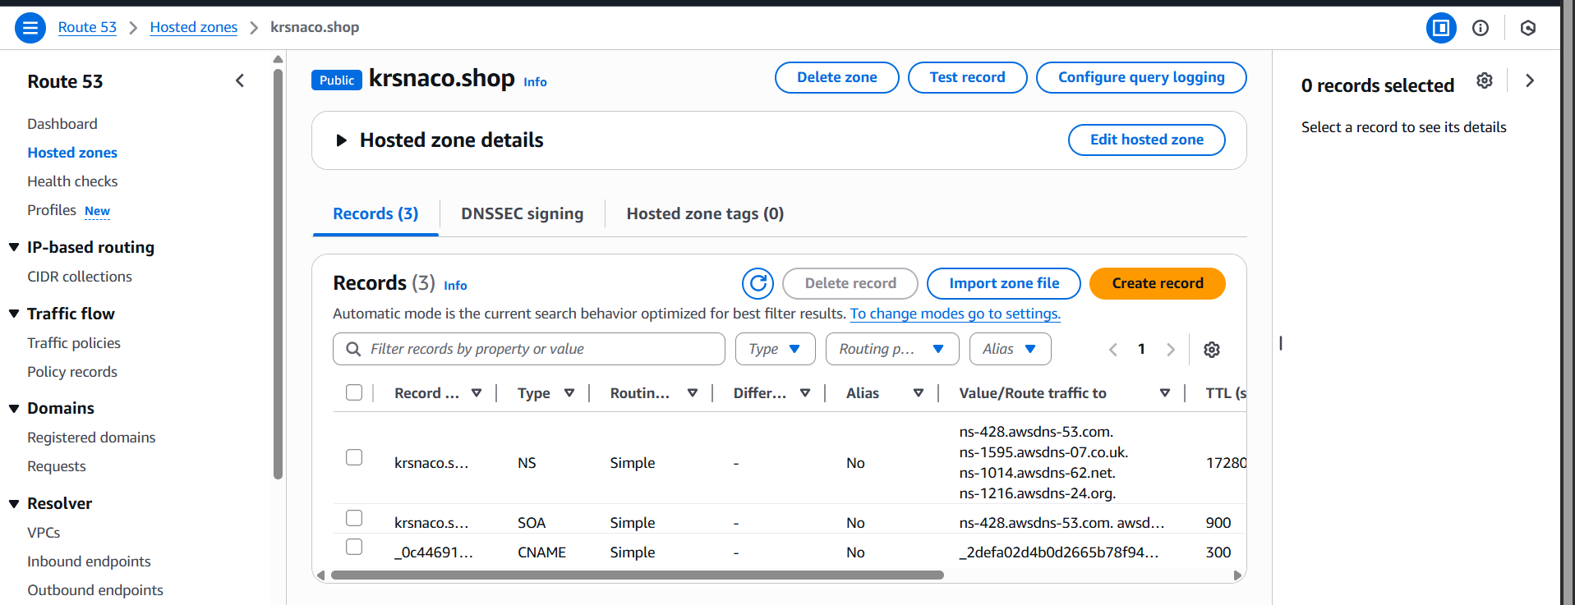  
Route53 ---> Distributions ---> select your distribution ---> Create Record

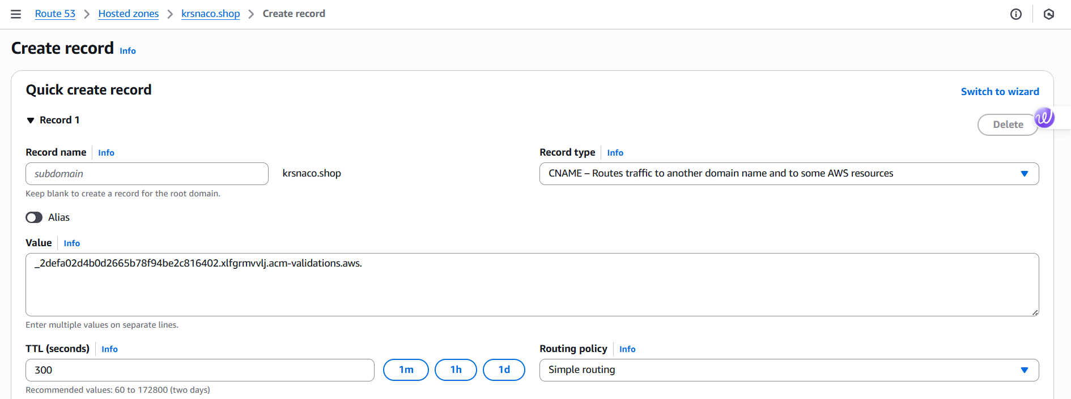

7) Share the Domain name in slack to test the connetivity.

https://krsnaco.shop/

