Launch one ec2 instance using amazon linux 2.

Install Docker

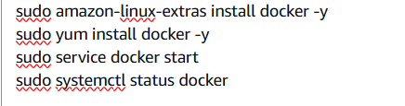

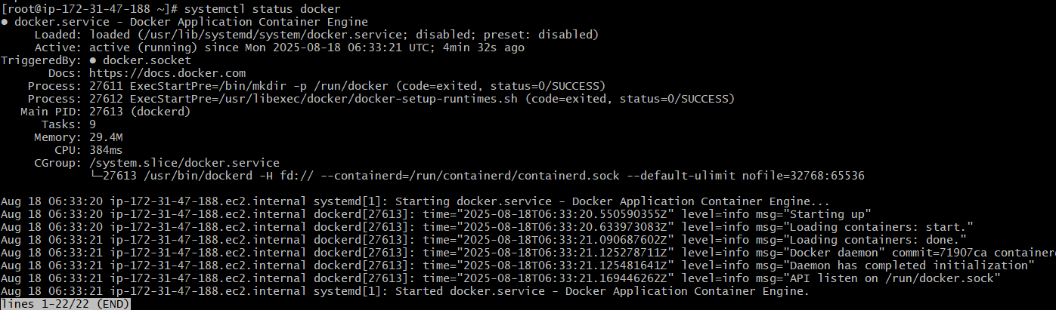

Install Jenkins

We need to stop 8080 port after the Jenkins installed so the Apache tomcat can use the port, basically both use the same port, so we can stop the port 8080 or assign a new port for either of them to run both simultaneously

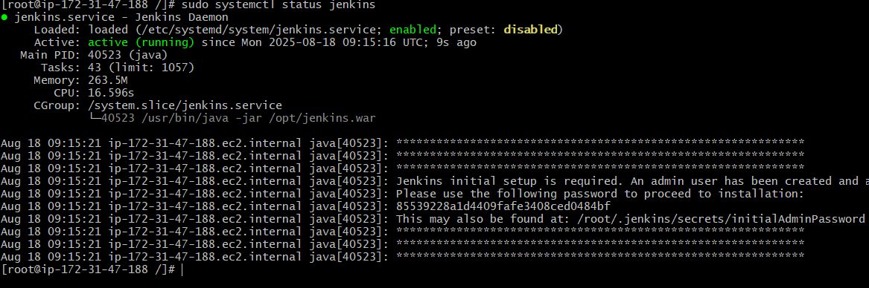

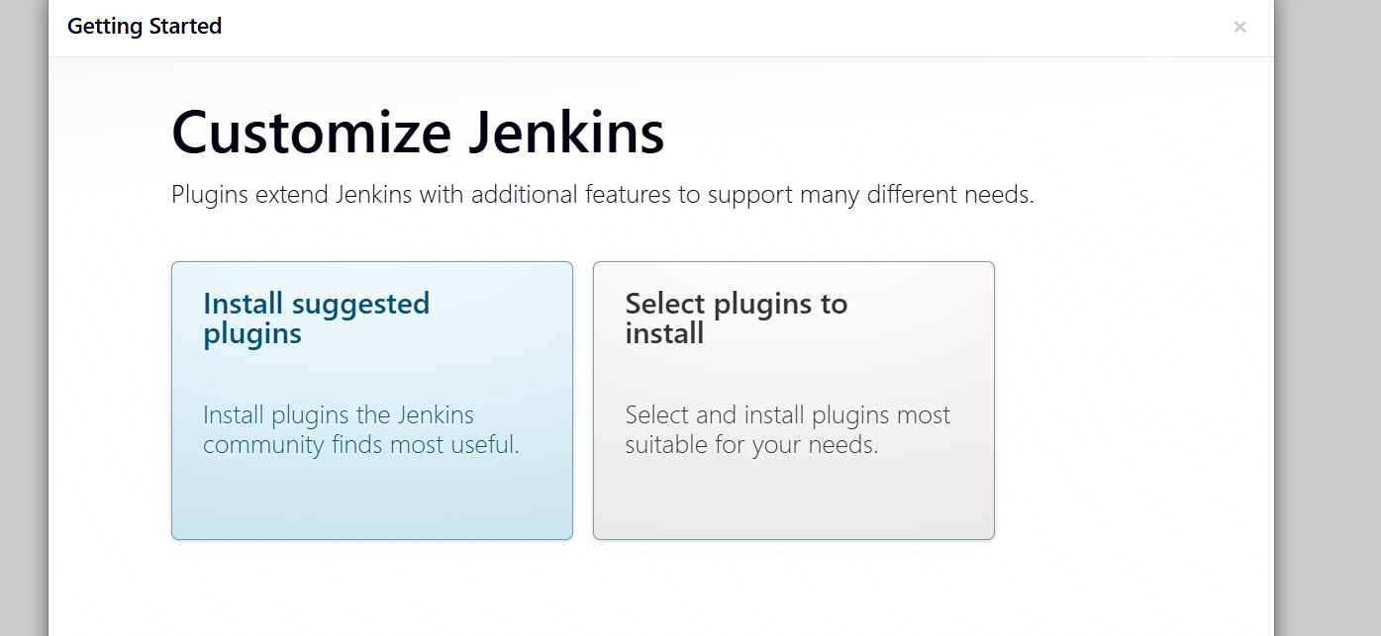

Install apache

We need to stop httpd and then start the nginx

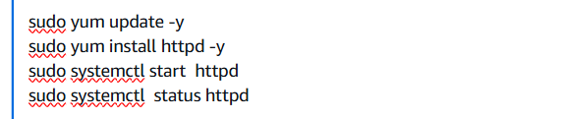

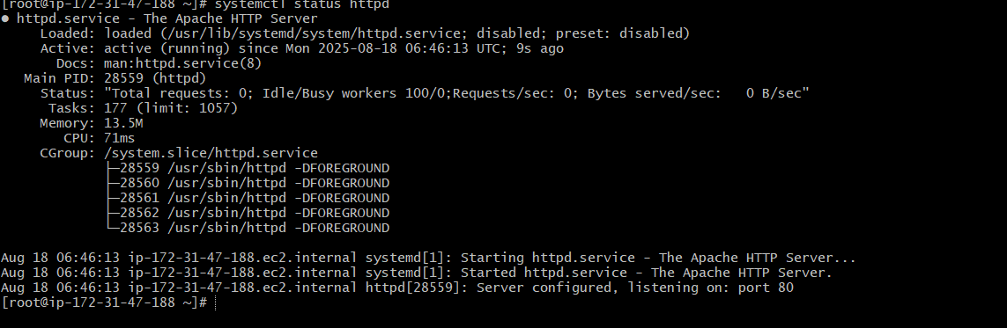

Install nginx

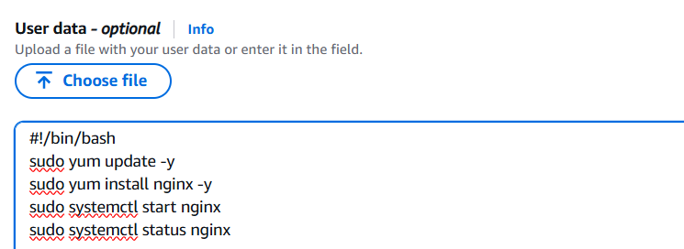

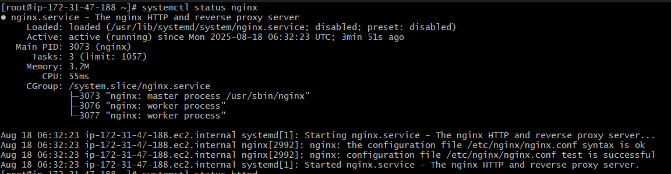

Install Apache Tomcat

