IBM Interview Questions:
Scoop :
1. Give a example of having encryption you can do in Sqoop command.
Hive:
1. Managed & External Table
2. Bucketing in Hive
3. Explain Mapside Join in Hive
Spark:
1. Spark Architecture
2. Narrow and Wide Transformation
3. Broadcast Variable in Spark
4. Scenario given of 2 tables (perform any join)
5. If executor memory is of 10 GB and num executor 5, will this perform individually or at same time (refer spark submit formula - calculations)
In Spark, executors work in parallel, not one after another.
6. Deploy Modes in Spark
7. Performance Tuning in Spark
8. Spark Bucketing
df.write \
.format("parquet") \
.bucketBy(8, "customer_id") \
.sortBy("customer_id") \
.saveAsTable("customer_bucketed")
9. Spark Windowing
General Questions:
1. Explain YARN in Hadoop 2.0
2. Versioning in S3.
• Versioning is a feature in S3 that allows you to store multiple versions of the same object in a bucket.
• Every object gets a unique version ID.
• When versioning is enabled:
- Overwriting an object does not delete the previous version.
- Deleting an object adds a delete marker but retains previous versions.
- Versioning States
State | Description
Enabled | All new objects get version IDs. Overwrites preserve old versions.
Suspended | New versions not created; existing versions are retained.
Disabled | Default state; overwrites delete old objects permanently (no versioning).

Other questions on project:
1. Do you use cloudera or cloud for production.
Scenario Questions:
- Python Question - Remove duplicates from list.
1. Using set() (Fast, order not preserved)
lst = [1, 2, 3, 2, 4, 1]
result = list(set(lst))
print(result)
Notes
- Time complexity: O(n)
- Order is not guaranteed
- Most commonly mentioned basic solution

2. Preserve Order (Recommended in interviews)
lst = [1, 2, 3, 2, 4, 1]

result = []
for i in lst:
if i not in result:
result.append(i)

print(result)
Output
[1, 2, 3, 4]
Notes
- Preserves insertion order
- Time complexity: O(n²) (due to in check)
- 5. Using List Comprehension
- lst = [1, 2, 3, 2, 4, 1]
- result = []
- [result.append(x) for x in lst if x not in result]
- print(result)

- Python Question - A list was given of fruits, take a count of individual fruits and keep that fruits and count in key value pair i.e. dictionary

fruits = ["apple", "banana", "apple", "orange", "banana", "apple"]
1. Using Dictionary (Basic Logic – Interview Friendly)
fruits = ["apple", "banana", "apple", "orange", "banana", "apple"]

fruit_count = {}
for fruit in fruits:
if fruit in fruit_count:
fruit_count[fruit] += 1
else:
fruit_count[fruit] = 1
print(fruit_count)
Output
{'apple': 3, 'banana': 2, 'orange': 1}

//by using the dictionary default value style

fruit_count = {}
for fruit in fruits:
fruit_count[fruit] = fruit_count,get(fruit,0)+1
print(fruit_count)
Output
{'apple': 3, 'banana': 2, 'orange': 1}

3. Spark/SQL - 1 table given, take the sum of salary of every dept.

MPhasis interview :
1: till me about your project and daliy activity in your project
2. Role and respondality >> check this
3. what type of scheduling tool are you using
4. do you have knowledge on Airflow
5.what are the type of transformation used in your project
6. why spark is fast then Mapreduces
7. what are the optimazation tools in spark
8. program to find prime number in python
num = 29
if num <= 1:
print("Not Prime")
else:
for i in range(2, num):
if num % i == 0:
print("Not Prime")
break
else:
print("Prime")
9.2nd highest age in SQL
10 . Table A (4 records ) Table B ( 6 records)

ID (Left) | ID (Right)
0 | 0
1 | 0
1 | 1
NULL | 1
NULL | 0
NULL | NULL

question is count(*) for
inner join ?
left join ?

1. COUNT(*) vs COUNT(column)
COUNT(*)
- Counts all rows
- Includes rows with NULL values
- Most commonly used
SELECT COUNT(*) FROM A;
Result
4

COUNT(column_name)
- Counts only non-NULL values
- Ignores NULLs
SELECT COUNT(emp_id) FROM A;
>>

a) CROSS JOIN (No condition)
SELECT COUNT(*)
FROM A, B;
Result
4 × 6 = 24
Reason: Cartesian product

b) INNER JOIN
SELECT COUNT(*)
FROM A
INNER JOIN B
ON A.id = B.id;
Result
- Only matching rows
- If 3 records match → result = 3

c) LEFT JOIN
SELECT COUNT(*)
FROM A
LEFT JOIN B
ON A.id = B.id;
Result
- Minimum = 4
- Includes all rows from A

d) RIGHT JOIN
SELECT COUNT(*)
FROM A
RIGHT JOIN B
ON A.id = B.id;
Result
- Minimum = 6
- Includes all rows from B

e) FULL OUTER JOIN
SELECT COUNT(*)
FROM A
FULL OUTER JOIN B
ON A.id = B.id;
Result
matching rows
+ non-matching rows from A
+ non-matching rows from B

3. COUNT with NULLs after JOIN (Important)
SELECT COUNT(B.id)
FROM A
LEFT JOIN B
ON A.id = B.id;
- Rows from A with no match in B → B.id = NULL
- These rows are not counted
So:
- COUNT(*) ≠ COUNT(B.id)

4. Same Concept in Spark SQL
SELECT COUNT(*) FROM A;
SELECT COUNT(col1) FROM A;
Spark behavior
- Same as SQL
- COUNT(*) includes NULL rows
- COUNT(column) ignores NULLs
Interview Summary (Strong Answer)
“COUNT(*) counts total rows including NULLs.
COUNT(column) ignores NULL values.
In joins, COUNT(*) counts joined rows, while COUNT(column) depends on NULL presence.”
11. what are CTE and subqueries
1. Subquery
Definition
A subquery is a query written inside another SQL query.
It is executed first, and its result is used by the outer query.

Types of Subqueries
a) Scalar Subquery (returns single value)
SELECT *
FROM employees
WHERE salary > (
SELECT AVG(salary)
FROM employees
);

b) Multiple-row Subquery
SELECT *
FROM employees
WHERE dept_id IN (
SELECT dept_id
FROM departments
WHERE location = 'INDIA'
);

c) Correlated Subquery (runs for each row)
SELECT *
FROM employees e
WHERE salary > (
SELECT AVG(salary)
FROM employees
WHERE dept_id = e.dept_id
);

Characteristics of Subqueries
- Nested inside SELECT, WHERE, FROM, or HAVING
- Can be hard to read if deeply nested
- Correlated subqueries may be slow
>>
2. CTE (Common Table Expression)
Definition
A CTE is a temporary named result set defined using the WITH clause,
which can be referenced like a table.

Basic Syntax
WITH cte_name AS (
SELECT ...
)
SELECT *
FROM cte_name;

12 what is differene b/w union and unionall and which query will run faster
13 what is differene b/w OLAP and OLTP
Aspect | OLTP | OLAP
Full Form | Online Transaction Processing | Online Analytical Processing
Purpose | Day-to-day transactions | Data analysis & reporting
Operations | INSERT, UPDATE, DELETE | SELECT, AGGREGATE
Data Volume | Small per transaction | Very large (historical data)
Query Type | Simple, short queries | Complex, long-running queries
Response Time | Milliseconds | Seconds to minutes
Concurrency | High (many users) | Low to medium
Data Structure | Highly normalized | Denormalized (star/snowflake)
Data Changes | Frequent | Mostly read-only
Indexing | Minimal | Heavy indexing
Examples | Banking, Order systems | BI reports, dashboards
Tools | MySQL, PostgreSQL, Oracle | Hive, Redshift, Snowflake

14 if a table having duplicate records how you will handle
15 emp ID having duplicate how to remove given a scenario
Tech Mahindra interview:
Hadoop theory and concepts
Difference between delete and truncate
1. DELETE
Definition
DELETE is a DML (Data Manipulation Language) command used to remove specific rows or all rows from a table.
Syntax
DELETE FROM employees WHERE dept_id = 10;
Characteristics
- Supports WHERE clause
- Deletes rows one by one
- Can be rolled back (if transaction not committed)
- Fires DELETE triggers
- Table structure remains intact
- Slower for large tables

2. TRUNCATE
Definition
TRUNCATE is a DDL (Data Definition Language) command that removes all rows from a table at once.
Syntax
TRUNCATE TABLE employees;
Characteristics
- Cannot use WHERE clause
- Deallocates data pages (fast)
- Cannot be rolled back (auto-commit in most DBs)
- Does not fire triggers
- Resets identity / auto-increment
- Faster than DELETE

SQL theory and concepts
Python theory and concepts
Zookeeper - what does it do?
In HDFS, ZooKeeper is used only in High Availability setups to manage leader election and automatic failover between Active and Standby NameNodes, ensuring there is no split-brain scenario.”
Components of HDFS
Fault tolerance
Bucketing Vs Partitioning
Performance tuning in Hive
Difference between Hive and SQL/RDBMS
Partition Vs Bucketing
Difference between RDD and Dataframes
What is RDD
Performance tuning in Spark
Tech Mahindra Interview for Hadoop Developer role:
1. Daily activities and roles
2. How is client management done normally CHECK THIS
3. Given one SQL scenario for selecting odd emp id's from table and follow up que's
“We can select odd employee IDs using the MOD function or remainder operator where emp_id % 2 = 1.”
4. spark jobs performance tuning, catalyst optimizer
5. what are SQL joins. given scenario and asked to select required join
6. Hadoop components and followed by que's how each component works
7. How do we use python in daily activities and name few known packages
We use Python daily for data processing, API integration, and analytics, leveraging libraries like PySpark , requests etc”
Commonly Used Python Packages
Core / Built-in
- os – File and directory operations
- sys – Runtime environment interaction
- datetime – Date and time handling
- json – JSON parsing
Data Engineering / Analytics
- pyspark – Distributed data processing
Automation & Scripting
- requests – API calls
- logging – Application logging

8. spark file formats
9. Transformations
10. shuffling and partitions
11. what are AWS Tools to handle jobs
12. Explain complete pipeline
Programming.com ( 1st round)
Rdd vs dataframe
Cache vs persist vs checkpointing
Performance optimization technique
Star schema vs snowflake schema CHECK THIS
Fact table vs dimension table CHECK THIS
Fact Table — Definition
A fact table stores quantitative, measurable data (metrics) related to a business process and contains foreign keys that reference dimension tables.
Key points:
- Holds numeric measures (e.g., sales_amount, quantity, revenue)
- Typically very large
- Used for aggregation and analysis
- Contains foreign keys to dimensions
Example measures:
- sales_amount
- order_count
- premium_amount

Dimension Table — Definition
A dimension table stores descriptive, contextual attributes that explain the facts and is used for filtering, grouping, and labeling data.
Key points:
- Holds descriptive attributes
- Typically smaller
- Used in WHERE, GROUP BY, SELECT clauses
- Contains primary keys
Example attributes:
- customer_name
- product_category
- policy_type
- date, region, channel

Quick Comparison
Aspect | Fact Table | Dimension Table
Purpose | Store metrics | Store descriptive context
Data type | Numeric / measurable | Textual / categorical
Size | Large | Small
Keys | Foreign keys | Primary keys
Update frequency | Frequent (transactional) | Less frequent (slow-changing)
Example | fact_sales | dim_customer, dim_product

Simple Example
Fact Table: fact_sales
date_id | product_id | customer_id | sales_amount | quantity
Dimension Table: dim_customer
customer_id | customer_name | region | segment

Interview One-Liners
- Fact table:
“A fact table stores measurable business metrics and references dimension tables via foreign keys.”
- Dimension table:
“A dimension table stores descriptive attributes that provide context to facts and are used for filtering and grouping.

Project passage
2nd round
Create entire data pipeline for myntra delivery
Why spark inserts are faster than updates and deletes
• No need to scan existing data
• No rewrite required
• No shuffle in most cases
• Minimal I/O
Scenario 1:
empid empname dept address contact salary joining_dt
101 Kevin IT NY 123456789 10000 31-03-2020
102 jacob IT NY 123456789 10000 31-03-2020
103 Tine IT San Fr 123456789 10000 31-03-2020
104 John Infra SF 123456789 20000 03-04-2022
105 Nisha Infra SF 123456789 25000 03-04-2022
106 Mike Tech NY 123456789 35000 10-11-2016
107 Arri Tech NY 123456789 40000 10-11-2016
108 Mona Tech SE 123456789 10000 10-11-2016

dept salary
IT 30000
Infra 45000
Tech 85000

SELECT
dept,
SUM(salary) AS total_salary
FROM employee
GROUP BY dept;

Interview Extension Questions
1️⃣ Highest paid department
SELECT dept, SUM(salary) AS total_salary
FROM employee
GROUP BY dept
ORDER BY total_salary DESC
LIMIT 1;

2️⃣ Average salary per department
SELECT dept, AVG(salary) AS avg_salary
FROM employee
GROUP BY dept;

3️⃣ Department with more than 2 employees
SELECT dept
FROM employee
GROUP BY dept
HAVING COUNT(*) > 2;

from pyspark.sql import functions as F

df.groupBy("dept") \
.agg(F.sum("salary").alias("total_salary")) \
.show()

Scenario 2:
Input
emp_id emp_name out_time
E001 Ramesh Rao 15-09-2025 12:45
E001 Ramesh Rao 15-09-2025 18:10
E002 Anita Desai 15-09-2025 13:00
E002 Anita Desai 15-09-2025 17:50
E003 Vikram Shah 15-09-2025 12:30
E003 Vikram Shah 15-09-2025 19:05
E001 Ramesh Rao 15-09-2025 20:10
E002 Anita Desai 15-09-2025 19:30
E003 Vikram Shah 15-09-2025 20:40
E002 Anita Desai 15-09-2025 21:20

Output
emp_id emp_name out_time
E001 Ramesh Rao 15-09-2025 20:10
E002 Anita Desai 15-09-2025 21:20
E003 Vikram Singh 15-09-2025 18:40

SELECT
emp_id,
emp_name,
MAX(out_time) AS out_time
FROM attendance
GROUP BY emp_id, emp_name;
More Accurate Version (If Timestamp Stored as String)
If out_time is stored as string:
SELECT
emp_id,
emp_name,
MAX(TO_TIMESTAMP(out_time, 'DD-MM-YYYY HH24:MI')) AS out_time
FROM attendance
GROUP BY emp_id, emp_name;

✅ Window Function Version (Interview-Strong Answer)
SELECT emp_id, emp_name, out_time
FROM (
SELECT *,
ROW_NUMBER() OVER (
PARTITION BY emp_id
ORDER BY out_time DESC
) AS rn
FROM attendance
) t
WHERE rn = 1;
✔ Preferred in production
✔ More flexible if ties exist

✅ PySpark Solution
from pyspark.sql import functions as F
df.groupBy("emp_id", "emp_name") \
.agg(F.max("out_time").alias("out_time")) \
.show()

Scenario 3:
input_list = [1,1,2,3,4,5,6,1,1,1,2,6,7]
output_list[1,2,3,4,5,6,7])
Scenario 4:
[apple,orange,banana,apple, kiwi, apple, banana]
{apple:3, orange:1, banana:2, kiwi:1}

Accenture Interview Questions For data engineer role
Introduction and project experience/Project passage
difference between groupby key and reducedBy Key

groupby:
How It Works Internally
- Shuffles all values across the network
- Stores full value lists in memory
- Performs aggregation after shuffle

Problems
- High network traffic
- High memory usage
- Risk of OutOfMemoryError
2. reduceByKey
What it Does
- Combines values per key using a function
- Returns:
(K, V)
Example
rdd.reduceByKey(lambda x, y: x + y).collect()
Output
[('a', 3), ('b', 3)]

How It Works Internally
- Performs local aggregation (map-side combine)
- Shuffles reduced data
- Final reduce on each partition

Why reduceByKey Is Faster
- Less data shuffled
- Less memory usage
- Optimized execution

Difference between groupby key and groupby? What are different use cases to use these two keys?

Aspect | groupByKey | groupBy
API Level | RDD | DataFrame / Dataset
Input | Pair RDD | DataFrame
Output | Iterable values | Aggregated columns
Shuffle Volume | High | Optimized
Map-side combine | No | Yes
Optimization | None | Catalyst + Tungsten
Performance | Slow | Fast

What is catalyst optimizer and how did you use it?
optimization techniques in Hive?
What is map side join in hive?
what is difference between client and cluster mode and when we use these two different modes?
How do you design ETL pipelines in spark? CHECK THIS ???
How will you do debugging in spark? CHECK THIS ??

“In Spark, debugging is done by inspecting small samples with show() or take(), validating schemas with printSchema(), analyzing execution plans with explain(), monitoring jobs in Spark UI, using logs, caching intermediate results, and testing transformations on subsets of data.”

Narrow and wide transformations?
What is leneage in spark?
Few other theoretical questions from gold video
Do you have experience in data bricks?
I have not worked extensively on Databricks, but I have strong hands-on experience with Apache Spark and PySpark on AWS EMR.
Since Databricks is Spark-based,
I am comfortable with core Spark concepts such as DataFrames, Spark SQL, performance tuning, and job optimization, and I can quickly adapt to Databricks environments.
Do you have experience in snowflake?
if we are using count() in spark, will spark job get triggered or not when we use count()?
Scenarios:
1. Count by words using RDD and get tops 5 words that are mostly used(Gave 3 sentences in a list)
2. RDD scenario: gave test data and asked to create rdd, read rdd by importing pyspark functions.
[(1,HR,3000),(2,IT,3500),(3,admin,4000),(4,HR,5000),(5,admin,6500)]
Get average of each department
data = [
(1, "HR", 3000),
(2, "IT", 3500),
(3, "admin", 4000),
(4, "HR", 5000),
(5, "admin", 6500)
]
rdd = sc.parallelize(data)

# Step 1: Map → (department, (salary, 1))
dept_salary = rdd.map(lambda x: (x[1], (x[2], 1)))
rough:::
('HR', (3000, 1))
('IT', (3500, 1))
('admin', (4000, 1))
('HR', (5000, 1))
('admin', (6500, 1))
# Step 2: ReduceByKey → (department, (total_salary, total_count))
dept_sum_count = dept_salary.reduceByKey(
lambda a, b: (a[0] + b[0], a[1] + b[1])
)
('HR', (8000, 2))
('IT', (3500, 1))
('admin', (10500, 2))
dept_sum_count.foreach(print)
# Step 3: Calculate average
dept_avg = dept_sum_count.mapValues(
lambda x: x[0] / x[1]
)
dept_avg.collect()

3.RDD scenario: gave test data and asked to get first 2 ranks of each category CHECK THIS

data = [
("A", 90),
("A", 85),
("A", 70),
("B", 95),
("B", 88),
("B", 60)
]

rdd = sc.parallelize(data)

result = (
rdd
.groupByKey()
.mapValues(lambda scores: sorted(scores, reverse=True)[:2])
)

print(result.collect())

NOTE:: For all scenarios, Interviewer opened his own console, gave the problem scenario, Asked me to create data, read data and get the output as expected.

Zensar Interview
Tell about your project
1. Advantages and Disadvantages of Python CHECK THIS ?
2. What are Oops concepts in Python?
3. Abstraction vs Encapsulation along with real time example
1. Abstraction
Definition
Abstraction means hiding the internal implementation and exposing only what the user needs to know.
It focuses on what an object does, not how it does it.
Real-Time Example (Car)
When you drive a car:
- You use steering, accelerator, brake
- You do not know how the engine, gearbox, or fuel injection works
➡️ That is abstraction
2. Encapsulation
Definition
Encapsulation means wrapping data and methods together and restricting direct access to internal variables.
It focuses on how data is protected.
Real-Time Example (Bank Account)
- Balance cannot be changed directly
- Must use deposit() or withdraw()
➡️ That is encapsulation

Feature | Abstraction | Encapsulation
Focus | What an object does | How data is protected
Hides | Implementation logic | Internal data
Achieved by | Abstract classes, interfaces | Access modifiers
Purpose | Reduce complexity | Protect data
Design level | High-level | Low-level

4. Lists vs Tuples vs Set
5. Coalesce vs Repartition.
6. Scenario: Reduce 4 partitions to 2 and how coalesce and repartition will work?
7. DAG vs Lineage

Aspect | DAG | Lineage
Meaning | Execution plan | Transformation history
Created | On action | On transformation
Used by | Scheduler | Fault tolerance
Level | Physical | Logical
Breaks into | Stages & tasks | Parent dependencies
Exists in | SparkContext / DAG Scheduler | RDD metadata

8. Stages vs Tasks vs Job
1️⃣ Spark Job
Definition
A Job is the highest-level unit of work in Spark, created when an action is called.
Key points
- Triggered by actions like count(), collect(), show(), write()
- A single action = one Spark job
- A job consists of one or more stages
Example
df.filter("age > 30").groupBy("dept").count().show()
- .show() triggers 1 Spark Job

2️⃣ Spark Stage
Definition
A Stage is a logical execution step inside a job that consists of tasks which can run without shuffling data.
Key points
- Stages are separated by shuffle boundaries
- Two main types:
  - Shuffle Map Stage
  - Result Stage
- Each stage runs on multiple executors
Example
df.groupBy("dept").count()
This creates:
- Stage 1 → Read + partial aggregation (map side)
- Stage 2 → Shuffle + final aggregation (reduce side)

3️⃣ Spark Task
Definition
A Task is the smallest unit of execution in Spark.
Key points
- A task runs on one partition
- One task = one partition = one executor thread
- Tasks execute in parallel across executors
Example
- If a stage has 100 partitions
- That stage will have 100 tasks

4️⃣ Relationship Between Job, Stage, and Task
Action
↓
Spark Job
↓
Stages (separated by shuffle)
↓
Tasks (one per partition)

5️⃣ Real Example with Numbers
Assume:
- Data has 200 partitions
- groupBy() causes a shuffle
Execution:
Level | Count
Job | 1
Stages | 2
Tasks in Stage 1 | 200
Tasks in Stage 2 | 200

6️⃣ Why This Matters (Performance & Debugging)
Issue | Level to Check
Job failure | Action-level
Slow execution | Stage-level
Skew / straggler | Task-level

7️⃣ Interview One-Liners
- Job:
“A Spark job is created when an action is executed and represents the full computation.”
- Stage:
“A stage is a set of tasks that can run without data shuffle and is separated by shuffle boundaries.”
- Task:
“A task is the smallest unit of work in Spark and processes a single data partition on an executor.”

9. Given one code and asked to tell number of stages, tasks and job in that
10. Difference between Transformations and actions
11. What are the different s3 classes used in your project? CHECK THIS
“In our project, we mainly used S3 Standard for active data, S3 Standard-IA for less-frequently accessed historical data, and S3 Glacier for long-term archival, managed using lifecycle policies.”
12. How do you trigger step function? CHECK THIS
13. Delete vs truncate vs drop
14. How do you import spark for using read and write functions.
15. Narrow vs Wider Transformations
Scenarios
16. Given nested listed and asked to flatten the list without using any built-in functions
data = [1, [2, 3], [4, [5, 6]], 7]
def flat_data(inputdata):
result=[]
for item in inputdata:
if isinstance(item,list):
result.extend(flat_data(item))
else:
result.append(item)
return result
print("flat data is" , flat_data(data))

17. Return Second highest element from list without using any built-in functions CHECK THIS

def second_highest(arr):
first = None
second = None

for num in arr:
if first is None or num > first:
second = first
first = num
elif num != first and (second is None or num > second):
second = num
return second

lst = [10, 5, 20, 8, 20]
print(second_highest(lst))

18. Spark scenario to read csv data from s3 folder, perform aggregation, filters and write results to s3
19. A(id) B(id)
1 1
1 1
0 (blank)
0 (blank)
1 (blank)
null null
null null
Count(*) for inner, left, right and full joins

Tech Mahindra

1. What is RDD and Dataframe
2. What are the python packages you have used
“I have used Python standard libraries like os, sys, json, datetime, requests, and PySpark for ETL, data processing, and cloud operations.”
Package | Purpose / Use
os | File/directory operations, environment variables
sys | System-level parameters, path management
datetime | Date/time manipulations for ETL pipelines
json | Reading/writing JSON data
re | Regular expressions for data parsing
logging | Logging pipelines and scripts
requests | Fetching data from Web APIs
pyspark | Spark RDDs, DataFrames, Spark SQL

3. What is yarn
4. Hadoop Architecture
5. What is Mapreduce
6. How do you optimize pyspark
7. How will provide security for RestAPI

Can say like OAuth 2.0 / JWT – Token-based authentication.
8. What is indexing
Indexing is a database optimization technique that improves the speed of data retrieval from a table without scanning the entire table.
9. How will you optimize SQL queries
10. Pyspark scenario
data =
[
" Hello World"
" Hello Spark"
" Hello Python Spark"
" Big Data with Spark and Python"
" World of Data and Analytics"
]
output:
Words count
Hello. 3
Spark. 3
Python. 2
Data. 2
World. 1
With. 1
Of. 1
Analytics 1
Today's Altimetrik Interview Questions: KITTU IMP

⦁ Why am I switching company when I have already worked for 6 years in the same company
⦁ What is your role in project and how do you work and what is the procedure of entire data pipeline and till deployment
My Role in the Project
I work as a Data Engineer responsible for designing, building, and maintaining scalable data pipelines in a cloud environment.
My core responsibilities include:
- Understanding business requirements from product and analytics teams
- Designing end-to-end ETL/ELT pipelines
- Developing PySpark and SQL transformations
- Orchestrating workflows using Airflow
- Ensuring data quality, performance, security, and reliability
- Supporting deployment and production monitoring

⦁ Follow up scenario: lets say a spark job is scheduled at 6 pm but before that there is issue with data and job fails. But once the error is fixed, I want the job to be rescheduled automatically without me scheduling manually. Is it possible and how?
“Yes, it’s possible by using Airflow retries, sensors, and deferrable scheduling. The job is configured to automatically retry or wait for data availability, so once the issue is fixed, the Spark job resumes without manual intervention.”
⦁ Memory issues in spark
1. Common Memory Issues in Spark
1️⃣ OutOfMemoryError (OOM)
Occurs when:
- Executor heap memory is insufficient
- Large shuffles, joins, or aggregations
- Collecting large data to driver
Typical errors
java.lang.OutOfMemoryError: Java heap space
GC overhead limit exceeded

2️⃣ Driver Memory Issues
Caused by:
- collect(), toPandas(), countByKey()
- Large broadcast variables
- Large query plans
Impact
- Driver crash
- Job failure even if executors are healthy

3️⃣ Shuffle Memory Exhaustion
Occurs during:
- groupBy, join, distinct, orderBy
- High cardinality keys
- Data skew
Symptoms
- Spill to disk
- Long GC pauses
- Executor OOM

4️⃣ Storage Memory Pressure
Occurs when:
- Excessive caching (cache(), persist())
- Large DataFrames cached at MEMORY_ONLY
Result
- Cache eviction
- Recomputations
- OOM

5️⃣ Garbage Collection (GC) Overhead
Occurs when:
- Large objects
- Small executor heap sizes
- High churn of temporary objects
Symptom
GC overhead limit exceeded

2. Spark Memory Model (Very Important)
Executor memory is divided as:
Executor Memory
├── Reserved Memory (~300MB)
├── User Memory
├── Spark Memory (Unified)
│ ├── Execution Memory (shuffles, joins)
│ └── Storage Memory (cache)
Controlled by:
spark.executor.memory
spark.memory.fraction (default 0.6)
spark.memory.storageFraction (default 0.5)

3. How to Identify Memory Issues
🔹 Spark UI
- Executors → Memory Used / Spilled
- Stages → Shuffle spill (memory & disk)
- GC time %
🔹 Logs
- OOM stack traces
- GC warnings
🔹 Metrics
- High shuffle spill
- Long task durations
- Frequent executor loss

4. Common Causes & Fixes
A. Large Data in Single Partition
Cause
- Skewed keys
- Low partition count
Fix
spark.conf.set("spark.sql.shuffle.partitions", 400)
df = df.repartition(400)

B. Wrong Join Strategy
Cause
- Large-to-large joins
- Broadcast threshold exceeded
Fix
spark.conf.set("spark.sql.autoBroadcastJoinThreshold", "50MB")
or
from pyspark.sql.functions import broadcast
df.join(broadcast(dim_df), "id")

C. Over-Caching
Cause
- Unnecessary cache()
Fix
df.unpersist()
Use:
persist(StorageLevel.MEMORY_AND_DISK)

D. Driver OOM
Cause
df.collect()
df.toPandas()
Fix
- Use limit()
- Write to storage instead of collecting
- Increase driver memory
--driver-memory 8G

E. Insufficient Executor Memory
Cause
- Too many cores per executor
- Small heap size
Best Practice
Executors: 4–5 cores
Memory: 8–16 GB per executor
Example:
--executor-memory 12G
--executor-cores 4
--num-executors 20

F. Shuffle Spill & GC Issues
Fixes
spark.memory.fraction=0.7
spark.sql.adaptive.enabled=true
spark.sql.adaptive.skewJoin.enabled=true

5. Production-Grade Tuning Checklist
Area | Recommendation
Executor cores | 4–5
Executor memory | 8–16 GB
Partitions | 2–4 × total cores
Cache level | MEMORY_AND_DISK
Avoid | collect(), toPandas()
Enable AQE | Yes

6. Strong Interview Summary
“Most Spark memory issues are caused by large shuffles, skewed data, improper joins, or over-caching. I usually diagnose them using Spark UI and fix them by adjusting partitioning, executor sizing, join strategies, and caching levels rather than just increasing memory.”

7. Real-World Example (Interview Story)
“We had executor OOM due to skewed groupBy. We enabled AQE skew handling, increased shuffle partitions, and repartitioned on a salted key, which eliminated memory spills and reduced runtime by 40%.”

⦁ Cache and persist
⦁ Team Size

8 –4 DEV 1 LEAD 1 ba 1 testers 1 devops
⦁ Broadcast join and what if I perform broadcast join and then the dataframe size becomes greater than node size. What happens after that?
⦁ Have you ever used AWS Glue
⦁ Limitations or disadvantage of AWS services particularly EMR
Limitations / Disadvantages of AWS EMR
Limitation | Explanation | Real-Project Context
Cost | Running large EMR clusters continuously can be expensive. | In our project, we optimized cost by using spot instances for worker nodes.
Startup Time | Cluster provisioning may take a few minutes; not ideal for real-time workloads. | For streaming jobs, we use persistent clusters or serverless EMR.
Limited Control Over Hardware | You cannot fine-tune hardware beyond instance type selection. | For very high-memory jobs, instance type selection is critical.
Complexity for Large Workflows | Managing multiple Spark jobs, Hive, or Hadoop on EMR can be complex. | Solved by using Step Functions or Airflow to orchestrate ETL pipelines.
Cluster Management Overhead | For traditional EMR (non-serverless), you need to manage scaling, nodes, termination, etc. | Serverless EMR removes much of this overhead.
Limited Built-in Monitoring | CloudWatch provides metrics, but deep profiling requires extra setup. | In our project, we integrated Ganglia and Spark UI for performance monitoring.
Data Locality | S3-backed clusters have network I/O overhead vs HDFS on local disks. | Spark jobs reading large S3 datasets may be slightly slower due to data transfer.
Spot Instance Risks | Using spot instances for cost optimization can lead to sudden node termination. | Implemented checkpointing and job retries to handle interruptions.
General AWS Limitations to Mention (Optional)
- Vendor lock-in: Moving workloads from AWS EMR to other cloud providers requires migration effort.
- Service limits: API rate limits, default vCPU quotas, and S3 request limits may impact scale.
- Network latency: Cross-region access can slow down data transfer.

3️⃣ How to Mitigate EMR Limitations (Project Context)
- Use EMR Serverless → Avoid cluster provisioning overhead.
- Spot + On-demand Mix → Reduce cost while minimizing interruption risk.
- S3 optimized reads → Use columnar formats like Parquet/ORC and partitioning.
- Monitoring & Logging → CloudWatch + Spark UI + EMR logs for performance tuning.
- Retry & Checkpointing → Handle spot instance interruptions and job failures.

4️⃣ Interview One-Line Answer
“While AWS EMR is scalable and flexible, its limitations include cost, startup time, cluster management overhead, network I/O for S3, spot instance risks, and monitoring complexity, which we mitigate using serverless EMR, spot/on-demand mix, and checkpointing.”

⦁ How do you rate yourself in Python
⦁ Follow up question: What is generator in python
1) text_data = ["Hello world hello spark", "Spark is great they're spark is awesome"]
Output:
+-------+-----+
| word|count|
+-------+-----+
| spark| 3|
| hello| 2|
| is| 2|

from pyspark.sql.functions import *
data=[('Hello world hello spark',), ("Spark is great they're spark is awesome",)]
columns=["word"]
df=spark.createDataFrame(data,columns)
df.show(truncate=False)
df1=df.withColumn("word",expr(""" explode(split(word," "))"""))\
df1.select(lower("word").alias("word")).groupby("word").agg(count("word").alias("cnt")).show()
df1.printSchema()

2)

Input :
DOCTOR | PATIENT
JOHN | SAM
JOHN | PETER
JOHN | ROBIN
BEN | ROSE
BEN | GRAY
Output:
DOCTOR | PATIENT
JOHN | SAM, PETER, ROBIN
BEN | ROSE, GRAY
3)cust id which has bought all the products

Customer:

+-------+-------+

|cust_id|prod_id|

+-------+-------+

| 100| 5|

| 200| 5|

| 300| 5|

| 300| 5|

| 100| 6|

| 300| 6|

| 400| 5|

| 400| 5|

| 500| 5|

+-------+-------+

Product:

+---------+-------+

|prod_name|prod_id|

+---------+-------+

| apple| 5|

| orange| 6|

+---------+-------+

Result :

+-------+

|cust_id|

+-------+

| 300|

| 100|

+-------+
4)python program to print the chracters which are consecutive to each other and their respective count
name = "saikrisshhhna"
output: [('s', 2), ('h', 3)] CHECK ME
name = "saikrisshhhna"

result = []
count = 1

for i in range(1, len(name)):
if name[i] == name[i - 1]:
count += 1
else:
if count > 1:
result.append((name[i - 1], count))
count = 1

if count > 1:
result.append((name[-1], count))

print(result)

wipro today interview questions L1 round
about your project
what are services used in your project and explain it
how do you handle failures in airflow CHECK THIS
what is a DAG in airflow CHECK THIS
you get daliy s3 data - how to load only new data CHECK THIS
job failing due to out of memory CHECK THIS
how did you handle execption in python
what is difference b/w list /tuple /dictionary
load 10 lakh records and read and write in othe location CHECK ME
what is skewness and how to slove skewness
point to remember :
When to Use Repartition by Column
- Before joins
- Before groupBy / aggregations
- To fix data skew
- When writing data partitioned by a column

performance tunning in spark
what is coalesce and repartition
spark submit deployment
memory tuning in spark and given on case related to tunning
spark archiiture
in sql what is index
what is the use of partitionby

infosys L1 - i have 3.5 experience

1.Find second Highest salary in employee table write query in sql
2.Employee table you have to write self join to pair of the employee working in same department

| emp_id | emp_name | dept_id |
| ------ | -------- | ------- |
| 1 | Ram | 10 |
| 2 | Ravi | 10 |
| 3 | Sita | 20 |
| 4 | John | 10 |
| 5 | Meena | 20 |

SELECT
e1.emp_id AS emp1_id,
e1.emp_name AS emp1_name,
e2.emp_id AS emp2_id,
e2.emp_name AS emp2_name,
e1.dept_id
FROM employee e1
JOIN employee e2
ON e1.dept_id = e2.dept_id
AND e1.emp_id < e2.emp_id;

🧠 Why e1.emp_id < e2.emp_id?
It ensures:
- No self pairing (1 ≠ 1)
- No duplicate reverse pairs
- Clean unique combinations

📌 Output
For dept 10:
emp1 | emp2
Ram | Ravi
Ram | John
Ravi | John
For dept 20:
emp1 | emp2
Sita | Meena

3.Spark session using pyspark
4.Calculate the average salary in department using data frame

data = [
(1, "Ram", 10, 50000),
(2, "Ravi", 10, 70000),
(3, "Sita", 20, 60000),
(4, "John", 10, 80000),
(5, "Meena", 20, 55000)
]

from pyspark.sql import SparkSession
from pyspark.sql import Window
spark=SparkSession.builder.appName("AverageSalary").getOrCreate()
data=[
(1, "Ram", 10, 50000),
(2, "Ravi", 10, 70000),
(3, "Sita", 20, 60000),
(4, "John", 10, 80000),
(5, "Meena", 20, 55000)
]
df=spark.createDataFrame(data,["empid","Name","deptid","salary"])
df.show()
avgsaldf=df.groupBy("deptid").agg(avg("salary").alias("avg_salary"))
avgsaldf.show()

5. spark submittion
6.what is difference b/w RDD and data frame
7.data Skewness and how to slove
8.dynamic resource allocation in spark
9. memory tunning in spark and how to handle memory tunning
10.what is difference b/w left join and left semi join and left anti join
Join Type | Output | Columns | Use Case
Left Join | All left rows + matching right rows (NULL if no match) | Left + Right | Standard join to enrich data
Left Semi Join | Only left rows that have a match | Left only | Filter left table based on right
Left Anti Join | Only left rows that have NO match | Left only | Find missing/non-matching data

11.DAG in Airflow CHECK ME
12 schema RDD
13 garbage collection in python with example
Forcing Garbage Collection (Rarely Needed)
import gc
gc.collect()
Returns number of objects collected.

Disabling / Enabling GC (Advanced)
gc.disable()
gc.enable()
Used only for performance tuning.

Interview One-Liner (Strong)
“Python uses reference counting for memory management and a cyclic garbage collector to clean up circular references.”

14 dynamic resource allocation in spark
15 AWS End-to-End Architecture Overview CHECK THIS
16 how to read and write CVS file to cloud server

HP- Client Mist
Tell me something about yourself.
Have you worked on any Data analytics tool
Can say AWS Athena is like hive in cloud
Difference between RDD and Dataframes.
Python Append vs extend
append() vs extend() in Python
append()
- Adds one element to the end of the list
- The element can be any object (including a list)
- Increases list size by 1
Example
a = [1, 2, 3]
a.append([4, 5])
print(a)
Output
[1, 2, 3, [4, 5]]

extend()
- Adds each element of an iterable to the list
- Flattens the iterable
- Increases list size by length of iterable
Example
b = [1, 2, 3]
b.extend([4, 5])
print(b)
Output
[1, 2, 3, 4, 5]

Key Differences (Interview Table)
Aspect | append() | extend()
Adds | Single element | Multiple elements
Accepts | Any object | Iterable only
Result | Nested list possible | Flat list
List size | +1 | +n

From where do you get source data.
Which format of file do you use.
Are you using RDD, when you use RDD and Dataframe.
Which tool you use for Workflow management.
Do you know visualization tools, have you used any.
Can say I used Athena for querying
AI interview with Terrabit:
1. Tell me about your work.
2. Tell me your experience in Hadoop and how you utilise in your role CHECK ME
3. Tell me your experience as a big data developer role CHECK ME
4. Could you please tell me about your Apache spark experience. CHECK ME
5. Share experience about ETL processes and how have you contributed to developing etl workflows in your role CHECK ME
6. Challenges faced while using spark in project
7. Follow up question: Tell me with an example
8. Can you share the decision making process you used in your project as a big data developer project
9. Tell me the scenario where you got the appreciation for the work

mphasis interview (4yrs Bigdata experience)
1.Tell me about your Roles & Responsibilities...?
2.What are the performance issues you faced in your project.Exaplain the whole process with a realtime example..?
3.What is Cach & Persist ? Explain with an example from your project?
4.What is Lazy evaluation in Spark ? Explain me with an example from your project ?
5.What do you know about Data shuffling ?
6.What is Narrow & Wide transformation ? Give me examples ?
Further---Why we do Data Shuffling...? Why each Transformation / Data shuffling creates a stage ?

7.You are given a list of transaction records in the form:

transactions = [
{"id": 1, "user": "A", "amount": 120, "type": "credit"},
{"id": 2, "user": "B", "amount": 50, "type": "debit"},
{"id": 3, "user": "A", "amount": 200, "type": "credit"},
{"id": 4, "user": "C", "amount": 75, "type": "debit"},
{"id": 5, "user": "B", "amount": 300, "type": "credit"},
{"id": 6, "user": "A", "amount": 30, "type": "debit"}
]

👉 Write Python code to:

Compute net balance per user (credits − debits). CHECK MEE

Return the top 2 users by balance in descending order...?
8.How do you find a bug in SPARK...?
Explain the whole debugging process ?
9.What is Data skewness ? How you overcome it in your day to day project ?
10.Explain how Hadoop works (Hadoop architecture) ? Even on high level would be enough...?
11.Have you performed any SQL query optimisations ? Tell me about each of them ?
12.What is Lazy evaluation in Spark, Explain with an realtime example from your project? CHECK THIS
13.How do you add data to HDFS ? Which are the methods you used ? Do you use EC2 / Incremental import ? CHECK ME
14.What is the name of the table that you copy data , before merging into HDFS ?
15.What is HIVE ? What is sqoop import ? Do you know the commands ?
16.What are Partitions & Bucketing in HIVE ? Why we do that ?
17.
Table A Table B
___ ___
C1 C2
__ __

1 1
1 1
2 1
3 2
3 2
4 3
null null
null

Could you find the record count for inner, left, right and full outer join...?

Table A (C1)
1
1
2
3
3
4
NULL
NULL

Table B (C2)
1
1
1
2
2
3
NULL

Recalculate Other Joins (for clarity)
Left Join
- 1 → 6 rows
- 2 → 2 rows
- 3 → 2 × 1 = 2 rows
- 4 → 1 row with NULL
- NULL → 2 rows with NULL
Total Left Join = 6 + 2 + 2 + 1 + 2 = 13
Right Join
- 1 → 2 × 3 = 6
- 2 → 1 × 2 = 2
- 3 → 2 × 1 = 2
- NULL → 0 matches → 1 row
Total Right Join = 6 + 2 + 2 + 1 = 11
Full Outer Join
- Left + Right − Inner = 13 + 11 − 10 = 14 ✅ (same as before)

✅ Corrected Summary Table
Join Type | Record Count
Inner Join | 10
Left Join | 13
Right Join | 11
Full Outer Join | 14

18.Do you know the difference between a List & Tuple?
19. What is "in it" class in Python ? write the code if you know it?
20. I have a table with 1 million records in HDFS ? How do I upload further data into it ? Explain the process ?
21. scenario
employee_id,date,hours_worked,project_id
101,2025-01-01,8,P001
102,2025-01-01,6,P002
101,2025-01-02,7,P005
103,2025-01-01,5,P003
102,2025-01-02,8,P002
101,2025-01-03,9,P004
Show the most recent project each employee worked on (based on the latest date)...?

from pyspark.sql.window import Window
from pyspark.sql.functions import row_number

window_spec = Window.partitionBy("employee_id") \
.orderBy("date".desc())

result = df.withColumn("rn", row_number().over(window_spec)) \
.filter("rn = 1") \
.select("employee_id", "date", "project_id")

result.show()

Infosys
1. Colaesce and Reparition
2. Pandas and Pyspark
3. Delete and Truncate
4. union and unionall
5. what is init function
6. Decorator
7. list vs array
Lists are built-in Python collections that can store heterogeneous elements, while arrays require elements of the same type and are more memory- and computation-efficient for numerical data.”
8. why tuple is faster
“Tuples are faster than lists because they are immutable, which allows Python to allocate memory efficiently and optimize access, whereas lists have extra overhead to support dynamic resizing.”
Feature | List | Tuple
Mutability | Mutable | Immutable
Memory | More (dynamic) | Less (fixed)
Speed | Slightly slower | Slightly faster
Use Case | When data changes frequently | When data is constant / read-only

9. where we can use tuple over list
10. list vs tuple vs set vs dictionary

tell me about your project and your self
tell me one project that you used SQL in your project s
“In my recent project, we built a data pipeline for an insurance company to process policy and claim data. SQL was used extensively for data validation, transformation, and reporting.”
SQL Use Cases in the Project
Use Case | Example
Data Extraction | Extracted data from multiple source tables: SELECT policy_id, customer_id, premium, start_date FROM policies
Data Transformation | Used JOINs and CASE statements to enrich data: SELECT p.policy_id, c.customer_name, CASE WHEN c.age>60 THEN 'Senior' ELSE 'Adult' END AS age_group FROM policies p JOIN customers c ON p.customer_id=c.customer_id
Aggregation & Reporting | Calculated total claims, premiums, and trends using GROUP BY: SELECT state, SUM(premium) as total_premium, COUNT(*) as policy_count FROM policies GROUP BY state
Data Quality Checks | Checked duplicates, nulls, and invalid records using SQL: SELECT policy_id, COUNT(*) FROM policies GROUP BY policy_id HAVING COUNT(*)>1
Incremental Loading | Identified new records for ETL using: SELECT * FROM source_table WHERE last_updated > '2025-01-01'
Outcome
- SQL helped validate large datasets before Spark ETL processing.
- Enabled quick aggregation and reporting for business users.
- Reduced pipeline errors by catching duplicates and missing data early.

One-Line Interview Answer
“In my insurance data pipeline project, I used SQL to extract, transform, and validate data from multiple source tables, perform aggregations and joins, and prepare datasets for Spark ETL processing.”

what is the difference b/w data lake and data warehouse
“A data lake stores raw, unstructured and structured data for future processing and analytics, while a data warehouse stores processed, structured data optimized for fast querying and reporting.”

what is the difference b/w ETL and ELT
“ETL transforms data before loading it into the warehouse, while ELT loads raw data first and then transforms it inside the target system, leveraging modern cloud processing power.”

Key Differences
Feature | ETL | ELT
Transformation | Before loading | After loading
Target System | Traditional DW (limited processing power) | Cloud DW / Big Data Lakehouse (high processing power)
Data Volume | Usually smaller | Can handle huge volumes
Performance | Slower for very large datasets | Faster with modern cloud systems
Tools | Informatica, Talend, SSIS | Spark, Snowflake, BigQuery, Redshift
Use Case | Legacy DW, on-prem systems | Cloud DW / Lakehouse, scalable analytics

how to dicide we can go to ETL or ELT
“We choose ETL when transformations must happen before loading into a DW with limited processing power, and ELT when we can load raw data first and leverage the target system’s compute for transformations, especially in modern cloud environments.”

can you please explain high level architecture of you project
have you worked on deployment project or support project
what is data domain and kind of data you deal
what is the client line of business
what kind of raw data you getting from client
can you please till me few table which you have in snow flake
you project is data lake project or data warehouse CHECK MEE
have you work on slowly changing demination CHECK MEE
what was the pipe line you used in your porject
how do you ensure already data loaded is not loaded again .

I ensure already loaded data is not reloaded by using incremental loading techniques like last-updated timestamps, unique IDs, staging tables with anti-joins, or partition-based loading, making the ETL pipeline idempotent.”
do you know start schema and slow flake schema CHECK THIS

which schema is better for reporting
1️⃣ Common Schemas in Data Warehousing
Schema | Description | Typical Use Case
Star Schema | One fact table in the center linked to multiple dimension tables. Denormalized dimensions. | Reporting, dashboards, OLAP queries
Snowflake Schema | Fact table linked to normalized dimension tables (dimension tables can have sub-dimensions). | Analytical queries, complex hierarchies, storage optimization

optimazation tools in spark
what is broadcast variable in spark
can you please explain to join large data frame efficently in spark and inculde any technicals that shaffling will not happened much
coalesce V/s Repertition
what are best partises loging and monitoring ETL process for both python and scala CHECK THIS
what is window functions
Schema evalotion
Schema evolution is the ability of a data system to handle changes in schema over time—such as adding, removing, or modifying columns—without breaking existing pipelines or historical data.
programs

Change Type | Example | Safe?
Add column | address added | ✅ Yes
Drop column | old_flag removed | ⚠️ Depends
Rename column | cust_id → customer_id | ❌ Not automatic
Data type change | int → bigint | ⚠️ Limited
Column order change | Reordered fields | ✅ Yes (columnar formats)

1 .chanage row data to columns data
Input:
name | subject | marks
Ram | Math | 80
Ram | English | 75
Ravi | Math | 90
Ravi | English | 85

out put
+------+----+-------+
| name |Math|English|
+------+----+-------+
| Ram | 80 | 75 |
| Ravi | 90 | 85 |
+------+----+-------+

SELECT
name,
MAX(CASE WHEN subject = 'Math' THEN marks END) AS Math,
MAX(CASE WHEN subject = 'English' THEN marks END) AS English
FROM student
GROUP BY name;

df.groupBy("name") \
.pivot("subject") \
.sum("marks") \
.show()

from pyspark.sql import functions as F

df.groupBy("name").agg(
F.max(F.when(F.col("subject") == "Math", F.col("marks"))).alias("Math"),
F.max(F.when(F.col("subject") == "English", F.col("marks"))).alias("English")
).show()

2. find highest rank using window funtion pyspark
3. self join query
Self join: imp point:

Df1=df.alias(e1)
Df2=df.alias(e2)

4. find nth rank of the given table
5. Write a query to print all prime numbers less than or equal to . Print your result on a single line, and use the ampersand () character as your separator (instead of a space).

For example, the output for all prime numbers would be: CHECK THIS
2&3&5&7

6. Program
Data =[45,46,48,49,51]
Go through the sequence and print missing numbers
Python program

# Given data
data = [45, 46, 48, 49, 51]

# Find missing numbers
missing_numbers = [x for x in range(data[0], data[-1]+1) if x not in data]

# Print missing numbers
print("Missing numbers:", missing_numbers)

Virtusa interview 5+ years
Roles
Questions from the project passage what we say.
Write a pyspark code to find the customer who purchases daily. faq_7.py
Write a pyspark code to find the avg salary of all department and find the department which is getting higher than the avg salary faq_8.py

TCS - Interview :5 + years
Explain about yourself and project
explain spark architecture
persist and caching
spark session creation
read csv, add col a column based on existing col gender ,
if value is female in new column add value as 'F', 'M' for Males,
Difference between Coalesce and Repartition.
Difference between RDD and Dataframes.
Narraow vs Wide transformations with Example
Name
a
b
c
d

select the 2nd colum id write the query in SQL
Write code in Python:
s = "aaaabbcdc" second repetitive char
s = "aaaabbcdc"

# Dictionary to store character counts CHECK ME ME
count = {}

# List to store the order of repetitive characters
repeats = []

for char in s:
if char in count:
count[char] += 1
# Add to repeats only **first time it becomes repetitive**
if count[char] == 2:
repeats.append(char)
else:
count[char] = 1

# Second repetitive character
if len(repeats) >= 2:
print("Second repetitive character:", repeats[1])
else:
print("No second repetitive character found")
Tech mahindra Interview questions

1. Python :
What is a decorator
What is a mutable and immutable
What are the data types (set, tuples, list)
Program for the decorator
Difference between cache and persist
Lazy evaluation
Broad cast variable
Difference between rdd and data frames
Day to day activities
Cluster size
Core size
Through which method the data scheduling will happen

Primary Methods for Data Scheduling
1️⃣ Apache Airflow (Most Common in Data Pipelines)
- Scheduling happens using DAGs (Directed Acyclic Graphs)
- Uses:
  - schedule_interval
  - start_date
- Triggers jobs based on time, dependencies, or events
Example:
DAG(
dag_id="daily_etl",
schedule_interval="0 2 * * *", # Runs daily at 2 AM
start_date=datetime(2024, 1, 1)
)
Used for:
- Spark jobs
- EMR jobs
- AWS Glue jobs
- SQL pipelines

2️⃣ Cron Jobs (Basic Scheduling)
- OS-level scheduler
- Used for simple batch jobs
Example:
0 2 * * * spark-submit etl_job.py
Limitations:
- No dependency handling
- No retries or monitoring
- Not scalable for complex pipelines

Second highest salary using 3 tables in pyspark code and sql
Assumed 3 Tables
1️⃣ employee
emp_id | emp_name | dept_id
2️⃣ salary
| emp_id | salary |
3️⃣ department
| dept_id | dept_name |
We want:
Employee details (after joining 3 tables) having second highest salary

emp_df = spark.table("employee")
sal_df = spark.table("salary")
dept_df = spark.table("department")
# Join all tables
df = emp_df.join(sal_df, "emp_id") \
.join(dept_df, "dept_id")
window_spec = Window.orderBy(col("salary").desc())
df2 = df.withColumn("rnk", dense_rank().over(window_spec))
second_highest = df2.filter(col("rnk") == 2)
second_highest.show()

Alternative PySpark (Without Window)
second_salary = df.select("salary") \
.distinct() \
.orderBy(col("salary").desc()) \
.limit(2) \
.collect()[1][0]
result = df.filter(col("salary") == second_salary)
result.show()

Using Window Function (Recommended)
SELECT *
FROM (
SELECT e.emp_id,
e.emp_name,
d.dept_name,
s.salary,
DENSE_RANK() OVER (ORDER BY s.salary DESC) AS rnk
FROM employee e
JOIN salary s ON e.emp_id = s.emp_id
JOIN department d ON e.dept_id = d.dept_id
) t
WHERE rnk = 2;

Virtusa
1. Sqoop syntax used for transfer
2. Reduce and reduce by key
1️⃣ reduce() in Spark
What it does
- Action
- Aggregates all elements of an RDD into a single value
- Uses a binary associative function
Syntax
rdd.reduce(function)
Example
rdd = sc.parallelize([1, 2, 3, 4, 5])
result = rdd.reduce(lambda a, b: a + b)
print(result)
Output
15
Key Points
- Works on entire RDD
- Returns one value
- Triggers a Spark job
- No concept of keys

2️⃣ reduceByKey() in Spark
What it does
- Transformation
- Works on key-value pair RDDs
- Aggregates values per key
Syntax
rdd.reduceByKey(function)
Example
rdd = sc.parallelize([
("HR", 3000),
("IT", 4000),
("HR", 2000),
("IT", 1000)
])

result = rdd.reduceByKey(lambda a, b: a + b)
print(result.collect())
Output
[('HR', 5000), ('IT', 5000)]
Key Points
- Operates per key
- Returns RDD
- Uses map-side combine (more efficient)
- Does not trigger execution until an action is called

3️⃣ Main Differences
Feature | reduce | reduceByKey
Type | Action | Transformation
Works On | RDD | Pair RDD (key, value)
Output | Single value | RDD
Key Support | ❌ No | ✅ Yes
Shuffle | Yes | Optimized (map-side aggregation)
Performance | Less efficient | More efficient

4️⃣ When to Use What
Use reduce()
- When you want one final result
- Example: total count, total sum
Use reduceByKey()
- When aggregating grouped data
- Example: total salary per department, word count

5️⃣ Interview One-Line Answer
“reduce() aggregates all elements of an RDD into a single value, while reduceByKey() aggregates values for each key in a key-value RDD and is more efficient due to map-side aggregation.”

6️⃣ Common Follow-Up Question
Why is reduceByKey better than groupByKey?
Because reduceByKey performs local aggregation before shuffle, reducing network traffic.

3. Hive managed and external table
4. Cache and persist
5. In cache and persist which one is in memory and disk
6. Narrow and wide transformation
7. What is function used to find difference of dates in pyspark IMP ***
from pyspark.sql.functions import unix_timestamp
df = df.withColumn(
"hours_diff",
(unix_timestamp("end_ts") - unix_timestamp("start_ts")) / 3600
)
8. What are the AWS services used
9. In Aws how to access clusters
Interview One-Line Answer
“In AWS, I usually access EMR clusters via SSH using the master node DNS and key pair, monitor jobs through the EMR console, and submit Spark jobs programmatically using EMR steps, Airflow, or Step Functions.”
10. What is AWS sns and sqs CHECK THIS
11.What are lists in python
12.In production whether to use list or generators
Short Answer (Interview-Ready)
In production, generators are preferred for large or streaming data to save memory, while lists are used when data needs to be reused, indexed, or accessed multiple times.

Key Differences in Production Context
Aspect | List | Generator
Memory usage | Loads all data into memory | Lazy evaluation, one item at a time
Performance | Faster for repeated access | Faster startup, slower if re-iterated
Reusability | Can iterate multiple times | Can be iterated only once
Indexing | Supports indexing | No indexing
Scalability | Limited by memory | Highly scalable

Why generators are used in production rather than list
13.Spark architecture
14. When sqoop is used
What encryption method used
15.How sqoop incremental works
16.Do you know about data lake CHECK THIS

What is a Data Lake?
A data lake is a centralized repository that stores raw data in its original format—structured, semi-structured, and unstructured—at any scale.
- Data is stored as-is
- Schema is applied when data is read (schema-on-read)

Types of Data Stored
- Structured: tables, CSV
- Semi-structured: JSON, XML, Avro

17.Pyspark code scenario
Tabel with cust id and transaction date
Find customers with continuous transaction

Infosys interview

1) tell about yourself? roles and responsibilities?
2)
Emp Table

EmpID Name Desgination HireDate Dept No Salary
1 Sam Consultant 17-Feb-20 15 30000
2 Ron System Engineer 24-Apr-22 12 20000
3 Anu Technology Analyst 12-Jan-20 21 35000
4 Arun System Engineer 7-Jul-24 16 25000
5 Anu Senior System Engineer 12-Jan-20 21 26300
5 Anu Technology Analyst 12-Jan-20 21 35000
Dept Table
Dept No Rating
15 3
12 5
16 4
21 4
21 3.5
join above 2 tables and remove duplicates
faq_9.py

3) from the above table find count of HireDate? faq_9.py
4) partitioning
5) data skewness and the solution?
6) what are internal table and external table?
7)how the deployment done in your project?
8) which scheduler is used in your project?
9) do you know Hadoop and sqoop? asked to write some commands in sqoop?

HCL Tech Interview :
Fill nulls with last non-null value above using SQL and Pyspark
Id coursename
1 Java\
2 Null
3 null
4 null
5 data Engineering
6 Null
Faq_10.py
what is narrow and wide transformations
what is difference between parquet and Delta lake
“Parquet is a columnar file format, whereas Delta Lake is a transactional storage layer built on Parquet that supports ACID transactions, time travel, and data updates.”
what is predicate pushdown
Predicate Pushdown
Predicate pushdown is a query optimization technique where filter conditions (WHERE clauses) are pushed as close to the data source as possible, so that only the required data is read and processed.

Why Predicate Pushdown is Important
- Reduces I/O
- Reduces network traffic
- Improves query performance
- Lowers memory and CPU usage

How It Works
Instead of:
Read all data → Apply filter → Process result
Spark/Query engine does:
Apply filter while reading data → Read only matching rows

Example in Spark (Parquet)
df = spark.read.parquet("/data/sales") \
.filter("year = 2025")
- Filter is pushed down to Parquet
- Only rows where year = 2025 are read

Supported Formats
File Format | Predicate Pushdown
Parquet | Yes
ORC | Yes
Delta Lake | Yes (enhanced)
CSV / JSON | No

what is lineage
and few more questions from gold video

HCL Tech interview:

Tell me about your work and what exactly you do
Coalesce and Repartition
Data Skewness and the solutions
Salting
Predicate pushdown
data pruning
Data Pruning
Data pruning is a query optimization technique that reduces the amount of data read and processed by skipping unnecessary files, partitions, or rows during query execution.
In simple terms:
Spark reads only the data that is actually required.

Why Data Pruning Is Important
- Minimizes I/O operations
- Improves query performance
- Reduces CPU and memory usage
- Lowers cost in cloud environments

Types of Data Pruning in Spark
1. Partition Pruning
Skips entire partitions based on filter conditions.
Example
df = spark.read.parquet("/sales") \
.filter("year = 2025")
If data is partitioned by year, Spark reads only the 2025 partition.

2. Predicate Pushdown (Row-Level Pruning)
Filters rows at the storage layer.
- Supported by Parquet, ORC, Delta
- Skips rows that do not match filter conditions

Explain Spark Architecture
What does Driver Program do?
Difference between Spark and Hadoop. Why is Spark Faster?
What is fault tolerance in Spark
Fault Tolerance in Apache Spark
Fault tolerance in Spark is the ability of Spark to automatically recover from failures (node, executor, or task failures) without losing data or restarting the entire job.
Spark achieves this primarily through RDD lineage and task re-execution.

How Spark Handles Failures
1. RDD Lineage (Core Concept)
- Every RDD maintains a lineage graph (DAG)
- Lineage records how the RDD was built from source data
- If a partition is lost, Spark recomputes only that partition using lineage
Example:
HDFS → map → filter → reduce
What is DAG
Difference between Narrow and Wide Transformations
What is Spark Lineage
If a spark job fails due to out of memory issue then what is your strategy to resolve the issue
When a Spark job fails due to an Out Of Memory (OOM) error, the resolution strategy should be systematic, combining code-level optimizations, Spark configuration tuning, and data-handling best practices. Below is a production-grade, interview-ready approach.

1. Identify Where OOM Occurred
First, confirm the failure type:
- Executor OOM → java.lang.OutOfMemoryError: Java heap space
- Driver OOM → occurs in collect(), toPandas(), large broadcasts
- Shuffle OOM → occurs during joins, aggregations
Use:
- Spark UI → Executors tab
- YARN / EMR logs
- Stage and task metrics

2. Code-Level Optimizations (First Priority)
Avoid Driver Memory Overload
❌ Bad:
df.collect()
✅ Good:
df.show()
df.write.parquet("s3://...")

Use Filter & Select Early (Data Pruning)
df = df.select("id", "amount").filter("year = 2025")

Fix Skewed Joins
- Detect skewed keys in Spark UI
- Use:
  - Salting
  - Broadcast join (only for small tables)
broadcast(df_small)

Replace groupByKey with reduceByKey
- Reduces memory pressure

Cache Only When Required
❌ Over-caching causes OOM
✅ Use correct storage level
df.persist(StorageLevel.MEMORY_AND_DISK)

3. Partition Management
Increase Parallelism
df.repartition(200)
Avoid:
df.coalesce(1)

Tune Shuffle Partitions
spark.sql.shuffle.partitions=200
(Default is 200; adjust based on data size)

4. Spark Configuration Tuning
Increase Executor Memory
spark.executor.memory=8g
spark.executor.memoryOverhead=2g

Increase Number of Executors
spark.executor.instances=10

Use Appropriate Memory Fraction
spark.memory.fraction=0.6
spark.memory.storageFraction=0.3

5. Storage Format & Join Strategy
Use Columnar Formats
- Prefer Parquet / Delta
- Enable predicate pushdown & column pruning

Avoid Large Broadcasts
- If broadcast table grows beyond executor memory → OOM
- Disable auto broadcast if needed
spark.sql.autoBroadcastJoinThreshold=-1

6. Checkpoint Long Lineages
df.checkpoint()
Useful when:
- Complex transformations
- Repeated failures

7. Real-World Interview Answer
“When a Spark job fails due to OOM, I first identify whether it’s driver, executor, or shuffle memory. Then I optimize the code by avoiding collect, applying filters early, fixing skewed joins, tuning partitions, and adjusting executor memory and shuffle configurations.”

8. Quick Checklist
✔ Avoid collect()
✔ Use Parquet / Delta
✔ Tune shuffle partitions
✔ Handle data skew
✔ Increase executor memory
✔ Persist wisely

One-Line Interview Summary
“OOM issues in Spark are resolved by optimizing code, fixing data skew, tuning partitions, and properly configuring executor memory rather than only increasing resources.”

Have you worked on Data Warehousing

Scenario 1:

You're a Data Engineer at a company working on the UPI transaction analytics pipeline. You receive daily transaction logs from multiple Indian banks.

The data includes customer PAN, bank name, transaction time, and amount.

Due to fraud detection audits, you need to find the Top 3 highest transactions per customer (based on PAN) in the last 30 days.

data = [

( "ABCDE1234F", "SBI", "2024-06-01 10:00:00", 9000),

("ABCDE1234F", "ICICI", "2024-06-15 11:30:00", 12000), ("ABCDE1234F", "HDFC", "2024-06-20 09:45:00", 15000),

("ABCDE1234F", "SBI", "2024-06-25 08:15:00", 11000), ("ABCDE1234F", "BOI", "2024-06-27 14:05:00", 5000), ("ΧΥΖΑΒ99997", "SBI", "2024-06-05 13:30:00", 7000),

("XYZAB9999Z", "ICICI", "2024-06-12 15:30:00", 8000), ("ΧΥΖΑΒ99997", "HDFC", "2024-06-20 17:30:00", 9500), ("ΧΥΖΑΒ99997", "SBI", "2024-06-29 12:30:00", 6500),

I

Columns PAN, bank_name, txn_time,amount

In sql and pyspark
faq_11.py

Scenario 2:

CustomerID ProductID sales
1 101 20
1 105 60
1 102 30
2 101 20
2 104 25
2 101 10

Customerid Total_sales Total_sales_above_30
1 3 1
2 3 0

Tell me the logic in SQL
SELECT
CustomerID,
COUNT(*) AS Total_sales,
SUM(CASE WHEN sales > 30 THEN 1 ELSE 0 END) AS Total_sales_above_30
FROM sales_table
GROUP BY CustomerID
ORDER BY CustomerID;

Zensar interview questions (4 Years Exp)
1. Tell me about Your self?
2. a = 1,2
print(a)
What will be the Output?

3.Convert an
Input: [1,2,[3,4],[5,6,7],8,[9,10]]
Output: [1,2,3,4,5,6,7,8,9,10]
without using built in function?

4.input = "The sky is blue"
print the reverse of string?
Example:
input_str = "The sky is blue"

# Reverse using slicing
reversed_str = input_str[::-1]

print(reversed_str)
Output:
eulb si yks ehT

Alternative Methods
- Using reversed() and join()
reversed_str = ''.join(reversed(input_str))
print(reversed_str)
- Using a loop
reversed_str = ''
for char in input_str:
reversed_str = char + reversed_str
print(reversed_str)

5.How to read CSV file using data frame and after how to insert a row into the data frame?
6.map
flatmap
filter
groupby
count
collect()

How many stages will get created?

7.transformations Vs stages?
8.Executor vs driver?
9.
Table A
col1
1
1
blank
blank

Table B
col1
1
0
1
1

tell me sum of rows, when we do left join, right join, full outer join & inner join

CGI Interview (6 years Experience)
1. Tell me about yourself
2. what do you do in AWS
3. Which scheduler do you use in project
4. Do you know Hadoop and Sqoop?

Scenario: CHECK MEE
df (ride_id, driver_id, pickup_city, request_time, fare_amount)
In the above scenario, what is difference between rides at given two timeframe. write a spark code?
Value Labs
1. how do you extract streaming data.
2. Any example pipeline from extraction to till Power Bi Dashboard
3.About VCP
4. Narrow and Wide transformations
5. Partitions
6. few more questions from gold video.
7. Input = [1,2,4,5,6] output must be in sequence in python code
8. How to extract data from SQL Server
10: Write in Spark
ID Programming language
A Python, Java, C

Output : A Python
B Java
C C

result_df = df.withColumn(
"Programming_language",
explode(split(df["Programming_language"], ","))
).withColumn(
"Programming_language",
trim("Programming_language") # removes extra spaces
)
Accenture interview questions

1) Tell me about your experience in data Engineer.
2) He asking How to enable the source data in your EMR (correct question I am not understand)
3)which spark version you are using
4)spark 3.2 you know about AQE.

scenario questions:-

5)You have 2 df one is 2TB data size another one 700GB data size when you doing inner join getting memory issue how to solve?
When you try to inner join two large DataFrames like 2TB and 700GB, running into memory issues is common in Spark because joins are shuffle-heavy operations. Here’s a production-grade strategy to handle this:

1️⃣ Use Broadcast Join (if applicable)
- Spark can broadcast the smaller table to all executors.
- Smaller table size < spark.sql.autoBroadcastJoinThreshold (default ~10MB)
- 700GB is too big for broadcasting in this case → skip for now.

2️⃣ Repartition Before Join
- Ensure both DataFrames are partitioned on the join key
- Avoid data skew which causes some executors to run out of memory
df_large = df_large.repartition("join_key")
df_small = df_small.repartition("join_key")

joined_df = df_large.join(df_small, on="join_key", how="inner")
- Repartitioning distributes data evenly across executors.

3️⃣ Use Salting to Handle Skewed Keys
If some keys have huge number of records, memory may blow up.
from pyspark.sql.functions import concat, lit, rand

# Add a random salt to key
df_small = df_small.withColumn("join_key_salt", concat("join_key", lit("_"), (rand()*10).cast("int")))
df_large = df_large.withColumn("join_key_salt", concat("join_key", lit("_"), (rand()*10).cast("int")))

# Join on salted key
joined_df = df_large.join(df_small, on="join_key_salt", how="inner")
- Reduces skew-induced executor OOM.

4️⃣ Increase Parallelism & Memory
spark.conf.set("spark.sql.shuffle.partitions", 2000) # Increase if needed
spark.conf.set("spark.executor.memory", "16g")
spark.conf.set("spark.executor.memoryOverhead", "4g")
- Avoid coalesce(1) before join
- Use enough executors to handle large shuffle

5️⃣ Avoid Collect / toPandas
- Don’t bring 2TB + 700GB into driver
- Always write to disk / S3 / Hive / Delta after join:
joined_df.write.mode("overwrite").parquet("s3://joined-data/")

6️⃣ Consider Map-Side / Sort-Merge Join
- Spark uses shuffle join by default
- For large tables, Sort-Merge Join is memory-efficient
- Ensure both tables are sorted and partitioned on join key
# Already default in Spark 2.x+ for large joins
df_large.join(df_small, "join_key", "inner")

6)you have customer data like IND,UK,SINGAPORE I need Singapore data first top of the DataFrame second India third UK How to order it? Faq_12.py
7)Tell me in your experience facing any issues production issues.
8) How you identify the salting issue?

Altrimetrik Interview Questions:

1.Introduction about yourself and about project.
2.what is the source you are handling, and what is the ETL Tool you are utilizing.
3.how the data lands in s3 from snowflake(whats the pipeline here).
4.Apart from EMR AND S3 What other AWS Service you have used.
5.Do you have exposure to Redshift apart from Snowflake.
6.How many pipelines you have running in your project. CHECK THIS
7.in real time are you using Clustered EMR or its Serverless.
8.the process which you are working is it batch processing or stream processing.
9.What is the maximum data volume you are handling daily in and out.
10.How have you designed your pipeline to scan the data ? is it incremental or whole refresh.(explain pipeline architecture)
11.what Different transformation you have worked on?
12.have you encountered any performance bottle neck when using wider transformation?
13.memory optimization technique that you have used.
14.caching and persist difference( types ) advantages.
15.When to use Bucketing
16.have you encountered any data skewness? how did you handle.
17. File formats used.
18. data structures available in python.
19. what are different libraries that you have worked with or aware of in Python.
19. do you know what is boto3, have you not integrated EMR S3 With boto3.
• Boto3 is the official AWS SDK for Python.
• It allows you to interact programmatically with AWS services like S3, EMR, DynamoDB, SNS, SQS, and more.

20.How to get incremental data from source to S3, How do you do it in your daily job.
CHECK THIS

Scenario based Question.

1. Table: sensor_readings

sensor_id reading_time temperature
1 2024-02-01 10:00:00 22.5
1 2024-02-01 10:01:00 22.7
1 2024-02-01 10:04:00 22.9
1 2024-02-01 10:05:00 23.0
2 2024-02-01 10:00:00 20.0
2 2024-02-01 10:03:00 20.3

Expected Output:
sensor_id missing_from missing_to
1 2024-02-01 10:02:00 2024-02-01 10:03:59
2 2024-02-01 10:01:00 2024-02-01 10:02:59

faq_12.py

Prodapt GCP Data Engineer
1.which file format is used for source in your project
2. In aws services which service provide database services
FYI
Key Points About Snowflake on AWS
Aspect | Snowflake | AWS Native (Redshift)
Service Type | SaaS, managed by Snowflake | AWS-managed service
Deployment | Runs on AWS, Azure, or GCP | Runs only on AWS
Scaling | Auto-scaling, multi-cluster | Manual or RA3 scaling
Storage/Compute | Fully separated | Coupled (except RA3)
Maintenance | Automatic | Needs vacuum/analyze in Redshift
Pricing | Usage-based (compute + storage) | Usage-based (compute + storage)

3.what is airflow
4.In airflow who can you pass message one task to another CHECK THIS by using XCOM can
5.In your project which orchestration is used explain about that
6.how to read the data in spark
7.In airflow to trigger the data proc.what are the steps involved?
8. Tell the services which you know in GCP cloud
9.find the min age and max age without using min and max functions
Faq_13.py

HCL interview 5+ years

1.Project Explanation,
2.introduce yourself, what is your role, what you do day today in your job.
3.what are the tools and technologies you have used related to bigdata.
4.what is your contribution in you project, whats end goal of the project.
3.optimzation techniques.
4.cache and persist.
5.Joins
6.Accumulator How have you used it in your work.

Real-World Usage (Production)
- Counting error rows while processing large datasets
- Tracking invalid records during ETL pipelines
- Monitoring metrics in long-running Spark jobs
- Example:
“In our ETL pipeline, we used an accumulator to count the number of malformed JSON records while reading millions of logs from S3. Valid records were processed normally, and at the end, the driver logged the total number of invalid rows for monitoring.”

7.Narrow Vs Wide transformation
8.Explain DAG
9.When does a new stage gets created
10.have you worked on kafka, Scala.
11.Have you worked on Hive.
12.Bucketting and Partitioning in hive.
13.Have you faced the error in your day to day job How do you handle.
14.classes in spark
15.what is Slowly changing Dimension(SCD) are you aware of it.
16.Which version of spark are you using.
17.different types of Encoder available in spark.
❌ “Encoders are not used in PySpark”
✅ “Encoders exist internally but are not exposed to PySpark users”

As we don’t have datasets in pyspark,
In scala spark we have the encoders concept.
18.serilazers that you have used in spark.
2.Write Scala code for below question. Do not use spark sql.

Create new column “company_domain” from email column.
It will contain valid value after @ like gmail.com. However, if value is invalid then populate it as NULL (record 3 & 4).

Input Dataframe:

User_id email
U1 john.wick@gmail.com
U2 babu.bhaiya@stargarage.org
U3 anuradha@laxmichitfund
U4 raju@.ius

Expected Ouput:

User_id email company_domain
U1 john.wick@gmail.com gmail.com
U2 babu.bhaiya@stargarage.org stargarage.org
U3 anuradha@laxmichitfund NULL
U4 raju@.ius NULL

Faq_14.py

3.Scenario based questions:

1.Given a string val str = "abbabcdexeabc".
Find the substring with max length with non-repeating characters.
Output : "abcdex
Wipro interview questions:_
5 years experience

1)project passage
2)Write pyspark query without using pivot already covered
3)What is AQE(Adaptive Query Execution)?
4)How you do dynamic partition in Hive ?
5)If you join 2 datasets How many partitions will be created by default?
6)How you functionally used salting methods?
Real Project Scenario (Functional Usage)
In our insurance pipeline, we were aggregating transaction data by policy_id. A few policies had millions of records, causing skewed partitions and executor OOM during groupBy.
We used salting to distribute those hot keys.

Step-by-Step Salting Implementation (PySpark)
Step 1️⃣ Identify Skewed Key
df.groupBy("policy_id").count().orderBy("count", ascending=False).show()

Step 2️⃣ Add Salt Column
from pyspark.sql.functions import rand, concat, lit, floor

salted_df = df.withColumn(
"salt",
floor(rand() * 10) # 10 buckets
)

Step 3️⃣ Create Salted Key
salted_df = salted_df.withColumn(
"policy_salt",
concat(df.policy_id, lit("_"), df.salt)
)

Step 4️⃣ Aggregate Using Salted Key
partial_agg = salted_df.groupBy("policy_salt") \
.sum("premium_amount")

Step 5️⃣ Remove Salt (Final Aggregation)
from pyspark.sql.functions import split

final_agg = partial_agg.withColumn(
"policy_id",
split("policy_salt", "_")[0]
).groupBy("policy_id").sum("sum(premium_amount)")

7)SSD optimization techniques in Spark ?

TCS interview questions
Tell me about yourself
Project passage
How to load hive tables
Coalesce and repartition
Hive performance tuning
Spark performance tuning
Shuffling
Partitions
What are the file types we are getting from source
If a table in hive is not Partition and how to make it Partition
Inheritance
How to call the functions in python
Spark submit query
10th highlight sal program
Factorial program
Spark ufd and how did you use
We have 2 files file 1 and file 2 how to call the functions from file 1 to file 2
We have numbers 1 to 10 list how to order the numbers
1️⃣ Using sort() (in-place sorting)
numbers = [1, 5, 3, 10, 2, 8, 7, 4, 9, 6]

# Sort in ascending order
numbers.sort()
print(numbers)
# Output: [1, 2, 3, 4, 5, 6, 7, 8, 9, 10]

# Sort in descending order
numbers.sort(reverse=True)
print(numbers)
# Output: [10, 9, 8, 7, 6, 5, 4, 3, 2, 1]

2️⃣ Using sorted() (returns a new sorted list)
numbers = [1, 5, 3, 10, 2, 8, 7, 4, 9, 6]

asc_order = sorted(numbers)
print(asc_order)
# Output: [1, 2, 3, 4, 5, 6, 7, 8, 9, 10]

desc_order = sorted(numbers, reverse=True)
print(desc_order)
# Output: [10, 9, 8, 7, 6, 5, 4, 3, 2, 1]

Managed and external tables.
How do you get the data from on Prem to cloud
If a job is taking more time how do you increase the performance.
If job is stuck how do you find where it is stuck and how do you analyse
Quest Global interview Q & A
Day to day activities as a big data developer?
What amount of data u have received daily?
What are the Scala Collection
Immutable collection and Mutable collection
What are the different optimization technique you used?
What is OPTION data type in Scala?
What are the AWS Services u have used
What is EMR service?
What is AWS Glue?

Scenario :
id,seqno.,startdate,enddate,state

state is moving from start to error find out filter the record strt to error and endtostart
-->spark query
val df=spark.read("").format().option("")
val windowspec=Window.partiotionBy("id").orderBy("date")
val dfwithstrttoerror=df.withColumn("startdate",lag("date",1).over(Windowspec))
.withColumn("enddate",lead("date",1).over(Windowspec))
val errorrecords=dfwithstrttoerror.filter(col("error")===true)
val result=errorrecords.withColumn("time_error",col("date").cast("long")-col("endtostart").cast("lon")
.withColumn("time_error",col("
Explain Option data type in Scala with example?
val list=List(1,2,3,4,5)
val rdd=sc.parrallize(list)
val map=rdd.map(x=>Option(x))
d=rdd.map(x=Option(x))

rdd=optionRdd.filter(_.isDefined)
val values=optionrdd.collect()

How to ETL optimize

To debug a Spark job (not at the task or stage level)

Eniya interview qs >>> eniya
Wipro:
- Project Passage
- Write python program to generate right angle using stars
#Right Angled triangle
# rows=int(input("Enter the number of rows: "))
# for i in range(1, rows+1):
# print("*" * i)
#Right Aligned Triangle
# rows=int(input("Enter the number of rows: "))
# for i in range(1,rows+1):
# print(" " * (rows-i) + "*" * i )
#Left Aligned Inverted Triangle
# rows=int(input("Enter the number of rows: "))
# for i in range(rows,0,-1):
# print("*" * i)
#Right Aligned Inverted Triangle
# rows=int(input("Enter the number of rows: "))
# for i in range(rows,0,-1):
# print(" " * (rows-i) + "*" * i)
#Pyramid Triangle
rows=int(input("Enter the number of rows: "))
for i in range(1,rows+1):
print(" " * (rows-i) + "*" * (2*i-1))
#Inverted Pyramid Triangle
# rows=int(input("Enter the number of rows: "))
# for i in range(rows,0,-1):
# print(" " * (rows-i) + "*" * (2*i-1))

- Write python program to list the integers and remove duplicates
my_list=(34,89,76,34,28,74,76)
unique_list=list(set(my_list))
print(unique_list)

- What is Lambda in python
- Difference between Indexes and View
1. Index
What is an Index?
An index is a database object that improves the speed of data retrieval operations on a table by providing a fast lookup structure.
Think of it like an index in a book.

Key Characteristics of Index
- Improves SELECT query performance
- Created on table columns
- Physically stores pointers to data
- Requires additional storage
- Slows down INSERT, UPDATE, DELETE operations
CREATE INDEX idx_emp_id ON employee(emp_id);

2. View
What is a View?
A view is a virtual table based on the result of a SQL query.
It does not store data (except materialized views).
Think of it like a saved query.

Key Characteristics of View
- Used for simplifying complex queries
- Improves readability and security
- Does not store data physically
- Always shows latest data
- Performance depends on underlying query
CREATE VIEW emp_view AS
SELECT emp_id, emp_name, dept
FROM employee;

- Spark Architecture
- How to create Dataframe
- Difference between groupby key and reduceby key
- What is RDD
- Window functions
- How to recover missed data in spark?
- How to handle data skewness?
Interviewer asked about my experience in databricks. I told her I haven’t worked on databricks. I worked on EMR and step functions

===========================================================================

Tech Mahindra:
- Project Passage
- Pyspark coding for word count
data = [
("Hello world",),
("Hello Spark",),
("Hello Python Spark",),
("Big data with Spark and Python",),
("World of data and analytics",)
]
Output:
Hello: 3
World: 2
Spark: 3
Python: 2
Big: 1
Data: 2
With: 1
And: 1
Analytics: 1

faq_15.py

- Python GIL
The Global Interpreter Lock (GIL) is a mutex (lock) in CPython that ensures only one thread executes Python bytecode at a time, even on multi-core CPUs.
- HDFS Architecture
- How will you optimize pyspark jobs
- How will you optimize SQL queries
- Partitioning & Bucketing
Wipro L2:
- Which version of spark are you using?
- Difference between spark 2.0 and 3.0
Aspect | Spark 2.x | Spark 3.x
Release Focus | Unified engine | Performance + SQL improvements
Query Engine | Catalyst + Tungsten | Catalyst + Adaptive Query Execution (AQE)
Performance | Good | Significantly faster
ANSI SQL | Partial | Full ANSI compliance (optional)
Join Optimization | Static | Dynamic (runtime)

2. Adaptive Query Execution (AQE) – Biggest Change
Spark 2.x
- Query plan is fixed at compile time
- Join strategy chosen before execution
Spark 3.x
- Query plan is adjusted at runtime
- Optimizations include:
  - Dynamic join selection
  - Skew join handling
  - Shuffle partition coalescing
Example:
SET spark.sql.adaptive.enabled=true;

- What is AQE(Adaptive Query Execution)?
- Write pyspark query without using pivot
Input:
StudentId, Subject, Marks, Year
1, English, 90, 2024
1, Maths, 91, 2024
1, Physics, 92, 2024
1, Chemistry, 93, 2024
1, Physics, 98, 2025
1, Chemistry, 87, 2025
1, English, 92, 2025
1, Maths, 95, 2025
1, Biology, 70, 2024

Output:
StudentId, English, Maths, Physics, Chemistry, Biology, Year
1, 90, 91,92,93, 70, 2024
1, 92, 95,98,87, 0, 2025

REP ONE

- T_CUST_DETAIL
CUST_ID, PROD_ID, Purchase_Date
Find customers who have made a purchase every month for the last six months.
Faq_16.py

=======================================================================
Photon Interview Questions:
1. Project Passage
2. Spark Architecture
3. What is Data Skewness and how can we handle it?
4. What is DAG?
5. Job, Stages and Task
6. Interview asked me to write a pyspark code and asked about how many jobs, stages and task will get created based on the code I have written
Read data from a text file, convert it to DF and count the words
7. Managed Table and External Table
8. What is small file issue in spark and how do you handle it

“The small file issue occurs when Spark handles many tiny files, causing high metadata and scheduling overhead. It is handled using repartition/coalesce, compaction, AQE, and proper partitioning.”

What is the Small File Issue in Spark?
The small file issue occurs when a Spark job reads or writes a very large number of small files (for example, thousands of files each a few KB or MB).
Spark is optimized for large, sequential reads, not for handling many tiny files.

Why Is It a Problem?
1. Metadata Overhead
- Each file requires metadata lookup from:
  - HDFS NameNode
  - S3 / ADLS / GCS
- Too many small files can overload the NameNode or object storage API

2. Too Many Tasks
- Spark creates one task per file or per block
- Many small files → many tasks
- Results in:
  - High scheduling overhead
  - Underutilized executors

3. Poor Performance
- Increased job startup time
- More shuffle
- Wasted CPU and memory resources

Common Causes
- Writing data with high partition count
- Writing streaming data frequently
- Daily/hourly ingestion with low data volume
- Improper use of repartition() or partitionBy()

How to Handle Small File Issue
1. Repartition Before Write (Most Common)
df.repartition(10).write.parquet("output_path")
- Reduces number of output files
- Best for large shuffles

2. Coalesce Before Write (Avoid Shuffle)
df.coalesce(5).write.parquet("output_path")
- Merges partitions without shuffle
- Best when reducing partitions

9. Coalesce and Repartitioning
10. Partitioning and Bucketing
11. Table1 = empid,dept_name
Table2 = empid,salary,emp_name
find 2nd highest salary of the employee for each dept
- Challenges faced in the project
Virtusa F2F interview Questions:
- Project Passage
- How many jobs totally run and what are those jobs?
- When jobs running, what will you observe?
“While a Spark job is running, I monitor the Spark UI to observe jobs, stages, tasks, executor utilization, shuffle metrics, and logs to identify performance or failure issues.”
- How many spark programs totally are there in your project?
- What is the maximum number of methods you have written in your spark program?
Answer for 5th Question:
In my Spark applications, I typically structure the code into multiple reusable methods for readability and maintenance.
On average, I’ve written around 5 to 8 methods in a single Spark program, depending on the complexity of the pipeline.

For example, I generally create separate methods for:
1.Reading data (from S3, Snowflake, or Kafka)
2.Data cleaning or validation
3.Transformations and aggregations
4.Writing data (back to S3 or database)
5.Utility methods for logging, configuration, or schema handling

1️⃣ read_data()

This method reads data from various sources like S3, Snowflake, or Kafka.
I usually define the source paths, file format (like CSV, Parquet), and Spark read options here.
Example:

df = spark.read.format("csv").option("header", "true").load("s3://input-bucket/")

2️⃣ transform_data()

This method applies all transformations such as filtering, joins, column renaming, or aggregations.
Example:

df_transformed = df.filter(df.status == "active").groupBy("region").count()

3️⃣ validate_data()

This is where I perform data quality checks — like checking for nulls, duplicates, or schema mismatches.
Helps ensure that only clean data moves to the next step.

4️⃣ write_data()

This method writes the final processed data into target storage like S3, Redshift, or Snowflake, often in Parquet format.
I also handle partitioning and compression here.
Example:

df.write.mode("overwrite").parquet("s3://output-bucket/")

5️⃣ main()

This is the entry point of the program — where I initialize the Spark session, call all the above methods in sequence, and handle any exceptions.

- What is Cache and Persist?
- How will you confirm that your program is optimized and there is no need to optimize further?
“I confirm a Spark program is optimized by validating execution plans, Spark UI metrics, resource utilization, and SLA compliance. If there are no bottlenecks such as skew, excessive shuffle, or underutilized resources, and the job meets performance SLAs, further optimization is not required.”
- What is Catalyst Optimizer?
- Which is more effective Coalesce or Repartitioning?
- What is Bucketing and Partitioning?
- How to read data from RDBMS using spark?
- Challenges faced during project
- How will you know that new data got added to the s3 bucket
“We detect new data in S3 using event-based mechanisms like S3 Event Notifications, or metadata-based checks such as last modified timestamps, file counts, or manifest/control files, depending on whether the pipeline is real-time or batch.”

Experion Interview Questions:
- Project Passage
- If a job fails in between, I want to rerun the job from the part where it got failed not from the beginning. How will you rerun from the middle?
- How will you get the latest data from the source?
From S3 / Data Lake Sources
a) Timestamp / Partition-Based Read (Most Common)
If data is partitioned by date:
s3://bucket/data/date=2025-01-07/
We read only the latest partition:
df = spark.read.parquet("s3://bucket/data/date=2025-01-07/")
Or dynamically:
- Compare with last processed date stored in metadata table

- Spark pros and spark cons
“Spark applications consist of driver, executors, DAG, shuffle and checkpoint files, while its main limitations are high memory usage, expensive shuffles, small file issues, and tuning complexity.”
- Performance tuning in spark
- If you have small dataset and large dataset, how will you join these 2 tables without using broadcast join?
- data = [("East", "Jan", 200),("East", "Feb", 300),("East", "Mar", 250),("West", "Jan", 400),
("West", "Feb", 350),("West", "Mar", 450)]

columns =["Region", "Month", "Sales"]

- The cummulative sales for each region over months.
- The rank of each month based on sales within the same region.
- from pyspark.sql import SparkSession
from pyspark.sql.window import Window
from pyspark.sql.functions import sum as spark_sum
spark=SparkSession.builder.appName("Cumulative").getOrCreate()
data = [("East", "Jan", 200),
("East", "Feb", 300),
("East", "Mar", 250),
("West", "Jan", 400),
("West", "Feb", 350),
("West", "Mar", 450)]
columns =["Region", "Month", "Sales"]
df=spark.createDataFrame(data,columns)
# createwindow=Window.partitionBy("Region").rowsBetween(Window.unboundedPreceding,0)
# cumsales_df=df.withColumn("sum_sales",spark_sum("Sales").over(createwindow))
# cumsales_df.show()
createwindow=Window.partitionBy("Region").orderBy(col("Sales").desc())
rank_df=df.withColumn("rank",dense_rank().over(createwindow))
rank_df.show()

- data = [(1, "U1", 100),

(2, "U1", 200),

(3, "U1", 100),

(4, "U2", 150),

(5, "U2", 150),

(6, "U3", 300)]

columns = ["txn_id", "user_id", "amount"]

find users who made duplicate transactions (same amount multiple times)
faq_17.py
Capgemini Interview Questions:
  - how will you get incremental data from source? CHECk THIS
  - what is fact and dimension?
Facts store measurable business metrics, while dimensions store descriptive attributes that provide context for analyzing those metrics.”
  - performance tuning in spark
  - spark surrogate key
A surrogate key is a system-generated unique identifier used in dimension tables, and in Spark it is typically generated using monotonically_increasing_id() or window functions for incremental loads.”
  - how much data you are handling in your project?
  - Do you know about SCD types and what is SCD type2? CHECK THIS
  - Add a column to the last named “AddressNull” if address column is null then it should be True if not null then false. Add a column to the last named “Gender_Valid” if gender has ‘M’ or ‘F’ the it should be True if not then false.
df = df.withColumn(
"AddressNull",
when(col("Address").isNull(), True).otherwise(False)
).withColumn(
"Gender_Valid",
when(col("Gender").isin("M", "F"), True).otherwise(False)
)
  - Select mitigation and risk id which has duplicate records
  - Delete the duplicate rows and keep only one row
  - person - name, mobil no, gender,dob,city,state
city info- city,state,population
    - list delhi, female, age>75
    - display % female population in delhi
  - what will be the output of below 2 queries? Will it be same or different?
query 1
select year, month, state, product_id, count(*) as num_sold
from product_transactions
group by year, month, state, product_id

query 2

select year, month, state, product_id, count(*) as num_sold
from product_transactions
group by product_id, year, month, state

UST Global Interview Questions:
Scenario:
You’re given a DataFrame df with:
+------------+-----------+----------+--------+
| customerId | orderDate | category | amount |
+------------+-----------+----------+--------+

Write PySpark logic to:
1> Remove null customerId or negative amount.
2> Extract year_month from orderDate.
3> Calculate monthly spend per customer per category.
4> Save output as partitioned Parquet files by year_month.
Tech Mahindra:
- find missing numbers in the list: my_list=[45,47,48,49,50,52,53]
- what is sparksession and sparkcontext?
“SparkContext is the low-level execution engine, while SparkSession is the unified high-level entry point that provides access to DataFrames, SQL, and Hive, and internally manages the SparkContext.”
- Difference between RDD and Dataframes?
Aspect | RDD | DataFrame
Abstraction Level | Low | High
Schema | No | Yes
Optimization | Manual | Automatic
Performance | Slower | Faster
Memory Usage | Less efficient | More efficient
API | Functional (map, flatMap) | SQL-like
Use Case | Complex logic | Structured data

- What is Lazy Evaluation?
- Optimization techniques in spark
- Diff blw coalesce and repartitioning
- What is Cache and Persisit?
- Does Cache follows Lazy evaluation?
In Spark, cache() is a transformation, not an action.
Therefore, it does not execute immediately when called.
- I have 1GB of data and 1 wide transformation is there. how many jobs, stages and tasks are created
- 3 csv files
employee data - empid, empname, deptid
dept data - deptid, deptname
salary data - empid, salary_date, salary
Find the 2nd highest salary for each department

Hcl round 1 interview questions:
1. Project passage
2. ⁠What is the consumption layer?
3. ⁠What is structured streaming?
4. ⁠Optimization techniques in spark
5. Difference between RDD, Dataframe and Dataset
6. ⁠Why Dataframe is better than RDD?
7. ⁠What is the difference between Map and Flatmap
8. ⁠What is Coalesce and how will be the performance
9. ⁠3 challenges faced during project
10. ⁠What is Data skewness and how to resolve it
11.emp-
id,name,deptid,gender,sal
1,abc,101,M,4000
2,pqr,101,F,5000
3,def,102,M,3000
4,gef,103,F,6000
dept-
deptid,deptname
101,IT
102,HR
103,FIN

1) find highest sal from each deptname
2) update gender col, M to Male and F to Female
3) join emp with dept and select id,name,deptid,deptname

CGI:
- Explain Jobs, Stages and Tasks
- Difference between Narrow and Wide Transformation
- Spark Optimization Technique
- How will you make sure that data migration is completed from one source to another source
- What is Salting Technique
salted_df = df.withColumn("salted_key",
concat(col("key"), lit("_"), (rand() * 10).cast("int")))
final_df = salted_result.groupBy("key").agg(sum("value"))
- What will be the output if I use reducebykey
data = [("Alice", 100),
("Bob", 200),
("Alice", 300),
("Bob", 150),
("Charlie", 400)]
- What is Transformation and Action?
- Select, where, orderby, having, joins and groupby. What is the execution order?
Fatima Was Going Home So Ordered Lollypop (LIMIT)
(FROM/JOIN → WHERE → GROUP BY → HAVING → SELECT → ORDER BY)

product_id,region,sales
pen,North,100
pen,south,50
pencil,east,70
pencil,north,80

select * from product groupby region,product_id
dense_rank() over sales as rank
having rank=1

table 1
A
A
B

table 2
A
B
C

table 3
A
B
C
C

orders- product_id,amount,trans_date
101,20,oct 1 2025
102,50,oct 5 2025
103,80,sept 18 2025
101,30,oct 5 2025
101,50,oct 28 2025
101,150,sept 1 2025

products - product_id,product_name
101,mouse
102,keyboard
103,speakers

product_name,total_amount

trans_date1= date(trans_date)
df1=orders.filter(trans_date1 <= 30)
df2=df1.groupBy("product_id").agg(sum(amount) as total_amount)
joindf=df2.join(products,"product_id","inner").select(product_name,total_amount)
joindf.show()

10GB

core memory- 4
num-executors=

Compare the current quarter sales and previous quarter sales for each product and show the percentage increase or decrease

Highest mark student from each class with the total marks, there could be more than one student with same highest mark

stud_id, stud_name,total_marks,class

select stud_name, total_marks, class from students groupby class
Dense_rank() over total_marks as rank
having rank=1

Emp csv file : emp_id,dept_id,salary
dept parquet file : dept_id,dept_name

Find the highest salary for each dept and write to csv file, if dept name =HR filter out that department.
emp_id,dept_name, salary

spark=sparkSession.builder.appname("HighestSalary").getOrCreate()
emp_df=spark.read.format(csv).option(header,True).options(InferSchema,True).load("emp.csv")
dept_df=spark.read.parquet("dept.parquet")

createWindow=Window.partitionBy("dept_id").orderBy(col("salary").desc())
rank_df=emp_df.withColumn("rank",Dense_rank().over(createWindow))
filter_df=rank_df.filter("rank=1")
join_df=filter_df.join("dept_df","dept_id","inner").filter("dept_name" != 'HR').select("emp_id","dept_name","salary")
join_df.show()

Abhishek interview qs: ****
1) Hadoop is a fault tolerant
2) Can there be a 40 and 50 replication
Can by configuring in hdfs-site.xml (dfs.replication) but that much minimum data nodes should be available in cluster.
3)Rdd
4) Why external table is important
1. Data Safety (Most Important)
DROP TABLE table_name;
- Managed table → deletes both metadata and HDFS data
- External table → deletes only metadata, data remains intact
This protects critical production data from accidental loss.

5) Default storage in hive
The default storage for Hive tables is HDFS, and the default table type is a Managed (Internal) table.
1. Default Storage Location
When you create a table without specifying a LOCATION, Hive stores data in:
/user/hive/warehouse/<database>.db/<table_name>/
Default File Format
If no storage format is specified:
- TEXTFILE is the default
- Row delimiter: \n
- Column delimiter: Ctrl+A (\001)
6) Orc vs parquet
Just note on compressions .
Feature | ORC | Parquet
Compression | ZLIB, SNAPPY | SNAPPY, GZIP, ZSTD

7)Why orc is used for historical
8) Use case for hive
Hive is used for SQL-based batch analytics and data warehousing on large datasets stored in HDFS or cloud storage.
9) Metadata used in hive
10) Spark to hive connection
11) How do you invoke spark job
spark-submit \
--master <master-url> \
--deploy-mode <client|cluster> \
--class <main-class> \
--num-executors <num> \
--executor-memory <memory> \
--executor-cores <cores> \
<application-jar-or-py-file> \
[application-arguments]

spark-submit \
--master yarn \
--deploy-mode cluster \
--name "Employee ETL Job" \
/home/user/etl_employee.py \
--input /data/raw/employee/ \
--output /data/curated/employee/

12) Difference between client mode and cluster mode
Aspect | Client Mode | Cluster Mode
Driver Location | Runs on the client machine | Runs inside the cluster
Client Dependency | Client must stay alive | Client can disconnect
Use Case | Development / testing | Production workloads
Fault Tolerance | Low | High
Log Access | Client console | YARN / Spark History Server

13) How do you make configuration files access
How to Make Configuration Files Accessible to Spark Jobs
In Spark, configuration files (like hive-site.xml, core-site.xml, hdfs-site.xml, or any custom config) need to be visible to the Spark driver and executors so they can access metadata, storage, and cluster settings. Here’s a structured explanation.

1. Place Configuration Files in $SPARK_HOME/conf/
- Copy files like hive-site.xml, core-site.xml, hdfs-site.xml to:
$SPARK_HOME/conf/
- Spark automatically picks them up when you start a job.
Use Case:
- Hive integration
- HDFS access
- Custom properties for Spark jobs

14) How to pass configuration files
1. Using --files in spark-submit
This is the most common way to distribute configuration files.
spark-submit \
--master yarn \
--deploy-mode cluster \
--files /path/to/hive-site.xml,/path/to/log4j.properties \
my_spark_job.py

15)How to monitor the spark job
16)How to find error in spark job
Here’s a structured, practical approach to finding and debugging errors in Spark jobs, which works for both PySpark and Scala Spark and is interview-friendly:

1️⃣ Check the Spark UI
- Spark UI is the first place to look. Accessible at:
- http://<driver-node>:4040
- Tabs to focus on:
  - Jobs → Shows which jobs failed
  - Stages → Check failed stages, task duration, and skewed partitions
  - Tasks → See individual task failures and logs
  - SQL (if using DataFrames / Spark SQL) → Query plan and execution details
Key metrics to look for:
- Disk Bytes Spilled → OOM or memory issues
- Shuffle Read/Write → Network or partition issues
- Task failures / retries → Root cause

2️⃣ Examine Logs
A. Driver Logs
- Contains the main exception or stack trace
- Access via:
  - YARN: yarn logs -applicationId <app_id>
  - EMR: Logs in S3 or /var/log/spark
  - Local: Console output if running spark-submit locally
B. Executor Logs
- Useful for:
  - Memory errors (OutOfMemoryError)
  - Data serialization issues
  - Skewed partition errors

3️⃣ Common Spark Job Errors
Error Type | Cause | How to Debug
OutOfMemoryError | Large shuffle / too many partitions / large RDD | Increase executor memory, repartition, use Kryo serialization
Task not serializable | Passing non-serializable object to RDD / UDF | Use @transient, broadcast variables, or make object serializable
ShuffleRead / ShuffleWrite | Skewed partitions | Check spark.sql.shuffle.partitions, use salting for keys
FileNotFound | Missing input data | Verify S3/HDFS path
PySpark exception | Python object incompatible with JVM | Use proper Row schema or DataFrame Encoders

4️⃣ Use try/except in PySpark for Task-Level Debugging
from pyspark.sql import SparkSession

spark = SparkSession.builder.appName("DebugExample").getOrCreate()

try:
df = spark.read.csv("s3://bucket/nonexistent.csv")
df.show()
except Exception as e:
print("Spark job failed due to:", e)
- Helps catch errors before the whole job fails.

5️⃣ Debugging Strategies
- Check small subset of data first → Reduce runtime and isolate error.
- Check DataFrame schema → Use df.printSchema() before transformations.
- Validate data types → Especially when joining DataFrames / using UDFs.
- Check for nulls / duplicates → Common source of runtime exceptions.
- Use accumulators / logs → Track number of bad rows or exceptions.

6️⃣ Real-World Example
“In our ETL job, a Spark job processing 2TB of S3 data failed due to OutOfMemoryError. Using Spark UI, we identified two stages with extremely large shuffle partitions. We fixed it by repartitioning by key, increasing executor memory, and enabling Kryo serialization. Job succeeded afterward.”

✅ Interview One-Liner
“To find errors in a Spark job, I check Spark UI for failed stages and tasks, examine driver and executor logs, validate schemas and data types, and debug using small data subsets and logging/accumulators to isolate the problem.”

17) Optimization things in spark
18) Joins in spark
19) Reading modes and writing modes in spark
20) What if so many small files exist in spark what to do in this situation
21) Difference between coalesce and reparation
22) 10 partition reduce 5 partition will shuffle happen
23) Adaptive query execution in spark
Adaptive Query Execution (AQE) in Spark is a runtime optimization framework that dynamically optimizes query plans based on actual data statistics, rather than relying only on estimates made at query compile time.
24) Dynamic resource allocation
25) Employees Salary greater than managers salary sql query
26) Second highest salary of each department in spark
27) Library in spark scala
28) Query in hive to create a table
29) Create a column of struct type
data = [("Alice", 25, "NY"), ("Bob", 30, "CA")]
# Create DataFrame
df = spark.createDataFrame(data, ["name", "age", "state"])
# Define a struct column
from pyspark.sql.functions import struct
df_with_struct = df.withColumn("personal_info", struct("age", "state")) ***SUPER

30)Identify the palindrome and type it
def check_palindrome(s):
# Remove spaces and make lowercase (optional)
s_clean = ''.join(s.split()).lower()

# Check if string equals its reverse
if s_clean == s_clean[::-1]:
print(f"'{s}' is a palindrome")
else:
print(f"'{s}' is not a palindrome")

# Examples
check_palindrome("radar")
check_palindrome("hello")
check_palindrome("A man a plan a canal Panama")

Inherit cloud interview questions

1) explain about your project
2)what is windowing functions
3) without using a distinct and duplicate function how will you remove duplicates from columns
data = [("Alice",), ("Bob",), ("Alice",), ("Charlie",)]
df = spark.createDataFrame(data, ["name"])
df.show()
df.groupby("name").agg(first("name").alias("new_name")).drop("name").show()

4 scenerio (input
Table A

id
0
1
2
10
4
5

Output

Id
1
3
12
14
9

window = Window.orderBy("id")

result = df.withColumn(
"id",
col("id") + lead("id").over(window)
).filter(col("id").isNotNull())

result.show()

5) scenario
Column has dob :22-03-1998

I need as output age:26years 9months 200days
from datetime import datetime
from dateutil.relativedelta import relativedelta
# Input DOB as string
dob_str = "22-03-1998"
dob = datetime.strptime(dob_str, "%d-%m-%Y") # convert to datetime
# Current date
today = datetime.today()
# Calculate difference using relativedelta
age = relativedelta(today, dob)
# Format output
print(f"{age.years} years {age.months} months {age.days} days")

Virtusa
1. SCD Type 1 CHECK ME
2. SCD Type 2
3. Find only 2 columns out of many columns in dataframe
4. Amount sales type date
Sales are for 1 year 2024-2025
Need Month-wise sales amount for each sale type
5. Anti -join
6. Coalesce
7. Project Passage
8. Questions related to Source table and Target Table CHECK ME
SCD-( slowly changing dimension).changing of attributes\values of entities over period of time .
scd type 1- is overwritten , we are not maintaining the history
scd type 2- we will make previous version of record inactive and make new version of record as active
scd type 3- we are going to create new column for new (update value) attribute.

ICICI Interview Questions
1. Introduction
2. How to access parquet file format
3. Another file format used in spark
4. Difference between primary and foreign key
A primary key uniquely identifies each record in a table and cannot be null, while a foreign key establishes a relationship by referencing a primary key in another table and enforces referential integrity.”
5. Difference between primary and unique
6. Can I have more than one primary key in table
7. Joins with example
8. Find duplicate values in sql
9. Find highest 7th value
10. How to write dataframe
11. How to create session in pyspark

Aspire solutions:
1.what is big data?
2.how to create AWS pipeline?
3.write a code for view list in Hadoop?
hdfs dfs -ls /user/hive/warehouse
Hadoop fs -ls <>
3.write a code copy the file to one location to another in Hadoop?
hdfs dfs -cp /source/path/file.txt /target/path/
hdfs dfs -put /local/path/file.txt /hdfs/path/ [to windows to hdfs]
4.which spark version used?
5.do left join and rank number? Mostly they Are asking sql.
6.why we use big data?
7.write Linux code for sed?
Serach/delete/ …generate a new ,don’t modif
sed 's/india/INDIA/gi' file.txt
stream editor

HCL interview questions
spark architecture
cache and persist
joins
normalization
Normalization is the process of structuring a relational database to reduce redundancy and eliminate data anomalies by organizing data into normal forms.”
Aggregations
Aggregations are operations that summarize data by applying functions like sum, count, and average over a group of records, commonly used for analytical processing.”
SCD
Mapreduce
services used in AWS
replace null value with default value
Wipro interview questions
Into
explain project
cluster size
how to check spark version
spark-submit –version
spark-submit –version
spark-shell –version
sc.version

spark architecture
python types
left and right join

Virtusa Interview:
1. Introduce yourself
2. Scenario where you used PySpark to solve data processing issue.
I used PySpark to optimize a large-scale insurance data processing job by fixing shuffle-heavy aggregations, applying broadcast joins, partition pruning, and converting data to Parquet, which reduced runtime by 50% and stabilized the pipeline.”
3. Word count program using pyspark
4. Difference between Left Join and InnerJoin and where would you use one over the other
5. In Data pipeline, you face data quality issues. How would you investigate and resolve the issues.
Ex:
I run data quality checks at each layer.
Typical Checks
- Record count reconciliation
- Null / not-null checks
- Duplicate key checks
- Range checks (age > 0, amount >= 0)
- Referential integrity
- Schema validation
Example (PySpark):
df.filter(col("policy_id").isNull()).count()
6. What was the project challenge you faced and how you overcame it?
7. What were the GIT commands you used in your work and what was its importance in your work?
Example Workflow in Daily Work
- git pull → Get latest code
- git checkout -b feature/new-etl-job → Create new branch
- git add . && git commit -m "added new ETL logic" → Save changes
- git push origin feature/new-etl-job → Push branch for review
- Create pull request → Team review → Merge into main

✅ Interview One-Liner
“I used Git commands for version control, collaboration, branching, merging, and deployment, which allowed me to manage code safely, track changes, and work efficiently in a team environment.”

Mphasis
1. Explain the Project
2. Explain Project Architecture?
3. Explain entire ETL process that you run?end to end
4. Techniques & steps used while running GCP pipeline?
5. Do you use Kafka while data ingestion?
6. optimization Techniques
7. Configuration Techniques
8. Product Id. Product Name. Total Sales. Find out top 5 products having highest sales
Saturday task:
1.ACL is a mechanism used to manage access to buckets and objects.Each bucket & object has an acl attached to it,which consists of a set of rules defining who has access and what level of access.
2.s3 life cycle policy is a set of rules that automate the management of objects stored in an amazon s3 bucket.these rules define actions to be taken on objects over their life time,such as transitioning them to different storage classes or deleting them after a specified period.this helps optimize storage costs and manage data efficiently.

TCS Interview questions

List vs tuple
Broadcast join
Coalesce and repartition
Hive indexing
Data loads in hive table
Types of hive tables
Group by vs reduce by key
How to load csv file to spark
Narrow and wide transformation
How to write data to spark
Write a code to show difference between rank and dense rank
Write a code to find the 5th highest salary
Write a code to filter items with unique userid
Write a code to find the total distance of travel between two locations CHECK THIS
SQL query for below:
Table consists of logged in data(user id and country) by a particular user, for example whenever a user logged in then a record will be updated. As per below data userid 1 logged in 3 times from India and userid 2 logged in 2 times from India.
(a) SQL query to fetch highest details of user who logged more times from a particular country.
(b) SQL query to fetch details of user who logged in only once.

Accenture interview
1. Tell about yourself
2. Performance tuning did in your project
3. Join transaction table big table to small customer table , three queries get the transaction details per region per date
a. How do you do partition on big table to optimize the performance
b. Join customer table with transaction to get transaction id per customer
C. Per customer get the region and date transaction details
4. Scenario transactional table CHECK ME
[{Trans_id : "T1", cust_id: 123,trans_date: 27th June 2025},
[{Trans_id : "T2", cust_id: 123,trans_date: 28th June 2025},
{Trans_id : "T3", cust_id: 123,trans_date: 30th June 2025},
{Trans_id : "T4", cust_id: 123,trans_date: 29th June 2025},
{Trans_id : "T5", cust_id: 123,trans_date: 29th June 2025},
{Trans_id : "T6", cust_id: 123,trans_date: 3rd July 2025},
{Trans_id : "T7", cust_id: 123,trans_date: 4rd July 2025},
{Trans_id : "T8", cust_id: 123,trans_date: 5th july 2025}]

Output : max consecutive days -4
Current streak - 3
We have to check the maximum consecutive dates the transaction happend and the latest transaction on consecutive days i.e July 3rd 4th and 5th

6. Interviewer write and a code and ask me the output
Table 1 = 1,2
Df = select * from table1
Df2 =df
Insert into table1 values (3,4)
Df3 = df2
Df3.show()

She also added df2.cache()
And ask me to get df3 output

Cache() and persist() difference

TCS interview completed
1. Tell about yourself
2. Tell about your project
3. Scenario question, Count the odd one out numbers4. How will you deploy the pyspark job read the job and deploy the job.
5. Run a program to deploy a CSV file in cloud

CAPGEMINI INTERVIEW QUESTIONS

1. How will you understand your partition is skewed (out of 80, 78 jobs ran, 2 still stuck) how will you increase efficiency to reduce the time to 35% in emr? What methods will you use?
Ans: AQE, check for skewness(how will you check where will you check, which partition is creating the issue how will you know how will you resolve it? Ans i gave: on salting aqe and also increasing or decreasing the executors, but the interviewer said no this is not how you check)❌

A. Spark UI (Primary Signal)
I start with the Spark UI → Stages tab.
Indicators of skew:
- Most tasks finish quickly
- Few tasks (e.g., 2 out of 80) run significantly longer
- Large difference in:
  - Task duration
  - Shuffle read/write size
This confirms partition-level skew, not cluster resource shortage.

B. Task Metrics Analysis
In the stuck tasks:
- Shuffle Read Size is much larger
- Executor CPU is underutilized
- One or two partitions contain disproportionate data

C. Data-Level Validation
I verify skewed keys:
df.groupBy("join_key").count().orderBy(F.desc("count")).show(10)

Fmi
spark.conf.set("spark.sql.adaptive.enabled", "true")
spark.conf.set("spark.sql.adaptive.coalescePartitions.enabled", "true")
spark.conf.set("spark.sql.adaptive.skewJoin.enabled", "true")

2. How you do spark submit in EMR, write the entire command❌️

3. Sliding window what is it?✅️
4. Plaindrome and no. Of repeating chars as python coding without slicing✅️
5. Static & dynamic partitioning example with code no definition ✅️
6. Monthly moving avg of sales table✅️
7. [CSK, KKR, MI, LSG, RCB]----- unique matches played b/w them & total matches played by each team provides each team plays two matches 1vs2 2vs1✅️

Marketlegos Interview Experience- L1

🛑 Completely AI handled the interview (not written based, completely video based along with audio )

It will ask questions after 10 secs, we need to answer and based on answer it through questions

1. Intro
2. Explain Project and follow up questions
3. About RDD and Dataframe and its differences
4. Explain situation where you handle failure and how you overcome them
5. Colesce in SQL and where it can be used
6. Optimization in spark
7. Broadcast join
8. RDD vs Dataframe based on performance
9. SQL senerio (innnerjoin and grouping)

Sigmoid Interview Experience- L1

1. Introduction
2. Deep Project explanation
3. Followup questions on project (pyspark,Scheduling)
4. About AWS functions S3,EC2,EMR
5. DSA question - group anagram
6. Asked do you have experience on PowerBI or Terraform
Brillio:
1) Generate 1 to 10 in sql
SELECT LEVEL AS num
FROM dual
CONNECT BY LEVEL <= 10;
2. Second highest salary using python(no sql, pyspar)
3. Is reshuffling happening if you do coalesce or repartition?
4. What you did when you encountered data spillage?
What I Did When I Encountered Data Spillage (Spark / EMR)
Context
Data spillage occurred during a heavy shuffle stage (groupBy / join) where intermediate data did not fit into executor memory, causing spill-to-disk, long task durations, and occasional failures.

1. How I Identified Data Spillage
I first confirmed the issue using the Spark UI:
- In Stages → Tasks, I saw:
  - High Shuffle Spill (Memory/Disk) metrics
  - Tasks running significantly longer
  - Executors with high disk I/O wait
- Executor logs showed:
  - Spill to disk
  - ExternalSorter messages
This confirmed the issue was memory pressure during shuffle, not cluster instability.

2. Immediate Corrective Actions
A. Reduced Shuffle Volume
- Avoided unnecessary wide transformations
- Removed unused columns before joins
df = df.select("join_key", "required_col1", "required_col2")
This reduced shuffle size directly.

B. Increased Shuffle Parallelism
Instead of adding memory blindly, I increased partitions:
spark.conf.set("spark.sql.shuffle.partitions", 600)
Effect:
- Smaller partitions
- Less memory pressure per task
- Reduced spills

3. Structural Fixes (High Impact)
A. Enabled Adaptive Query Execution (AQE)
spark.conf.set("spark.sql.adaptive.enabled", "true")
spark.conf.set("spark.sql.adaptive.coalescePartitions.enabled", "true")
spark.conf.set("spark.sql.adaptive.skewJoin.enabled", "true")
AQE dynamically split skewed partitions and reduced shuffle spill.

B. Converted Shuffle Join to Broadcast Join (When Possible)
df_large.join(F.broadcast(df_small), "key")
This completely eliminated shuffle on the smaller table.

C. Handled Skew Explicitly
For skewed keys, I applied salting to distribute data evenly:
df = df.withColumn("salt", F.floor(F.rand() * 10))
df = df.withColumn("join_key_salted",
F.concat("join_key", F.lit("_"), "salt"))

1️⃣ How I Identified Data Spillage
I confirmed spillage using:
- Spark UI
  - Stages → Tasks → Shuffle Read/Write (Spilled bytes)
  - Messages like:
    - Spilled X GB to disk
- Executor logs
  - UnsafeExternalSorter spilled
- Metrics
  - High shuffle size
  - Skewed partitions

2️⃣ Root Causes I Observed
Cause | Explanation
Large shuffle operations | groupBy, join, orderBy
Data skew | Few keys holding massive data
Insufficient executor memory | Spill from memory to disk
Too many partitions | Small partitions + overhead
Unoptimized joins | Large-to-large joins
Serialization overhead | Using Java serializer

3️⃣ Actions I Took to Resolve Data Spillage
A. Reduced Shuffle Size
- Replaced groupByKey with reduceByKey / aggregateByKey
- Filtered data before joins
- Selected only required columns

B. Handled Data Skew
- Identified skewed keys using:
- group by key order by count(*) desc
- Applied salting technique
- Used broadcast joins for smaller tables
- Enabled:
- spark.sql.adaptive.enabled = true

C. Optimized Memory & Executors
- Tuned Spark configs:
- spark.executor.memory=8g
- spark.executor.memoryOverhead=2g
- spark.sql.shuffle.partitions=200
- Reduced excessive parallelism

D. Used Better Serialization
- Switched to Kryo Serializer:
- spark.serializer=org.apache.spark.serializer.KryoSerializer

E. Partition Optimization
- Repartitioned data on join keys:
- df.repartition("join_key")
- Used coalesce() to reduce partitions post-shuffle

F. Caching Strategy
- Cached only when reused multiple times:
- df.persist(StorageLevel.MEMORY_AND_DISK)
- Avoided unnecessary caching

4️⃣ Validation After Fix
- Re-ran job and checked:
  - Reduced spill to disk
  - Balanced task execution time
  - Stable executor memory
- Spark UI confirmed:
  - Lower shuffle size
  - Fewer failed tasks

Interview-Ready One-Liner
“When I faced data spillage, I analyzed Spark UI for shuffle spill, identified skew or memory pressure, optimized joins and aggregations, tuned memory and partitions, and validated improvements by rechecking spill metrics.”

5. Spark Architecture in detail
6. Salting used in pyspark write the code
7. AQE (adaptive query execution
8. 2nd highest id using row number,[10, 4, 20, 99, 4, 51, 10, 20, 51] in pyspark

1 What is cluster
2 How to upload and export (not sure)
3 Size of the cluster

4 how do you secure data
5 how do you perform ETL using aws services
And something difference between persist and another i dont know

SQL query for below:
Table consists of logged in data(user id and country) by a particular user, for example whenever a user logged in then a record will be updated. As per below data userid 1 logged in 3 times from India and userid 2 logged in 2 times from India.
(a) SQL query to fetch highest details of user who logged more times from a particular country.
(b) SQL query to fetch details of user who logged in only once.

TCS interview questions -
1) Tell me about yourself
2) Roles and responsibilities in your project and technical skills used
3) Explain Spark architecture
4) what is container in spark
5) coalesce vs repartition
6) read csv, add col a column based on existing col gender ,
if value is female in new column add value as 'F', 'M' for Males,save that file as parquet with one partition

7) Solve below scenarios only using SQL -
Pull out the even rows

Name
a
b
c
d

8) Tell the no. of output rows for inner join, left join and right join?
A B
0 0
1 1
0 0

9) Solve using SQL only -
Df1= name, age, sal, id
Df2= id2, dept

Output:
Second highest salary deptwise
Name, age, id , dept

Infovision interview qs
What is the count of outputs of these two tables when do u perform inner,left,right,outer
Table1
1
1
1
2
2
Null
3
3
4
5
null

Table2
1
1
2
Null
3
3
4
6

2) what is the diff bw rdd and map reduce
3) which file format is using for your project
4)how can you read the data through df
5)where will you write the data?
6)second highest sal
7)if you have data in hadoop in one server then how will you copy it to other hadoop server
8)what is coalesce and repartitioning
9)how can you evaluate spark is faster than mapreduce
10)write basiclinux commands

Wipro

1.explain yourself
2.explain project
3.how do you deploy code
4.what is the spark version you are using
5.where do you save your code after coding in intellij
6.what is apachesaprk
7.what is rdd and dataframe
8.what is shuffling
9.what are partitions
Partitions are a way to physically divide large tables into smaller pieces based on column values, allowing query engines to scan only relevant data and significantly improve performance

10.order_id customer_id order_date amount
1 101 2024-01-01 250
2 102 2024-01-05 300
3 101 2024-01-10 450
4 103 2024-01-11 500
5 101 2024-02-01 100
For each customer_id, find the date of their first order, and the total amount they have spent overall.
from pyspark.sql import functions as F
data = [
(1, 101, "2024-01-01", 250),
(2, 102, "2024-01-05", 300),
(3, 101, "2024-01-10", 450),
(4, 103, "2024-01-11", 500),
(5, 101, "2024-02-01", 100)
]

df = spark.createDataFrame(
data, ["order_id", "customer_id", "order_date", "amount"]
).withColumn("order_date", F.to_date("order_date"))
result = df.groupBy("customer_id").agg(
F.min("order_date").alias("first_order_date"),
F.sum("amount").alias("total_amount_spent")
)
result.show()

CDP

A Customer Data Platform (CDP) is a centralized system that collects, integrates, and manages customer data from various sources. The goal is to create a unified, persistent customer profile that can be used for analytics and personalized customer experiences.

As per Perplexity

Cloudera Data Platform (CDP)
• Cloudera Data Platform is a comprehensive enterprise data cloud solution used for managing, securing, and analyzing data across hybrid and multi-cloud environments.
• It includes tools and services for data engineering, data warehousing, machine learning, and analytics.
• Data engineers working with “CDP” typically build, manage, and optimize data pipelines and workflows using Cloudera’s ecosystem.

Customer Data Platform (CDP)
• Customer Data Platform is a software solution that centralizes and unifies customer data from multiple sources to create a single customer view, mainly for marketing and analytics purposes.
• While data engineers may interact with CDPs in organizations focused on marketing data, the term is more commonly associated with marketing technology roles.

So again Perplexity’s response

In a data engineering interview, when they mention CDP, it almost always refers to Customer Data Platform, not Cloudera Data Platform—unless the job or context specifically involves Cloudera’s big data ecosystem.
This is because:
• Customer Data Platform (CDP) is a widely used term in marketing and data engineering roles focused on unifying customer data for analytics and personalization. Interviews for data engineers working on customer data, marketing analytics, or personalization projects typically mean this CDP.
• Cloudera Data Platform (CDP) is specific to Cloudera’s big data products and usually comes up in roles focused on big data infrastructure, Hadoop, or cloud data engineering within Cloudera environments.
If unsure during the interview, it’s perfectly fine to clarify:
“Just to confirm, when you say CDP, are you referring to Customer Data Platform for customer data unification and marketing use cases, or Cloudera Data Platform for big data infrastructure?”
This shows your awareness of both meanings and helps you tailor your answers accordingly.
Summary:
• In most data engineering interviews, CDP = Customer Data Platform (software to unify and activate customer data).
• For Cloudera-specific roles, CDP = Cloudera Data Platform (big data platform).
• Clarify if uncertain.

🔹 Tables:

Table A:
A Row ID
0 A1
1 A2
0 A3
Table B:
B Row ID
0 B1
1 B2
0 B3
Let’s join them on A = B.
---

✅ INNER JOIN (A JOIN B ON A = B)

A B A_Row B_Row

0 0 A1 B1
0 0 A1 B3
0 0 A3 B1
0 0 A3 B3
1 1 A2 B2
✅ Total: 5 rows
---
✅ LEFT JOIN (A LEFT JOIN B ON A = B)
A B A_Row B_Row
0 0 A1 B1
0 0 A1 B3
1 1 A2 B2
0 0 A3 B1
0 0 A3 B3

Same as inner join in this case since all A rows matched.

✅ Total: 5 rows
✅ RIGHT JOIN (A RIGHT JOIN B ON A = B)
A B A_Row B_Row
0 0 A1 B1
0 0 A3 B1
0 0 A1 B3
0 0 A3 B3
1 1 A2 B2
9th Question

In this case ,
what I understand

It may be wrong as well ...

Let us check ✅

Df1 schema

Name , age , salary, id,

Df2 Second table schema

Id2, dept

Let us consider
id and id2 as department ids in both DFs

Apply to DF1
Window partition by dept id ordered by salary desc

Df3 based on df1
Apply dense rank ..

Get second highest salary by filter

In order to get the department name...

Perform join operation...on Df1 and Df3...
Above is DSL operation
Get salaries without join
Get name of department..join operation

EPAM interview question:
1. Explain about project
2. Followup question on the project like
a. what are all the sources like s3, snowflake
b. where the pyspark job scheduled/running
c. who is consuming the output data
d. which format the data is coming(json, parque etc.,)
3. what kind of business data you are using and the domain
4. what sort of cluster is being used(the size of the cluster, core, RAM, hard disk etc.,)
5. how the memory configuration is calculated
6. dynamic memory allocation
7. performance tuning
8. how you are deciding the cluster numbers(ex: 120-150 node cluster)
9. on what basis you are increasing the memory/scaling up the cluster size
On What Basis I Increase Memory or Scale Up the Cluster
I do not scale by intuition. I scale only after validating Spark UI, executor metrics, and workload characteristics.

1. When I Increase Memory (Vertical Scaling)
I increase executor/driver memory only if evidence shows memory pressure.
Metrics I Check (Spark UI → Executors / Stages)
- Frequent GC time > 10–15%
- Executor failures with:
  - OutOfMemoryError
  - GC overhead limit exceeded
- High Shuffle Spill (Memory/Disk) even after partition tuning
- Cached DataFrames evicting frequently
Actions Taken
- Increase:
  - spark.executor.memory
  - spark.executor.memoryOverhead
- Reduce:
  - Executor cores (to reduce memory contention)
Rule of thumb:
If tasks fail or spill due to memory exhaustion, increase memory.

2. When I Scale Horizontally (More Executors / Nodes)
I scale cluster size only when parallelism is insufficient.
Metrics I Check
- CPU utilization consistently > 80–85%
- Many pending tasks waiting for slots
- Tasks are uniform but slow
- No major skew or spill observed
Actions Taken
- Increase:
  - num-executors
  - Worker nodes
- Enable:
  - Dynamic Allocation
Rule of thumb:
If CPU is saturated and tasks are evenly distributed, add executors.

3. When I Do NOT Scale the Cluster
I avoid scaling when:
- Only few tasks are slow → indicates skew, not capacity
- CPU is idle but tasks are stuck → indicates skew or shuffle imbalance
- High spill due to poor partitioning
In these cases, I fix:
- Skew
- Join strategy
- Shuffle partitions

4. Decision Matrix (Interview Gold)
Symptom | Action
OOM / GC pressure | Increase memory
High shuffle spill | Increase partitions, AQE
CPU fully utilized | Scale executors
Few tasks slow | Fix skew
Idle CPU | Fix partitioning

5. EMR-Specific Considerations
- Prefer more executors over bigger executors
- Use instance type based on workload:
  - Memory-heavy → r-series
  - CPU-heavy → c-series
- Verify YARN memory allocation

6. How I Validate Scaling Worked
Before vs After comparison:
- Stage duration
- Max task runtime
- Executor idle time
- Cost per job
Scaling is accepted only if:
- Runtime improves significantly
- Cost increase is justified

Final Interview Answer (Short & Strong)
“I increase memory only when Spark UI shows OOM, GC pressure, or excessive spills. I scale cluster size when CPU is saturated and tasks are evenly distributed. If only a few tasks are slow, I fix skew instead of scaling.”

10. how you are copying the data from prod to dev environment
30-Second Spoken Answer
“Yes, PROD to DEV data copy can be handled by the DevOps team, but it is a shared responsibility. DevOps manages infrastructure, IAM access, automation, and CI/CD pipelines, while the Data Engineering team defines which data to copy, applies masking or transformation logic, and validates data quality. Security teams approve access and compliance. This separation ensures safety, correctness, and auditability.”

Common Follow-Up Questions & Answers
Q1. Why shouldn’t DevOps copy full PROD data to DEV?
Answer:
Because of cost, compliance, and security risks. DEV usually needs only sampled or recent partitions, and PROD may contain sensitive PII.

Q2. Who decides what data to copy?
Answer:
Data Engineering decides the dataset scope, partitions, and masking rules. DevOps only implements the automation.

Q3. How do you ensure sensitive data is protected?
Answer:
By applying data masking or hashing, using least-privilege IAM roles, and restricting DEV access.

Q4. What tools are typically used?
Answer:
- DevOps: Terraform, AWS CLI, Jenkins/GitHub Actions
- Data Engineering: Spark, Glue, Hive
- Storage: S3 / HDFS

Q5. How do you validate the copied data?
Answer:
Row count reconciliation, schema checks, null/duplicate checks, and partition validation.

11. how you are debugging if there is any issue in prod
12. Joins
13. Write query for below in SQL
Question- Remove duplicate pairs(condition - don't use cross join) - (ex: If HYD-BLR is there means BLR-HYD is duplicate. So only one entry should be there for HYD <-> BLR)
---------------------------------------------------------------------
CITY1 City2
HYD BLR
BLR HYD
CHN HYD
HYD CHN
PUN HYD
HYD PUN
HYD CHN

Tricky:

from pyspark.sql.functions import least, greatest

df2 = df.withColumn("city1", least("CITY1", "CITY2")) \
.withColumn("city2", greatest("CITY1", "CITY2")) \
.select("city1", "city2") \
.distinct()

df2.show()
SQL / Hive
SELECT DISTINCT
LEAST(city1, city2) AS city1,
GREATEST(city1, city2) AS city2
FROM city_table;
14. Write a python code for this(if there is same pattern then true or else false)

s = 'egg', t='add' op=True

s = 'foo', t='bar' op=False
CHECK ME

15. What are the CI/CD tools being used
16. What is the version control tool
17. Have you faced rate limit exceeded error in AWS CHECK ME
“While consuming Web APIs, I faced HTTP 429 rate-limit errors. I handled them by controlling Spark parallelism, implementing exponential backoff retries, honoring Retry-After headers, batching requests, and reprocessing failed calls separately. This stabilized ingestion without violating API limits.”
What Is Backoff Retry?
Backoff retry is a controlled retry mechanism where each retry waits longer than the previous one before making the next request.
It prevents overwhelming the API when rate limits are hit.

Why Backoff Is Required for Web APIs
When an API returns HTTP 429 (Too Many Requests):
- The server is telling you to slow down
- Immediate retries increase throttling
- Backoff gives the server time to recover

How Backoff Retry Works (Step-by-Step)
Step 1: First API Call
- Request is sent
- If response is 200 → success
- If response is 429 → trigger retry logic

Step 2: Apply Wait Before Retry
You wait for a certain time before retrying.
Simple exponential backoff
Retry 1 → wait 1 second
Retry 2 → wait 2 seconds
Retry 3 → wait 4 seconds
Retry 4 → wait 8 seconds
Formula:
wait_time = base_time * (2 ^ retry_attempt)
Example:
- base_time = 1 second
- retry_attempt = 0,1,2,3

18. What is the basic observation while comparing Snowflake warehouse with some other warehouse
The basic observation is that Snowflake is cloud-native with complete separation of compute and storage, enabling elastic scaling, high concurrency, and lower operational overhead compared to traditional warehouses.”
19. What is the build tool you are using
“In PySpark, pip and requirements.txt act as the build mechanism, while CI tools handle packaging and deployment.”
Example (What Actually Happens)
requirements.txt
pyspark==3.4.1
Jenkins / CI Step
pip install -r requirements.txt
zip -r pyspark_job.zip src/
Submission
spark-submit \
--py-files pyspark_job.zip \
main.py
20. how you are automating all these jobs executions(Airflow)

Wipro interview
Lit function
“lit() in PySpark is used to create a column with a literal/constant value, which can then be used in transformations or expressions.”
Rdd
Datasets
Join
How to do export in hive
What are the methods to rename
Spark read formula with csv format
Scenario using group by
Dataframe

Merhods to renamed
Withcolumnrenamed()
Alias()
Selectexpr()

BANK OF AMERICA - today interview questions

✅ Hive & SQL questions:
    - How do you pull 3 months of data from a transactions table in Hive?
  - SELECT *
  - FROM transactions
  - WHERE txn_date >= add_months(current_date, -3);
2. How would you write a Hive query to pull 90 days of data every time?
3. How to get top 3 spenders for each month from the transactions table for a given year (e.g., 2024)?
Refer:
. Query Using Date Filter
a) If transaction_date is a column
SELECT *
FROM transactions
WHERE transaction_date >= add_months(current_date, -3);
- add_months(current_date, -3) → 3 months before today
- Scans only rows where transaction_date >= 3 months ago

b) If table is partitioned by dt (recommended for Hive)
SELECT *
FROM transactions
WHERE dt >= date_format(add_months(current_date, -3), 'yyyy-MM-dd');

Pull Last 3 Months Exactly (Optional)
If you want month-wise aggregation:

SELECT year(transaction_date) as yr,
month(transaction_date) as mon,
count(*) as txn_count,
sum(amount) as total_amount
FROM transactions
WHERE transaction_date >= add_months(current_date, -3)
GROUP BY year(transaction_date), month(transaction_date)
ORDER BY yr, mon;

4. How to parameterize the year (2024) from an HDFS file and use it in Hive?
In hive :
YEAR=$(hdfs dfs -cat /configs/year.txt)
hive -hiveconf YEAR=$YEAR -e "
SELECT *
FROM transactions
WHERE year = ${hiveconf:YEAR};
"
-hiveconf passes the variable to Hive

${hiveconf:YEAR} is used inside the Hive query

In SPARK:
year_file = "hdfs:///configs/year.txt"
year = spark.read.text(year_file).collect()[0][0] # returns '2024' as string

✅ Spark Job & Scheduling questions :
5. How do you schedule the above logic (top 3 spenders) as a daily Spark job?
✅ File Loading questions :
6. How do you load a tab-delimited data file with headers into HDFS?
7. If the target Hive table is already in Parquet format, how do you load the tab-delimited text data into it?
8. You have 3 separate data files (2023, 2024, 2525) — how do you load each one into its respective year partition in a partitioned Hive table?

df.write \
.format("parquet") \
.bucketBy(10, "customer_id") \ Bucketing divides the data into 10 buckets based on the customer_id column.
.sortBy("customer_id") \
.mode("overwrite") \
.saveAsTable("bucketed_customer_data")
whether this will work for export in hive ?

Sparksession.enablehivesupport()
Spark.sql(select * from hive table )

Or insert into values to write the. Data to hive
Df.write.insertinto(hivetable, overwrite=True)

Mphasis-
1. Project explanation
2. Optimization techniques
3. Deep dive into coalesce & repartition
4. Cache & Persist
5. Broadcast Join
6. SCD type 1,2,3 CHECK ME
7. Data Swekness
8. Snowflake
9. Spark Architecture
10. Why is Spark a lazy evolution
9. Second-highest salary
10. Use of EMR
11. Glue? Have you worked on glue?
12. ADF? How are you using airflow?
12. Dense rank VS Rank
10. PySpark program to find the largest element in an array
“I use PySpark’s built-in array_max function to find the largest element in an array column efficiently without exploding the array.”
data = [
(1, [3, 5, 2, 9]),
(2, [10, 4, 7]),
(3, [1, 2, 3])
]

df = spark.createDataFrame(data, ["id", "numbers"])
df.show(truncate=False)
df_max = df.withColumn("max_number", array_max("numbers"))
df_max.show(truncate=False)

11. Write the output of all joins from the given data (not code, only output)

Infosys interview questions
Lazy evaluation
Windowing functions
Cache and persist
Map reduce
MapReduce is a programming model for processing large datasets in parallel across a distributed cluster.
It was popularized by Hadoop and works in two main steps:
Step | Description
Map | Processes input data and generates key-value pairs.
Reduce | Aggregates values of the same key to produce the final output.

Coalesce & repartition
Transformations
Ec2
Blob storage
How do u transfer data from hadoop to cloud environment

1. Most Common Approach: DistCp (HDFS → Cloud Storage)
Tool
Apache DistCp (Distributed Copy)
Example (HDFS → S3)
hadoop distcp \
hdfs://namenode:8020/data/ \
s3a://target-bucket/data/
Why DistCp
- Parallel, fault-tolerant
- Scales to TB/PB data
- Preserves directory structure
Use case: Bulk migration from Hadoop to cloud
3. Hadoop to Cloud via Spark
When transformation is required during migration.
df = spark.read.parquet("hdfs:///data")
df.write.mode("overwrite").parquet("s3://bucket/data")
Advantages
- Schema evolution
- Format conversion (ORC → Parquet)
- Data validation

4. Using Sqoop (RDBMS on Hadoop Side)
For data in relational databases connected to Hadoop:
sqoop import \
--connect jdbc:mysql://host/db \
--table transactions \
--target-dir /hdfs/transactions
Then push to cloud via DistCp.

Spark
How to get lost data CHECK ME
Rank and dense rank
Snowflake
Emr

Infosys interview questions
Proj passage
Followup questions
Window function
MR
Coleasce and repartition
Over head memory
1. What is Overhead Memory?
Overhead memory is the extra memory allocated for JVM or task execution beyond the memory used for actual computation (executors, tasks, caching).
In Spark, it is the memory needed for the task execution environment, including:
- JVM overhead
- Python worker processes (for PySpark)
- Internal bookkeeping (shuffle buffers, network IO, serialization)
- Memory for temporary objects
Think of it as “memory the system needs to run the job, not the memory for your data”.

2. Where It Comes From (Spark Example)
Spark Executor Memory Breakdown
Component | Description
spark.executor.memory | Memory for RDD/DataFrame storage and computation
spark.executor.memoryOverhead | Memory reserved for JVM, Python, shuffle, and internal operations
- Default: 10% of executor memory (min 384 MB)
- In PySpark, Python processes require additional memory, so overhead may need to be higher

Example:
spark-submit \
--executor-memory 4G \
--conf spark.executor.memoryOverhead=1G \
your_spark_job.py
- 4 GB → memory for Spark tasks
- 1 GB → overhead memory (Python worker, shuffle, JVM objects)
- Total per executor = 5 GB

Fault tolerance
Cache and persist
Rank and dense rank
Union and union all in Sql
Aws glue
Types of joins
Broadcast and shuffle join
2nd rank fun using Sql

Infosys interview questions:
Project passage
How you deal with delta data CHECK ME
Performance tuning techniques
Your role in solving performance tuning issue
How you handle production issues ?
When and How does the client send sign off mail?
The client sends a sign-off mail after successful UAT, data validation, and stakeholder approval. It is typically an official email confirming acceptance of deliverables and serves as formal closure or go-live approval.”
What is data bricks ? CHECK ME
What is the advantage of using data bricks ? CHECK ME
How to convert dictionary keys to column names?
data = {"id": 1, "name": "A", "age": 25}

df = spark.createDataFrame([data])
df.show()
What is your team size?
“Our team had 8 members: 4 data engineers, 1 tech lead, 1 QA, 1 product owner, and 1 DevOps/support engineer.”

And roles and responsibilities:
“As a Data Engineer, I built and maintained Spark-based ETL pipelines on AWS EMR, handled data ingestion, transformation, performance tuning, Airflow orchestration, and production support.”

What are burn down charts , in what scenario we use them?
A burndown chart is an Agile project management tool used to track progress of work completed versus time during a sprint or release.
It visually shows:
- Remaining work (usually in story points or hours)
- Time (days in the sprint)
The goal is to see whether the team is on track to complete committed work by the sprint end.

What is lazy evaluation in spark ?
How good are you in Python programming ?
How do you find and remove duplicate records when you see that one customer ID has many addresses?
What functions you have used to remove duplicates?

Scenario: subsdf dataframe:

+---+-------+------------------------+---------------------+

|id |name |info |subjects |

+---+-------+------------------------+---------------------+

|1 |Alice |{age -> 25, gender -> F}|[math, physics] |

|2 |Bob |{age -> 30, gender -> M}|[math, history] |

|3 |Charlie|{age -> 28, gender -> M}|[history, literature]|

+---+-------+------------------------+---------------------+

out dataframe:

+----------+---+---+

| subject| F| M|

+----------+---+---+

| history| 0| 2|

|literature| 0| 1|

| math| 1| 1|

| physics| 1| 0|

+----------+---+---+

data = [
(1, "Alice", {"age": "25", "gender": "F"}, ["math", "physics"]),
(2, "Bob", {"age": "30", "gender": "M"}, ["math", "history"]),
(3, "Charlie", {"age": "28", "gender": "M"}, ["history", "literature"])
]
column=['id','name','details','subjects']
df=spark.createDataFrame(data,column)
df.show()
df.printSchema()
df2=df.select("id",
"name",
col("details")['age'].alias('age'),
col("details")['gender'].alias('gender'),
explode('subjects').alias('subject'))

df2.show()
df3=df2.groupBy('subject','gender').agg(count('gender').alias('count'))
df3.show()
df4=df3.select("subject",
coalesce(when(col('gender')=='F',col('count')),lit(0)).alias("F"),
coalesce(when(col('gender')=='M',col('count')),lit(0)).alias("M")
)
df4.show()
==================
o/p
=======
+----------+---+---+
| subject| F| M|
+----------+---+---+
|literature| 0| 1|
| physics| 1| 0|
| math| 0| 1|
| history| 0| 2|
| math| 1| 0|
+----------+---+---+

Wipro
1. In which table you store the data in S3? CHECK ME
2. explain complete pipeline in aws
3. explain airflow
4. some cluster related in aws
5. how will you write final output data in aws somthing like that
6. aws operators
7. Python datatypes
8. how will you read large csv file and filter amount column for amt > 1000
9. second highest salary in employee table write SQL

For 1qq we don't have tables in s3 , s3 stores files in bucket
data = [
(1, "Alice", {"age": "25", "gender": "F"}, ["math", "physics"]),
(2, "Bob", {"age": "30", "gender": "M"}, ["math", "history"]),
(3, "Charlie", {"age": "28", "gender": "M"}, ["history", "literature"])
]

df = spark.createDataFrame(data, ["id", "name", "info", "subjects"])

df.show()
df.printSchema()

df1=df.withColumn("subjects",explode("subjects"))\
.withColumn("age",col("info.age"))\
.withColumn("gender",col("info.gender"))\
.drop("info")
df1.show()
df1.printSchema()

df2=df1.groupBy("subjects").pivot("gender",["F","M"]).agg(count("gender")).fillna(0).withColumnRenamed("subjects","subject")
df2.orderBy("subjects").show()
df2.printSchema()

Infosys
1) difference b/w DAG and RDD
2)Where do we use structType and structField
3)what is spark session and write a code to declare spark session
4)how can we read data from SQL , write it and show it
5)RDD v/s DataFrame
6)if we have many small files then how can we optimize it
7) Difference b/w list and tuple
8)how many languages we can use on spark
9)how catalyst optimizes in Spark
10)what are transformation and action code
11)mapreduce v/s spark
12)how to count duplicates
13)how to drop duplicates

SourceFuse :

1.Tell about your project ?
2.challenges you faced during your project
3.repartition and coalesce
4.how to setup airflow from scratch CHECK ME
5.diff between AWS EMR and AWS Glue, which one you prefer and why ?
6.Difference between OLAP and OLTP
“OLTP systems handle day-to-day transactional operations with frequent updates, while OLAP systems are optimized for complex analysis and reporting on historical data.”
7.How many types of executors are there in Airflow CHECK ME
8.if you are doing join operation where will process will happen (Tell it in spark Architecture)
9.Scenario on Right Join for same Column in both Dataset

LT interview
Yourself
Python data structures
Global and local variable
Libraries
Difference between python and pyspark
Why pyspark is more use
“PySpark is popular because it combines Spark’s distributed processing power with Python’s simplicity, enabling fast, scalable, and fault-tolerant big data processing.”
How to transfer from pyspark

1. Transfer Data from PySpark to S3 / HDFS (Most Common)
Write DataFrame to S3
df.write \
.mode("overwrite") \
.parquet("s3://my-bucket/curated/sales/")
Other formats:
df.write.csv("s3://bucket/path/")
df.write.json("s3://bucket/path/")
df.write.orc("s3://bucket/path/")

2. Transfer Data from PySpark to Hive Table
df.write \
.mode("append") \
.saveAsTable("database.sales")
For external table:
df.write \
.option("path", "s3://bucket/hive/sales") \
.saveAsTable("database.sales_ext")

3. Transfer Data from PySpark to RDBMS (MySQL / Postgres / Oracle)
Using JDBC:
df.write \
.format("jdbc") \
.option("url", "jdbc:mysql://host:3306/db") \
.option("dbtable", "sales") \
.option("user", "user") \
.option("password", "password") \
.mode("append") \
.save()

4. Transfer Data from PySpark to Snowflake
df.write \
.format("snowflake") \
.options(**sfOptions) \
.option("dbtable", "SALES") \
.mode("append") \
.save()
(Internally uses S3 as staging.)

5. Transfer Data from PySpark to Pandas (Small Data Only)
pdf = df.toPandas()
⚠️ Use only when data fits in driver memory.

6. Transfer Data Between DataFrames (In-Memory)
df2 = df.select("id", "amount")
Used for transformations within Spark.

Interview-Ready One-Liner
“In PySpark, data is transferred by writing DataFrames to external systems like S3, Hive, or databases using df.write with appropriate formats such as Parquet, JDBC, or Delta.”

## Contata (Data Developer)

1. Intro
2. Project Passage
1. what type of performance techniques used for optimization.
2. what is PySpark?
PySpark is the Python API for Apache Spark, which allows you to write Spark applications using Python instead of Scala or Java.
- Apache Spark → fast, distributed Big Data processing engine
- PySpark → makes Spark accessible to Python developers

3. Difference between RDD and DataFrame
4. Map and Flatmap

5.
lst = ['apple', 'banana', 'apple', 'orange', 'banana', 'apple']
Output
{'apple': 3, 'banana': 2, 'orange': 1} in python
6 . How do you join largetable with smalltable in Pyspark.
7 . What is joins in sql and types of joins?
8.
Input:lst= [1, [2, 3], [4, [5, 6]]]
Output: [1, 2, 3, 4, 5, 6] —-in python

9.

Input: "aabbcdde"
Output: 'c' —- python

10.
firstname secname (create fullname)
df.withcolumn("fullname",expr("firstname+' '+ secname")).show()

11. How do you find duplicates in dataframe?

Medium Level:
1️⃣ Write a query to find the second highest salary in an employee table.
SELECT MAX(salary) AS second_highest_salary
FROM employees
WHERE salary < (SELECT MAX(salary) FROM employees);
SELECT salary
FROM (
SELECT salary,
DENSE_RANK() OVER (ORDER BY salary DESC) AS rnk
FROM employees
) t
WHERE rnk = 2;
2️⃣ Fetch all employees whose names contain the letter “a” exactly twice.
1. Using REGEXP_COUNT (Best if Supported)
SELECT *
FROM employees
WHERE REGEXP_COUNT(LOWER(name), 'a') = 2;

Using Length Difference (Works in Most Databases)
SELECT *
FROM employees
WHERE LENGTH(LOWER(name)) - LENGTH(REPLACE(LOWER(name), 'a', '')) = 2;

3️⃣ How do you retrieve only duplicate records from a table?
1. Using GROUP BY and HAVING (Most Common)
Example: Find duplicate employees by email
SELECT email, COUNT(*) AS cnt
FROM employees
GROUP BY email
HAVING COUNT(*) > 1;
Returns: only the duplicated values (not full rows).

2. Retrieve Full Duplicate Records (Very Common Interview Ask)
Using a subquery
SELECT *
FROM employees
WHERE email IN (
SELECT email
FROM employees
GROUP BY email
HAVING COUNT(*) > 1
);

3. Using Window Functions (Best Practice)
SELECT *
FROM (
SELECT *,
COUNT(*) OVER (PARTITION BY email) AS cnt
FROM employees
) t
WHERE cnt > 1;

4️⃣ Write a query to calculate the running total of sales by date.
SELECT
order_date,
sales,
SUM(sales) OVER (
ORDER BY order_date
ROWS BETWEEN UNBOUNDED PRECEDING AND CURRENT ROW
) AS running_total
FROM sales_table
ORDER BY order_date;
5️⃣ Find employees who earn more than the average salary in their department.
SELECT *
FROM (
SELECT *,
AVG(salary) OVER (PARTITION BY department_id) AS avg_dept_salary
FROM employees
) t
WHERE salary > avg_dept_salary;
6️⃣ Write a query to find the most frequently occurring value in a column.
1. Using GROUP BY and ORDER BY (Most Common)
SELECT column_name,
COUNT(*) AS freq
FROM table_name
GROUP BY column_name
ORDER BY freq DESC
LIMIT 1;
Explanation
- Groups records by the column
- Counts occurrences
- Sorts by frequency descending
- Picks the top value

2. Using Window Function (Enterprise-Grade)
SELECT column_name
FROM (
SELECT column_name,
COUNT(*) OVER (PARTITION BY column_name) AS freq
FROM table_name
) t
ORDER BY freq DESC
LIMIT 1;

7️⃣ Fetch records where the date is within the last 7 days from today.
from pyspark.sql.functions import current_date, date_sub
df_last_7_days = df.filter(
df.order_date >= date_sub(current_date(), 7)
)
8️⃣ Write a query to count how many employees share the same salary.
SELECT salary,
COUNT(*) AS employee_count
FROM employees
GROUP BY salary
HAVING COUNT(*) > 1;
9️⃣ How do you fetch the top 3 records for each group in a table?
SELECT *
FROM (
SELECT *,
DENSE_RANK() OVER (
PARTITION BY department_id
ORDER BY salary DESC
) AS rnk
FROM employees
) t
WHERE rnk <= 3;
🔟 Retrieve products that were never sold (hint: use LEFT JOIN).
SELECT p.*
FROM products p
LEFT JOIN sales s
ON p.product_id = s.product_id
WHERE s.product_id IS NULL;
💡 Challenging Level:
1️⃣ Retrieve customers who made their first purchase in the last 6 months.
1. Preferred Approach (Using MIN + HAVING)
SELECT customer_id
FROM orders
GROUP BY customer_id
HAVING MIN(order_date) >= CURRENT_DATE - INTERVAL '6' MONTH;

2️⃣ How do you pivot a table to convert rows into columns?
from pyspark.sql.functions import sum

pivot_df = df.groupBy("product_id") \
.pivot("month") \
.agg(sum("sales"))

pivot_df.show()
3️⃣ Write a query to calculate the percentage change in sales month-over-month.
SELECT
month,
total_sales,
LAG(total_sales) OVER (ORDER BY month) AS prev_month_sales,
ROUND(
((total_sales - LAG(total_sales) OVER (ORDER BY month)) * 100.0)
/ LAG(total_sales) OVER (ORDER BY month), 2
) AS mom_percent_change
FROM (
SELECT
DATE_FORMAT(order_date, 'yyyy-MM') AS month,
SUM(sales) AS total_sales
FROM sales
GROUP BY DATE_FORMAT(order_date, 'yyyy-MM')
) t
ORDER BY month;
4️⃣ Find the median salary of employees in a table. CHECK ME
SELECT
PERCENTILE_CONT(0.5) WITHIN GROUP (ORDER BY salary) AS median_salary
FROM employees;
5️⃣ Fetch all users who logged in consecutively for 3 days or more.
Fetching users who logged in consecutively for 3 days or more is a classic gaps-and-islands problem in SQL. Here’s a clean, interview-ready solution.

Assumed Table
logins(user_id, login_date)
- login_date is of type DATE
- Each row = one login by a user

1. Using Window Functions (Recommended)
WITH ranked_logins AS (
SELECT
user_id,
login_date,
ROW_NUMBER() OVER (PARTITION BY user_id ORDER BY login_date) AS rn
FROM logins
),
islands AS (
SELECT
user_id,
login_date,
DATE_SUB(login_date, rn) AS grp -- Creates a constant value for consecutive dates
FROM ranked_logins
)
SELECT user_id
FROM islands
GROUP BY user_id, grp
HAVING COUNT(*) >= 3;
Explanation
- ROW_NUMBER() assigns sequential numbers per user ordered by login_date.
- Subtracting the row number from the date gives a constant value for consecutive days — this is the “island”.
- Group by this constant (grp) and count days in the island.
- Filter groups with 3 or more consecutive days.

2. Example
user_id | login_date | rn | grp
101 | 2024-01-01 | 1 | 2023-12-31
101 | 2024-01-02 | 2 | 2023-12-31
101 | 2024-01-03 | 3 | 2023-12-31
- COUNT(*) = 3 → user 101 qualifies

3. PySpark Version
from pyspark.sql.window import Window
from pyspark.sql.functions import row_number, col, count, expr, date_sub

w = Window.partitionBy("user_id").orderBy("login_date")

df_ranked = df.withColumn("rn", row_number().over(w)) \
.withColumn("grp", expr("date_sub(login_date, rn)"))

df_result = df_ranked.groupBy("user_id", "grp") \
.agg(count("*").alias("consecutive_days")) \
.filter(col("consecutive_days") >= 3) \
.select("user_id")

4. Interview One-Liner (Strong)
“I use ROW_NUMBER() to assign sequential numbers per user, subtract it from login dates to identify consecutive date ‘islands’, and then filter groups with 3 or more consecutive days.”

6️⃣ Write a query to delete duplicate rows while keeping one occurrence.
Assumptions
Table: employees(id, name, email, salary)
- Duplicate rows are identified by all columns except maybe a unique ID.

1. Using ROW_NUMBER() (Most Common Approach)
WITH duplicates AS (
SELECT *,
ROW_NUMBER() OVER (
PARTITION BY name, email, salary
ORDER BY id
) AS rn
FROM employees
)
DELETE FROM employees
WHERE id IN (
SELECT id
FROM duplicates
WHERE rn > 1
);
Explanation
- ROW_NUMBER() assigns a unique rank to duplicates per group.
- rn = 1 → first occurrence (keep)
- rn > 1 → duplicate rows (delete)

7️⃣ Create a query to calculate the ratio of sales between two categories.
Assumed Table
sales(category, amount)
We want the ratio of total sales between Category A and Category B.

Using Subqueries
SELECT a.total_sales * 1.0 / b.total_sales AS sales_ratio
FROM
(SELECT SUM(amount) AS total_sales FROM sales WHERE category = 'A') a,
(SELECT SUM(amount) AS total_sales FROM sales WHERE category = 'B') b;

8️⃣ How would you implement a recursive query to generate a hierarchical structure? CHECK ME
9️⃣ Write a query to find gaps in sequential numbering within a table.
1. Assumed Table
Table: orders(order_id INT)
- order_id should be sequential: 1, 2, 3, … but some numbers may be missing.

2. Using Window Functions (LEAD) – Recommended Approach
SELECT
order_id + 1 AS start_gap,
next_order_id - 1 AS end_gap
FROM (
SELECT
order_id,
LEAD(order_id) OVER (ORDER BY order_id) AS next_order_id
FROM orders
) t
WHERE next_order_id IS NOT NULL
AND next_order_id - order_id > 1;
Explanation
- LEAD(order_id) gives the next row’s order_id
- next_order_id - order_id > 1 identifies a gap
- Returns start and end of the missing range
Example Output
start_gap | end_gap
4 | 4
7 | 7

🔟 Split a comma-separated string into individual rows using SQL. CHECK ME

💡 Advanced Problem-Solving:
1️⃣ Rank products by sales in descending order for each region.
1. Using RANK() Window Function (Most Common)
Assume table: sales(region, product_id, amount)
SELECT
region,
product_id,
amount,
RANK() OVER (PARTITION BY region ORDER BY amount DESC) AS sales_rank
FROM sales
ORDER BY region, sales_rank;

2️⃣ Fetch all employees whose salaries fall within the top 10% of their department.
1. Using PERCENT_RANK() Window Function (Preferred)
Assume table: employees(employee_id, department_id, salary)
SELECT *
FROM (
SELECT *,
PERCENT_RANK() OVER (
PARTITION BY department_id
ORDER BY salary DESC
) AS pr
FROM employees
) t
WHERE pr <= 0.10
ORDER BY department_id, salary DESC;
Explanation
- PERCENT_RANK() → ranks employees within their department as a percentile
- ORDER BY salary DESC → highest salaries get lower percentile numbers (0 = top)
- Filter pr <= 0.10 → top 10% of salaries

3️⃣ Identify orders placed during business hours (e.g., 9 AM to 6 PM).
1. Assumptions
Table: orders(order_id, order_ts)
- order_ts is TIMESTAMP
- Business hours: 9 AM – 6 PM

SELECT *
FROM orders
WHERE hour(order_ts) BETWEEN 9 AND 17;
PySpark DataFrame Version
from pyspark.sql.functions import hour, col

df_business_hours = df.filter(hour(col("order_ts")).between(9, 17))
df_business_hours.show()

4️⃣ Write a query to get the count of users active on both weekdays and weekends. CHECK ME
Assumptions
Table: user_activity(user_id, activity_date)
- activity_date is a DATE
- Weekdays: Monday–Friday

SELECT COUNT(*) AS active_both
FROM (
SELECT user_id,
MAX(CASE WHEN DAYOFWEEK(activity_date) BETWEEN 2 AND 6 THEN 1 ELSE 0 END) AS weekday_flag,
MAX(CASE WHEN DAYOFWEEK(activity_date) IN (1,7) THEN 1 ELSE 0 END) AS weekend_flag
FROM user_activity
GROUP BY user_id
) t
WHERE weekday_flag = 1
AND weekend_flag = 1;
5️⃣ Retrieve customers who made purchases across at least three different categories.
Assumptions
Table: purchases(customer_id, category_id, purchase_id)
- Each row represents a purchase
- Goal: count distinct categories per customer
SQL Query Using GROUP BY and HAVING
SELECT customer_id
FROM purchases
GROUP BY customer_id
HAVING COUNT(DISTINCT category_id) >= 3;
Explanation
- COUNT(DISTINCT category_id) → counts unique categories per customer
- HAVING → filters customers with at least 3 categories
- PySpark DataFrame Version
- from pyspark.sql.functions import countDistinct, col

- df_customers = df.groupBy("customer_id") \
- .agg(countDistinct("category_id").alias("category_count")) \
- .filter(col("category_count") >= 3) \
- .select("customer_id")

- df_customers.show()

Interview from YUBI

1.find highest salary from below table
EMP_ID EMP_NAME SALARY DEPARTMENT_ID
1 Alice 70000 10
2 Bob 81000 10
3 Carol 75000 10
4 Dan 90000 20
5 Eva 90000 20
6 Frank 88000 20
7 Grace 79000 30
8 Helen 82000 30

SELECT MAX(SALARY) AS highest_salary
FROM employees;
SELECT EMP_ID, EMP_NAME, SALARY, DEPARTMENT_ID
FROM employees
WHERE SALARY = (SELECT MAX(SALARY) FROM employees);

2. Find the highest salary in pervious month of the employee from given
EMP_ID SALARY_MONTH SALARY
1 2024-01-01 5000
1 2024-02-01 5100
1 2024-03-01 5150
2 2024-01-01 6000
2 2024-02-01 6050
2 2024-03-01 6100
3 2024-01-01 7000
3 2024-02-01 7000
3 2024-03-01 7100
Assumed Table
employee_salaries(EMP_ID, SALARY_MONTH, SALARY)

1. Using LAG() to Get Previous Month Salary
SELECT
EMP_ID,
SALARY_MONTH,
SALARY,
LAG(SALARY) OVER (
PARTITION BY EMP_ID
ORDER BY SALARY_MONTH
) AS prev_month_salary
FROM employee_salaries
ORDER BY EMP_ID, SALARY_MONTH;
PySpark DataFrame Version
from pyspark.sql.window import Window
from pyspark.sql.functions import lag, col

w = Window.partitionBy("EMP_ID").orderBy("SALARY_MONTH")

df.withColumn("prev_month_salary", lag("SALARY").over(w)).show()

3. Find highest order of customer from the below tables
Customer ID Name City
1 John Levi New York
2 Jane Tye Los Angeles
3 Mike Foley Chicago
4 Alice White New York

* Orders Table:
Order ID Customer ID Order Date Order Total
100 1 2023-07-01 100.00
101 2 2023-06-15 50.00
102 3 2023-07-05 150.00
103 1 2023-07-07 75.00
104 4 2023-07-02 200.00

SELECT
c.Customer_ID,
c.Name,
c.City,
MAX(o.Order_Total) AS highest_order
FROM Customer c
JOIN Orders o
ON c.Customer_ID = o.Customer_ID
GROUP BY c.Customer_ID, c.Name, c.City
ORDER BY c.Customer_ID;
4. print the the output as below for given array CHECK ME
a= [1, 3, 2, 4]
output = [3 , 4, 4, -1]
5. find the slowest and highest index of 9 in given array
nums = [2, 2, 2, 2, 3, 4, 5, 5, 8, 9, 9, 9, 9]
Python Code
nums = [2, 2, 2, 2, 3, 4, 5, 5, 8, 9, 9, 9, 9]

target = 9

# First occurrence
first_index = nums.index(target)

# Last occurrence
last_index = len(nums) - 1 - nums[::-1].index(target)

print("First index of 9:", first_index)
print("Last index of 9:", last_index)
Output
First index of 9: 9
Last index of 9: 12

2. Explanation
- nums.index(target) → returns the first occurrence of target.
- nums[::-1].index(target) → finds first occurrence from the end, so subtract from len(nums) - 1 to get the last occurrence.
- Works for arrays with multiple occurrences

6. Find the highest array
nums = [2, 2, 2, 2, 3, 4, 5, 5, 8, 9, 9, 9, 9]

Infosys Icompass
1. primary key constrait
2. foreign key can be null?
Yes, a foreign key can be NULL, and this is standard behavior in relational databases. Here’s a clear breakdown:

1. Foreign Key Basics
- A foreign key is a column (or set of columns) in one table that refers to the primary key of another table.
- Its main purpose is to enforce referential integrity between tables.

2. NULL in Foreign Keys
- A foreign key can have NULL values unless explicitly defined as NOT NULL.
- A NULL foreign key means “no reference” or “optional relationship”.
- The referential integrity constraint does not apply to NULL values.

3. if table1 primary key is foreign key in table2.
and foreign key has null values. If we perform join will we get proper data

Yes, but it depends on the type of join you use. Let me explain carefully.

1. Scenario
- Table1 has primary_key (e.g., id)
- Table2 has foreign_key referencing Table1.primary_key
- Some values in Table2.foreign_key are NULL

2. Behavior of Different Joins
a) INNER JOIN
SELECT t1.*, t2.*
FROM Table1 t1
INNER JOIN Table2 t2
ON t1.id = t2.foreign_key;
- Rows where foreign_key is NULL will NOT appear
- INNER JOIN only returns rows where the join condition is true
- So, NULL foreign keys are ignored in the result
Example
Table1.id | Table2.foreign_key
1 | 1
2 | 2
3 | NULL
- INNER JOIN returns only rows for foreign_key = 1 and 2
- Row with NULL foreign key is excluded

b) LEFT JOIN (Left Outer Join)
SELECT t1.*, t2.*
FROM Table1 t1
LEFT JOIN Table2 t2
ON t1.id = t2.foreign_key;
- Returns all rows from Table1
- Matching rows from Table2 will appear; if no match (including NULL), Table2 columns are NULL
- But this does not “resurrect” rows where Table2.foreign_key is NULL pointing to Table1
- If you switch it:
SELECT t1.*, t2.*
FROM Table2 t2
LEFT JOIN Table1 t1
ON t2.foreign_key = t1.id;
- This returns all rows from Table2, including those with foreign_key = NULL
- For NULL foreign_key, t1 columns will be NULL

c) RIGHT JOIN / FULL OUTER JOIN
- Similar rules apply:
  - NULL foreign keys will not match Table1’s primary key
  - Outer joins preserve rows from the side specified, filling unmatched columns with NULL

✅ Key Takeaways
- Foreign key can be NULL; this is valid
- INNER JOIN ignores NULL foreign keys because NULL = id is false
- LEFT JOIN from Table2 keeps rows with NULL foreign keys, but the joined Table1 columns will be NULL
- To include all data even when foreign key is NULL, you must use LEFT JOIN from the table containing the foreign key

Interview One-Liner:
“Yes, joins will work, but rows with NULL foreign keys will not match in an INNER JOIN. To include them, use a LEFT JOIN from the foreign key table, which will show NULLs for the unmatched parent table columns.”

4.what is the constraint for no duplicates but can take null
“The UNIQUE constraint ensures no duplicate values for a column but allows NULLs, unlike a PRIMARY KEY which forbids NULLs.”
5. what is left outer join?
6. How u read snowflake data
7. What are the EMR operators
In Apache Airflow, EMR operators are used to interact with AWS EMR (Elastic MapReduce) clusters. They allow you to create, manage, and run jobs on EMR clusters directly from your Airflow DAGs.
Here’s a detailed breakdown:

1. Main EMR Operators in Airflow
a) EmrCreateJobFlowOperator
- Purpose: Creates an EMR cluster.
- Use Case: Start a new cluster to run Spark, Hadoop, or Hive jobs.
- Example:
from airflow.providers.amazon.aws.operators.emr_create_job_flow import EmrCreateJobFlowOperator

JOB_FLOW_OVERRIDES = {
'Name': 'example_emr_cluster',
'ReleaseLabel': 'emr-6.12.0',
'Instances': {
'InstanceGroups': [
{'Name': 'Master nodes', 'Market': 'ON_DEMAND', 'InstanceRole': 'MASTER', 'InstanceType': 'm5.xlarge', 'InstanceCount': 1},
{'Name': 'Core nodes', 'Market': 'ON_DEMAND', 'InstanceRole': 'CORE', 'InstanceType': 'm5.xlarge', 'InstanceCount': 2}
],
'KeepJobFlowAliveWhenNoSteps': True,
},
'JobFlowRole': 'EMR_EC2_DefaultRole',
'ServiceRole': 'EMR_DefaultRole'
}

create_emr = EmrCreateJobFlowOperator(
task_id='create_emr_cluster',
job_flow_overrides=JOB_FLOW_OVERRIDES,
aws_conn_id='aws_default'
)

b) EmrAddStepsOperator
- Purpose: Adds steps (jobs) to an existing EMR cluster.
- Use Case: Submit Spark, Hadoop, or Hive jobs to a running cluster.
from airflow.providers.amazon.aws.operators.emr_add_steps import EmrAddStepsOperator

SPARK_STEPS = [
{
'Name': 'Spark example step',
'ActionOnFailure': 'CONTINUE',
'HadoopJarStep': {
'Jar': 'command-runner.jar',
'Args': ['spark-submit', '--deploy-mode', 'cluster', 's3://my-bucket/my_spark_script.py']
}
}
]

add_steps = EmrAddStepsOperator(
task_id='add_steps',
job_flow_id="{{ task_instance.xcom_pull(task_ids='create_emr_cluster', key='return_value') }}",
steps=SPARK_STEPS,
aws_conn_id='aws_default'
)

c) EmrStepSensor
- Purpose: Waits for a specific step in EMR to complete.
- Use Case: Ensures your DAG proceeds only after a step/job finishes.
from airflow.providers.amazon.aws.sensors.emr_step import EmrStepSensor

wait_for_step = EmrStepSensor(
task_id='wait_for_step',
job_flow_id="{{ task_instance.xcom_pull(task_ids='create_emr_cluster', key='return_value') }}",
step_id="{{ task_instance.xcom_pull(task_ids='add_steps', key='return_value')[0] }}",
aws_conn_id='aws_default'
)

d) EmrTerminateJobFlowOperator
- Purpose: Terminates the EMR cluster after completion.
- Use Case: Shut down clusters to save costs.
from airflow.providers.amazon.aws.operators.emr_terminate_job_flow import EmrTerminateJobFlowOperator

terminate_emr = EmrTerminateJobFlowOperator(
task_id='terminate_emr',
job_flow_id="{{ task_instance.xcom_pull(task_ids='create_emr_cluster', key='return_value') }}",
aws_conn_id='aws_default'
)

2. Typical Workflow in Airflow DAG
- Create Cluster → EmrCreateJobFlowOperator
- Add Steps / Jobs → EmrAddStepsOperator
- Wait for Steps Completion → EmrStepSensor
- Terminate Cluster → EmrTerminateJobFlowOperator

3. Notes
- EMR Operators rely on AWS connection defined in Airflow (aws_conn_id)
- Commonly used for Spark, Hive, Hadoop jobs in automated pipelines
- You can also combine EMR operators with S3 sensors to trigger jobs when data arrives

Interview One-Liner:
“Airflow EMR operators are used to manage AWS EMR clusters: create clusters, submit steps/jobs, monitor step completion, and terminate clusters, allowing automated big data workflows.”

8. If my vendor put the data in anytime during the day into S3 of AWS, how will the pipeline run in AWS.
“For unpredictable vendor data arrivals in S3, I use S3 event notifications or scheduled ETL jobs with metadata tracking to process only new files, ensuring the pipeline is event-driven and reliable.”

Virtusa
1. Daily data intake i said 4tB how long your job runs 4-5hrs
2. size of the executors running.
3. How many executors do you have.
4. Optimization tachniques you have used
5. Broadcast variables and accumulators
6. Coelese and repartition
7. Table columns - emp name, emp id, dept, salary - write in SQL
fetch the names of emp getting 4th highest salary in each dept
8. Single column table - Team
10 teams output give the team fixtures.
9. Reverse a string in java.

How will u read snowflake data?
By using packages and spark -snowflake connecter- is the correct answer

1.Find the overlapping date for id, that is for id 1 start and end is jan-mar and other is feb-apr. overlapping must be returned
data = [
(1, "2024-01-01", "2024-03-01"),
(1, "2024-02-15", "2024-04-01"),
(2, "2024-01-01", "2024-02-01"),
(2, "2024-03-01", "2024-04-01")
]

2.Find the top two products whose amount is high based on region CHECK ME
data = [
("A", "2024-07-01", "P1", 100),
("A", "2024-07-02", "P2", 200),
("A", "2024-07-03", "P3", 150),
("B", "2024-07-01", "P1", 120),
("B", "2024-07-03", "P2", 300),
]

3.In SQL Find customers who didn’t place any order in the last 90 days from the current date.
customer_id order_date
101 2023-01-01
101 2023-03-15
102 2023-02-01

SELECT customer_id
FROM orders
GROUP BY customer_id
HAVING MAX(order_date) < CURRENT_DATE - INTERVAL '90' DAY;

4.Find the highest salary of an employee
emp_id emp_name salary dept_id
1 John 5000 10
2 Alice 7000 10
3 Bob 4000 20
4 Mike 6000 10

5.By default is it ascending or descending in orderBy?
6.What is the S3 versioning and which one have you used?
1. Definition of S3 Versioning
- S3 Versioning is an Amazon S3 feature that allows you to keep multiple versions of the same object in a bucket.
- Every time an object is added or updated, S3 assigns it a unique version ID.
- You can retrieve, restore, or permanently delete specific versions of an object.

2. Benefits of S3 Versioning
- Data Protection
  - Accidental overwrites or deletions can be recovered.
- Audit Trail
  - Every change is stored as a separate version.
- Backup / Archival
  - Enables storing historical versions without manually managing copies.

3. Types of Versioning in S3
- Enabled
  - Every new/updated object gets a version ID.
- Suspended
  - Versioning is not active for new objects, but existing versions remain.
- Disabled
  - Versioning never exists for the bucket (default).

4. How I Have Used Versioning
- Use Case: Data pipelines in AWS
  - Source files from vendors are uploaded to S3
  - Versioning enabled to:
    - Track changes in raw files
    - Recover accidentally overwritten files
    - Maintain a history for audits
- Example:
Bucket: s3://vendor-data/
File: customer_data.csv

Version 1 → initial upload
Version 2 → updated with corrections
Version 3 → further updates
- My ETL jobs always process the latest version, but older versions are kept for backup or troubleshooting.

5. Additional Notes
- S3 versioning works well with lifecycle policies:
  - Automatically expire old versions after N days to save cost
- You can restore a previous version if a bad file is uploaded
- Combined with S3 event notifications, it allows pipelines to detect new versions

Interview One-Liner:
“S3 Versioning allows storing multiple versions of an object to prevent data loss from overwrites or deletions. I have used it in ETL pipelines to track vendor uploads, recover previous files, and maintain audit history.”

7.Do you know about slow changing dimension, FACT? CHECK ME
8.Are you aware of python or bash operators used in airflow?
Yes! In Airflow, there are operators specifically designed to run Python code or Bash commands as part of a DAG. Here’s a structured explanation:

1. PythonOperator
- Purpose: Execute a Python function in a DAG task.
- Use Case: Transform data, call APIs, or any Python logic as part of the workflow.
Syntax Example:
from airflow.operators.python import PythonOperator
from airflow import DAG
from datetime import datetime

def my_task_function(**kwargs):
print("Hello from PythonOperator")
return "Task completed"

with DAG(dag_id='python_operator_example', start_date=datetime(2026, 1, 1), schedule_interval='@daily') as dag:
python_task = PythonOperator(
task_id='run_python_function',
python_callable=my_task_function,
provide_context=True
)
- Key Points:
  - python_callable → the Python function to execute
  - provide_context=True → gives access to Airflow’s context variables (ds, ti, etc.)

2. BashOperator
- Purpose: Run Bash commands or scripts directly in a task.
- Use Case: Trigger shell scripts, run system commands, or execute CLI utilities.
Syntax Example:
from airflow.operators.bash import BashOperator
from airflow import DAG
from datetime import datetime

with DAG(dag_id='bash_operator_example', start_date=datetime(2026, 1, 1), schedule_interval='@daily') as dag:
bash_task = BashOperator(
task_id='run_bash_command',
bash_command='echo "Hello from BashOperator"'
)
- Key Points:
  - bash_command → the Bash command to execute
  - Can run scripts or chain commands using &&

3. Differences / When to Use
Feature | PythonOperator | BashOperator
Executes | Python functions | Bash commands / scripts
Returns | Python objects | Strings (stdout)
Use Case | Logic, API calls, ETL tasks | System commands, shell scripts
Error Handling | Python exceptions | Bash exit codes

4. Example Combined DAG
python_task >> bash_task
- Python task runs first, then triggers Bash task

Interview One-Liner:
“PythonOperator executes Python functions inside a DAG, while BashOperator runs Bash commands or scripts. Both are widely used to orchestrate ETL, system tasks, or scripts in Airflow pipelines.”

9.How do you evaluate that the script written by you is optimal?
Example Answer (Interview Style)
“I evaluate the optimality of my script in multiple dimensions:
- First, I verify correctness using test cases and edge scenarios.
- I measure performance and optimize time and memory usage, such as avoiding unnecessary loops or shuffles in Spark jobs.
- I ensure scalability by testing with larger datasets and leveraging caching, partitioning, or broadcast joins.
- I follow coding standards for readability and maintainability.
- Finally, I monitor logs and metrics to identify bottlenecks and ensure reliable execution.”

photon interview question for 2 rounds

They may ask project-based questions and scenario-based questions

What challenges did you face in implementing them and how did you resolve that?
So can you explain the architecture you used for real time data processing?
Do you handle some heterogeneous data sources, right? So so how?
Suppose you have a. You know a delay in ETL pipeline where your data engine is delayed. Now how? How would you debug and optimize it?

How would you handle schema evaluation in you know hive while maintaining backward compatibility?

When asked “How would you handle schema evolution in Hive while maintaining backward compatibility?”, the key is to explain how to manage changes in table structures without breaking existing jobs or downstream consumers. Here’s a structured way to answer:

1. Understand Hive Schema Evolution
- Hive supports adding or changing columns, but removing or renaming columns can break compatibility.
- Schema changes can happen because:
  - Vendor provides new data columns
  - Business requirements change
  - Upgrading sources (new API fields)

2. Best Practices for Backward Compatibility
a) Additive Changes
- Add new columns at the end of the table schema
- Provide default values or allow NULLs
- Existing queries continue to work because old columns remain unchanged
ALTER TABLE transactions ADD COLUMNS (discount DOUBLE);
- Queries using old columns do not break

b) Use Schema-on-Read
- Hive reads data at query time (not write time)
- Schema evolution is easier with formats like Parquet or ORC:
  - Old data with fewer columns is still readable
  - Missing columns return NULL

c) Versioned Tables
- Maintain table versions when structural changes are significant:
  - transactions_v1, transactions_v2
- Downstream jobs can continue to read older version until updated

d) Avoid Dropping or Renaming Columns
- Dropping columns breaks queries that rely on them
- Renaming columns requires updating all dependent pipelines
- Instead: mark columns as deprecated and remove later after migration

e) Maintain Metadata / Catalog
- Keep Hive Metastore metadata up-to-date
- Document new columns and their purpose
- Communicate changes with all teams consuming the data

f) Test Backward Compatibility
- Run existing queries on new schema version
- Validate that old results are consistent with new table

3. Example Scenario
Suppose your original table is:
CREATE TABLE transactions (
transaction_id INT,
customer_id INT,
amount DOUBLE
)
STORED AS PARQUET;
Schema evolution:
ALTER TABLE transactions ADD COLUMNS (discount DOUBLE);
- Old queries: SELECT transaction_id, amount FROM transactions; → still works
- New queries: SELECT transaction_id, amount, discount FROM transactions; → uses new column
- Backward compatibility is maintained

✅ Interview One-Liner
“In Hive, I handle schema evolution by adding new columns at the end, allowing NULLs for new fields, using schema-on-read with Parquet/ORC, avoiding dropping or renaming existing columns, and testing downstream queries to ensure backward compatibility.”

SQL Question
-----------------
What is Rank, Row_Rank, Dence Rank
What is Index and what are types of Index
An index is a database object that speeds up data retrieval. Types include single-column, composite, unique, clustered, non-clustered, bitmap, and full-text indexes, each suited for different query patterns.”
What is View? Materialized View - (SQL – Hive)
1. View
- A View is a virtual table in the database.
- It does not store data physically; instead, it stores a SQL query.
- Whenever you query the view, the database executes the underlying query.
Features:
- Simplifies complex queries
- Can be used to restrict access to certain columns or rows
- Always reflects the latest data in the base table
Example in SQL:
CREATE VIEW active_customers AS
SELECT customer_id, name, city
FROM customers
WHERE status = 'active';
- Querying active_customers is like running the underlying SELECT query
SELECT * FROM active_customers;
- No storage overhead because data isn’t stored separately

2. Materialized View (MV)
- A Materialized View is a physical copy of data generated from a query.
- Data is stored on disk, unlike a regular view.
- Can be refreshed periodically to reflect changes in the base table.
Features:
- Improves query performance because it avoids recomputing the query each time
- Useful for aggregations or joins on large datasets
- Can be refreshed automatically or manually
Example in SQL (Oracle/PostgreSQL):
CREATE MATERIALIZED VIEW sales_summary AS
SELECT product_id, SUM(amount) AS total_sales
FROM orders
GROUP BY product_id
WITH DATA; -- stores data physically
- You can refresh it later:
REFRESH MATERIALIZED VIEW sales_summary;

3. In Hive
- Hive Views:
CREATE VIEW active_customers AS
SELECT customer_id, name
FROM customers
WHERE status = 'active';
- Works like SQL View — virtual, no storage, query executed at runtime
- Hive Materialized Views (introduced in Hive 3+):
  - Stores precomputed results for performance
  - Supports automatic incremental refresh
CREATE MATERIALIZED VIEW mv_sales_summary
AS
SELECT product_id, SUM(amount) AS total_sales
FROM orders
GROUP BY product_id;

Hive
----
Why are we moving from Hive to Spark?
what is Mange and External table
How to remove Hive Data from HDFS once done Hive job?
What is Partition in Hive? what are the types of partitions available?
What is Bucketing
Handling SCD 2 in Hive

Spark
-----
What is CSV, Avro and ORC
What are technologies and tools used in Project or coding
Difference between narrow and wide transformation in spark
What are map and flatMap?
what are DAG and lineage
What is Spark Architecture and it's components
How to fix delay of execution due to Data skewness which skewness is raised based on one of Date column in DataFrame
What is Repartition and coalesce
What is Optimizer in Spark and how works Catalytic optimizer
Difference between the RDD, DataFrame, Dataset
What is Checkpoint
What is System requirement for 25GB data file? ( How many executor, notes, memory allocation, block size)
How to handle out of memory error in spark?
Which JOIN will use while join 2 huge side DataFrame?
Did you use any Kafka streaming or like? For processing the data, what are the things you are using like? You can say some tools name?
Can you explain like how spark handles that DAG execution and how it like improves performance or traditional MapReduce?
how does Spark streaming ensure fault tolerance?
If any nodes fails then?
What is right aid logging?
Kafka lag is there for, you know strict. You can monitor the Kafka light also.
So do you know await is blue or Lambda the services?

SQL Query - Coding
------------------
Write an SQL query to get the second highest salary from the Employee table.
Use the DENSE_RANK() window function and the OVER clause to get the Nth highest salary.
How to remove duplicate row records from only one table?

Write join queries by using 2 DataFrame

See if I give you to write some vice prescript. So can you write down now you have to write a skill query to calculate the running total of transaction for each customer ordered by date.
calculate the top three highest selling products from a data set with some columns you have like product ID and sell them out. Top three highest selling products.
Python/Scala Coding
------------------
write a program to reverse a String?
Write a program to find given word is Palindrome or not

Blackstraw technologies:
1. What is the total number of records we have after we perform inner, left, right and full outer join?
table a
1
2
3
0
null

table b
1
2
2
3
4
null
null

2.print current time,date,day in python IMP
can get the current date, time, and day in Python using the datetime module. Here’s a simple example:

from datetime import datetime

# Get current datetime
now = datetime.now()

# Current date
current_date = now.date()

# Current time
current_time = now.time()

# Current day of the week
current_day = now.strftime("%A") # Full weekday name, e.g., Monday

print("Current Date:", current_date)
print("Current Time:", current_time)
print("Current Day:", current_day)

Sample Output
Current Date: 2026-01-14
Current Time: 18:25:43.123456
Current Day: Wednesday

3. union , union all difference
4.python list comprehension
5.difference between tuple, list
6. lambda function and an example for that

Data Nimbus L1 Interview

1) Tell me about yourself
2) What all are the sources you use. Have you used Deltalake ? And how to read delta lake in Spark ?
3) StructType
4) Fact vs dim table
5) Repartition vs coalesce
6) 2nd Highest Salary SQL query
7) Window Functions and how to use it in pyspark
8) How do you handle duplicate records

Hexaware-L1 Round

1) Project Discussion
2) Spark optimization
3) Data Validation
4) python related questions, depend on how candidate explain last project architecture and flow and roles and responsibilities daily
5) Task & Stages
6) brodcast joins
7) partitioning & bucketing
8) partitioning, re-partitioning and cache
9) python liabraries
10) Coding-pyspark

You are given a JSON file where each record represents a department with a list of employee IDs.

The input JSON format is as follows.

{"dept_id": 101, "e_id": [1001, 1002, 1003]}

{"dept id": 102, "e_id": [1004, 1005]}

Your task is to write a PySpark script to transform this data so that each employee ID appears as a

separate row while keeping the corresponding dept_id. The expected output should look like this:

dept_id e_id

----------------

101 1001

101 1002

101 1003

102 1004

102 1005

12) Coding Python for read file from S3 bucket
13) narrow and wide transformation difference and ask few of there names
14) advantages and disadvantage of lambda function
15) What is Transformation & Actions in pyspark

Hi team, as many of you have asked, these are the questions that I have been asked in interviews till now:
Frequently asked
1. Project passage
2. Optimisation techniques
3. In case of data pipeline failure, how do you get notifications
4. In case of data pipeline slowness, what are the possible reasons
5. Second highest salary
6. Word count
7. Data skewness problem
8. Broadcast variable
9. Hive tables
10. Spark architecture
11. SCD Type 1,2
12. Snowflake
13. ETL pipeline process
14. Data quality checks
15. Delta Lake

Moderately asked
1. Hive metastore
2. Load data from S3 into hive
3. What is the advantage of executors and cores?
4. How do you decide the nodes, executors memory?
5. Catalyst optimiser in detail
6. Tungster
7. Types of clusters in AWS
8. Self-join scenarios
9. UDFs
10. CTE?
11. Difference between RDDs and Dataframes?
12. Fault tolerance?
13. On-premise (Spark, scheduling) spark commands?
14. Unit Testing
15. Bucketing (in deep)
16. Spark checkpointing

Rarely asked
1. Unit Testing
2. What are containers?
3. How does broadcast join happen to reduce shuffling of data, and how it happen in the backend
4. Airflow, how the cluster works in airflow
5. Serialised vs deserialised
6. How you decide no of nodes in EMR
7. Git merge, git rebase (GIT)
8. Cluster memory = 500GB, Data memory = 1000 gb(will it work)
9. On-premise (spark, scheduling) spark commands?
10. How to get alerts in on -premise?
11. Why executor core is max 5-6 ?
12. Corrupt data while ingesting, how do you deal with it?
13. How you deal with special characters in data while ingesting?
14. Cust id orders (find customers not ordered in 2024)
15. Find max selling newspaper in each state?
16. Count, how to display half data?
17. Delta data
18. Arrays, struck?
19. prod_id. Date. Sales amount (Running the total of sales of each product acc to date)
20. Deep Use cases & scenarios from project

Comcast:
1.Tell me about yourself
2.spark architecture
3.Project related questions
4.explain spark
5.find the max salary using pyspark
6.find the second highest salary using pyspark
7.deep dive into complex data processing
8.spark optimization techniques
9.airflow related questions
10.different between left join and left anti join
11.difference between parquet and json
12.what is cte

CDK interview Questions:-

1. Self introduction
2. PROJECT
3. Batch Processing or Steam processing
4. How do you load data into Development Environment , write code . RDBMS
5. What are the transformations used
6. Cache and persist
7. Coalesce and repartition
8. What are the file formats
9. What's your ETL pipeline
10. There are two tables at the customer table and an order table. How will you find who all are not placed in any order in the current month CHECK ME
11. There is a list orderid, 1, 2, 4, 5, 6, 8. How will you find missing orderid write a query.

WITH ordered AS (
SELECT orderid,
LEAD(orderid) OVER (ORDER BY orderid) AS next_id
FROM orders
)

SELECT orderid + 1 AS missing_orderid
FROM ordered
WHERE next_id IS NOT NULL
AND next_id <> orderid + 1;
12. How to find duplicate orders.
13. Write prime number code in pyspark or python.
14.write pyspark code to load data from S3.

Mphasis Interview questions:
Tell about yourself
Project Passage explanation
How much strong in pyspark, scala, SQL
How will you handle exceptional cases
How will you handle Memory slowness
Explain the spark submit and architecture
Matches between the teams, won, lost and total matches played – Scenario CHECK ME
What is the difference between scala and pyspark
Why are you not using scala in your project
What are the source of your data
How will you handle duplicates and null values in raw data

Create an RDD from a local collection of integers, square each number using map, and then sum all the squared values using reduce.rdd

result = sc.parallelize([1,2,3,4,5]) \
.map(lambda x: x*x) \
.reduce(lambda x,y: x+y)

print(result)

2)

employee_ID | performance_score | year
1 | 85 | 2020
1 | 80 | 2019
1 | 75 | 2018
2 | 70 | 2020
2 | 70 | 2019
2 | 65 | 2018
3 | 72 | 2019
3 | 68 | 2018

Write a code to identify employee_IDs whose performance score increased in three consecutive years. FAQ_6

1) Convert Table A to Table B without using pivot function in Apache pySpark or in sql? FAQ_5

Table A
StudentId, Subject, Marks, Year
1, English, 90, 2024
1, Maths, 91, 2024
1, Physics, 92, 2024
1, Chemistry, 93, 2024
1, Physics, 98, 2025
1, Chemistry, 87, 2025
1, English, 92, 2025
1, Maths, 95, 2025
1, Biology, 70, 2024

Table B
StudentId, English, Maths, Physics, Chemistry, Biology, Year
1, 90, 91,92,93, 70, 2024
1, 92, 95,98,87, 0, 2025

2) Data Cleanup: get phone number in separate column REGEX
I/P:
NAME|ADDRESS_AND_PHONE
Ani|32, Smoky Street, Bangalore 560066 {8971212121}
Saket|111, Puri Sea View Road, Buvaneswar {}
Gopal|{321456987}

O/P:
NAME|ADDRESS|PHONE
Ani|32, Smoky Street, Bangalore 560066|8971212121
Saket|111, Puri Sea View Road, Buvaneswar|
Gopal||321456987

3) boradcast joins
4) which version r u using and what is the advantage of 3.5 copare to 2x

Mphasis Interview questions:
Tell about yourself
Project Passage explanation
How much strong in pyspark, scala, SQL
How will you handle exceptional cases
How will you handle Memory slowness
Explain the spark submit and architecture
Matches between the teams, won, lost and total matches played - Scenario
What is the difference between scala and pyspark
Why are you not using scala in your project
What are the source of your data
How will you handle duplicates and null values in raw data

Sourcefuse interview 2nd round questions
1.Explain about your technical skills?
2.Back fuel of airflow?
3.coalesce and repartition
4.normalisation
5.multi processing and threading
6.Did you used redshift?
7.second highest salary
8. Flatten the data [
{"order_id": 1, "customer": "Alice", "items": [{"id": 101, "price": 50},{"id":102,"price":70}]},
{"order_id": 2, "customer": "Bob", "items": [{"id": 103, "price": 200}]}
] faq_4.py
9.rdd and dataframe
10.explain row number, rank, dense rank
11. Delete and truncate difference
12. What is Spark
13. Difference between Hive and rdbms
14. Capitalist optimizer
15. What is map reduce
16. Glue and lambda related questions?

Mphasis interview--------

self Intro
Projectr passage
what is S3 bucketing and objects
how many projects have u done
what is Glue in detail
How to integrate hive table to glue what is cli commands
if we have different sources of data in s3.then what is the command is different souce of the data
optimization techniques for spark
what is emr
what is ETL process.what is your client name
what is command to write the data in glue to hdfs
how to create s3 bucket
# Create a bucket
aws s3api create-bucket \
--bucket my-company-data-2026 \
--region us-east-1 \
--create-bucket-configuration LocationConstraint=us-east-1
how to import newly added data in sqoop
what is sqoop
what are the automate jobs in aws
what is SCD and its types

Glue is an AWS service for small-scale data processing, but in my project, I used EMR.

Ey -
1. Self intro
2. ⁠project passage
3. ⁠write code to fetch web api data
4. ⁠python udf code
5. ⁠snowflake data read
6. ⁠how u make sure ur data is not corrupted
7. ⁠aws glue
1. What is AWS Glue?
- AWS Glue is a fully managed ETL (Extract, Transform, Load) service provided by AWS.
- It helps prepare and transform data for analytics, machine learning, or loading into data warehouses.
- Glue automates much of the heavy lifting of building ETL pipelines, including schema discovery and job scheduling.

2. Key Features
Feature | Description
ETL Jobs | Transform data using Python (PySpark) or Scala scripts
Glue Data Catalog | Central metadata repository for tables and schema; integrates with Athena, Redshift, EMR
Crawlers | Automatically scan data sources (S3, RDS, DynamoDB) and infer schema
Job Scheduling | Schedule jobs or trigger on events using workflows
Serverless | No infrastructure management; scales automatically
Integration | Works with S3, Redshift, RDS, Athena, DynamoDB, EMR

3. Components of AWS Glue
- Glue Data Catalog
  - Stores metadata about your data (tables, columns, types)
  - Acts as a Hive-compatible metastore for queries and analytics
- Glue Crawlers
  - Automatically detect schema and table partitions
  - Update the Glue Data Catalog
- Glue Jobs
  - ETL scripts that read, transform, and write data
  - Can be Spark-based PySpark or Scala
- Glue Triggers / Workflows
  - Automate job execution based on time schedules or events
- Glue Development Endpoints
  - Interactive notebooks to develop and test ETL scripts

4. Typical Use Case / Workflow
- Crawl Raw Data in S3 using Glue Crawler → updates Data Catalog
- Create Glue ETL Job → transform data (e.g., clean, aggregate, join)
- Load Data → write into S3, Redshift, or other sinks
- Schedule Job → run daily or trigger when new data arrives

8. ⁠cloudwatch
What is CloudWatch?
- Amazon CloudWatch is a monitoring and observability service for AWS resources and applications.
- It collects metrics, logs, and events from AWS services and custom applications.
- Helps to monitor performance, detect anomalies, set alarms, and automate actions.

9. ⁠lambda functions
10. ⁠window functions code

Virtusa Second rond for Acentra client

1) whenever file come in s3 i want to run glue etl and consume file using pyspakr how to do this
2) what is the main difference between reading csv and parquet file
main differences between reading CSV and Parquet files, especially in a Big Data / PySpark context:

1. File Format Type
Feature | CSV | Parquet
Format | Plain text (row-based) | Columnar, binary format
Readability | Human-readable | Not human-readable (binary)
Storage Size | Larger | Smaller (columnar + compression)

2. Performance
- CSV:
  - Row-based → reads all columns, even if you need only a few
  - Parsing text → slower, more CPU usage
  - No built-in compression by default
- Parquet:
  - Columnar → reads only the required columns → faster queries
  - Supports predicate pushdown → only reads matching rows (filtering at storage level)
  - Built-in compression → smaller files → faster I/O

3. Schema Handling
Feature | CSV | Parquet
Schema | Not stored in file → inferred | Schema stored in file → reliable
Data Types | All text → need type casting | Preserves types (int, float, date, etc.)
Corrupt / Bad Data | Easy to produce errors | Less prone due to schema enforcement

4. Use Cases
- CSV:
  - Simple data exchange between systems
  - Small datasets, human-readable logs
  - Ad-hoc analysis
- Parquet:
  - Big Data pipelines (Hive, Spark, Redshift, Athena)
  - Analytical queries, aggregations
  - Column filtering and compression needed

3) udf function to calculate salary caluculation based on our own company logic in pyspark
4) how to save data in postgreysql table if few records to insert and few update records after transformation
5) my owned logic of sal calculation function is taking to much time how to find and resolve
6) different save mode and why use delta table CHECK THIS
7) i want to check weather column having data or not using pyspark
non_empty_count = df.filter(col("name").isNotNull() & (trim(col("name")) != "")).count()
print(f"Non-empty rows in 'name': {non_empty_count}")
check if a column has data by filtering rows where the column is not null and not empty, then count the rows or use aggregation to verify presence of data.”
8) how to call udf in pyspark or how pass parameter
9) how to save badrecords while reading csv
10) Star & Snowflake schema explaination and different types of fact and dimension tables with example CHECK THIS
11) print 1 to 10 using sql without looping of statements
SELECT LEVEL AS n
FROM dual
CONNECT BY LEVEL <= 10;
12) find employees who is not having any dept as per dept table

NICE software interview Questions

1) write a pyspark code to find which product is not sold data frame are given below

["product_id", "product_name"]
[(1, "Laptop"),
(2, "Tablet"),
(3, "Smartphone"),
(4, "Monitor"),
(5, "Keyboard") ]

["sale_id", "product_id", "sale_date"]
(101, 1, "2025-01-01")
(102, 3, "2025-01-02"),
(103, 5, "2025-01-03")

from pyspark.sql import SparkSession

spark = SparkSession.builder.appName("UnsoldProducts").getOrCreate()

# Product DataFrame
product_data = [
(1, "Laptop"),
(2, "Tablet"),
(3, "Smartphone"),
(4, "Monitor"),
(5, "Keyboard")
]

product_cols = ["product_id", "product_name"]
product_df = spark.createDataFrame(product_data, product_cols)

# Sales DataFrame
sales_data = [
(101, 1, "2025-01-01"),
(102, 3, "2025-01-02"),
(103, 5, "2025-01-03")
]
sales_cols = ["sale_id", "product_id", "sale_date"]
sales_df = spark.createDataFrame(sales_data, sales_cols)
unsold_products_df = (
product_df
.join(sales_df, on="product_id", how="left_anti")
)

unsold_products_df.show()
left_anti returns:
Rows from the left DataFrame that do NOT have a match in the right DataFrame.

2) Convert following table into type-2 using pyspark code CHECK ME

["product_id", "product_name"]
[(1, "Laptop"),
(2, "Tablet"),
(3, "Smartphone"),
(4, "Monitor"),
(5, "Keyboard") ]

3) tell me detail about partitioning and bucketing and given following schema tell me on which column you create partition and bucket
Product_name, order_id ,order_Date, city, state, country

1. Partitioning
Definition
- Partitioning divides a table into sub-directories based on a column value.
- Each partition stores rows with the same value of the partition column.
- Reduces the amount of data scanned during queries (predicate pushdown).
Key Points
- Best for columns with low/moderate cardinality (e.g., 10s–100s of unique values)
- Each partition creates a folder in HDFS/S3
- Queries that filter on the partition column scan only relevant partitions, improving performance
Example
CREATE TABLE orders (
order_id INT,
product_name STRING,
city STRING,
state STRING,
country STRING
)
PARTITIONED BY (order_date STRING);
- Query filtering WHERE order_date='2024-01-01' scans only that partition

2. Bucketing
Definition
- Bucketing divides data into files inside each partition using a hash function on a column.
- Each bucket stores rows hashed to that bucket, helping efficient joins and sampling.
Key Points
- Best for high-cardinality columns (many unique values)
- Number of buckets is fixed (CLUSTERED BY ... INTO N BUCKETS)
- Used for joins, aggregations, and sampling
Example
CREATE TABLE orders_bucketed (
order_id INT,
product_name STRING,
order_date STRING,
city STRING,
state STRING,
country STRING
)
PARTITIONED BY (state)
CLUSTERED BY (order_id) INTO 8 BUCKETS;
- Data is partitioned by state, and bucketed by order_id into 8 files per partition
- Optimizes join operations on order_id

3. Choosing Partition and Bucket Columns
Given the schema:
Product_name, order_id, order_date, city, state, country
Partitioning Choice
- order_date is the best candidate:
  - Low/moderate cardinality per day/month
  - Queries often filter by date range → reduces data scanned
- Alternative: If queries often filter by country or state, you could add a second partition for country (multi-level partitioning)
Bucketing Choice
- order_id or product_name:
  - High cardinality → good for bucketing
  - Helps optimize joins or aggregations on order_id
- Example: CLUSTERED BY (order_id) INTO 16 BUCKETS

4. Recommended Table Design
CREATE TABLE orders_final (
product_name STRING,
order_id INT,
city STRING,
state STRING,
country STRING
)
PARTITIONED BY (order_date STRING)
CLUSTERED BY (order_id) INTO 16 BUCKETS
STORED AS PARQUET;
- Partition: order_date → for fast date-range queries
- Bucket: order_id → for efficient joins/aggregations
- Stored as Parquet → supports columnar storage and predicate pushdown

5. Summary
Concept | Column Choice | Reason
Partition | order_date | Queries often filter on date → reduces data scanned
Bucket | order_id | High cardinality → optimizes joins and aggregations

4) perfomance tunining
5) spark sumbit commands
spark-submit \
--master yarn \
--deploy-mode cluster \
--num-executors 20 \
--executor-cores 4 \
--executor-memory 8G \
--driver-memory 4G \
--conf spark.sql.shuffle.partitions=400 \
--conf spark.serializer=org.apache.spark.serializer.KryoSerializer \
s3://my-bucket/jobs/etl_job.py
6) calculate revenue as per given table in sql

Product table

ProductID | ProductName | Category | Price
------------------------------------------------
1 | Laptop | Electronics | 1000
2 | Smartphone | Electronics | 700
3 | Office Chair | Furniture | 150
4 | Desk Lamp | Furniture | 40
5 | Headphones | Accessories | 100

Sales Table

SaleID | ProductID | Quantity | SaleDate | Region
----------------------------------------------------
101 | 1 | 2 | 2025-08-01 | North
102 | 2 | 5 | 2025-08-01 | South
103 | 3 | 1 | 2025-08-02 | North
104 | 2 | 3 | 2025-08-03 | East
105 | 5 | 4 | 2025-08-04 | West
106 | 1 | 1 | 2025-08-04 | East
107 | 4 | 2 | 2025-08-04 | South

7) other questions from gold video

>>>>>>>>>>>>kanna>>>>>>>>>>>>

Apache Hadoop consists of a small set of core components, each responsible for a specific function in a big-data ecosystem.

1️⃣ HDFS (Hadoop Distributed File System)
Storage Layer
Purpose
- Stores large files across multiple machines
- Provides fault tolerance via replication
Sub-Components
- NameNode – Manages metadata (file names, block locations)
- DataNode – Stores actual data blocks
- Standby NameNode – High availability
- Secondary NameNode – Checkpointing

2️⃣ YARN (Yet Another Resource Negotiator)
Resource Management Layer
Purpose
- Manages cluster resources (CPU, memory)
- Schedules jobs across the cluster
Sub-Components
- ResourceManager
- NodeManager
- ApplicationMaster

3️⃣ MapReduce
Processing Layer
Purpose
- Batch processing framework
- Executes programs using Mapper and Reducer
Components
- Mapper
- Reducer
- Shuffle & Sort

4️⃣ Hadoop Common Utility & Support Layer
Purpose
- Shared libraries and utilities
- Provides configuration, I/O, RPC, logging

High-Level Architecture
Hadoop Common
↑
MapReduce → Processing
YARN → Resource Management
HDFS → Storage

Modern Hadoop Ecosystem (Add-On Tools)
Tool | Purpose
Hive | SQL on Hadoop
Pig | Data flow scripting
HBase | NoSQL database
Sqoop | RDBMS ↔ HDFS
Flume | Log ingestion
Oozie | Workflow scheduling
Spark | Fast in-memory processing
ZooKeeper | Coordination service

Interview One-Liner
“Hadoop has four core components: HDFS for storage, YARN for resource management, MapReduce for processing, and Hadoop Common for shared utilities.”

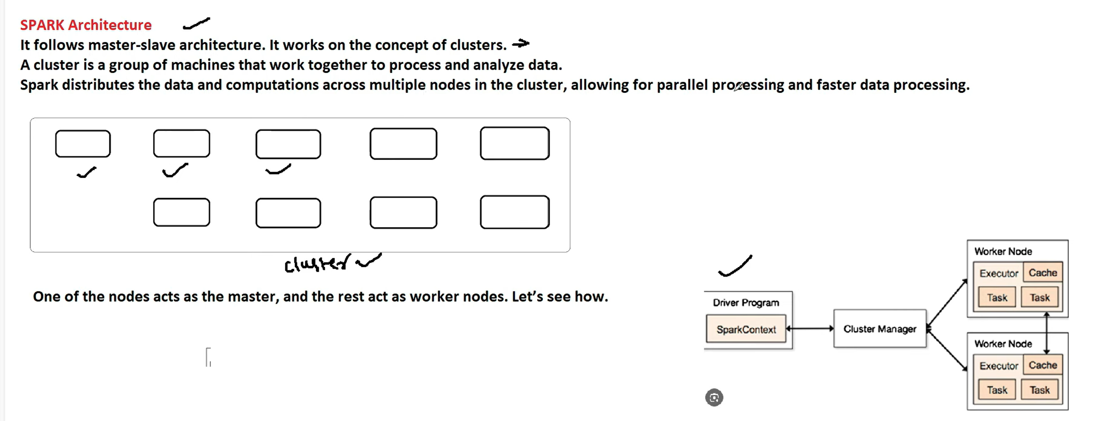
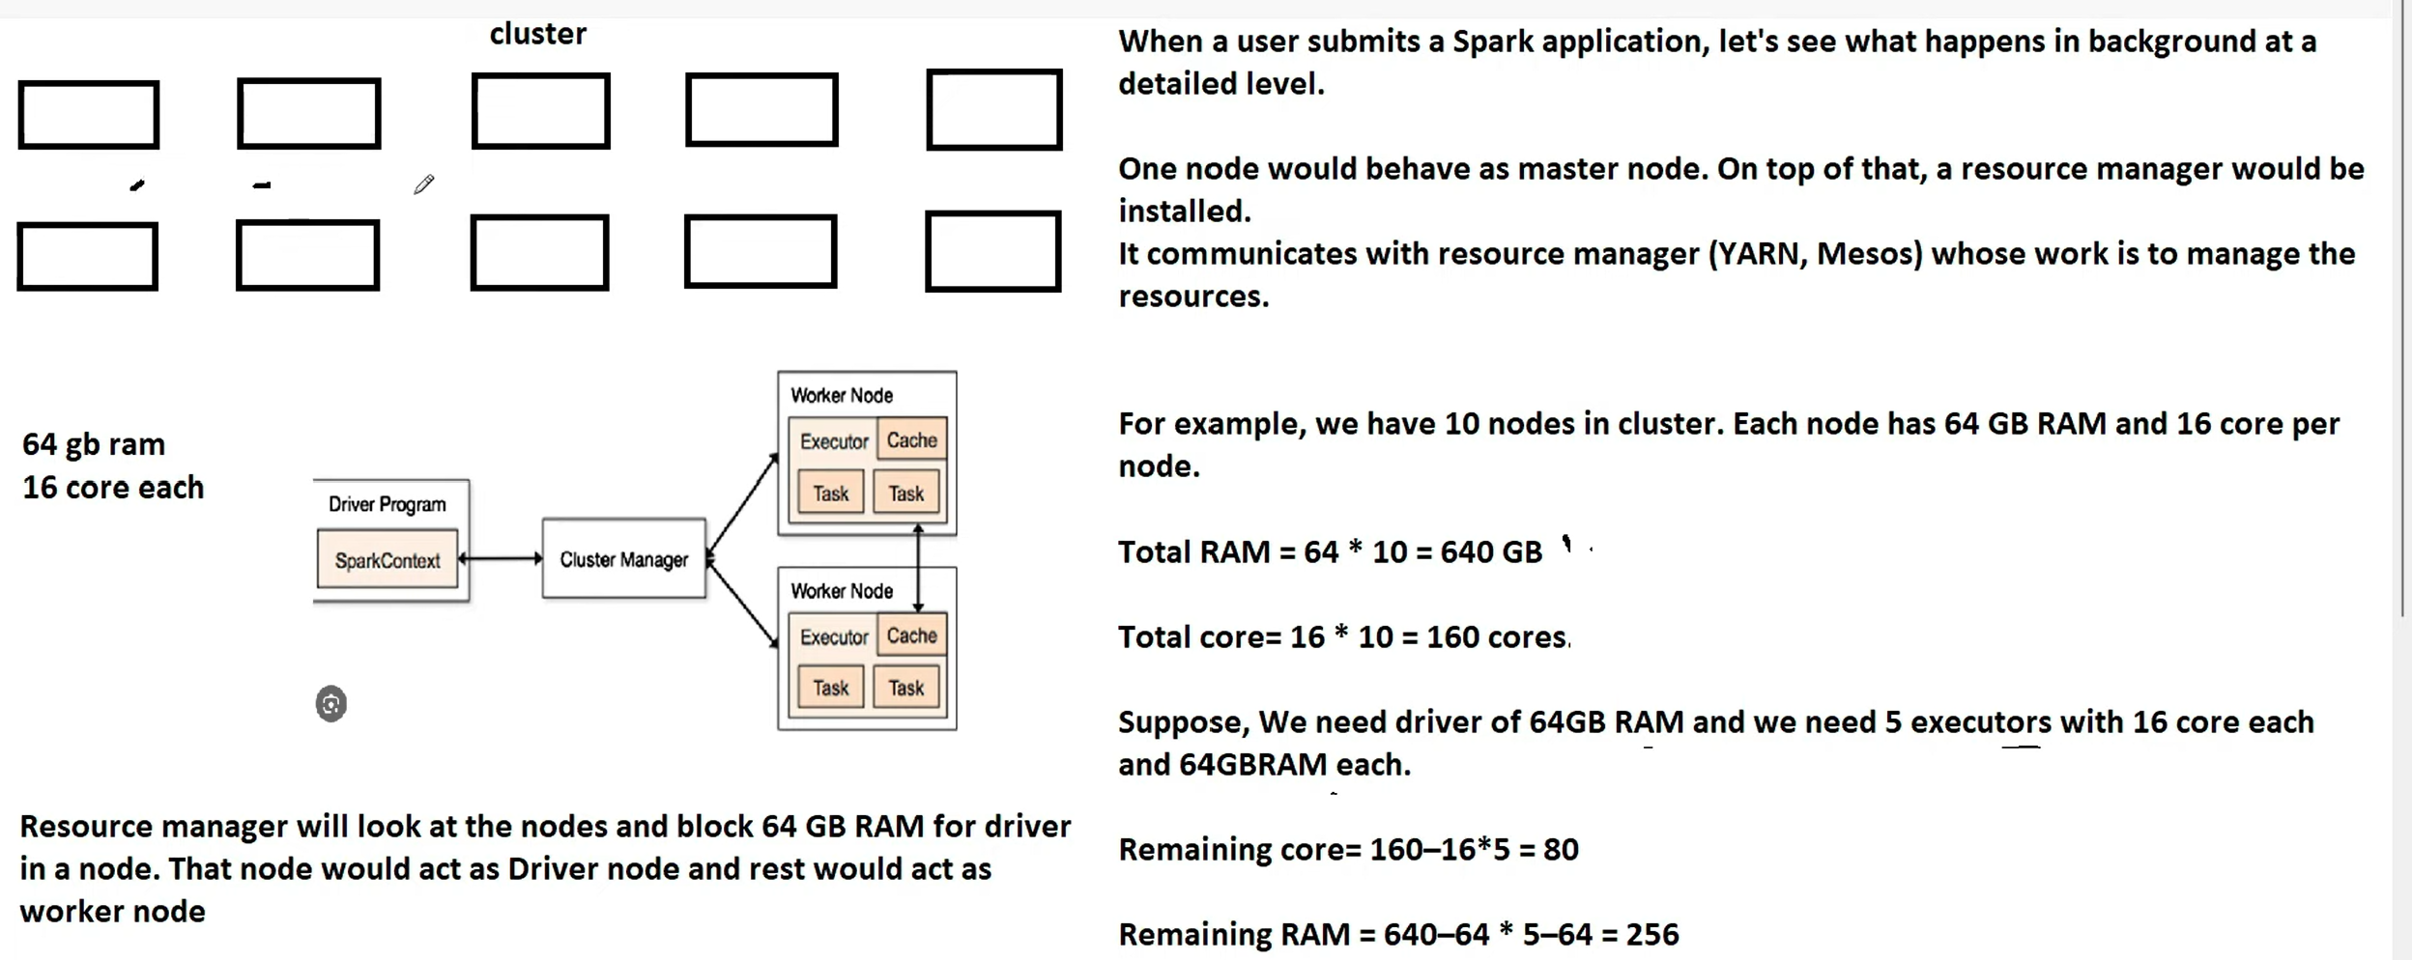

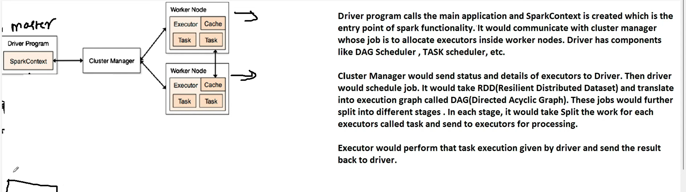

“A DataFrame is a distributed, schema-based, immutable data structure that allows SQL-like operations on large datasets efficiently.”
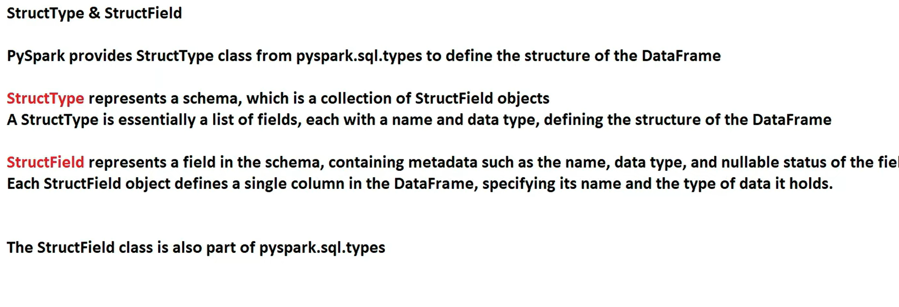

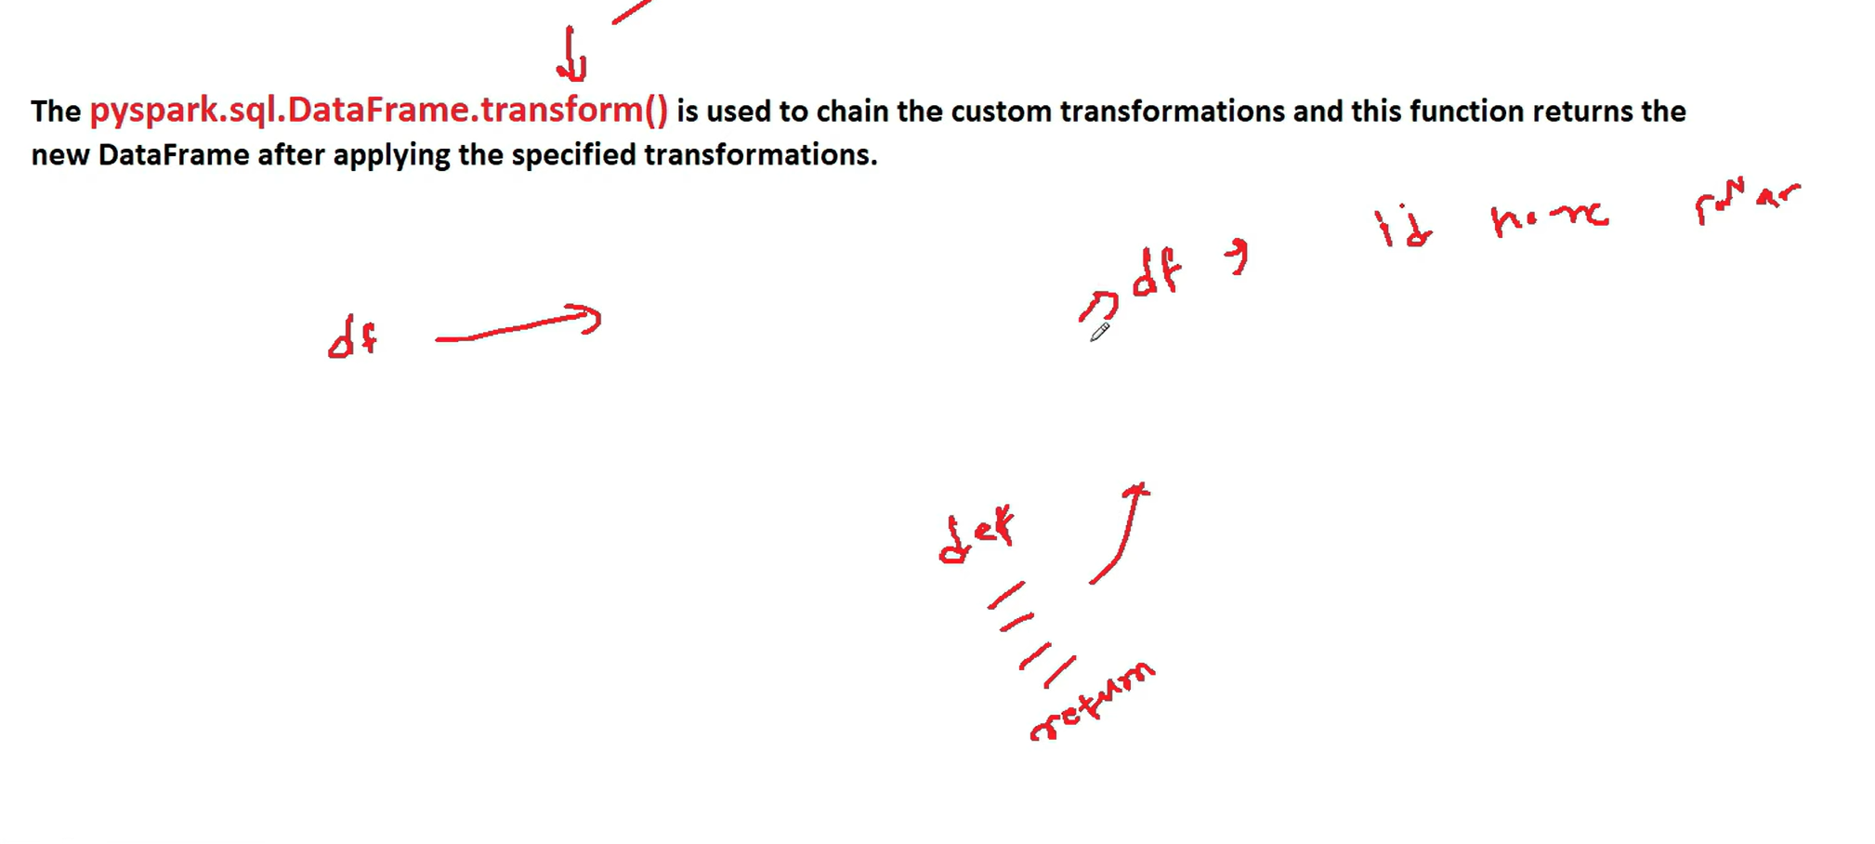

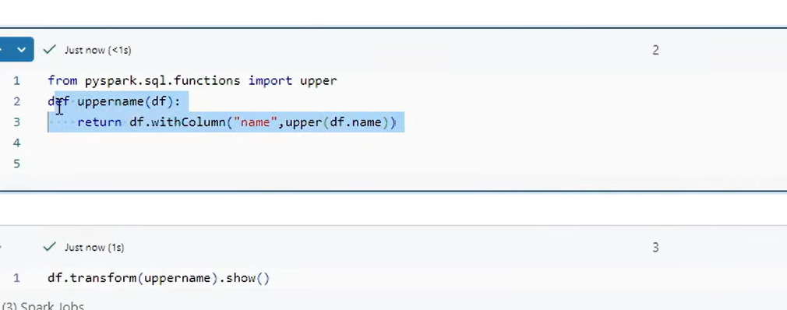

From_json(column,schema)
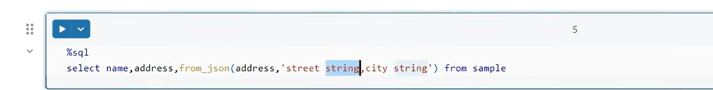

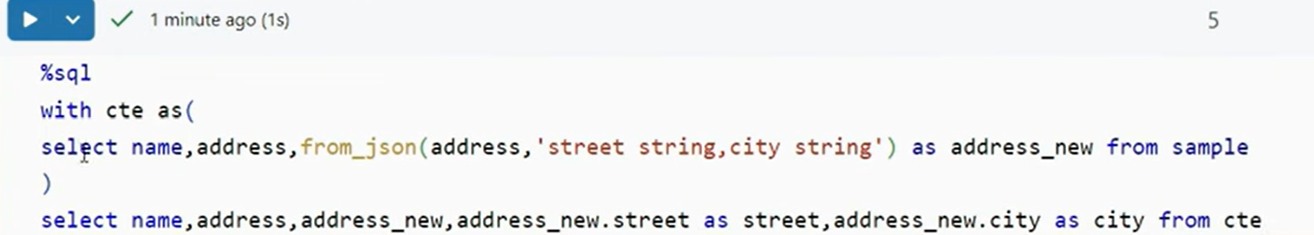

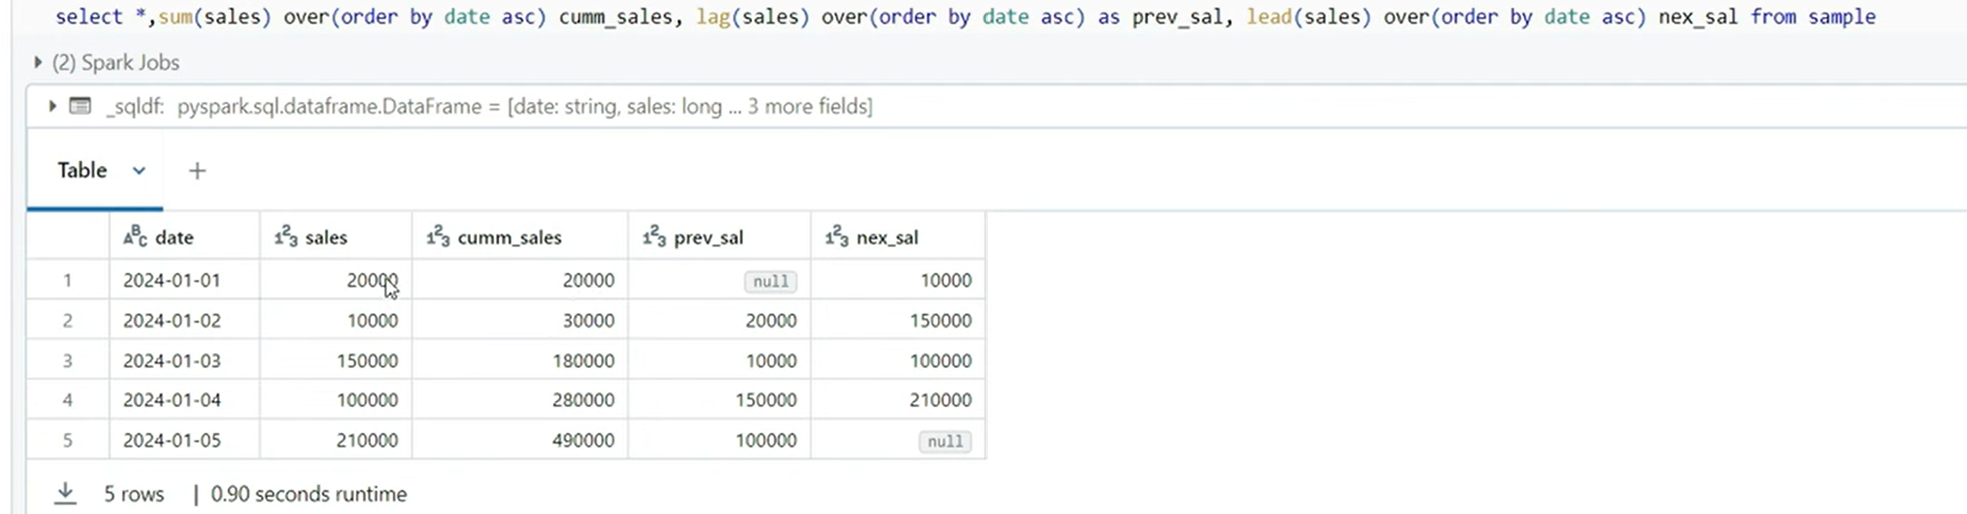
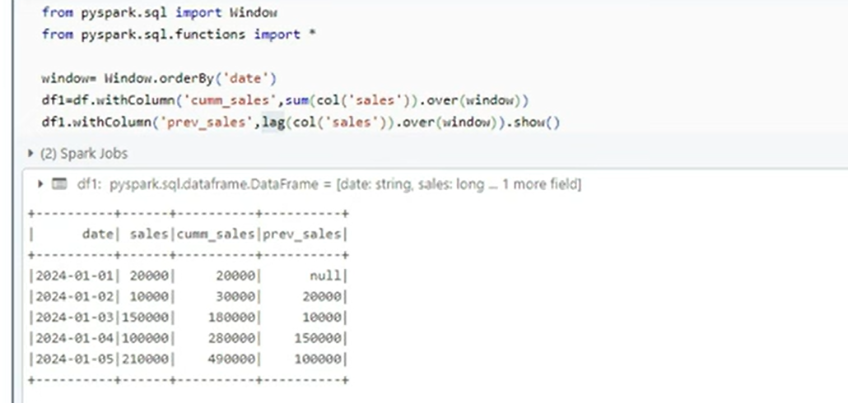

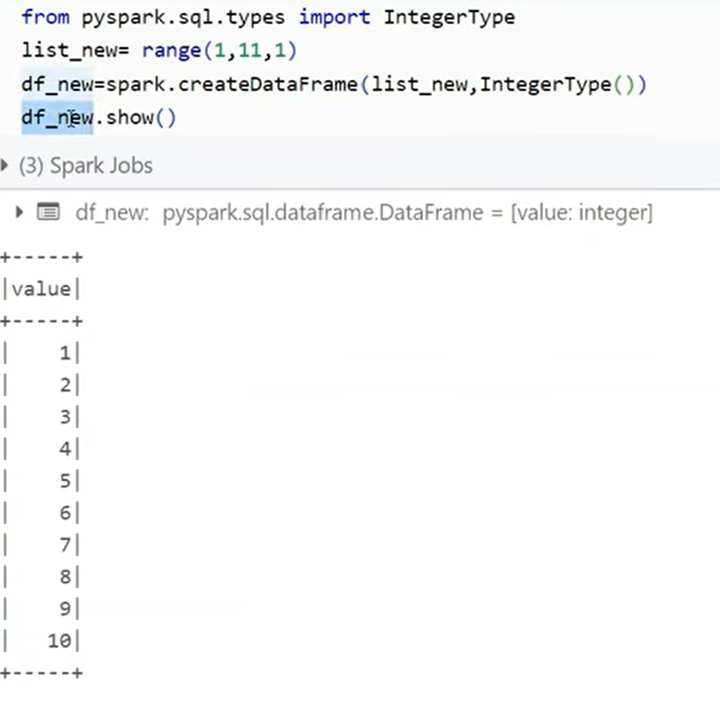

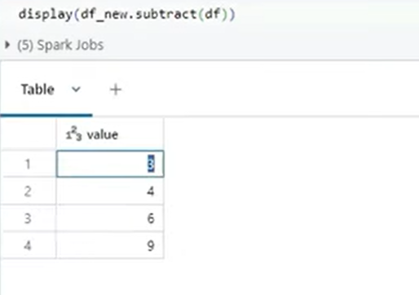
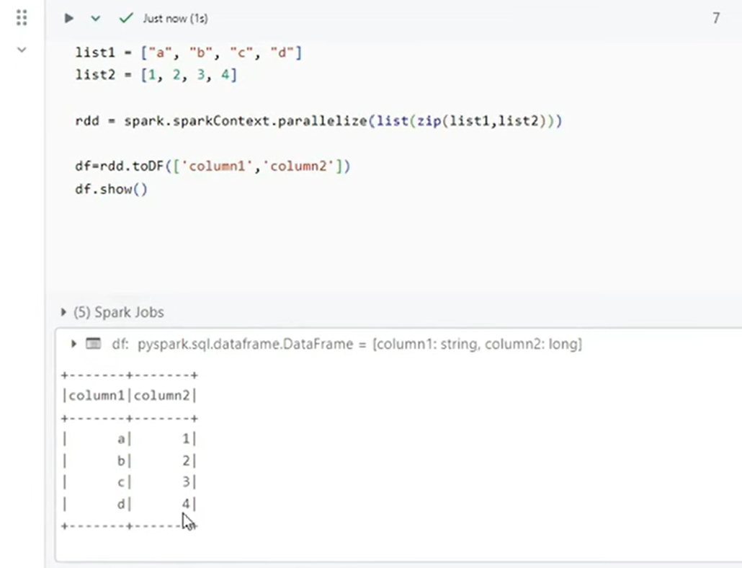

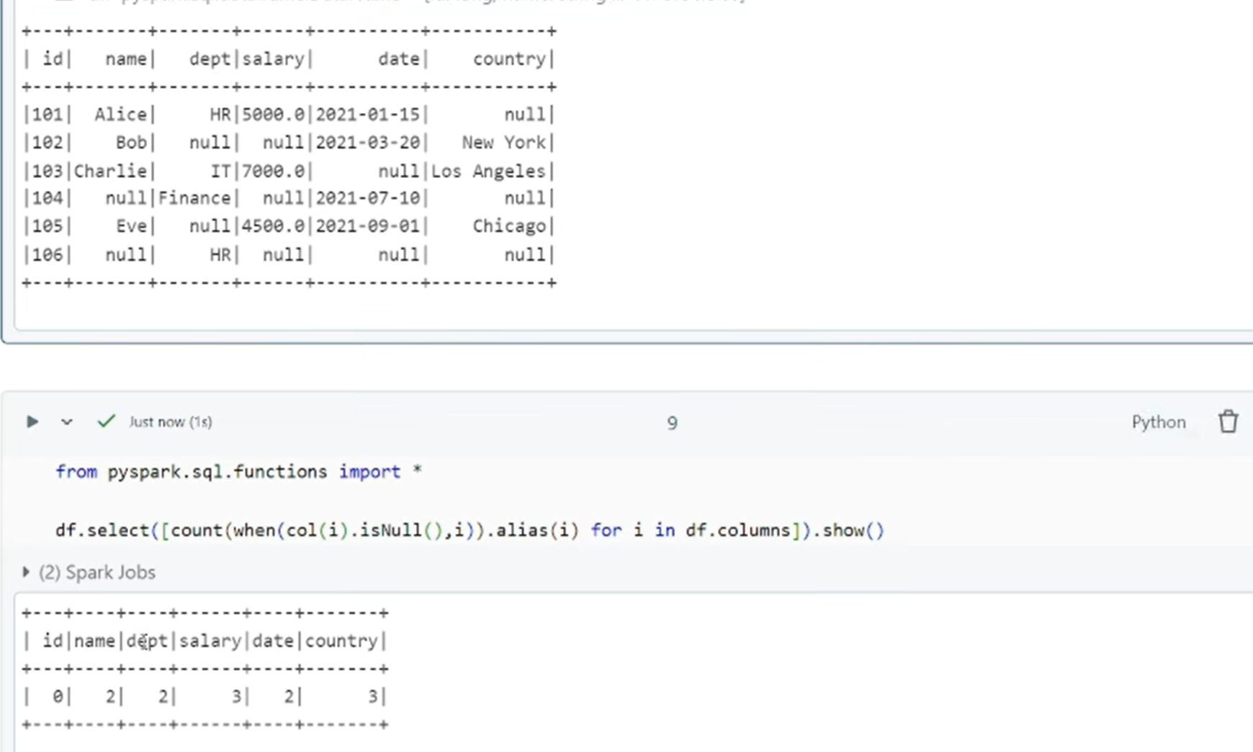
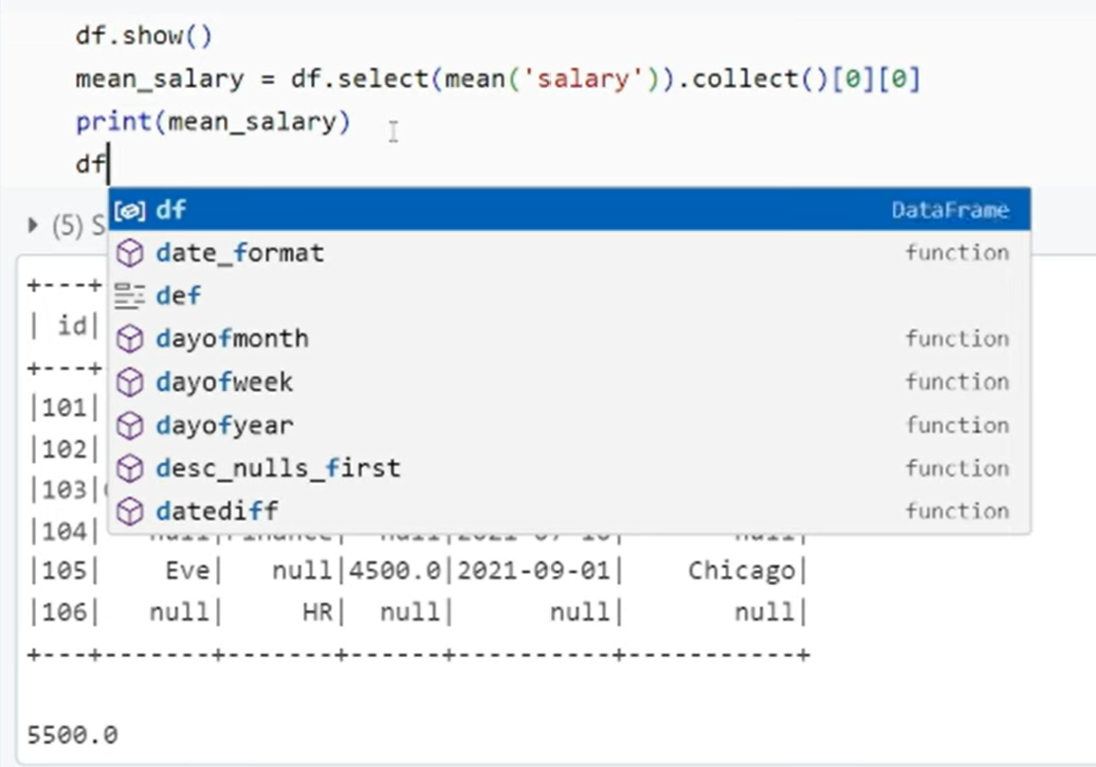

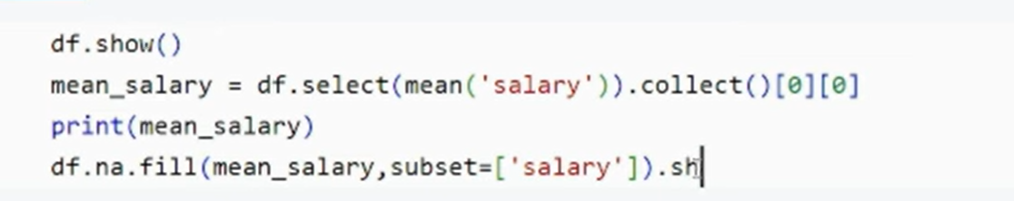

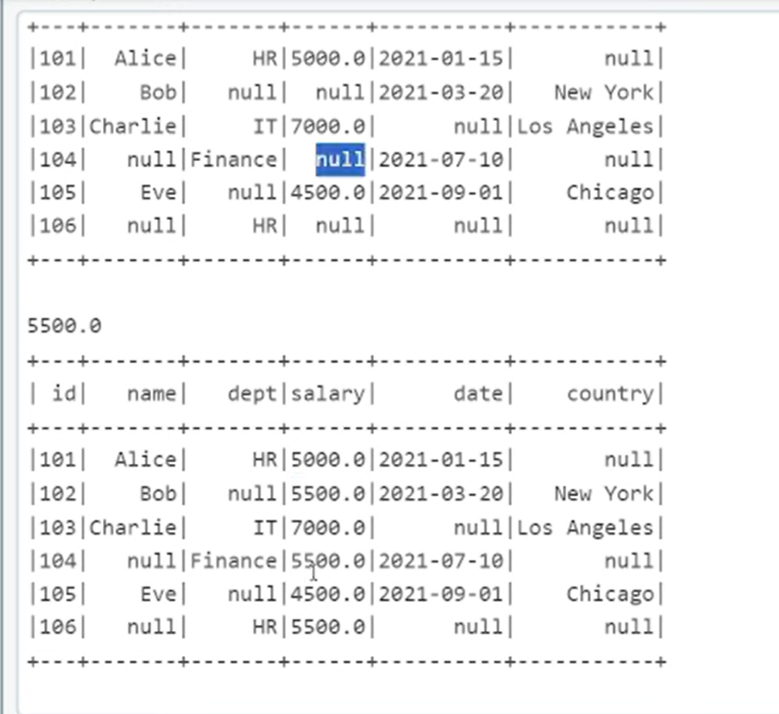

from pyspark.storagelevel import StorageLevel imp ***

df.persist(StorageLevel.MEMORY_AND_DISK)

>>>>kanna

In Apache Airflow, a DAG stands for Directed Acyclic Graph.
What an Airflow DAG is
An Airflow DAG is a logical blueprint that defines:
- What tasks need to run
- In what order they should run
- Under what schedule and conditions
It describes the workflow structure, not the execution itself.
Breaking down the term
- Directed: Tasks have a defined direction of execution (upstream → downstream).
- Acyclic: There are no loops; a task cannot depend on itself, directly or indirectly.
- Graph: Tasks are nodes, and dependencies between tasks are edges.
Key components of a DAG
- DAG object
  - Defines the workflow metadata such as schedule, start date, retries, and owner.
- Tasks
  - Individual units of work (e.g., run a Spark job, call an API, execute SQL).
  - Implemented using Operators (PythonOperator, BashOperator, SparkSubmitOperator, etc.).
- Dependencies
  - Define the execution order between tasks using >> or <<.
Simple example
from airflow import DAG
from airflow.operators.bash import BashOperator
from datetime import datetime

with DAG(
dag_id="sample_etl_dag",
start_date=datetime(2024, 1, 1),
schedule_interval="@daily",
catchup=False
) as dag:

extract = BashOperator(
task_id="extract",
bash_command="echo Extracting data"
)

transform = BashOperator(
task_id="transform",
bash_command="echo Transforming data"
)

load = BashOperator(
task_id="load",
bash_command="echo Loading data"
)

extract >> transform >> load
What a DAG does not do
- A DAG does not execute code by itself.
- It only defines task orchestration; the Airflow scheduler and workers handle execution.
DAG in interview-friendly terms
“An Airflow DAG is a directed acyclic graph that defines the workflow of tasks, their dependencies, and scheduling, enabling reliable orchestration of data pipelines.”

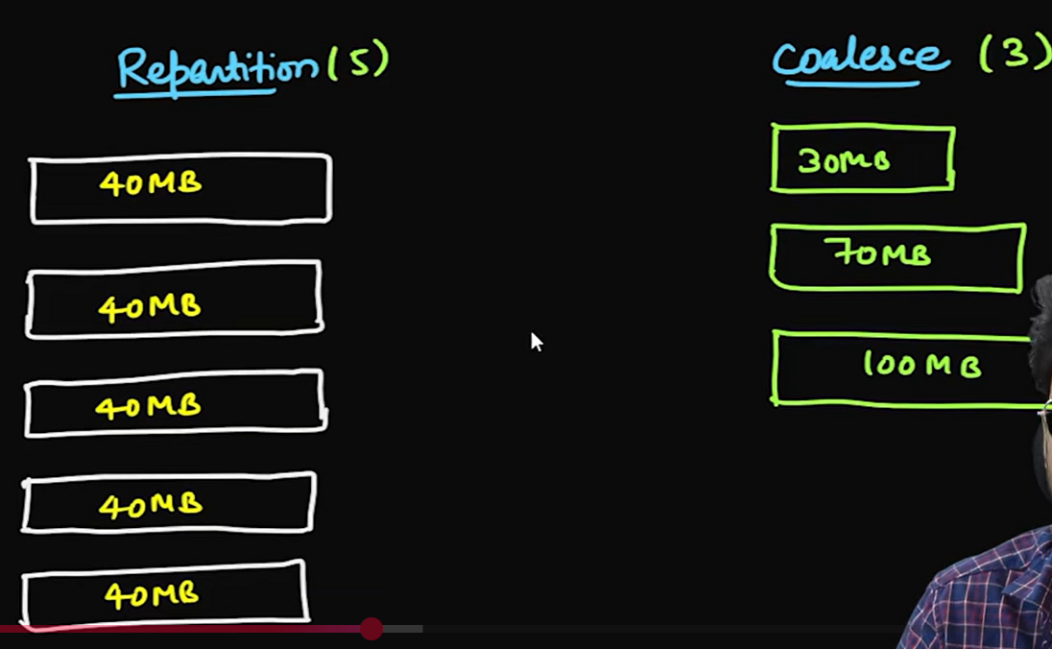

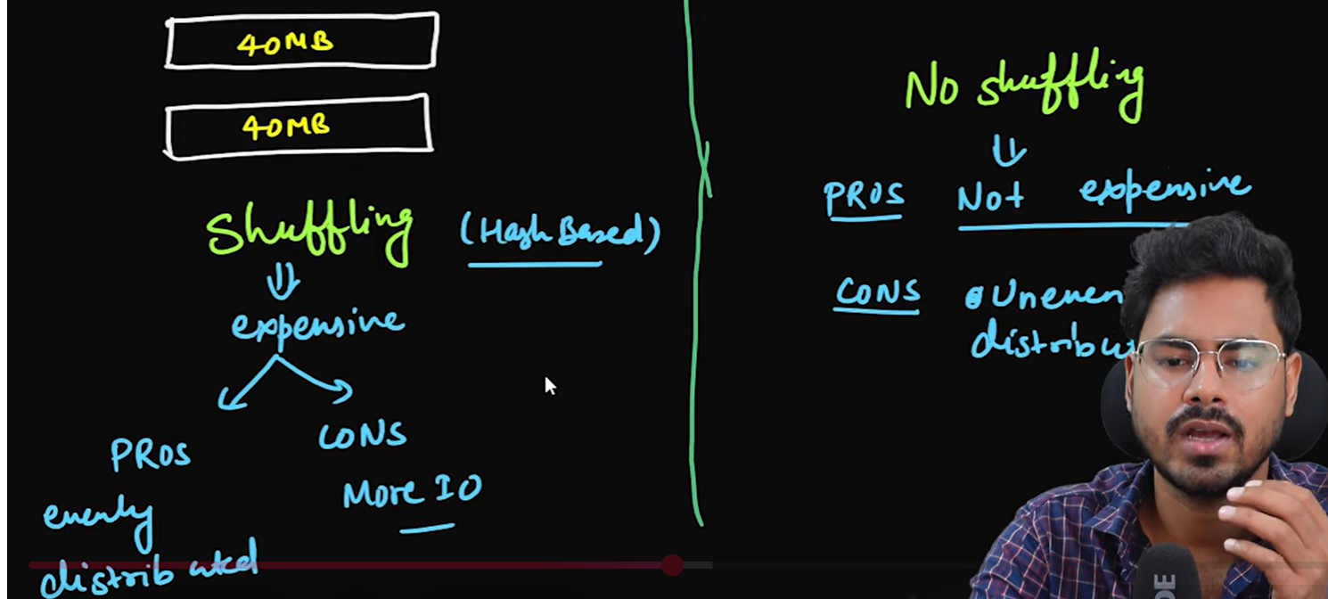

Repartition and coalesce

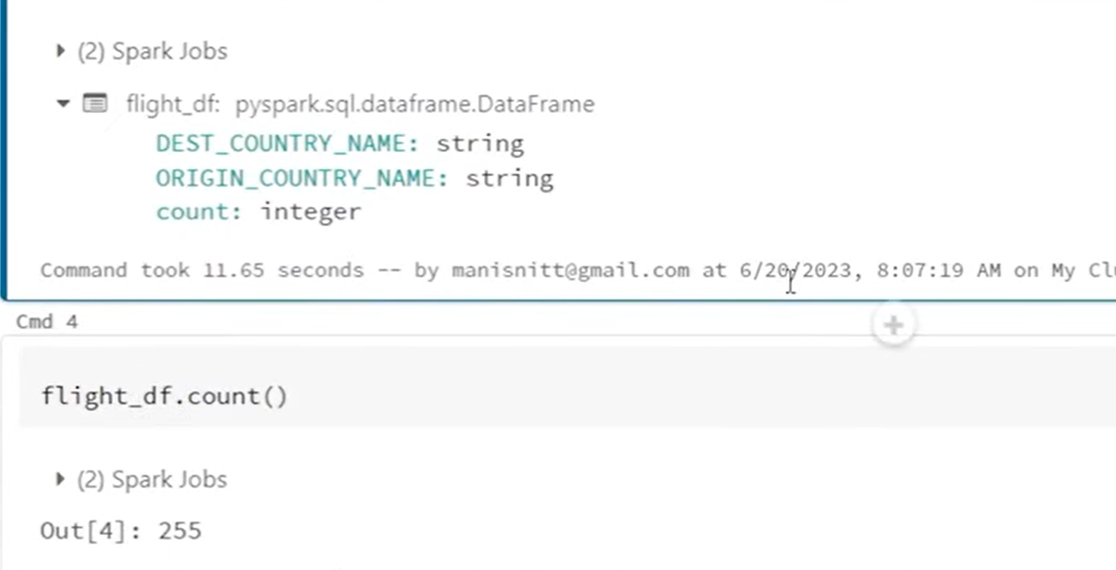

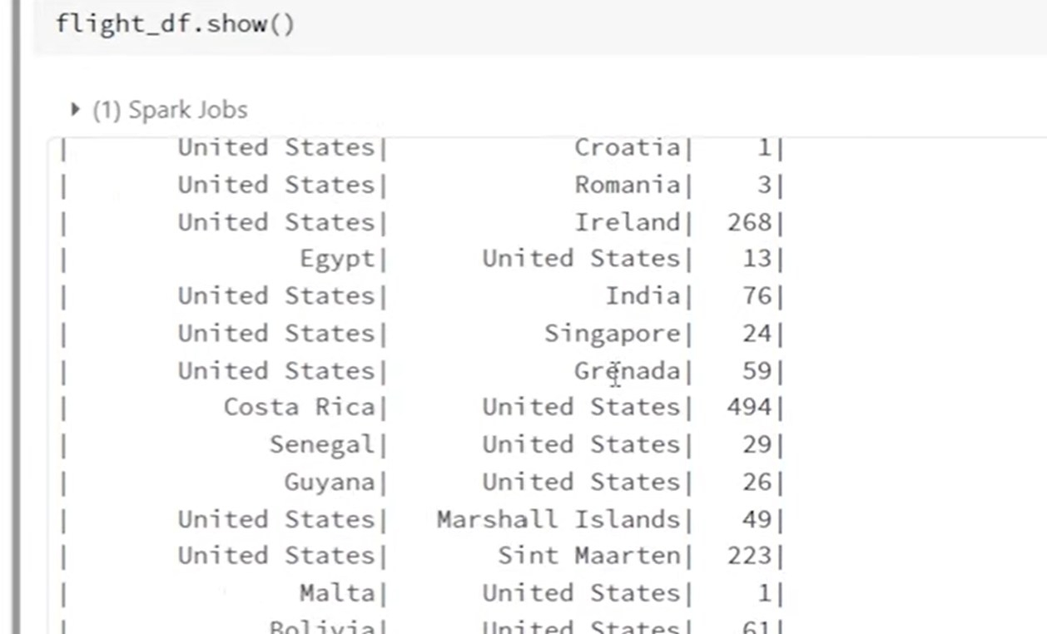

255 records

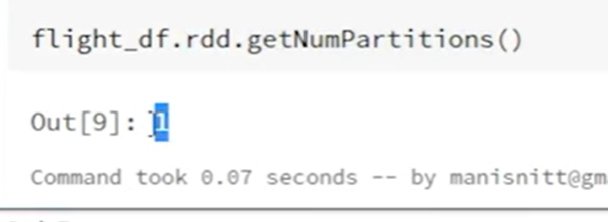

Now repartition(4)

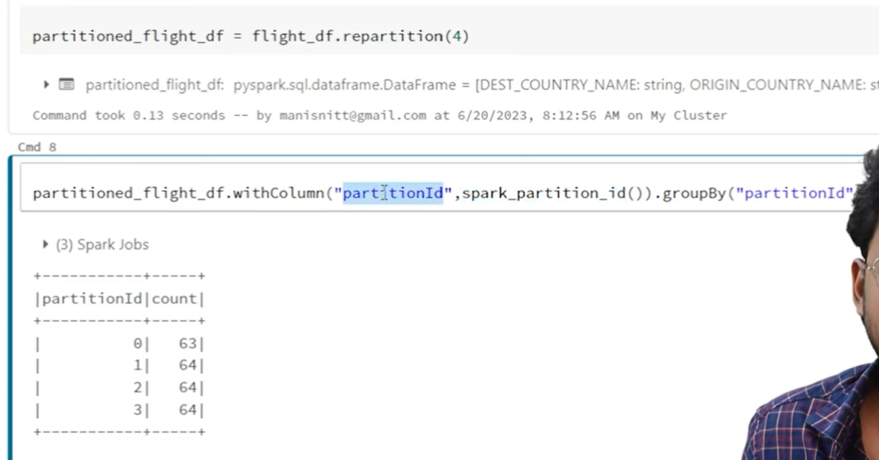

Function is spark_partition_id()

Incase of repartion(8) ,equally distributed the data
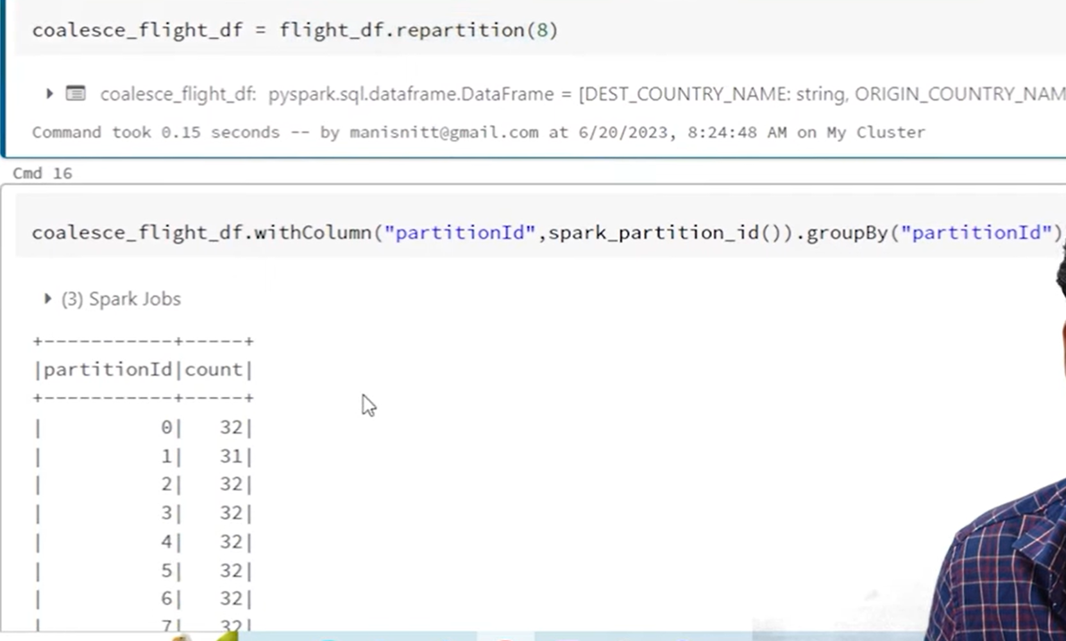

But in coalesce(3)
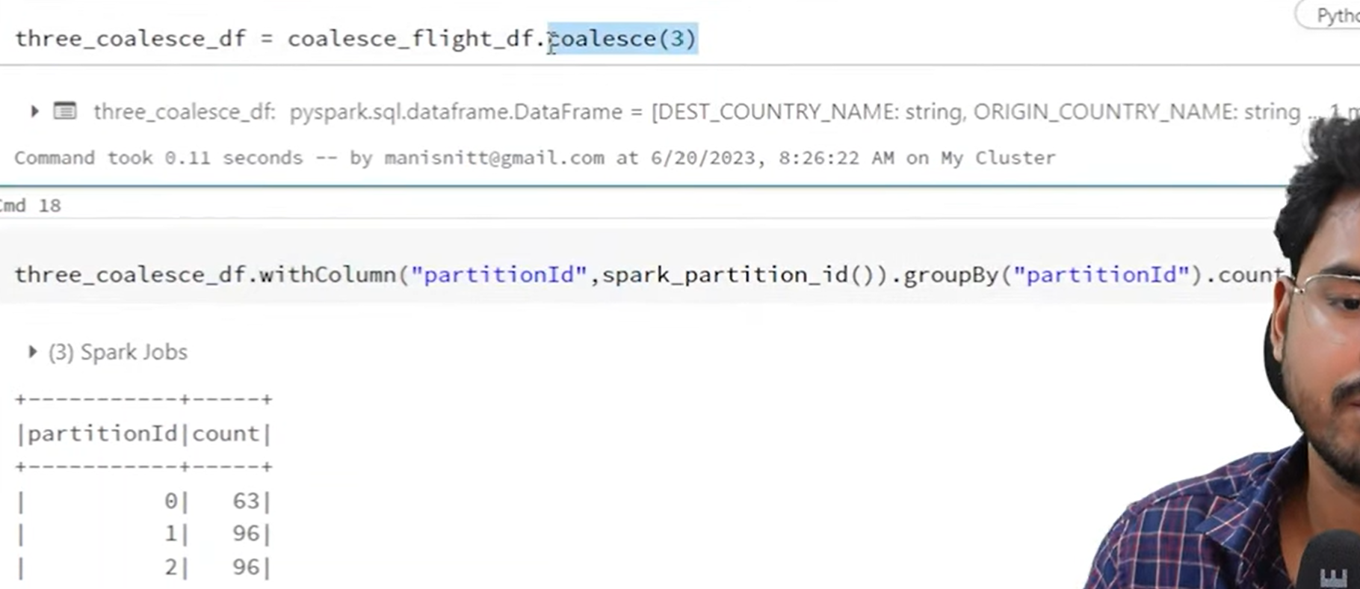

If we repartion the same into 3 partitions then

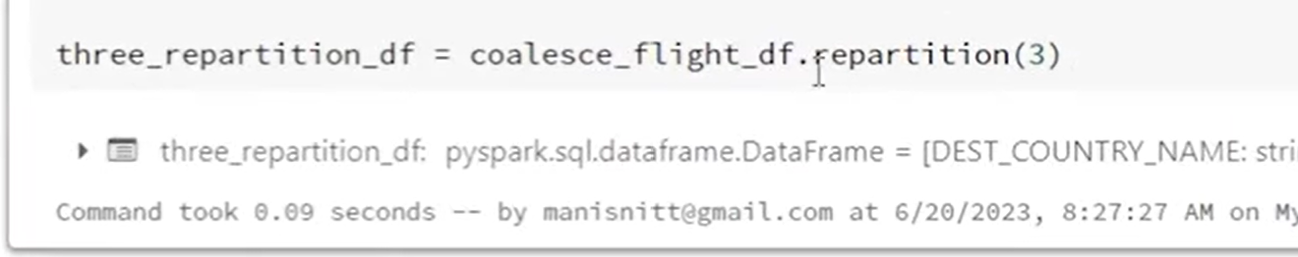

Then evenly distributed:

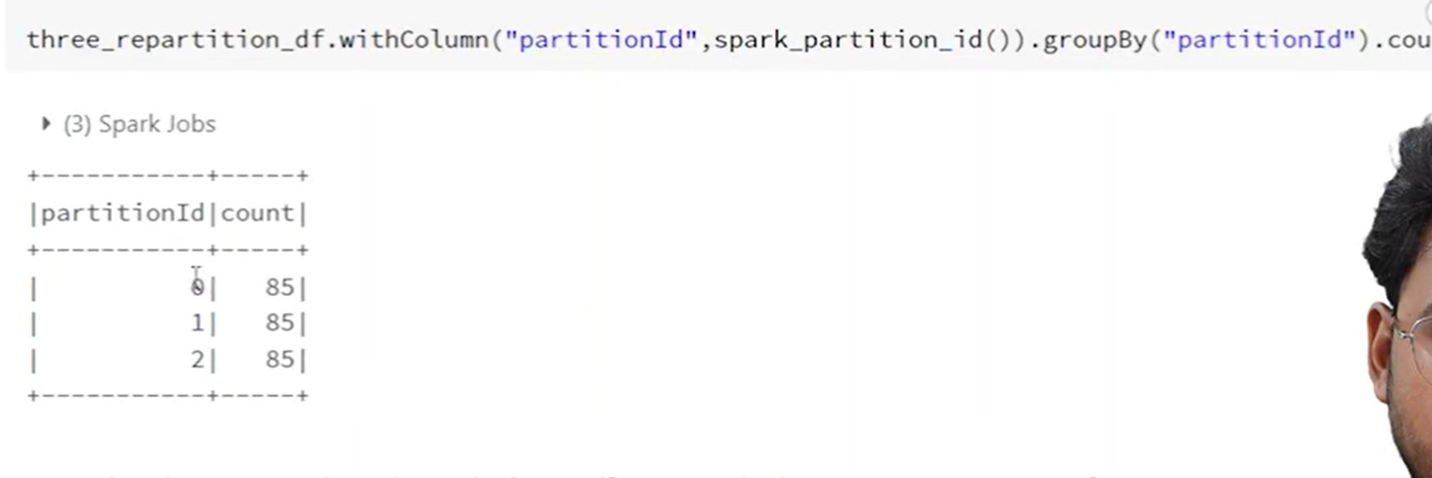

In caolesce also shuffling happen but it is whole the partition at a time not the data by reduction (like hashing etc..).
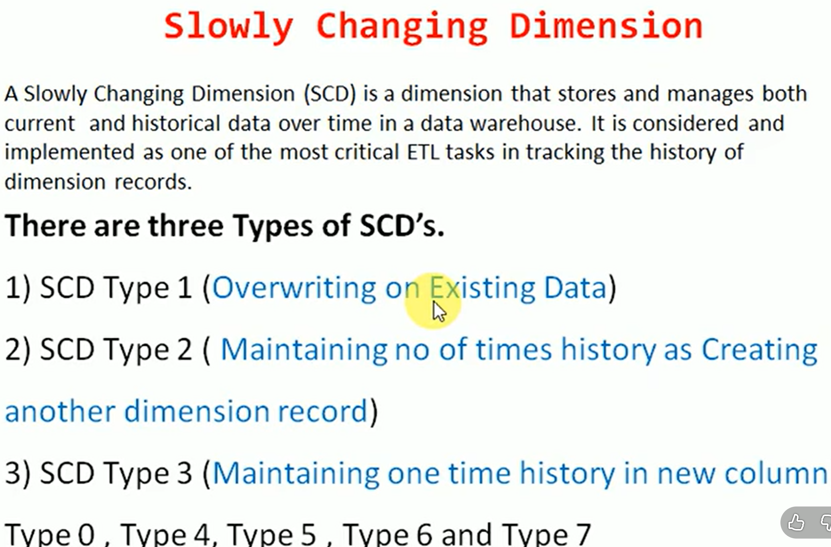

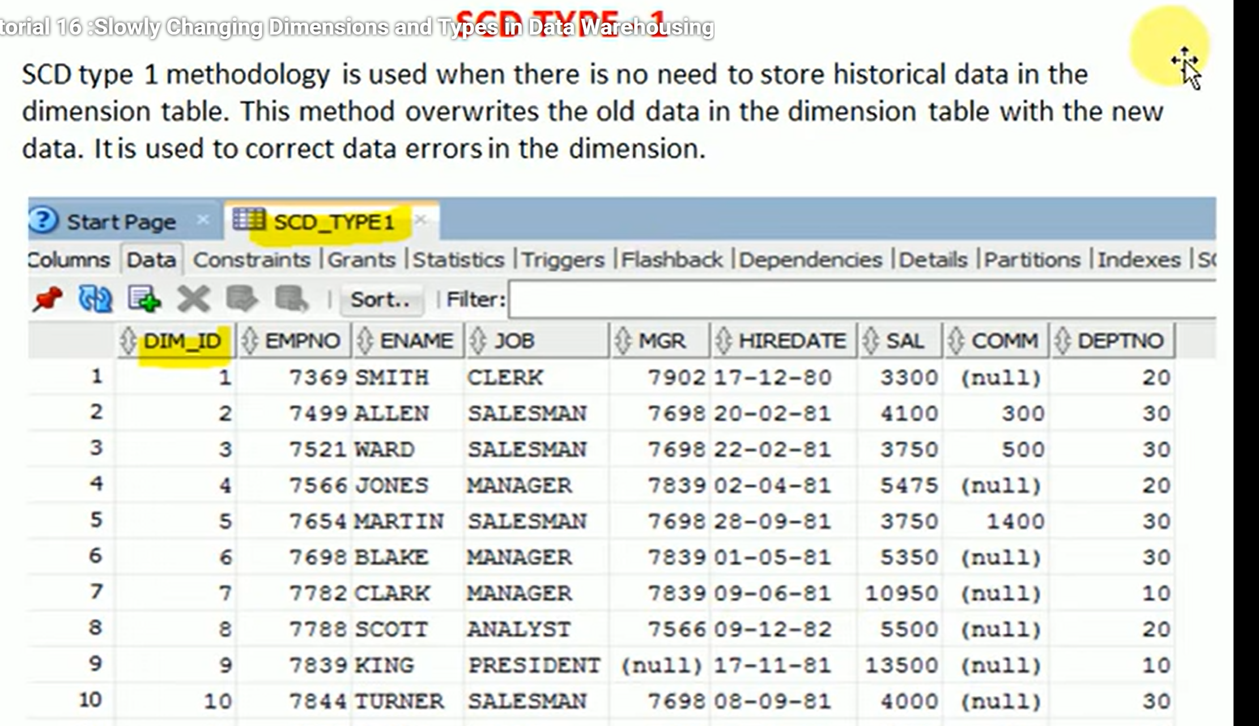

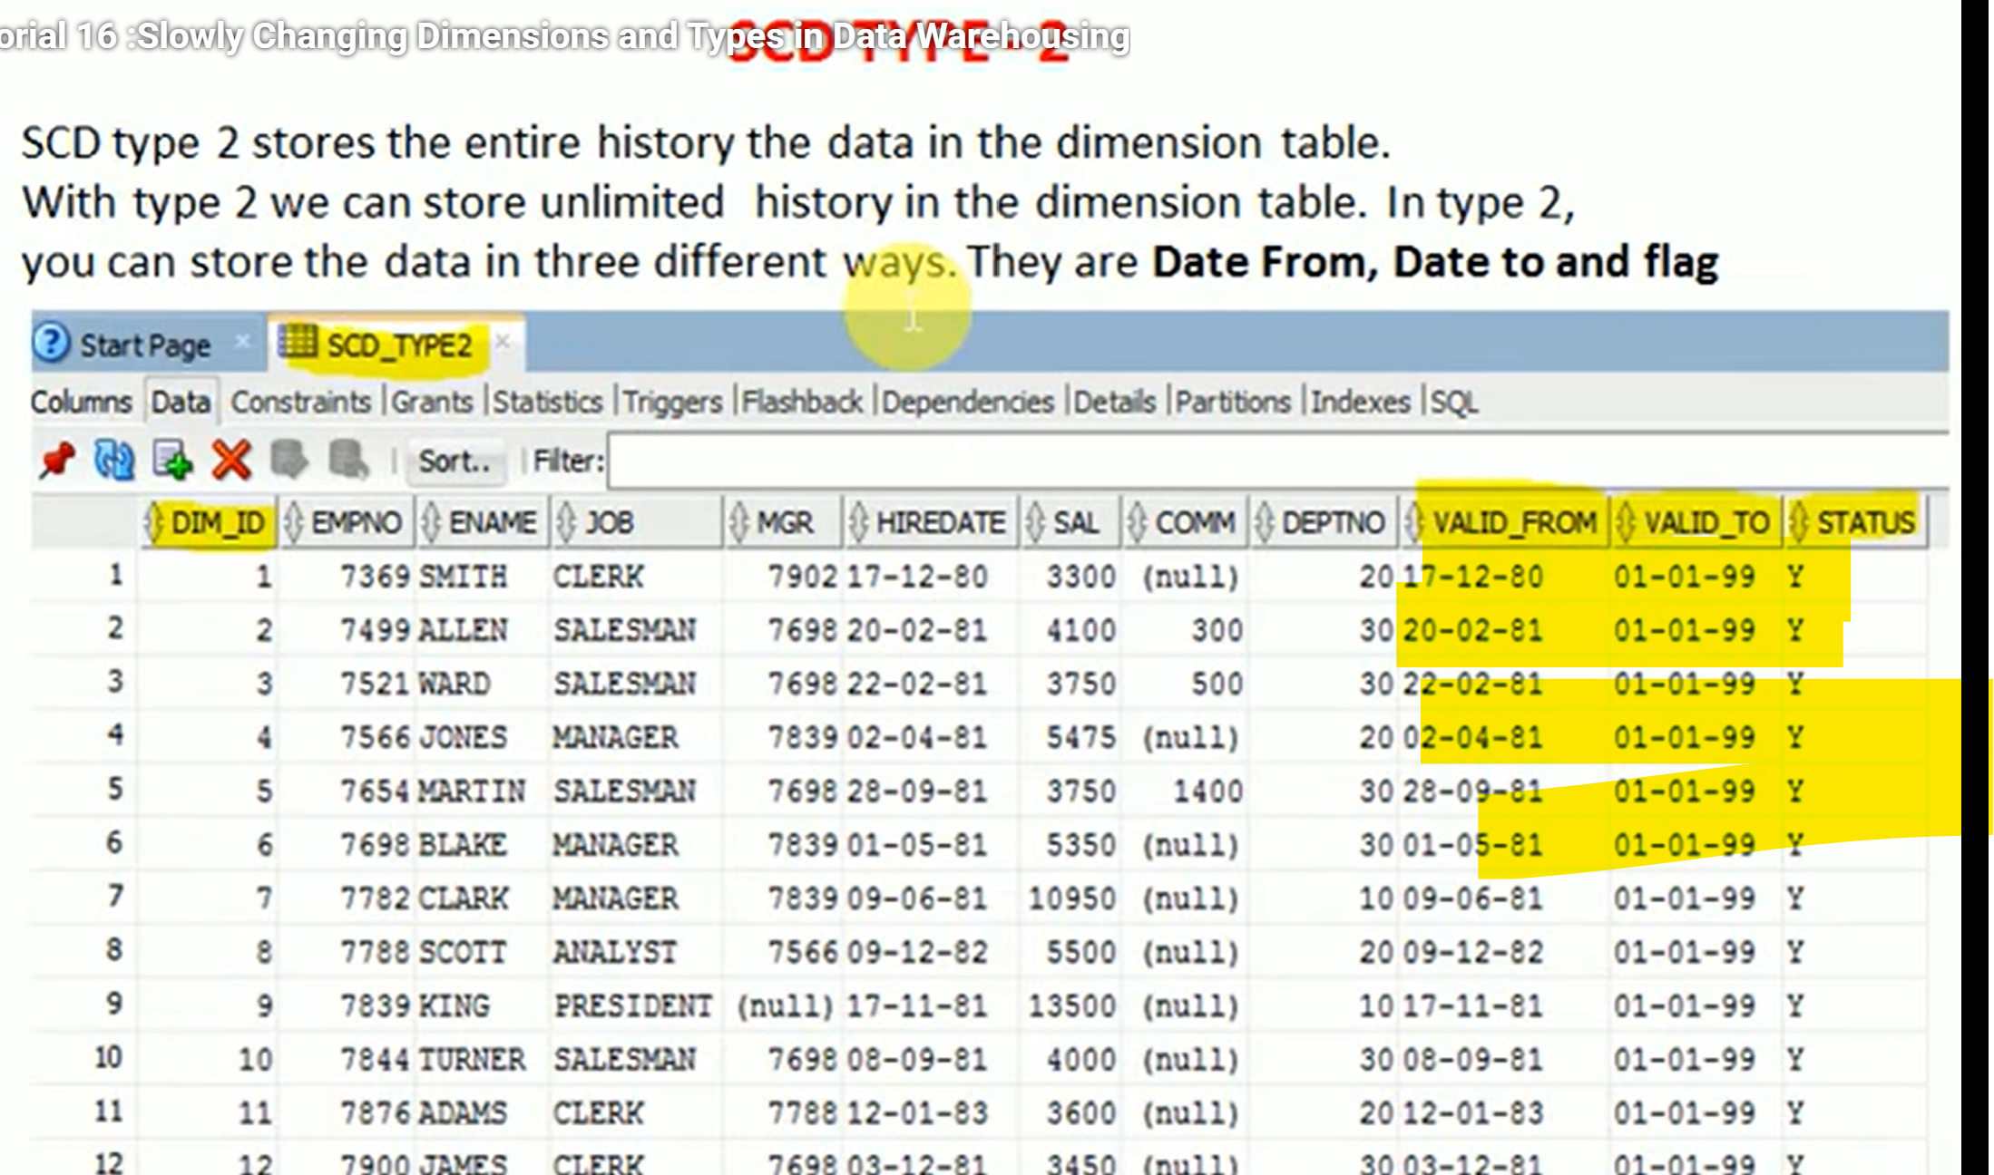

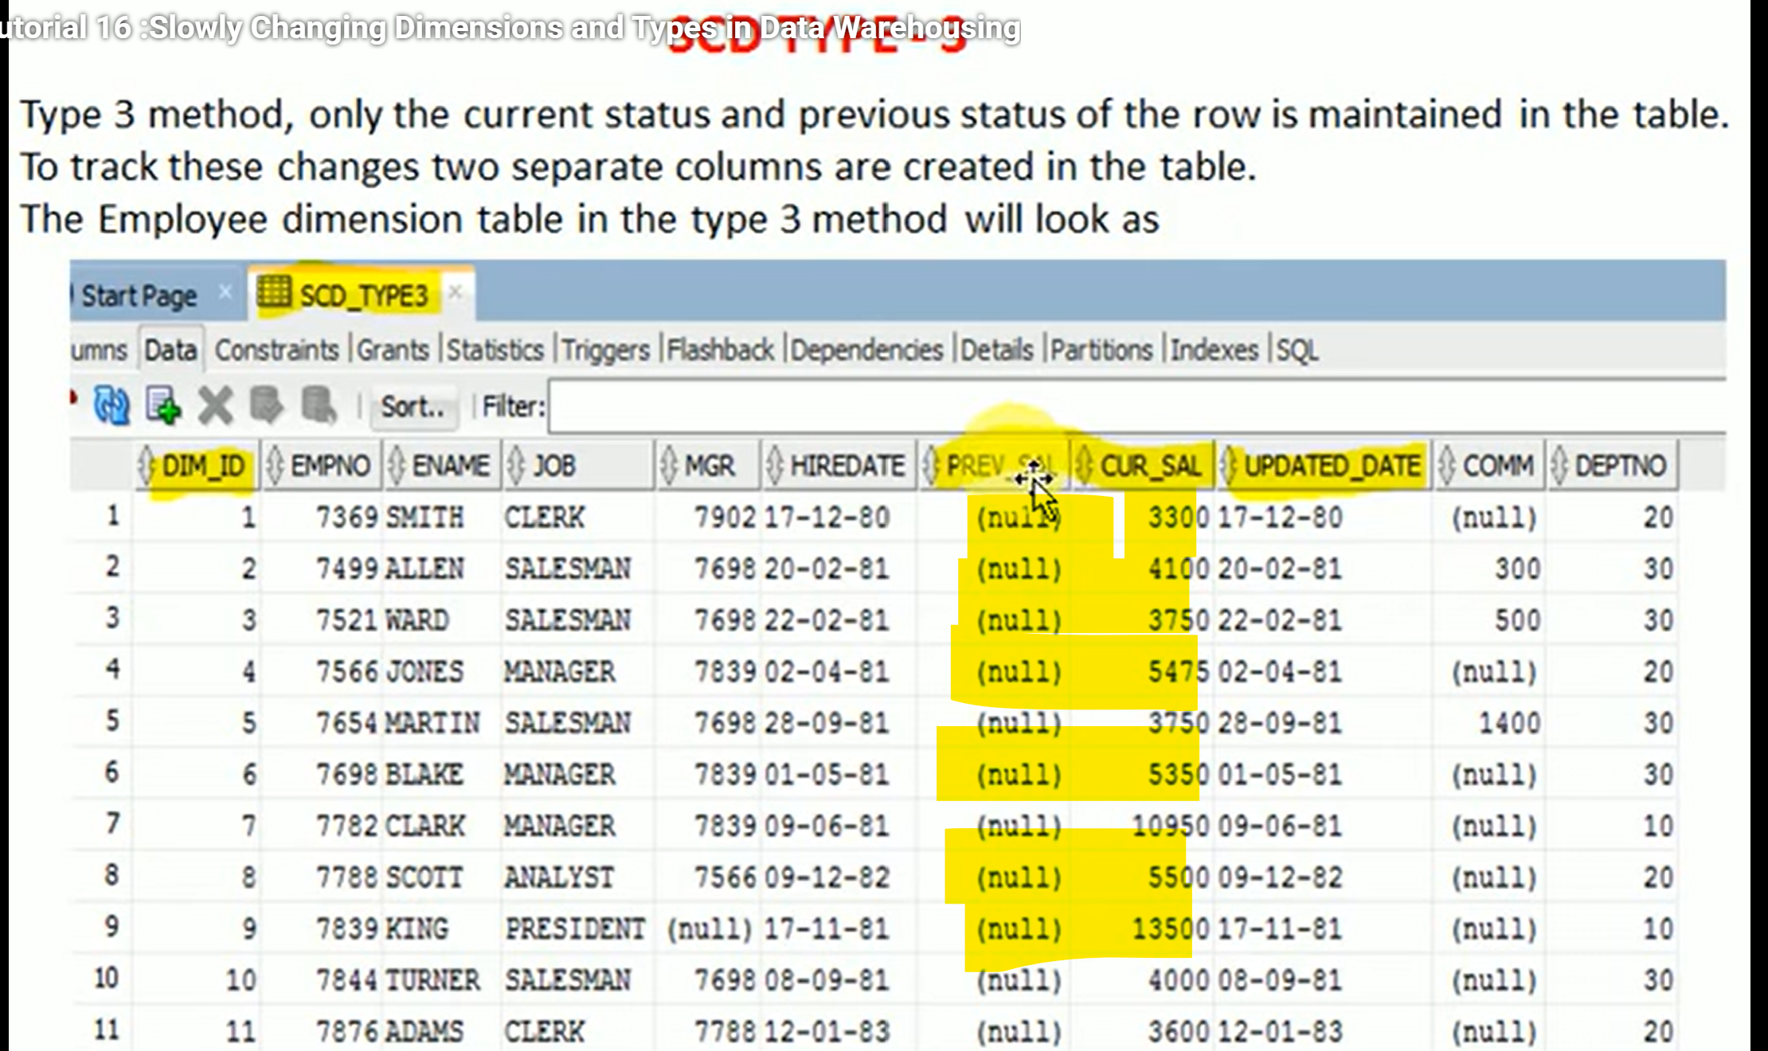

left_anti returns:
Rows from the left DataFrame that do NOT have a match in the right DataFrame.

