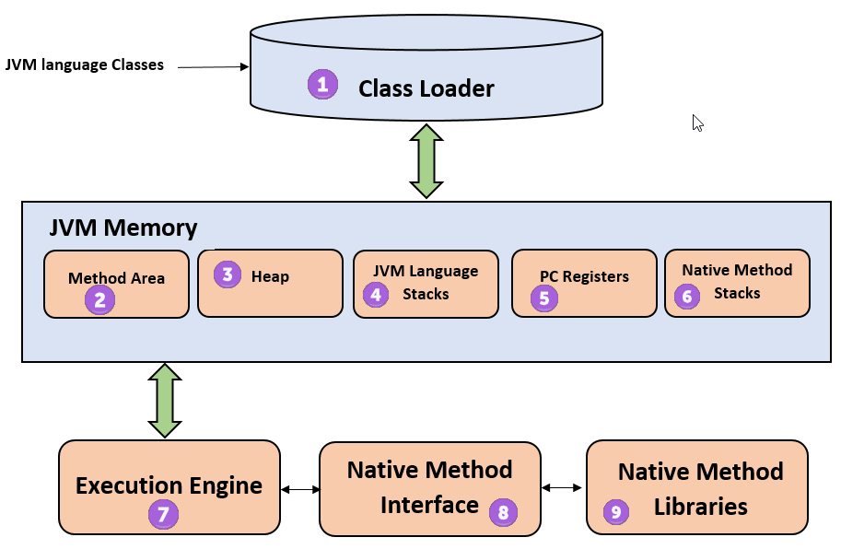

**1) ClassLoader** The class loader is a subsystem used for loading class files. It performs three major functions viz. Loading, Linking, and Initialization.

**2) Method Area** JVM Method Area stores class structures like metadata, the constant runtime pool, and the code for methods.

**3) Heap** All the [Objects](https://www.guru99.com/java-oops-class-objects.html), their related instance variables, and arrays are stored in the heap. This memory is common and shared across multiple threads.

**4) JVM language Stacks** Java language Stacks store local variables, and it’s partial results. Each thread has its own JVM stack, created simultaneously as the thread is created. A new frame is created whenever a method is invoked, and it is deleted when method invocation process is complete.

**5)  PC Registers** PC register store the address of the Java virtual machine instruction which is currently executing. In Java, each thread has its separate PC register.

**6) Native Method Stacks** Native method stacks hold the instruction of native code depends on the native library. It is written in another language instead of Java.

**7) Execution Engine** It is a type of software used to test hardware, software, or complete systems. The test execution engine never carries any information about the tested product.

**8) Native Method interface** The Native Method Interface is a programming framework. It allows Java code which is running in a JVM to call by libraries and native applications.

**9) Native Method Libraries** Native Libraries is a collection of the Native Libraries(C, C++) which are needed by the Execution Engine.

**Software Code Compilation & Execution process** In order to write and execute a software program, you need the following

**1) Editor**– To type your program into, a notepad could be used for this

**2) Compiler**– To convert your high language program into native machine code

**3) Linker**– To combine different program files reference in your main program together.

**4) Loader**– To load the files from your secondary storage device like Hard Disk, Flash Drive, CD into RAM for execution. The loading is automatically done when you execute your code.

**5) Execution** – Actual execution of the code which is handled by your OS & processor.

