Employee

EmpNo, EmpName, EmpSal

Department

DeptId, DeptName

EmpDept

EmpNo, DeptId

Write a SQL Query to Get the Highest Salaried Employee Details in Each Department

Select

e.empno, e.empname, e.empsal, ed.deptid,

d.deptid, d.deptname

From

public.empdept ed,

public.employee e,

public.department d

Where 1=1

and ed.empno = e.empno

and ed.deptid = d.deptid

Order by

ed.deptid;

Select

max(e.empsal), ed.deptid

From

public.employee e, public.empdept ed

where 1=1

and e.empno = ed.empno

group by ed.deptid;

Select

e.empno, e.empname, e.empsal, ed.deptid, d.deptname

From

public.empdept ed,

public.employee e,

public.department d

Where 1=1

and ed.empno = e.empno

and ed.deptid = d.deptid

and e.empsal in (Select Max(e.empsal)

From public.employee e, public.empdept ed

Where e.empno = ed.empno

Group By ed.deptid);

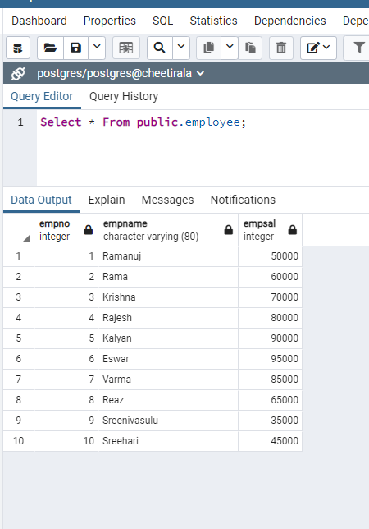

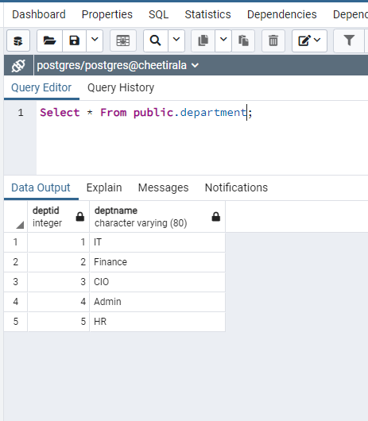

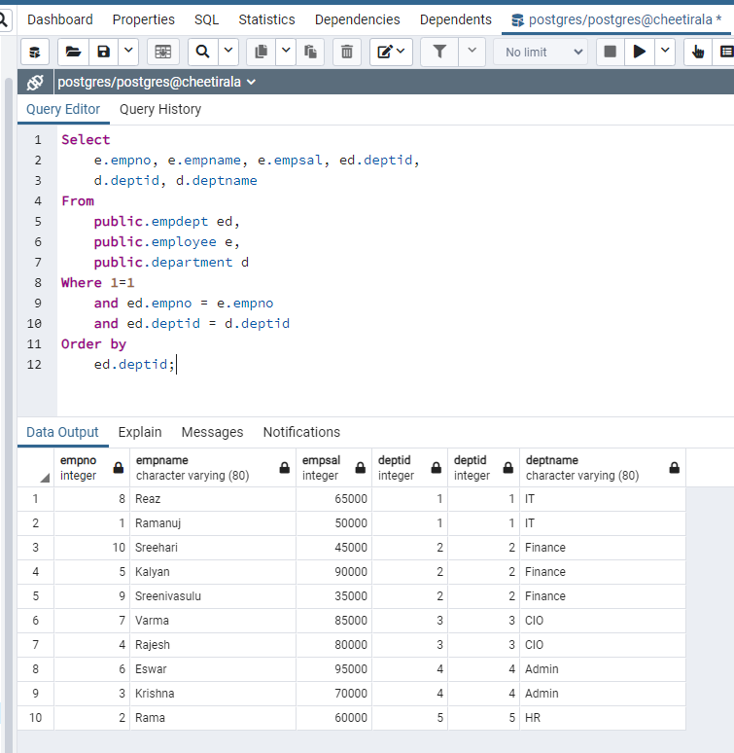

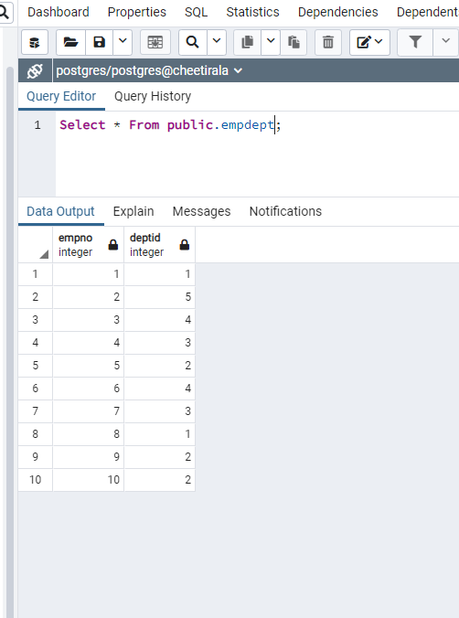

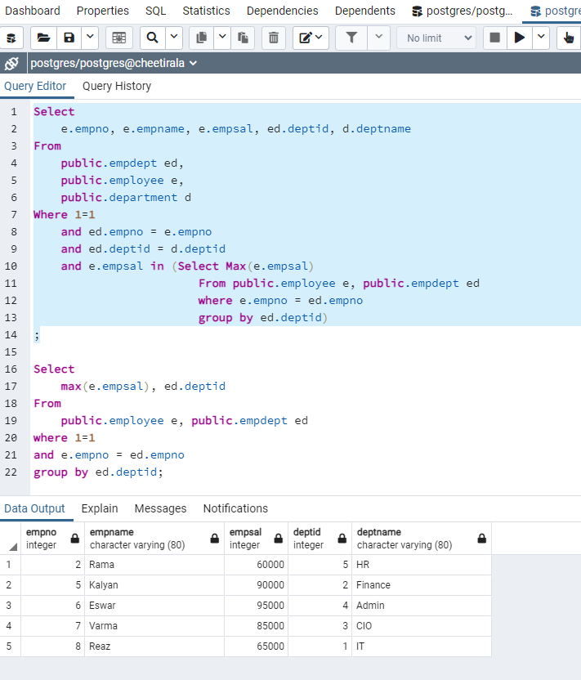

/\* Table Creation \*/

CREATE TABLE employee (

EmpNo int,

EmpName varchar(80),

EmpSal int

);

CREATE TABLE Department (

DeptId int,

DeptName varchar(80)

);

CREATE TABLE EmpDept (

EmpNo int,

DeptId int

);

INSERT INTO public.department(deptid, deptname) VALUES (1, 'IT');

INSERT INTO public.department(deptid, deptname) VALUES (2, 'Finance');

INSERT INTO public.department(deptid, deptname) VALUES (3, 'CIO');

INSERT INTO public.department(deptid, deptname) VALUES (4, 'Admin');

INSERT INTO public.department(deptid, deptname) VALUES (5, 'HR');

Select \* From department;

INSERT INTO public.employee(empno, empname, empsal) VALUES (1, 'Ramanuj', 50000);

INSERT INTO public.employee(empno, empname, empsal) VALUES (2, 'Rama', 60000);

INSERT INTO public.employee(empno, empname, empsal) VALUES (3, 'Krishna', 70000);

INSERT INTO public.employee(empno, empname, empsal) VALUES (4, 'Rajesh', 80000);

INSERT INTO public.employee(empno, empname, empsal) VALUES (5, 'Kalyan', 90000);

INSERT INTO public.employee(empno, empname, empsal) VALUES (6, 'Eswar', 95000);

INSERT INTO public.employee(empno, empname, empsal) VALUES (7, 'Varma', 85000);

INSERT INTO public.employee(empno, empname, empsal) VALUES (8, 'Reaz', 65000);

INSERT INTO public.employee(empno, empname, empsal) VALUES (9, 'Sreenivasulu', 35000);

INSERT INTO public.employee(empno, empname, empsal) VALUES (10, 'Sreehari', 45000);

select \* from public.employee;

INSERT INTO public.empdept(empno, deptid) VALUES (1, 1);

INSERT INTO public.empdept(empno, deptid) VALUES (2, 5);

INSERT INTO public.empdept(empno, deptid) VALUES (3, 4);

INSERT INTO public.empdept(empno, deptid) VALUES (4, 3);

INSERT INTO public.empdept(empno, deptid) VALUES (5, 2);

INSERT INTO public.empdept(empno, deptid) VALUES (6, 4);

INSERT INTO public.empdept(empno, deptid) VALUES (7, 3);

INSERT INTO public.empdept(empno, deptid) VALUES (8, 1);

INSERT INTO public.empdept(empno, deptid) VALUES (9, 2);

INSERT INTO public.empdept(empno, deptid) VALUES (10, 2);

select \* From public.empdept;