**Project Report Guidelines**

# Your success of the project includes your ability to design, conduct, document the results and communicate the significance of project experiments. Your project report should describe the project purpose, procedure, findings, and conclusions.

Type your project reports by using a good word processor and learn its features (formatting, tables, etc.). Handwritten project reports will not be accepted. Always use complete sentences, and try to be as clear as possible in your wording. Check your spelling and try to use correct grammar. Any data sheets and graphs should be neat and readable.

**Contents and Organization:**

# The project report should include the following sections:

* Title Page
* Introduction
* Report of Each Part
* Conclusion

These sections should be clearly titled and organized in the exact manner as shown above. The graphic at the right depicts the organizational scheme which you should have and an approximate number of pages which each section might typically have. These pages are merely an approximation and serve to give an idea of the magnitude of the report.

1. Title Page

CPE166 Advanced Logic Design

Lab Number

Student Name:

1. Table of Contents

List major sections and their page numbers should be listed on the right side of the page.

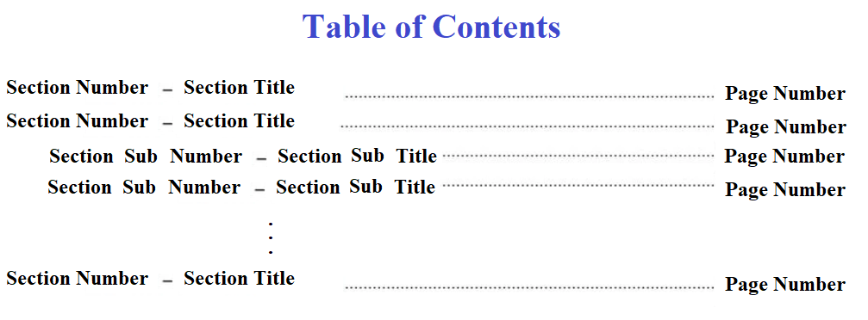



1. Introduction

The introduction should include the purpose (what was tested), problem (why was the experiment conducted), and scope (what was analyzed) of the report. In this section, you should discuss why you are doing the experiment and what you hope to learn from it. You should include 3 or 4 sentences to discuss any concepts that are relevant to the experiment and the importance of the subject matter.

1. Report of Each Part a). Design Purpose:

This part is typically one paragraph that summarizes the design purpose, and the methods employed.

* 1. Engineering Data - Schematics/Logic Diagrams, and State Diagrams.
  2. Verilog Design
  3. Verilog testbench design and simulation waveforms. Give an interpretation of the simulation data, and discuss its significance.
  4. Result Discussion:

Discuss the results you obtained, explaining whether they met your expectations or were unexpected. Describe the problems you faced and how you solved them. Explain the key findings and give the major conclusions.

1. Conclusion

The conclusion is one or two concluding paragraphs to the project. This section describes the work you did, conclusions that you draw from the work, and what you learned from the project.

Missing any part of the above report will result in grade deduction. All reports must be computer generated.

Submit only one copy of your project report electronically before or on your project due date to your lab instructor’s canvas website.

Project report resubmission after due date will not be accepted.

You won't get any credit for a project if you just show demo without submitting the project report. No report submission or a report later than deadlines will result in 0 grade for your project.