# Objective

In this assignment you will be practicing while loop, String class, Random class and Scanner class.

# Problem

Design and implement an application that simulates the number matching game in which three numbers between 1- 9 inclusive are randomly generated and printed side by side. Your program examines the three generated numbers based on the following

* if the three generated numbers are matching then the person will win 300
* if two of the three random numbers are matching then the person will win 100
* no matching number, the person will not win anything

your program must keep track of the amount money the person has gained throughout playing the game and displays the total amount at the end.

Here is a partial sample output

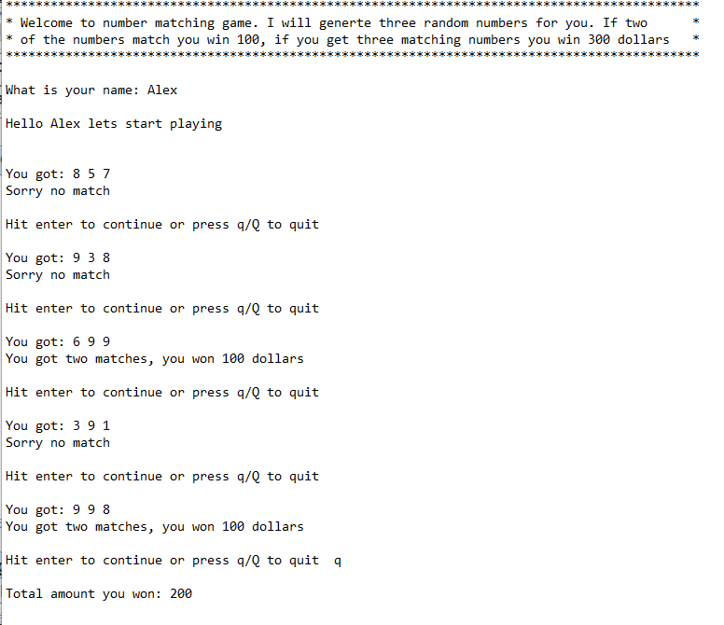

For a compete sample output refer to the provided file called **number matching sample output.txt**

# Requirements

1. Your program should allow another player to start the game once the first player is done playing. Refer to the sample output
2. Feel free to be creative by adding more features to the program
3. make sure to provide the block comments for each method describing what the method does.
4. solutions with just the main method will get partial credit. You must have multiple methods in your program
5. A java shell has been provided. However, feel free to write the program the way you want by not using my shell. make sure to provide methods
6. Your program should include the following methods or similar methods if you are not using the provided shell. Create a java class and implement the following methods in the given order.

* **public static int getRandNum (Random rand):** This method gets a Random object as its parameter and returns a random number between 1 - 9. The code to generate a random number between 1-9 is : int x = rand.nexrInt(9) + 1
* **public static int match (int n1, int n2, int n3):** This method gets three numbers as its parameters. compares the numbers. if the three numbers are the same returns 3, if the two numbers out of three are the same returns 2, otherwise should return 0. you need couple condition statements to cover all different combinations. for example, one of the conditions is:

if(n1 == n2 && n2 == n3) return 3;

* **public static void description ():** This method displays the description of the program. refer to the sample out.
* **public static void play (Random rand):**  for the description of this method refer to the provided shell. implement the code based on the given pseudocode.
* **public static void main (String [] args):** for the description refer to the provided java shell. Implement the code based on the given pseudocode