Case Study:
Instacart SQL Data Analytics

Juglair Kristel Claire

Contents
Introduction 3
Case study 3
Methods and Tools 3
Source 8

Introduction
Instacart is a grocery delivery and pickup service where users can select items from local grocery stores through the Instacart app or website, and then either have them delivered to their doorstep by a personal shopper or prepared for pickup at the store.

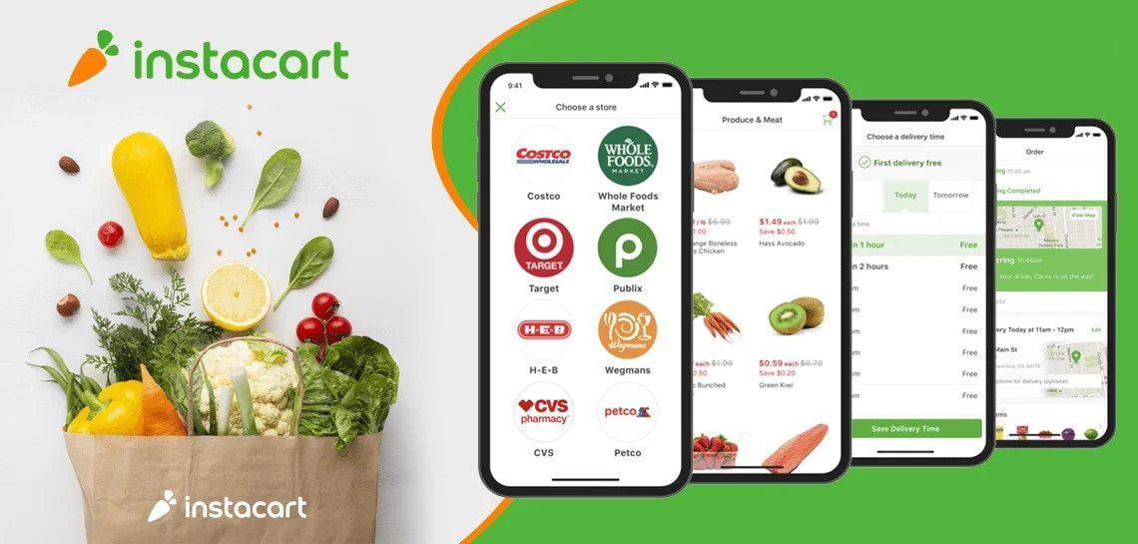
Source: https://api.datalemur.com/assets/4208a77d-1c41-49a3-9f88-57875d40cc93

Assuming Instacart manager needs to analyse the market data over time to understand how the business is changing or staying the same, but data engineering found some logging errors in the pipeline and currently there are not date fields in the market data tables, this research is expected to find a way to analyse Instacart’s business changes over time without explicit dates.

Methods and Tools
This case study is part of the Data Lemur (DL) SQL course and it is intended to practice data exploration of a complex database through SQL. Since the original dataset linked by DL is not available anymore, the full dataset has been downloaded on Kaggle competition “Instacart Market Basket Analysis”.

This research includes the use of tools like:
- PostgreSQL – as server hosting the complete DB;
- Visual Studio Code and the SQL Tools extension – as coding environment to execute and display SQL queries.

Case study background: grocery orders data
The available Instacart market data is composed of five tables as follows:
- order_products_train – this table specifies which products were purchased in each Instacart order during the current quarter (Q3).
The reordered column indicates if the customer has a previous order that contains the product.
Column Name | Type
order_id | integer
product_id | integer
add_to_cart_order | integer
reordered | integer boolean (1 or 0)
- order_products_prior – this table contains previous order contents for all customers. This data is organized in a table with the same columns and data type of order_products_train, since it was collected in Q2.
- orders – this table contains information of both previous tables and some more information about the users that made the orders.
Column Name | Type
order_id | integer
user_id | integer
eval_set | character varying (50)
order_number | integer
order_dow | integer
order_hour_of_day | integer
days_since_prior_order | integer
The eval_set column indicates from which table the row comes from. The values that can be assumed are:
  - prior – data comes from a past collection, specifically the second quarter of the year.
  - train – data is about the current situation, particularly about the third quarter.
  - test – this data is coming from a table that is going to be ignored for this research purposes, since it typically is used for testing Machine Learning Models (ML).
- products – this table contains information about each item in the Instacart product catalog.
Column Name | Type
product_id | integer
product_name | character varying (255)
aisle_id | integer
department_id | integer
- departments – this table is about each department of Instacart.
Column Name | Type
department_id | integer
department | character varying (255)
- aisles – this table contains information of each aisle in a grocery store.
Column Name | Type
aisles_id | Integer
aisles | character varying (255)

Analysis

1. Analisi prodotti più venduti nel tempo
praticamente nel tempo la gente da q2 a q3 ha iniziato a comprare più junk food, mentre prima acquistavano prodotti più salutari
ipotesi:
- aumento dei prezzi dei prodotti più salutari a parità di salari > allora la gente acquista solo quello che può permettersi, allora il cibo spazzatura
- q2 è mag-giu-lug-ago, il periodo della prova costume, per cui forse la gente fa attenzione all'alimentazione per essere in linea durante il periodo estivo, mentre q3 (set-ot-nov-dic) è il periodo in cui, di ritorno dalle vacanze molti tornano a lavorare e non hanno più tempo per fare attenzione all'alimentazione
Solutions: convenzioni con supermercati per prodotti salutari a prezzi più bassi per favorire un corretto stile di vita?
2. Analisi di reparti
inoltre vedo da q3_orders (e dal segno negativo delle order_diff) che in q3 tutti i reparti hanno venduto meno rispetto a q2, e che dunque i clienti hanno:
- o acquistato meno (calo domanda complessiva)
- o utilizzato meno instacart > instacart perde engagement [verifica]
Ipotesi:
- fatto la spesa in altri modi, recandosi personalmente ai supermercati
- le persone hanno ripreso abitudini pre-pandemia o abitudini stagionali
- fine promozioni estive

3. Analisi utenti
come facciamo a capire veramente a cosa è dovuto il calo degli ordini?
- Calo utenti? Perché? c'è qualcosa che il team instacart può fare per aumentare il traffico di utenti?
Approfondimento:
  - Tendenze di acquisto Q2/Q3
  - Customer retention (orde_number)
  - Giorni e ore di picco di ordini (order_dow – order_hour_of_day)
  - Frequenza media di acquisto per utente in q2 e q3

Structure
- Analysis of selling
- most sold products over time which products are more requested?
- departments that sold the most over time why customers’ lifestyle changed? And why?
- reordered products over time why the amount increased or decreased?
- Hypothesis
- Business solutions

Our Solution: High-Level Overview
- Identify the two specific tables you should focus on to understand broad trends over time.
- Consider a phenomenon in the data that may have changed over time. Choose something practical that you can highlight to your manager.
- Define in plain ol' English how you plan to investigate the data to solve the data analysis task.
- Express that approach in SQL.
- If your observed phenomenon has changed over time, develop 2 or more hypotheses to explain potential causes of that change. If your observed phenomenon has not changed over time, develop 2 or more hypotheses to explain why this phenomenon has remained stagnant.
- Consider other relevant factors aside from just the Instacart data, such as food trends, seasonality, supply chain, etc.
BONUS: Based on your hypotheses, write a recommendation to leadership explaining how they should either:
- Support this phenomenon if it’s helpful to Instacart business, or
- Combat this phenomenon if it’s harmful to Instacart business.

Our Solution: Analyzing Prior vs. Current Products.
As a data analyst, one surprising event you might want to investigate using SQL could be a sudden and significant change in the reordering behavior of certain products in the current orders compared to their behavior in the prior orders.
Specifically, you could look for products that were not frequently reordered in the past (based on data from ic_order_products_prior) but are now being reordered more frequently in the current orders (from ic_order_products_curr).

This query joins the prior and current orders tables to the product, department, and aisles tables. The crux of the query lies in the SUMs, which allow us to compare product reorders across the prior and current orders tables. We select a lot of other fields so that we can use them to aggregate later as needed.
Finally, in the HAVING clause, we filter on products that were previously reordered fewer than 10 times, and are currently reordered 10 or more times. 10 is a nice round number to start with but a different number (or a measure of percent change) would work for this methodology too.

The first few rows of results should look like this:
product_id | product_name | aisle_id | department_id | department | aisle | prior_reorders | current_reorders
8174 | Organic Navel Orange | 24 | 4 | produce | fresh fruits | 0 | 30
7948 | Organic Unsalted Butter | 36 | 16 | dairy eggs | butter | 0 | 24
8193 | Russet Potato | 83 | 4 | produce | fresh vegetables | 0 | 24

Our Solution: Analyzing Changes in Reorders By Department, Aisle
Looking at this granular view won’t give us a broad picture of changes over time, so let’s do some summarizing. We can wrap the above query in a CTE (Common Table Expression) called increased_orders and do some quick aggregation

Our Solution: Hypothesis Behind Re-order Change
Now it’s time for the actionable part of our work: figuring out what this data means for the company, and what we'll do because of the data.
We’ll start by developing some hypotheses to explain potential reasons for the increase in reorders of produce items.
First of all, we mentioned that it’s currently Q3, which means we’re somewhere between June and August in this scenario. Fruits and vegetables might become more popular in the summer months due to their freshness and nutritional value. So we’ll call hypothesis #1 seasonality.
It’s possible that limited-time discounts, bundle deals, or loyalty programs could drive higher reorders. We should check in with the marketing department and see if there were any deals or discounts related to produce recently. We’ll call hypothesis #2 deals.
We could also take a more skeptical approach to things and see if these products were even available before, or if a recent increase in supply chain activity has allowed for more reorders. When we see reorders go from 0 to 30 for the Organic Navel Orange, we have to ask if the conditions around those orders have changed at all. We’ll call hypothesis #3 availability.
We could keep going, but with the 3 hypotheses below, we’ve covered step 5 of the strategy framework:
- Seasonality: Produce is more popular in the summer due to its freshness and nutritional value.
- Deals: Discounts, bundle deals, or loyalty programs around produce could drive higher reorders.
- Availability: Recent shifts in supply chain and availability may have influenced consumers’ ability to buy produce.

Our Solution: Our Business Recommendation
Here is the bonus recommendation informed by our hypotheses:
After analyzing our current order data compared to previous order data, we discovered that the reorder rates for produce have significantly increased across both departments and aisles. Increased produce sales are beneficial for the company, so leadership should capitalize on customers’ higher propensity to reorder produce during the summer months.
If not already implemented, marketing should consider promoting bundle deals on produce to incentivize new buyers, who may then become repeat customers for those products. Additionally, team members working with suppliers and grocers should ensure the consistent availability of popular produce items, including Organic Navel Oranges, Russet Potatoes, and Cantaloupes, in order to maintain high reorder rates.

Conclusions

Source

Information
- https://www.instacart.com/
- https://datalemur.com/sql-tutorial/instacart-sql-data-analytics-case-study
- https://www.kaggle.com/datasets/psparks/instacart-market-basket-analysis

Images
- https://api.datalemur.com/assets/4208a77d-1c41-49a3-9f88-57875d40cc93

Source: https://www.instacart.com/
Data Lemur is a platform that contains hundreds of official interview questions used by FAANG and other companies’ recruiters to test SQL and Python skills. Also, it offers an SQL learning path of which this study case is part. Source: https://datalemur.com/sql-tutorial/instacart-sql-data-analytics-case-study
Kaggle is a platform that contains huge number of datasets and that, for that reason, reunites Data Scientists, researchers and other professionals who can practice, do reports and compete to sharp analytical skills. Source: https://www.kaggle.com/datasets/psparks/instacart-market-basket-analysis

