**How does the installation look:**

Installation for Windows  
This is the installation instructions for installing Cisco VPN Client from Cisco ASA.

Open your Internet Explorer and type in **https://corporate.elkem.com/external**  
Accept the certification, by clicking on the "Continue to this website (not recommended)."  
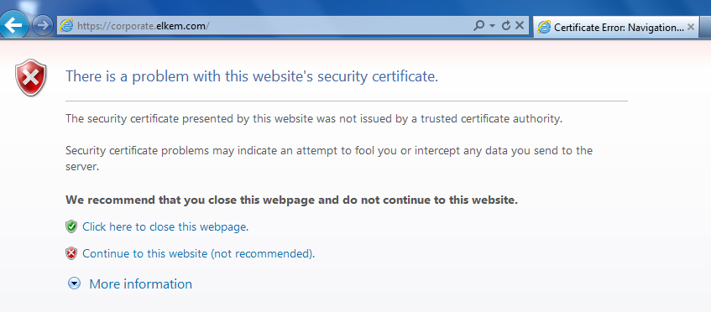  
  
  
In the dropdown menu, choose the following group: **Elkem-External**  
Type in your username and password provided to you by Elkem Network Administrator (by email)  
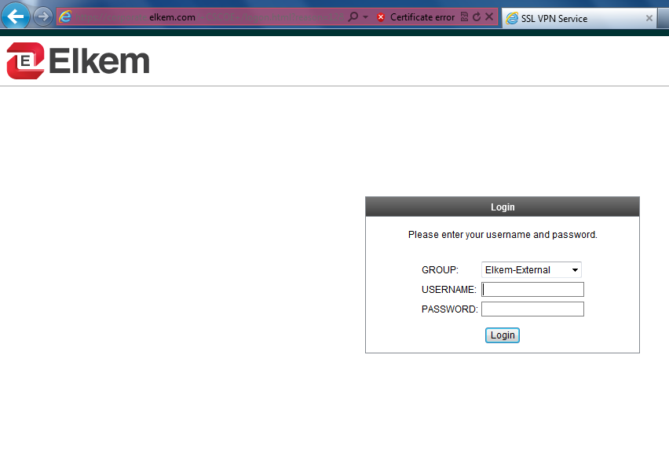  
  
Accept this banner to proceed, click on Continue  
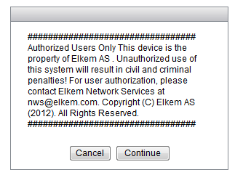  
  
Since this is an Windows 7 64-bit version, you need to click on **"Windows 7/Vista/64/XP"** to continue.  
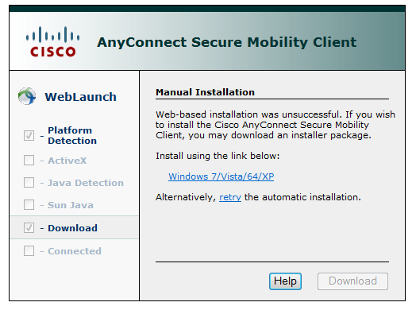  
In the bottom of the screen you can see the downloaded file. Please click on **"RUN"** to start installing the client.  
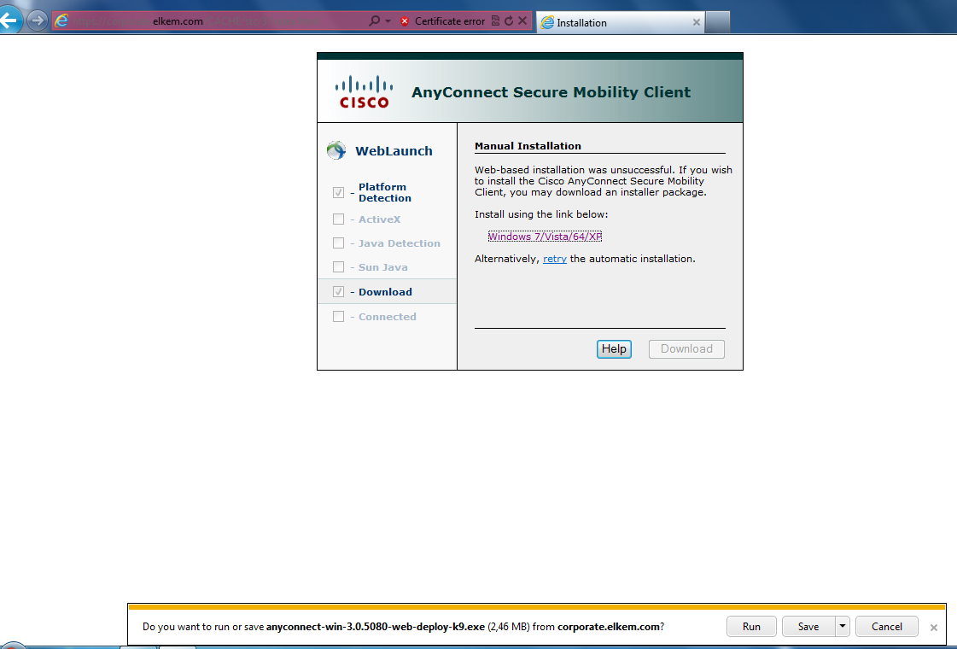  
  
The installation begins, follow the intruction given in the wizard.  
Click on **"next"**, to continue  
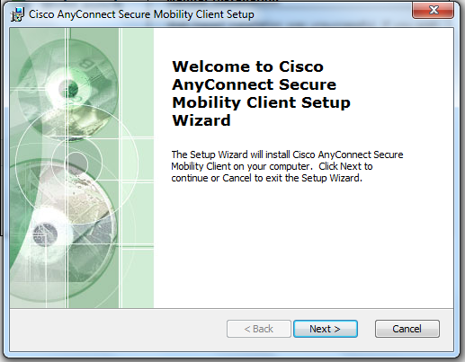  
  
Accept the License Agreement. Click on **"next"**, to continue  
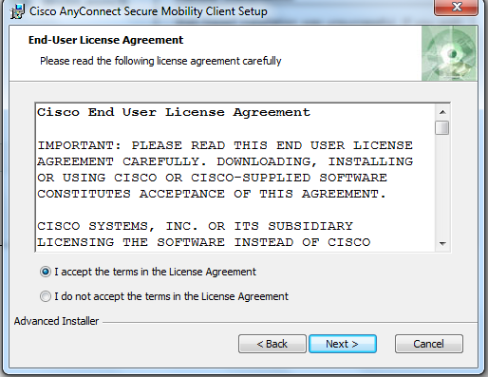  
  
Click install to star installing.  
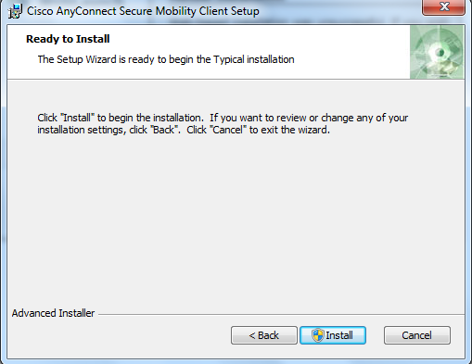  
  
The installation is finish, click on **"finish"**  
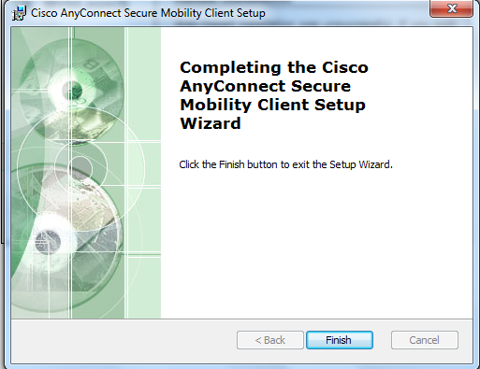  
  
Start the Cisco Client by starting it from Windows application.  
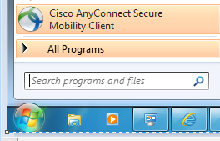  
  
Once the client has started for the first time it looks like this.  
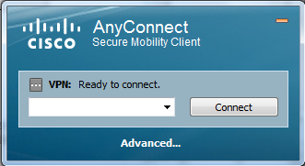  
  
Enter the following string into the white dropdown menu:

**corporate.elkem.com/external**

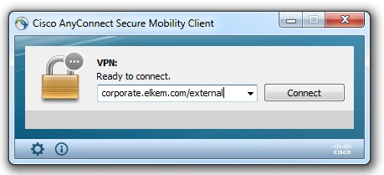  
  
  
  
Accept the Certificate by click on **"Accept"** or **"OK"**  
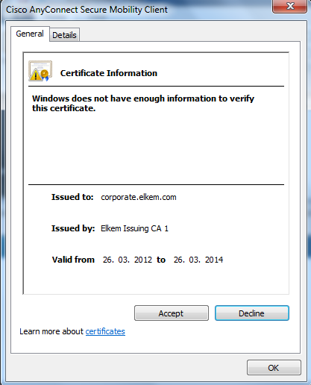  
  
  
  
Type in your username and password provided to you by Elkem Network Administrator (by email)  
  
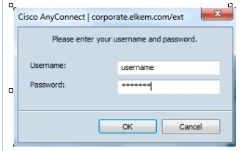  
  
  
  
Accept the Banner to proceed.  
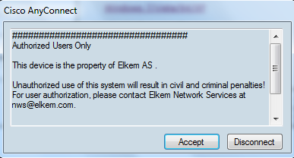  
  
Once the vpn session is ok, the client looks like this.  
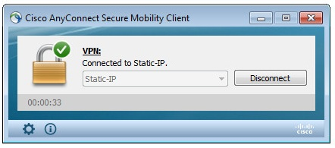  
  
  
You are now connected to Elkem ASA External Network with Cisco VPN