Task 1: General Knowledge

Thank you for your detailed report. The information helped us find the cause for the issue.
To fix this problem you need to:
1. Install SQL Server Data Tools – June 2013 update
2. Migrate your Project:

-Right Click on the Project name and select “Reload Project”

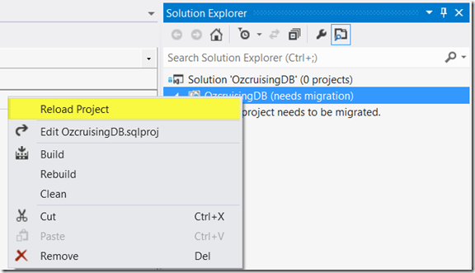

-This will launch the “One-way Upgrade wizard” which converts your project into the latest version of SSDT.

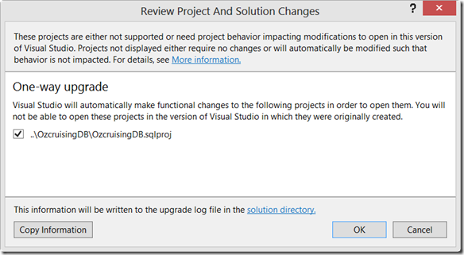

I hope this information helps. Please let me know if I can assist you any further. Thank you in advance.

Best regards: ...

Task 2: More Info

Hello,

I have download and tried the code from the Music Store Tutorial in trying to reproduce the problem, but to no avail – everything is working as expected on our site. Please provide the following details – hopefully they will help us pinpoint the exact reason for this behavior:

1. What is the exact version of KendoUI that you are using.

2. What is the exact version of JQuery that you are using.

3. What is the exact version of your Browser that you are using.

4. Please send us the exact steps to reproduce the problem. If possible, send us some screenshots of the errors that have been occurred.

Thank you in advance for your patience and cooperation.

Best regards: ...

Task 3: Angry Customer

We apologize that you have been waiting that long. And I understand your frustration.
However the Office2013 Theme is under development for some time already but we had some difficulties due to its complexity.

Now everything is fine and we expect to release it with the upcoming October.

Thank you for your patience.

Kindly regards: ...

Task 4: Hash Table

Indeed, I verified that the issue exists in the current version of the implementation.

The problem was that the operator "==" cannot be applied to operands of type:
System.Collections.Generic.LinkedListNode<System.Collections.Generic.KeyValuePair<K,T>>' and 'K' .
In the method RemoveKey(K key)

Now the problem is fixed by exchanging the "==" with the method .Equals()

We apologize for this mistake.

Also thanks to your feedback and example code we discovered that the Method: " ReAddValues" works slow for bigger number of values inserted in the hash table.
For now we have manage to fix the issue.
As for the implementation we will make sure to address the issue and release a patch in the near future

Best Regards ...

