HCI 102 THESIS DOCUMENTATION
Front End Documentation
Project Title
CLCST Library Management System

Prepared for Human Computer Interaction 102
Central Luzon College of Science and Technology
Learning Resource Center and Library Management System

Prepared by: ________________________________
Section: ________________________________
Date: October 13, 2026

TABLE OF CONTENTS
Chapter 1 Introduction
1.1 Project Overview
1.2 Purpose of the Front End
1.3 Objectives
1.4 Scope
1.5 Limitations
Chapter 2 Front End Design
2.1 User Interface Design
2.2 Human Computer Interaction Principles Applied
2.3 Navigation Structure
2.4 Wireframes and Screenshots
Chapter 3 System Implementation
3.1 Login Page
3.2 Dashboard Pages
3.3 Forms and User Actions
3.4 Responsive Design
3.5 Technologies Used
Chapter 4 Front End Source Code
4.1 Folder Structure
4.2 Login and Registration Source Code
4.3 Blade and Tailwind Styling
4.4 Interaction and Validation
4.5 Components Used
4.6 UI Components
Chapter 5 Testing Evaluation and Conclusion
5.1 Front End Testing
5.2 Browser Compatibility
5.3 Usability Evaluation
5.4 Findings
5.5 Recommendations
5.6 Conclusion
Appendices

CHAPTER 1

INTRODUCTION

1.1 Project Overview
The CLCST Library Management System is a web based library portal developed for Central Luzon College of Science and Technology. The project provides a clear online interface for library users, students, faculty members, and library staff. It supports common library activities such as account registration, sign in, book catalog search, book reservation, borrowing records, return monitoring, renewal requests, notifications, fines, user profiles, and help support.
The system was created as a Laravel application using Blade templates and Tailwind CSS through CDN. The interface focuses on the front end experience required for HCI 102. It uses realistic library data and working routes so users can navigate the system and understand how the library process flows from sign in to book search, borrowing, reservation, and account management.
The design follows Human Computer Interaction principles by using familiar navigation, readable labels, consistent colors, visible status messages, and clear action buttons. The interface separates the student dashboard from the faculty and staff dashboard so each user type sees tools that match their role.

1.2 Purpose of the Front End
The front end was developed to make library tasks easier to understand and faster to perform. Instead of using technical terms that may confuse users, the system uses direct labels such as Book Catalog, Borrowing, Library Desk, My Borrowed Books, Notifications, and My Profile.
- Provide a clean sign in and registration experience for students, faculty members, and staff.
- Allow users to search books by title, author, ISBN, call number, category, or barcode.
- Show book availability, shelf location, copy status, and reservation buttons in one readable page.
- Give students a dashboard for current loans, reservations, borrowing history, fines, notifications, and support.
- Give faculty and staff a dashboard for catalog search, borrowed books, reservations, renewal requests, academic requests, course reserves, reading lists, instruction sessions, feedback, notifications, and profile management.
- Apply HCI rules such as consistency, feedback, visibility, error prevention, accessibility, and user control.

1.3 Objectives

General Objective
To develop a user friendly front end for the CLCST Library Management System that follows Human Computer Interaction principles and supports student, faculty, and staff library tasks.

Specific Objectives
- Design clear login, registration, student dashboard, faculty dashboard, staff dashboard, catalog, borrowing, reservation, notification, history, fines, support, and profile pages.
- Use consistent navigation and a universal sidebar for each dashboard type.
- Use simple terms and labels that are easy for students and faculty members to understand.
- Reduce user errors through visible validation, clear button labels, status badges, and confirmation messages.
- Create responsive layouts that work on desktop, laptop, tablet, and mobile screen sizes.
- Use real looking book covers, realistic book data, copy numbers, barcodes, and library shelf locations.
- Prepare the Laravel project for shared hosting by avoiding required Node.js or Vite builds and using CDN based styling.

1.4 Scope
The project scope covers the front end and route based interaction of a school library management portal. The included pages and functions are listed below.
Area | Included Features
Authentication | Login page, registration page, role selection, sign in routing, and registration submission.
Student Dashboard | Dashboard, book catalog, borrow and return page, reservations, notifications, borrowing history, fines and penalties, my account, shelf scanner, and help support.
Faculty and Staff Dashboard | Dashboard, search books, my borrowed books, my reservations, renewal requests, borrowing history, recommend a book, academic requests, course reading lists, course syllabus reserves, library instruction sessions, notifications, my profile, library feedback, and support.
Book Catalog | Search filters, realistic book models, copy availability, shelf location, reservation buttons, and physical copy status.
Interactive Actions | Book hold requests, reservation cancellation, loan renewal, fine payment, and role based dashboard redirection.
Documentation | HCI focused front end documentation, screenshots, source code summary, testing, findings, and recommendations.

1.5 Limitations
- The current version uses Laravel controller data and session based sample records for demonstration, not a fully connected production database for every module.
- Internet access is required for CDN resources such as Tailwind CSS, Google Fonts, and Material Symbols unless they are downloaded locally later.
- The system is intended for modern browsers such as Chrome, Microsoft Edge, Firefox, and Safari.
- Mobile application packaging is not included; the system is designed as a responsive web application.
- Some administrative workflows are represented as front end pages and prototype actions and still need complete database, authentication, and permission controls before real deployment.

CHAPTER 2

FRONT END DESIGN

2.1 User Interface Design
The user interface uses a formal school library theme. The dominant visual identity is green, white, and neutral gray, which fits the CLCST library branding and gives the system a calm academic appearance. Yellow accents are used only for alerts, due date warnings, badges, and important labels.
- Layout: The dashboard pages use a fixed left sidebar, a top header, and a scrollable main content area so navigation remains stable while content changes.
- Theme: The interface uses a school library style with CLCST identity, CELTECH logo treatment, card based information sections, and readable status badges.
- Color Palette: Dark green is used for main actions, white for content areas, light gray for backgrounds, yellow for warnings, red for errors, and blue or green for system statuses.
- Typography: The pages use readable sans serif fonts and clear heading sizes. Important labels use bold weight and small badges to support scanning.
- Icons: Material Symbols and simple icon buttons are used for books, notifications, barcode scanning, profile, history, help, logout, and navigation actions.

2.2 Human Computer Interaction Principles Applied
HCI Principle | Application in the System
Consistency | The student dashboard and faculty/staff dashboard use universal sidebars, consistent button styles, shared green action colors, and repeated card layouts.
Visibility | The sidebar shows all main pages. Status badges show due dates, available copies, reservations, warnings, and unread notifications.
Feedback | The system gives success messages after registration, reservation, cancellation, renewal, and fine payment actions. Buttons and badges also show current status.
Error Prevention | Forms use required fields, clear labels, password confirmation, file upload rules, and visible validation messages.
Recognition Rather Than Recall | Navigation labels use plain language. Users can recognize Book Catalog, My Borrowed Books, Notifications, My Profile, and Help and Support without memorizing commands.
User Control | Users can cancel reservations, renew loans, clear forms, return to dashboards, and log out from the sidebar.
Accessibility | The design uses strong contrast, readable fonts, keyboard friendly links and buttons, explicit labels, and responsive layouts.
Responsive Design | The pages use flexible grids and Tailwind responsive classes so cards and forms adjust for desktop, laptop, tablet, and smaller screens.

2.3 Navigation Structure
The navigation is divided by user role. Students see library tasks related to borrowing and personal account management. Faculty and staff see additional academic request tools and professional borrowing features.
Login / Register
-> Student Dashboard
-> Book Catalog
-> Borrow / Return
-> Reservations
-> Notifications
-> Borrowing History
-> Fines and Penalties
-> My Account
-> Help and Support
-> Logout
Login / Register
-> Faculty or Staff Dashboard
-> Search Books
-> My Borrowed Books
-> My Reservations
-> Renewal Requests
-> Borrowing History
-> Recommend a Book
-> Faculty Academic Requests
-> Course Reserves Setup
-> Syllabus References
-> Inter Library Loan
-> Notifications
-> My Profile
-> Library Feedback
-> Logout

2.4 Wireframes and Screenshots
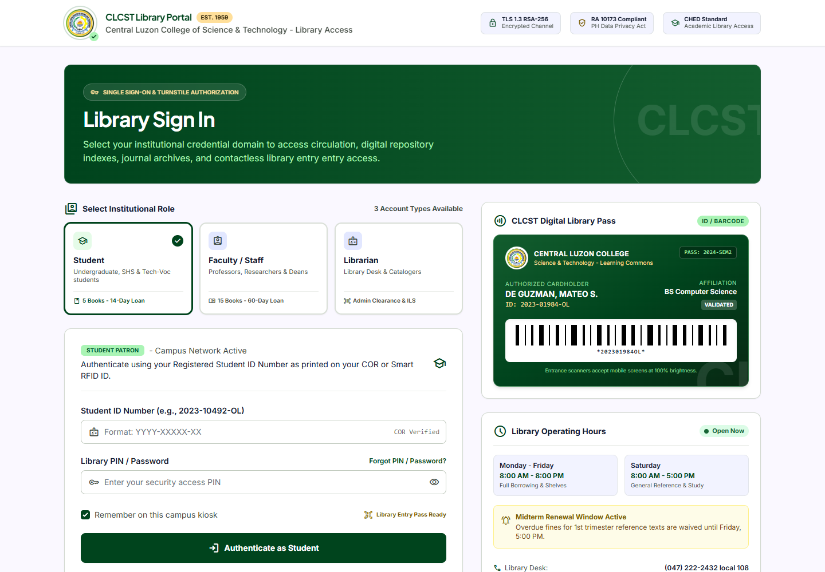
Figure 1. Login Page
The login page separates student, faculty, and staff access and uses clear sign in controls. The design supports role recognition and simple account access.
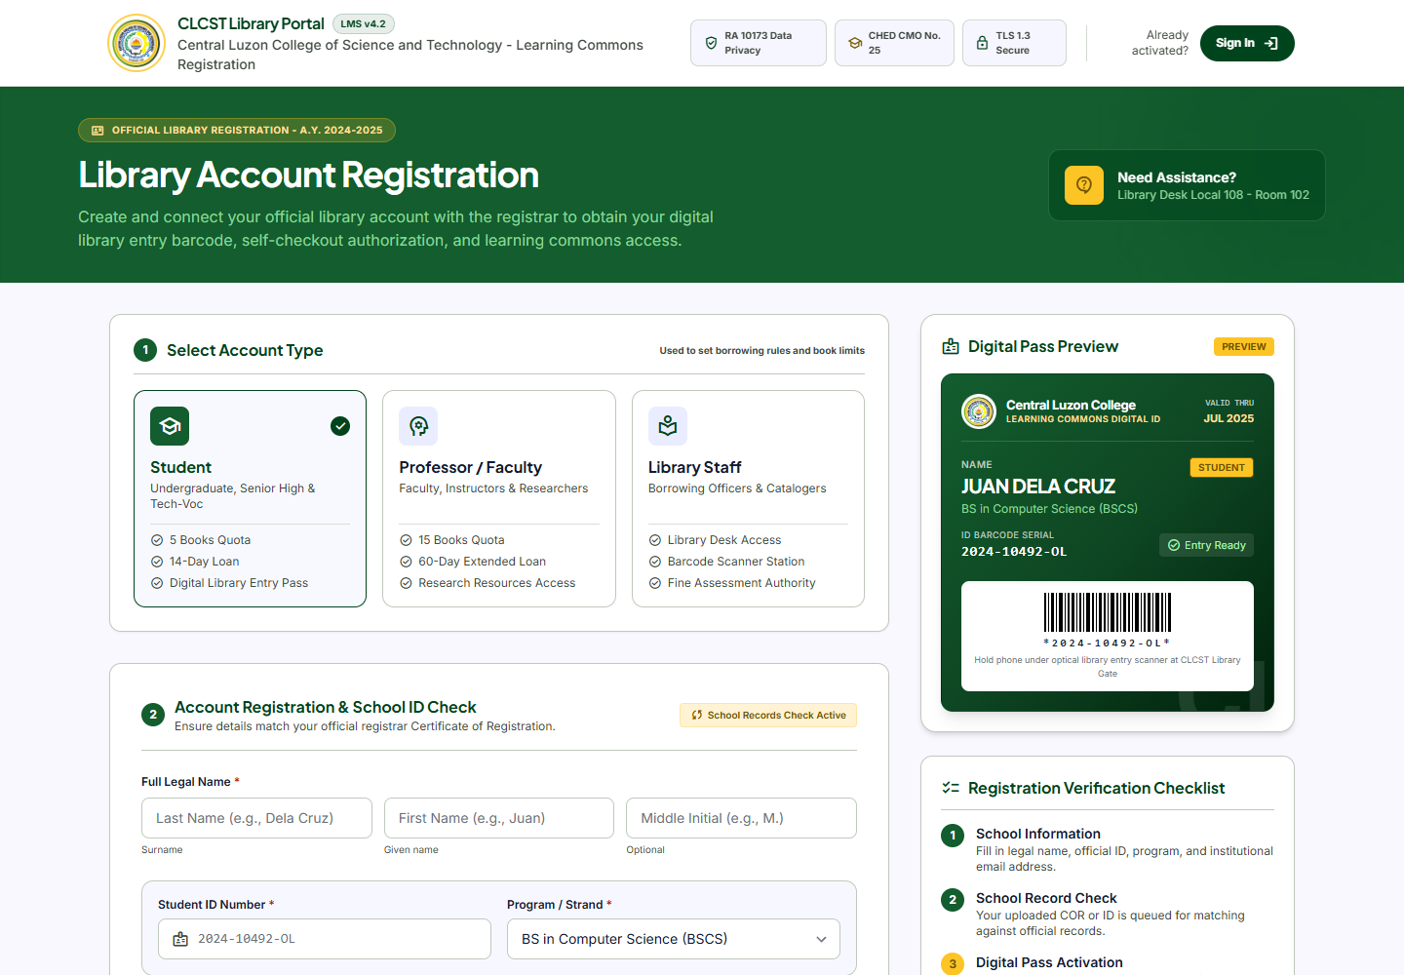
Figure 2. Registration Page
The registration page allows users to choose account type, enter school information, upload a credential file, and submit the registration form with consent.
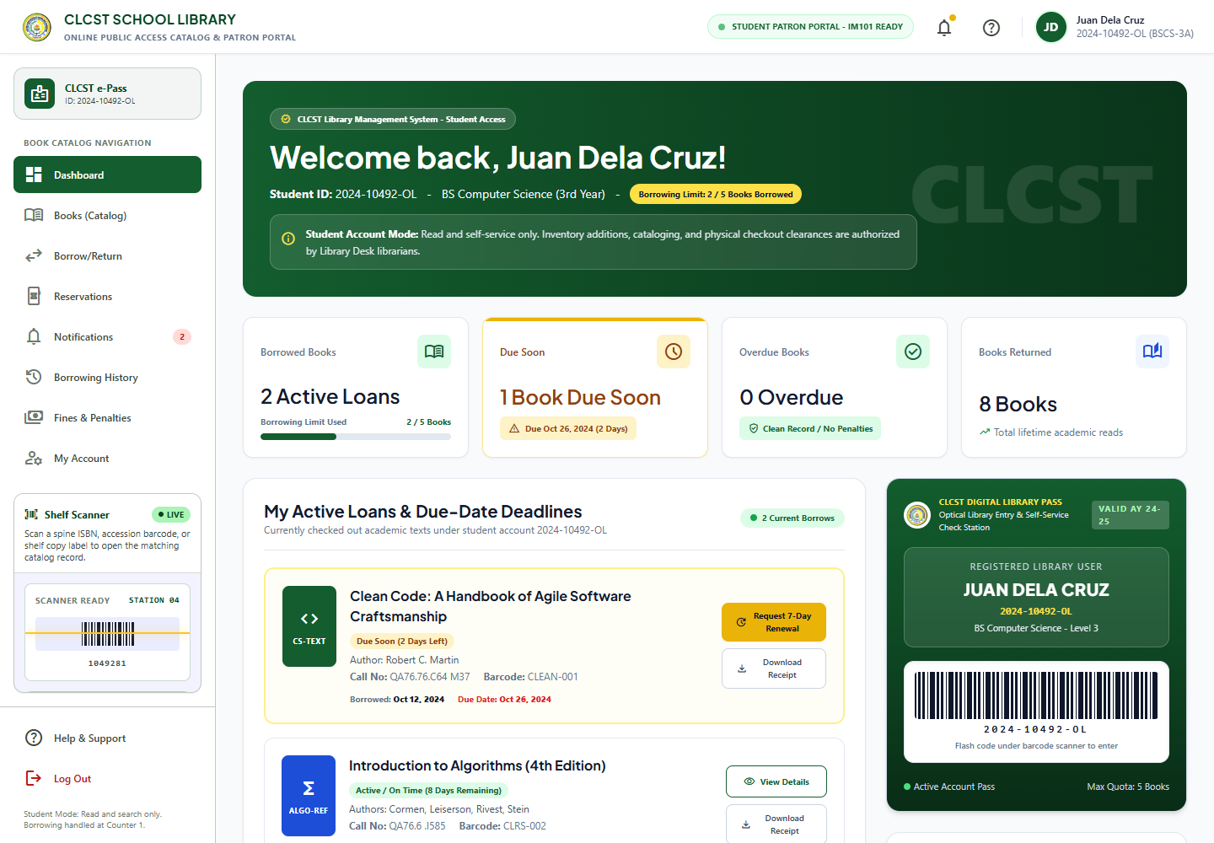
Figure 3. Student Dashboard
The student dashboard summarizes current loans, book search, due date alerts, library pass information, and quick library actions.
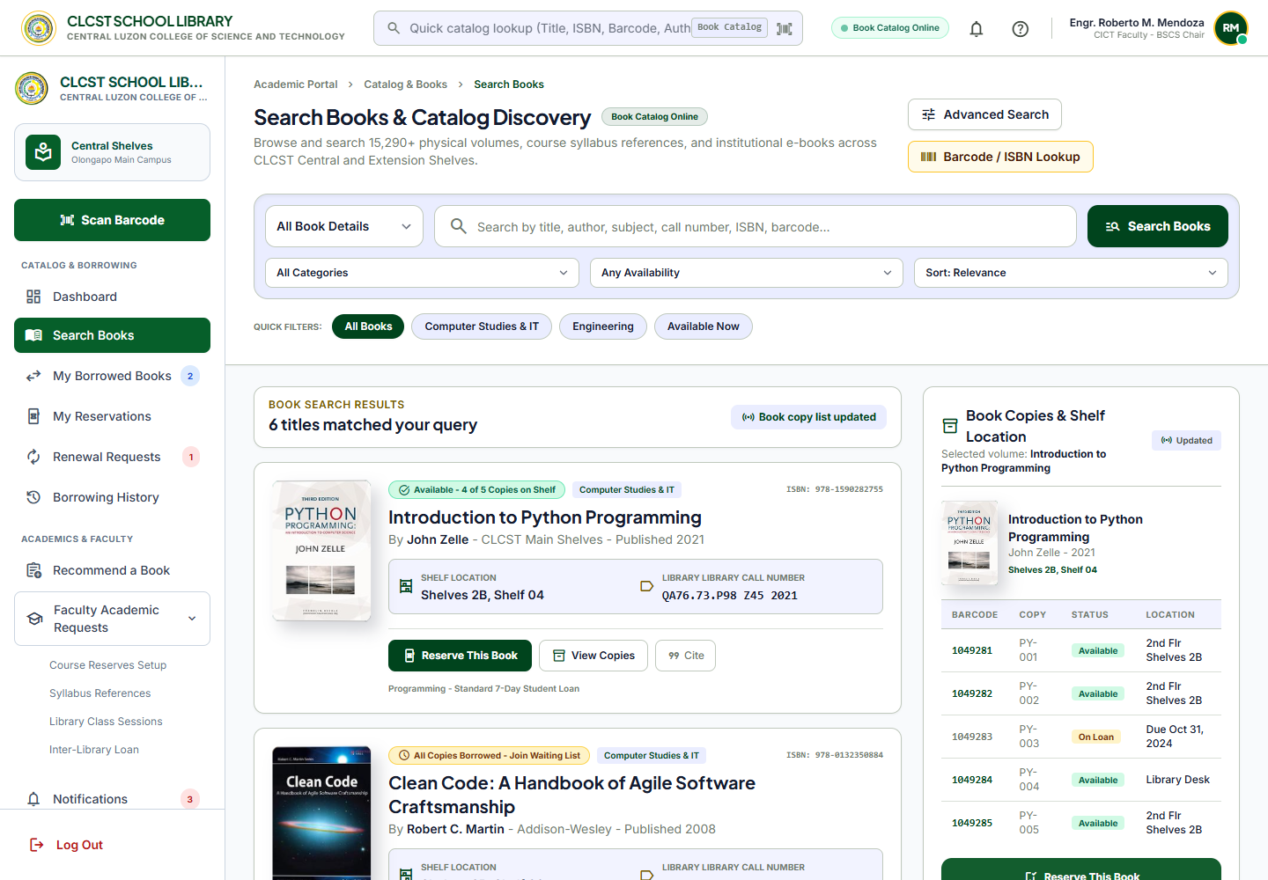
Figure 4. Book Catalog and Resource Discovery
The catalog page includes search filters, realistic book covers, copy availability, shelf location, and reserve buttons.
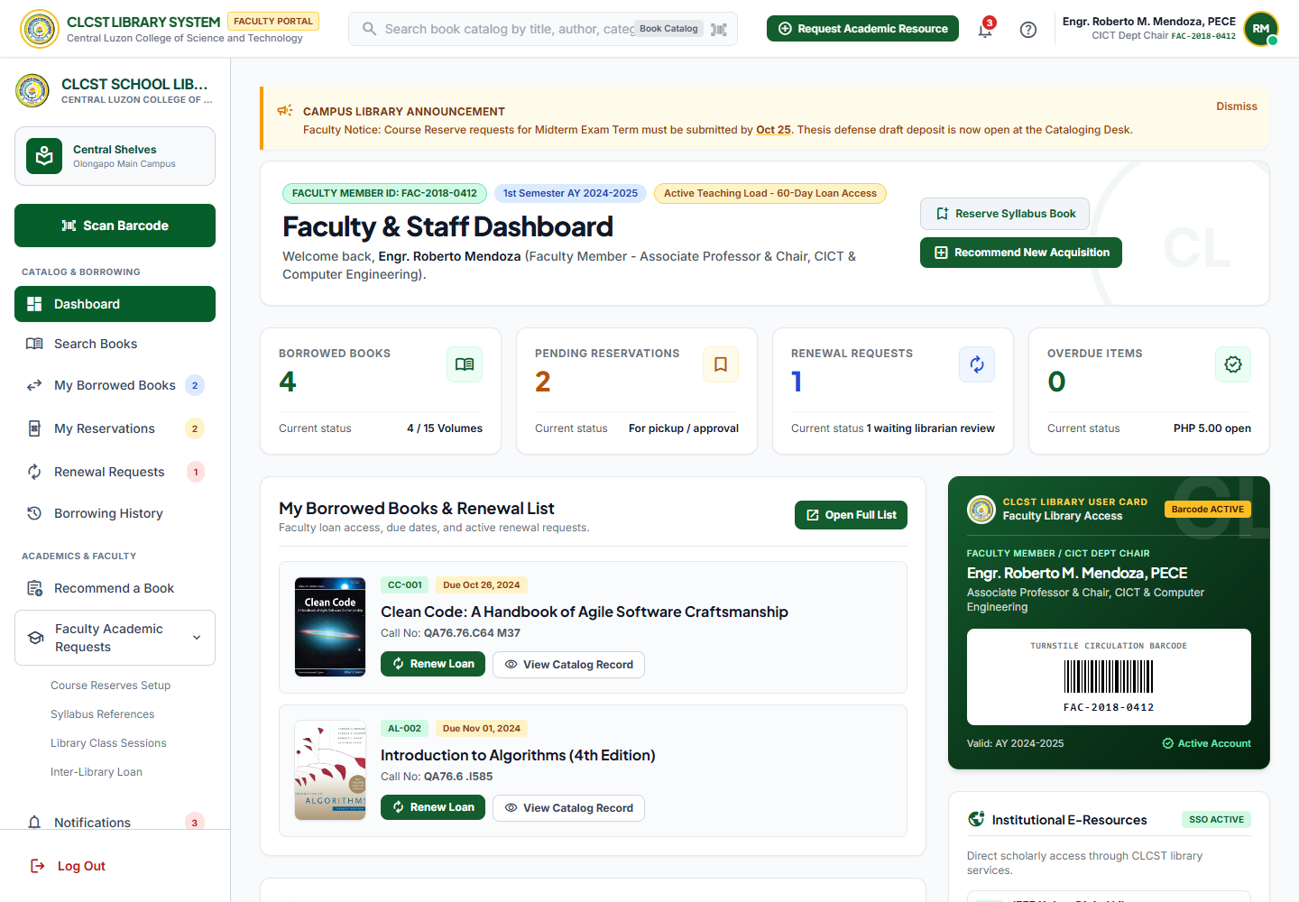
Figure 5. Faculty and Staff Dashboard
The faculty and staff dashboard supports academic library work, borrowed books, reservations, renewals, and catalog access.

CHAPTER 3

SYSTEM IMPLEMENTATION
This chapter explains how the main pages were implemented in the Laravel project. The application uses routes in routes/web.php, controller methods in HomeController.php, and Blade files inside resources/views.

3.1 Login Page
The login page is the first access point of the system. Users can sign in as a student, faculty member, or library staff member. The design uses clear labels, school identity, and direct buttons. When a user submits the login form, the controller redirects the user to the correct dashboard based on selected role.
- Purpose: Allow users to access the system through role based sign in.
- Interface Components: CLCST branding, role choices, email or ID field, password field, sign in button, and registration link.
- Validation: Required role, required email or ID, and required password fields.
- Buttons: Sign In and Create Account links are clearly labeled.
- Screenshot: See Figure 1 in Chapter 2.

3.2 Dashboard
The system includes separate dashboard experiences for students and faculty or staff. This separation improves usability because each user type sees tools that match their work. The student dashboard focuses on personal library activity. The faculty and staff dashboard includes academic and library service tools.
Dashboard | Main Functions
Student Dashboard | Current loans, due dates, quick catalog search, e-pass, alerts, reservations, fines, notifications, support, and account profile.
Faculty Dashboard | Search books, borrowed books, reservations, renewal requests, academic requests, reading lists, course reserves, instruction sessions, notifications, and profile.
Staff Dashboard | Library desk view, borrower follow up, records, reports, academic service tools, and support actions.

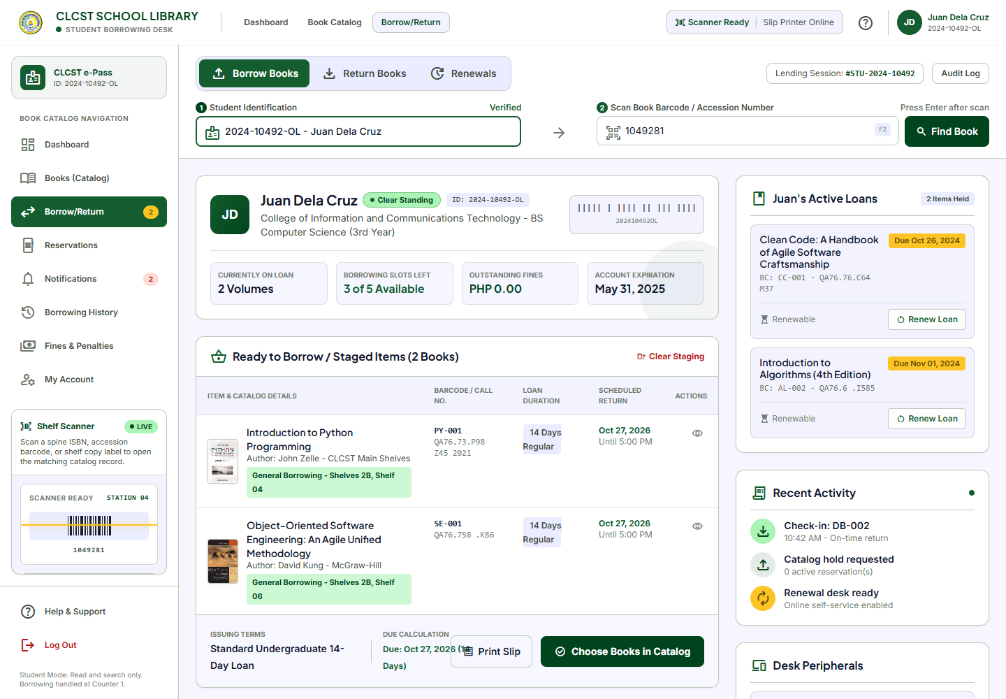
Figure 6. Borrow and Return Page
The borrow and return page presents student identification, barcode scanning, staged books, recent returns, and active loan actions in one workflow.
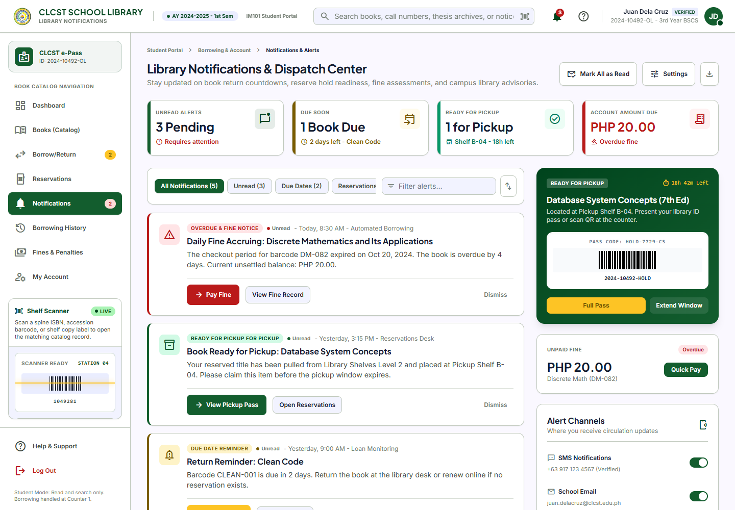
Figure 7. Notifications Page
The notifications page groups due date reminders, reservation notices, and account alerts so users can see important updates quickly.

3.3 Forms
The system includes several forms and action controls. Forms are designed with clear labels, visible required indicators, readable placeholders, and direct submit buttons. The registration form includes account type, full name, school ID or employee ID, program or department, institutional email, mobile number, password, document upload, and consent checkbox.
- Add Form: Registration creates a new library account request.
- Edit Form: Profile and academic request pages are structured for future editable account and request details.
- Delete Confirmation: Reservation cancellation uses a clear cancel action before removing a reservation from the session.
- Search: Book catalog search supports all fields, title, author, ISBN, call number, category, availability, and sort options.
- Pagination: The current prototype displays controlled sample result sets; pagination can be added when database records increase.

3.4 Responsive Design
The layouts use Tailwind responsive classes, flexible grids, and scrollable content areas. The sidebar and content panels adapt to different screen sizes. Cards stack on smaller screens, while desktop screens show multi column layouts for faster scanning.
Device Type | Responsive Behavior
Desktop | Full sidebar, large content area, multi column cards, and right side detail panels.
Laptop | Same structure as desktop with adjusted spacing and readable cards.
Tablet | Cards and forms wrap into fewer columns, maintaining clear touch targets.
Mobile | Content stacks vertically and buttons remain visible for touch interaction.

3.5 Technologies Used
Technology | Purpose
Laravel | PHP framework used for routing, controllers, Blade views, sessions, validation, and project structure.
Blade | Template engine used to build reusable pages, partial sidebars, and dynamic content display.
Tailwind CSS CDN | Used for utility based styling without requiring Node.js or Vite during shared hosting deployment.
Material Symbols | Used for readable interface icons in buttons, sidebar links, and status labels.
HTML5 | Provides semantic page structure, forms, links, tables, and responsive markup.
CSS | Supports custom visual styling, layout behavior, and responsive polish.
JavaScript | Used for simple interactive elements such as form controls, file upload previews, and UI behavior.
MySQL Ready Environment | The .env file is prepared for MySQL credentials when the prototype is connected to a real database.

CHAPTER 4

FRONT END SOURCE CODE
This chapter documents the important source code areas of the CLCST Library Management System. The complete project files are stored in the Laravel project folder and GitHub repository. Only the most important portions are shown here to explain the implementation.

4.1 Folder Structure
library-app/
app/
Http/
Controllers/
HomeController.php
routes/
web.php
resources/
views/
auth/
login.blade.php
register.blade.php
books/
catalog.blade.php
partials/
student-sidebar.blade.php
staff-sidebar.blade.php
celtech-logo.blade.php
favicon.blade.php
student/
dashboard.blade.php
borrow-return.blade.php
reservations.blade.php
notifications.blade.php
history.blade.php
fines.blade.php
account.blade.php
support.blade.php
staff/
dashboard.blade.php
section.blade.php
public/
storage/
composer.json
.env

4.2 Login Page Source Code
The login page is connected to Laravel routes and the HomeController. The user selects a role, enters credentials, and submits the form. The controller then redirects the user to the matching dashboard.
Route::get('/login', [HomeController::class, 'login']);
Route::post('/login', [HomeController::class, 'authenticate'])->name('login.authenticate');
Route::get('/student/dashboard', [HomeController::class, 'studentDashboard'])->name('student.dashboard');
Route::get('/faculty/dashboard', [HomeController::class, 'facultyDashboard'])->name('faculty.dashboard');
Route::get('/staff/dashboard', [HomeController::class, 'staffDashboard'])->name('staff.dashboard');
The route design supports simple and readable URLs. The role based dashboard separation improves navigation and reduces confusion between student and faculty or staff tasks.

4.3 CSS Example
The project uses Tailwind CSS through CDN to avoid Node.js and Vite requirements. This supports shared hosting compatibility and keeps deployment simpler for beginner users.
<script src="https://cdn.tailwindcss.com"></script>
<link href="https://fonts.googleapis.com" rel="preconnect">
<link href="https://fonts.gstatic.com" rel="preconnect" crossorigin>
<link href="https://fonts.googleapis.com/css2?family=Inter:wght@400;500;600;700;800&display=swap" rel="stylesheet">
Tailwind utility classes are used throughout the Blade files for layout, color, spacing, typography, and responsive behavior. The visual style is consistent because the same color and spacing patterns are reused across pages.

4.4 JavaScript Example
JavaScript is used only where interaction is needed, such as registration role selection, file upload preview, password visibility, and small UI controls. Keeping JavaScript focused helps the interface stay maintainable.
const roleInputs = document.querySelectorAll('.role-option input[type="radio"]');
const selectedIdInput = document.getElementById('selectedPatronId');
roleInputs.forEach((input) => {
input.addEventListener('change', () => {
document.querySelectorAll('.role-panel').forEach((panel) => panel.classList.add('hidden'));
document.querySelector(`[data-role-panel="${input.value}"]`).classList.remove('hidden');
});
});
This script supports the registration page by showing the correct student, faculty, or staff ID section based on the selected account type.

4.5 Components Used
Component | Use in the System
Cards | Used for dashboard summaries, loan details, catalog items, notifications, support topics, and profile sections.
Navigation Bar | Used at the top of dashboard pages for system status, profile information, help, and notifications.
Sidebar | Used as a universal dashboard navigation area for students and faculty or staff.
Forms | Used for login, registration, catalog search, renewal requests, recommendations, feedback, and academic request pages.
Tables | Used for source documentation, testing summaries, copy tracking, borrowing records, and evaluation results.
Badges | Used for available copies, due dates, active status, warnings, unread notifications, and book categories.
Buttons | Used for sign in, generate, search, reserve, renew, pay fine, cancel, submit, logout, and help actions.

4.6 UI Components
- Login Card: Provides role based sign in in one focused panel.
- Registration Form: Collects role, name, ID, department, email, mobile number, password, document upload, and consent.
- Student Sidebar: Includes Dashboard, Books Catalog, Borrow/Return, Reservations, Notifications, Borrowing History, Fines and Penalties, My Account, Help and Support, and Log Out.
- Faculty and Staff Sidebar: Includes Dashboard, Search Books, My Borrowed Books, My Reservations, Renewal Requests, Borrowing History, Recommend a Book, Academic Requests, Notifications, My Profile, and Log Out.
- Book Catalog Cards: Show realistic book covers, title, author, call number, location, availability, and reservation actions.
- Notification Items: Show alerts with priority labels and action buttons.
- Profile Sections: Show contact information, borrowing access, account details, and support actions.

CHAPTER 5

TESTING EVALUATION AND CONCLUSION

5.1 Front End Testing
Front end testing was performed by opening the local Laravel server and checking the main routes. The tests focused on page loading, navigation, forms, buttons, and visible interface behavior.
Test | Result | Remarks
Login page | Passed | The login page loads and displays role based access.
Registration page | Passed | The registration page loads, shows account type panels, upload area, and submit button.
Student dashboard | Passed | The dashboard loads with sidebar, catalog search, loans, alerts, and profile summary.
Book catalog | Passed | Search page loads with filters, realistic books, copy availability, and reserve buttons.
Borrow and return page | Passed | The page loads with barcode search, staged items, recent returns, and active loan sections.
Faculty dashboard | Passed | The dashboard loads with faculty/staff specific tools and navigation.
Staff pages | Passed | Staff section routes load through the shared staff layout.
Laravel feature tests | Passed | The project test suite completed successfully with 2 passing tests.

5.2 Browser Compatibility
Browser | Status
Google Chrome | Passed
Microsoft Edge | Passed
Firefox | Expected compatible because the system uses standard HTML, CSS, and JavaScript.
Safari | Expected compatible for modern versions with responsive web standards.

5.3 Usability Evaluation
A 5 point Likert scale can be used to evaluate the interface. The suggested scale is 5 Strongly Agree, 4 Agree, 3 Neutral, 2 Disagree, and 1 Strongly Disagree.
No. | Question | Rating
1 | The interface is easy to use. | 5 4 3 2 1
2 | The navigation labels are understandable. | 5 4 3 2 1
3 | The buttons are clearly labeled. | 5 4 3 2 1
4 | The colors and typography are pleasant and readable. | 5 4 3 2 1
5 | The book catalog is easy to search and understand. | 5 4 3 2 1
6 | The dashboard shows important information clearly. | 5 4 3 2 1
7 | The system gives clear feedback after user actions. | 5 4 3 2 1
8 | The overall experience is satisfactory. | 5 4 3 2 1

5.4 Findings
- The interface is easier to understand when simple terms such as Book Catalog, Borrowing, Library Desk, My Profile, and Notifications are used.
- The universal sidebars help users move between pages without needing to return to the top of the page.
- The book catalog is more realistic and useful when book covers, call numbers, barcodes, shelf locations, and copy status are visible.
- The student dashboard and faculty or staff dashboard should remain separate because each role has different library needs.
- The current prototype is effective for front end demonstration, but full deployment still requires database integration, authentication security, and role permissions.

5.5 Recommendations
- Connect all modules to a MySQL database for real users, books, loans, reservations, fines, notifications, and reports.
- Add complete authentication and authorization so students, faculty, and staff can only access allowed pages.
- Add server side validation for every form and show clear success or error messages.
- Improve accessibility further by adding skip links, focus indicators, alt text for all meaningful images, and optional high contrast mode.
- Optimize page loading by downloading external CSS, fonts, and icons locally if the system is deployed in an environment with limited internet access.
- Add printable reports for borrowing history, fines, library usage, overdue items, and academic requests.
- Perform usability testing with actual students, faculty members, and library staff and revise labels based on their feedback.

5.6 Conclusion
The CLCST Library Management System front end meets the project objective by providing a usable, responsive, and user centered interface for library services. The design applies HCI principles through clear navigation, consistent layout, understandable labels, visible feedback, accessible typography, and role based dashboards. The project is ready for further development into a complete database driven library system.

APPENDICES

Appendix A Complete HTML and Blade Source Code Location
The complete Blade source code is located in resources/views. The most important files are login.blade.php, register.blade.php, catalog.blade.php, student dashboard pages, staff dashboard pages, and shared sidebar partials.

Appendix B CSS and Styling
Styling is handled through Tailwind CSS CDN, Google Fonts, Material Symbols, and page level utility classes inside Blade templates. This avoids required Node.js builds and supports shared hosting deployment.

Appendix C JavaScript
JavaScript is used for small front end interactions such as role selection, upload preview, password visibility, and interface controls. The project avoids heavy client side dependencies.

Appendix D Components
The system uses reusable dashboard cards, sidebars, tables, forms, status badges, search bars, notification cards, profile panels, and action buttons.

Appendix E Screenshots of All Pages
Login page screenshot
Appendix screenshot showing the completed interface for this page.
Registration page screenshot
Appendix screenshot showing the completed interface for this page.
Student dashboard screenshot
Appendix screenshot showing the completed interface for this page.
Book catalog screenshot
Appendix screenshot showing the completed interface for this page.
Borrow and return page screenshot
Appendix screenshot showing the completed interface for this page.
Faculty and staff dashboard screenshot
Appendix screenshot showing the completed interface for this page.
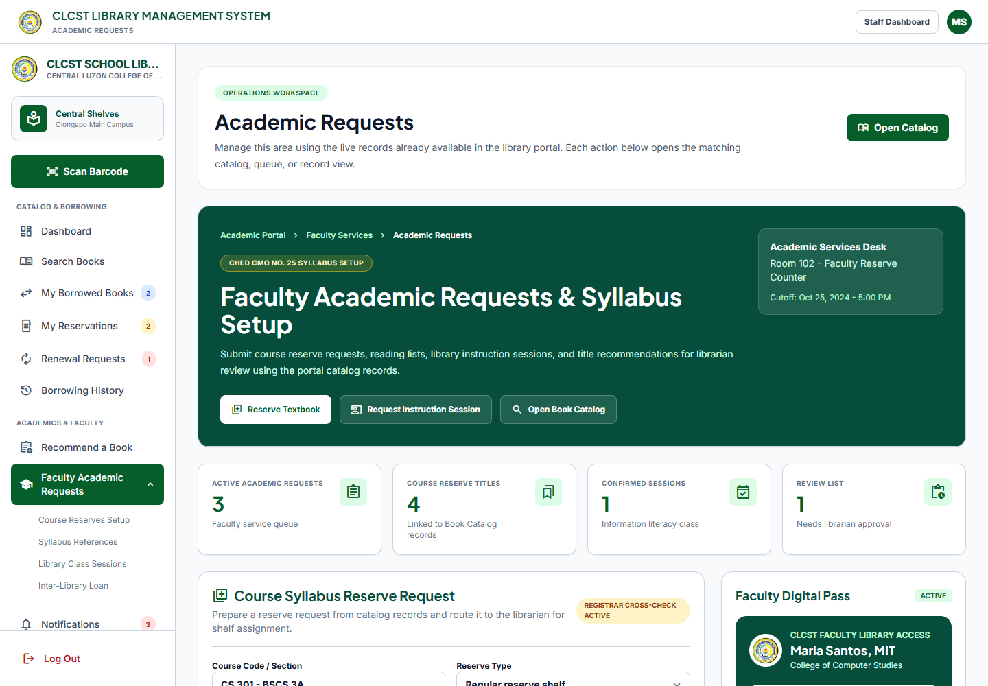
Faculty academic requests screenshot
Appendix screenshot showing the completed interface for this page.
Notifications screenshot
Appendix screenshot showing the completed interface for this page.

Appendix F Usability Testing Questionnaire
Use the questionnaire in Section 5.3 during user testing. Collect ratings from students, faculty members, and library staff, then compute the average score for each question.

Appendix G User Evaluation Results
This section may be completed after usability testing. Suggested columns are Respondent Number, Role, Average Rating, Positive Comments, Problems Found, and Recommended Improvement.

