HCI 102 THESIS DOCUMENTATION
Front-End Documentation
Project Title
CLCST Library Management System
Central Luzon College of Science and Technology
Learning Resource Center and Library Management System
Prepared by: CLCST Library Management System Project Team
Course: Human Computer Interaction 102
Submitted to: HCI 102 Instructor
Date: November 12, 2026

CHAPTER 1
INTRODUCTION
1.1 Project Overview
The CLCST Library Management System is a web-based application developed for the Central Luzon College of Science and Technology Learning Resource Center. It replaces paper logs and separate spreadsheets with one relational system for catalog records, physical book copies, borrowing, returns, reservations, fines, announcements, account approval, academic requests, reports, audit logs, and library policies.
The application provides five role-specific portals: Student, Faculty, Librarian, Administrator, and Super Administrator. A user signs in with a school email address or school or employee ID. The role stored in the database determines the only portal and actions the account may use. The interface is implemented with Laravel Blade, a locally built Tailwind stylesheet, custom CSS and JavaScript, and responsive layouts for desktop and mobile devices.
The current repository version includes session-based website authentication, a JWT-protected JSON API, role-based access control, private credential and profile-photo storage, offline front-end assets, barcode and QR scanning, bulk CSV import and export, and an automated test suite covering access, circulation, security, interactions, API behavior, and page rendering.

1.2 Purpose of the Front-End
The front-end was developed to make daily library work understandable, efficient, and difficult to perform incorrectly. It presents only the tasks appropriate to the signed-in role and uses the terms already used by students, faculty, librarians, and administrators.
• Provide simple, consistent navigation within each role portal.
• Show book availability, loan status, due dates, reservations, fines, account status, and requests clearly.
• Support quick catalog search, barcode or QR input, responsive tables, and common circulation actions.
• Prevent errors through validation, confirmations, RBAC, ownership checks, and centralized borrowing rules.
• Provide immediate success, warning, and error feedback after every important action.
• Remain usable on desktop, laptop, tablet, and phone screens, with keyboard navigation and reduced-motion support.

1.3 Objectives
General Objective
To develop a secure, responsive, user-centered front-end for the CLCST Library Management System that follows Human-Computer Interaction principles and supports accurate library services for all authorized roles.
Specific Objectives
• Design an academic interface that uses the CLCST identity, clear hierarchy, readable typography, and consistent controls.
• Implement server-enforced role-based access for Student, Faculty, Librarian, Administrator, and Super Administrator accounts.
• Allow patrons to search, reserve, renew, and track books and to view notifications, fines, and borrowing history.
• Provide librarians with working catalog, inventory, checkout, return, reservation, fine, announcement, and request tools.
• Provide administrators with account approval, data management, reports, activity logs, and bulk CSV operations.
• Allow the super administrator to manage roles, policies, security information, reports, and system settings.
• Reduce user errors through field validation, confirmation dialogs, permission checks, and plain-language feedback.
• Provide responsive and accessible layouts, keyboard-friendly navigation, visible focus states, and motion preferences.

1.4 Scope
The project covers the complete front-end and its connected Laravel back-end behavior for the following roles and pages.
Role | Pages and functions included
Student | Dashboard, Books (Catalog), My Loans, Reservations, Notifications, Borrowing History, Fines & Penalties, My Account, Borrowing Policy, Help & Support, and Logout
Faculty | Dashboard, Search Books, My Borrowed Books, My Reservations, Borrowing History, Fines & Penalties, Notifications, Recommend a Book, Course Reserves, Reading Lists, Library Class Sessions, Inter-Library Loan, Academic Requests, My Profile, Library Feedback, Borrowing Policy, Help & Support, and Logout
Librarian | Dashboard, catalog and copy management, inventory, checkout, returns, overdue books, reservations, fines, account review, requests and feedback, announcements, reports, activity logs, policy reference, alerts, profile, support, and bulk book data
Administrator | Dashboard, account approval and management, book records, library transactions, reports, user and book import or export, activity logs, announcements, profile, and librarian operations
Super Administrator | All portals and library operations, users, roles and permissions, staff accounts, borrowing rules, fine settings, system policies, security monitoring, analytics, audit logs, data export, and system status
Shared services | Registration, sign in, logout, private documents, profile photos, notifications, barcode and QR scanner, responsive sidebars, pop-up confirmations, JWT API, audit logging, and offline front-end assets

1.5 Limitations
• The system is a responsive web application and not a native Android or iOS application.
• There is no self-service password reset by email. A librarian or administrator resets a forgotten password from Account Review and gives the user a temporary password, which the user changes from the profile page.
• Email and SMS due-date notices are not sent; notifications are displayed inside the system.
• Fines are recorded in the system, while actual payment is completed through the school cashier.
• Camera scanning requires localhost, 127.0.0.1, or HTTPS because of browser security rules.
• Book-cover images from Open Library and a public development tunnel require internet access. If a cover cannot load, the system shows a local placeholder; the core interface assets remain available offline.
• Formal usability evaluation results must be collected from actual students, faculty, librarians, and administrators before Appendix G is completed.

CHAPTER 2
FRONT-END DESIGN
2.1 User Interface Design
The interface follows the appearance of a formal academic library. Deep green communicates the school and library identity; warm white backgrounds reduce glare; brass accents indicate emphasis without competing with the records. The layouts use generous spacing, visible section headings, clear form labels, and role-specific navigation.
Design element | Application in the system
Layout | Persistent top bar, role-specific sidebar, centered content container, responsive cards, tables, and forms
Theme | Formal academic-library identity with calm surfaces and restrained motion
Color palette | Deep green for navigation and primary actions, warm white for pages, brass for emphasis, and semantic green, amber, red, and blue states
Typography | Readable sans-serif text, larger headings, clear labels, compact metadata, and a serif display face on the authentication pages
Icons | Material Symbols paired with text so meaning is not dependent on icons alone
Status | Text-and-color badges for active, pending, available, on loan, due soon, overdue, paid, and waived states

2.2 Human-Computer Interaction Principles Applied
HCI principle | How it is applied
Consistency | Each portal keeps the same layout, spacing, button hierarchy, sidebar, and feedback style across all pages.
Visibility | Dashboards and badges show loans, due dates, reservations, fines, pending accounts, requests, and alerts.
Feedback | Forms return field-level validation, confirmation dialogs, loading feedback, and success or error messages.
Error prevention | Client and server validation, CSRF protection, RBAC, record ownership checks, and borrowing rules prevent invalid actions.
Recognition rather than recall | Plain labels, icons with text, active-page highlighting, saved sidebar position, search, and Ctrl+K Quick Jump reduce memory load.
User control and freedom | Users can cancel their own reservations, manage notification states, update profile details, and sign out; destructive staff actions require confirmation.
Flexibility and efficiency | Search, filtering, pagination, barcode and QR input, keyboard navigation, bulk CSV data, and reusable forms support frequent tasks.
Accessibility | Readable contrast, semantic labels, keyboard operation, visible focus, responsive layouts, and prefers-reduced-motion support.
Minimalist design | Only role-relevant information and actions are emphasized; decorative effects never replace labels or status text.

2.3 Navigation Structure
After sign in, the system opens the dashboard for the role stored in the account. Each portal keeps one universal sidebar across all of its pages. On desktop the sidebar can collapse to an icon rail; on phones it opens as a slide-in menu. Its scroll position is restored between pages.
Student
Sign In → Dashboard → Books (Catalog) → My Loans → Reservations → Notifications → Borrowing History → Fines & Penalties → My Account → Borrowing Policy → Help & Support → Logout
Faculty
Sign In → Dashboard → Search Books → My Borrowed Books → My Reservations → Borrowing History → Fines & Penalties → Notifications → Recommend a Book → Course Reserves → Reading Lists → Library Class Sessions → Inter-Library Loan → Academic Requests → My Profile → Library Feedback → Borrowing Policy → Help & Support → Logout
Librarian
Sign In → Dashboard → Books and Inventory → Checkout and Returns → Reservations and Fines → User Verification → Requests and Announcements → Reports and Activity Logs → Profile and Support → Logout
Administrator
Sign In → Dashboard → User Accounts and Approvals → Book Records and Transactions → Reports → Import and Export → Activity Log → Announcements → Profile → Logout
Super Administrator
Sign In → Dashboard → Users, Roles, and Staff → Full Library Operations → Borrowing and Fine Policies → Reports and Security → Audit Logs → Data Export → System Status → Profile → Logout

2.4 Wireframes
The final working interfaces below serve as high-fidelity wireframes because they show the approved layout, hierarchy, controls, and responsive behavior used in the implemented application.
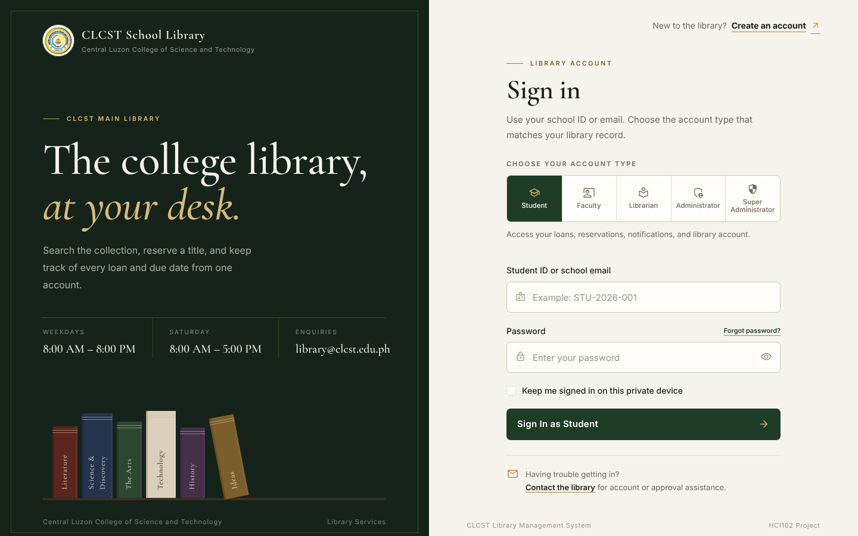
Figure 1. Sign In Page
Role selection, school ID or email, password entry, remember-device control, and account creation link.
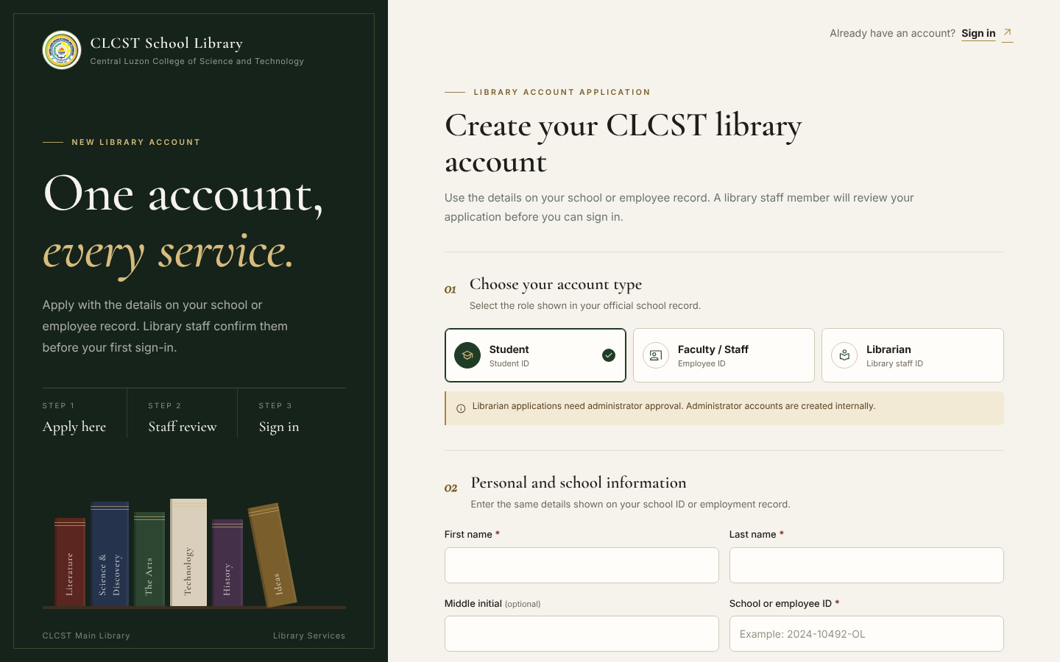
Figure 2. Registration Page
Student, Faculty, or Librarian registration with school details, password confirmation, private credential upload, and privacy consent.
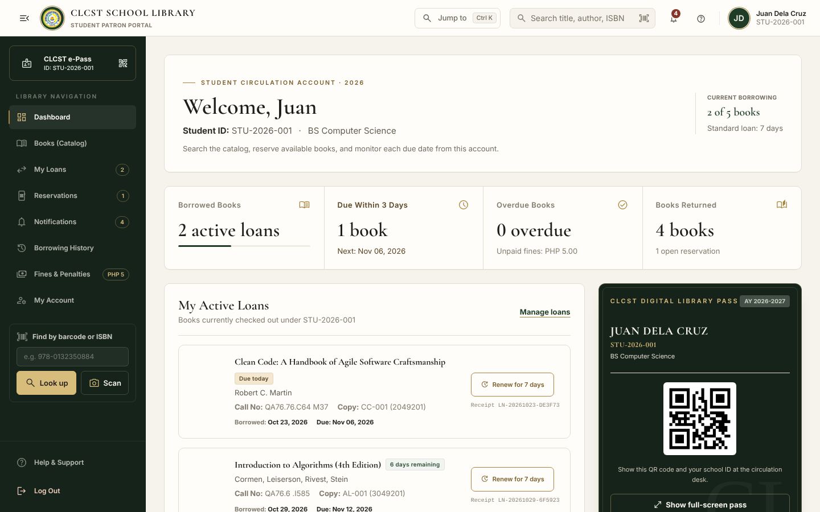
Figure 3. Student Dashboard
Loans, due dates, e-Pass, notifications, catalog access, and quick actions presented in a role-specific layout.
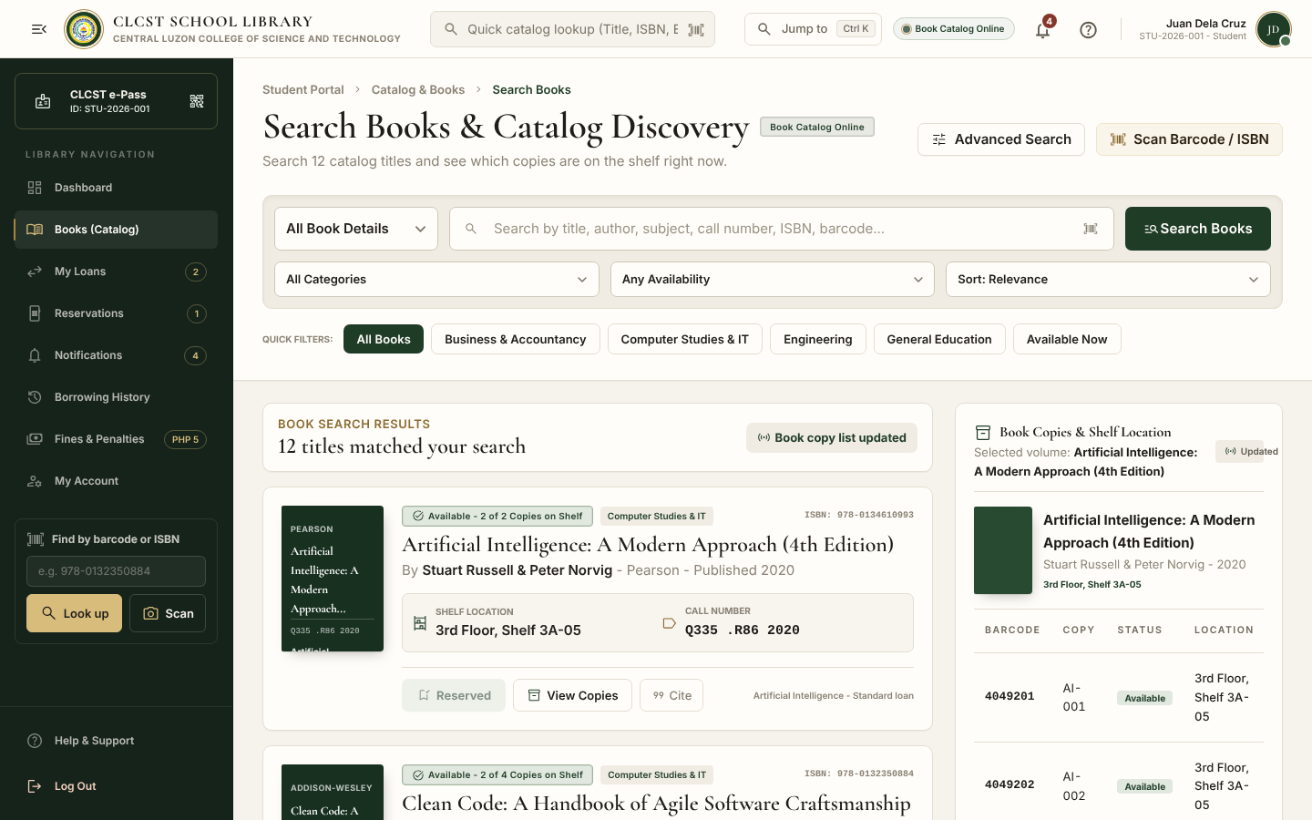
Figure 4. Book Catalog
Search, category and availability filters, realistic book records, copy status, call numbers, and reservation actions.
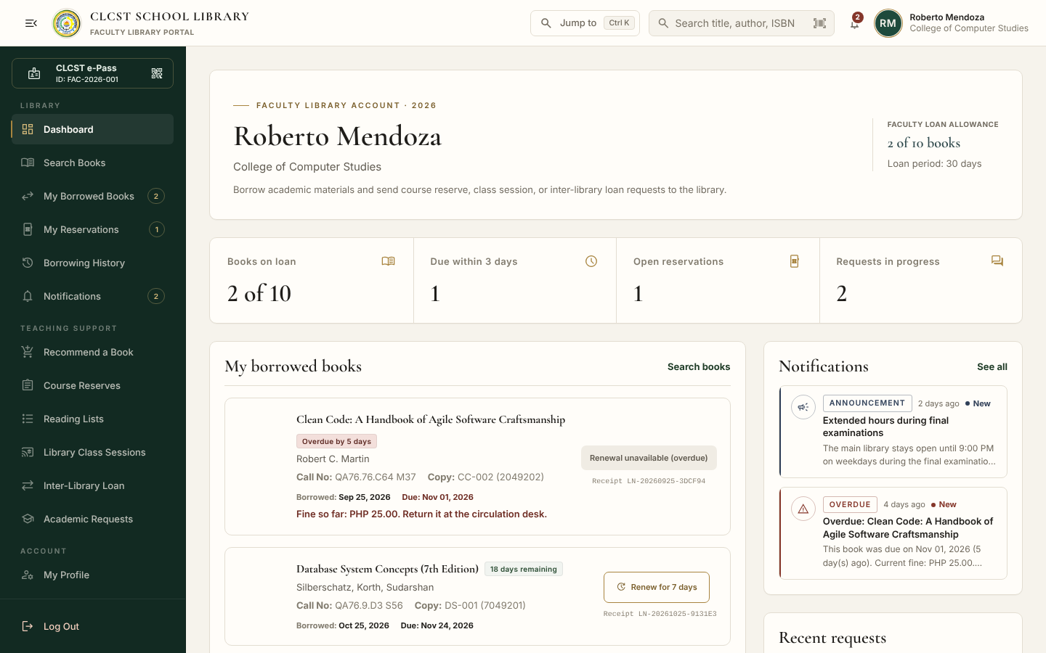
Figure 5. Faculty Dashboard
Faculty loan summary, academic requests, notifications, and quick access to course-related services.
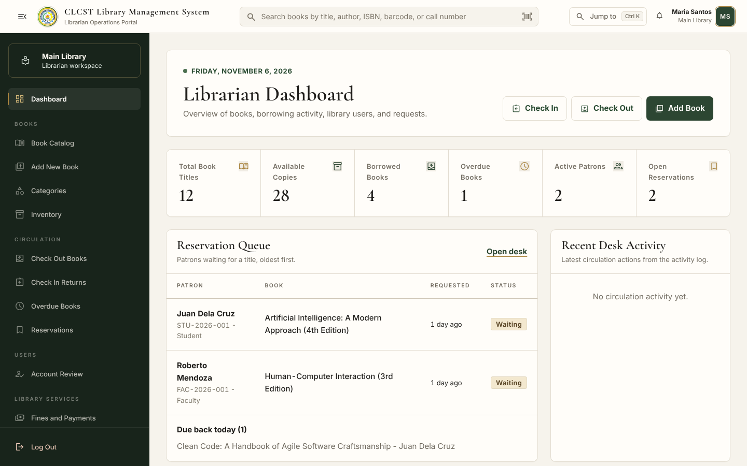
Figure 6. Librarian Dashboard
Circulation counts, reservation queue, recent desk activity, and shortcuts to checkout, returns, and book maintenance.
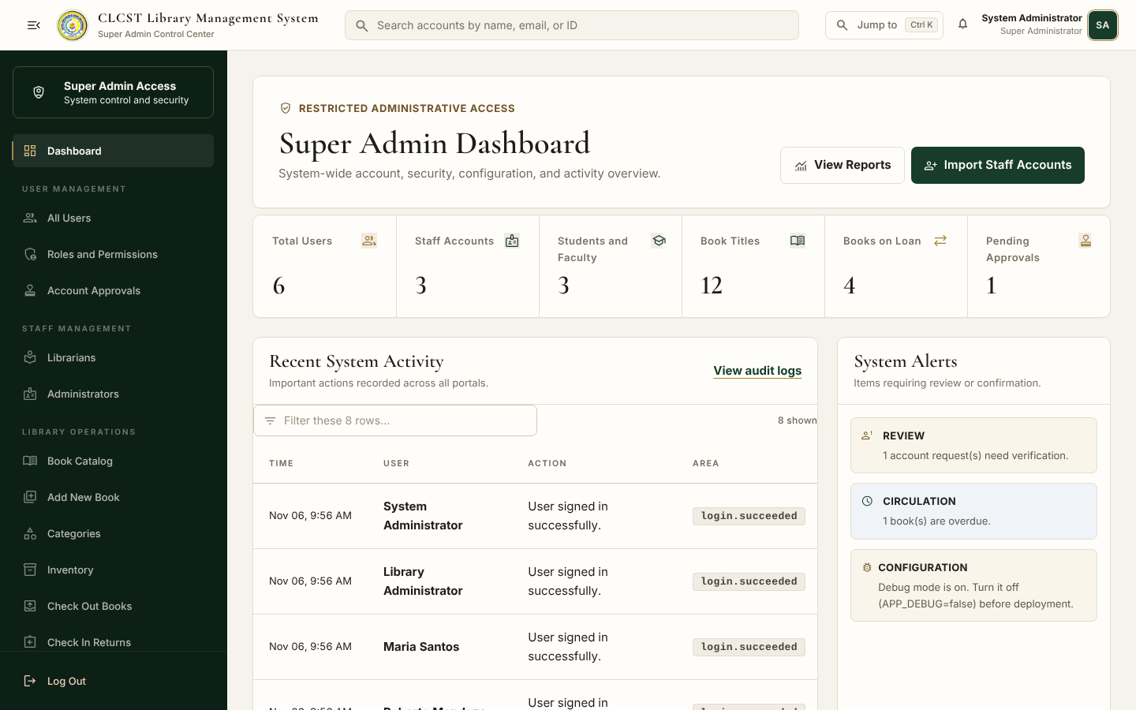
Figure 7. Super Administrator Dashboard
System-wide account, collection, circulation, security, and activity indicators.
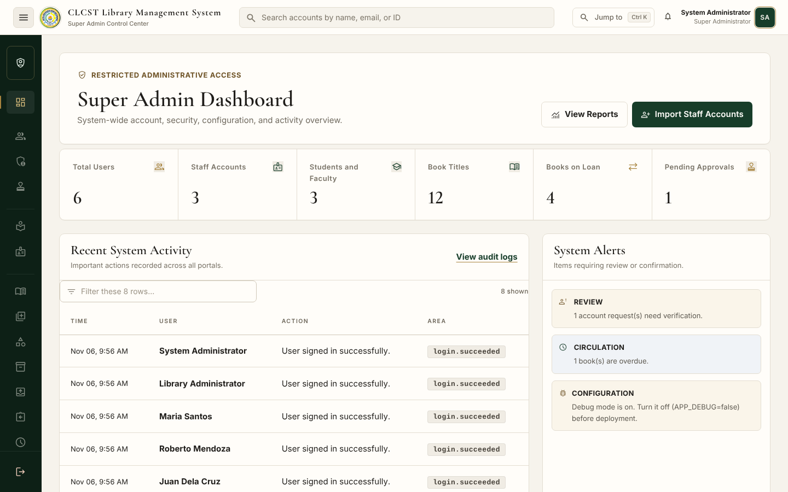
Figure 8. Collapsed Sidebar
Desktop users can reduce the sidebar to icons while preserving role identity and active-page state.
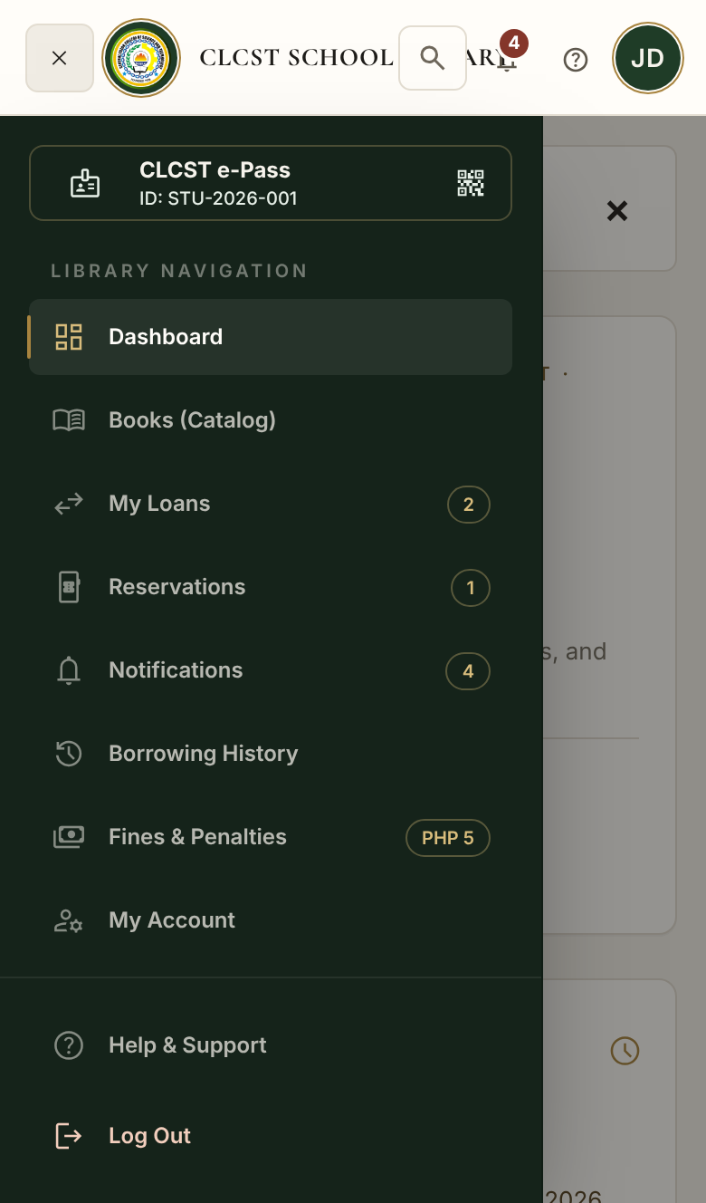
Figure 9. Phone Sidebar
The same navigation becomes a slide-in menu on small screens.

CHAPTER 3
SYSTEM IMPLEMENTATION
This chapter explains how the principal pages and interactions were implemented in Laravel. Routes are declared in routes/web.php and routes/api.php, business logic is placed in controllers and services, database records use Eloquent models, and interfaces are rendered through Blade templates.
3.1 Login Page
Purpose
The sign-in page authenticates all five roles from one interface. The account type chosen on the page must match the role saved in the database. Successful authentication regenerates the session and opens the correct dashboard; failed and wrong-role attempts are rate-limited and recorded in the audit log.
Interface Components
• Account type buttons
• School ID or institutional email field
• Password field with visibility control
• Keep me signed in option
• Sign In button
• Create an account link
• Forgot password and library assistance links
Validation and Security
• Only institutional email addresses ending in @clcst.edu.ph or a valid school ID are accepted.
• Passwords are hashed with bcrypt and follow a minimum 10-character mixed-case and numeric policy.
• Login is route-limited and repeated failures are tracked per identifier and IP address.
• Pending or suspended accounts cannot sign in.
• Sessions are encrypted, regenerated at sign in, and invalidated at logout; protected pages send no-cache headers.
• The API uses HS256 JWT access tokens with expiry, revocation, role checks, and suspended-account checks.
Buttons
The primary button states the selected role, for example Sign In as Student. Account-type controls provide visible selected states. The registration link uses a secondary outlined treatment so the main task remains clear.
Screenshot
Figure 10. Implemented Sign In Page
The page combines clear role guidance with strict server-side authentication and a formal school-library visual identity.

3.2 Dashboard
Purpose
Each dashboard summarizes the work and information that matters most to its role. Metrics come from the relational database rather than static placeholders.
Dashboard | Widgets, cards, and navigation
Student | Active loans, upcoming due dates, overdue status, returned-book count, e-Pass, catalog search, notifications, and quick actions
Faculty | Faculty loan allowance, borrowed books, request status, academic-service links, notifications, and profile access
Librarian | Titles, copies, loans, overdue books, reservations, fines, users, pending approvals, circulation queue, and recent desk actions
Administrator | Users, pending accounts, book titles, transactions, reports, recent account activity, bulk data, and audit information
Super Administrator | Total users and staff, collection and circulation statistics, failed sign-ins, system alerts, recent activity, policies, and maintenance information

Charts
Reports and Analytics uses database totals and horizontal comparison bars for loans by month, popular books, collection status, fines, and account activity. The dashboards prioritize summary cards and actionable lists instead of decorative charts.
Navigation
Dashboard shortcuts use named Laravel routes. The universal sidebar marks the current page, preserves its scroll position, collapses on desktop, and opens as an overlay on phones.
Screenshots
Figure 11. Student Dashboard Implementation
Database-driven borrowing status and self-service actions.
Figure 12. Librarian Dashboard Implementation
Operational counts, queue status, and circulation shortcuts.
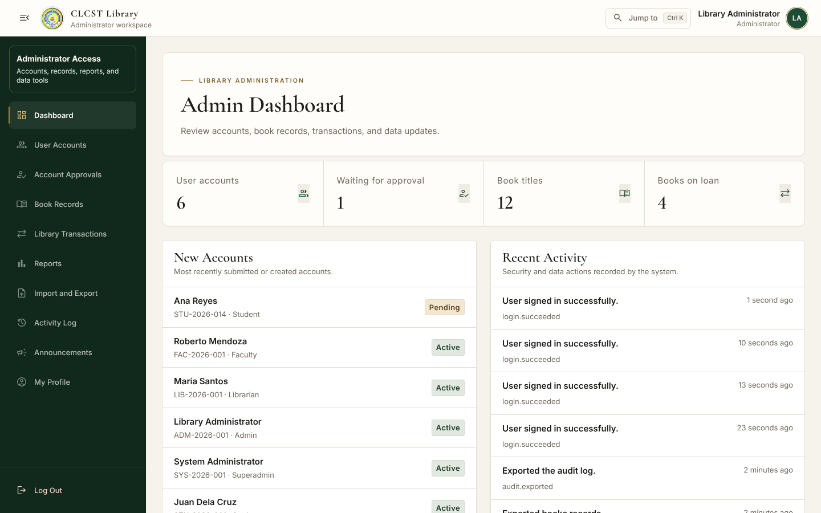
Figure 13. Administrator Dashboard Implementation
Account, record, report, and activity oversight.
Figure 14. Super Administrator Dashboard Implementation
System-wide administration, policy, security, and monitoring.

3.3 Forms
Forms use Blade templates, CSRF tokens, Laravel validation, old-input restoration, permission checks, and plain-language error messages. Actions that change records are confirmed before submission and report success or failure afterward.
Form or action | Implementation
Add and edit book | Validates title, author, ISBN, category, call number, shelf location, loan policy, year, and physical-copy count
Reserve and cancel | Checks reference status, available copies, patron ownership, reservation limits, and existing queue entries
Renew loan | Checks due date, renewal count, waiting list, overdue state, and patron ownership
Checkout and return | Uses patron ID or e-Pass and copy barcode; applies limits, due dates, waiting lists, receipts, copy status, and automatic fines
Account approval | Authorized reviewers open the private ID file and may approve, suspend, reactivate, or issue a temporary password only for roles below their own management level. Reviewers cannot apply these actions to their own account.
Profile photo | Accepts JPG, PNG, or WebP up to 2 MB, checks image dimensions, stores it privately, and replaces the previous file
Search and pagination | Server-side query filters preserve URL values and paginate catalogs, accounts, inventory, loans, reservations, and logs
Bulk CSV data | Downloads exact templates, imports at most 2,000 validated rows in one transaction, exports authorized records, and neutralizes spreadsheet formulas

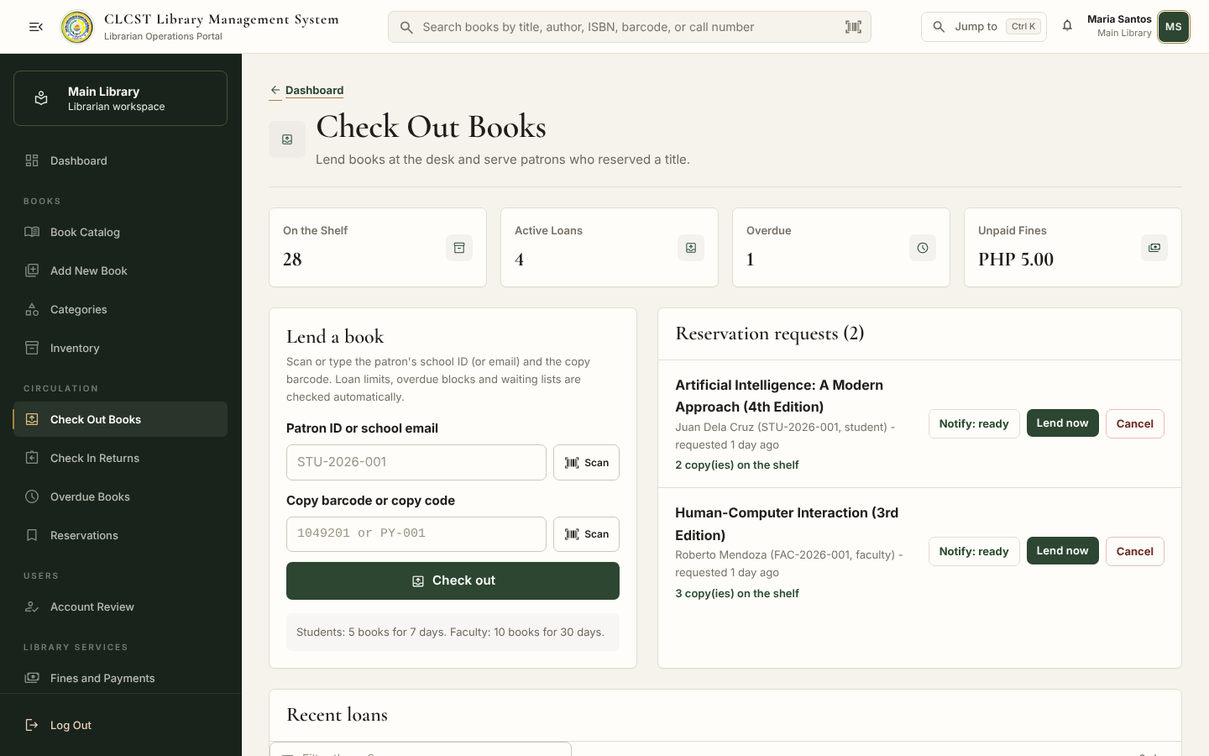
Figure 15. Check Out Books Form
The librarian identifies the patron, scans or enters the copy barcode, reviews reservations, and confirms the loan.
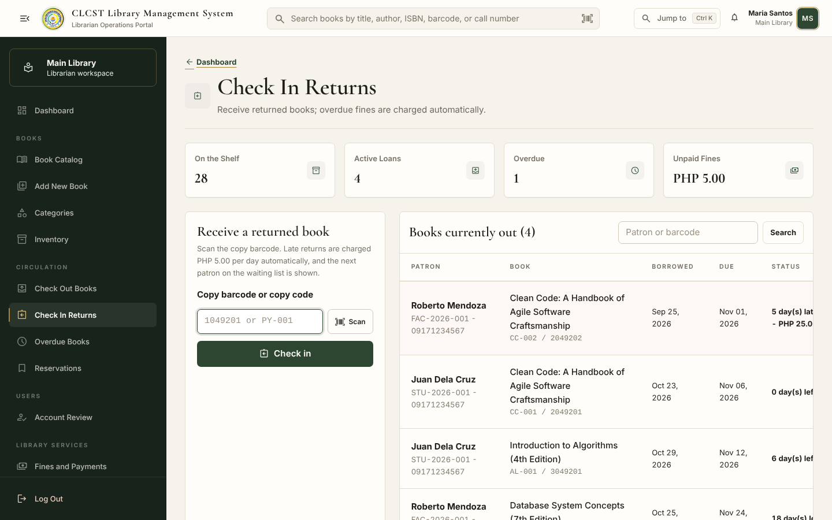
Figure 16. Check In Returns Form
Returning a copy closes the loan, updates its status, calculates a late fine when necessary, and identifies the next waiting patron.

3.4 Responsive Design
Screen | Behavior
Desktop | Full sidebar or collapsed icon rail, multi-column dashboard metrics, wide tables, and side-by-side forms
Laptop | Cards wrap to available width, tables scroll inside their containers, and sidebars remain available
Tablet | Reduced columns, stacked form groups, touch-sized controls, and preserved navigation
Mobile | Slide-in sidebar, single-column cards, full-width buttons, horizontal table containers, and no page-level sideways scrolling

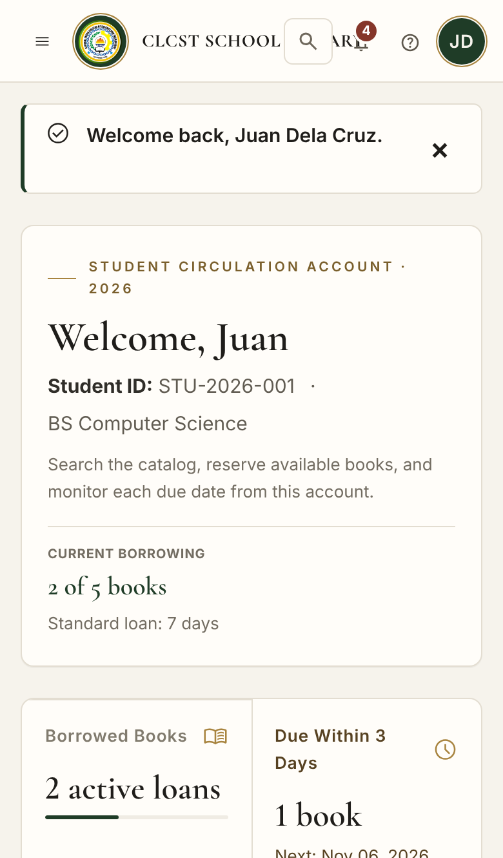
Figure 17. Student Dashboard on a Phone
The page stacks important account and borrowing information without removing core actions.
Figure 18. Sidebar on a Phone
The universal sidebar opens over the current page and closes after navigation.

3.5 Technologies Used
Technology | Purpose
HTML5 through Blade | Semantic page structure, forms, tables, dialogs, and reusable partials
CSS3 and Tailwind CSS 3 | Responsive utilities, locally built stylesheet, design tokens, layout, and forms
Custom CSS | CLCST visual identity, authentication layout, sidebar behavior, motion, status, and interaction polish
JavaScript | Sidebar state, barcode and QR scanning, confirmation dialogs, notifications, table filtering, Quick Jump, and motion
Laravel 13 and PHP 8.3 | Routing, validation, authentication, authorization, controllers, services, storage, sessions, and tests
SQLite and MySQL or MariaDB | Relational local and deployment databases
JWT HS256 | Authenticated JSON API for external clients
PHPUnit | Automated feature and unit tests
Git and GitHub | Version control, collaboration, and repository history
Bootstrap | Not used. Tailwind CSS and custom Blade components provide the equivalent responsive UI patterns.

CHAPTER 4
FRONT-END SOURCE CODE
Only important excerpts are included in this chapter. The complete application source is stored in the submitted GitHub repository and indexed in Appendices A through C.
4.1 Folder Structure
clcst-library-management-system/
├── app/
│ ├── Http/Controllers/ Auth, patron, librarian, admin, API, bulk data
│ ├── Http/Middleware/ portal access, JWT, security headers
│ ├── Models/ users, books, copies, loans, reservations, fines
│ ├── Services/ circulation rules and library settings
│ └── Support/ JWT, reports, patron notifications
├── config/library.php loan, reservation, fine, and JWT defaults
├── database/ migrations, factories, and demo seeders
├── public/
│ ├── css/ Tailwind build, fonts, app, modern, UI actions
│ ├── fonts/ local fonts and Material Symbols
│ ├── images/ CELTECH logo and image assets
│ └── js/ sidebar, UI actions, scanner, interactions
├── resources/views/
│ ├── auth/ sign in and registration
│ ├── student/ and staff/ student and faculty portals
│ ├── librarian/ circulation and collection workspace
│ ├── admin/ superadmin/ administration portals
│ ├── management/ account review and bulk data
│ ├── errors/ 403, 404, 419, 429, 500, 503
│ └── partials/ shared sidebars and components
├── routes/web.php and routes/api.php
└── tests/Feature and tests/Unit

4.2 Login Page Source Code
HTML and Blade Structure
<form method="POST" action="{{ route('login.authenticate') }}">
@csrf
<input name="identifier" required autocomplete="username">
<input name="password" type="password" required autocomplete="current-password">
<label><input name="remember" type="checkbox" value="1"> Keep me signed in</label>
<button type="submit">Sign In</button>
</form>

Route and Server Validation
Route::post('/login', [AuthController::class, 'store'])
->middleware('throttle:10,1')
->name('login.authenticate');

$credentials = $request->validate([
'role' => ['required', Rule::in(User::ROLES)],
'identifier' => ['required', 'string', 'max:150'],
'password' => ['required', 'string', 'max:255'],
]);

Blade provides the accessible form structure and CSRF token. The route limiter slows automated attempts. AuthController normalizes the identifier, checks that the selected account type matches the saved role, verifies the hashed password, rejects inactive accounts, regenerates the session, records the audit event, and redirects to the correct portal. Protected responses use no-cache headers so a signed-out dashboard cannot be reopened with the browser Back button.

4.3 CSS Example
.clcst-portal {
--ui-accent: #244632;
--ui-gold: #a8843f;
background: #f6f3ec;
color: #17231b;
}

.clcst-portal .clcst-sidebar a[aria-current="page"]::before {
content: "";
position: absolute;
left: -1px;
top: 9px;
bottom: 9px;
width: 2px;
background: var(--ui-gold);
}

The shared variables keep the school palette consistent across all portals. The active-page marker gives users a persistent location cue. Responsive rules in the same stylesheets collapse grids and change the sidebar into a mobile overlay.

4.4 JavaScript Example
const reduceMotion = window.matchMedia('(prefers-reduced-motion: reduce)').matches;

document.addEventListener('keydown', (event) => {
const quickJump = (event.ctrlKey || event.metaKey) && event.key.toLowerCase() === 'k';
if (quickJump && !typing(document.activeElement)) {
event.preventDefault();
openQuickJump();
}
});

localStorage.setItem('clcst-sidebar', collapsed ? 'collapsed' : 'expanded');

The JavaScript layer adds optional efficiency and feedback without replacing server validation. It remembers the sidebar state and position, provides keyboard Quick Jump, handles dialogs and scanner input, filters long tables, and disables unnecessary animation when the user prefers reduced motion.

4.5 Bootstrap Components Used
Bootstrap is not installed in this project. The professor's required component categories are implemented with Tailwind CSS, custom CSS, Blade partials, and plain JavaScript instead.
Requested component | Implemented equivalent
Cards | Tailwind and custom card sections for metrics, loans, books, notices, forms, and policies
Navbar | Blade top bars with school identity, search or Quick Jump, notifications, and account identity
Sidebar | Role-specific Blade sidebars with collapse, mobile overlay, active-page state, and scroll memory
Modal | Custom confirmation, result, scanner, book-details, and notification dialogs
Table | Responsive Blade tables with pagination or quick filtering
Buttons | Primary, secondary, destructive, icon, and compact action styles
Forms | Blade forms with Tailwind form controls, labels, help text, CSRF, validation, and old-input restoration

4.6 UI Components
UI component | Use
Login card | Role-guided credentials, password assistance, privacy guidance, and account creation
Navigation bar | Logo, current system state, quick navigation, notifications, and signed-in account
Sidebar | All pages available to the role, active-page marker, counts, support, and logout
Dashboard cards | Live database counts, urgent states, quick actions, and role-specific summaries
Data table | Accounts, loans, copies, fines, reports, requests, and audit events
Pagination | Server-side page navigation that preserves filters in the query string
Search bar | Catalog, account, copy, loan, transaction, and audit-log searches
Modal windows | Confirmation, result, scanner, notification, advanced search, and copy details
Badges | Plain-text status for account, copy, loan, reservation, request, and fine states
Library e-Pass | Patron identity and QR or barcode input for desk transactions

CHAPTER 5
TESTING, EVALUATION, AND CONCLUSION
5.1 Front-End Testing
The latest repository was tested with php artisan test. All 80 automated tests passed with 846 assertions. The tests cover page rendering and the server behavior that protects every front-end action.
Test file | Tests | Coverage
AccessControlTest | 26 | Strict role matching, session regeneration and invalidation, portal redirects, approvals, credential files, cache protection, role hierarchy, and protected account actions
CirculationTest | 13 | Reservations, checkout, returns, limits, renewals, fines, waiting lists, and hold expiry
SecurityTest | 10 | Institutional email, passwords, output escaping, SQL safety, CSRF, headers, cache rules, and CSV protection
ReviewFixesTest | 6 | Import edge cases, identifier normalization, malformed queries, and protected credential access
InteractionTest | 5 | Notification states, reservation messages, ISBN normalization, and scanner permissions
JwtApiTest | 5 | JWT sign in, role restrictions, expiration, forgery rejection, and logout revocation
PortalPagesTest | 5 | Every role portal page renders with relational demo data
ProfilePhotoTest | 4 | Upload, replacement, removal, file validation, and private access
RoleIsolationTest | 3 | Every protected page and staff action rejects unauthorized roles
LoanFineTest | 3 | Fine calculations and loan model behavior

Functional test | Result
Sign in and role routing for all five roles | Passed
Registration, private ID upload, and approval | Passed
Catalog search, details, scanner, reservation, and renewal | Passed
Checkout, return, automatic fine, and waiting-list handling | Passed
Universal sidebars, mobile menu, and scroll-position memory | Passed
Profile updates and profile-photo lifecycle | Passed
Bulk book and user CSV import and export | Passed
Audit log search and CSV export | Passed
Custom error pages and protected-page cache control | Passed
JWT API authentication and authorization | Passed

5.2 Browser Compatibility
Browser or viewport | Status
Google Chrome | Passed
Microsoft Edge | Passed
Chromium automated screenshots | Passed
Mozilla Firefox | Expected to work; include in final acceptance test
Safari on iPhone and Mac | Responsive layout prepared; include in final acceptance test
Phone viewport below 768 pixels | Passed responsive layout review

5.3 Usability Evaluation
Use the 5-point Likert Scale questionnaire in Appendix F with actual Student, Faculty, Librarian, and Administrator respondents. Scores are: 5 Strongly Agree, 4 Agree, 3 Neutral, 2 Disagree, and 1 Strongly Disagree. Appendix G is reserved for the real results.
The interface is easy to use.
The sidebar labels are easy to understand.
I can find the page I need quickly.
Buttons clearly state what they do.
The colors and text are pleasant and easy to read.
The book catalog is easy to search.
The dashboard shows the information I need first.
The system clearly reports whether an action worked or failed.
The system works well on my phone.
Overall, I am satisfied with the system.

5.4 Findings
Usability testing with participants has not yet been completed. The findings below come from implementation review, automated tests, responsive screenshots, and task-flow inspection; they are design observations rather than measured survey results.
• The staff pages use familiar library terms such as Check Out Books, Check In Returns, My Loans, and Fines and Payments so users do not need to interpret generic system labels.
• Each portal keeps the same sidebar on every page. This corrects the earlier behavior where administrators could be moved into the librarian sidebar on shared pages.
• The sidebar remembers its scroll position, and Ctrl+K Quick Jump reduces navigation effort in staff portals with many links.
• Barcode and e-Pass input are designed to reduce repeated typing of school IDs and copy numbers at the circulation desk.
• Role, name, initials or profile photo, and portal label help users confirm which account is active on a shared computer.
• Confirmation dialogs and result messages are used to prevent mistakes and make the outcome of record-changing actions clear.
• Server-enforced RBAC, record ownership, private files, audit logs, and no-cache headers prevent common navigation, shared-computer, and post-logout access problems.
• Responsive layouts preserve the same terminology and actions rather than presenting a separate mobile experience.

5.5 Recommendations
• Conduct supervised usability sessions and complete Appendix G with real respondents from every role.
• Add verified self-service email password reset when institutional mail is available; until then, keep staff-issued temporary passwords and require users to change them from their profile.
• Add email or SMS due-date reminders when the school approves a messaging provider and privacy process.
• Before deployment, give every account a unique password, set APP_ENV to production and APP_DEBUG to false, deploy through HTTPS, and set production session cookies to Secure.
• Add scheduled encrypted database backups and a documented restore exercise.
• Review accessibility with keyboard-only, screen-reader, zoom, and color-contrast tests involving actual users.
• Continue simplifying high-frequency librarian tasks after observing real circulation-desk work.

5.6 Conclusion
The CLCST Library Management System fulfills the project objective of providing a usable, responsive, secure, and role-appropriate academic library interface. Students and faculty receive self-service access to the catalog, loans, reservations, notifications, requests, and account information. Librarians receive working collection and circulation tools. Administrators manage accounts, records, reports, and bulk data, while the super administrator controls policy, security, permissions, and system-wide oversight.
The design applies HCI principles through consistent navigation, visible system status, plain language, immediate feedback, validation, confirmations, keyboard support, responsive layouts, and accessible motion behavior. The Laravel back end reinforces the interface with RBAC, private uploads, audit logging, circulation rules, protected sessions, security headers, and tested database operations. The current checkout passes 80 automated tests with 846 assertions. The remaining academic work is to conduct the planned usability evaluation with real respondents, complete Appendix G without fabricated results, and follow the production deployment steps in Section 5.5.

APPENDICES
Appendix A: Complete HTML and Blade Source Code
The complete server-rendered interface is contained in resources/views in the submitted repository. Because the project uses Laravel Blade, the HTML is organized as reusable layouts, pages, and partials rather than copied into one file.
• resources/views/auth - sign in and registration
• resources/views/student - Student portal
• resources/views/staff - Faculty portal
• resources/views/librarian - Librarian workspace
• resources/views/admin - Administrator portal
• resources/views/superadmin - Super Administrator portal
• resources/views/management - Account Review and Import and Export
• resources/views/books - catalog and book dialogs
• resources/views/errors - 403, 404, 419, 429, 500, and 503 pages
• resources/views/partials - sidebars and reusable interface components
Repository: https://github.com/krstnkye/CLCST-Library-Management-System-HCI102.git
Verified documentation baseline commit: 17247dec965312dfb2eae036da2591c9f4ccf9ca

Appendix B: Complete CSS Source Code
• public/css/tailwind.css - production Tailwind utility build
• public/css/app.css - shared project rules
• public/css/modern.css - portal identity, hierarchy, responsive refinements, and authentication design
• public/css/ui-actions.css - scanner, dialogs, action feedback, and interaction components
• public/css/fonts.css - local font and icon declarations
• resources/css/tailwind.css - Tailwind build input
• tailwind.config.js - project colors, font families, content paths, and plugins

Appendix C: Complete JavaScript Source Code
• public/js/sidebar.js - desktop collapse, phone overlay, and sidebar scroll memory
• public/js/ui-actions.js - confirmations, result dialogs, scanner, notifications, and page actions
• public/js/ui-interactions.js - progress indicator, table filters, count-up, Quick Jump, and back-to-top
• public/js/ui-motion.js - shared motion initialization
• public/js/vendor/html5-qrcode.min.js - bundled barcode and QR scanner library
• public/js/vendor/qrcode-generator.js - bundled e-Pass QR generator

Appendix D: Bootstrap Components
Bootstrap is not used. The project implements the required component categories with Tailwind CSS, Blade partials, custom CSS, and plain JavaScript. The component mapping is documented in Section 4.5, and the complete styles and scripts are included in Appendices B and C.

Appendix E: Screenshots of All Pages
Figure 19. Sign In
Implemented page or responsive state from the current CLCST Library Management System.
Figure 20. Registration
Implemented page or responsive state from the current CLCST Library Management System.
Figure 21. Student Dashboard
Implemented page or responsive state from the current CLCST Library Management System.
Figure 22. Book Catalog
Implemented page or responsive state from the current CLCST Library Management System.
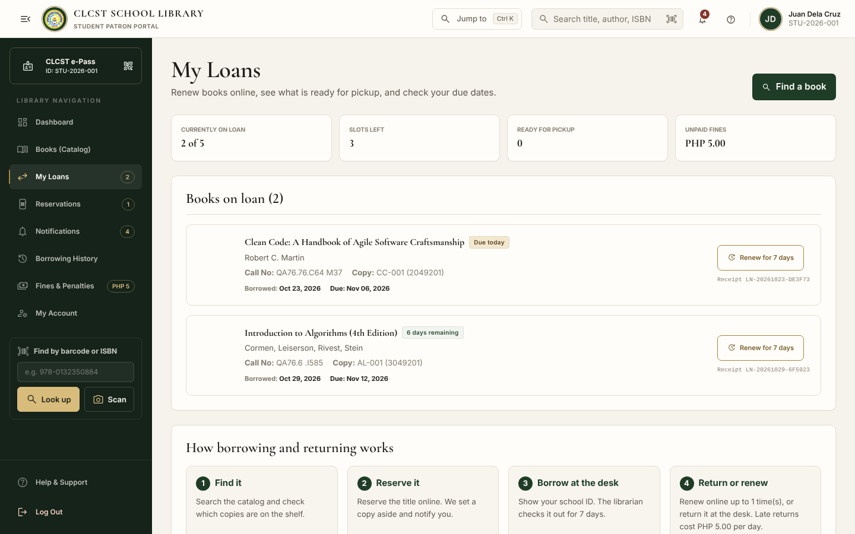
Figure 23. Student My Loans
Implemented page or responsive state from the current CLCST Library Management System.
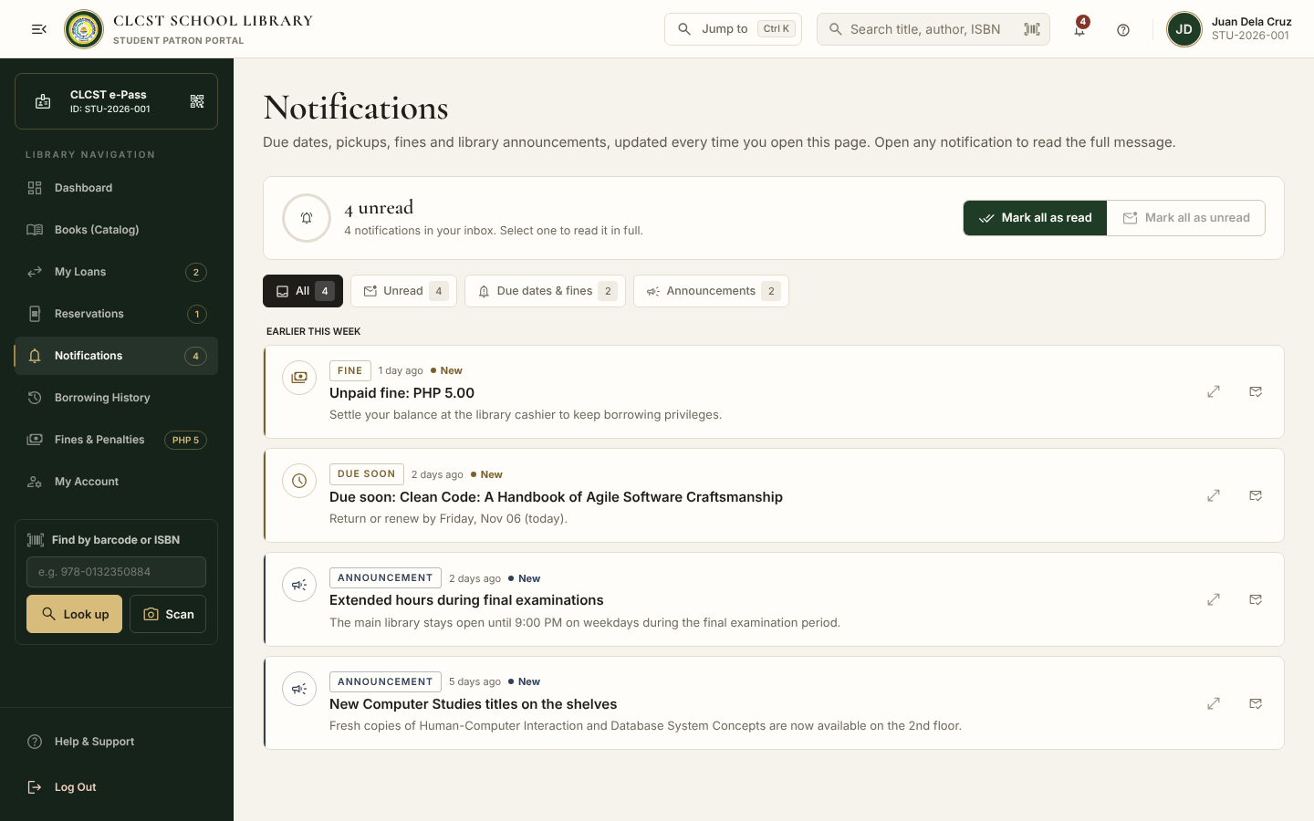
Figure 24. Student Notifications
Implemented page or responsive state from the current CLCST Library Management System.
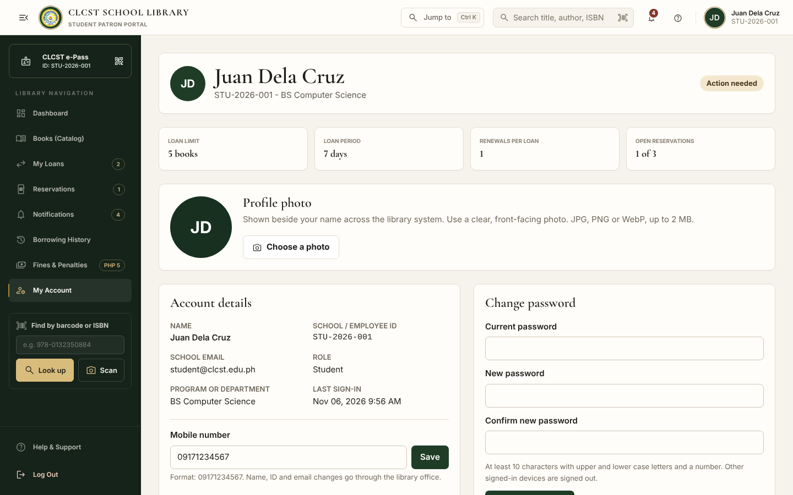
Figure 25. Student My Account
Implemented page or responsive state from the current CLCST Library Management System.
Figure 26. Faculty Dashboard
Implemented page or responsive state from the current CLCST Library Management System.
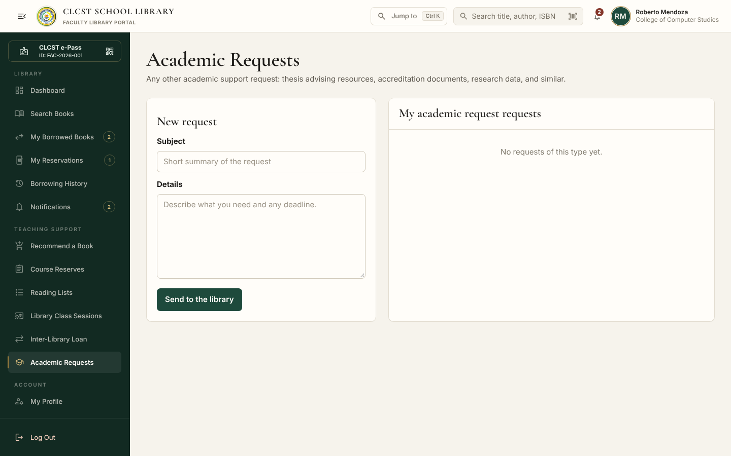
Figure 27. Faculty Academic Requests
Implemented page or responsive state from the current CLCST Library Management System.
Figure 28. Librarian Dashboard
Implemented page or responsive state from the current CLCST Library Management System.
Figure 29. Check Out Books
Implemented page or responsive state from the current CLCST Library Management System.
Figure 30. Check In Returns
Implemented page or responsive state from the current CLCST Library Management System.
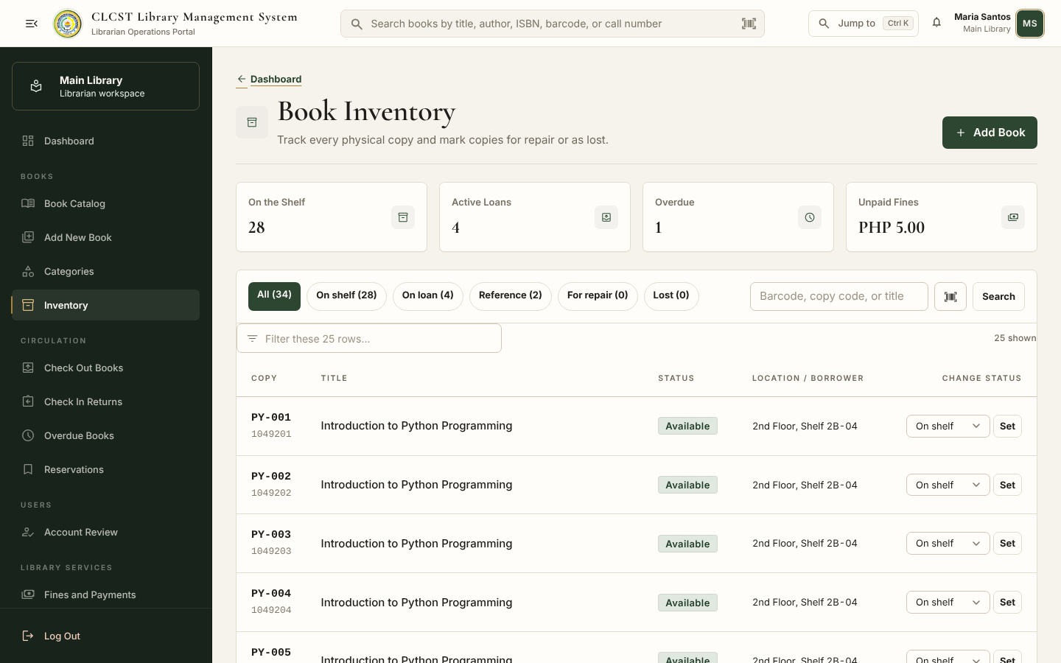
Figure 31. Book Inventory
Implemented page or responsive state from the current CLCST Library Management System.
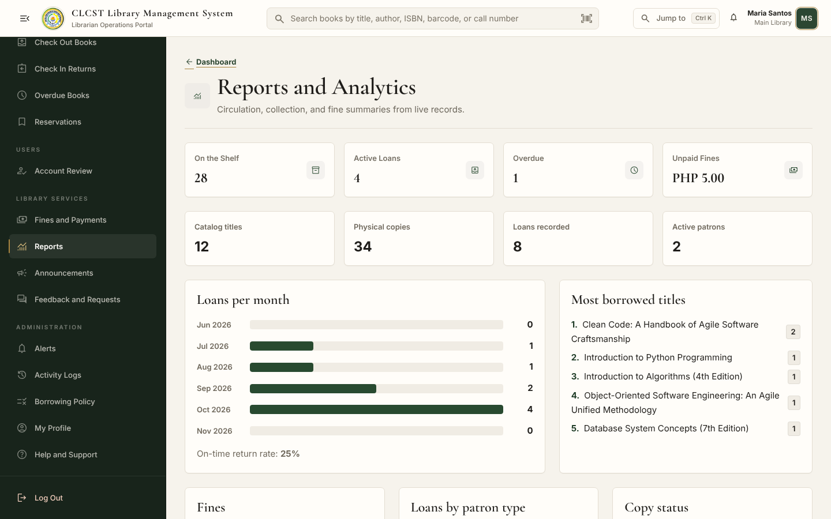
Figure 32. Reports and Analytics
Implemented page or responsive state from the current CLCST Library Management System.
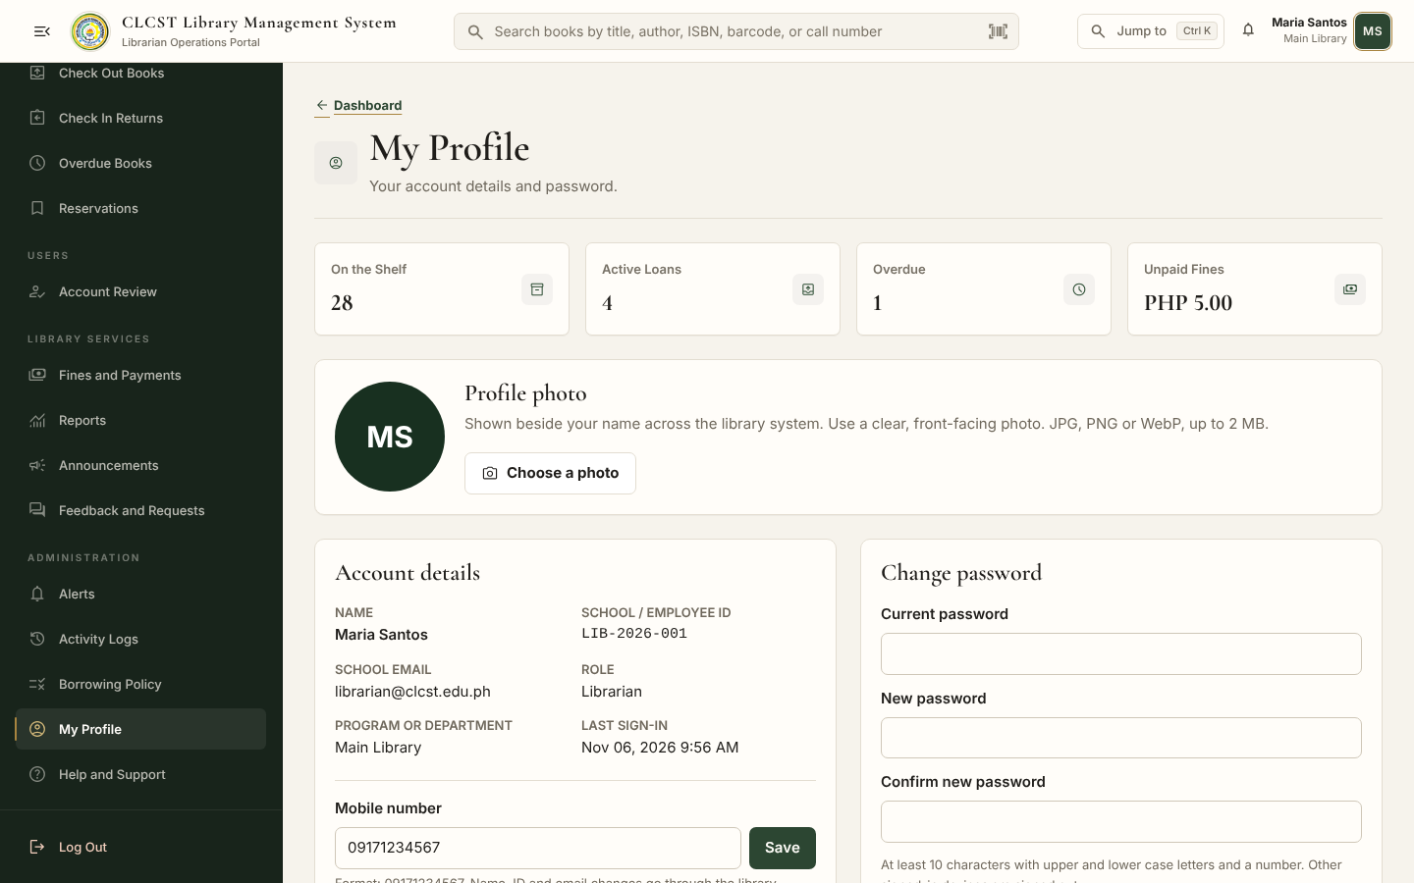
Figure 33. Librarian My Profile
Implemented page or responsive state from the current CLCST Library Management System.
Figure 34. Administrator Dashboard
Implemented page or responsive state from the current CLCST Library Management System.
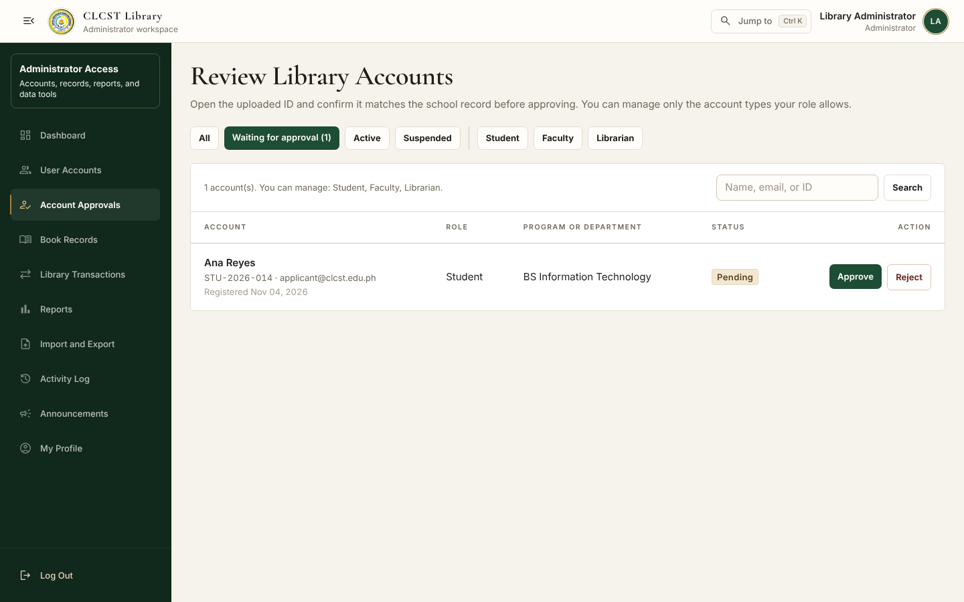
Figure 35. Account Review
Implemented page or responsive state from the current CLCST Library Management System.
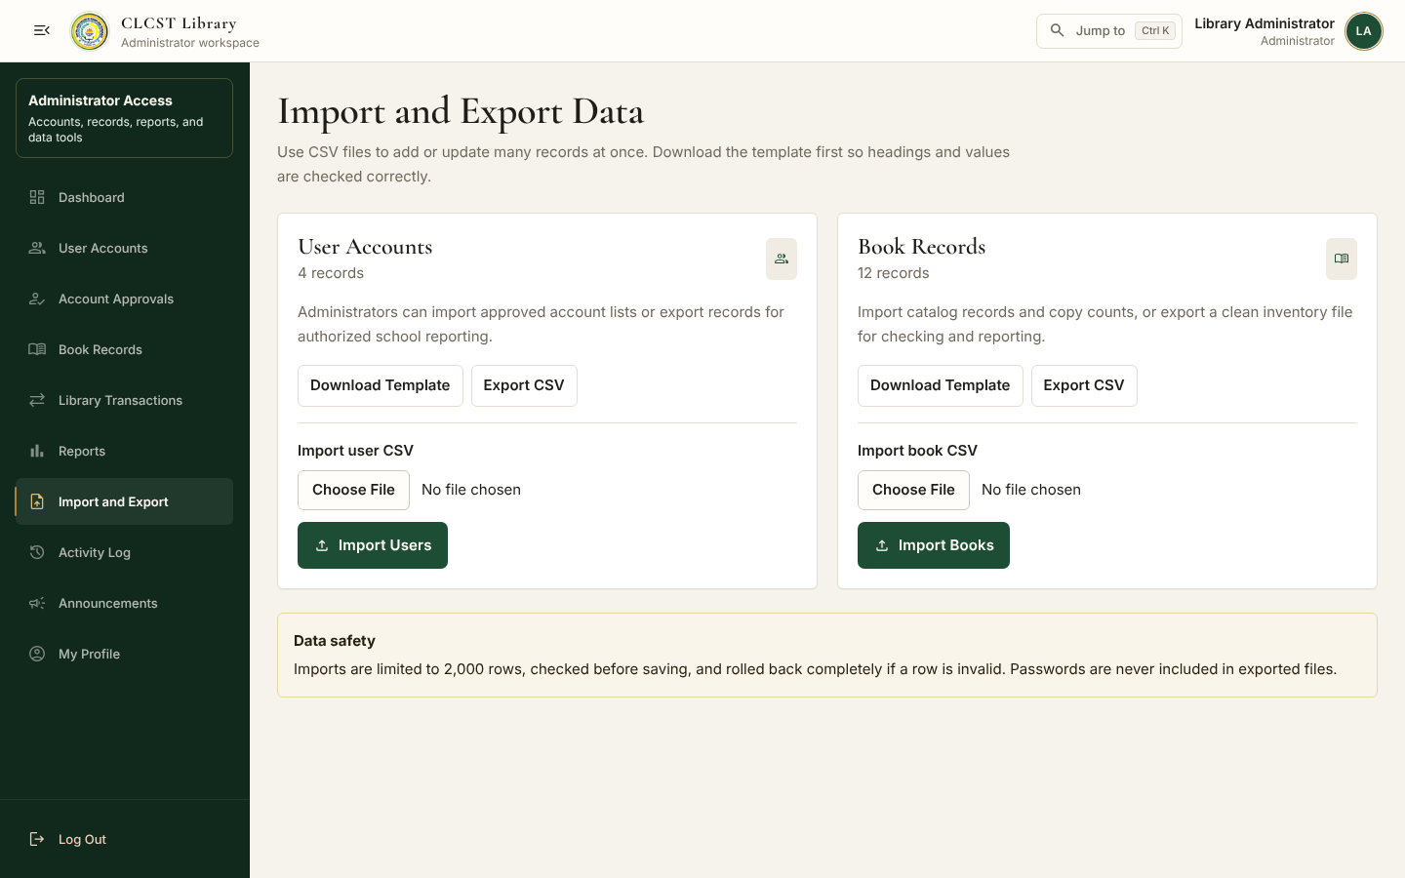
Figure 36. Import and Export
Implemented page or responsive state from the current CLCST Library Management System.
Figure 37. Super Administrator Dashboard
Implemented page or responsive state from the current CLCST Library Management System.
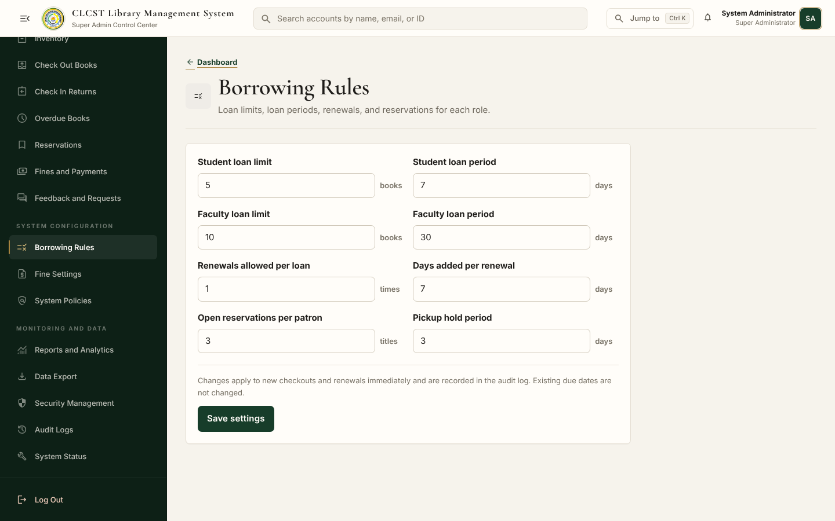
Figure 38. Borrowing Rules
Implemented page or responsive state from the current CLCST Library Management System.
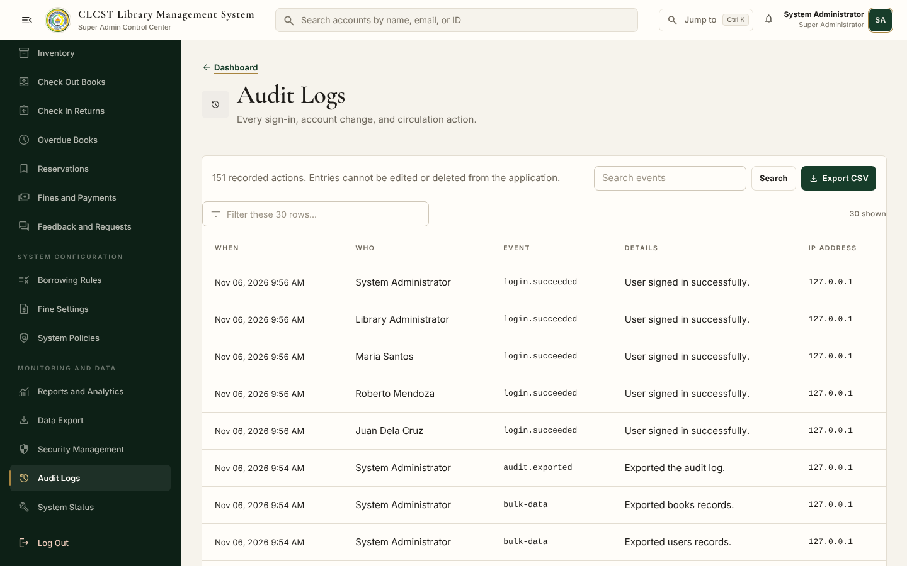
Figure 39. Audit Logs and CSV Export
Implemented page or responsive state from the current CLCST Library Management System.
Figure 40. Collapsed Sidebar
Implemented page or responsive state from the current CLCST Library Management System.
Figure 41. Phone Student Dashboard
Implemented page or responsive state from the current CLCST Library Management System.
Figure 42. Phone Sidebar Menu
Implemented page or responsive state from the current CLCST Library Management System.
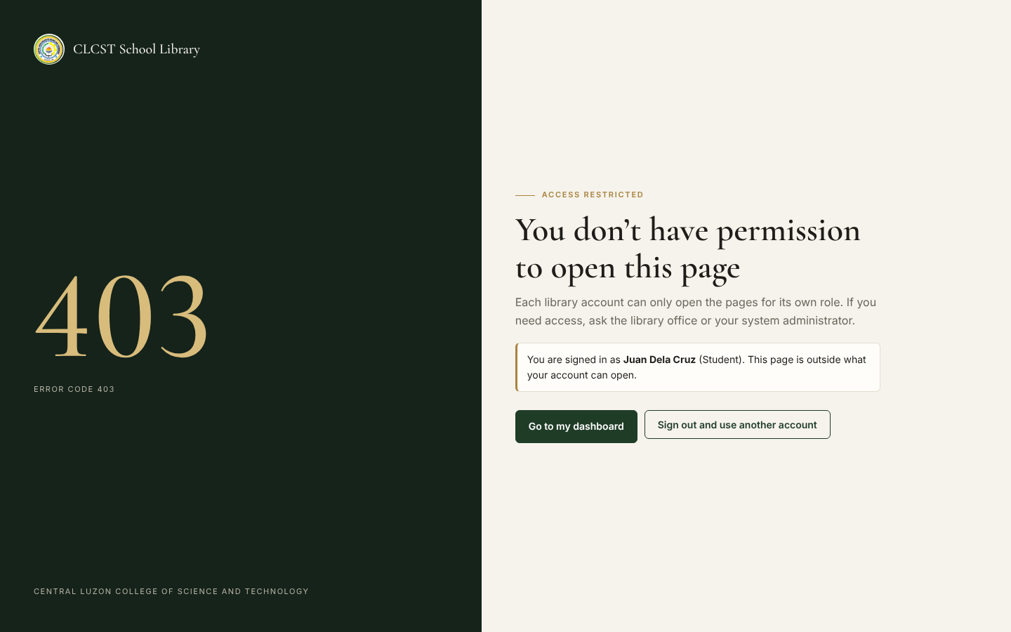
Figure 43. Access Denied 403
Implemented page or responsive state from the current CLCST Library Management System.
Appendix F: Usability Testing Questionnaire
Respondent role: ☐ Student ☐ Faculty ☐ Librarian ☐ Administrator
Instruction: Circle one rating for each statement. 5 Strongly Agree, 4 Agree, 3 Neutral, 2 Disagree, 1 Strongly Disagree.
No. | Statement | Rating
1 | The system is easy to use. | 5 4 3 2 1
2 | The sidebar labels are easy to understand. | 5 4 3 2 1
3 | I can find the page I need quickly. | 5 4 3 2 1
4 | Buttons clearly state what they do. | 5 4 3 2 1
5 | The colors and text are pleasant and easy to read. | 5 4 3 2 1
6 | The book catalog is easy to search. | 5 4 3 2 1
7 | The dashboard shows the information I need first. | 5 4 3 2 1
8 | The system clearly tells me whether an action worked or failed. | 5 4 3 2 1
9 | The system works well on my phone. | 5 4 3 2 1
10 | Overall, I am satisfied with the system. | 5 4 3 2 1

Comments or suggestions: ________________________________________________________________

Appendix G: User Evaluation Results
This section must be completed after supervised usability testing. No respondent ratings or comments are fabricated in this documentation.
Respondent | Role | Average rating | Positive comments | Problems found | Improvement
1
2
3
4
5
6
7
8
9
10

Summary and computed average: _____________________________________________________________

