PRODUCT INVENTORY SYSTEM: An Inventory Management System Using Python, Tkinter, and SQLite

BSIT-3-ALPHA

MEMBERS:
Mayo, Nathaniel B.
Pader, Derick R.
Cantano, Chloe

DATE

Project Overview
The Product Inventory System is a desktop application that helps a user keep track of the products in a small store or stock room. It was made using Python, with Tkinter for the window and buttons and SQLite for saving the records. For each product, the system records the product ID, product name, category, quantity, and unit price.
The system has the basic inventory functions: adding a new product, viewing the saved products, searching, updating product details, and deleting products that are no longer needed. It also gets the total amount of each product and the total value of all the products, and it tells the user when a product is running low. All records are saved in a database file named inventory.db, so the data is still there after the program is closed and opened again.
The app uses a dark design, but it can also be switched to light mode. Everything is on one main screen, so the user can see the product table, the summary cards, and the product form at the same time without opening many windows.

Objectives
The main objective of the Product Inventory System is to give a simple and organized way to manage product inventory records.
Specifically, the system aims to:
- To provide an organized way of recording products and their details.
- To allow users to add, view, search, update, and delete product records.
- To help users monitor stock levels by showing which products are low on stock or out of stock.
- To lessen mistakes by checking what the user types and getting the totals automatically.
- To provide an easy-to-use interface where all the main tasks can be done on one screen.
- To keep the records saved in a database so they are not lost when the program is closed.
- To help users quickly find products using the search box, category filters, and column sorting.

Scope and Limitations

Scope
The Product Inventory System focuses on managing the product records of a small inventory. The system covers the basic operations needed to keep product records organized and up to date.

The system includes the following features:
- Add Product – Allows users to save a new product by entering the product name, category, quantity, and unit price. The product ID is given automatically by the system. If the same product (same name, category, and price) is added again, the system adds the new quantity to the existing record instead of making a duplicate.
- View Records – Shows all saved products in a table with the ID, product name, category, stock, status, unit price, and total amount. The DB Records button also opens a separate window that shows the rows exactly as they are saved in inventory.db.
- Search and Filter – Allows users to search for a product by its ID, name, or category, and to show only one category by clicking the category buttons above the table. Users can also click a column heading to sort the table.
- Update Records – Allows users to click a product in the table, change its details in the form, and save the changes.
- Delete Records – Allows users to remove a selected product after confirming in a pop-up message.
- Inventory Monitoring – Shows the total inventory value, the number of products and units, and a low stock alert. Products with less than 10 pieces are marked as low stock, and products with 0 pieces are marked as out of stock.
- Activity Log and Product Inspector – The activity log lists the actions done while the app is open, and the product inspector shows the details and stock bar of the selected product.
- Light and Dark Mode – Allows users to switch the colors of the app using the theme button or Ctrl+L. The app remembers the last mode that was chosen.
The category list comes with six choices: School Supplies, Food, Drinks, Cleaning, Electronics, and Other. Users can also type their own category if the product does not fit any of these.

Limitations
The Product Inventory System can do the basic inventory tasks, but it also has some limitations:
- The system is only for keeping product inventory records and does not cover other business operations.
- It does not include online purchasing, payment processing, sales, or order management.
- It does not have a login or user accounts, so anyone using the computer can change the records.
- It works on one computer only. The data is saved in a local file (inventory.db) and is not shared online with other users.
- The activity log is only kept while the app is open and is cleared when the app is closed.
- The records are only as accurate as the data entered by the user, so the stock may be wrong if it is not updated.
- The low stock limit is fixed at 10 pieces for all products and cannot be changed inside the app.

Data Design (In-Memory)
- Data Structures Used: When the app runs, the products from the database are loaded into a List of Dictionaries (self.products = []), where each dictionary is one product. The app also uses a List (self.log_entries = []) to keep the activity log of the current session, and a Tuple (CATEGORIES) for the default category choices. The total of each product is not saved in the database. It is solved every time as quantity × unit price.
- Key Representation: Each product is identified by its product_id, which is the primary key in the database. It is a number that SQLite gives automatically (1, 2, 3, and so on). In the table, it is shown as P001, P002, and so on. The app uses this ID to find the selected product when updating or deleting.
- Sample Record Structure:
{'product_id': 1, 'product_name': 'Ballpen (Black)', 'category': 'School Supplies', 'quantity': 120, 'unit_price': 8.5, 'total': 1020.0}
- Additional Sample Records:
  - {'product_id': 2, 'product_name': 'Yellow Pad Paper', 'category': 'School Supplies', 'quantity': 45, 'unit_price': 35.0, 'total': 1575.0}
  - {'product_id': 4, 'product_name': 'Instant Noodles', 'category': 'Food', 'quantity': 80, 'unit_price': 16.75, 'total': 1340.0}
  - {'product_id': 6, 'product_name': 'Bottled Water 500ml', 'category': 'Drinks', 'quantity': 60, 'unit_price': 15.0, 'total': 900.0}

File Design (Persistent Storage)
- File Name Used: inventory.db (an SQLite database file). It is made automatically in the same folder as main.py the first time the app runs.
- Table Format Used: products ( product_id | product_name | category | quantity | unit_price )
- Rules in the Table: product_id is an INTEGER PRIMARY KEY that counts up by itself. product_name and category are TEXT and cannot be empty. quantity is an INTEGER and unit_price is a REAL number, and both must be 0 or more.
- Example Rows:
  - 1 | Ballpen (Black) | School Supplies | 120 | 8.5
  - 2 | Yellow Pad Paper | School Supplies | 45 | 35.0
  - 4 | Instant Noodles | Food | 80 | 16.75
  - 6 | Bottled Water 500ml | Drinks | 60 | 15.0
- Other File: settings.json only remembers if the user picked dark mode or light mode. It stays on the user's computer and is not uploaded to GitHub.

Program Flow/Algorithm
- Start the System
  - The user runs main.py. The program connects to inventory.db and makes the products table if it does not exist yet.
  - The saved products are loaded from the database, and the dark or light mode used last time is applied.
- Display Main Screen
  - The system shows the main screen with the summary cards, the product table, the Product Control Panel, the activity log, and the product inspector.
  - If some products have less than 10 pieces, a low stock alert is written in the activity log.
- Select an Operation
  - The user picks one of the available functions:
    - Add Product
    - View Records
    - Search, Filter, or Sort
    - Update Product
    - Delete Product
    - Switch Theme
    - Exit
- Add Product
  - The user types the product name, picks or types a category, and enters the quantity and unit price. The computed total is shown while typing.
  - The user clicks Add Product or presses Enter.
  - The system checks that the name and category are not empty, that the quantity is a whole number that is not negative, and that the price is a valid number that is not negative.
  - If there is a problem, a red message is shown in the form and the cursor moves to the field that needs fixing.
  - If a product with the same name, category, and price already exists, the new quantity is added to it. If not, a new record is saved with a new ID.
  - The table and summary cards are refreshed, a short message appears in the bottom-right corner, and the action is written in the activity log.
- View Records
  - The system shows all products in the table, newest first, with the ID, product, category, stock, status, unit price, and total amount.
  - Low stock rows are shown in orange and out of stock rows are shown in red.
  - The user can click DB Records to open the Database Records window, which shows the rows saved in inventory.db.
- Search, Filter, or Sort
  - The user types in the search box (or presses Ctrl+F to go to it). The table updates right away and only shows products whose ID, name, or category matches.
  - The user can click a category button to show only that category, or click All to show everything.
  - The user can click a column heading to sort the table. Clicking it again reverses the order.
  - If nothing matches, the table shows a message saying that no products match the search or filter.
- Update Product
  - The user clicks a product in the table. Its details are loaded into the form, and the Update and Delete buttons are turned on.
  - The user changes the details and clicks Update or presses Enter.
  - The system checks the new values the same way as in Add Product.
  - The record is updated in the database, the table and totals are refreshed, and a success message is shown.
- Delete Product
  - The user selects a product and clicks Delete or presses the Delete key.
  - The system asks if the user is sure about deleting the product.
  - If the user clicks Yes, the record is removed from the database. If the user clicks No, nothing is deleted.
  - The table and totals are refreshed, a success message is shown, and the deletion is written in the activity log.
- Switch Theme
  - The user clicks the Light Mode or Dark Mode button, or presses Ctrl+L.
  - The screen is drawn again in the other colors. The typed values, search text, and activity log are kept.
  - The choice is saved in settings.json so the app opens in the same mode next time.
- Save Changes
  - Every add, update, and delete is saved to inventory.db right away, so there is no separate save button.
  - This makes sure that the records are still there the next time the app is opened.
- Exit
  - The user closes the window.
  - Since all changes are already saved, the program simply closes. The activity log is cleared.

Basic Flow
Start → Load Records from inventory.db → Main Screen → Select Operation → Add / View / Search / Update / Delete → Validate Input → Save to Database → Refresh Table and Totals → Return to Main Screen → Exit

Entity-Relationship Diagram.

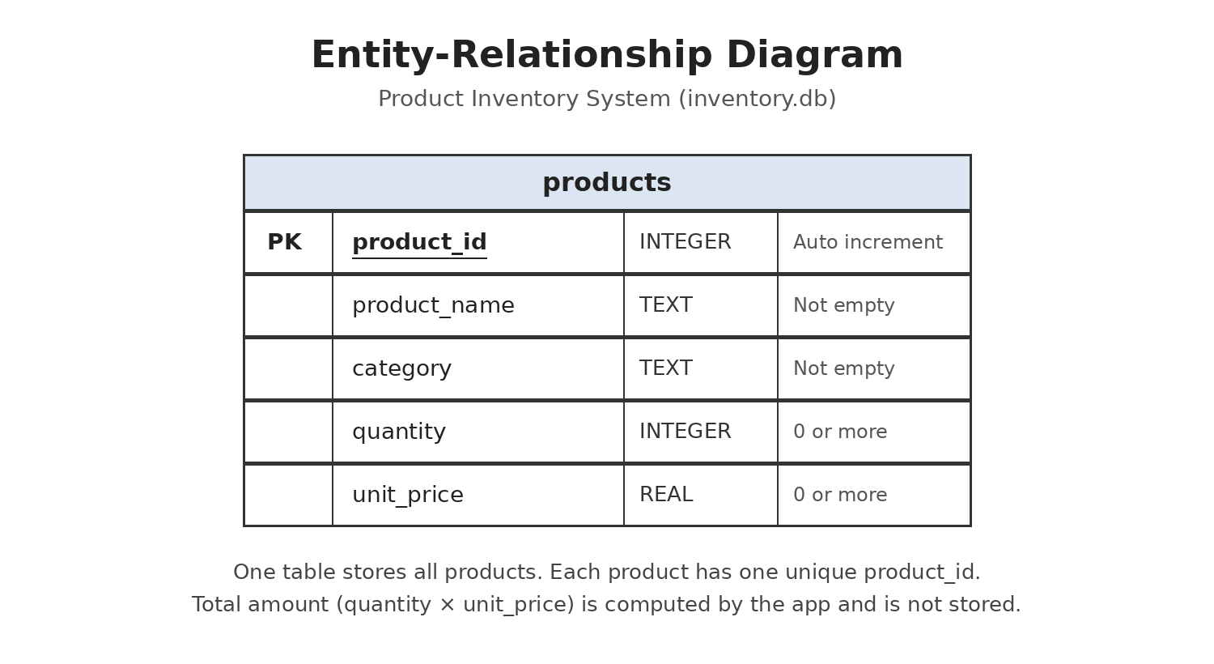

Entity Relationship Diagram
The diagram above shows the products table, which is the only table in the system's database. Each product has its own product_id, and the other columns hold the product's details.

Exception Handling Plan
- Expected User Mistake: Invalid numeric input (typing letters in Quantity, like "abc"). Exception Handled: ValueError from int(). Message: "Quantity must be a whole number."
- Expected User Mistake: Invalid price (typing letters or a negative number in Unit Price). Exception Handled: ValueError from float(), plus a check if the price is below 0. Message: "Please enter a valid price."
- Expected User Mistake: Negative quantity (like -5). Exception Handled: Logical check (quantity < 0). Message: "Quantity cannot be negative."
- Expected User Mistake: Leaving Product Name or Category empty. Exception Handled: Logical check after removing extra spaces. Message: "Please enter a product name." or "Please enter a category."
- Expected User Mistake: Adding a product that already exists (same name, category, and price). Exception Handled: Logical check in the database (not case-sensitive). The new quantity is added to the old record instead of making a duplicate. Message: "Same product already exists, so its quantity was increased."
- Expected User Mistake: Clicking Update or Delete without selecting a product. Exception Handled: The Update and Delete buttons stay off until a product is selected, plus a logical check. Message: "Please select a product to update." or "Please select a product to delete."
- Expected User Mistake: Database file missing on first run. Exception Handled: CREATE TABLE IF NOT EXISTS. SQLite makes inventory.db automatically. Message: No message. The app starts with an empty product list.
- Expected User Mistake: Database error while saving. Exception Handled: sqlite3.DatabaseError. Message: Pop-up: "Unable to save changes. Please try again."
Error messages are shown in red inside the form, and success messages appear for a few seconds in the bottom-right corner. Only the delete confirmation and database errors use a pop-up window.
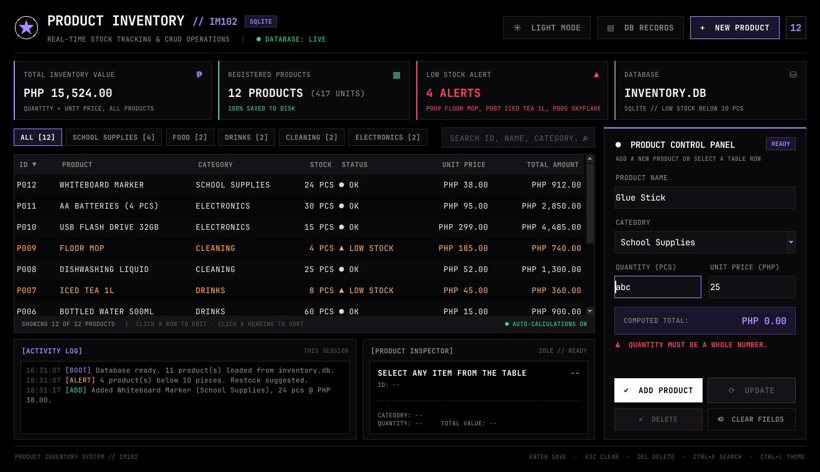
Error message shown inside the form
Testing Evidence
Test Case | Test Purpose | Test Condition | Expected Output | Actual Output | Remarks
Invalid Numeric Input | To test the system's exception handling when a user types letters instead of numbers. | If the user types letters (e.g., "abc") in the Quantity field and clicks Add Product. | The system should catch the ValueError and show "Quantity must be a whole number." The app must not crash. | The red message "Quantity must be a whole number." appeared in the form and the cursor moved to the Quantity field. The app did not crash. | Complete
Duplicate Product | To test that the same product is not saved twice. | If the user adds "Ballpen (Black)", School Supplies, 8.50, quantity 10, while the same product already exists with 120 pieces. | The system should not make a new row. It should add 10 to the existing record and tell the user. | No new row was made. The quantity of P001 went from 120 to 130 and "Same product already exists, so its quantity was increased." appeared. | Complete
Missing Input Fields | To test that the needed details are filled in before saving. | If the user leaves the Product Name blank and clicks Add Product. | The system should not save and should ask the user to enter a product name. | "Please enter a product name." appeared and the cursor moved to the Product Name field. Nothing was saved. | Complete
Successful Add & View | To test if the system correctly saves a new record and shows it in the table. | If the user enters Whiteboard Marker, School Supplies, 24, and 38.00, then clicks Add Product. | A success message should appear, and the new product should show right away in the table with the totals updated. | "Product added successfully." appeared. P012 Whiteboard Marker was added at the top of the table and the summary cards were updated. | Complete
Successful Update | To test if the system can correctly change an existing record. | If the user clicks P007 Iced Tea 1L, changes the quantity from 8 to 40, and clicks Update. | A success message should appear, and the new quantity should show in the table and in DB Records. | "Product updated successfully." appeared. P007 now shows 40 PCS with status OK, and the low stock alert went down by one. | Complete
Negative Quantity | To test that stock cannot go below zero. | If the user enters -5 in Quantity and clicks Add Product. | The system should block the save and show "Quantity cannot be negative." | The product was not saved and "Quantity cannot be negative." appeared. | Complete
Delete with Confirmation | To test that a product is only deleted after the user agrees. | If the user selects P009 Floor Mop, clicks Delete, then clicks Yes. (Also tried clicking No.) | The system should ask first. Yes should remove the record, and No should keep it. | The confirmation pop-up appeared. After Yes, P009 was removed and "Product deleted successfully." appeared. After No, the record stayed. | Complete
Search and Filter | To test if the user can quickly find products. | If the user types "pen" in the search box, then clears it and clicks the Drinks button. | Only the matching products should be shown. | "pen" showed P003 Pencil No. 2 and P001 Ballpen (Black). Drinks showed only the 2 drink products. | Complete
Saved After Closing | To test that records are kept in the database. | If the user closes the app and opens it again. | All saved products should still be in the table. | All products were loaded again from inventory.db. | Complete

Conclusion and Recommendations
What was achieved:
The group built a working inventory system that can add, view, search, update, and delete product records. The records are saved in an SQLite database, so they are kept even after the app is closed. The system also checks what the user types before saving, gets the totals automatically, and shows which products are low or out of stock. All the main tasks can be done on one screen, and the user can switch between dark mode and light mode.
What could be improved:
- Add a login so that only allowed users can change the records.
- Let the user set a different low stock limit for each product.
- Save the activity log in the database so the history is not lost when the app is closed.
- Add a way to print or export the product list to Excel or PDF.
- Add a backup button for the inventory.db file.

Contribution Summary

- Menu Flow & CRUD Core:

- Data Structures & Database Handling:

- Exception Handling & Documentation:

Dashboard
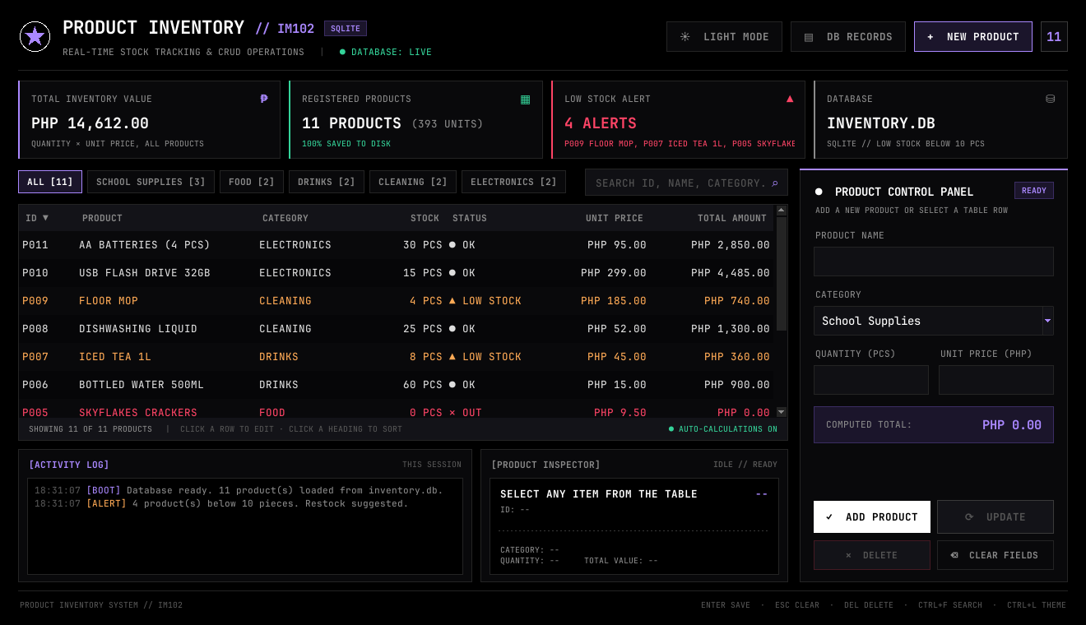
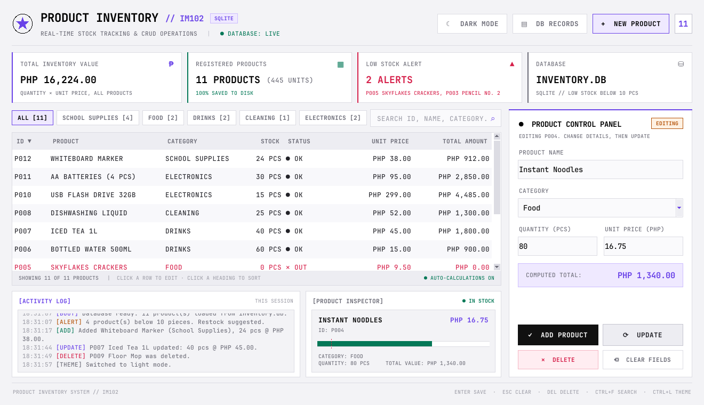
Explanation:
This is the main screen of the system. At the top are the Light Mode, DB Records, and New Product buttons, and a box that shows how many products are saved. Below them are four summary cards: Total Inventory Value (quantity × unit price of all products), Registered Products with the total number of units, Low Stock Alert, which lists the products with less than 10 pieces, and the database file. The middle part has the category buttons, the search box, and the product table, while the Product Control Panel on the right is where products are added and edited. At the bottom are the Activity Log, which lists what was done while the app is open, and the Product Inspector, which shows the details of the selected product. The second picture shows the same screen in light mode, which can be turned on with the Light Mode button or Ctrl+L.
View Records
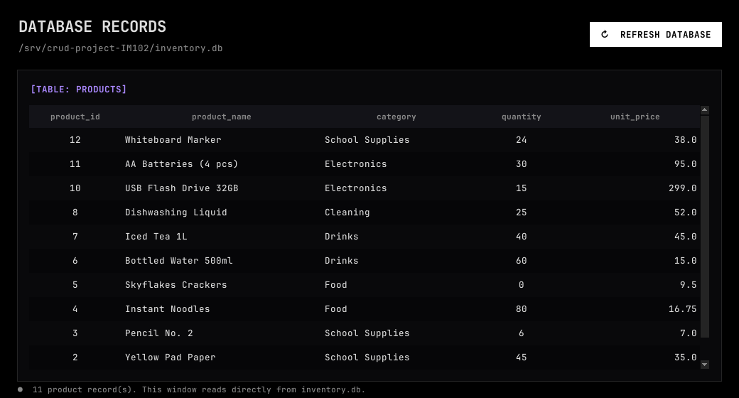
Explanation:
All saved products are shown in the table on the main screen, with the newest product at the top. Each row shows the ID, product name, category, stock, status, unit price, and total amount. The status is OK, LOW STOCK (orange, less than 10 pieces), or OUT (red, 0 pieces). The picture above is the Database Records window, which opens when the DB Records button is clicked. It shows the rows exactly as they are saved in the products table of inventory.db, and the Refresh Database button loads them again.
Adding a New Product
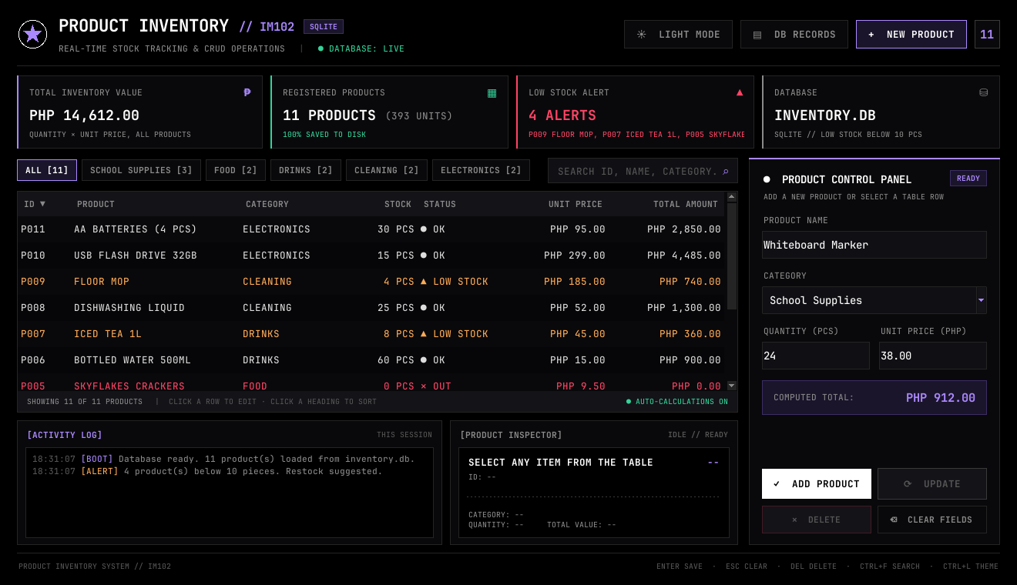
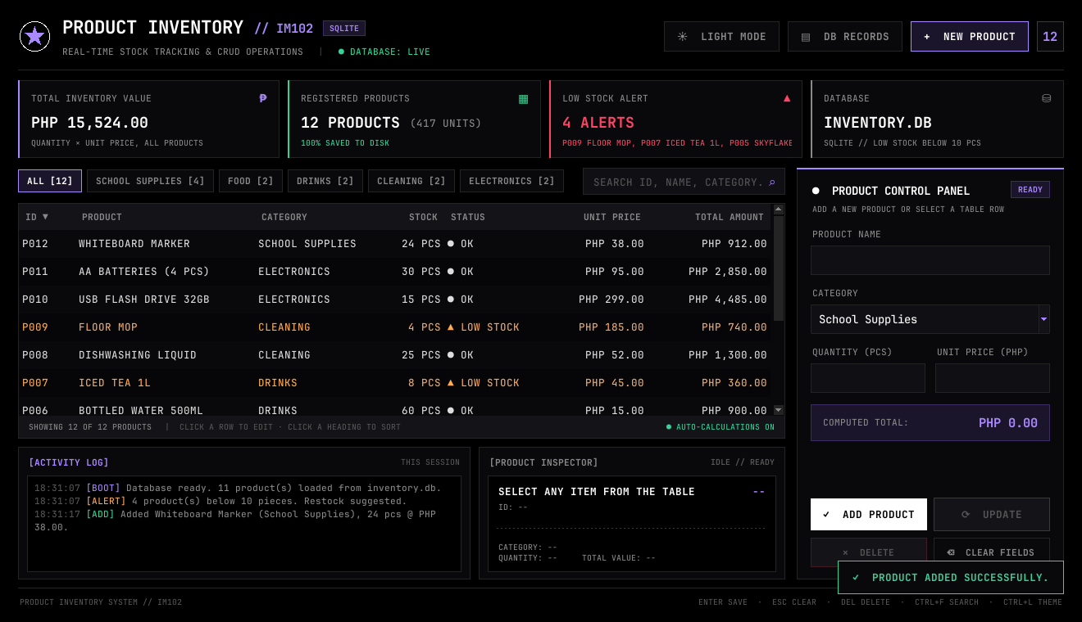
Explanation:
To add a product, the user types the product name, picks a category from the list (or types a new one), and enters the quantity and unit price. The Computed Total changes while the user types. After clicking Add Product or pressing Enter, the product is saved with a new ID, it appears at the top of the table, the summary cards are updated, and "Product added successfully." shows in the bottom-right corner. If the same product with the same category and price already exists, the quantity is added to it instead. If something is wrong, like letters in the Quantity field, a red message appears in the form and nothing is saved, as shown in the picture under the Exception Handling Plan.
Search, Filter, and Sort
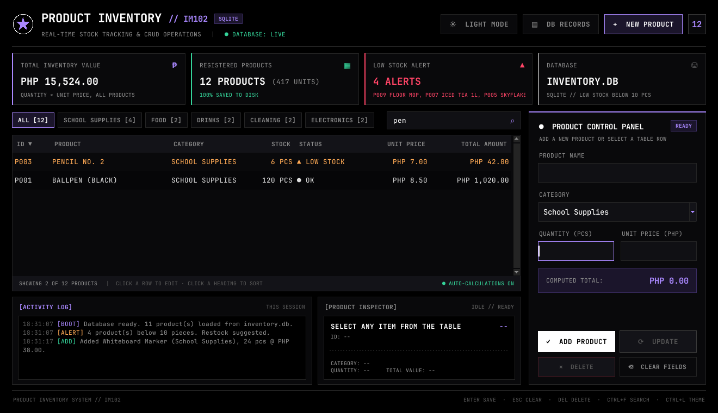
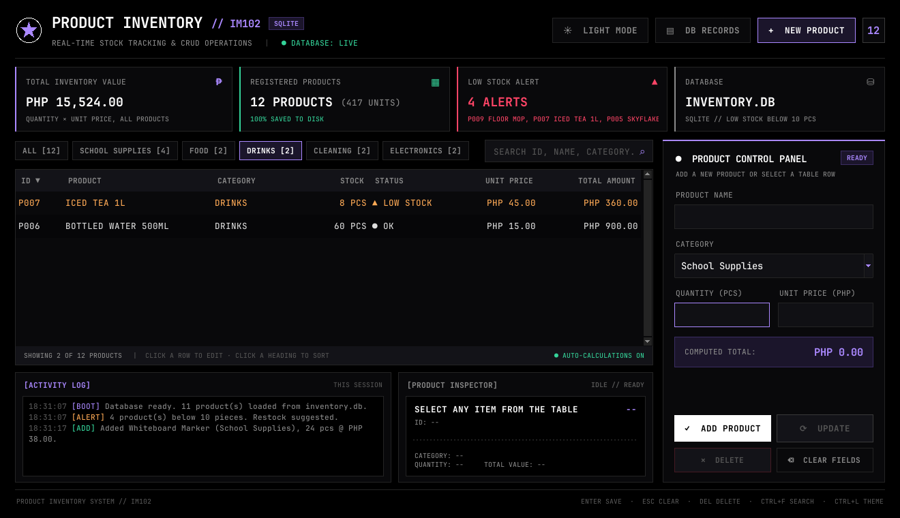
Explanation:
The search box above the table filters the products while the user types. It checks the product ID, name, and category, so typing "pen" shows Pencil No. 2 and Ballpen (Black). Pressing Ctrl+F moves the cursor to the search box. The category buttons show only one category, and the number in brackets is how many products are in it. In the second picture, only the Drinks are shown. Clicking a column heading sorts the table by that column, and clicking it again reverses the order. For example, sorting by Stock puts the products that need restocking on top. The bottom of the table shows how many products are being shown.
Update Record
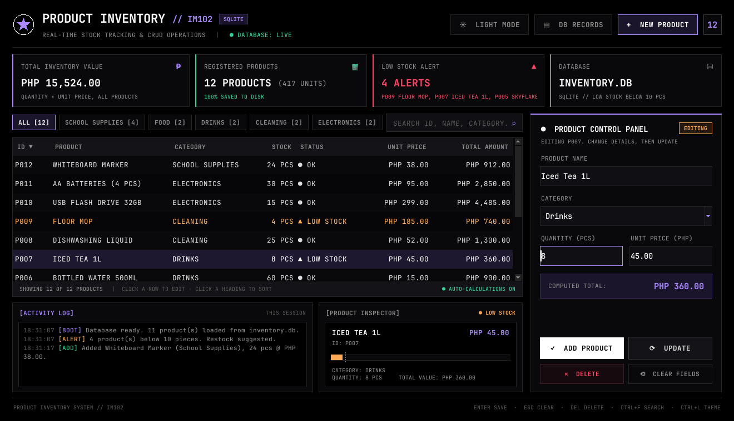
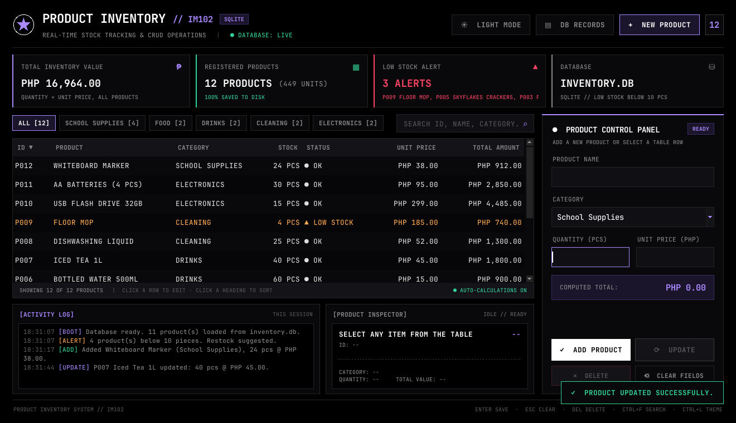
Explanation:
To update a product, the user clicks its row in the table. The details are loaded into the form, the label changes to EDITING, and the Update and Delete buttons are turned on. The Product Inspector also shows the product's details and a stock bar, where the red dotted line marks the low stock limit. In this example, the quantity of Iced Tea 1L was changed from 8 to 40. After clicking Update, the record was saved, its status changed from LOW STOCK to OK, and "Product updated successfully." appeared.
Delete Record
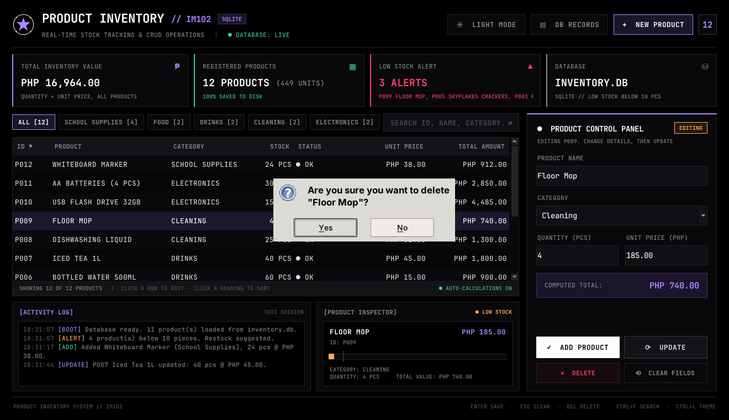
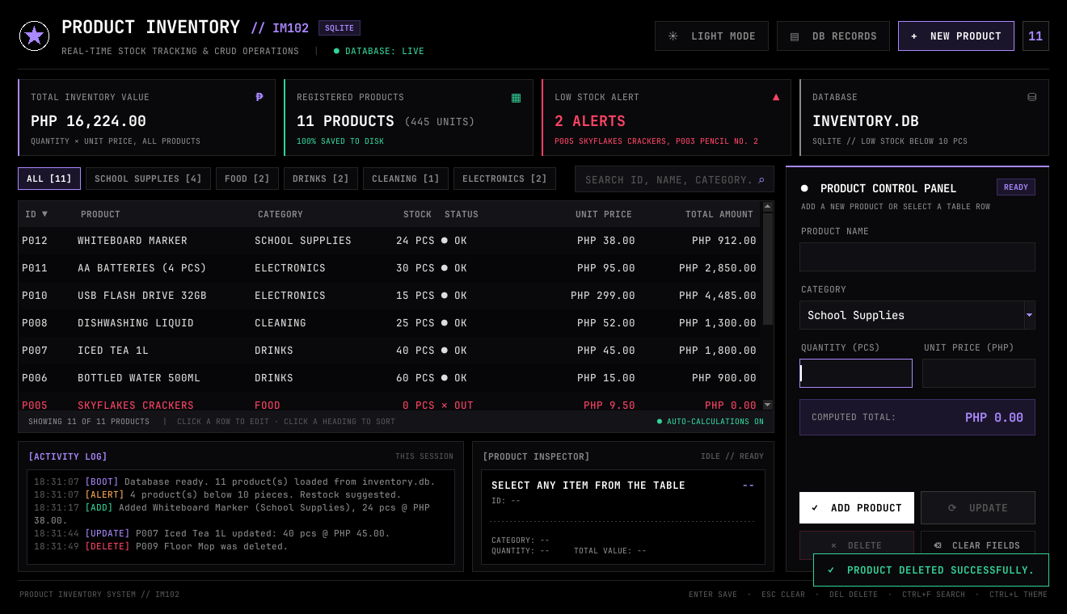
Explanation:
To delete a product, the user selects it in the table and clicks Delete or presses the Delete key. The system first asks if the user is sure. If Yes is clicked, the product is removed from the database, the table and totals are refreshed, and "Product deleted successfully." appears. If No is clicked, nothing is deleted. In this example, P009 Floor Mop was deleted, so the product count went from 12 to 11.
System Development Life Cycle (Waterfall Model, Agile, Spiral)
Agile is a way of building a system step by step, like a loop. The team works on one small part at a time, tests it, asks for feedback, and then makes it better. With Agile, it is easy for the team to make changes when there are new requests or suggestions. Because of this, the team does not waste time redoing big parts, and the system stays useful for the people who will use it.
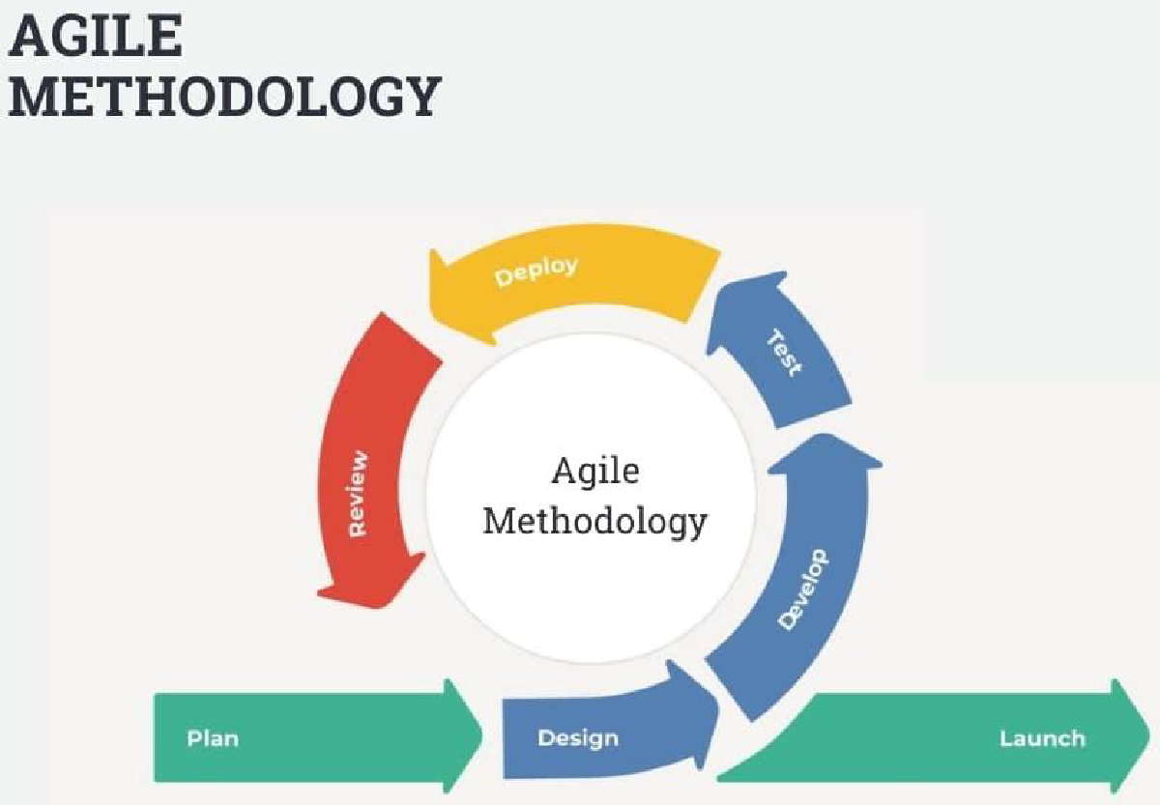

Agile Methodology
The group chose this method because the system was built in small parts, such as the product form, the product table, the database, and the design. Each part could be tested and improved on its own before everything was put together.

Planning/Plan
In this phase, the group talked about what the system needs to do and how inventory is usually recorded by hand. The group listed the main features: adding, viewing, searching, updating, and deleting products.
Design
In this phase, the group planned the layout of the main screen and the structure of the products table in the database.
Develop
The system was built one part at a time using Python, Tkinter, and SQLite. After each part was done, it was checked and improved. For example, the design was changed to a dark theme with a light mode option, and the pop-up messages for errors and success were changed to messages inside the window.
Testing
In this phase, the group tested the system using the test cases in the Testing Evidence part. This was to make sure every function works and that wrong input does not make the program crash.
Deploy
In this phase, the system can be used on any computer that has Python installed by running main.py. No extra packages are needed because Tkinter and SQLite already come with Python.
Review
In this last phase, the group checks if the objectives and features were met and lists what can still be improved.

Source Code:
The complete source code is saved on GitHub: https://github.com/krstnkye/crud-project-IM102
The program is made of four Python files:
- main.py – the main window and all the add, view, search, sort, update, and delete functions.
- database.py – makes the products table and runs the SQL commands that save, read, update, and delete records.
- database_viewer.py – the Database Records window that shows the rows saved in inventory.db.
- theme.py – the colors, fonts, and table style, and the code that switches between dark mode and light mode.

