HOSIS Housekeeping Subsystem Documentation

Overview of the Proposed Software
- Background and Objectives: The Housekeeping subsystem is an implemented module of the Hotel Operations and Services Integrated System (HOSIS). It manages room readiness, cleaning tasks, inspections, schedules, guest housekeeping requests, lost and found records, and maintenance issues reported by housekeeping staff. Its objective is to maintain accurate room-readiness records and support controlled information exchange with Front Office and Engineering.
The target users are active Housekeeping personnel with the HOUSEKEEPING role and a position of HOUSEKEEPER, INSPECTOR, or SUPERVISOR. An ADMIN account can also access protected functions. Other department accounts are denied at the Housekeeping login.
- Development & Hardware Platform:
  - OS and Platform Requirements: The subsystem is implemented as a browser-based application. It runs through a React and Vite frontend and does not require a dedicated Android, iOS, or desktop installation.
  - Hardware Specifications: Users can access the subsystem from a desktop computer, laptop, or tablet that can run a current browser and connect to the HOSIS server. The local development environment requires Node.js and PostgreSQL; production capacity requirements must be determined from the final hotel deployment size.
- Core Functions and Storage: Authorized users can monitor room status, create and assign cleaning tasks, record inspections, manage schedules, process guest requests, record and release found items, and report maintenance issues. The implemented PostgreSQL schema stores shared staff, room, and guest records and Housekeeping-owned records prefixed with hk_.
- Database & Environment: The project uses React and Vite for the web interface, Node.js with Express for the REST API, and PostgreSQL as the centralized HOSIS database. JWT authentication and role-based access control protect subsystem functions.
- Scope and Limitations: The implementation covers one hotel property and the Housekeeping workflow defined by HK-001 through HK-015. It excludes linen and cleaning-supply inventory, barcode or QR scanning, item photographs, electronic door-lock control, IoT room sensors, automated HVAC control, native mobile applications, and the internal interfaces of other HOSIS departments.

Description of the Software
- Detailed Purpose: The implemented subsystem reduces manual coordination by maintaining one source of truth for room condition, cleaning ownership, inspection decisions, staff schedules, guest service requests, lost and found custody, and maintenance follow-up.
The subsystem applies the implemented HOSIS permission model through JWT authentication, bcrypt password verification, backend role checks, and position-based restrictions for supervisor and inspector actions. Regulatory requirements outside the approved academic project scope are not claimed.
- System Architecture Overview: The module follows the HOSIS modular architecture, meaning Housekeeping operates as part of one integrated application rather than as an independent system. The general architecture is:
User Browser -> React and Vite Frontend -> Express REST API -> PostgreSQL HOSIS Database
The Housekeeping subsystem exposes integration points for other HOSIS modules. When Front Office checks a guest out, the room becomes DIRTY and Housekeeping receives a CHECKOUT cleaning task. An INSPECTED room creates a Front Office notification stating that the room is ready for release, which Front Office marks as read after releasing the room. A maintenance issue can set a room to OUT_OF_ORDER; Engineering views the request and marks it REPAIRED through its own endpoint, then Housekeeping closes the request, changes the room to DIRTY, and creates or reopens a high-priority cleaning task.
- Core Components:
  - Room Status Management - Displays all shared room statuses and their history. By hand, Housekeeping may only mark a room DIRTY (from AVAILABLE, OCCUPIED, CLEAN, or INSPECTED) or CLEAN (from DIRTY). CLEAN is also set when a cleaning task is completed, INSPECTED only by a passed inspection, and OUT_OF_ORDER only by a maintenance request. Front Office retains ownership of AVAILABLE, RESERVED, and OCCUPIED, and a room leaves OUT_OF_ORDER only through the maintenance-release workflow.
  - Cleaning Task Management — Allows supervisors to create or update cleaning tasks, assign a housekeeper, and track progress until cleaning is completed.
  - Inspection — Allows inspectors to record the result of an inspection; rooms that fail are returned for re-cleaning, and rooms that pass are marked INSPECTED.
  - Schedule Management — Maintains staff shifts, workloads, and assigned areas.
  - Guest Request Management — Records guest housekeeping requests, assigns staff to process them, and tracks completion.
  - Lost & Found Management — Records found items, stores and labels them, supports record search, and releases items when a valid claim is confirmed.
  - Maintenance Reporting — Allows housekeeping staff to report maintenance issues to Engineering and set the room OUT OF ORDER when needed; only Engineering can mark the repair REPAIRED.
  - User Interface and Access Control - Provides the Staff Login, Housekeeping Overview, Room Status, Cleaning Tasks, Inspection, Schedules, Lost and Found, Guest Requests, and Maintenance pages. Protected API requests require a valid JWT and the correct role or position.
The module does not currently specify barcode scanning, QR-code scanning, or optical capture mechanisms as required features. These should not be treated as existing functions unless they are approved as additional project requirements.

Features of the Software
Table 1.1: Room Operations Features
Feature Name | Core Functionality | UI Elements / Components | Translators & Outputs
Room Status (HK-001 – HK-003) | View shared room status and perform only Housekeeping-owned status transitions | Room list/grid, room selector, status dropdown, Save button | Updated room status; status-log entry; Front Office notice when inspection passes
Cleaning Tasks (HK-004 – HK-006) | Create/update tasks, assign a housekeeper, perform cleaning | Task form, housekeeper selector, task status controls | Cleaning task record with start and completion time
Room Inspection (HK-007) | Inspect a cleaned room and record pass or fail | Inspection form, result selector, remarks field | Inspection record; room marked INSPECTED, or returned for re-cleaning
Housekeeping Schedule (HK-008 – HK-009) | View and create/update staff shifts and workloads | Schedule table/calendar, shift form, area selector | Schedule entries per staff member and date
Table 1.2: Guest Service and Support Features
Feature Name | Core Functionality | Interface / Hardware Requirements | Operations & Processing
Guest Requests (HK-013 – HK-014) | Record, assign, process, and complete guest requests | Web form, request list, status controls; desktop, laptop, or tablet browser | Request validated and saved; staff assigned; completion time recorded
Lost & Found (HK-010 – HK-012) | Record found items, store/label, search records, release valid claims | Item form, search box, claim form; desktop or laptop browser | Item and claim records; claim validated before item is released
Maintenance Reporting (HK-015) | Report an issue to Engineering and set the room OUT OF ORDER | Maintenance request form with category, description, and priority | Maintenance request created; room status updated; cleaning task created after repair
Login & Access Control | Authenticate housekeeping staff and show only permitted functions | Login form, dashboard, role-based menu | Credentials verified; access denied if not authorized

Software Development Team & Methodology

Software Development Team Structure
- Figure 1.1 Housekeeping Subsystem Development Team Structure
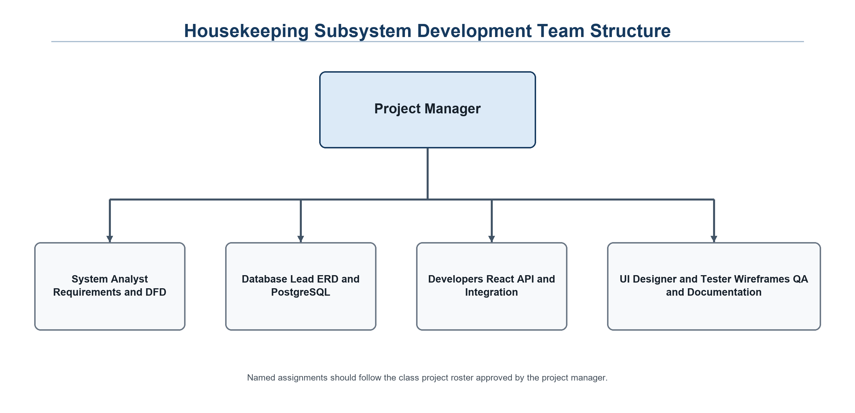

SDLC Model Selection
- Model Choice: Agile incremental development
- Rationale: Agile supported repeated review of shared room-status rules, database relationships, interface frames, API behavior, and integration contracts. The implementation was verified through automated workflow tests after each major feature group was completed.

Software Planning

Gantt Chart
- Figure 1.2 Housekeeping Subsystem Development Gantt Chart
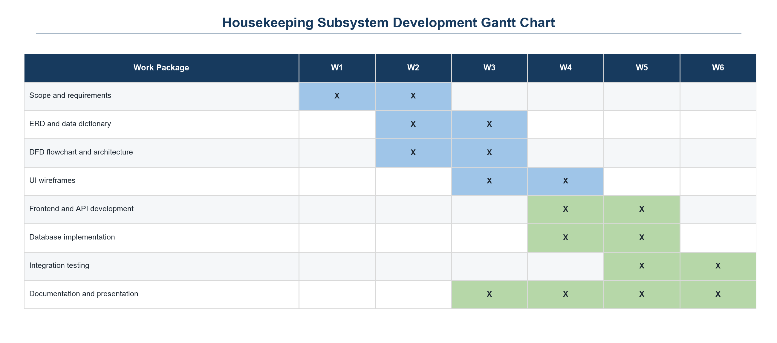

Development Timeline & Phases
- Week 1: Planning Phase (Scheduling, initial functional requirements analysis).
- Week 2: Actual Functional Analysis & Detailed Requirements Evaluation.
- Week 3: System Architecture & Design (Logical and physical design modeling, ERD, and flowcharts).
- Week 4: Program Development and Implementation - React pages, Express routes, PostgreSQL schema, authentication, and role restrictions.
- Week 5: Software Testing and Debugging - Automated API workflow tests, browser verification, database validation, and defect correction.
- Week 6: Final System Evaluation & Project Finalization.

Software Analysis
- Requirements Elicitation: Requirements were gathered from the HOSIS system documentation (System Scope, Users and Roles, Functional and Non-Functional Requirements) and from the Housekeeping Department flowchart. Each Housekeeping function was given a flowchart reference code (HK-001 to HK-015) to avoid scope ambiguity. These codes differ from the class HOSIS requirement codes (HK-001 to HK-011), so Table 1.4 maps one to the other.
- Documentation Strategy: Functional requirements are tracked against flowchart references, while non-functional requirements (security, usability, reliability, data integrity, maintainability, and performance) are tracked as categories with measurable criteria.
- Analysis Scope: The analysis defines what the Housekeeping module must do and the constraints it operates under (single hotel, web-based, integrated with Front Office and Engineering) rather than implementation details.

Specifications
- Software Specification: The Housekeeping subsystem is implemented with JavaScript and JSX, React 19, Vite 8, Node.js, Express 5, PostgreSQL 17, the pg database driver, bcrypt password hashing, and JSON Web Tokens. The interface is intended for current Chrome, Edge, or Firefox releases on Windows, macOS, or Linux.
- Hardware Specification:
  - Client Minimum Specifications: A desktop, laptop, or tablet capable of running a modern browser, with a stable network connection and sufficient memory for normal browser operation. No dedicated client installation is required.
  - Operational Metrics: The subsystem targets a response time of approximately three seconds for ordinary single-hotel operations. Functional correctness has been verified; formal load, concurrency, and production-scale performance tests remain part of final deployment validation.
  - Deployment Flow: PostgreSQL runs the shared hosis database on port 5432, the Express API runs on port 5000, and Vite serves the development frontend on port 5173 while forwarding /api requests to Express. Production deployment should use the class project's shared server, environment variables, and database instance.

Requirements Specifications

Functional Requirements
Table 1.3: Functional Requirements List
Requirement No. | Description
FR 1 | The system shall authenticate housekeeping staff at login and deny access to unauthorized users.
FR 2 | The system shall display a Housekeeping Dashboard and the functions available to the user’s role.
FR 3 | The system shall allow authorized users to view room status (HK-001) and select a room (HK-002).
FR 4 | The system shall display shared room statuses and allow only valid Housekeeping transitions. AVAILABLE, RESERVED, and OCCUPIED remain Front Office-owned; every Housekeeping status change is logged.
FR 5 | The system shall create a Front Office notification when a room passes inspection and becomes INSPECTED.
FR 6 | The system shall allow supervisors to create or update cleaning tasks (HK-004).
FR 7 | The system shall allow supervisors to assign a housekeeper to a cleaning task (HK-005).
FR 8 | The system shall allow housekeepers to perform cleaning and update task progress, including start and completion time (HK-006).
FR 9 | The system shall allow inspectors to inspect a cleaned room and record the result (HK-007).
FR 10 | The system shall return a room for re-cleaning when it fails inspection, and mark it INSPECTED when it passes.
FR 11 | The system shall allow authorized users to view staff schedules (HK-008) and create or update schedules, workloads, and shifts (HK-009).
FR 12 | The system shall allow staff to record found items (HK-010), store and label them, and search or view lost and found records (HK-011).
FR 13 | The system shall release an item and update its record only when a claim is confirmed valid (HK-012).
FR 14 | The system shall record guest requests (HK-013), assign and process them, and mark them complete (HK-014).
FR 15 | The system shall allow housekeeping staff to create a maintenance request for Engineering (HK-015) and, when needed, set the affected room OUT OF ORDER.
FR 16 | The system shall let Engineering mark the repair REPAIRED, then update the room status and create a cleaning task when Housekeeping releases the room.

Table 1.4: Requirement Code Mapping (Class HOSIS to Housekeeping Flowchart)
Class HOSIS Requirement | Housekeeping Flowchart Code and Implementation
HK-001 View rooms requiring cleaning | HK-001 View Room Status (Room Status page)
HK-002 Create housekeeping tasks | HK-004 Create or Update Task (Cleaning Tasks page)
HK-003 Assign cleaning tasks | HK-005 Assign Housekeeper
HK-004 View assigned cleaning tasks | HK-006 Perform Cleaning (own tasks and notifications)
HK-005 Update cleaning task status | HK-006 Perform Cleaning and Cleaning Completed?
HK-006 Update room cleaning status | HK-003 Update Room Status (logged)
HK-007 Inspect cleaned rooms | HK-007 Inspect Room (Inspection page)
HK-008 Record inspection results | HK-007 Inspection Passed?, Mark INSPECTED or Return for Re-cleaning
HK-009 Create lost and found records | HK-010 Record Found Item, Store and Label Item
HK-010 Update and track lost and found records | HK-011 Search or View Records and HK-012 Release Item
HK-011 View guest and room information | HK-002 Select Room (room details and guest names only)
System Scope 3.2 Housekeeping schedules | HK-008 View Staff Schedule and HK-009 Create or Update Schedule
System Scope 3.2 Housekeeping requests | HK-013 Record Request and HK-014 Complete Request
ENG-001 to ENG-003 and Section 9.4 | HK-015 Create Maintenance Request; Engineering updates the repair status
Section 9.1 Front Office to Housekeeping | Checkout sets the room DIRTY and creates a cleaning task

- Functional Workflow Summary: An active Housekeeping user logs in and receives a JWT. Supervisors create and assign tasks and schedules; assigned housekeepers start and complete cleaning; inspectors or supervisors record inspection results. A failed inspection returns the task and room for re-cleaning, while a passed inspection sets the room to INSPECTED and raises a Front Office notification. Staff can also process guest requests, found-item claims, and maintenance issues. Every protected action is validated by the backend and persisted in PostgreSQL.

Non-Functional Requirements
Table 1.5: Non-Functional Requirements List
Category | Metric / Specification
Speed | Standard pages and room status updates should respond within about 3 seconds under normal single-hotel workload.
Availability | The system should be available during hotel operating hours, including all housekeeping shifts, subject to scheduled maintenance and the deployment environment.
Capacity | The system should support the room inventory and daily task, request, inspection, and status-log volume of one hotel property.
Reliability | Room status and task data must remain consistent; every status change is logged and failed saves display a clear error.
Security | Credentials are verified at login; passwords are stored as hashes; functions are restricted by role.
Data Integrity | Records are linked by primary and foreign keys so tasks, inspections, claims, and logs always refer to valid rooms, staff, and guests.
Usability | Interfaces use clear labels, consistent navigation, and visible status values so that housekeeping staff can work with minimal training.
Maintainability | Frontend, backend, and database are kept in separate areas of the project to support future changes.

- Non-Functional Impact Summary: These requirements govern how fast, secure, and dependable the module feels to users without changing its primary business logic. Functional and security requirements are verified by the automated tests; the numeric speed and capacity targets will be measured during deployment validation.

Software Design

Logical & Physical Architecture
- Figure 1.3 Housekeeping Department Flowchart (Logical Diagram of System Workflow)
  - Narrative: The process begins when housekeeping staff log in. If not authorized, access is denied; otherwise the Housekeeping Dashboard opens. The user selects one of six functions — Manage Room Status, Manage Cleaning Tasks, Manage Housekeeping Schedules, Manage Lost & Found, Manage Guest Requests, or Report Maintenance Issue — and completes its steps. Decision points include Cleaning Completed?, Inspection Passed?, and Valid Claim?. The user then chooses Perform Another Task? to return to the dashboard or ends the session.
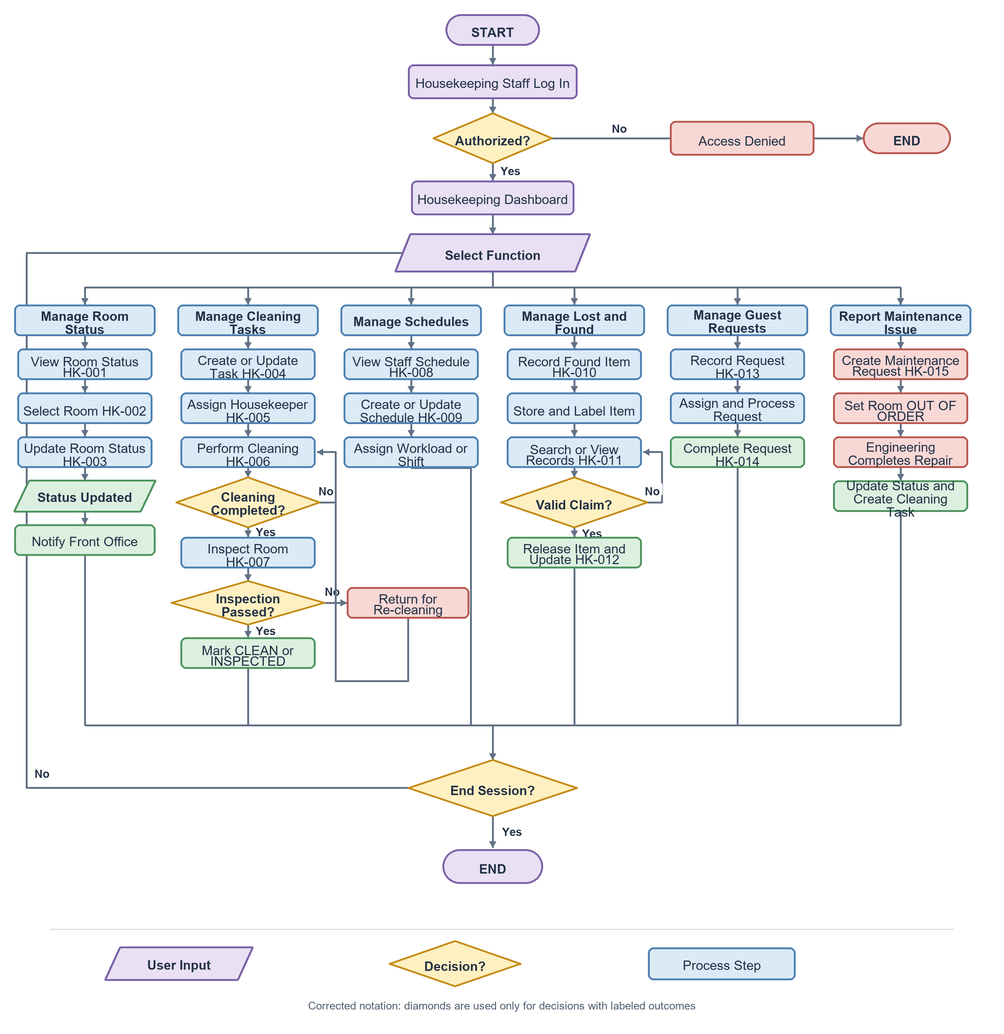
- Figure 1.4 HOSIS Housekeeping Physical Architecture
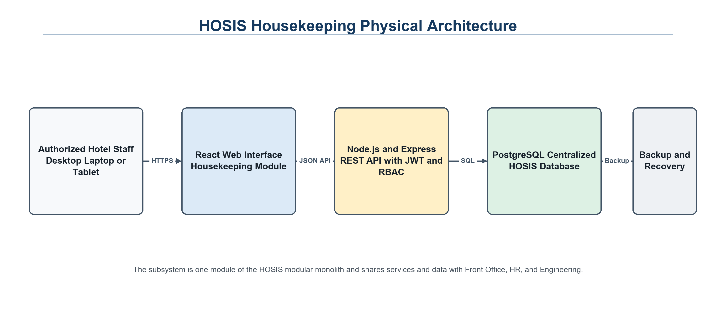
Housekeeping users access the React interface through a browser. The Node.js and Express API applies JWT authentication and role-based permissions before updating the centralized PostgreSQL database.
  - Narrative: Staff devices connect through the hotel network to the HOSIS web application. Browser requests reach the React interface and Node.js or Express REST API, which validates JWT credentials and role permissions before accessing PostgreSQL.

System Identity & Branding
- Figure 1.5 HOSIS Housekeeping System Identity
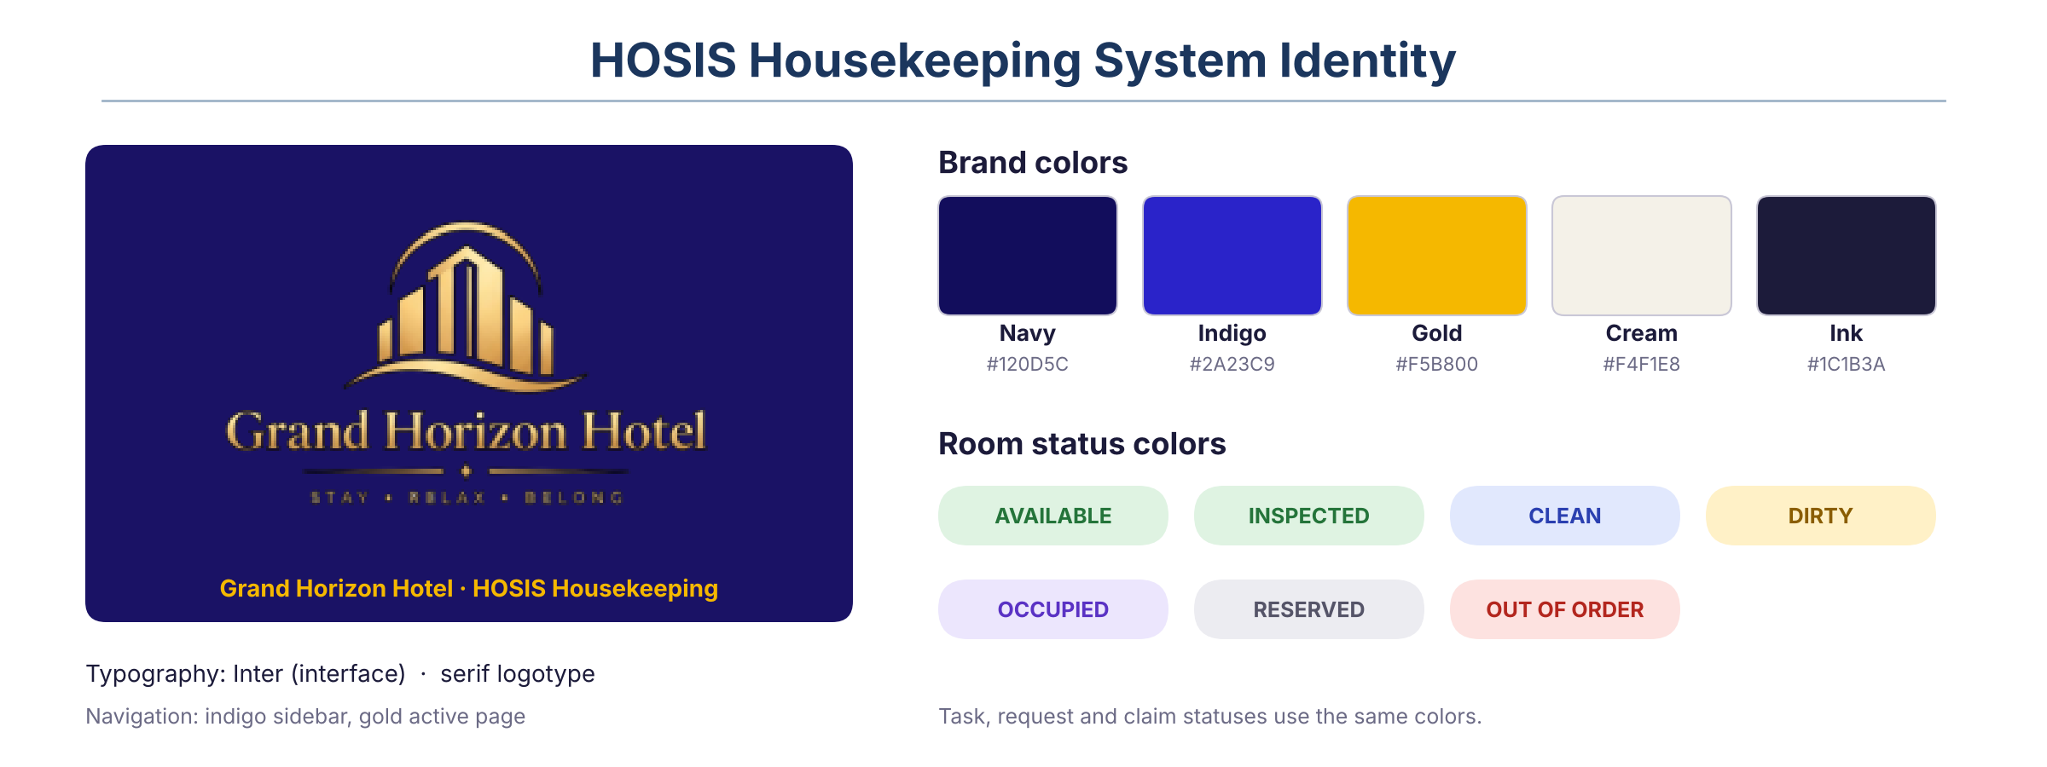
The subsystem uses the approved HOSIS name and the Grand Horizon Hotel logo. Housekeeping screens use the navy and indigo navigation with a gold indicator for the active page, the Inter typeface, and one set of status colors for rooms, tasks, requests, and claims.

User Interface Specifications

Implemented HOSIS Housekeeping User Interface
- Figure 1.6 Implemented HOSIS Housekeeping Interface Overview
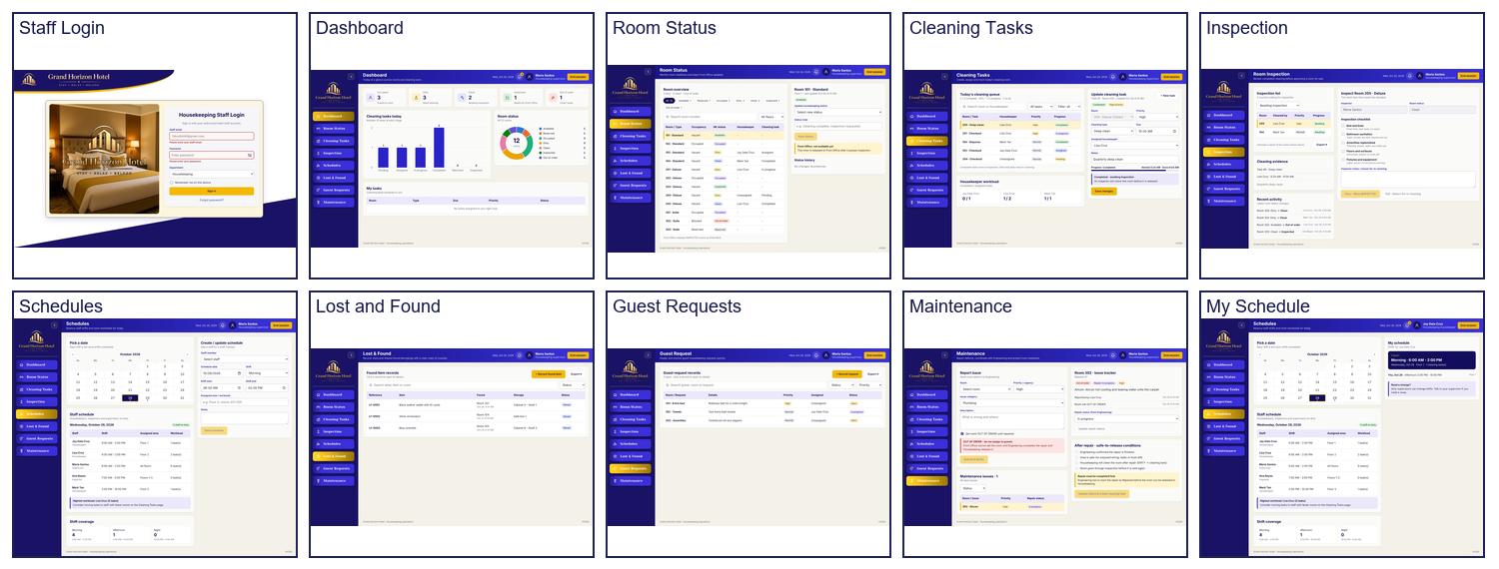
The following figures are captured from the implemented Housekeeping application with seeded development records. The React pages follow the supplied HOSIS UI HOUSEKEEPING UI Figma design while using live API data.
- Figure 1.7 Housekeeping Staff Login
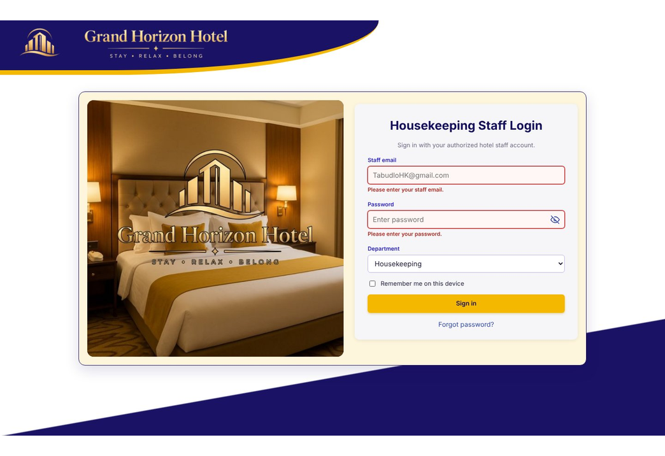
Login screen for authorized housekeeping staff using the Grand Horizon Hotel HOSIS interface.
- Figure 1.8 Housekeeping Dashboard
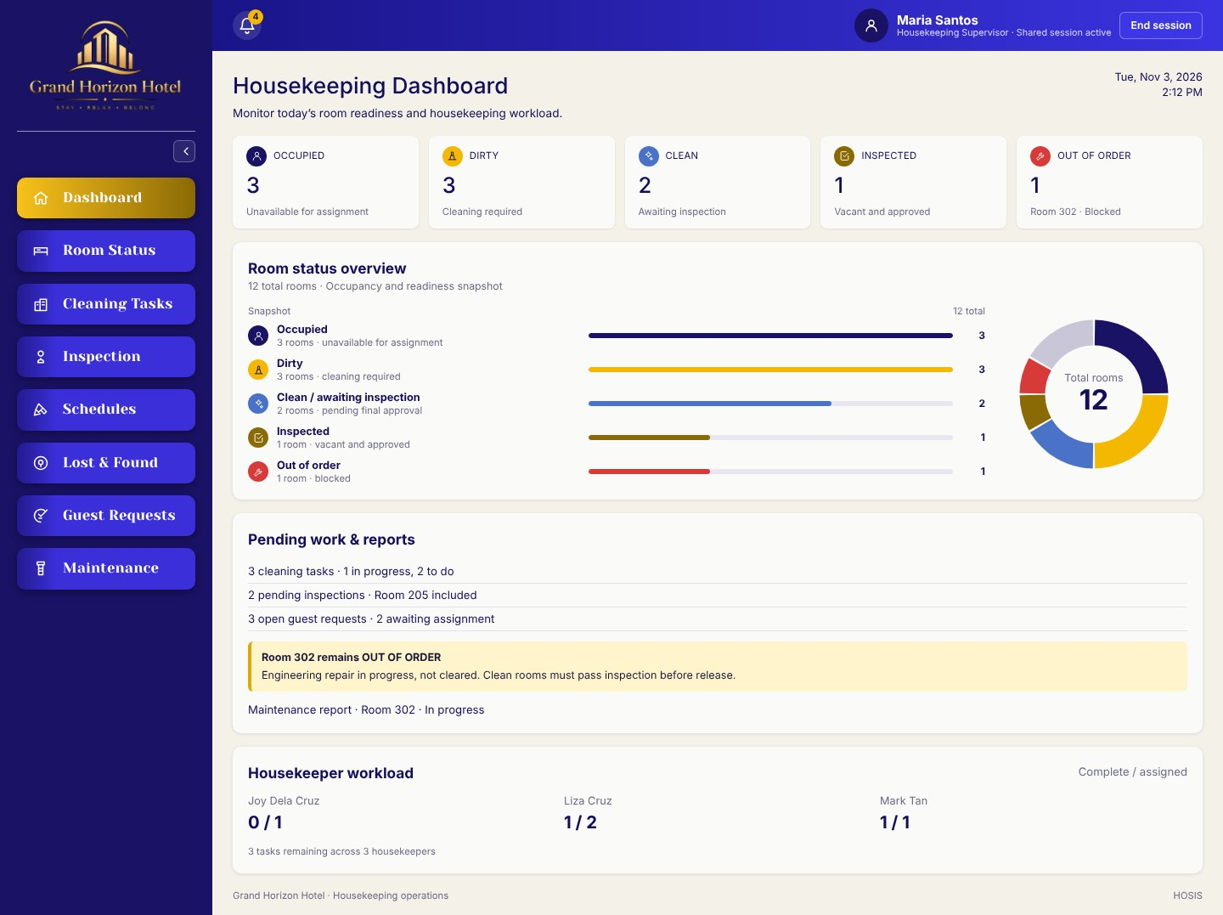
Dashboard with room status totals, the room status overview chart, pending work, and housekeeper workload.
- Figure 1.9 Room Status
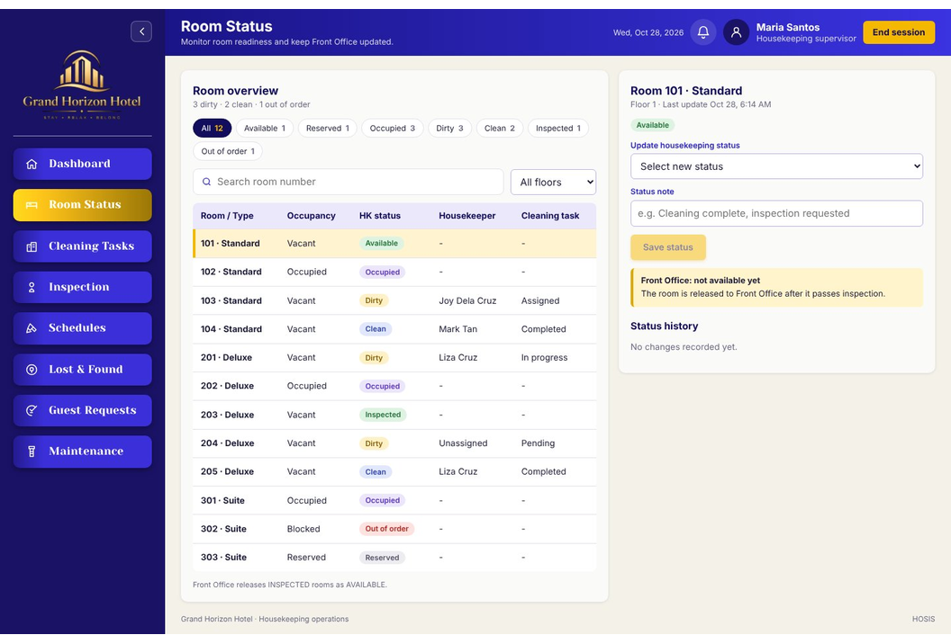
Room status workspace for reviewing room conditions, priorities, and operational notes.
- Figure 2.0 Cleaning Tasks
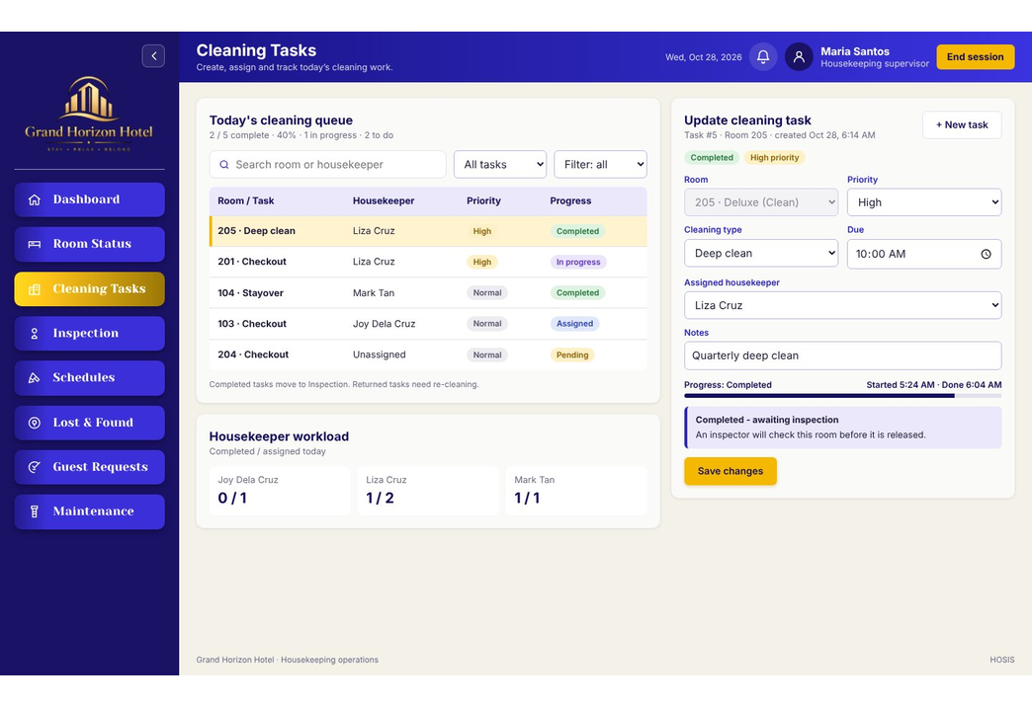
Cleaning task workspace for assignments, task details, updates, and attendant workload.
- UI Design Rationale: The implemented interface uses Grand Horizon Hotel branding, blue and purple navigation, a gold Housekeeping indicator, responsive work areas, status cards, compact tables, charts, calendar and date controls, a notification panel, and PDF or spreadsheet export controls where reports are available.

Supervisor and Inspector Interface
- Figure 2.1 Room Inspection
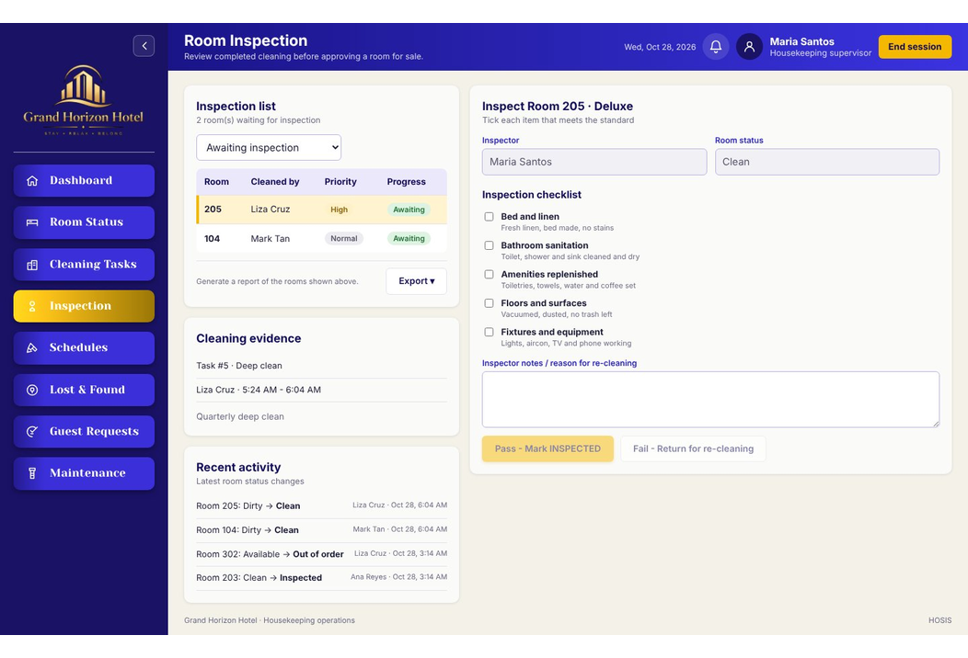
Inspection workspace for reviewing room readiness, checklist results, and follow-up action.
- Figure 2.2 Housekeeping Schedules
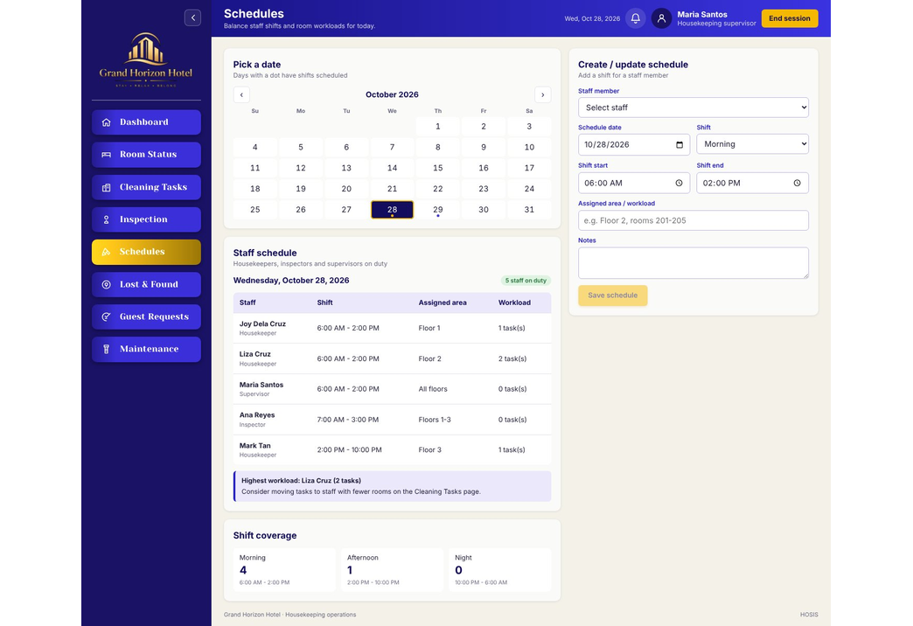
Scheduling workspace for shift assignments, coverage, staff availability, and workload planning.
- Figure 2.3 My Schedule
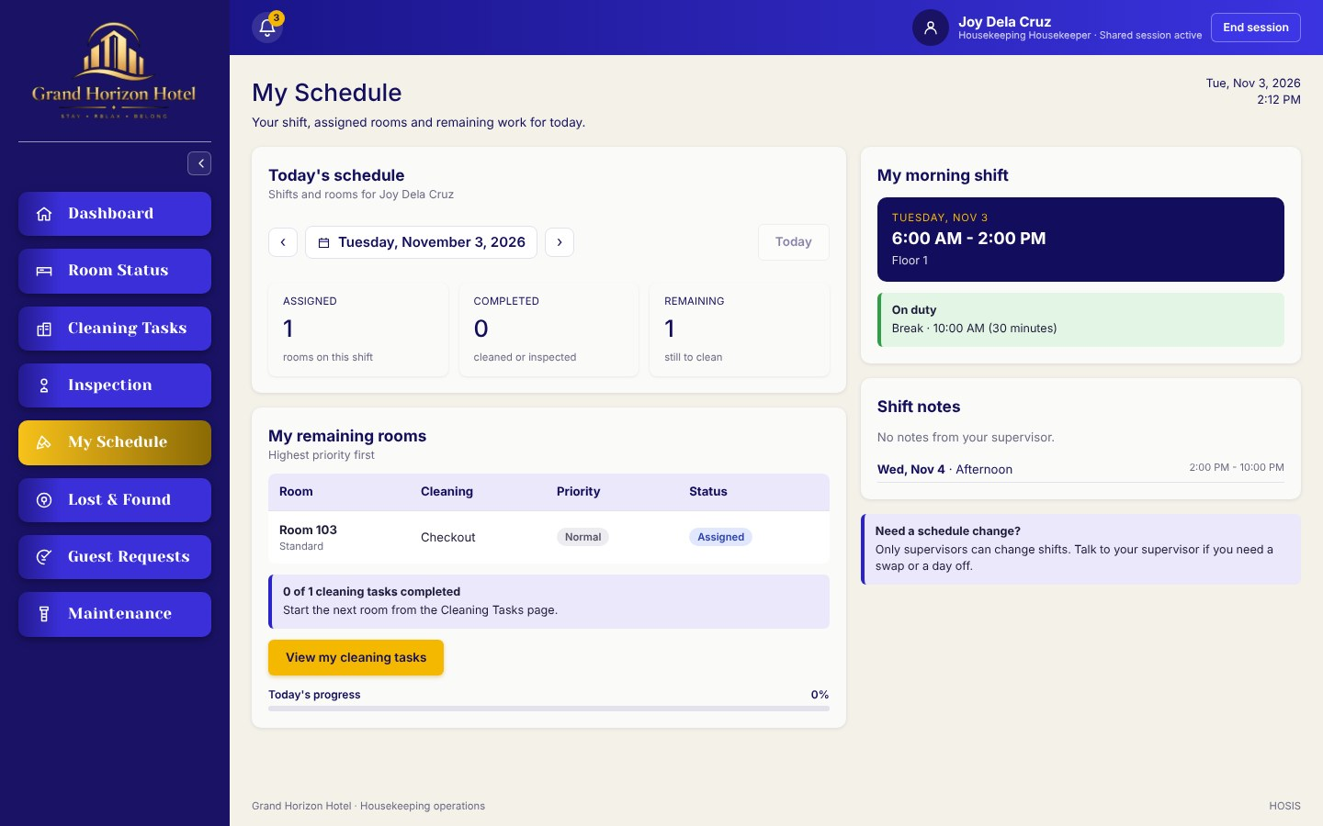
Personal schedule for housekeepers showing the shift, assigned rooms, remaining work, and upcoming shifts.
- Operational UI Rationale: Supervisors can coordinate schedules, assign work, inspect cleaned rooms, and monitor status changes through the same Housekeeping navigation structure.

Guest Service Lost and Found and Maintenance Interface
- Figure 2.4 Guest Requests
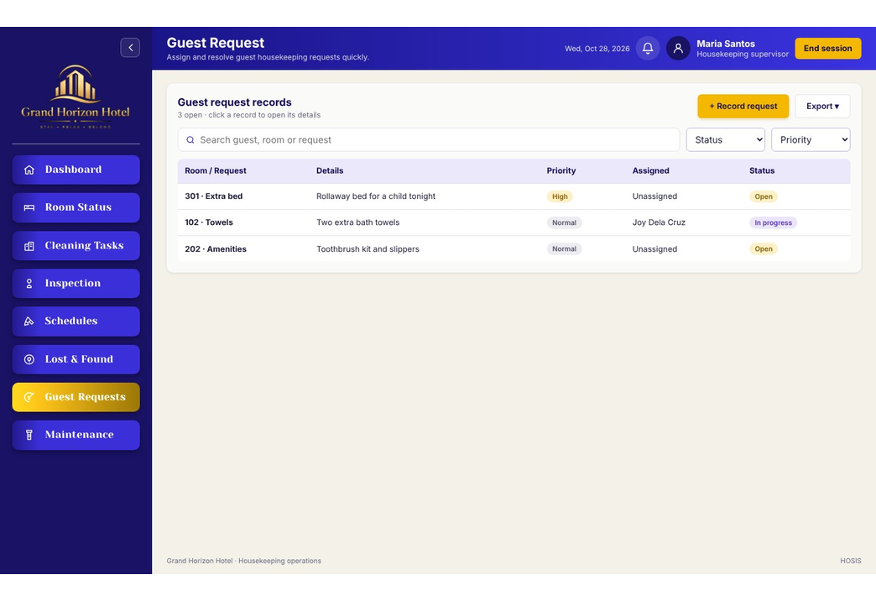
Guest request workspace for recording, assigning, tracking, and completing housekeeping service requests.
- Figure 2.5 Lost and Found
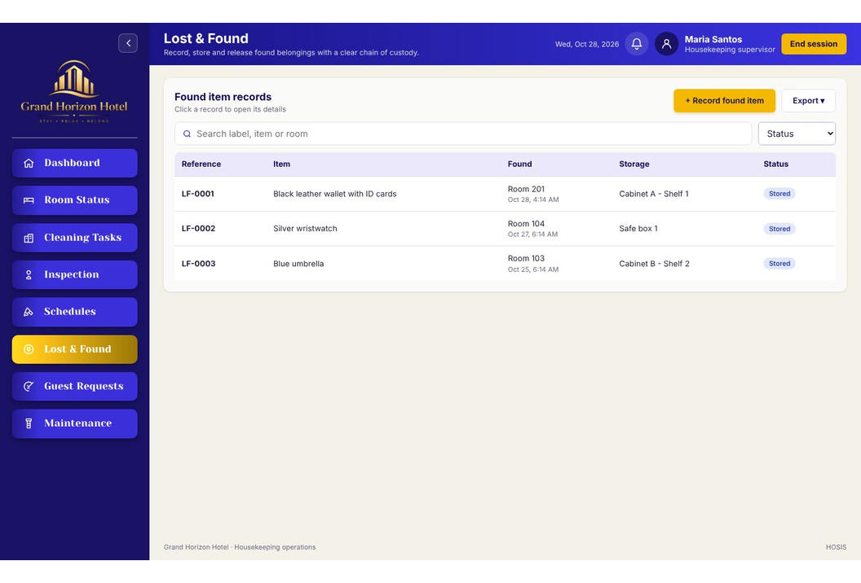
Lost and Found workspace for recording found items, storage details, claim status, and claimant verification.
- Figure 2.6 Maintenance Issues
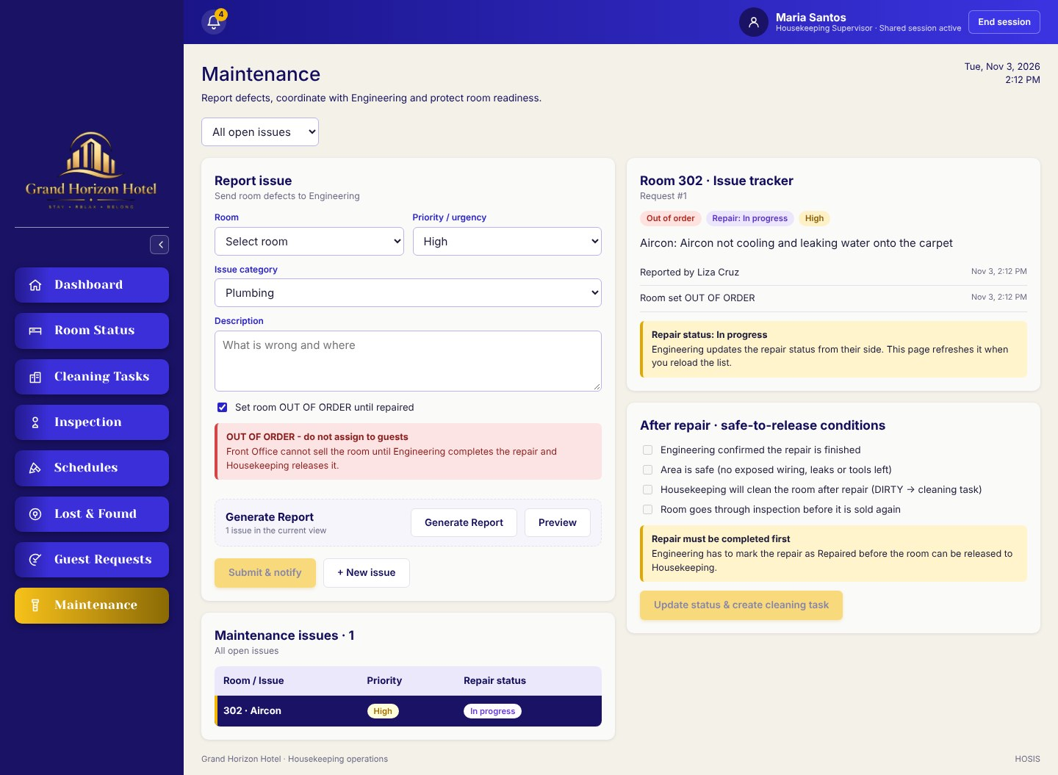
Maintenance issue workspace for reporting room defects, setting urgency, and monitoring repair follow-up.

Implementation Coverage

The implementation now contains ten Housekeeping views: Staff Login, Dashboard, Room Status, Cleaning Tasks, Room Inspection, Housekeeping Schedules, My Schedule, Lost and Found, Guest Requests, and Maintenance Issues. It also includes a notification panel, responsive or minimized navigation, modal forms, report exports, and role-based access-denied and end-session states.
- Interface Rationale: The implemented controls and descriptions remain within the Housekeeping scope and follow the group's approved Figma direction. Demonstration names, room numbers, dates, and status values come from seeded development data.

Flow Diagrams & Architecture Models

Role Activity Diagram
- Figure 2.7 Housekeeping Role Activity Diagram
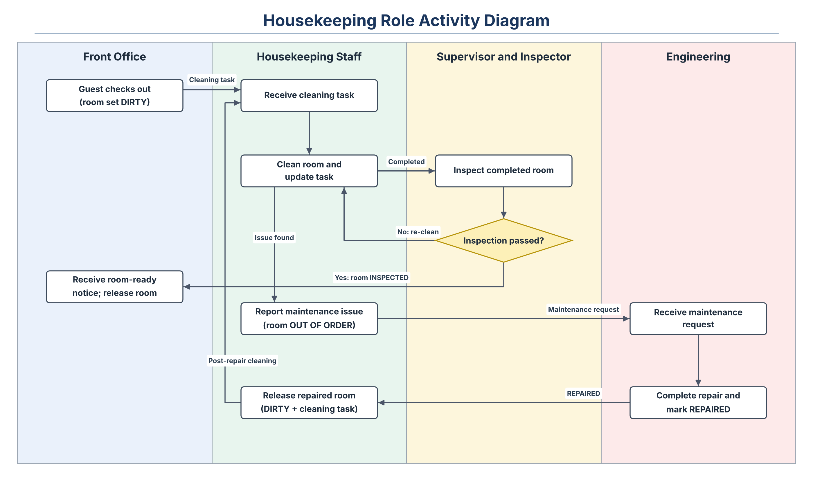
The diagram assigns checkout and room release to Front Office, cleaning work and maintenance reporting to Housekeeping, inspection decisions to the Supervisor or Inspector, and repairs to Engineering. A repaired room returns to Housekeeping for cleaning before it is inspected again.
- Narrative Breakdown: Housekeepers perform cleaning and report issues; supervisors assign tasks, inspect rooms, and manage schedules; Front Office checks guests out, which sets the room DIRTY and creates a cleaning task, and releases rooms after the room-ready notice; Engineering marks maintenance requests REPAIRED, after which Housekeeping releases the room for post-repair cleaning.

Technology Stack & Environment
- Frontend Framework: React with Vite
- Backend Runtime: Node.js
- Database Management System: PostgreSQL is the implemented centralized database. Housekeeping-owned tables use the hk_ prefix, while users, rooms, and guests are shared HOSIS tables. The supporting hk_front_office_notifications table records room-ready messages without changing the 11-entity conceptual ERD.

System Data Flow Diagrams (DFD) & Entity Relationship Diagrams (ERD)
- Figure 2.8 Housekeeping Login and Authorization DFD
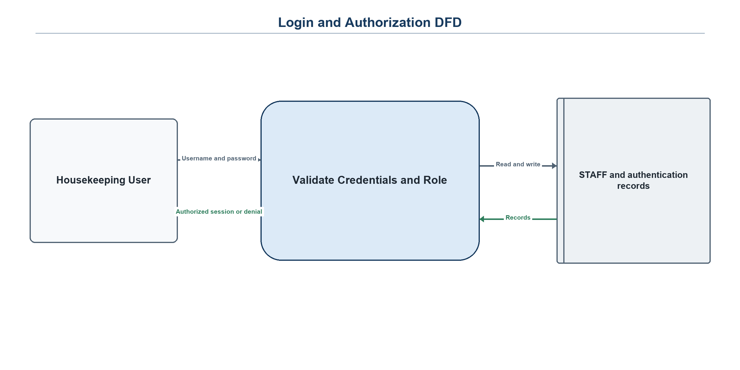
- Figure 2.9 Room Status and Cleaning Task DFD
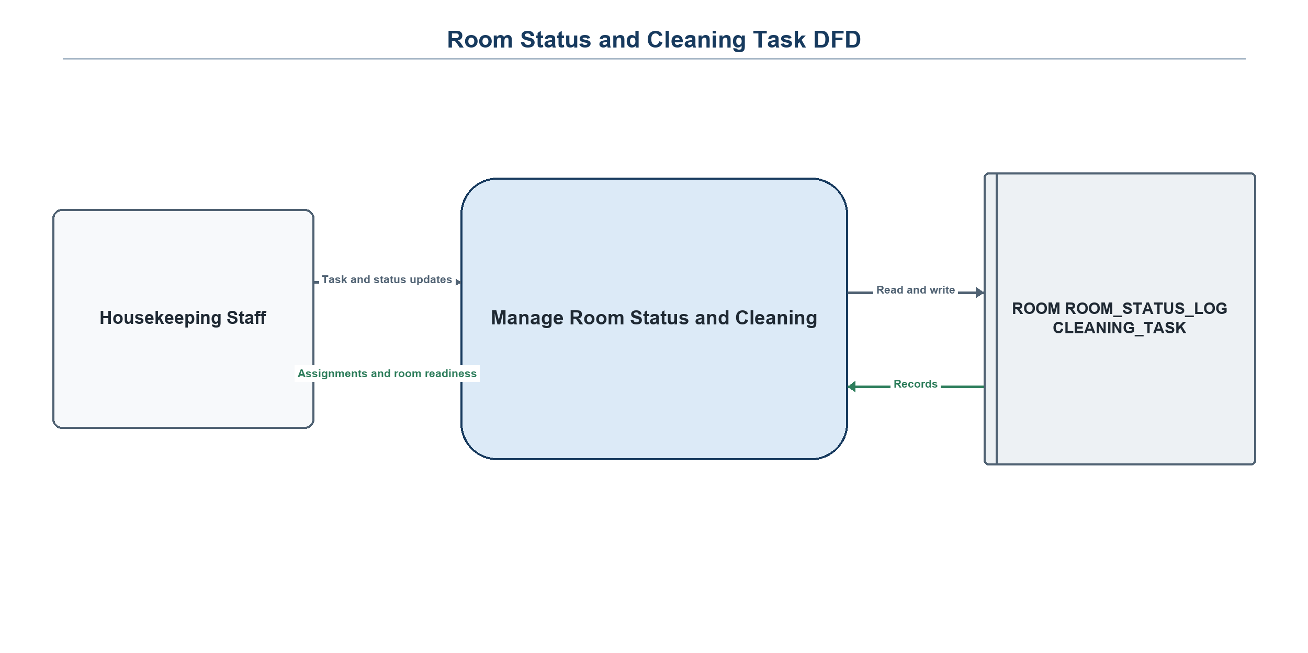
- Figure 3.0 Inspection and Re-cleaning DFD
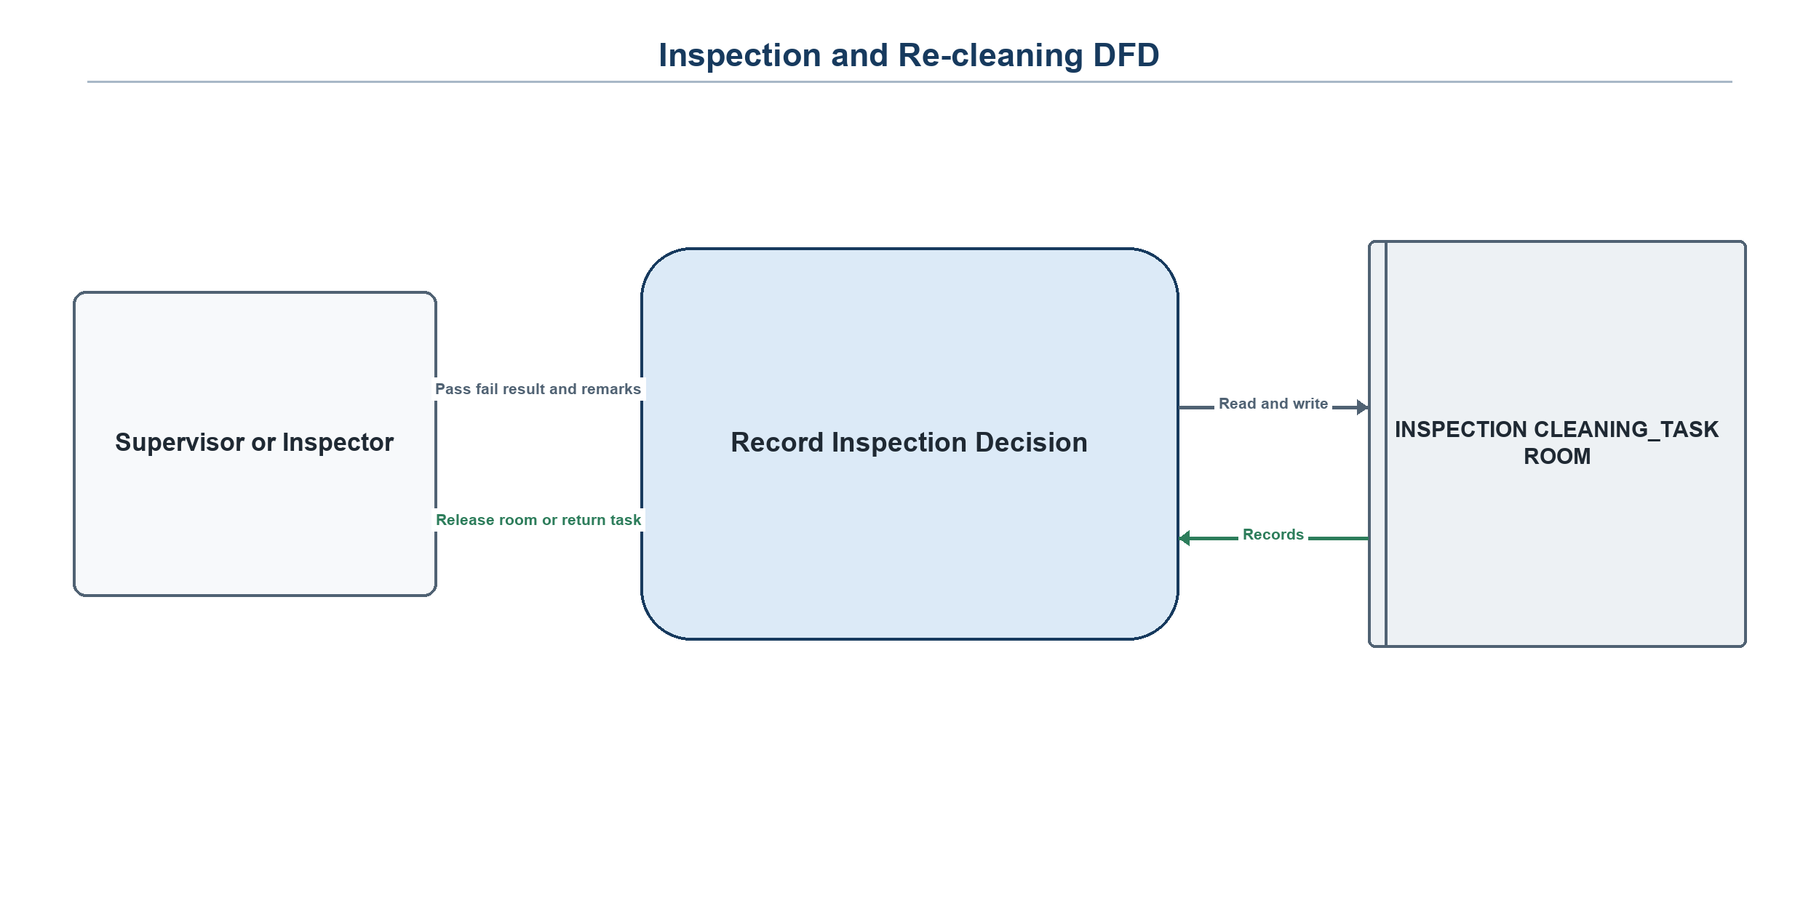
- Figure 3.1 Lost and Found and Guest Request DFD
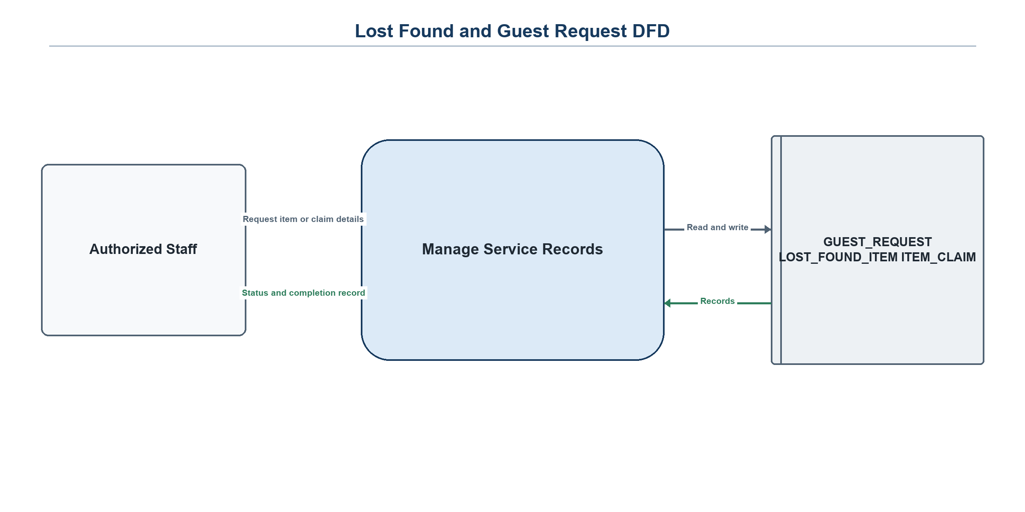
- Figure 3.2 Housekeeping Context Level DFD
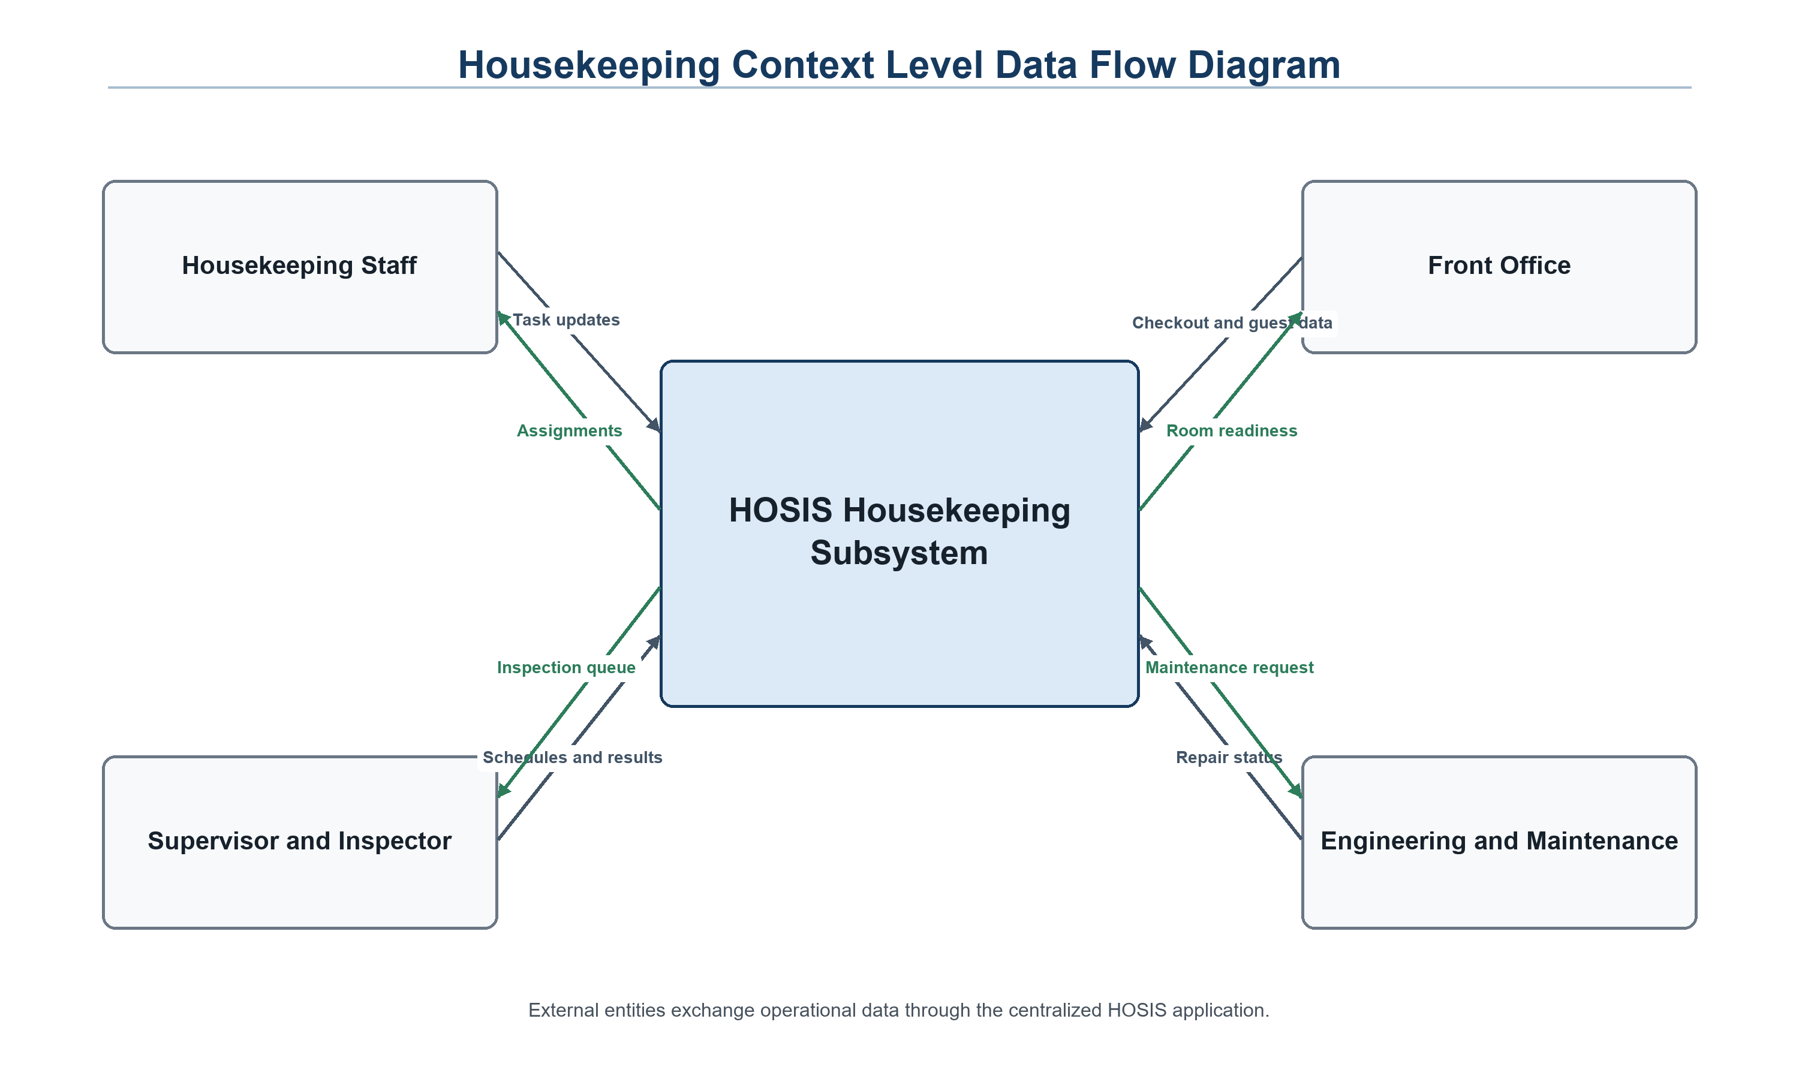
The context-level view shows only the exchanges needed by Housekeeping: staff authentication and work actions, checkout and room-ready notices with Front Office, and maintenance requests and repair status with Engineering. It does not document or claim the internal functions of those other subsystems.
- Figure 3.3 Housekeeping Entity Relationship Diagram (11 Entities)
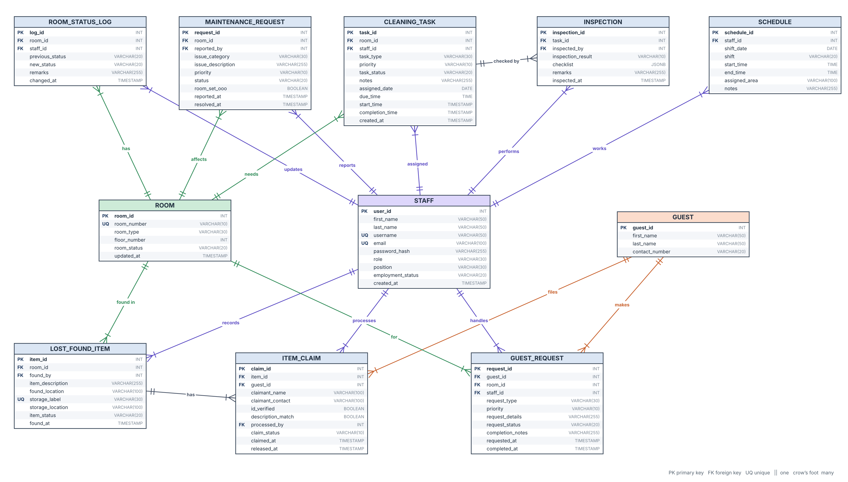
Notation: PK = primary key, FK = foreign key, UQ = unique. Each relationship is one-to-many (1:N), with the foreign key on the “many” side. There are no many-to-many relationships, so no junction tables are needed. Types follow the PostgreSQL schema.

Entities
Table 1.6: Entity Descriptions
Entity | Description
STAFF | Housekeeping personnel (housekeepers, inspectors, supervisors) who log in, perform cleaning, inspections, and updates.
ROOM | A shared hotel room and its current status: AVAILABLE, RESERVED, OCCUPIED, DIRTY, CLEAN, INSPECTED, or OUT_OF_ORDER.
ROOM_STATUS_LOG | History of every room status change, including who changed it and when.
CLEANING_TASK | A cleaning assignment for a room, given to a housekeeper, with progress and times.
INSPECTION | The result of an inspection of a cleaning task; a task may be inspected again after re-cleaning.
SCHEDULE | Shift and work area entries for staff members.
GUEST | A guest who makes housekeeping requests or item claims.
GUEST_REQUEST | A housekeeping request from a guest for a room, handled by a staff member.
LOST_FOUND_ITEM | An item found in a room, with storage label and status.
ITEM_CLAIM | A guest’s claim for a found item, processed by staff until released or rejected.
MAINTENANCE_REQUEST | An issue reported for a room that needs Engineering attention.

Data Dictionary
Table 1.7: STAFF
Attribute | Type | Key | Description
user_id | SERIAL | PK | Shared HOSIS user identifier; conceptual STAFF key
first_name | VARCHAR(50) |  | Staff first name
last_name | VARCHAR(50) |  | Staff last name
username | VARCHAR(50) | UQ | Unique login username
email | VARCHAR(100) | UQ | Login email address (unique, optional)
password_hash | VARCHAR(255) |  | bcrypt password hash
role | VARCHAR(30) |  | HOSIS department role
position | VARCHAR(30) |  | HOUSEKEEPER, INSPECTOR, or SUPERVISOR
employment_status | VARCHAR(20) |  | Account employment status
created_at | TIMESTAMP |  | Account creation time
Table 1.8: ROOM
Attribute | Type | Key | Description
room_id | SERIAL | PK | Shared room identifier
room_number | VARCHAR(10) | UQ | Unique room number
room_type | VARCHAR(30) |  | Room type
floor_number | INT |  | Floor number
room_status | VARCHAR(20) |  | Current shared room status
updated_at | TIMESTAMP |  | Most recent room update
Table 1.9: ROOM_STATUS_LOG
Attribute | Type | Key | Description
log_id | SERIAL | PK | Status-log identifier
room_id | INT | FK | References rooms.room_id
staff_id | INT | FK | References users.user_id
previous_status | VARCHAR(20) |  | Status before change
new_status | VARCHAR(20) |  | Status after change
remarks | VARCHAR(255) |  | Reason or workflow note
changed_at | TIMESTAMP |  | Date and time of change
Table 2.0: CLEANING_TASK
Attribute | Type | Key | Description
task_id | SERIAL | PK | Cleaning-task identifier
room_id | INT | FK | References rooms.room_id
staff_id | INT | FK | Assigned Housekeeping user
task_type | VARCHAR(30) |  | CHECKOUT, STAYOVER, DEEP_CLEAN, TOUCH_UP, or POST_REPAIR
priority | VARCHAR(10) |  | LOW, NORMAL, HIGH, or URGENT
task_status | VARCHAR(20) |  | PENDING through INSPECTED or RETURNED
notes | VARCHAR(255) |  | Task instructions
assigned_date | DATE |  | Work date
due_time | TIME |  | Target completion time
start_time | TIMESTAMP |  | Cleaning start time
completion_time | TIMESTAMP |  | Cleaning completion time
created_at | TIMESTAMP |  | Task creation time
Table 2.1: INSPECTION
Attribute | Type | Key | Description
inspection_id | SERIAL | PK | Inspection identifier
task_id | INT | FK | References hk_cleaning_tasks.task_id
inspected_by | INT | FK | Inspector or supervisor user
inspection_result | VARCHAR(10) |  | PASSED or FAILED
checklist | JSONB |  | Structured checklist results
remarks | VARCHAR(255) |  | Inspector remarks
inspected_at | TIMESTAMP |  | Inspection time
Table 2.2: SCHEDULE
Attribute | Type | Key | Description
schedule_id | SERIAL | PK | Schedule identifier
staff_id | INT | FK | References users.user_id
shift_date | DATE |  | Shift date
shift | VARCHAR(20) |  | MORNING, AFTERNOON, or NIGHT; one entry per staff member, date, and shift
start_time | TIME |  | Shift start
end_time | TIME |  | Shift end
assigned_area | VARCHAR(100) |  | Assigned floor or area
notes | VARCHAR(255) |  | Schedule notes
Table 2.3: GUEST
Attribute | Type | Key | Description
guest_id | SERIAL | PK | Shared guest identifier
first_name | VARCHAR(50) |  | Guest first name
last_name | VARCHAR(50) |  | Guest last name
contact_number | VARCHAR(20) |  | Guest contact number
Table 2.4: GUEST_REQUEST
Attribute | Type | Key | Description
request_id | SERIAL | PK | Guest-request identifier
guest_id | INT | FK | References guests.guest_id; optional
room_id | INT | FK | References rooms.room_id
staff_id | INT | FK | Assigned Housekeeping user
request_type | VARCHAR(30) |  | Request category
priority | VARCHAR(10) |  | LOW through URGENT
request_details | VARCHAR(255) |  | Requested service
request_status | VARCHAR(20) |  | OPEN, IN_PROGRESS, or COMPLETED
completion_notes | VARCHAR(255) |  | Completion record
requested_at | TIMESTAMP |  | Request time
completed_at | TIMESTAMP |  | Completion time
Table 2.5: LOST_FOUND_ITEM
Attribute | Type | Key | Description
item_id | SERIAL | PK | Found-item identifier
room_id | INT | FK | Room where item was found; optional
found_by | INT | FK | Housekeeping user who recorded the item
item_description | VARCHAR(255) |  | Item description
found_location | VARCHAR(100) |  | Where the item was found
storage_label | VARCHAR(30) | UQ | Generated LF storage label
storage_location | VARCHAR(100) |  | Physical storage location
item_status | VARCHAR(20) |  | STORED, RELEASED, or DISPOSED
found_at | TIMESTAMP |  | Date and time found
Table 2.6: ITEM_CLAIM
Attribute | Type | Key | Description
claim_id | SERIAL | PK | Claim identifier
item_id | INT | FK | References hk_lost_found_items.item_id
guest_id | INT | FK | References guests.guest_id; optional
claimant_name | VARCHAR(100) |  | Claimant name
claimant_contact | VARCHAR(100) |  | Claimant contact information
id_verified | BOOLEAN |  | Whether identity was verified
description_match | BOOLEAN |  | Whether description matched
processed_by | INT | FK | Housekeeping user processing claim
claim_status | VARCHAR(10) |  | VALID or REJECTED
claimed_at | TIMESTAMP |  | Claim processing time
released_at | TIMESTAMP |  | Item release time
Table 2.7: MAINTENANCE_REQUEST
Attribute | Type | Key | Description
request_id | SERIAL | PK | Maintenance-request identifier
room_id | INT | FK | References rooms.room_id
reported_by | INT | FK | Housekeeping user who reported issue
issue_category | VARCHAR(30) |  | Problem category
issue_description | VARCHAR(255) |  | Problem description
priority | VARCHAR(10) |  | LOW through URGENT
status | VARCHAR(20) |  | REPORTED, IN_PROGRESS, REPAIRED, or CLOSED
room_set_ooo | BOOLEAN |  | Whether room was set OUT_OF_ORDER
reported_at | TIMESTAMP |  | Report time
resolved_at | TIMESTAMP |  | Repair completion time
Supporting implementation table: hk_front_office_notifications stores room-ready messages with notification_id, room_id, message, created_by, created_at, and read_at (set when Front Office marks the notice as read). It supports integration but is not counted as a twelfth conceptual Housekeeping entity.

Relationships
Table 2.8: Entity Relationships (all 1 : N)
# | Relationship | Meaning | Foreign Key
1 | STAFF assigned CLEANING_TASK | A housekeeper is assigned many tasks; each task has one housekeeper | CLEANING_TASK.staff_id
2 | ROOM needs CLEANING_TASK | A room can have many cleaning tasks over time | CLEANING_TASK.room_id
3 | CLEANING_TASK checked_by INSPECTION | A task can be inspected more than once if returned for re-cleaning | INSPECTION.task_id
4 | STAFF performs INSPECTION | An inspector does many inspections | INSPECTION.inspected_by
5 | STAFF works SCHEDULE | A staff member has many schedule entries | SCHEDULE.staff_id
6 | ROOM has ROOM_STATUS_LOG | A room has many status changes recorded | ROOM_STATUS_LOG.room_id
7 | STAFF updates ROOM_STATUS_LOG | A staff member makes many status updates | ROOM_STATUS_LOG.staff_id
8 | GUEST makes GUEST_REQUEST | A guest can make many requests | GUEST_REQUEST.guest_id
9 | ROOM for GUEST_REQUEST | A room can have many guest requests | GUEST_REQUEST.room_id
10 | STAFF handles GUEST_REQUEST | A staff member processes many requests | GUEST_REQUEST.staff_id
11 | ROOM found_in LOST_FOUND_ITEM | Many items can be found in one room | LOST_FOUND_ITEM.room_id
12 | STAFF records LOST_FOUND_ITEM | A staff member records many found items | LOST_FOUND_ITEM.found_by
13 | LOST_FOUND_ITEM has ITEM_CLAIM | An item can have many claims (e.g., one rejected, then one valid) | ITEM_CLAIM.item_id
14 | GUEST files ITEM_CLAIM | A guest can file many claims | ITEM_CLAIM.guest_id
15 | STAFF processes ITEM_CLAIM | A staff member processes many claims | ITEM_CLAIM.processed_by
16 | ROOM affects MAINTENANCE_REQUEST | A room can have many maintenance requests | MAINTENANCE_REQUEST.room_id
17 | STAFF reports MAINTENANCE_REQUEST | A staff member reports many maintenance issues | MAINTENANCE_REQUEST.reported_by

Survey & Evaluation Tool

Questionnaire Template
- Target Respondent Groups: Housekeepers, supervisors or inspectors, Front Office staff, and authorized administrators who interact with room-readiness workflows.
- Evaluation Dimensions:
  - Accessibility: Website accessibility, ease of signing in and finding functions.
  - Information Collection: Form readability and input clarity.
  - Processing Performance: Speed of room status updates, task assignment, and record searches.
  - Workflow Accuracy: Correctness of room status, inspection, and claim handling.
  - Interface Design: UI clarity, button guidance, aesthetic appeal.
- Open Feedback: Recommendations and improvement suggestions section.

Software Testing & Quality Assurance

Test Plan
Table 2.9: Test Case Types
Category | Focus Area | Test Procedure
Functionality | Input limits and core feature execution | Validate required fields and the major workflows: room status update, task assignment, inspection, claim release.
Security Protection | Verification of user credentials and access layers | Test login authentication, credential verification, and role-based route guards.
Database | Data persistence and record accuracy | Input test records and verify database storage, retrieval, and foreign key links.
Usability | Interactive elements and link integrity | Audit interface links, buttons, and transitions across screens.
Performance | System stability under varying loads | Conduct multi-record entry and measure processing times.
Table 3.0: Test Deliverables
No. | Deliverable Name | Author | Reviewer / Approver
1 | Test Plan | Software Tester | Project Manager
2 | Functional Test Cases | Software Tester | Project Manager
3 | Defect Log | Software Tester | Lead Developer
4 | Periodic Status Reports | Software Tester | Project Manager
5 | Test Closure Report | Software Tester | Project Manager
Table 3.1: Severity Matrix
Severity Level | Classification | Impact Description
1 | Critical | System crash, data corruption, total unresponsiveness requiring reboot.
2 | High | Loss of critical function without an immediate system crash.
3 | Medium | Quality degradation; core task achievable via workaround.
4 | Low | Minor cosmetic issues or unclear non-blocking error messages.
5 | Pass / No Error | System behaves strictly as intended.
Table 3.2: Test Execution Matrix & Traceability
Test Condition | Identified Risk / Problem | Severity Level | Prevention / Resolution Plan | Expected Results & Remarks | Lead Role
Functionality - Login | Unauthorized user reaches the dashboard | 1 | Verify credential check and role guards | Unauthorized users see Access Denied | Tester
Functionality - Room Status | Status saved without a log entry | 2 | Test that every update writes to ROOM_STATUS_LOG | Status and log stay consistent | Tester
Functionality - Inspection | Failed room not returned for re-cleaning | 2 | Test fail path and pass path separately | Fail returns room to cleaning; pass marks INSPECTED | Tester
Functionality - Lost & Found | Item released without a valid claim | 2 | Validate claim status before release | Item released only for valid claims | Tester
Functionality - Inputs | Invalid character handling | 2 | Implement input validation rules and error alerts | Invalid input is rejected with a clear message | Tester
Security - Authentication | Malformed or unverified credentials | 4 | Add validation rules and password checks | Invalid attempts blocked with clear alert | Tester
Database - Record View | Data rendering errors | 3 | Validate DB responses and backend routes | Database accurately outputs UI records | Project Manager
Usability - Interface | Screen element overlap | 3 | Audit layout across screen sizes | Layout remains clear across screens | UI Designer
Performance - Platform | Browser or OS incompatibility | 2 | Execute tests across browsers and operating systems | Stable performance across targets | Project Manager

Test Data and Verified Implementation Results
- Verified Workflow 1 Authentication: Automated tests confirm that an incorrect password returns 401, a non-Housekeeping account returns 403, and an unauthenticated API request returns 401.
- Verified Workflow 2 Cleaning and Inspection: Automated tests cover supervisor task creation and assignment, assigned-housekeeper enforcement, duplicate-task prevention, cleaning completion, failed inspection, re-cleaning, passed inspection, status logs, and Front Office notification creation.
- Verified Workflow 3 Room Status: Automated tests confirm that Housekeeping can perform allowed status transitions, cannot set Front Office-owned statuses such as AVAILABLE, and cannot set INSPECTED or OUT_OF_ORDER by hand.
- Verified Workflows 4 through 6: Lost and found tests reject an invalid claim and release an item only for a valid claim; guest-request tests cover recording, assigning, processing, completion, and refusing staff from other departments; maintenance tests cover OUT_OF_ORDER, Engineering repair confirmation, release, and post-repair cleaning tasks.
- Verified Workflow 7 Scheduling: Automated tests confirm that only a supervisor can create schedules, invalid time ranges are rejected, and valid shifts appear in the selected date's coverage summary.
- Verified Workflow 8 Email Login and Notifications: Automated tests confirm login by email, the notification bell, recent activity, and My Schedule.
- Verified Workflow 9 Out-of-Order Protection: Automated tests confirm that an out-of-order room cannot be cleaned, completed, or inspected, that occupied rooms cannot be set out of order, and that the release reopens the open cleaning task.
- Verified Workflow 10 Front Office and Engineering Integration: Automated tests confirm checkout task creation, unread room-ready notices and marking them read, and that only Engineering can update repair status.
- Verified Workflow 11 Security Configuration: Automated tests confirm that repeated wrong passwords are locked out and that the server refuses a missing or example JWT secret.

Project Lifecycle Management

1. Planning and Design
- Problem identification: manual tracking of room status, cleaning, inspection, and lost and found records.
- System scope, users and roles, requirements, HOSIS flowchart, Housekeeping flowchart, and ERD were prepared.
- Visual hierarchy, typography, and status color-coding for quick reading of room readiness.

2. Software Construction
- Project folder structure with separate frontend, backend, database, and documentation areas.
- The React and Vite interface, Express API, PostgreSQL database, JWT authentication, role checks, and all Housekeeping pages have been implemented and run locally.
- The PostgreSQL schema implements the 11 conceptual entities, primary and foreign keys, status constraints, indexes, and a supporting Front Office notification table.

3. Monitoring and Controlling
- Scope validation and progress tracking against the HK-001 to HK-015 function list.
- Change control for schedule and requirement updates.
- Deliverable acceptance criteria verification.

4. Testing & QA Strategy
- Unit testing, manual end-user test scenarios, functional test suites, and User Acceptance Testing (UAT).

5. Maintenance Plan
- Corrective, adaptive, perfective, and preventive maintenance strategies after deployment.

Housekeeping Implementation Update

Current Implementation Status
Frontend: Ten functional Housekeeping views are implemented in React: Staff Login, Dashboard, Room Status, Cleaning Tasks, Inspection, Schedules, My Schedule, Lost and Found, Guest Requests, and Maintenance. The October 29 update added the revised Figma layout, charts, notifications, modal forms, date controls, export options, and responsive navigation.
Backend: Express exposes authenticated REST endpoints under /api/housekeeping, with transaction-based changes for room status, cleaning, inspection, claims, and maintenance release. Front Office uses the checkout and notification endpoints, and Engineering uses the incoming-maintenance and repair-status endpoints.
Database: PostgreSQL implements the 11 conceptual entities, five indexes, status constraints, and the supporting Front Office notification table. The shared users, rooms, and guests tables come from the class schema; a separate standalone file provides minimal versions for running the module on its own.
Security: bcrypt verifies passwords, JWT tokens expire after eight hours by default, repeated failed logins are locked out for 15 minutes, the server refuses to start without a private JWT secret, CORS is limited to the HOSIS frontend, and middleware enforces the HOUSEKEEPING role plus SUPERVISOR or INSPECTOR position requirements.

Latest Repository Update
Integration update (November 3, 2026, pull request #1 on the standalone repository): out-of-order protection, Engineering and Front Office endpoints, app-shell login support, security hardening, and a re-runnable seed. It builds on main revision f8d30c9, Update the Housekeeping UI to the new Figma screens.
Lost and Found correction: releasing a verified item now refreshes the selected record and list status immediately.
Frontend additions: Dashboard charts, notification panel, responsive menu, modal forms, calendar and date controls, report exports, and My Schedule.
Clock status: the latest main branch displays a live date and time without seconds. The separate live-header-clock branch adds seconds but conflicts with the newer layout and must be reapplied manually rather than merged directly.

Integration Readiness
The standalone module is prepared for controlled integration but is not a direct one-click merge. Its frontend lint and production build pass, and the backend tests pass on a freshly seeded database. The combined HOSIS repository still needs the Housekeeping frontend module, backend router, SQL schema, shared authentication, and finalized users, rooms, and guests tables, and the project manager must confirm the ownership decisions listed in the integration guide.

Verified Test Results
Fifteen automated API tests passed on November 3, 2026 for authentication, cleaning and inspection, room-status control, lost and found, guest requests, maintenance, scheduling, email login and notifications, out-of-order protection, Front Office and Engineering integration, and security configuration. The tests also pass when repeated on the same database. The frontend passed ESLint and a production Vite build on the same date.

Housekeeping Scope Boundary
This documentation covers the Housekeeping subsystem only. Front Office and Engineering appear only as external integration actors. The interfaces, databases, and internal processes of the other HOSIS subsystems (Front Office and Guest Services, Human Resources, Finance and Accounting, Sales and Marketing, and Engineering and Maintenance) are outside this document.

Results, Conclusions, & Recommendations

Results and Discussion
- Functionality Review: The standalone subsystem provides working pages and REST endpoints for room status, cleaning tasks, inspections, schedules, personal schedules, lost and found, guest requests, maintenance reporting, dashboard summaries, and Housekeeping notifications. The latest frontend passes lint and production build verification.
- Security Review: Login uses bcrypt password verification and signed JWTs, with a lockout after repeated failures. All Housekeeping routes require authentication; role and position guards restrict task management, schedule management, and inspection actions, and only Engineering can update repair status.
- Performance and Data Review: Database transactions protect multi-step room, task, claim, and maintenance changes. Foreign keys, checks, unique constraints, and indexes support integrity. Formal load and production concurrency testing are still required before deployment.

Summary
- The implemented Housekeeping subsystem covers room status, cleaning tasks, inspections, schedules, guest requests, lost and found, and maintenance reporting through a React interface, Express API, PostgreSQL schema, and role-based authentication.

Conclusion
- Conclusion: The Housekeeping subsystem is operational as a standalone development module and is organized for controlled integration through isolated Housekeeping paths. It has not yet been merged into the combined HOSIS main branch. Class-wide readiness depends on the project manager connecting the shared application shell, authentication, and user and room tables, and on Front Office and Engineering calling the integration endpoints, then rerunning the complete backend tests.

Recommendations
- Load and concurrency testing with the full hotel room inventory before deployment.
- Feature expansion, such as linen and supply inventory, password change and reset, and real-time notifications.
- UI/UX refinements and themes.
- Latency optimization for large datasets.
- Automated system maintenance and logging features.
- Broader device compatibility, including a future mobile app for housekeepers.

User Manual Appendix

Housekeeping Staff User Manual
- Step 1: Log In. Open the HOSIS URL and enter an active Housekeeping account. For local demonstration, use hk.supervisor (or maria.santos@grandhorizon.ph) for the supervisor account, or hk.inspector, hk.liza, hk.joy, and hk.mark for the other sample roles. The sample password is password123 and must be changed before a real deployment.
- Step 2: Open the Housekeeping Dashboard and select a function.
- Step 3: View Room Status (see which rooms are DIRTY, CLEAN, INSPECTED, OCCUPIED, or OUT OF ORDER).
- Step 4: Perform Assigned Cleaning (open your cleaning task, start it, and mark it complete).
- Step 5: Record Found Items or Guest Requests (fill in the form and save).
- Step 6: Report a Maintenance Issue (select the room, describe the problem, tick Set OUT OF ORDER if the room cannot be sold, and submit).
- Step 7: Choose another task or log out.

Supervisor / Inspector User Manual
- Step 1: Log In and open the Housekeeping Dashboard.
- Step 2: Create or Update Cleaning Tasks (choose the room and task type).
- Step 3: Assign a Housekeeper to each task.
- Step 4: Inspect Completed Rooms (record Pass or Fail with remarks).
- Step 5: Handle Inspection Results (failed rooms return for re-cleaning; passed rooms are marked INSPECTED and Front Office is notified).
- Step 6: Manage schedules and valid Lost & Found claims.
- Step 7: Release Repaired Rooms (after Engineering marks a maintenance request REPAIRED, complete the safe-to-release checks and release the room; it becomes DIRTY with a high-priority cleaning task).
- Step 8: Assign and Complete Guest Requests from the Guest Requests page.

Deployment and Integration Appendix

Standalone Development Requirements
Node.js and npm compatible with the project lock files.
PostgreSQL 17 with the database server and command-line tools installed.
Git and a current Chrome, Edge, or Firefox browser.
Access to the standalone repository at https://github.com/krstnkye/hosis-housekeeping.git.

Standalone Installation Procedure
Step 1: Clone the repository and switch to main (after pull request #1 is merged) so the latest interface and integration fixes are used.
Step 2: Create a PostgreSQL database named hosis.
Step 3: Load database/standalone/00-shared-tables.sql, then database/schema/06-housekeeping.sql, then database/seed/06-housekeeping-seed.sql. The seed resets all Housekeeping demo data each time it runs.
Step 4: Copy backend/.env.example to backend/.env and set DATABASE_URL, a JWT_SECRET of at least 16 characters, PORT, JWT_EXPIRES_IN, CORS_ORIGIN, and DB_TIME_ZONE.
Step 5: Run npm install and npm run dev in backend. The default API address is http://localhost:5000.
Step 6: Run npm install and npm run dev in frontend. The default interface address is http://localhost:5173.
Step 7: Sign in using a seeded Housekeeping account and verify each page against the workflow checklist. To demonstrate a repair before the Engineering module exists, run npm run engineering -- <request id> REPAIRED in backend.

Environment Variables
Table 3.3: Environment Variables
Variable | Development Example | Purpose
PORT | 5000 | Express API port
DATABASE_URL | postgres://postgres:<password>@localhost:5432/hosis | PostgreSQL connection
JWT_SECRET | A private secret of at least 16 characters | Signs authentication tokens
JWT_EXPIRES_IN | 8h | Token lifetime
CORS_ORIGIN | http://localhost:5173 | Browser origins allowed to call the API
DB_TIME_ZONE | Asia/Manila | Hotel time zone for "today" in queries

Housekeeping Integration Checklist
1. Copy frontend/src/modules/housekeeping into the combined frontend without replacing other subsystem modules.
2. Render HousekeepingApp in the class-wide application shell with the shell’s session and onLogout, so users sign in once, and preserve shared navigation ownership.
3. Copy backend/src/modules/housekeeping and mount it at /api/housekeeping in the shared Express application.
4. Reuse one global CORS configuration, JSON parser, error handler, server listener, and PostgreSQL connection pool.
5. Load database/schema/06-housekeeping.sql after the shared users, guests, and rooms schemas. Do not load database/standalone/00-shared-tables.sql in the combined database, and use the seed file only for development and demonstration data because it resets all hk_ tables.
6. Preserve the hk_ table prefix and /api/housekeeping route prefix to prevent collisions with other departments.
7. Install jspdf, jspdf-autotable, and write-excel-file in the combined frontend for report exports.
8. Confirm that the shared JWT supplies userId, name, role, and position and that Housekeeping role checks still deny other departments.
9. Run frontend lint and production build, then run the backend workflow tests against a freshly seeded test database.
10. Perform a joint acceptance test with Front Office for checkout tasks and room-ready notifications, and with Engineering for incoming requests, REPAIRED status, and repaired-room release.

Current Integration Decision
All ongoing Housekeeping development remains in the standalone repository until the project manager approves a feature branch for the combined HOSIS repository. Housekeeping files should be integrated through a branch and reviewed before they are merged into the combined main branch.

