Assignment 2

Title:- Implement SQL/DDL statement which demonstrate the use of SQL objects such as Table, View , Index , Sequence, different constraints etc with suitable examples.

Problem Statement:-

1. **Create Tables Employee:-**

CREATE TABLE employee ( ID INTEGER PRIMARY KEY,

Person_name VARCHAR(50), street VARCHAR(50),

city VARCHAR(50)

);

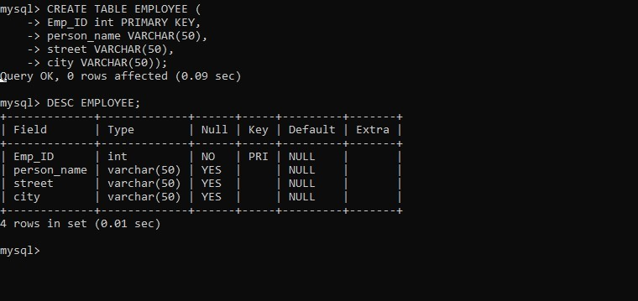

1. **Create Tables Works:-**

CREATE TABLE works (

ID INTEGER PRIMARY KEY,

company_name VARCHAR(50)

);

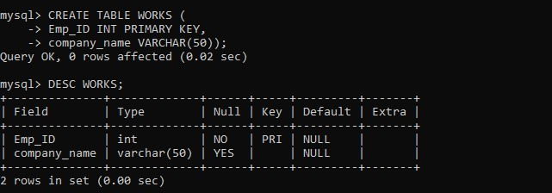

1. **Create Tables Company:-**

CREATE TABLE company (

company_name VARCHAR(50) PRIMARY KEY, city VARCHAR(50)

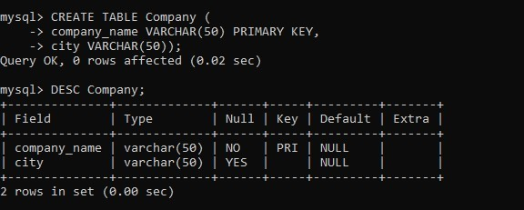);

1. **Create Tables manages:-**

CREATE TABLE manages (

ID INTEGER PRIMARY KEY,

manager_id INTEGER

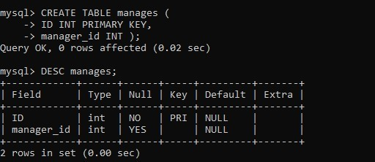);

1. **Add Columns(Salary: int in Work Table)**

ALTER TABLE WORKS

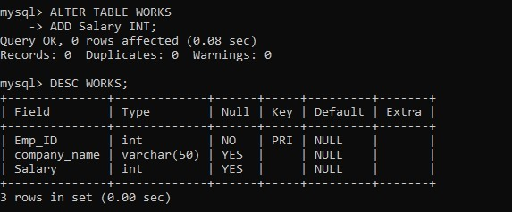ADD salary INT;

1. **Modify the type of city column in employee to string**

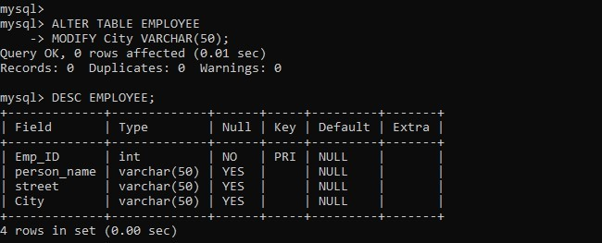ALTER TABLE employee MODIFY city VARCHAR(50);

1. **Delete column street from employee table**

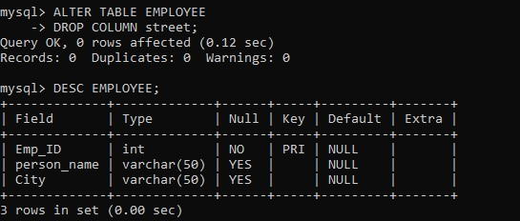ALTER TABLE employee DROP COLUMN street;

1. **Change the name of the column 'manager_id' to 'manager' in manages table**

ALTER TABLE manages

RENAME COLUMN manager_id TO manager;

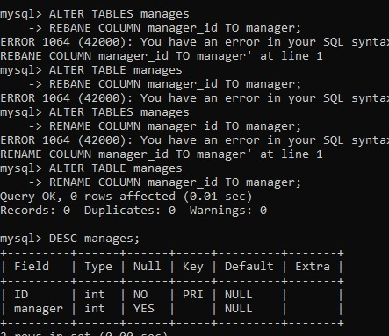

1. **Rename table 'company' to 'CMP'**

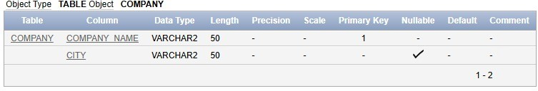ALTER TABLE company RENAME TO CMP;

1. **Drop table 'manages'**

DROP TABLE manages;

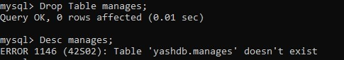

1. **Create a sequence to generate employee numbers for empno**

CREATE SEQUENCE emp_seq START WITH 1

INCREMENT BY 1 NOCACHE NOCYCLE;

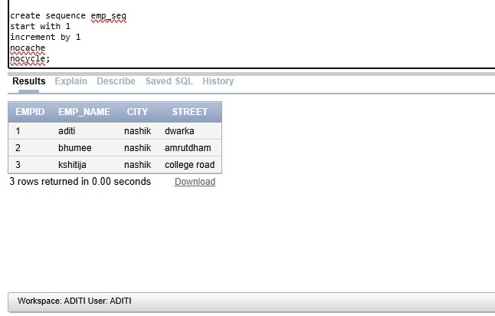

1. **Create an index on county column in employee table**

CREATE INDEX idx_county ON employee (county);

1. **Create a view for employees with salary < 50000 and city = 'Mumbai'**

CREATE VIEW low_salary_mumbai AS SELECT *

FROM employee

WHERE salary < 50000 AND city = 'Mumbai';