PRACTICAL 3

1. **Creating Tables and Inserting Records:**

CREATE TABLE Sailors (

sid INTEGER PRIMARY KEY,

sname VARCHAR(50),

rating INTEGER,

age REAL

);

CREATE TABLE Boat (

bid INTEGER PRIMARY KEY,

bname VARCHAR(50),

color VARCHAR(20)

);

CREATE TABLE Reserves (

sid INTEGER,

bid INTEGER,

day DATE,

FOREIGN KEY (sid) REFERENCES Sailors(sid),

FOREIGN KEY (bid) REFERENCES Boat(bid)

);

INSERT INTO Sailors VALUES (22, 'Dustin', 7, 45.0);

INSERT INTO Sailors VALUES (29, 'Brutus', 1, 33.0);

INSERT INTO Sailors VALUES (31, 'Lubber', 8, 55.5);

INSERT INTO Sailors VALUES (32, 'Andy', 8, 25.5);

INSERT INTO Sailors VALUES (58, 'Rusty', 10, 35.0);

INSERT INTO Sailors VALUES (64, 'Horatio', 7, 35.0);

INSERT INTO Sailors VALUES (71, 'Zorba', 10, 16.0);

INSERT INTO Sailors VALUES (74, 'Horatio', 9, 35.0);

INSERT INTO Sailors VALUES (85, 'Art', 3, 25.5);

INSERT INTO Sailors VALUES (95, 'Bob', 3, 63.5);

INSERT INTO Boat VALUES (101, 'Interlake', 'blue');

INSERT INTO Boat VALUES (102, 'Interlake', 'red');

INSERT INTO Boat VALUES (103, 'Clipper', 'green');

INSERT INTO Boat VALUES (104, 'Marine', 'red');

INSERT INTO Reserves VALUES (22, 101, TO_DATE('10/10/1998', 'DD/MM/YYYY'));

INSERT INTO Reserves VALUES (22, 102, TO_DATE('10/10/1998', 'DD/MM/YYYY'));

INSERT INTO Reserves VALUES (22, 103, TO_DATE('10/08/1998', 'DD/MM/YYYY'));

INSERT INTO Reserves VALUES (22, 104, TO_DATE('10/07/1998', 'DD/MM/YYYY'));

INSERT INTO Reserves VALUES (31, 102, TO_DATE('11/10/1998', 'DD/MM/YYYY'));

INSERT INTO Reserves VALUES (31, 103, TO_DATE('11/06/1998', 'DD/MM/YYYY'));

INSERT INTO Reserves VALUES (31, 104, TO_DATE('12/12/1998', 'DD/MM/YYYY'));

INSERT INTO Reserves VALUES (64, 101, TO_DATE('09/05/1998', 'DD/MM/YYYY'));

INSERT INTO Reserves VALUES (64, 102, TO_DATE('09/08/1998', 'DD/MM/YYYY'));

INSERT INTO Reserves VALUES (74, 103, TO_DATE('09/08/1998', 'DD/MM/YYYY'));

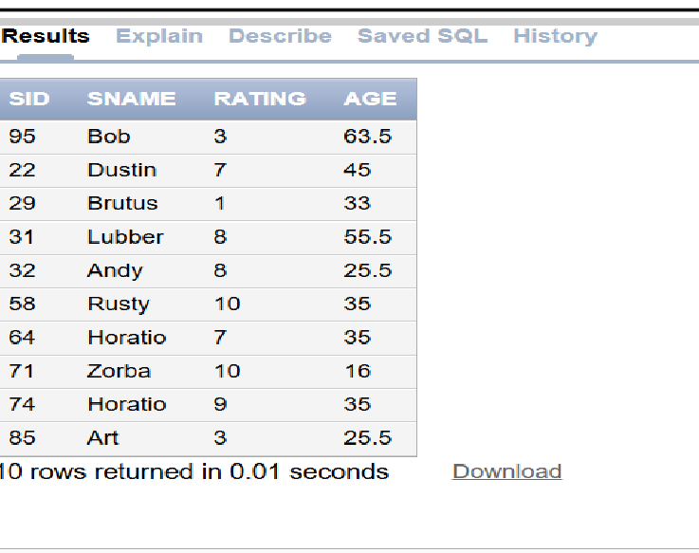

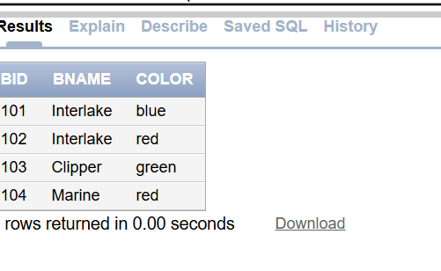

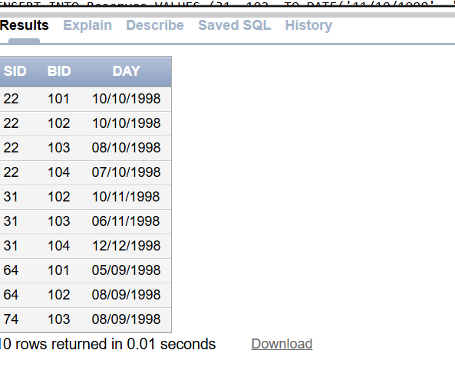

**1. Find the name and age of all sailors**

SELECT sname, age FROM Sailors;

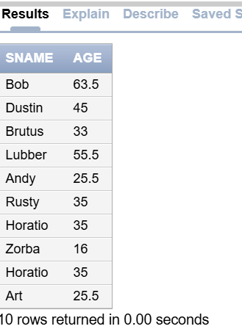

**2. Find all sailors with a rating above 7**

SELECT * FROM Sailors WHERE rating > 7;

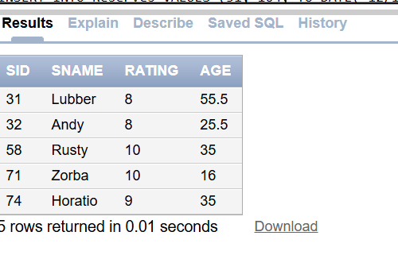

**3. Increase ratings of sailors by 10% whose age is less than 40**

UPDATE Sailors SET rating = rating * 1.1 WHERE age < 40;

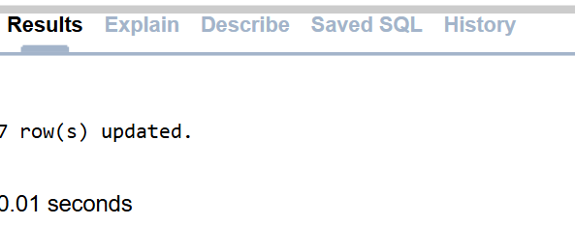

**4. Update rating of all sailors by 2 who have reserved boat on 11/12/98**

UPDATE Sailors

SET rating = rating + 2

WHERE sid IN (SELECT sid FROM Reserves WHERE day = TO_DATE('11/12/1998', 'DD/MM/YYYY'));

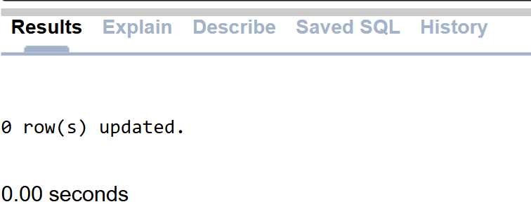

**5. Delete sailors whose rating is less than 3 and age is above 60**

DELETE FROM Sailors WHERE rating < 3 AND age > 60;

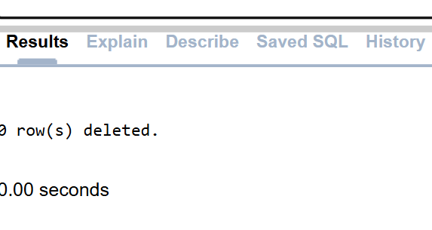

6)->

DELETE FROM Sailors2

WHERE rating<3 AND age>60;

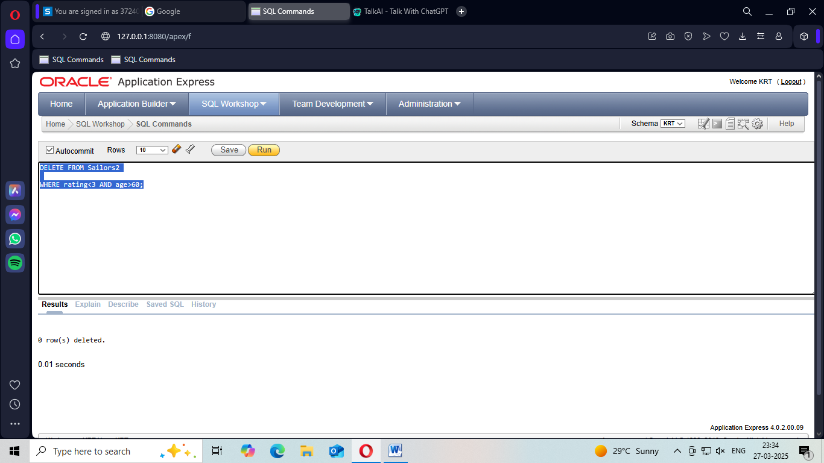

7)->

DELETE FROM Sailors2

WHERE sid IN (

SELECT sid

FROM Reserves2 WHERE sid = '102'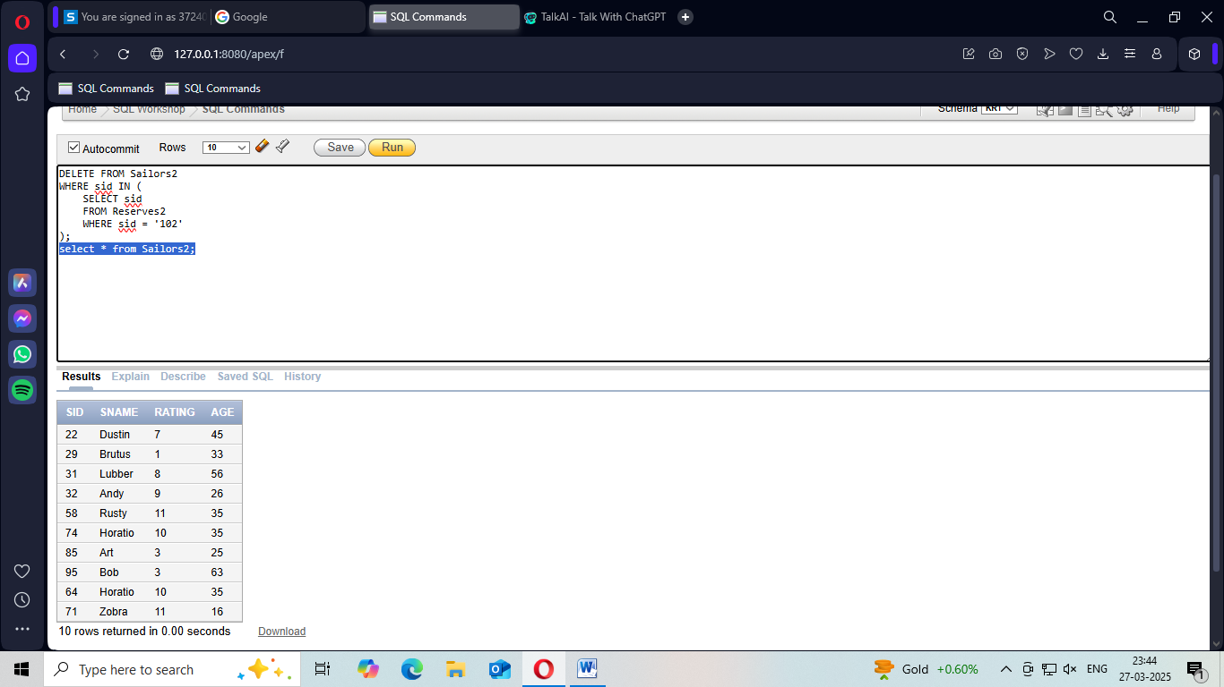

**B)1. Find the name of sailors who reserved ‘Interlake’ (Display names in uppercase)**

SELECT UPPER(S.sname)

FROM Sailors S

JOIN Reserves R ON S.sid = R.sid

JOIN Boat B ON R.bid = B.bid

WHERE B.bname = 'Interlake';

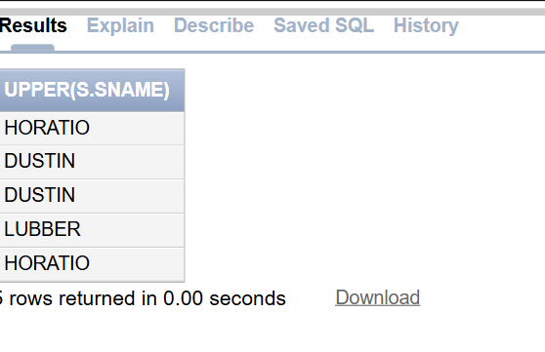

**2. Find the ratings of sailors whose name contains ‘us’**

SELECT sname, rating FROM Sailors WHERE sname LIKE '%us%';

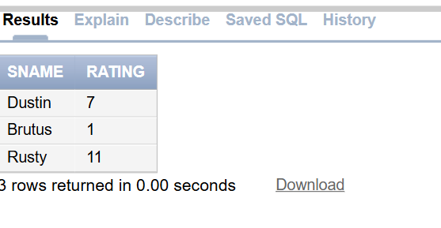

**3. Find the average age of sailors with a rating of 8**

SELECT AVG(age) FROM Sailors WHERE rating = 8;

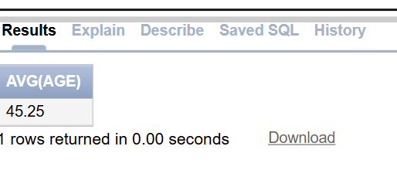

**4. Count the number of sailors with rating greater than 5**

SELECT COUNT(*) FROM Sailors WHERE rating > 5;

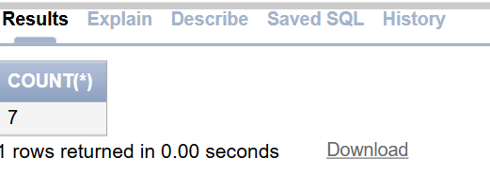

**5. Select the reservation date of boat with bid =101, reserved by sid =64, and add 2 months**

SELECT ADD_MONTHS(day, 2) FROM Reserves WHERE bid = 101 AND sid = 64;

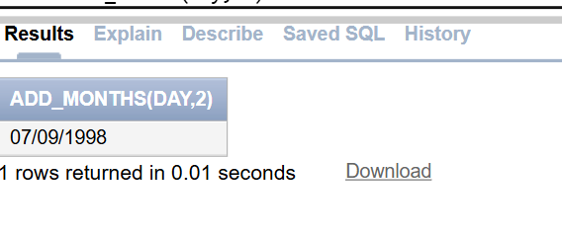

**6. Find the months between 12-Feb-2021 and the system current date**

SELECT MONTHS_BETWEEN(SYSDATE, TO_DATE('12/02/2021', 'DD/MM/YYYY')) FROM dual;

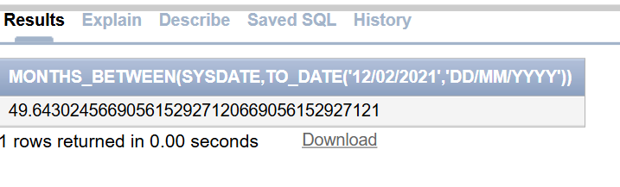

**7. Find the name of the boat along with the month of reservation**

SELECT B.bname, TO_CHAR(R.day, 'Month')

FROM Boat B

JOIN Reserves R ON B.bid = R.bid;

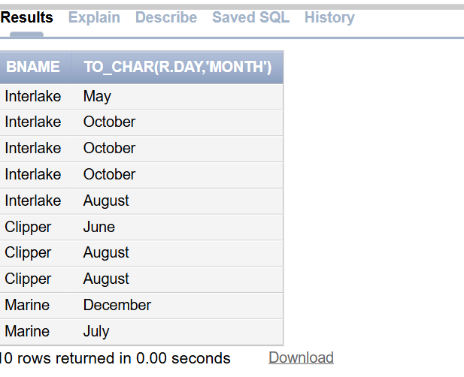

**8. Demonstrate numeric functions**

SELECT

ABS(-10),

SIGN(-10),

POWER(2, 3),

ROUND(45.678, 2),

MOD(10, 3),

FLOOR(45.67),

CEIL(45.67),

TRUNC(45.678, 1)

FROM dual;

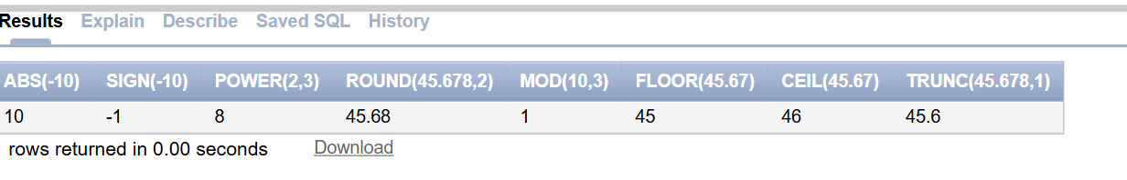

**9. Find the square root of ages of all sailors**

SELECT sname, SQRT(age) FROM Sailors;

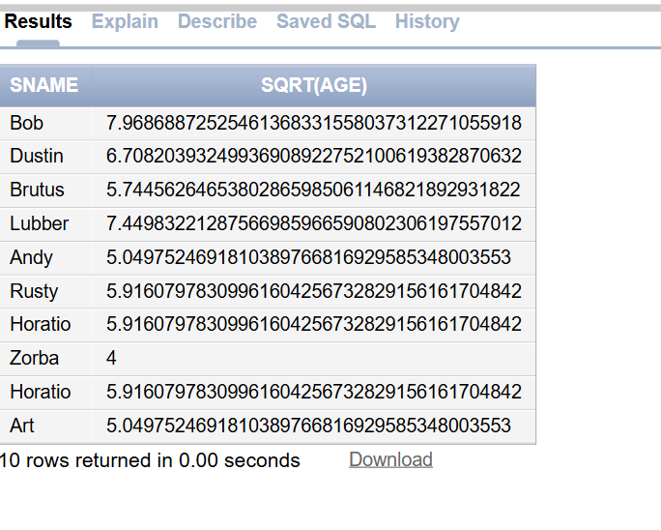

**10. Display dates of all boat reservations in the format "19-Jun-2005"**

SELECT TO_CHAR(day, 'DD-Mon-YYYY') FROM Reserves;

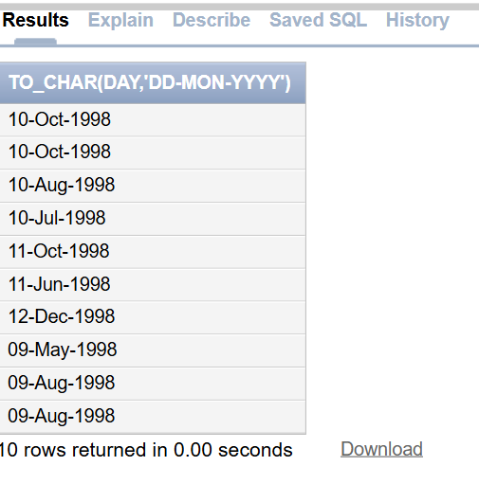

**11. Find the min and max rating from Sailors**

SELECT MIN(rating), MAX(rating) FROM Sailors;

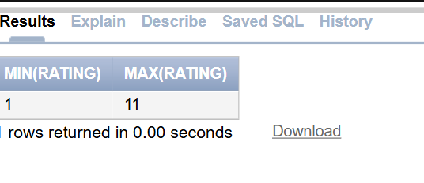

**C)**

**1. Find names of sailors whose name begins and ends with ‘B’ and has at least 3 characters**

SELECT sname FROM Sailors WHERE sname LIKE 'B%B' AND LENGTH(sname) >= 3;

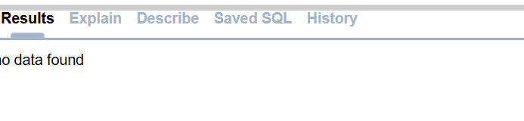

**2. Find sailors whose name begins with ‘A’ or ‘L’**

SELECT sname FROM Sailors WHERE sname LIKE 'A%' OR sname LIKE 'L%';

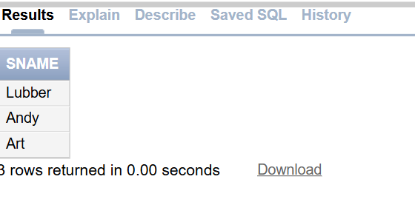

**3. Find sailors whose rating is greater than 7 and age is between 33 to 45**

SELECT sname FROM Sailors WHERE rating > 7 AND age BETWEEN 33 AND 45;

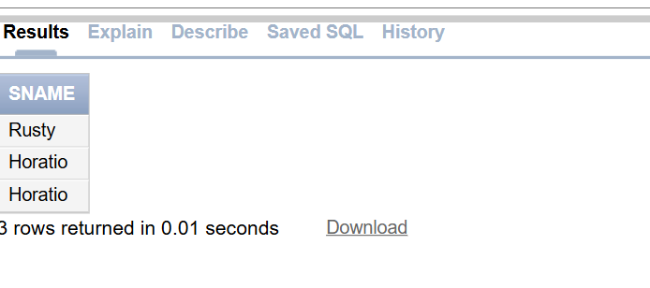

**4. Find sailors who have not reserved a boat on 10/10/98**

SELECT sname FROM Sailors WHERE sid NOT IN (SELECT sid FROM Reserves WHERE day = TO_DATE('10/10/1998', 'DD/MM/YYYY'));

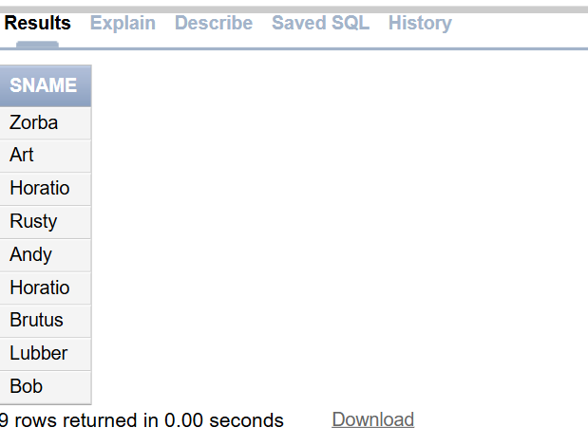

**5. Find sailors who reserved boat 103 (Using IN operator)**

SELECT sname FROM Sailors WHERE sid IN (SELECT sid FROM Reserves WHERE bid = 103);

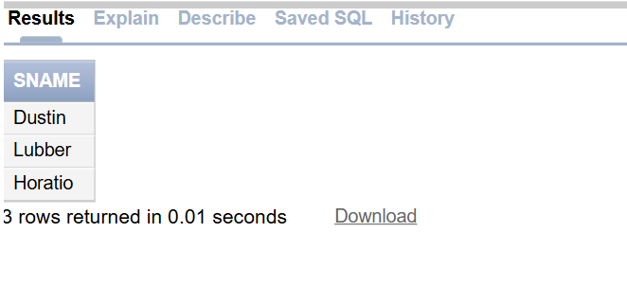

**6. Find sailors who reserved boat 103 (Using EXISTS operator)**

SELECT sname FROM Sailors S WHERE EXISTS (SELECT 1 FROM Reserves R WHERE R.bid = 103 AND R.sid = S.sid);

