ASSIGNMENT NO :4

1)->

select rating ,MIN(age) as minimum_age

from Sailors2

group by rating;

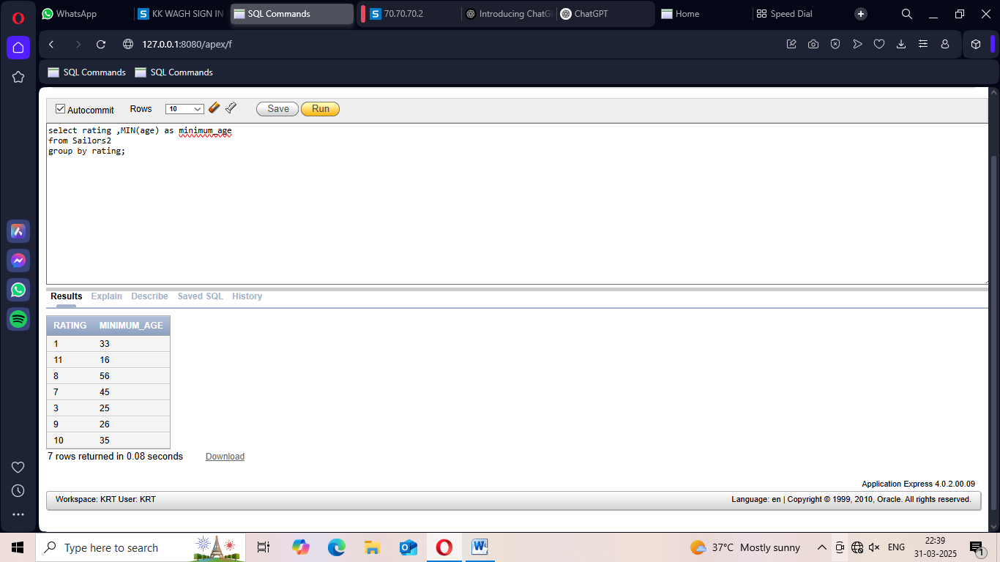

2)->

select bid,count(color) as no_of_boats

from Boat2

group by bid;

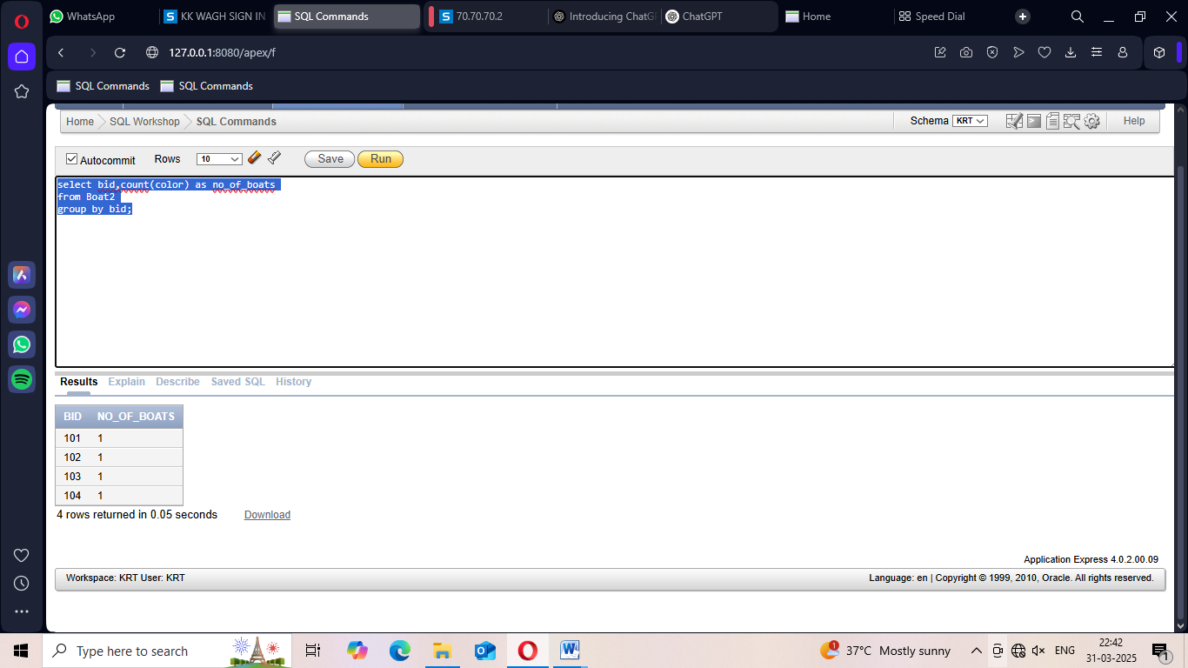

3)->

select rating ,MAX(age) as maximum_age

from Sailors2

group by rating;

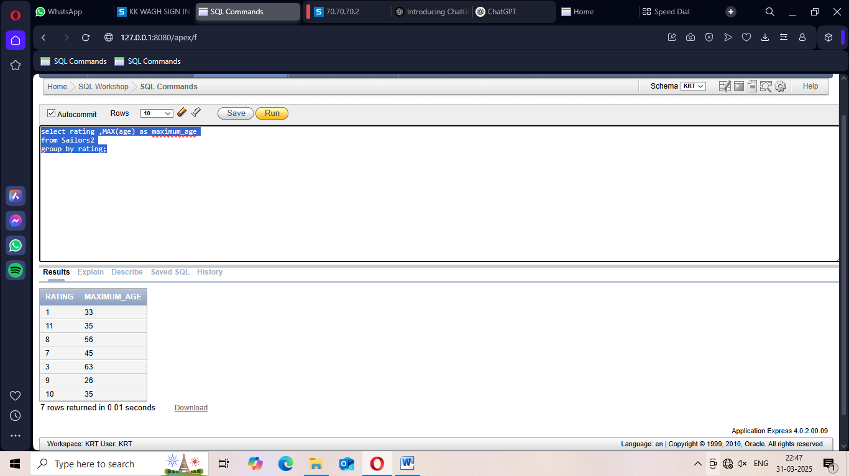

4)->

select b.bid,count(r.sid) as no_of_reservation

from Boat2 b

LEFT JOIN Reserves2 r ON b.bid=r.bid

group by b.bid

order by b.bid desc;

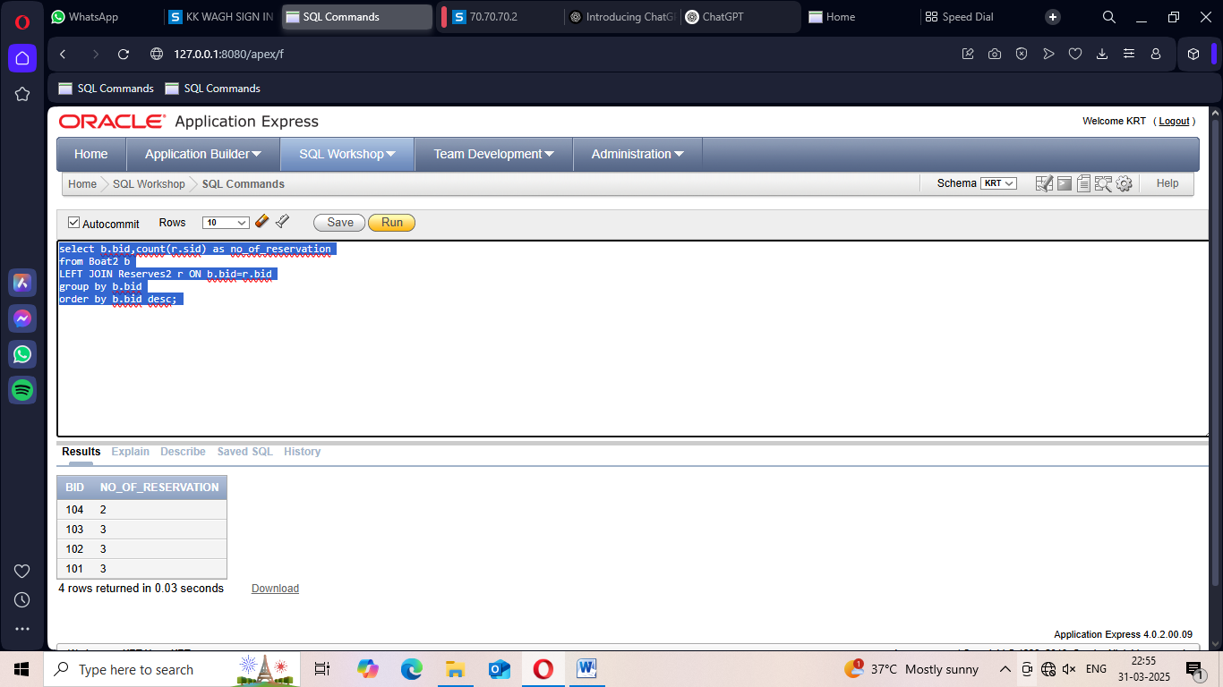

5)->

select rating,AVG(age) AS average_age

FROM Sailors2

GROUP BY rating

HAVING COUNT(*)>=2;

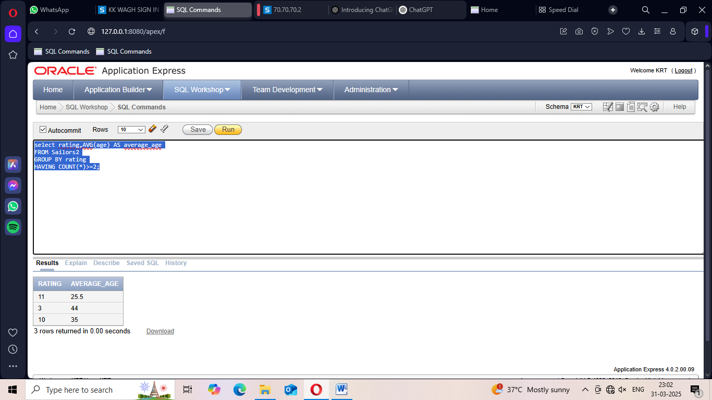

6)->

select s.rating ,MIN(age) as minimum_age

from Sailors2 s

where s.age >= 18

group by s.rating

having count(*)>1;

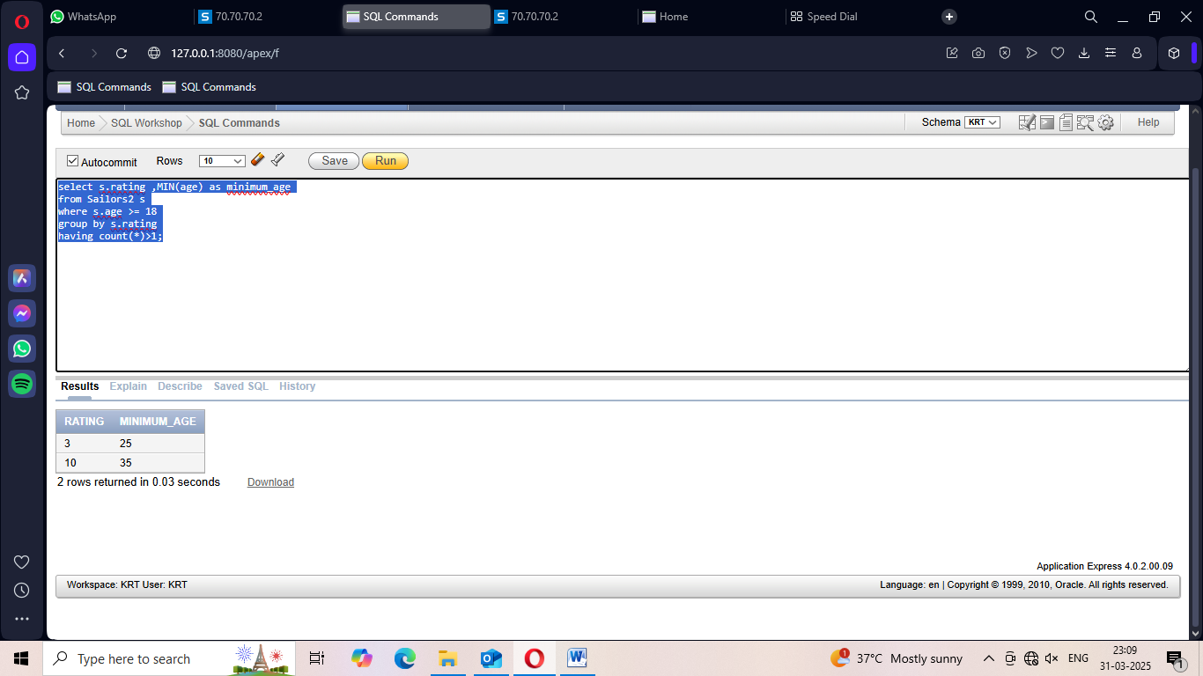

7)->

select s.sname,r.day

from Sailors2 s

JOIN Reserves2 r ON s.sid = r.sid

order by r.day ASC;

