“DOH MOBILE PASSPORT SERVICES DAY”
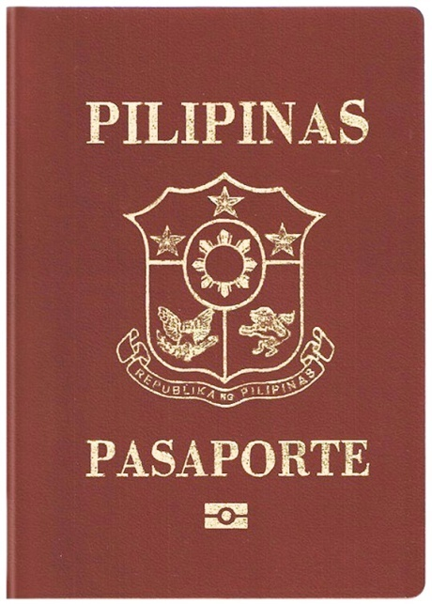

- Application for new passports and renewal of expired passports only
- Open to all permanent DOH employees and their 1st degree relatives (parents, children and spouse) and non-permanent DOH employees / support personnel (Job Orders, Contractuals and Security / Janitorial Staff excluding their relatives)
- Please contact Aileen, Nestor, Dodie of the Bureau of International Health Cooperation (BIHC) at locals 1339, 1301 for registration and other inquiries.
- Submit all documents/requirements to BIHC or before February 22, 2016
- Php 1,200.00 Processing Fee per person which shall be paid on March 12, 2016

See you at the DOH CONVENTION HALL ON MARCH 12, 2016,
9 AM TO 4 PM

A Project of the Department of Health through the Bureau of International Health Cooperation and the Department of Foreign Affairs, Regional Consular Coordinating Center

