Non-peer-reviewed research paper prepared for EarthArXiv submission
A Data-Driven Comparative Assessment of Pollution from Ethanol Production and Refrigeration & Air-Conditioning Systems
Global life-cycle emissions, pollutant screening, forecasting to 2050, and per-unit appliance comparison
Author: Tarun
Affiliation: Independent Researcher (No Company), India
Corresponding author email: krtarunsingh@gmail.com
ORCID: Not provided
Manuscript type: Research Paper
Target platform: EarthArXiv
GitHub repository: https://github.com/krtarunsingh/ac-rac-ethanol-emissions-study
Zenodo DOI: https://doi.org/10.5281/zenodo.21021495
Version: 1.0 - 28 June 2026

Abstract
This paper compares the environmental burden of fuel ethanol production with refrigeration and air-conditioning (RAC) systems, including household air conditioners and refrigerators. The analysis is global rather than country-specific and uses publicly available data from the International Energy Agency (IEA), United Nations Environment Programme (UNEP), Our World in Data, the International Institute of Refrigeration (IIR), the Renewable Fuels Association (RFA), and published peer-reviewed life-cycle studies on ethanol. The study treats carbon dioxide equivalent (CO2e) as the main climate metric, while SO2/SOx, NOx, VOC and particulate matter are modelled as screening indicators rather than regulatory inventories. Results show that AC and RAC systems are a much larger global climate problem than fuel ethanol production. In 2022, air conditioning alone was approximately 1.75 GtCO2e, while all cooling/RAC was roughly 3.6 GtCO2e. In comparison, global fuel ethanol production in 2025 was about 32 billion gallons, corresponding to roughly 0.13 GtCO2e/year using a 52.4 gCO2e/MJ ethanol life-cycle intensity. By 2050, AC-only emissions may approach 3.8 GtCO2e in a baseline scenario and all cooling/RAC may reach 7.2 GtCO2e under business-as-usual assumptions. A sustainable cooling pathway could reduce cooling emissions to around 2.6 GtCO2e by 2050. At the household functional-unit level, one 1.5-ton AC running continuously for 24 hours emits roughly 16.2 kgCO2e using a global-average electricity factor, while one refrigerator running for 24 hours emits roughly 0.67 kgCO2e. Producing one litre of ethanol is approximately 1.1 kgCO2e on a life-cycle basis, plus about 0.75 kg of physical biogenic fermentation CO2 that should be reported separately. The conclusion is data-based: RAC is more dangerous globally for climate change because of scale, electricity demand and refrigerant leakage; ethanol plants are more dangerous locally where wastewater, vinasse, VOC and boiler emissions are poorly controlled.

Keywords
CO2 emissions; CO2e; ethanol production; bioethanol; RAC; air conditioning; refrigerators; refrigerant leakage; HFCs; global warming potential; SOx; NOx; VOC; life-cycle assessment; forecasting.

1. Introduction
Climate pollution is often discussed only through vehicles, industries and power plants, but a large share of modern environmental load comes from hidden systems: cooling appliances, cold chains, household refrigerators, air conditioners, and biofuel production plants. Ethanol is promoted as a renewable transport fuel because the carbon in its feedstock is biogenic; however, producing ethanol still requires feedstock cultivation, transport, fermentation, distillation, steam, electricity and effluent treatment. RAC systems appear clean at the point of use, but they produce indirect emissions through electricity consumption and direct emissions through refrigerant leakage. For a data and AI/ML-oriented research approach, the correct question is not simply whether ethanol or AC is more polluting, but how their emissions compare under a defined functional unit, boundary and forecasting scenario.
This paper therefore compares two types of pollution sources: (1) ethanol production plants, which are industrial point sources, and (2) distributed RAC systems, which exist across millions to billions of homes, shops, vehicles, food chains and commercial buildings. The same analytical logic used in machine learning applies here: define features, define labels or metrics, separate direct and indirect variables, document assumptions, and make the model reproducible.

2. Research Objectives
- To compare global greenhouse-gas impact of ethanol production and RAC systems using public data.
- To estimate per-unit pollution from running one AC for a day, running one refrigerator for a day, and producing one litre of ethanol.
- To forecast future global risk to 2050 using simple, transparent scenario modelling.
- To compare climate pollutants and air-pollution indicators, including CO2e, SO2/SOx, NOx, VOC and PM2.5.
- To identify which system is more dangerous under different definitions of harm: global warming, household emissions, industrial wastewater, and local air pollution.

3. Scope and System Boundary
The analysis uses a global boundary and does not focus on any single country. For RAC, the boundary includes electricity consumed during operation and refrigerant leakage during operation. Manufacturing, shipping, installation and end-of-life recycling are discussed but not numerically modelled in the main per-day test. For ethanol, the boundary includes life-cycle carbon intensity per megajoule, plant fermentation CO2, refining/process energy, and wastewater concern. Because global measured totals for SO2/SOx, NOx and VOC from every AC, refrigerator and ethanol plant do not exist in a single public dataset, those pollutants are modelled as screening estimates using transparent factors. They should be treated as directional, not regulatory.

4. Data Sources
Table 1. Public sources and how they are used
Dataset / source | Value used | Use in paper
IEA Space Cooling | Space cooling electricity-related CO2 around 1 Gt in 2022; refrigerants add non-CO2 GHG risk | AC baseline climate context
Our World in Data AC synthesis | AC emissions about 1.75 GtCO2e in 2022 when refrigerants are included | AC total GHG anchor
UNEP Global Cooling Watch 2025 | Cooling emissions may reach 7.2 GtCO2e by 2050; sustainable pathway around 2.6 GtCO2e | RAC forecast
International Institute of Refrigeration | Refrigeration sector estimated at 4.14 GtCO2e and 7.8% of global GHG; AC model 77% indirect, 23% direct | RAC direct/indirect split
RFA Annual World Fuel Ethanol Production | World fuel ethanol production 32,000 million gallons in 2025 | Ethanol global scale
Xu et al. 2022 ethanol LCA | Corn ethanol baseline 52.4 gCO2e/MJ; production/refining 25.6 gCO2e/MJ | Ethanol CO2e calculation
EPA AP-42 methodology | Public emission-factor framework for stationary combustion | SOx/NOx/VOC screening logic

5. Methodology

5.1 Climate metric
The main climate metric is carbon dioxide equivalent (CO2e). CO2e converts different greenhouse gases into the warming effect of carbon dioxide over a selected time horizon, commonly 100 years. For RAC, CO2e has two major parts: electricity-based emissions and refrigerant leakage. For ethanol, CO2e is based on published life-cycle intensity per megajoule and is reported separately from physical fermentation CO2 because fermentation CO2 is generally biogenic.
RAC CO2e formula:
Total RAC CO2e = electricity use (kWh) x grid factor (kgCO2/kWh) + refrigerant leakage (kg) x refrigerant GWP
Ethanol CO2e formula:
Ethanol CO2e per litre = ethanol energy content (MJ/L) x ethanol carbon intensity (gCO2e/MJ) / 1000

5.2 Forecasting method
The forecast is intentionally simple and reproducible. It uses anchor points reported by public sources and applies compound annual growth or decline between the baseline and 2050 target values. This is not a deep climate integrated assessment model. It is a transparent screening forecast suitable for a research paper or data-science demonstration. For ethanol, the RFA 2021-2025 production trend is used to calculate observed growth, but a moderated 1.5% annual growth scenario is used as the main long-term forecast because the energy transition may reduce transport-fuel ethanol growth over time.

6. Global Data-Based Comparison
Table 2. Global emissions comparison and forecast anchors
sector | 2022_GtCO2e | 2050_GtCO2e_BAU_or_baseline | 2050_sustainable_GtCO2e
Air conditioning only | 1.750 | 3.800 | nan
All cooling/RAC | 3.600 | 7.200 | 2.600
Fuel ethanol production, LCA | 0.116 | 0.194 | nan
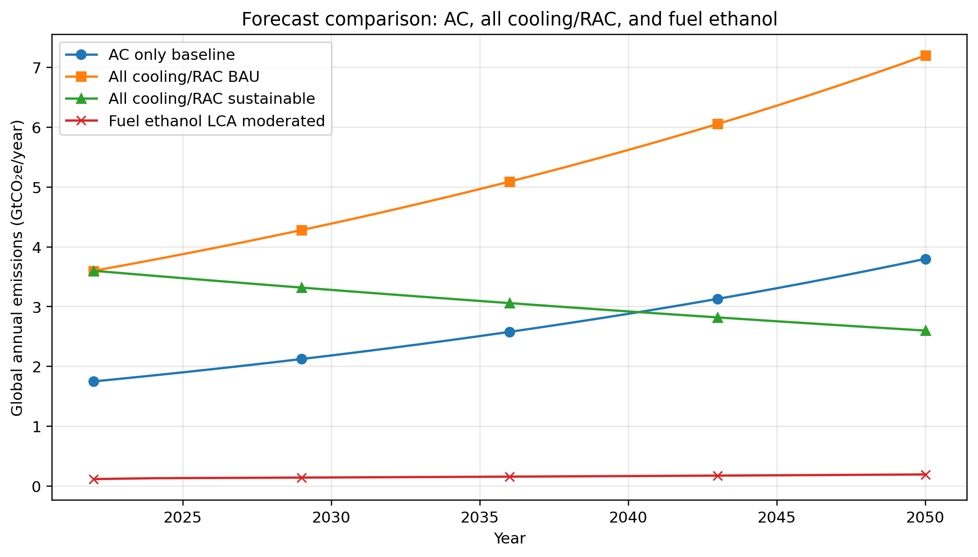
Figure 1. Forecast comparison of AC, all cooling/RAC and fuel ethanol emissions.
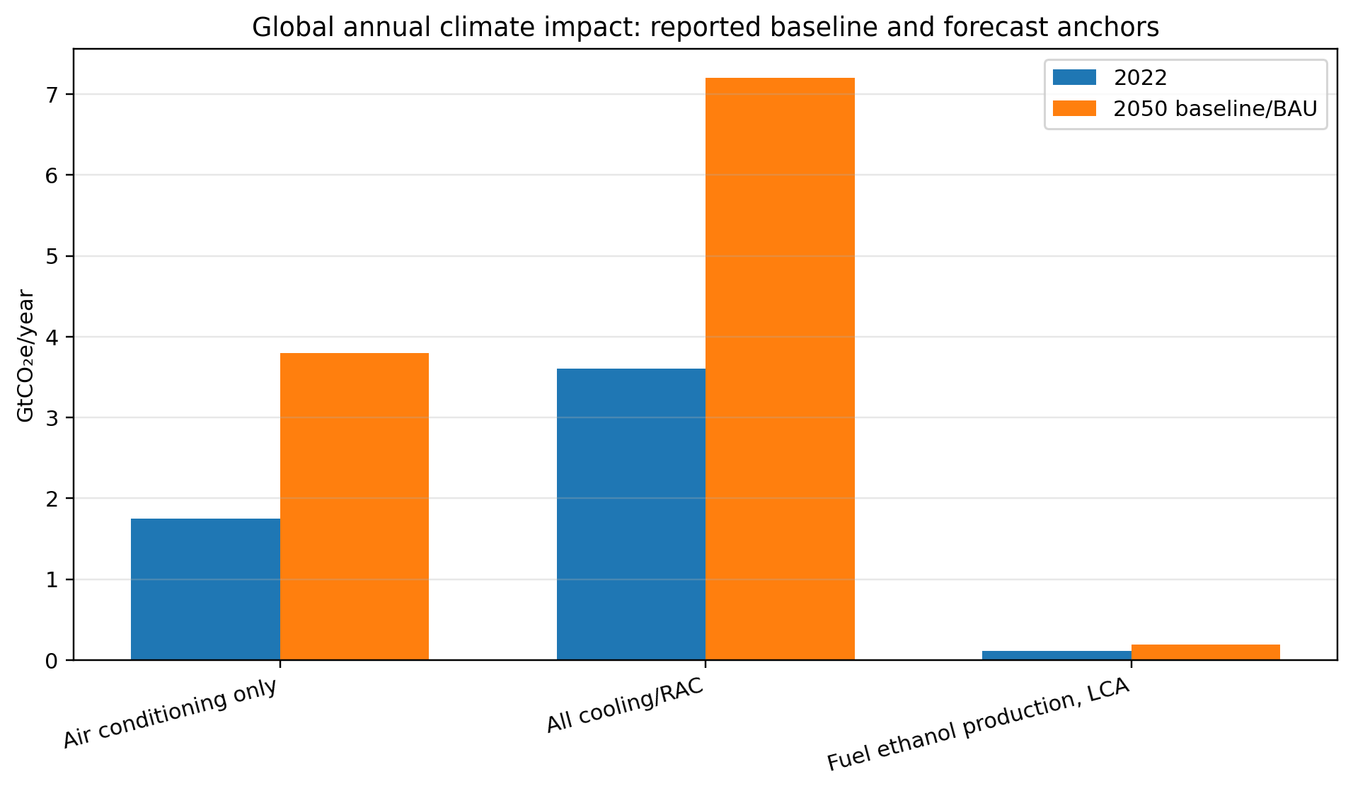
Figure 2. Global annual climate impact: baseline and 2050 anchors.
The global result is clear: RAC and cooling dominate ethanol production in total climate impact. In 2022, AC alone was approximately 1.75 GtCO2e and all cooling/RAC was approximately 3.6 GtCO2e. Using the 2025 world ethanol production value of 32 billion gallons and the published 52.4 gCO2e/MJ ethanol life-cycle intensity, fuel ethanol production corresponds to roughly 0.13 GtCO2e/year. Even if ethanol grows after 2025, its climate impact remains far below the forecasted climate load of AC and all cooling/RAC systems.
The reason is scale. One ethanol plant may be a visible industrial source, but RAC is a distributed global network of appliances. Every AC and refrigerator individually appears small, yet the total system creates electricity demand, peak load, fossil power generation and refrigerant leakage.

7. Per-Unit Comparison
Table 3. Per-unit climate comparison
case | energy_CO2e_kg | refrigerant_CO2e_kg | ethanol_or_biogenic_CO2_kg | total_CO2e_kg
1 AC, 24 h | 16.02 | 0.137 | 0.000 | 16.16
1 AC, 8 h night | 5.340 | 0.137 | 0.000 | 5.477
1 refrigerator, 24 h | 0.668 | 0.004 | 0.000 | 0.671
1 L ethanol production | 1.106 | 0.000 | 0.750 | 1.106
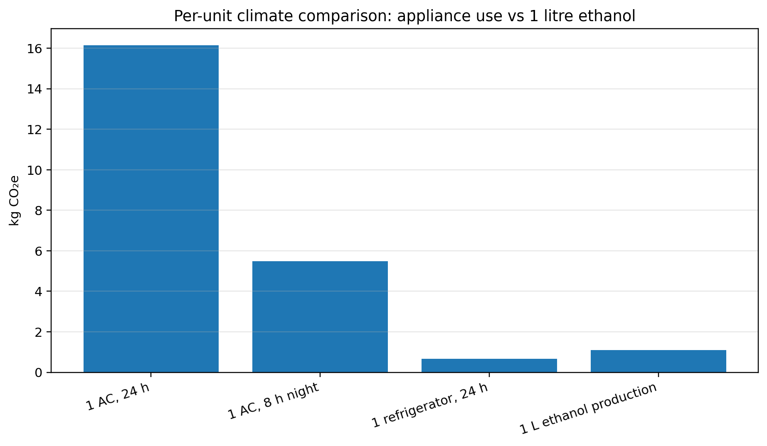
Figure 3. Per-unit climate comparison: appliance use versus 1 litre ethanol production.
A 1.5-ton AC running for 24 hours is estimated at roughly 16.2 kgCO2e using the global electricity factor of 445 gCO2/kWh plus a daily allocation of R-410A leakage. A refrigerator running for 24 hours is estimated at about 0.67 kgCO2e in an older HFC-134a leakage case. A modern hydrocarbon refrigerator would have even lower direct refrigerant climate impact. One litre of ethanol is about 1.1 kgCO2e using the 52.4 gCO2e/MJ life-cycle intensity and 21.1 MJ/L energy content. In addition, the plant physically releases about 0.75 kg of biogenic fermentation CO2 per litre unless captured.
Therefore, for a simple functional-unit test, one AC running for a full day is much more climate-polluting than producing one litre of ethanol. A refrigerator running for one day is lower than one litre ethanol production in climate-accounting terms, but refrigerators run every day for many years, which makes their lifetime electricity demand important.

8. SOx, NOx, VOC and PM2.5 Screening Results
The following charts show screening estimates, not measured global emissions. For AC and refrigerator, the pollutants are not emitted by the appliance inside the room; they are mainly emitted at power plants supplying electricity. For ethanol, the values shown here are plant heat-stage screening estimates from natural-gas boiler-style factors and do not include farming, fertilizer, transport or uncontrolled process vents.
Table 4. Screening pollutant estimates per functional unit
pollutant | 1 AC, 24 h_g | 1 refrigerator, 24 h_g | 1 L ethanol plant heat stage_g
SO2/SOx | 16.20 | 0.675 | 0.002
NOx | 19.80 | 0.825 | 0.360
VOC | 1.080 | 0.045 | 0.020
PM2.5 | 1.440 | 0.060 | 0.028
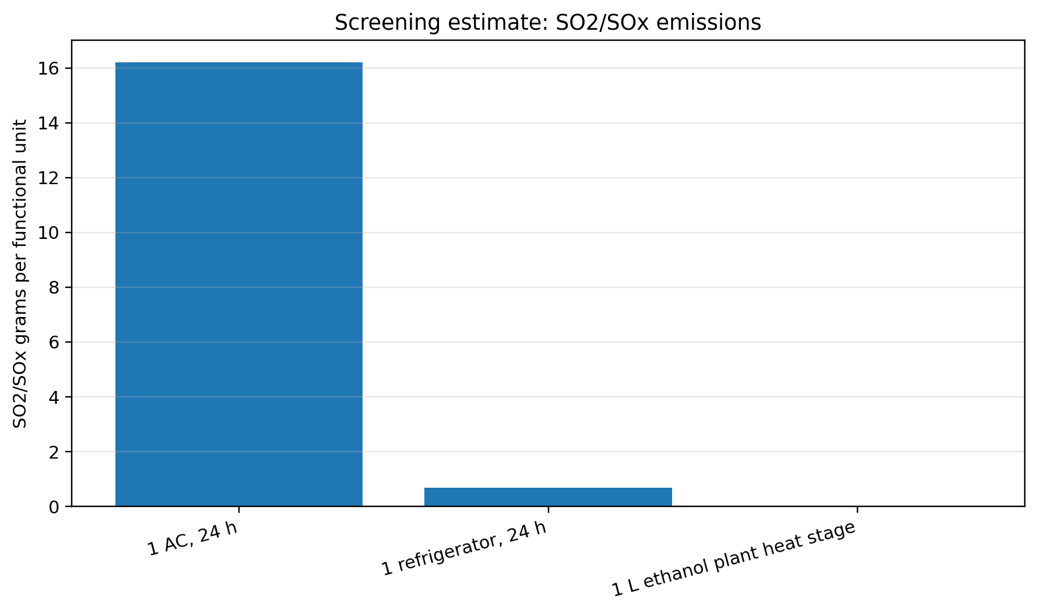
Figure 4. Screening estimate for SO2/SOx.
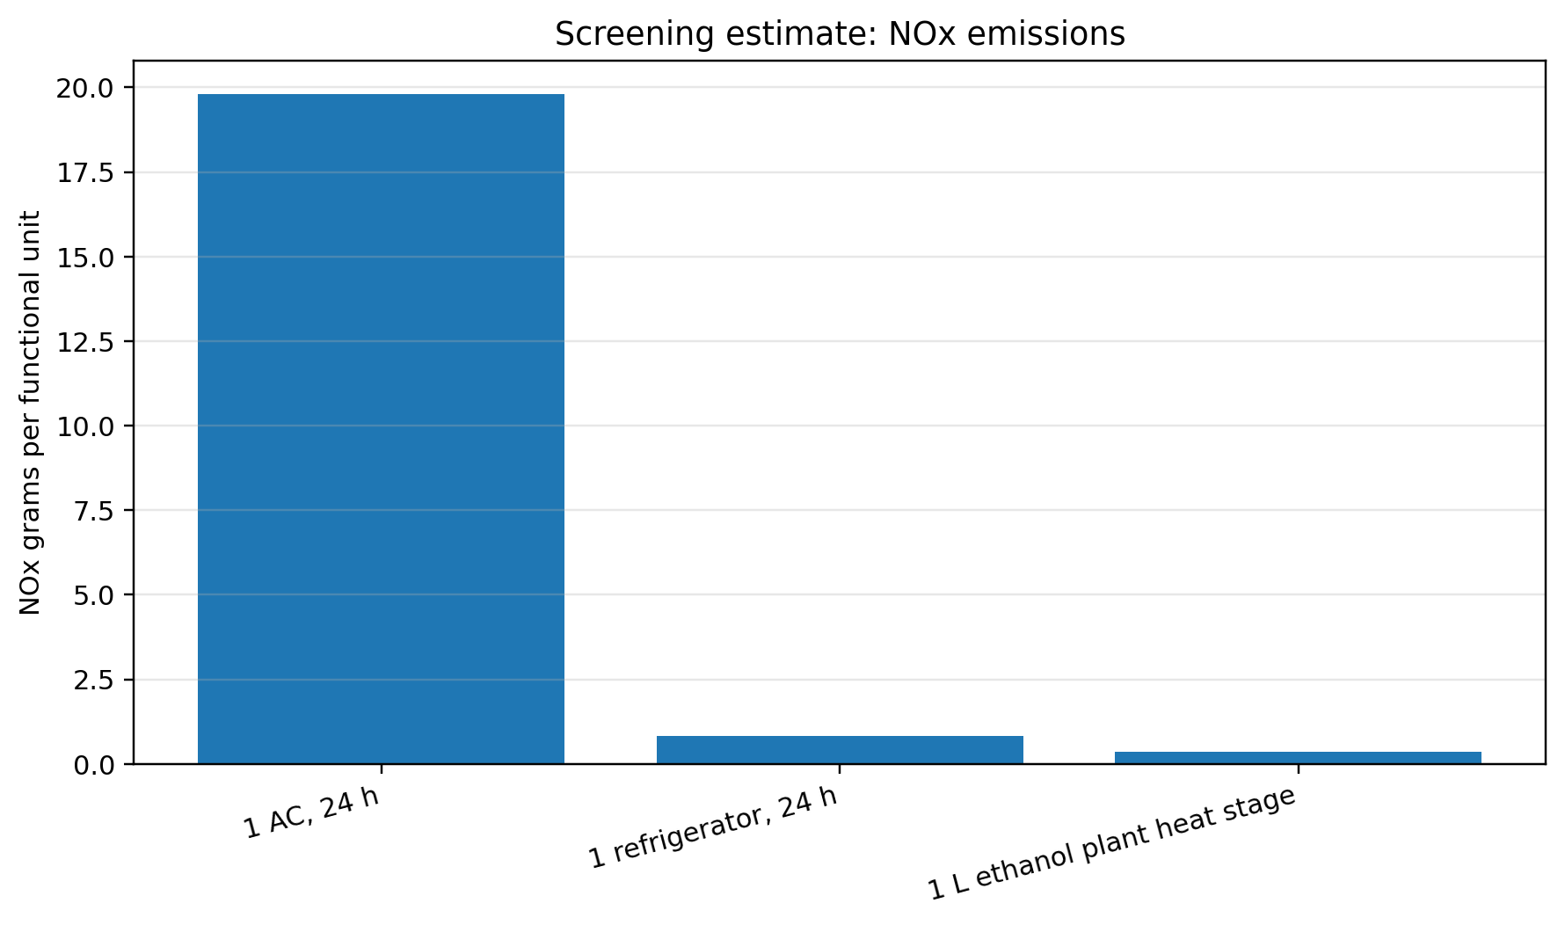
Figure 5. Screening estimate for NOx.
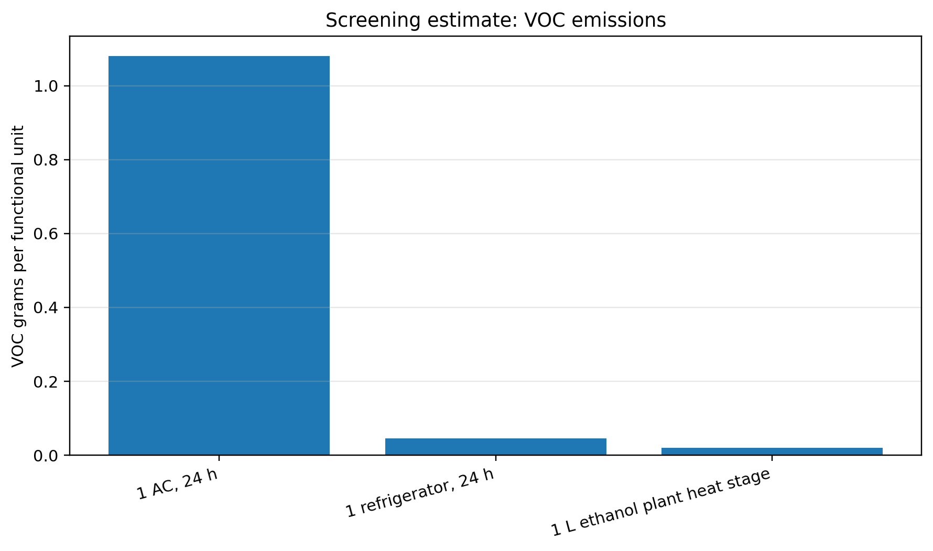
Figure 6. Screening estimate for VOC.
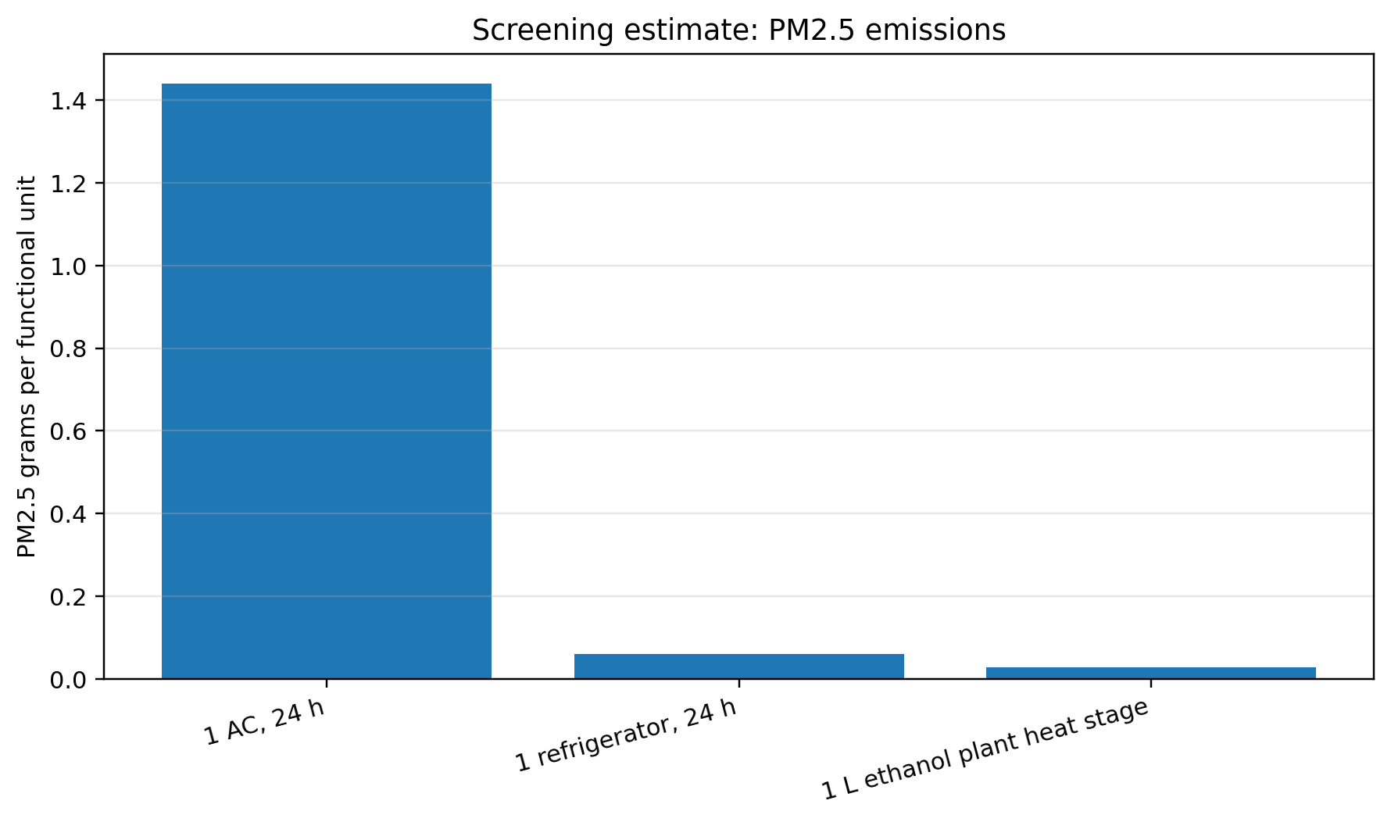
Figure 7. Screening estimate for PM2.5.
The screening model shows that the AC dominates power-sector SOx and NOx per day because it consumes much more electricity than a refrigerator. Ethanol plant heat-stage pollutant values per litre look smaller in this simplified chart, but this does not mean ethanol plants are harmless. The major local pollution danger of ethanol plants is wastewater, high-strength stillage/vinasse, odor, high biological and chemical oxygen demand, and process VOC release if control systems are weak.

9. Global Warming Potential of Refrigerants
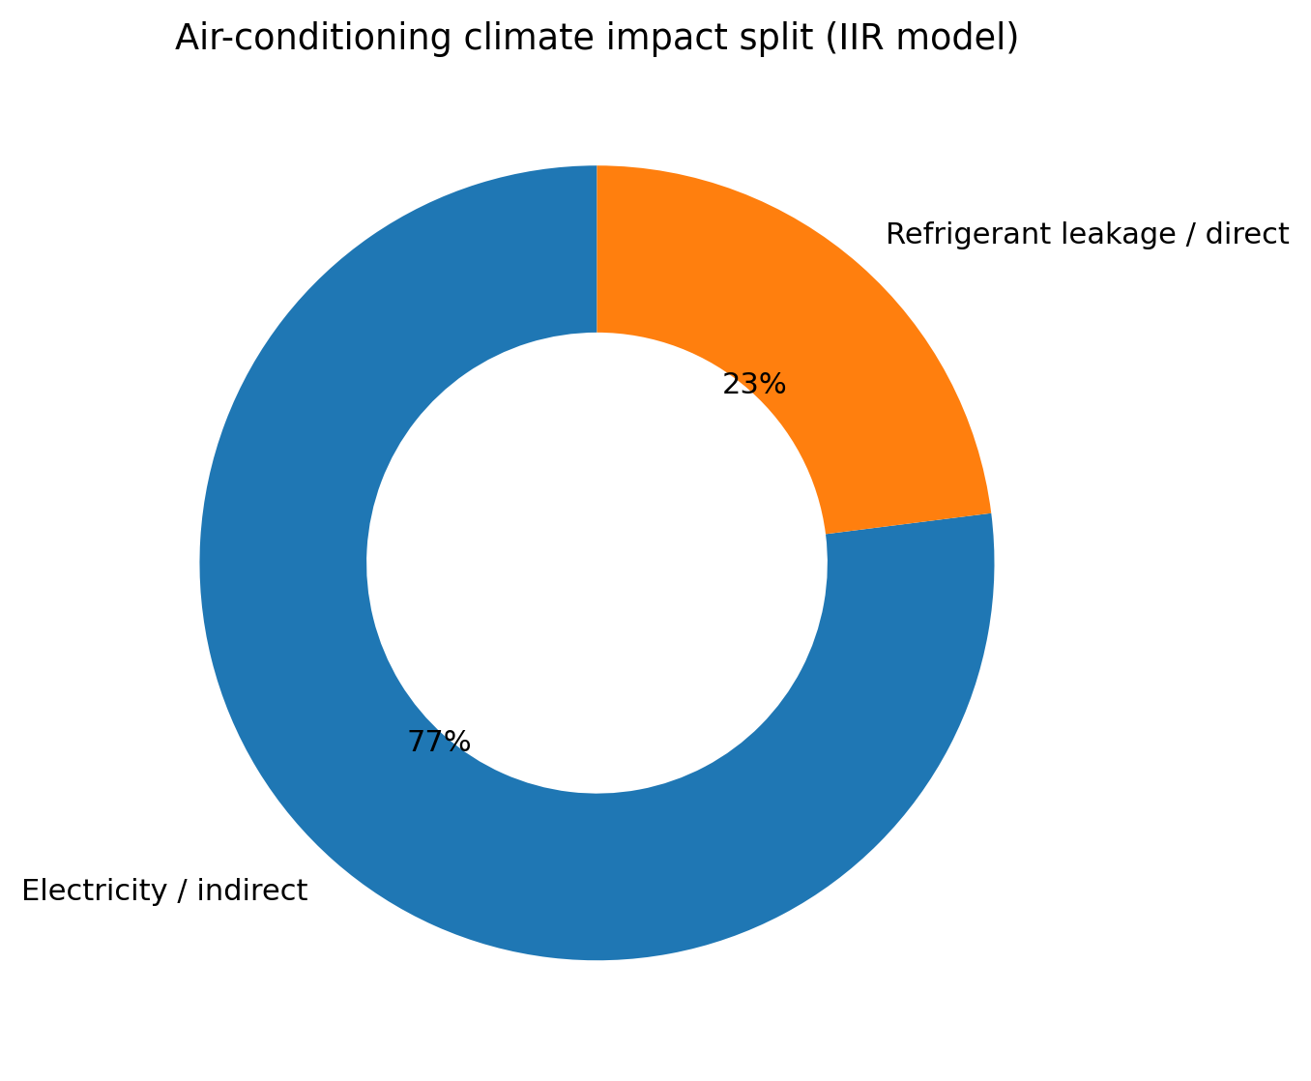
Figure 8. AC climate impact split: indirect electricity and direct refrigerant leakage.
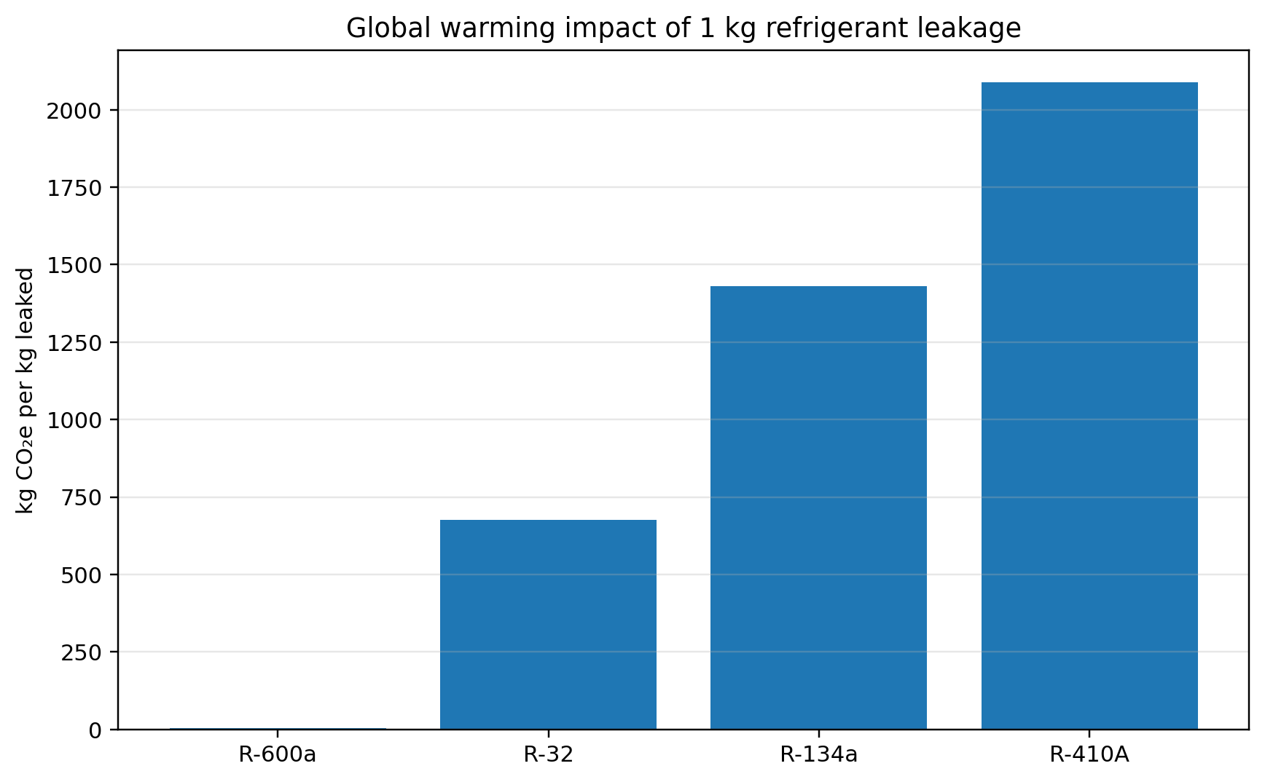
Figure 9. Global warming impact if 1 kg of refrigerant leaks.
Refrigerants make RAC dangerous because a small mass can create a large climate effect. For example, one kilogram of R-410A leakage is equivalent to roughly 2,088 kilograms of CO2e. R-134a is about 1,430 kgCO2e per kg leaked, while R-32 is lower but still high at about 675 kgCO2e per kg leaked. Modern hydrocarbons such as R-600a have much lower GWP, but safety and flammability requirements must be managed.
This is why ACs and refrigerators are not only electricity devices. They are also chemical-storage devices. Poor installation, bad servicing, informal gas refilling and improper disposal can convert a cooling appliance into a high-GWP leakage source.

10. Ethanol Production Pollution Beyond CO2
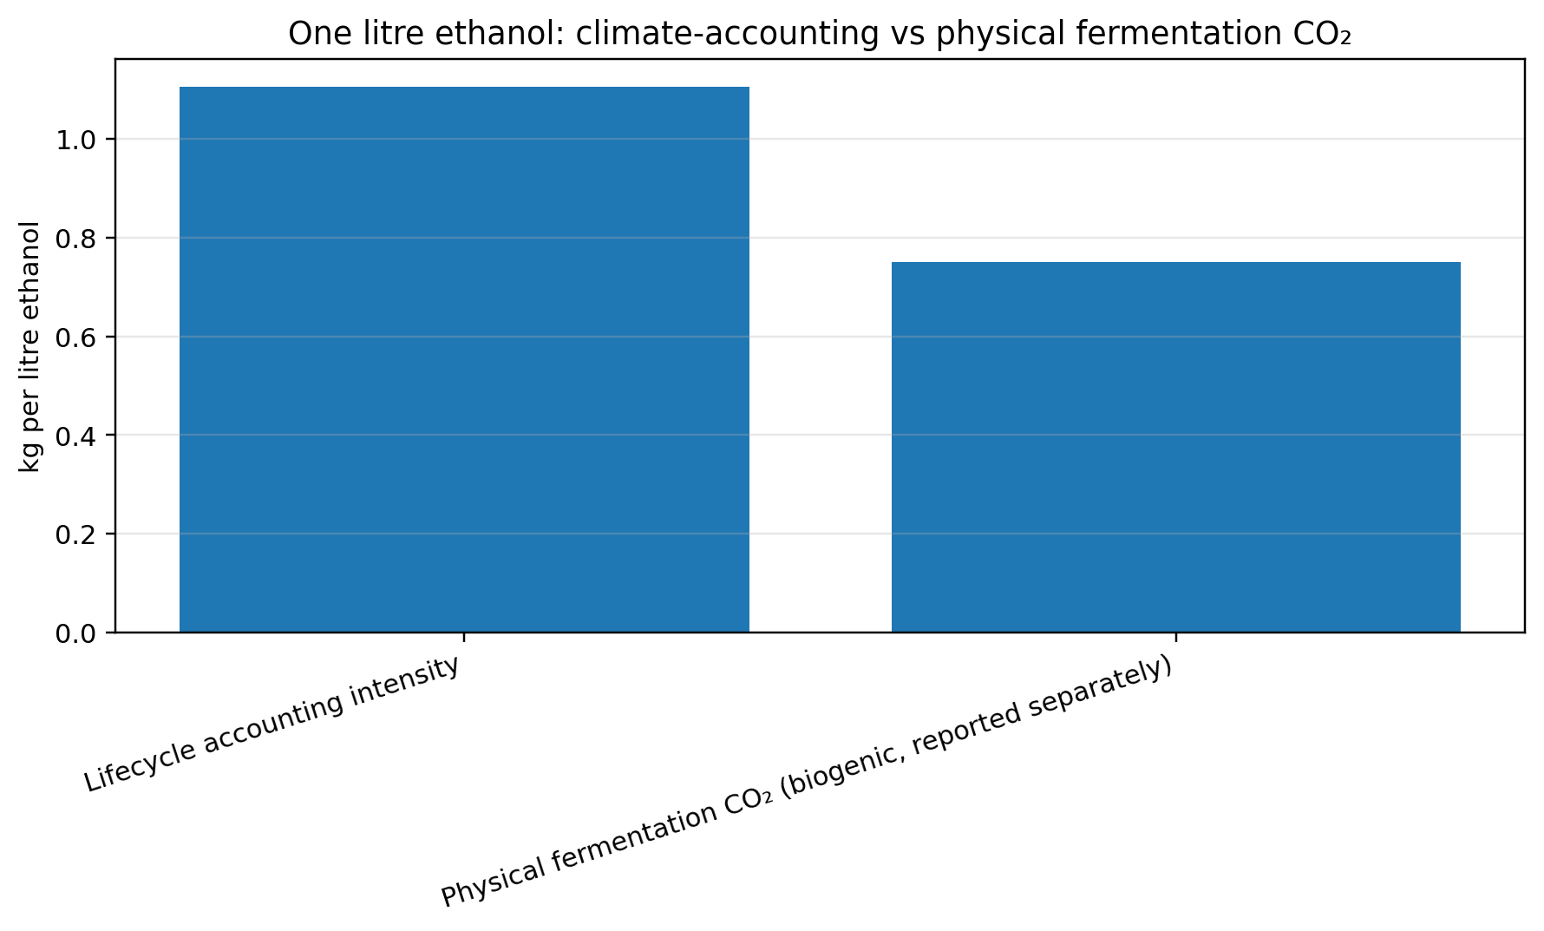
Figure 10. One litre ethanol: life-cycle CO2e and physical fermentation CO2.
Ethanol is different from RAC because its pollution is concentrated at production facilities and agricultural supply chains. The fermentation reaction converts sugar into ethanol and CO2, so a plant physically emits fermentation CO2. Because the carbon came from biomass, climate inventories usually treat this CO2 differently from fossil CO2, but from a plant-stack perspective it is still a real gas stream. This makes ethanol plants attractive for carbon capture because the fermentation CO2 stream can be relatively pure.
The more serious non-climate issue is wastewater. Distilleries are reported in the literature as among the more polluting industries because fermentation and distillation generate large volumes of high-strength liquid effluents. Vinasse/stillage can contain high organic load, color, odor, nutrients and salts. If untreated, it can reduce water quality, cause oxygen depletion and damage aquatic ecosystems. Therefore, ethanol is not automatically clean. It is only environmentally better when feedstock sourcing, energy, water use, effluent treatment and carbon capture are properly managed.

11. Final Test: 1 AC + 1 Refrigerator Running a Full Day
Using the global-average electricity factor and conservative high-GWP refrigerant assumptions, one 1.5-ton AC running for 24 hours plus one refrigerator running for 24 hours emits approximately 16.83 kgCO2e/day.
Breakdown: AC full-day operation is approximately 16.16 kgCO2e/day; refrigerator operation is approximately 0.67 kgCO2e/day. Together, this daily household cooling load equals roughly 15.2 litres of ethanol production on a life-cycle CO2e basis.
Danger interpretation: the AC is far more dangerous than the refrigerator on a daily climate basis because it consumes much more electricity and usually contains a larger refrigerant charge. The refrigerator is less intense per day, but it runs continuously throughout the year; old refrigerators with inefficient compressors or HFC refrigerants can become important lifetime pollution sources. The most dangerous part of both appliances is not visible smoke; it is indirect power-plant emissions and refrigerant leakage.

12. Discussion: Which Is More Harmful?
If the metric is global warming, RAC is more harmful globally than ethanol production because its annual emissions are already in the gigatonne range and are forecast to rise strongly without intervention. If the metric is local industrial pollution, ethanol plants can be more harmful near the production site, especially through wastewater, odor, VOC releases, high-COD effluent, boiler emissions and feedstock-related impacts. Thus, the correct conclusion is not one universal winner; the harmfulness depends on the pollution pathway.
From a policy and engineering perspective, the mitigation routes are different. RAC needs high-efficiency appliances, clean power, better building design, passive cooling, low-GWP refrigerants, skilled servicing, leak testing and safe end-of-life recovery. Ethanol needs low-carbon process heat, renewable electricity, efficient distillation, wastewater treatment, feedstock optimization, reduced fertilizer emissions and carbon capture of fermentation CO2.

13. Limitations
- The global RAC forecast uses public anchor points rather than a full integrated assessment model.
- SOx, NOx, VOC and PM2.5 results are screening estimates and should not be treated as regulatory inventories.
- The ethanol LCA value is based mainly on corn ethanol literature; sugarcane, molasses and cellulosic ethanol can differ significantly.
- Manufacturing emissions and end-of-life appliance disposal are not included in the main daily appliance test.
- Local grid electricity factors can change results strongly; the code is designed so users can replace the global factor with a regional value.

14. Conclusion
The data-supported conclusion is that refrigeration and air-conditioning systems are the larger global climate concern, while ethanol plants are a concentrated industrial pollution concern. In 2022, AC alone was around 1.75 GtCO2e, and all cooling/RAC was roughly 3.6 GtCO2e. By 2050, cooling emissions could reach 7.2 GtCO2e under business-as-usual conditions, while a sustainable cooling pathway could reduce this to about 2.6 GtCO2e. Global fuel ethanol production, even at 32 billion gallons/year, is closer to the low hundreds of million tonnes CO2e/year when modelled with a 52.4 gCO2e/MJ life-cycle intensity.
At the household test level, one AC running for a full day emits about 16.2 kgCO2e, one refrigerator about 0.67 kgCO2e, and one litre of ethanol production about 1.1 kgCO2e on a life-cycle basis. Therefore, one full-day AC run is approximately fifteen times more climate-polluting than producing one litre of ethanol. However, ethanol production can be more dangerous locally if wastewater and VOCs are poorly controlled. The best final decision is: RAC is the bigger global warming risk; ethanol plants are the bigger local industrial water-pollution risk.

15. Declarations and Availability Statements

15.1 Author Information
Tarun is an independent researcher based in India with an interest in data-driven environmental analysis, AI/ML-assisted research workflows, and reproducible Python-based modelling. The author is not affiliated with any company for this work.

15.2 Data and Code Availability
The Python forecasting model, CSV data tables, generated chart files, and supplementary research package are available through a public GitHub repository and archived through Zenodo. GitHub repository: https://github.com/krtarunsingh/ac-rac-ethanol-emissions-study; Zenodo DOI: https://doi.org/10.5281/zenodo.21021495. The analytical files prepared for release include forecast_and_pollution_model.py, forecast_timeseries.csv, global_forecast_comparison.csv, per_unit_co2e_comparison.csv, per_unit_screening_pollutants.csv, and generated figure PNG files.

15.3 Funding Statement
This research received no external funding. The work was conducted independently using publicly available data and author-generated Python scripts.

15.4 Declaration of Competing Interest
The author declares no known competing financial interests or personal relationships that could have appeared to influence the work reported in this paper.

15.5 Ethics Statement
This study used publicly available aggregate data, published literature, and computational modelling only. It did not involve human participants, animal subjects, clinical data, private personal data, or field experiments. Therefore, formal ethics approval was not required.

15.6 AI-use Disclosure
AI tools were used for language editing, structure improvement, article correction, formatting support, and code-drafting assistance. The author reviewed the manuscript, sources, assumptions, calculations, code logic, and conclusions and remains responsible for the final content.

15.7 Supplementary Material
The supplementary material should include the GitHub/Zenodo release package containing the manuscript source file, reproducible Python code, requirements file, CSV outputs, and all generated charts. EarthArXiv should receive the manuscript as one PDF, while supplementary code and data should be linked externally through GitHub and/or Zenodo.

References
[1] International Energy Agency. Space Cooling. https://www.iea.org/energy-system/buildings/space-cooling
[2] International Energy Agency. Electricity 2025: Emissions. https://www.iea.org/reports/electricity-2025/emissions
[3] Our World in Data. Air conditioning causes around 3% of greenhouse gas emissions. https://ourworldindata.org/air-conditioning-causes-around-greenhouse-gas-emissions-will-change-future
[4] UNEP. Global Cooling Watch 2025. https://www.unep.org/resources/global-cooling-watch-2025
[5] UNEP. Press release on sustainable cooling and 2050 emissions. https://www.unep.org/news-and-stories/press-release/amid-rising-heat-sustainable-cooling-can-slash-emissions-and-save
[6] International Institute of Refrigeration. Impact of the refrigeration sector on climate change. https://iifiir.org/en/fridoc/the-impact-of-the-refrigeration-sector-on-climate-change-141135
[7] International Institute of Refrigeration. Global air-conditioning CO2 emissions and energy impact. https://iifiir.org/en/news/iir-informatory-note-highlights-global-air-conditioning-s-co2-emissions-and-energy-impact
[8] Renewable Fuels Association. Annual Ethanol Production. https://ethanolrfa.org/markets-and-statistics/annual-ethanol-production
[9] Xu, H. et al. (2022). Life-cycle greenhouse gas emissions reduction potential for corn ethanol refining. Biofuels, Bioproducts and Biorefining. https://www.osti.gov/servlets/purl/1904178
[10] Mikucka, W. and Zielinska, M. (2020). Distillery Stillage: Characteristics, Treatment, and Valorization. https://pmc.ncbi.nlm.nih.gov/articles/PMC7578141/
[11] EPA. AP-42: Compilation of Air Emissions Factors from Stationary Sources. https://www.epa.gov/air-emissions-factors-and-quantification/ap-42-compilation-air-emissions-factors-stationary-sources
[12] EPA. Technology Transitions GWP Reference Table. https://www.epa.gov/hfcs/technology-transitions-gwp-reference-table
[13] Zhang, H. et al. (2026). Rising Air-Conditioning Use Intensifies Global Warming. Nature Communications. https://www.nature.com/articles/s41467-026-69393-1

Appendix A: Reproducible Python model
The complete Python file is provided separately as forecast_and_pollution_model.py. It contains the data anchors, assumptions, forecast calculations and chart-generation code.

