Analysis of PLACEMENT DATASET
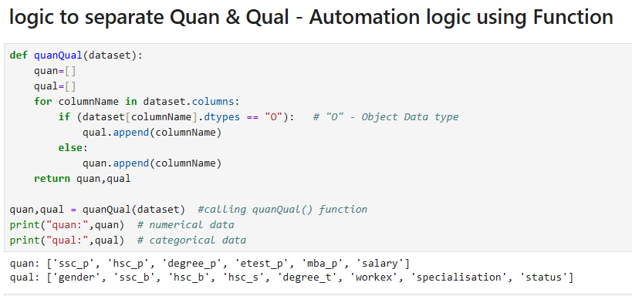

MEASURE OF CENTRAL TENDENCY
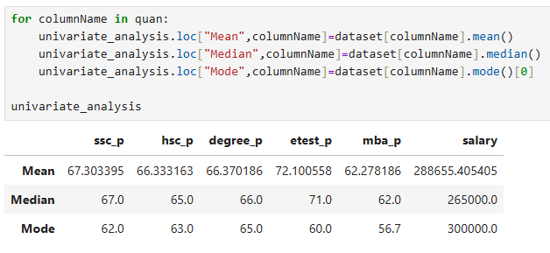

MY ANALYSIS IN BUSINEES POV:
Analysis of Placement Dataset Using Measures of Central Tendency
I analyzed the placement dataset by first separating the quantitative and qualitative columns. For the quantitative variables, I applied measures of central tendency—mean, median, and mode—to understand the overall academic and placement performance of the students.

🔹 Mean Analysis
The mean values provide an overview of the average performance of students across different stages of education:
- The mean SSLC pass percentage is 67%, indicating that students have, on average, performed at an average level in their SSLC board examinations.
- The mean HSC pass percentage is 66.3%, which also suggests an average performance among students.
- The mean degree pass percentage is 66.3%, showing that the overall degree performance of the batch is average.
- The mean E-test score is 72.1%, which reflects a good performance in the entrance test.
- The mean MBA pass percentage is 62%, indicating that students have performed at an average level during their MBA.
- The mean salary offered during placements is ₹2,88,655, which gives an idea of the average compensation received by students.
From the mean analysis, it can be inferred that most students demonstrate average academic performance, with relatively better results in the E-test.

🔹 Median Analysis
The median values help understand the central tendency without the influence of outliers:
- The median SSLC percentage is 67%
- The median HSC percentage is 65%
- The median degree percentage is 66%
These values indicate that the majority of students have performed at an average level academically.
- The median E-test score is 71%, suggesting that a significant group of students performed well in the test.
- The median MBA percentage is 62%, again reflecting an average performance.
- The median salary is ₹2,65,000, which is lower than the mean salary, indicating the presence of higher salary outliers in the dataset.
Since the median is less affected by extreme values, it provides a more realistic representation of the typical student’s performance and salary.

🔹 Mode Analysis
The mode identifies the most frequently occurring values:
- SSLC mode: 62%
- HSC mode: 63%
- Degree mode: 65%
- E-test mode: 60%
- MBA mode: 56.7%
- Salary mode: ₹3,00,000
This indicates that most students tend to score around these values, and the most common salary package offered is ₹3 LPA.

🔹 Overall Conclusion
From the analysis using measures of central tendency:
- The dataset represents a group of students who have generally average academic performance.
- Mean includes all values, including extreme scores (outliers).
- Median provides a better estimate of typical performance by excluding the influence of outliers.
- Mode helps identify the most common scores and salary offered.
Overall, this analysis shows that the batch consists predominantly of average-performing students, with comparatively better performance in the E-test and a commonly offered salary package of ₹3 LPA.

MEASURE OF LOCATION OF DATA

Percentile – Placement dataset Percentile analysis report:
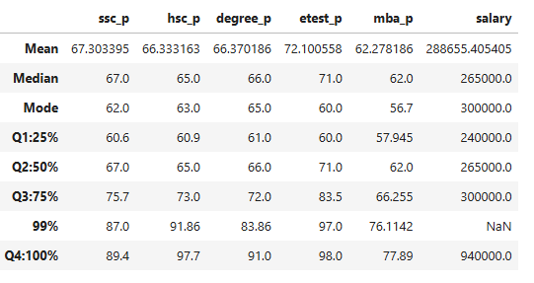
1. SSLC (Secondary School) Marks Analysis
The SSLC marks distribution shows a moderate and consistent performance trend among students. Most students scored between 60 and 75 marks, indicating average academic performance at the school level. The top-performing students scored between 87 and 89 marks, and there is no evidence of extreme outliers. Overall, SSLC scores demonstrate stable and balanced student performance.
2. HSC (Higher Secondary) Marks Analysis
HSC marks display a wider performance variation compared to SSLC marks. While the majority of students scored between 60 and 73 marks, a smaller group of students achieved significantly higher scores ranging from 91 to 97 marks. This indicates the presence of high-performing students and a stronger differentiation in performance levels.
3. Degree Marks Analysis
Degree marks show a uniform and stable performance distribution. Most students scored between 61 and 83 marks, with very few students scoring as high as 91 marks. The data spread indicates consistent academic evaluation and minimal extreme variations across students.
4. Employability Test (E-test) Analysis
The E-test marks demonstrate a larger performance spread, suggesting varied employability skill levels among students. Most students scored between 60 and 83 marks, while top performers scored between 97 and 98 marks. The close grouping among top scorers indicates strong competition and skill similarity at higher performance levels.
5. MBA Marks Analysis
MBA marks exhibit a tightly clustered distribution, with most students scoring between 57 and 76 marks. The smaller data spread suggests relatively uniform performance among students, indicating standardized evaluation patterns or similar academic outcomes.
6. Salary Distribution Analysis
The salary distribution is highly skewed, with the majority of students receiving placement packages between 2 to 3 LPA. A small number of students secured premium salary packages up to 9.4 LPA, indicating the presence of high-salary outliers. This suggests that while most placements fall within a moderate salary range, only a few students achieve significantly higher compensation.
Overall Insights
- Academic performance across SSLC, Degree, and MBA levels shows relatively consistent and moderate distribution.
- HSC and E-test results highlight stronger performance differentiation among students.
- Salary distribution indicates that most students receive moderate placement packages, with only a few achieving premium placements.
- Employability test scores suggest notable variation in practical and skill-based competencies among students.

Inter Quartile Range (IQR Method) – Placement dataset Outlier analysis report:
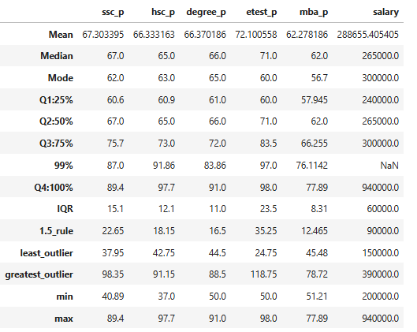
To identify outliers in the placement dataset, the Interquartile Range (IQR) method was applied. The lower and upper outlier boundaries were calculated using the 1.5 × IQR rule.

SSLC Marks
The calculated lower boundary is 37.95 and the upper boundary is 98.35.
The minimum score (40.89) and maximum score (89.4) fall within this range.
Therefore, no outliers are present in SSLC marks.
HSC Marks
The lower boundary is 42.75 and the upper boundary is 91.15.
The minimum score (37) is below the lower boundary and the maximum score (97) exceeds the upper boundary.
This indicates the presence of both lower and upper outliers in HSC marks.
Degree Marks
The lower boundary is 44.5 and the upper boundary is 88.5.
The minimum score (50) lies within the boundary, while the maximum score (91) exceeds the upper boundary.
Degree marks contain an upper outlier.
Employability Test (E-Test) Marks
The lower boundary is 24.75 and the upper boundary is 118.75.
Both the minimum (50) and maximum (98) values fall within the boundary.
No outliers are detected in E-test marks.
MBA Marks
The lower boundary is 45.48 and the upper boundary is 78.72.
Both minimum (51) and maximum (77) values fall within the acceptable range.
MBA marks do not contain outliers.
Salary
The lower boundary is 1,50,000 and the upper boundary is 3,90,000.
The maximum salary value of 9,40,000 exceeds the upper boundary.
Salary column contains significant upper outliers, indicating the presence of high-paying placement offers received by a small number of students.
Overall Conclusion
Most academic performance columns show stable score distributions with minimal outliers. However, HSC and Degree marks contain limited extreme values. The salary distribution contains significant upper outliers, suggesting unequal salary distribution where a small proportion of students receive premium placement packages.

BEFORE REPLACING OUTLIER AFTER REPLACING OUTLIER
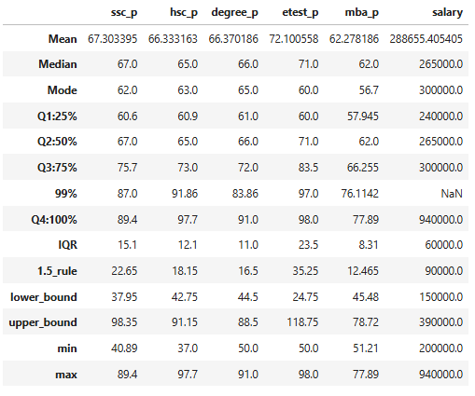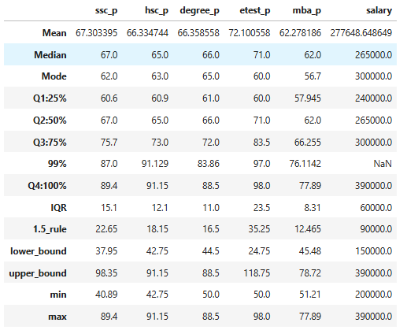
Outliers were treated using the IQR method. In the HSC pass marks column, both lower and upper outliers were handled. In the degree pass marks and salary columns, only upper outliers were treated. As a result of this outlier treatment, minor variations were observed across the percentile distribution (99th & 100th percentile).

