Analysis of PLACEMENT DATASET
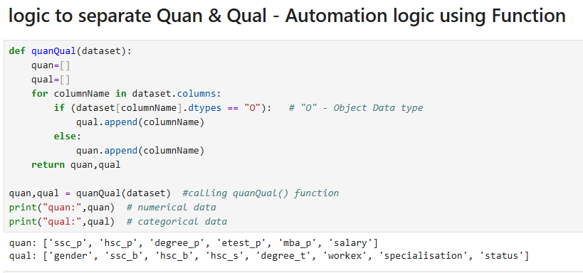

Measure of central tendency
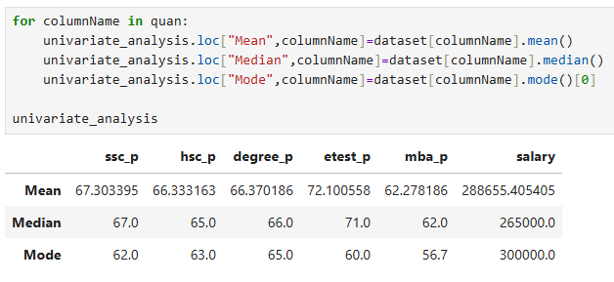

MY ANALYSIS IN BUSINEES POV:
Analysis of Placement Dataset Using Measures of Central Tendency
I analyzed the placement dataset by first separating the quantitative and qualitative columns. For the quantitative variables, I applied measures of central tendency—mean, median, and mode—to understand the overall academic and placement performance of the students.

🔹 Mean Analysis
The mean values provide an overview of the average performance of students across different stages of education:
- The mean SSLC pass percentage is 67%, indicating that students have, on average, performed at an average level in their SSLC board examinations.
- The mean HSC pass percentage is 66.3%, which also suggests an average performance among students.
- The mean degree pass percentage is 66.3%, showing that the overall degree performance of the batch is average.
- The mean E-test score is 72.1%, which reflects a good performance in the entrance test.
- The mean MBA pass percentage is 62%, indicating that students have performed at an average level during their MBA.
- The mean salary offered during placements is ₹2,88,655, which gives an idea of the average compensation received by students.
From the mean analysis, it can be inferred that most students demonstrate average academic performance, with relatively better results in the E-test.

🔹 Median Analysis
The median values help understand the central tendency without the influence of outliers:
- The median SSLC percentage is 67%
- The median HSC percentage is 65%
- The median degree percentage is 66%
These values indicate that the majority of students have performed at an average level academically.
- The median E-test score is 71%, suggesting that a significant group of students performed well in the test.
- The median MBA percentage is 62%, again reflecting an average performance.
- The median salary is ₹2,65,000, which is lower than the mean salary, indicating the presence of higher salary outliers in the dataset.
Since the median is less affected by extreme values, it provides a more realistic representation of the typical student’s performance and salary.

🔹 Mode Analysis
The mode identifies the most frequently occurring values:
- SSLC mode: 62%
- HSC mode: 63%
- Degree mode: 65%
- E-test mode: 60%
- MBA mode: 56.7%
- Salary mode: ₹3,00,000
This indicates that most students tend to score around these values, and the most common salary package offered is ₹3 LPA.

🔹 Overall Conclusion
From the analysis using measures of central tendency:
- The dataset represents a group of students who have generally average academic performance.
- Mean includes all values, including extreme scores (outliers).
- Median provides a better estimate of typical performance by excluding the influence of outliers.
- Mode helps identify the most common scores and salary offered.
Overall, this analysis shows that the batch consists predominantly of average-performing students, with comparatively better performance in the E-test and a commonly offered salary package of ₹3 LPA.

