Problem Statement: - Social Network Ad
How to develop an AI solution to personalize advertisements for users based on historical data, and predict whether a user is likely to purchase the advertised product. The AI system should display advertisements only to users with a high probability of making a purchase, in order to target the right customers effectively.
Class 0 – User purchased
Class 1 – User did not purchase
Support – Actual No. of. Samples in Each class

Random Forest Classifier
Code link: https://github.com/krthiksha/Machine-Learning-Classification_module/blob/main/1.RandomForest_classification.ipynb
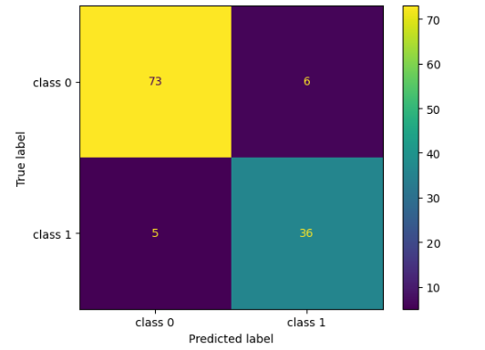
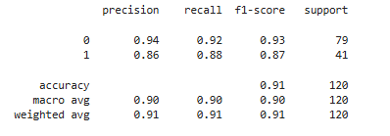

Classification report for random forest classifier
- What is the overall performance of the model?
Accuracy : 0.91
- What is the percentage of correctly classified class 0?
Recall of class 0 : 0.92
- What is the percentage of correctly classified class 1?
Recall of class 1 : 0.88
- What is the percentage of correctly and wrongly classified class 0?
Precision of class 0 : 0.94
- What is the percentage of correctly and wrongly classified class 1?
Precision of class 1 : 0.86
- Measure the balance between precision and recall for class 0?
F1 score of class 0 : 0.93
- Measure the balance between precision and recall for class 1?
F1 score of class 1 : 0.87
- What is the macro average of precision?
macro average of precision : 0.90
- What is the macro average of recall?
macro average of recall : 0.90
- What is the macro average of f1 score?
macro average of f1 score : 0.90
- What is the weighted average of precision?
weighted average of precision : 0.91
- What is the weighted average of recall?
weighted average of recall : 0.91
- What is the weighted average of f1 score?
weighted average of f1 score : 0.91

Algorithm : RandomForestClassifier
Accuracy (overall performance of the model) = 0.91
overall metrics performance (precision,recall,f1-score) = good

Result : Good Model

Decision Tree Classifier
Code link: https://github.com/krthiksha/Machine-Learning-Classification_module/blob/main/2.DecisionTree_classification.ipynb
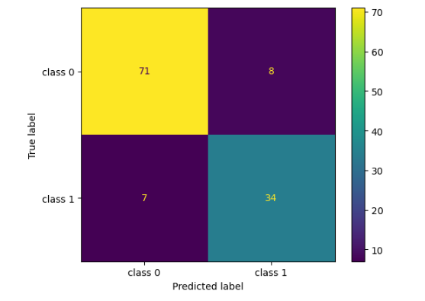
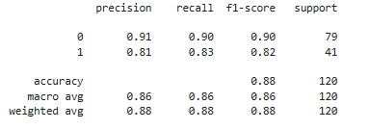

Classification report for random forest classifier
- What is the percentage of correct classification of both the classes?
Accuracy : 0.88
- How many actual positives did I find for class 0?
Recall of class 0 : 0.90
- How many actual positives did I find class 1?
Recall of class 1 : 0.85
- How correct my positive predictions for class 0?
Precision of class 0 : 0.92
- How correct my positive predictions for class 1?
Precision of class 1 : 0.81
- What is the overall performance of class 0?
F1 score of class 0 : 0.93
- What is the overall performance of class 1?
F1 score of class 1 : 0.87
- What is the macro precision?
macro average of precision : 0.87
- What is the macro recall?
macro average of recall : 0.88
- What is the macro f1 measure?
macro average of f1 score : 0.87
- What is the weighted precision?
weighted average of precision : 0.89
- What is the weighted recall?
weighted average of recall : 0.88
- What is the weighted f1 score?
weighted average of f1 score : 0.88

Algorithm : DecisionTreeClassifier
Accuracy (overall performance of the model) = 0.88
overall metrics performance (precision,recall,f1-score) = good

Result : Good Model but not better than Randomforestclassifier

SVC (support vector classifier)
Code: https://github.com/krthiksha/Machine-Learning-Classification_module/blob/main/3.SVM_classification.ipynb
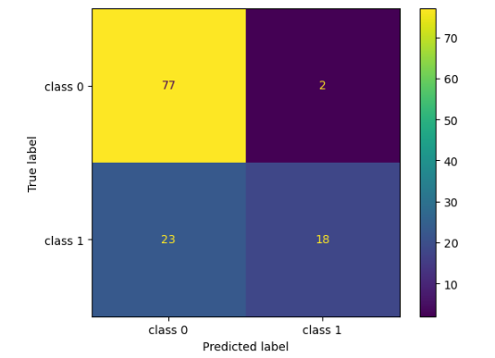
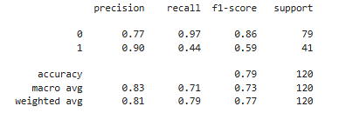

Classification report for random forest classifier
- Overall how many predictions where correct?
Accuracy : 0.79
- Of all actual users for class 0 (Not purchases), How many did the model correctly
Identified?
Recall of class 0 : 0.97
- Of all actual users for class 1 (purchased), how many did model correctly identified?
Recall of class 1 : 0.44
- Of all actual users for class 0 (not purchased), how many were actually correct?
Precision of class 0 : 0.77
- Of all actual users for class 1 (purchased), how many were actually correct?
Precision of class 1 : 0.90
- What is F1 measure of class 0?
F1 score of class 0 : 0.86
- What is F1 measure of class 1?
F1 score of class 1 : 0.59
- What is the average performance of precision for the model?
macro average of precision : 0.83
- What is the average performance of recall for the model?
macro average of recall : 0.71
- What is the average performance of f1 score for the model?
macro average of f1 score : 0.73
- What is the sum of product of proportion rate of each class in precision?
weighted average of precision : 0.81
- What is the sum of product of proportion rate of each class in recall?
weighted average of recall : 0.79
- What is the sum of product of proportion rate of each class in f1 score?
weighted average of f1 score : 0.77

Algorithm : SVC
Accuracy (overall performance of the model) = 0.79
overall metrics performance (precision,recall,f1-score) = poor

Result : poor model

LOGISTIC REGRESSION (CLASSIFICATION ALGORITHM)
Code: https://github.com/krthiksha/Machine-Learning-Classification_module/blob/main/4.Logistic_Regression_classification.ipynb
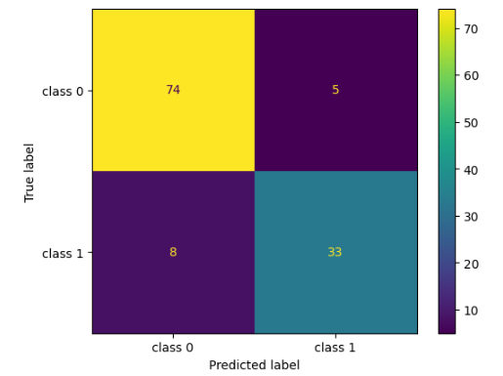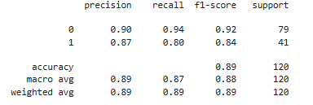
Algorithm : Logistic Regression
Accuracy (overall performance of the model) = 0.89
overall metrics performance (precision,recall,f1-score) = good
Result : good model but not better than Randomforestclassifier
PROBLEM STATEMENT:- Social network Ad (User Purchase Prediciton)
Algorithm: Logistic regression
SL.NO | solver | max_iter | C | Confusion matrix | model accuracy | Remark
1 | lbfgs | 100 | 1.0 | [[74 5]  [ 8 33]] | 0.89 (ConvergenceWarning) | Warning
2 | lbfgs | 120 | 1.0 | [[74 5]  [ 8 33]] | 0.89 | Good Model
3 | lbfgs | 200 | 1.0 | [[74 5]  [ 8 33]] | 0.89 | Good Model
4 | liblinear | 120 | 1.0 | [[79 0]  [41 0]] | 0.66 | poor
5 | newton-cg | 120 | 1.0 | [[74 5]  [ 8 33]] | 0.89 | Good Model
6 | newton-cholesky | 120 | 1.0 | [[74 5]  [ 8 33]] | 0.89 | Good Model
7 | sag | 120 | 1.0 | [[79 0]  [41 0]] | 0.66 | poor
8 | saga | 120 | 1.0 | [[79 0]  [41 0]] | 0.66 | poor
9 | lbfgs | 120 | 0.01 | [[74 5]  [11 30]] | 0.87 | Good Model

KNN classifier:
Code: https://github.com/krthiksha/Machine-Learning-Classification_module/blob/main/4.KNN_classification.ipynb

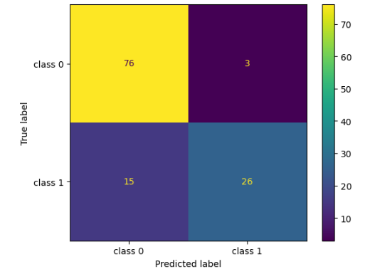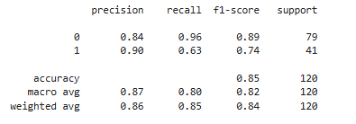
Algorithm : K nearest neighbors classifier
Accuracy (overall performance of the model) = 0.85
overall metrics performance (precision,recall,f1-score) = good
Result: good model but not better than Randomforestclassifier for the problem statement (social network ad)
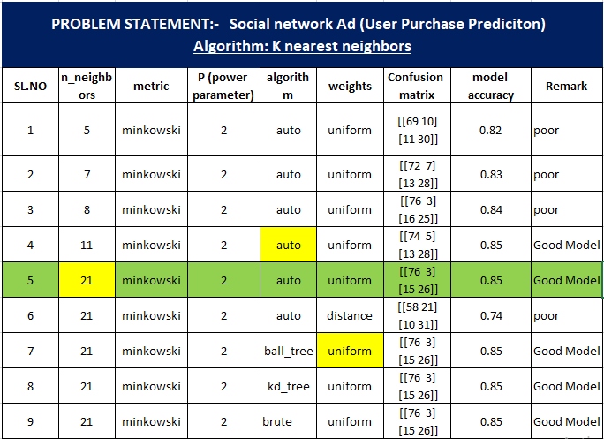

Naïve Bayes
Code: https://github.com/krthiksha/Machine-Learning-Classification_module/blob/main/4.NB_classification.ipynb
PROBLEM STATEMENT:- Social network Ad (User Purchase Prediciton)
Algorithm: Naïve Bayes
SL.NO | NB types | Confusion matrix | model accuracy | Remark
1 | GaussianNB | [[74 5]  [ 8 33]] | 0.89 | Good Model
2 | MultinomialNB | [[68 11]  [28 13]] | 0.68 | poor
3 | ComplementNB | [[42 37]  [20 21]] | 0.53 | poor
4 | BernoulliNB | [[79 0]  [41 0]] | 0.66 | poor
5 | CategoricalNB | [[76 3]  [ 9 32]] | 0.90 | Good Model

Algorithm : Naïve bayes - GaussianNB
Accuracy (overall performance of the model) = 0.89
overall metrics performance (precision,recall,f1-score) = good
Result: good model but the Randomforestclassifier model performance (0.91) for the problem statement (social network ad)

Best Model for social network ad problem is Random forest classifier with accuracy => 0.91
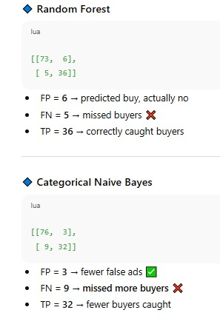s

Evaluation Metrics using Confusion Matrix

Accuracy
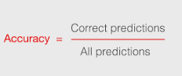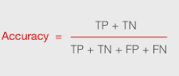

Accuracy Scenarios:
- Overall performance of the model?
- What is the Percentage of correct classification of both the classes?
- Overall how many predictions were correct?

Calculation of Random Forest classifier:
Accuracy = (73+36) / (73+36+5+6)
=109/120
=0.90833 ~ 0.91

Recall
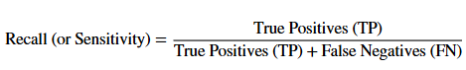

Recall Scenarios:
- Percentage of correctly classified of a specific class?
- How many actual positives did I find?
- Of all actual users for a specific class, how many did the model correctly identified?

Calculation of Random Forest classifier:
Recall (class 0) = 73 / (73+6)
= 73/79 = 0.92

Precision
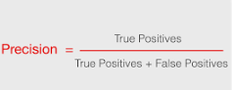

Precision Scenarios:
- Percentage of correctly and wrongly classified of a specific class?
- How correct my positive predictions for a specific class?
- Of all users for a specific class, how many were actually correct?

Calculation of Random Forest classifier:
Precision (class 0) = 73 / (73+5) = 73/78
= 0.9358 ~ 0.94

F1 score / F1 measure
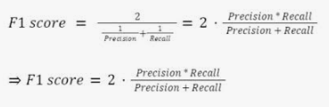

Scenarios:
- Balance between precision and recall for classes?
- Overall performance of a specific class?
- What is F1 measure of a specific class?

Calculation of Random Forest classifier:
F1 score (class 0) = 2 ((0.94 * 0.92) / (0.94 + 0.92))
= 2(0.8648/1.86)
= 2(0.464)
=0.9298 ~ 0.93

Macro average
Macro precision = (precision1 + precision2) / 2
Macro recall = (recall1 + recall2) / 2
Macro f1score = (f1score 1 + f1score 2) / 2

Calculation of Random Forest classifier:
Macro precision = (0.94 + 0.86) / 2 = 1.8/2 =0.90

Scenarios:
Metrics – (precision, recall, f1 score)
- Macro average of metrics
- Macro metrics
- Average performance for the metrics for the model

Weighted average
Weighted average = Sum (metrics * proportion rate)

Scenarios:
Metrics – (precision, recall, f1 score)
- Weighted average of metrics
- Weighted metrics
- Sum of product of proportional rate of each classes in metrics

Calculation of Random Forest classifier:
Weighted precision = (0.94 * (79/120)) + (0.86 * (41/120))
= (0.94 * (0.658)) + (0.86 * (0.34))
= 0.618 + 0.29
= 0.9085 ~ 0.91

Grid Search CV classification – algorithm comparison report

Random forest classifier
Grid search cv – parameter grid:
param_grid = {
"criterion": ["gini", "entropy", "log_loss"],
"max_features": ["sqrt", "log2", None],
"class_weight": ["balanced", "balanced_subsample"]
}
model = RandomForestClassifier()
Model Accuracy: 0.93
Confusion matrix:
[[54 4]
[ 2 20]]
Classification report:
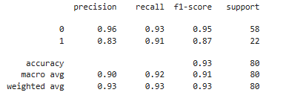
Result:
In the random forest classifier, the accuracy of the model is 0.93. And also in the confusion metric, the false negative is less, which is 2. And the recall of the model for purchased is 91, with precision of 83. It's overall performance is also good, with accuracy of 93 and also false negative is less, so that leads to the minimized missing of the buyers. So it is actually a very good model.

Support Vector classifier SVC
Grid search cv – parameter grid:
param_grid = {
"kernel": ["linear", "poly", "rbf", "sigmoid"], #precomputed - need x to be a square matrix
"gamma": ["scale", "auto"]
}
model = SVC(probability=True)
Model Accuracy: 0.95
Confusion matrix:
[[55 3]
[ 1 21]]
Classification report:
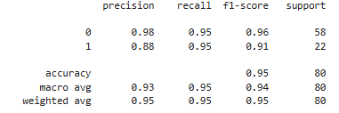
Result:
Support vector classifier for the same problem, accuracy of 95% and the confusion matrix false negative is actually 1 and the recall for both the classes is 95% with the precision of 83 for class 1 and 98 for class 0 and the overall performance is really very good and comparing to the random forest, support vector classifier is really performing much better than random forest so it is a very good model.

Decision tree classifier
Grid search cv – parameter grid:
param_grid = {
"criterion": ["gini", "entropy", "log_loss"],
"splitter" : ["best", "random"],
"max_features" : ["sqrt", "log2"],
}
model = DecisionTreeClassifier()
Model Accuracy: 0.91
Confusion matrix:
[[55 3]
[ 4 18]]
Classification report:
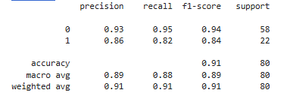
Result:
Decision tree classifier for the same problem, accuracy of the model is 91 percent, but the confusion matrix false negative is 4, which is greater number comparatively with support vector classifier and the random forest. The recall for the purchase is 82 and precision is 86, so that is also less. So I conclude that Decision Tree classifier model is performing good but it is comparatively less performance when comparing with the Random Forest and Support Vector classifier.

Logistic regression
Grid search cv – parameter grid:
param_grid = [
# L2 penalties
{
"solver": ["lbfgs", "newton-cg", "newton-cholesky", "sag"],
"penalty": ["l2", None]
},
# L1 penalties
{
"solver": ["liblinear", "saga"],
"penalty": ["l1"]
},
# ElasticNet
{
"solver": ["saga"],
"penalty": ["elasticnet"],
"l1_ratio": [0.1, 0.5, 0.9]
}
]
model = LogisticRegression()
Model Accuracy: 0.93
Confusion matrix:
[[56 2]
[ 4 18]]

Classification report:
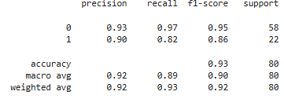
Result:
Logistic regression model accuracy 93%, but the confusion matrix false negative is 4, and recall for class 1 is 82 (purchased). So it is comparatively good model, but when comparing with the support vector classifier, which is with the highest accuracy and a good performing model, this logistic regression is performing less.

KNN
Grid search cv – parameter grid:
param_grid ={
"weights":["uniform", "distance"],
"algorithm":["auto", "ball_tree", "kd_tree", "brute"]
}
model = KNeighborsClassifier()
Model Accuracy: 0.95
Confusion matrix:
[[55 3]
[ 1 21]]

Classification report:
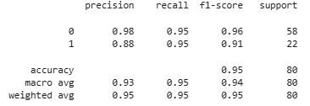
Result:
k-neighbor classifier algorithm, accuracy with a 95% and also confusion matrix for false negative is 1, recall is 95, precision is 88 for the class 1, and overall performing also it is good, and also all the metrics, accuracy scores are similar to the support vector classifier, which is one of the highest performing model as of now, as per the analysis. So I conclude that k-nearest neighbor is also performing same as the support vector classifier, so both the model is the highest performing model for the social network ad as of now, as per the analysis.

Naïve bayes
Grid search cv – parameter grid:
param_grid ={
"alpha" : [0.1, 0.5, 1.0],
"binarize" : [0.0, 0.5, 1.0]
}
model = BernoulliNB()
Model Accuracy: 0.90
Confusion matrix:
[[51 7]
[ 1 21]]

Classification report:
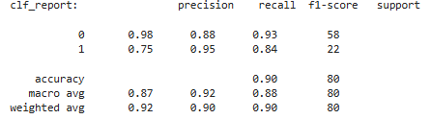
Result:
finalizing bernoulliNB – As minimizing missed purchases (false negatives) is more important
Naive bayes, Bernoulli NB, Model Accuracy 90%, Confusion Matrix False Negative is 1, but the Recall for Class 1 is 95, Precision for Class 1 is 75, so overall it is good, but comparing with the highest performing models KNN and the Support Vector Classifier, this model is performing less.

FINALIZED MODEL FOR SOCIAL NETWORK AD – problem statement
Algorithm : KNN classifier and Support vector classifier (SVC)
Model Accuracy: 0.95
Confusion matrix:
[[55 3]
[ 1 21]]

Classification report:
Analysis Report:
So, I finalize the model for Social Network Ad Problem Statement in order to find user will purchase or not purchase the product. K-nearest neighbor classifier algorithm and support vector classifier algorithm with accuracy of 95%. Both are performing well overall with minimized false negatives. So, the number of missing the buyers will be less. So, I conclude this both algorithm is performing well with accuracy 95% and I finalize this both at my final model.

