The changes I had made to the original home screen with Spotify. I did use my personal account to give a current redesign. (I don’t use my real name on applications.)

1. Removed the emoji from the title. I never cared for them before and brings down a design in a negative way.
2. Enlarged the fond a few sections. It gives an easier readability and reduces the large white space.
3. Removed the text at the navigation bar at the bottom and changed the library icon to a vinal icon. It gives more of a ‘saved file’ feel and aligns with collectors of music.
4. Also highlighted the icon on the navigation bar with color than using white. It is easier to see what page you are on and uses more of the logo color.
5. Increased the size of main ‘You may like’ section.
6. Added a like icon to place the song into favorites. I hate having to go to the song just to like it.
7. Replaced the white play icon to green to keep reenforcing the logo color.

Redesigned

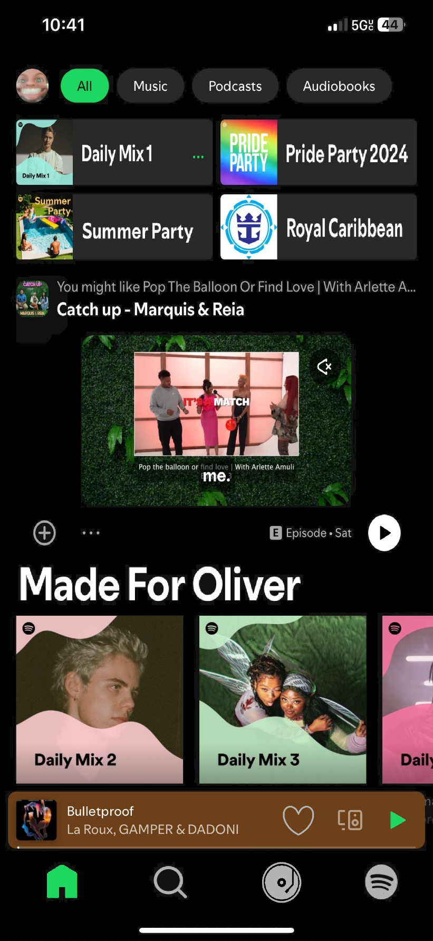

Original

