
POLYTECHNIC UNIVERISTY OF THE PHILIPPINES
Calauan Campus
Final Project for COMP 009 Object Oriented Programming
Project Title: OOPDex
Members:
1. CARAIG, Kurt John P. sig.
2. AUSTRIA, Norwin L. sig.
3. BATI, Daisuke Reggie C. sig.

Project Overview:

The OOPDex is a web application designed to facilitate the cataloging, searching, filtering, and management of Pokémon. The application is structured into two core components: a React-based front-end interface and a Spring Boot-based REST API back-end.

The primary purpose of the system is to allow authenticated users to view the official PokeDex, search or filter Pokémon by attributes, and manage a personal collection of captured Pokémon. Furthermore, the application provides administrative features allowing authorized users to manage the global Pokémon database (create, update, soft-delete, restore, or permanently delete entries) and administer user accounts.

Front-End Component

The front-end of the OOPDEX is a responsive, highly interactive single-page application built using React.

1. Landing Page
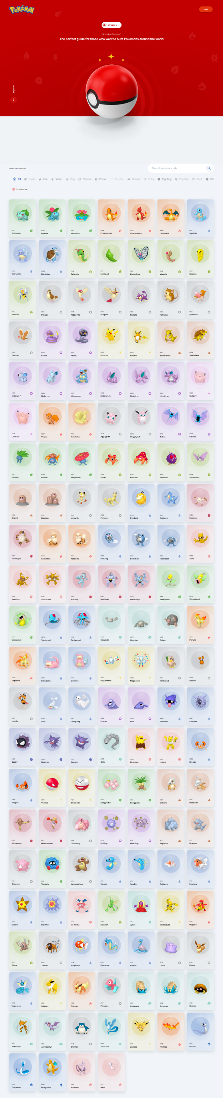
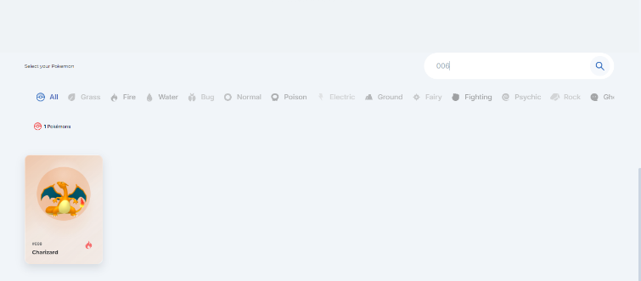
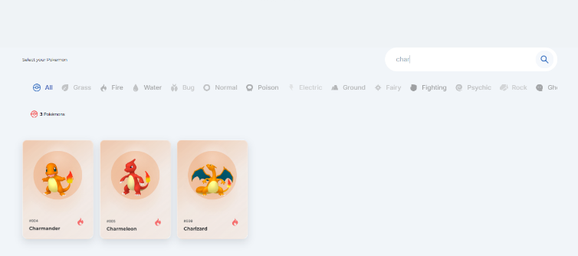
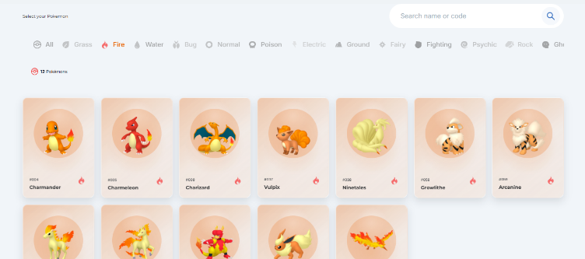
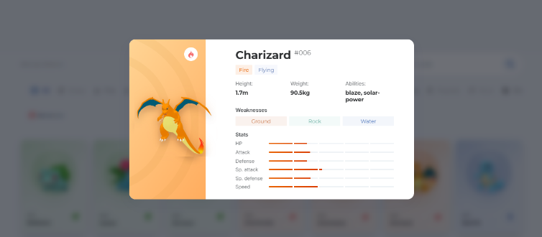
The Landing Page serves as the public entry point of the Pokémon Database System, providing visitors with immediate access to the available Pokémon records. Upon accessing this screen, users are presented with a searchable and organized collection of Pokémon cards displayed within the database. A login button is available for users who wish to sign in to an existing account or create a new account. Visitors can freely browse the database without authentication, allowing them to explore Pokémon information in a public view. The screen includes a search function that enables users to locate Pokémon by entering either the Pokémon name or identification code. Users may also narrow down displayed results through Pokémon type filters for more efficient navigation. Each Pokémon is represented by an interactive card containing basic information and imagery. When a user selects a Pokémon card, a modal window is displayed showing detailed information about the chosen Pokémon. The modal presents the Pokémon’s name, identification number, type classification, height, and weight. Additionally, users can view the Pokémon’s abilities, weaknesses, and statistical attributes within the same detail view. The interface is designed to provide quick access to Pokémon information while maintaining a simple and intuitive browsing experience. This screen supports both casual visitors and registered users by offering public accessibility alongside account authentication options. Overall, the Landing Page functions as the primary navigation point for exploring and searching the Pokémon database.

3. Registration Page
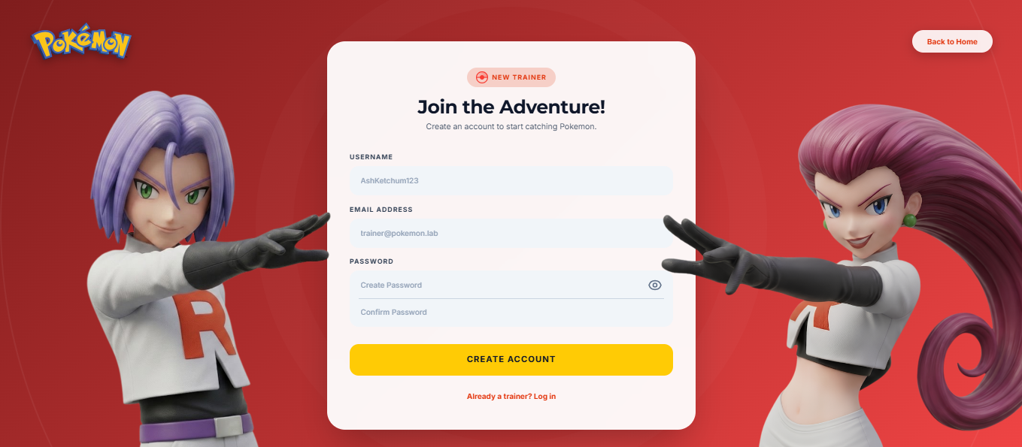
The Registration Page allows new users to create an account in the Pokémon Database System. Users must provide a username, email address, and password to complete the registration process. The username must contain 3 to 20 characters, while the email address must follow a valid format and end with @pokemon.lab. The password must contain at least 8 characters. A password visibility toggle is available to help users verify their password entries before submission. The Create Account button validates the provided information and creates a new user account when all requirements are met. Users who already have an account may select the Log In option to access the Login Page, while the Back to Home button returns them to the Landing Page.

2. Login Page
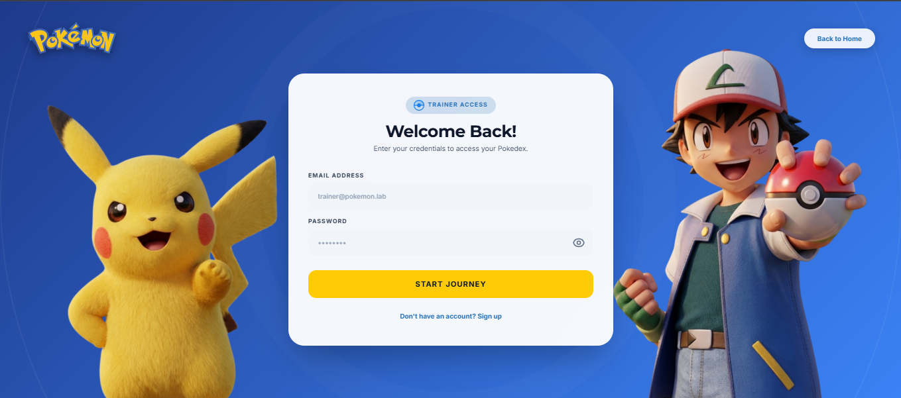
The Login Page serves as the authentication gateway of the Pokémon Database System. Users can enter their registered email address and password to access authorized system features. A password visibility toggle is provided to help users verify their input before logging in. The Start Journey button submits the credentials for authentication. Users without an existing account may select the Sign Up option to proceed to the registration page. A Back to Home button is also available for returning to the Landing Page. This screen ensures secure and controlled access to the system while providing navigation options for account registration and public access pages.

4. Admin Control Center Page
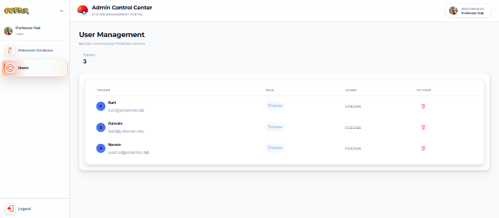
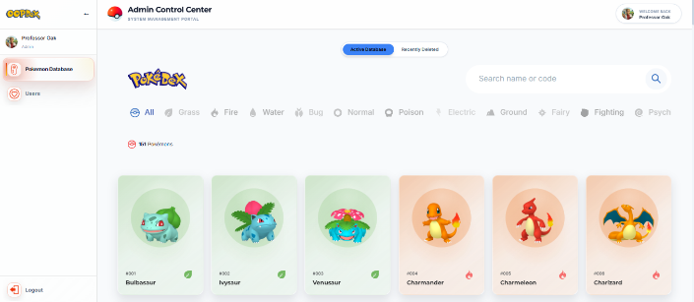
The Admin Control Center Page is the primary management interface of the Pokémon Database System, operated by Professor Oak as the designated administrator. This screen is divided into two modules: Pokémon Database and User Management. Within the Pokémon Database module, Professor Oak can view all Pokémon entries and perform actions such as editing, deleting, retrieving, and permanently removing records. A search bar allows Pokémon to be located by name or code, while filters enable quick categorization by type. The database is organized into two sections: Active Database and Recently Deleted. The Active Database represents the public-facing dataset, meaning any modification here directly affects what users see in the Pokédex interface on both the Landing Page and the User Panel. The Recently Deleted section serves as a temporary archive, allowing Professor Oak to review or restore entries before permanent removal.

In the User Management module, Professor Oak can access a list of registered trainers, including their name, email address, role, and date joined. This section also provides administrative actions such as evicting or deleting trainer accounts from the system. A Logout button is available to securely end the admin session and return to the login screen.

4.1. Admin Control Center Page ( Pokemon Edit Modal )
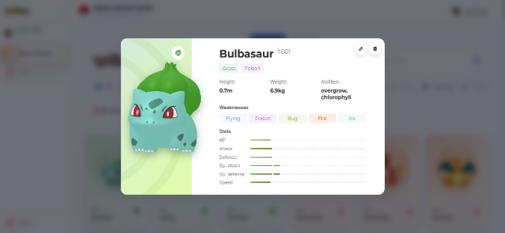
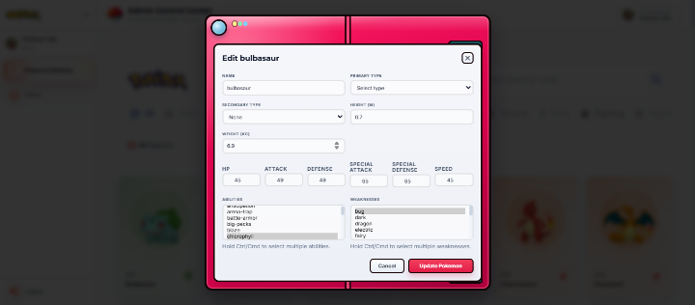
The Pokémon Edit Modal allows administrators to modify existing Pokémon records within the database. When a Pokémon card is selected, a modal window appears displaying detailed information about the chosen Pokémon. In the top-right corner of this modal, Edit and Delete buttons are available for administrative actions. Clicking the Edit button opens the Pokémon Edit Modal, where the admin can update specific attributes of the Pokémon. Editable fields include the Pokémon’s name, primary type, secondary type, height, weight, abilities, weaknesses, and stat values such as HP, Attack, Defense, Special Attack, Special Defense, and Speed. The Pokémon’s identification number (ID) remains fixed and cannot be altered to preserve database integrity.

Within the edit interface, dropdown menus and input fields are provided for accurate data entry, ensuring consistency across all Pokémon records. The Cancel button allows the admin to exit without saving changes, while the Update Pokémon button confirms and applies modifications to the database. This modal ensures that all updates are securely processed and immediately reflected in the Active Database, maintaining synchronization between the admin panel and the public Pokédex view.

4.2. Admin Control Center (Recently Deleted)
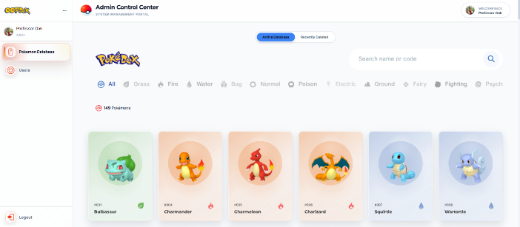
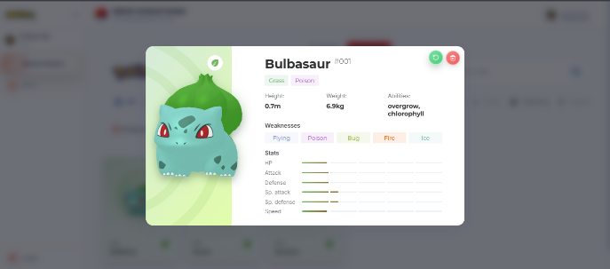
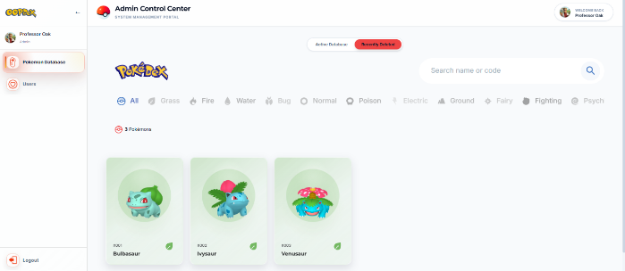
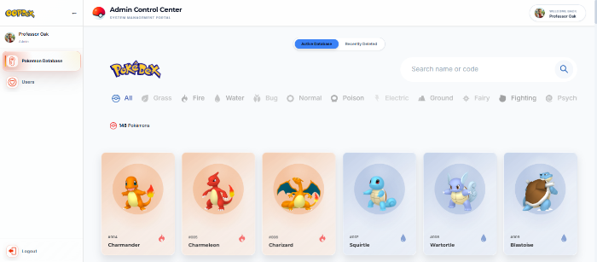
4
3
2
1

The Pokémon Database module within the Admin Control Center enables Professor Oak to manage all Pokémon records. In the Active Database, admins can view the complete list of Pokémon available to users, displayed as cards with their name, ID, and type. Selecting a card opens a modal showing detailed attributes such as height, weight, abilities, weaknesses, and stats. At the top-right corner of this modal, Restore/Retrieve and Delete buttons are available for administrative actions. When a Pokémon is deleted from the Active Database, it is automatically moved to the Recently Deleted section, which serves as a temporary archive for review or restoration.

As demonstrated, Bulbasaur, Ivysaur, and Venusaur were deleted from the Active Database and appeared in the Recently Deleted list. From there, Professor Oak could either permanently delete or restore them. Once restored, the Pokémon reappears in the Active Database and becomes visible again in the public Pokédex view. This workflow ensures safe and controlled data management, allowing recovery of mistakenly deleted entries while keeping the admin panel and user interface synchronized.

5. Trainer Dashboard
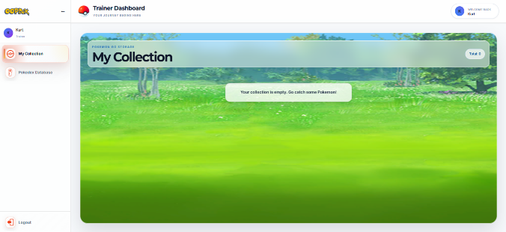
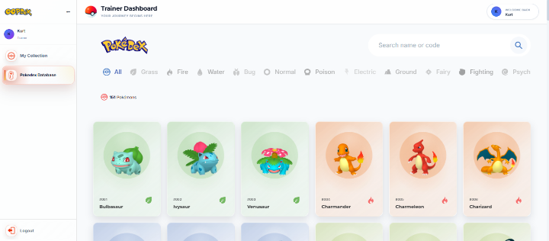
The Trainer Dashboard serves as the main interface for managing Pokémon activities. It is divided into two sections: My Collection and Pokédex. The My Collection page displays all Pokémon caught by the trainer, showing the total count and allowing management of stored Pokémon. If the collection is empty, a message prompts the trainer to begin catching Pokémon.

5.1 Trainer Dashboard (Add/Catch Pokemon )
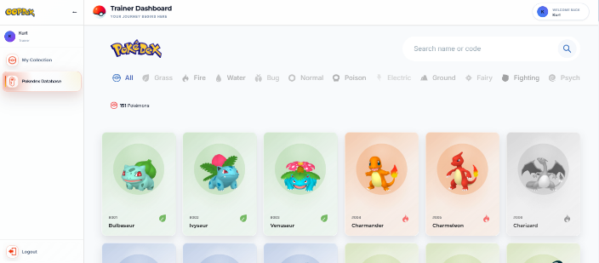
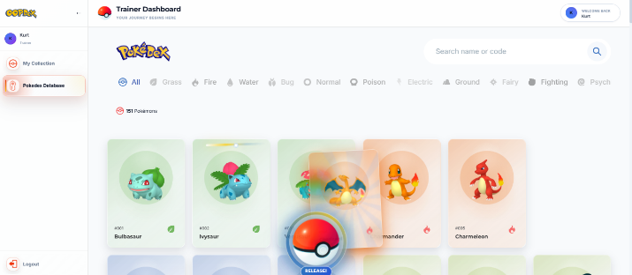
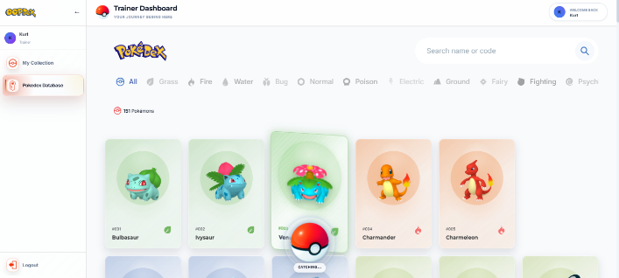
4
3
2
1
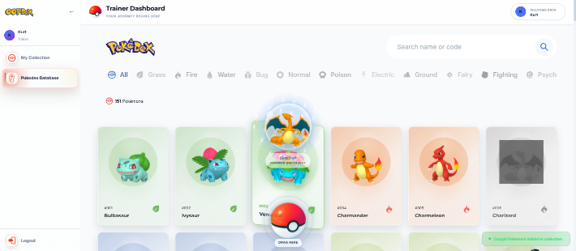

In the Pokédex section of the Trainer Dashboard, users can catch Pokémon directly from the displayed cards. To initiate a catch, the trainer must double-tap the card of the desired Pokémon and drag it toward the Pokéball located at the bottom center of the screen. Once released, a short animation plays, showing the catching process.

When the catch is successful, a “Gotcha!” animation appears, confirming that the Pokémon has been added to the trainer’s collection. The caught Pokémon’s card then turns gray, indicating it has already been captured. Despite this, trainers can still tap the gray card to open the Pokémon modal and view its details. This interactive feature provides a dynamic and engaging way to expand the trainer’s collection while maintaining access to Pokémon information.

5.2 Trainer Dashboard (Delete/Release Pokemon )
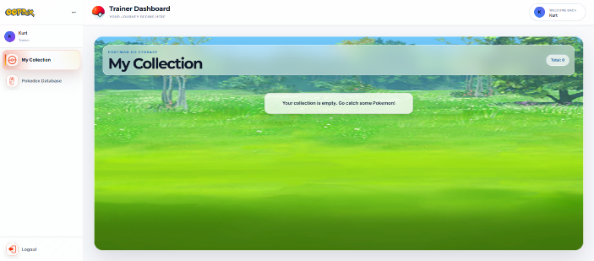
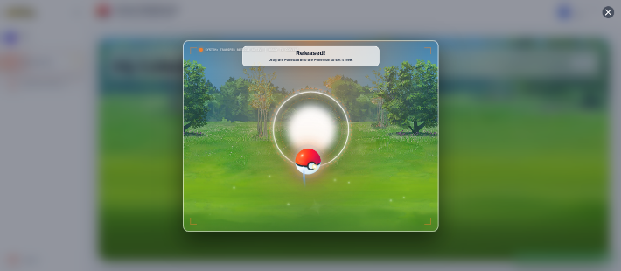
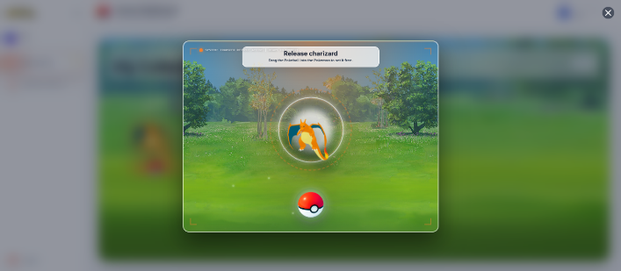
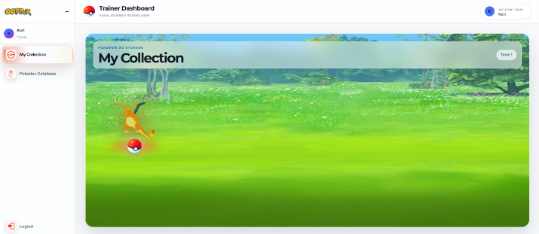
4
3
2
1

In the My Collection section of the Trainer Dashboard, trainers can release Pokémon they no longer wish to keep. To begin the process, hover over the Pokémon you want to release and click the Pokéball that appears beneath it. This action opens a mini-game modal where the trainer must drag the Pokéball toward the Pokémon to set it free.

Once the Pokéball reaches the Pokémon, a “Released!” animation confirms the successful release. The Pokémon is then removed from the collection, and the total count updates automatically. This interactive feature provides a smooth and engaging way to manage stored Pokémon while maintaining a realistic gameplay experience.


POLYTECHNIC UNIVERISTY OF THE PHILIPPINES
Calauan Campus
Final Project for COMP 009 Object Oriented Programming
Back-End Component

Project Structure
The backend is organized using a Model-View-Controller (MVC) architecture with the Service-Repository pattern, separating REST endpoint exposure, core business policies, and database access.
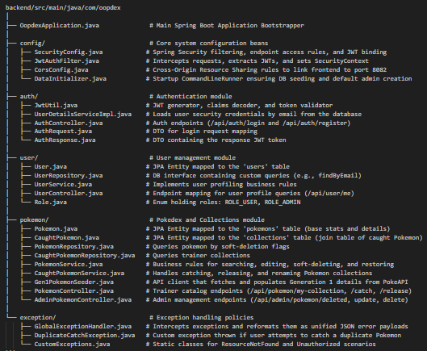

Database Structure

Table Name | Purpose
users | Holds registered user profiles and administrative accounts. Stores database IDs, unique emails, unique usernames, hashed password keys, and user authorization roles.
pokemons | Acts as the central Pokedex catalog registry. Stores Generation 1 Pokemon names, stats (HP, Attack, Defense, Special Attack, Special Defense, Speed), physical dimensions (weight, height), abilities, element types list, weaknesses list, and a soft-delete status flag.
collections | Tracks relationship mappings representing which users have caught which Pokemon. Links user_id and pokemon_id together. Tracks capture timestamps (date_caught) and optional custom nickname fields. Features a database constraint enforcing that (user_id, pokemon_id) must be unique to prevent duplicates.

Challenges and Solutions
1. Manual Pokemon Database Seeding and PokeAPI Syncing
Challenge: During development, one of the primary issues encountered was that manually inputting and seeding all 151 Generation 1 Pokemon entries—including their exact metric details, abilities, base stats, and type weaknesses—into the database one-by-one is extremely tedious, repetitive, and highly prone to human error.
Solution: We resolved this by building an automatic sync seeder (`Gen1PokemonSeeder`). Upon backend startup, the system performs a count check. If entries are missing, it loops from ID 1 to 151 and makes REST requests to the external PokeAPI to parse details, calculate type weaknesses, and save them automatically. To prevent redundant operations and API rate limits, the seeder checks `pokemonRepository.existsById(id)` to perform incremental seeding.
Project Source: <Gdrive, Onedrive, or github repo link>

